Suppl. Table 1. Used antibodies and fluorochromes. Selected markers are surface molecules involved in the pathogenesis and prognosis of CLL.

Antigen | Clone | Fluorochrome | Manufacturer
CD69 | FN50 | FITC | BD Biosciences
CD184 | 12G5 | PE | BD Biosciences
CD86 | 2331 (FUN-1) | APC | BD Biosciences
CD185 | J252D4 | PerCP Cy5.5 | BioLegend
CD45 | J33 | PC7 | Beckman Coulter
CD19 | J3-119 | AlexaFluorTM 700 | Beckman Coulter
CD19 | J3-119 | AlexaFluorTM 750 | Beckman Coulter
CD5 | BL1a | ECD | Beckman Coulter
CD3 | UCHT1 | APC | Beckman Coulter
CD27 | 1A4CD27 | PC5.5 | Beckman Coulter

Suppl. Fig. 1. Gating strategy of the determination of the CLL cell ratio.
The proportion of CLL cells was assessed using anti-CD45, anti-CD19, anti-CD5, and anti-CD3 antibodies. Living cells, lymphocytes, monocytes and granulocytes were identified based on side scatter (SSC) and CD45 dot-plot. B-cell to lymphocytes and T-cell to lymphocytes ratios were calculated based on CD19 and CD3 expressions. Finally, the proportion of CLL cells among CD19 positive lymphocytes was assessed by CD5 expression. The CLL cell ratio among B-cells was above 98% in each sample, therefore CLL cells were considered as B-cells.

Suppl. Fig. 2. Gating strategy of the investigated surface markers.

Living cells, lymphocytes, monocytes, granulocytes were identified based on their forward scatter (FSC) and side scatter (SSC) properties, and B-cells by CD19 expression (A). According to our measurements, the CD19 negative lymphocyte population (purple) was suitable as an internal negative control for CD69, CD184, CD185, and CD86. Concerning CD27, the granulocyte population (orange) was used as an internal negative control (B). Calculating the relative MFI value, the MFI value of CD19 negative lymphocytes was subtracted from the MFI value of B-cells (black) to determine the relative expression of CD184, CD185, CD69, and CD86. In case of CD27, the MFI value was calculated by subtracting the MFI value of granulocytes from the MFI value of B-cells (C).

Suppl. Fig. 3 Identification of the BTK^{C481S} resistance mutation by digital droplet PCR.
On the representative dot-plots, BTK^{C481S} mutation negative (A), and BTK^{C481S} positive (B) cases are displayed. The cut-off variant allele frequency (VAF) level was 0%. Samples were considered BTK^{C481S} positive if the BTK^{C481S} mutation was detected with a VAF higher than 0%. The green dot population represents the droplets containing only wild type DNA. Orange dots represent droplets with wild type and mutant DNA as well, while the blue dot population represents droplets containing mutant DNA only. Grey dots are empty droplets containing water. VAF was calculated in each sample as the ratio of droplets containing mutant DNA (blue) to droplets with wild type DNA molecules (green).
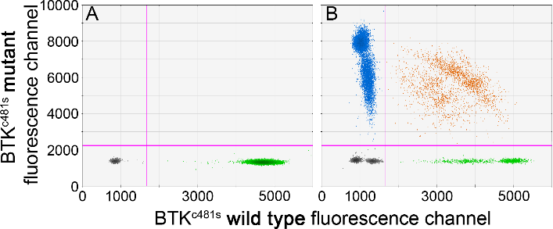

Suppl. Fig. 4 Potential compartmental differences in bone marrow (BM) and peripheral blood (PB) of the immunophenotype of CLL cells
We used 6 paired BM and PB samples in order to examine the expression level of CD69 and CD86 in various compartments. In the case of CD27 no comparison was made due to the lack of granulocyte populations in some samples. The expression of CD86 showed correlation in PB and BM, (p=0.041, R=0.83) (Fig. Supl. 4 A) in contrast with CD69, which did not show any correlation (p=0.166, R=0.646) (Fig. Supl. 4 B).
B
A

