STATIC VS DYNAMIC CONNECTIVITY: HOW LANDSCAPE CHANGES AFFECT CONNECTIVITY PREDICTIONS IN THE IBERIAN PENINSULA

Teresa Goicolea, M Cruz Mateo-Sánchez.
ETSI Montes, Forestal y del Medio Natural, Universidad Politécnica de Madrid, Ciudad Universitaria s/n, 28040, Madrid, Spain.
Corresponding author: Teresa Goicolea, ORCID: 0000-0002-4069-6001
e-mail address: t.goicolea@gmail.com;

Table S1: Resistance values assigned to each land cover type in CORINE land cover map.
Data source | CORINE CODE | Land cover description | Resistance value
CORINE | 3.1.1 | Broad-leaved forest | 1
 | 3.1.2 | Mixed forest | 2
 | 3.1.3 | Coniferous forest | 3
 | 3.2.2, 3.2.3, 3.2.4 | Scrub and/or herbaceous vegetation associations | 8
 | 3.3.4 | Burnt areas | 15
 | 3.2.1 | Natural grasslands | 25
 | 2.4.4 | Agro-forestry areas | 25
 | 2.3.1 | Pastures | 40
 | 2.4.3 | Land principally occupied by agriculture, mixed with natural vegetation | 50
 | 3.3.5 | Glaciers and perpetual snow | 65
 | 4.1.1, 4.1.2 | Inland wetlands | 65
 | 3.3.1, 3.3.2,3.3.3 | Open spaces with little or no vegetation: Beaches, sands, bare rocks… | 70
 | 2.2.1, 2.2.2, 2.2.3 | Permanent (woody) crops | 75
 | 2.4.1, 2.4.2 | Heterogeneous agricultural areas | 100
 | 4.2.1, 4.2.2, 4.2.3 | Maritime wetlands | 110
 | 2.1.1, 2.1.2, 2.1.3 | Non permanent (herbaceous) crops | 125
 | 5.X.X | Water bodies | 250
 | 1.X.X | Urban and artificial areas | 1000
OPEN STREET MAP | - | National roads* | 500
 | - | Highways and motorways* | 1000

APENDIX S1. Conversion of effective distances into probabilities of spatial dispersal.

The spatial probability of direct dispersal between each pair of nodes was calculated with:
$${sp}_{ij}=e^{-k·{ed}_{ij}}$$

Where ${ed}_{ij}$ and ${sp}_{ij}$ are the effective distance and the spatial probability of direct dispersal between nodes i and j; and $k$ is a constant set for each scenario and dispersal distance. This constant was calculated by assigning a spatial probability of 0.5 to the species median effective dispersal distance (${med}_{ij}$).

$$k=-\frac{\ln{0.5}}{{med}_{ij}}$$
Where ${med}_{ij}$is the product of each dispersal distances (i.e., 1, 2, 5, 10, 30, 50 km) and the median landscape resistance value of the spatio-temporal scenario.

Table S2. Total and ecoregions habitat coverage. First, amount of lost, stable, and gained habitat area from 1990 to 2018. Focal habitat area in 1990 (A1) is equal to the sum of lost and stable habitat area, while focal habitat area in 2018 (A2) is the sum of stable and gained habitat area. Second, relative habitat coverage, given by the percentage of study area (or ecoregion area) covered by habitat in 1990 and 2018. Third, focal habitat change between 1990 and 2018$.$, i.e., $dA=(A_{2}-A_{1})/A_{1}*100\%.$ Ecoregions names can be found in Table 1 of the main text.

 | Ecoregion
 | 33 | 21 | 19 | 16 | 15 | 9 | 8 | 6 | TOTAL
Stable area (km2) | 1252,11 | 7219,92 | 0,00 | 5544,44 | 2196,90 | 9103,03 | 1699,85 | 13430,41 | 40446,67
Lost area (km2) | 363,72 | 5923,61 | 0,00 | 2277,18 | 233,08 | 8302,43 | 635,93 | 3142,36 | 20878,31
Gained area (km2) | 1812,96 | 3461,12 | 3,47 | 5275,94 | 2656,86 | 13601,92 | 2633,79 | 16027,48 | 45473,53
Relative habitat coverage in 1990 (%) | 12,04 | 18,63 | 0,00 | 13,61 | 8,70 | 5,84 | 6,78 | 21,70 | 10,56
Relative habitat coverage in 2018 (%) | 22,84 | 15,14 | 0,13 | 18,83 | 17,39 | 7,62 | 12,58 | 38,57 | 14,79
Focal habitat change (%) | 89,69 | -18,74 | - | 38,34 | 99,74 | 30,45 | 85,53 | 77,75 | 40,11
Mean patch area in 1990 | 5,98 | 20,07 | - | 8,80 | 16,31 | 5,54 | 4,72 | 23,02 | 9,70
Mean patch area in 2018 | 11,19 | 13,15 | 3,47 | 10,78 | 21,10 | 5,85 | 6,53 | 32,23 | 11,04

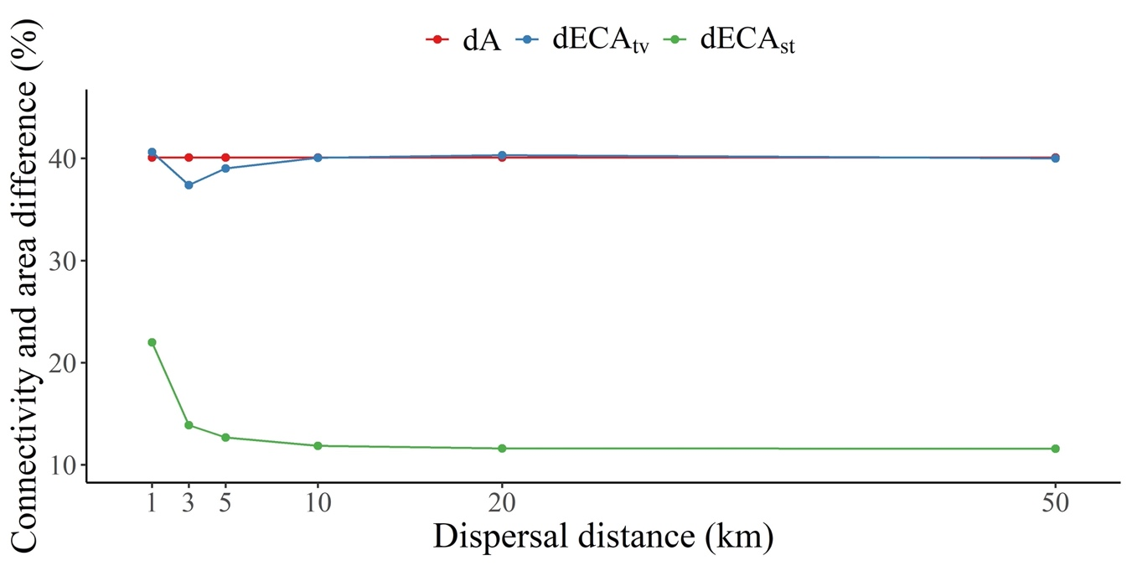
Fig. S1. Change in habitat area (dA) and overall connectivity (dECA) from 1990 to 2018 (sub index 2) and from the static to the spatio-temporal scenario (sub index st) of the whole Iberian Peninsula.
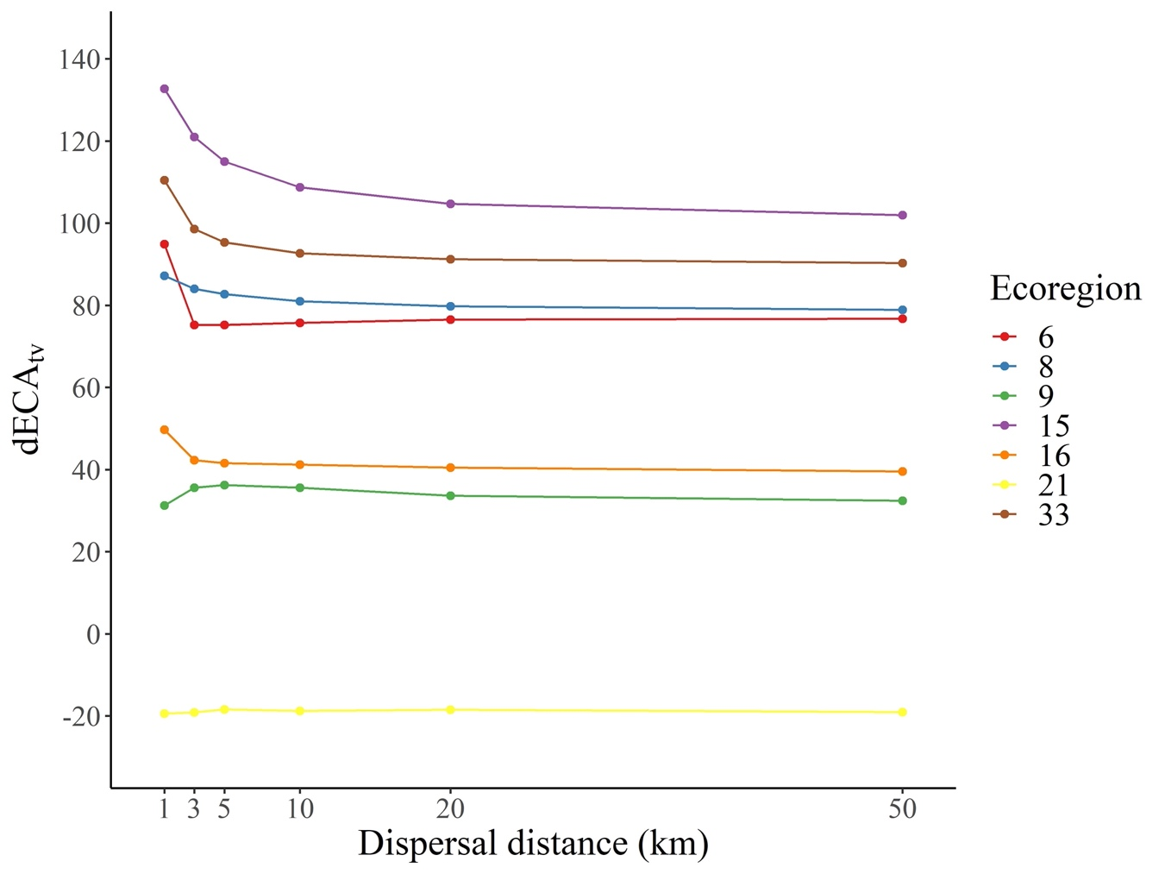
Figure S2. Changes in overall connectivity for each ecoregion. Measured as the difference in overall Equivalent connected Area (ECA) between the two static scenarios: dECA₂ = (ECA₂ - ECA₁) / ECA₁ *100. Ecoregions names can be found in Table 1 of the main text.
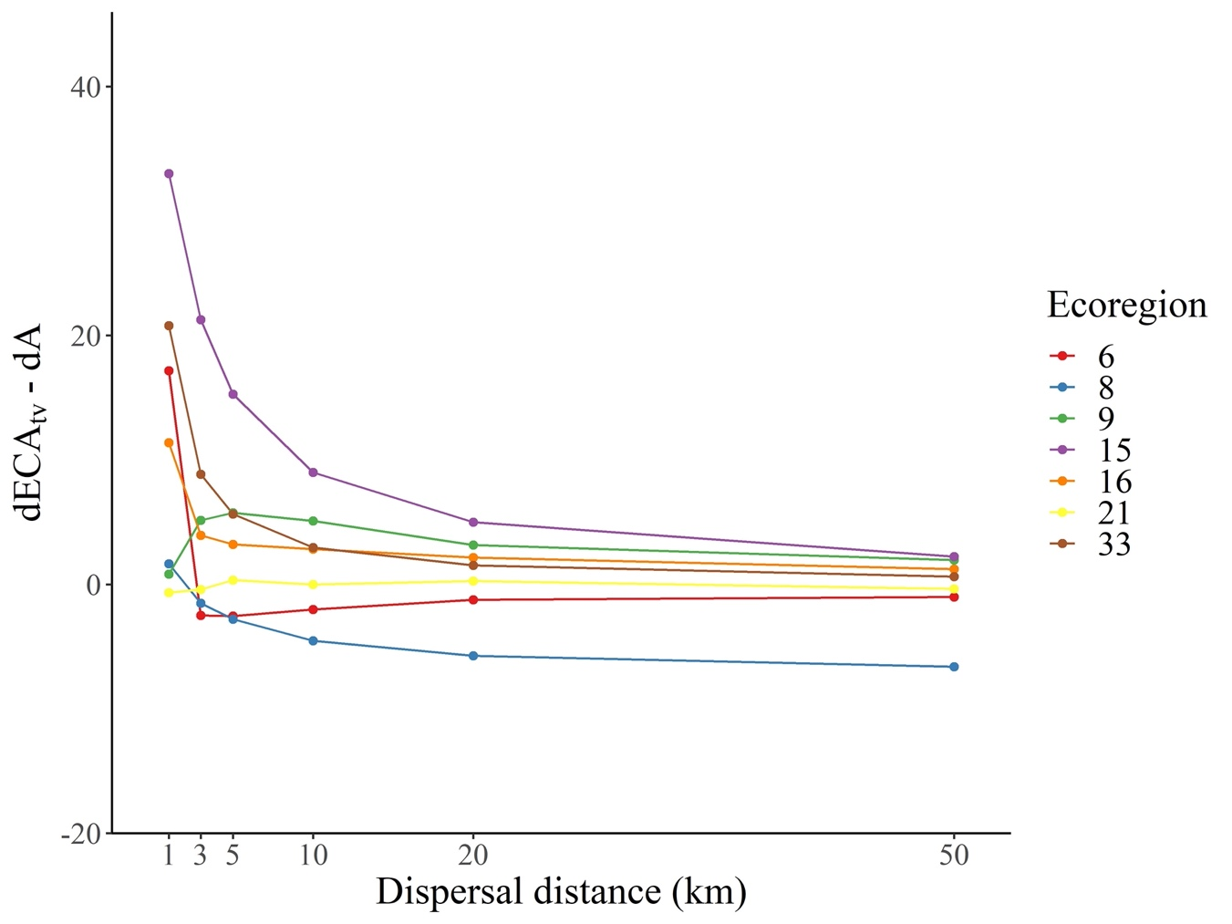

Figure S3. Difference between ecoregions changes of global connectivity (dECA₂) and habitat area (dA₂) from 1990 to 2018. Ecoregions names can be found in Table 1 of the main text.

Table S3. Percentage of shared priority conservation area between approaches. Ecoregions names can be found in Table 1 of the main text. S1, S2, ST and TV represent the static at t1 (1990), static at t2 (2018), spatio-temporal and time-varying approaches respectively.

Compared aproches | Ecoregion |  |  |  |  |  |  | Total Study area
 | 33 | 21 | 16 | 15 | 9 | 8 | 6
S1 - S2 | 23,71 | 60,70 | 50,74 | 48,19 | 40,09 | 38,34 | 0,00 | 35,95
S1 - TV | 97,43 | 100,00 | 99,04 | 100,00 | 100,00 | 100,00 | 100,00 | 99,81
S2 - TV | 91,98 | 96,73 | 96,17 | 100,00 | 100,00 | 95,81 | 100,00 | 98,71
S1 - ST | 97,80 | 100,00 | 92,13 | 100,00 | 100,00 | 100,00 | 100,00 | 98,96
S2 - ST | 91,98 | 96,73 | 89,18 | 100,00 | 100,00 | 94,00 | 100,00 | 97,86
ST - TV | 100,00 | 100,00 | 88,49 | 100,00 | 97,15 | 89,24 | 100,00 | 97,00

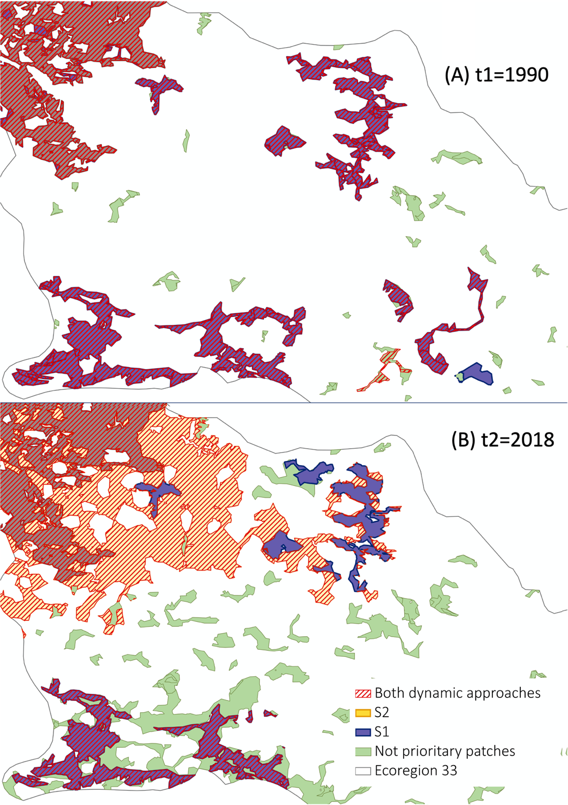

Fig. S4. Detail of an area in ecoregion 33 (Pyrenees conifer and mixed forests) at two snapshots (A) t1=1990 and (B) t2=2018 showing the priority patches identified by the different connectivity approaches: static at t1 (S1), static at t2 (S2) and dynamic approaches (time-varying and spatio-temporal). The upper image (A) only shows patches active at t1 and the lower image (B) only those existents at t2. The priority patches identified by the two dynamic approaches are represented together as they correspond to the same patches in this area but also in most of the Iberian Peninsula. Each dynamic approach has two sets of priority patches: one including only patches active at t1 (image A), and another one with patches active at t2 (image B).

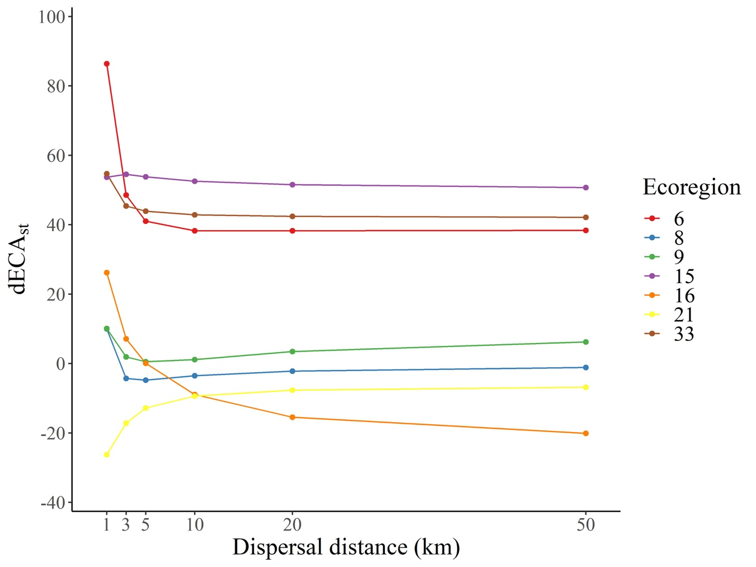

Figure S5. Changes in overall connectivity (ECA) between the spatio-temporal and the initial static scenario. It is measured as dECA_{st} = (ECA_{st} – ECA₁)/ECA₁. Ecoregions names can be found in Table 1 of the main text.

Table S4. Mode of contribution to connectivity of each type of habitat patch (gained, lost and stable). The results are shown as the mean contribution (%) of each connectivity fraction (intra, flux and connector) of all ecoregions and dispersal distances considered. For example, the 92.45 % of the contribution of lost nodes was through the Flux fraction.

 |  | Mode of contribution to connectivity
 |  | Intra | Flux | Connector
Node type | Lost | 7.55 | 92.45 | 0.00
 | Gained | 30.92 | 69.08 | 0.00
 | Stable | 15.71 | 80.70 | 3.59

