Supplementary materials：Possible competition model
SFigure1: Multiple mediation pathway models
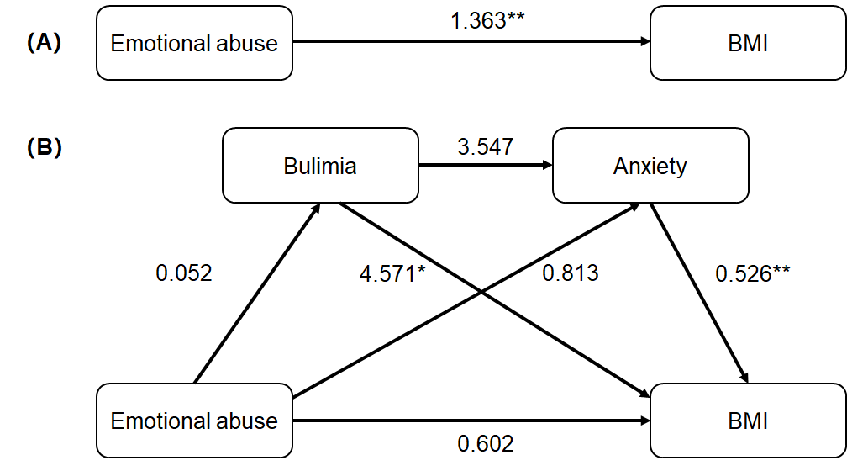
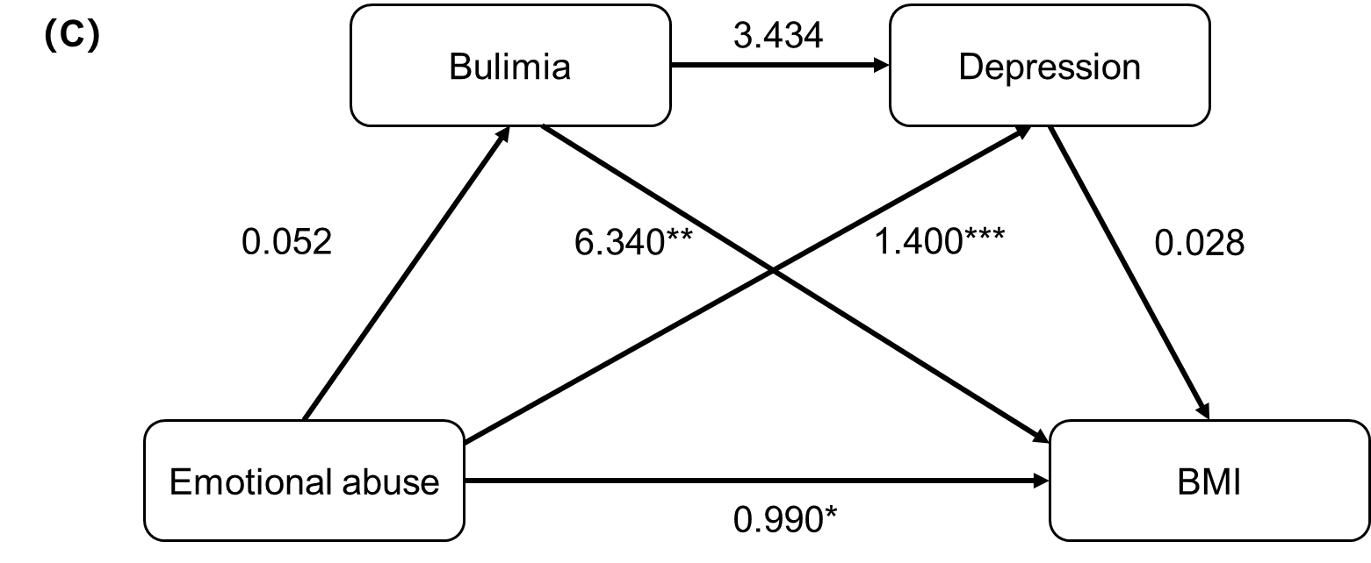

SFigure1: Multiple mediation pathway models. (A) Total effects of emotional abuse on BMI; (B) Model1: Bulimia and anxiety as multiple mediate variables; (C) Model2: Bulimia and depression as multiple mediate variables. BMI: Body Mass Index. *p<0.05, **p<0.01, ***p<0.001.

Regression model |  | Goodness-of-fit indices |  |  | Regression coefficient and significance
Outcome variable | Predictor variable | R | R² | F | β | t
Total effects
BMI |  | 0.331 | 0.110 | 9.793
 | Emotional abuse |  |  |  | 1.363 | 3.129**
Model1: Anxiety as one of the multiple mediate variables
Bulimia |  | 0.244 | 0.059 | 3.614
 | Emotional abuse |  |  |  | 0.052 | 1.901
Anxiety |  | 0.383 | 0.146 | 6.764
 | Bulimia |  |  |  | 3.547 | 1.624
 | Emotional abuse |  |  |  | 0.813 | 1.811
BMI |  | 0.599 | 0.359 | 10.758
 | Bulimia |  |  |  | 4.571 | 2.055*
 | Anxiety |  |  |  | 0.526 | 2.861**
 | Emotional abuse |  |  |  | 0.602 | 1.534
Model2: Depression as one of the multiple mediate variables
Bulimia |  | 0.244 | 0.059 | 3.614
 | Emotional abuse |  |  |  | 0.052 | 1.901
Depression |  | 0.455 | 0.207 | 10.847
 | Bulimia |  |  |  | 3.434 | 1.492
 | Emotional abuse |  |  |  | 1.400 | 3.513***
BMI |  | 0.462 | 0.214 | 7.632
 | Bulimia |  |  |  | 6.340 | 2.913**
 | Depression |  |  |  | 0.028 | 0.244
 | Emotional abuse |  |  |  | 0.990 | 2.018*

STable1: Bootstrap analysis of multiple mediation effects

STable1: Bootstrap analysis of multiple mediation effects. BMI: Body Mass Index. *p<0.05, **p<0.01, ***p<0.001

STable2：Results of the multiple mediation analysis
 | Effect size | SE | Percentage of total effects | 95% CI
 |  |  |  | Lower limit | Upper limit
Total effects
Emotional abuse→BMI | 1.312 | 0.416 | 100.00% | 0.482 | 2.141
Model1: Anxiety and bulimia as multiple mediate variables
Indirect effects | 0.761 | 0.388 | 55.83% | 0.272 | 1.743
Pathway1: Emotional abuse→Bulimia→BMI | 0.237 | 0.189 | 17.39% | 0.011 | 0.832
Pathway2: Emotional abuse→Anxiety→BMI | 0.428 | 0.331 | 31.40% | 0.043 | 1.265
Pathway3: Emotional abuse→ Bulimia→Anxiety→BMI | 0.097 | 0.076 | 7.12% | 0.007 | 0.34
Model2: Depression and bulimia as multiple mediate variables
Indirect effects | 0.373 | 0.276 | 27.37% | -0.057 | 1.109
Pathway4: Emotional abuse→Bulimia→BMI | 0.328 | 0.214 | 24.06% | 0.039 | 0.906
Pathway5: Emotional abuse→Depression→BMI | 0.04 | 0.178 | 2.93% | -0.319 | 0.409
Pathway6: Emotional abuse→ Bulimia→Depression→BMI | 0.005 | 0.028 | 0.37% | -0.023 | 0.121

STable2: Results of the multiple mediation analysis. BMI: Body Mass Index.

