Timing assessment of response to fluid challenge in patients with septic shock

Hui-Bin Huang^{1，4}, MD; Biao Xu^{2，4}, MD; Guang-Yun Liu^{3，4}, MD; Ting Yang⁴, MD; Li Weng⁴, MD; Bin Du⁴, MD

Additional file
Corresponding author: Bin Du
Medical ICU, Peking Union Medical College Hospital, Peking Union Medical College and Chinese Academy of Medical Sciences,
1 Shuai Fu Yuan, Beijing, 100730, PR China, Tel: 8610-6915-5036, Fax: 8610-6915-4037, Email: dubin98@gmail.com

1. Appendix file 1
Flowchart of the study design…..…………………………………………………………………………….…………………………………...…..…………….….…..2
2. Appendix file 2
Patient flow diagram.………………………………………………………………………………….………….………………….…..…..……………………………..3
3. Appendix file 3
Table: Patient characteristics before fluid challenge……………………………………………………………………………………………..………………….……..4
4. Appendix file 4
Table: Comparison of cardiac index at predefined time points among NR, ER, and LR patients in gelatin and normal saline group........................................................5
5. Appendix file 5
Table: Comparison of patient characteristics of hemodynamics at predefined time points in gelatin and normal saline group..............................................................…6

Additional file 1：Flowchart of the study design
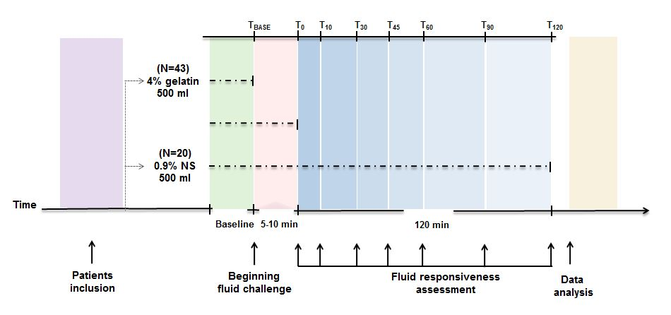
Additional file 2：Patient flow diagram 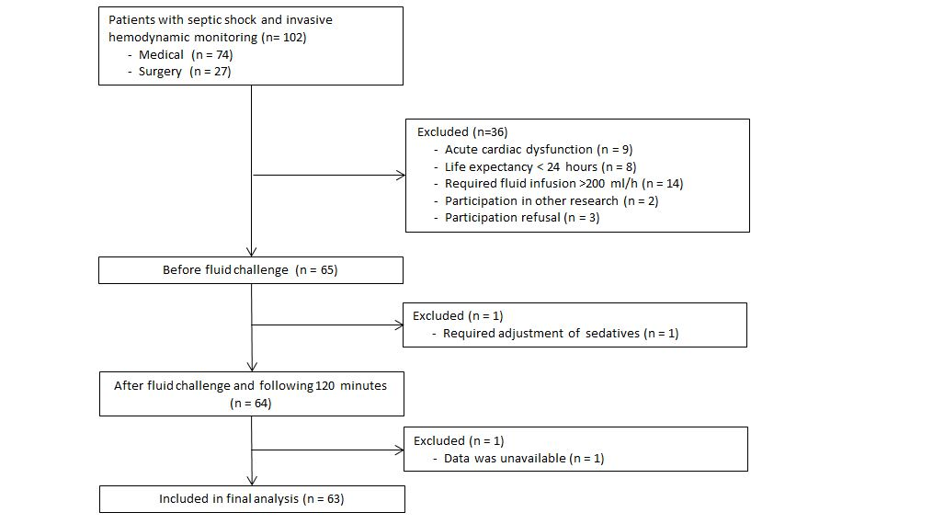
Additional file 3
Table: Patient characteristics before fluid challenge
 | ER (n=31) | LR (n=14) | NR (n=18) | p value for  all groups | p value  ER vs. LR | p value  ER vs. NR | p value  LR vs. NR
Age, year | 59.4±16.7 | 61.1±13.2 | 58.1±20.4 | 0.887 | 0.728 | 0.817 | 0.636
Male, n | 25 | 7 | 7 | 0.362 | 0.252 | 0.354 | 0.297
Body surface area (m²) | 1.83±0.16 | 1.89±0.22 | 1.79±0.16 | 0.294 | 0.329 | 0.383 | 0.151
APACHE II | 24.4±6.84 | 26.1±5.0 | 26.9±6.94 | 0.404 | 0.418 | 0.226 | 0.698
Lactate at baseline (mmol/L) | 2.9 (2.2-4.2) | 1.9 (1.4-2.8) | 2.05 (1.6-4.2) | 0.151 | 0.203 | 0.173 | 0.135
CRRT, n | 8 | 2 | 1 | 0.186 | 0.636 | 0.167 | 0.213
PC/VC | 18 | 8 | 10 | 0.986 | 0.789 | 0.898 | 0.945
PS | 14 | 5 | 6 | 0.676 | 0.789 | 0.610 | 0.658
PEEP, mmHg | 7.9±4.0 | 6.9±4.5 | 8.4±4.6 | 0.691 | 0.513 | 0.711 | 0.428
NE, n | 31 | 13 | 18 | 0.169 | 0.680 | 0.087 | 0.267
NE, μg/kg/min | 0.53 (0.35-1.63) | 0.50 (0.3-0.8) | 0.5 (0.29-1.11) | 0.745 | 0.784 | 0.893 | 0.569
Fluid maintenance, mL | 119.3±85.3 | 103.4±41.9 | 121.2±83.3 | 0.778 | 0.511 | 0.944 | 0.475
ICU mortality, n | 16 | 6 | 7 | 0.665 | 0.824 | 0.573 | 0.758
Data are expressed in median (interquartile range) or mean ± SD or count.
APACHE II = acute physiology and chronic health evaluation II; CRRT = continuous renal replacement therapy; EPI = epinephrine; ER = early responsiveness; FiO2 = fraction of inspired oxygen; LR = late responsiveness; NE = norepinephrine; FC = fluid challenge; ICU = intensive care unit; NR = non-responsiveness; PC = pressure control; PEEP = positive end-expiratory pressure; PS = pressure support.
Additional file 4
Table: Comparison of cardiac index at predefined time points among NR, ER, and LR patients in gelatin and normal saline group
Variables |  | Tb | T₀ | T₁ | T₂ | T₃ | T₄ | T₅ | T₆
4% Gelatin | NR | 4.55±1.04 | 4.46±1.07 | 4.50±1.06 | 4.58±1.26 | 4.46±1.13 | 4.34±1.13 | 4.40±1.06 | 4.28±1.2
 | ER | 3.52±0.97 | 4.28±1.04 | 4.65±1.25 | 4.73±1.18 | 4.69±1.17 | 4.31±1.06 | 4.22±1.06 | 4.07±1.03*
 | LR | 3.06±1.04 | 3.14±1.01 | 3.58±1.28 | 3.85±1.25 | 3.81±1.11 | 3.72±1.13 | 3.52±1.20 | 3.60±1.05*
Normal saline | NR | 3.52±1.00 | 3.52±1.00 | 3.67±1.09 | 3.57±1.03 | 3.58±1.06 | 3.50±1.00 | 3.57±1.03 | 3.45±0.95
 | ER | 3.29±1.09 | 3.74±1.21 | 3.98±1.28 | 3.70±1.18 | 3.60±1.23* | 3.48±1.18 | 3.46±1.12 | 3.40±1.07
 | LR | 5.20±1.54 | 5.40±1.65 | 6.08±2.12 | 5.80±1.72* | 5.50±1.77 | 5.46±1.76 | 5.36±1.29 | 5.48±1.56
ER = early responder; LR = late responder; NR = non-responder;
T₀ = immediately at end of FC;
T₁ = 10 min after FC;
T₂ = 30 min after FC;
T₃ = 45 min after FC;
T₄ = 60 min after FC;
T₅ = 90 min after FC;
T₆ = 120 min after FC.

Additional file 5
Table: Comparison of patient characteristics of hemodynamics at predefined time points in gelatin and normal saline group
Variables |  | T_{b} | T₀ | T₁ | T₂ | T₃ | T₄ | T₅ | T₆
MAP (mmHg) | Gel | 81.9±10.8 | 88.0±13.7 | 87.7±13.8 | 87.2±12.6 | 85.2±12.9 | 85.7±12.4 | 86.0±13.4 | 84.0±14.1
 | NS | 83.6±8.7 | 88.2±13.2 | 85.9±10.1 | 83.9±9.9 | 82.1±9.1 | 83.1±10.2 | 81.2±9.6 | 79.1±7.7
HR (bpm) | Gel | 117.3±19.1 | 113.1±17.8 | 113.5±17.8 | 116±18.2 | 115.9±18.8 | 116.3±18.0 | 116.5±18.4 | 117.2±18.4
 | NS | 109.1±25.5 | 107.5±22.3 | 107.2±22.8 | 109.7±25.1 | 108.0±24.2 | 109.6±24.0 | 110.6±24.4 | 110.9±24.6
Hb (g/L) | Gel | 96.7±27.5 | 87.4±25.1 | 87.3±24.5 | 87.0±24.9 | 88.1±24.6 | 88.0±24.8 | 89.4±24.7 | 88.6±26.3
 | NS | 86.2±19.4 | 79.2±19.0 | 81.1±18.6 | 82.4±19.2 | 82.9±19.3 | 83.4±19.2 | 83.3±19.3 | 83.5±19.3
CVP (mmHg) | Gel | 10.2±4.1 | 13.8±4.8 | 13.1±4.7 | 12.6±4.6 | 12.2±4.7 | 12.0±4.7 | 11.7±4.7 | 11.2±4.5
 | NS | 12.1±4.9 | 14.7±5.1 | 13.4±4.9 | 12.6±4.6 | 12.1±4.5 | 11.9±4.8 | 11.7±4.4 | 11.4±4.6
CI (L/min/m²） | Gel | 3.71±1.13 | 4.09±1.13 | 4.39±1.25 | 4.50±1.23 | 4.45±1.17 | 4.19±1.10 | 4.13±1.12 | 4.03±1.12
 | NS | 3.84±1.39 | 4.09±1.46 | 4.41±1.72 | 4.19±1.55 | 4.07±1.52 | 3.98±1.50 | 3.97±1.36 | 3.94±1.44
SVRI (dyn·s/cm⁵/m²) | Gel | 1631±564 | 1533±565 | 1439±507 | 1400±475 | 1374±469 | 1477±540 | 1516±582 | 1524±586
 | NS | 1719±751 | 1702±974 | 1569±840 | 1596±649 | 1560±634 | 1598±777 | 1593±728 | 1520±660
CI = cardiac output index; CVP = central venous pressure; Gel = gelatin; Hb = hemoglobin; HR = heart rate; MAP = mean arterial pressure; NS = normal saline;
PAWP = pulmonary arterial wedge pressure; SVRI = systemic vascular resistance index.
T₀ = immediately at end of FC (fluid challenge);
T₁ = 10 min after FC;
T₂ = 30 min after FC;
T₃ = 45 min after FC;
T₄ = 60 min after FC;
T₅ = 90 min after FC;
T₆ = 120 min after FC.

