Supplemental Figure 1
Dissolved organic carbon assessed at the end of the experiment: carbon only effect. Displayed on boxplots are the median, the two hinges of the box represent the interquartile range, and the whiskers extend 1.5 * interquartile range, outlying points are plotted individually. Different letters denote statistically significant treatment effects based on pairwise comparisons adjusted using Tukey’s test., alpha = 0.1. Different letters denote statistically significant treatment effects based on pairwise comparisons adjusted using Tukey’s test., alpha = 0.1.
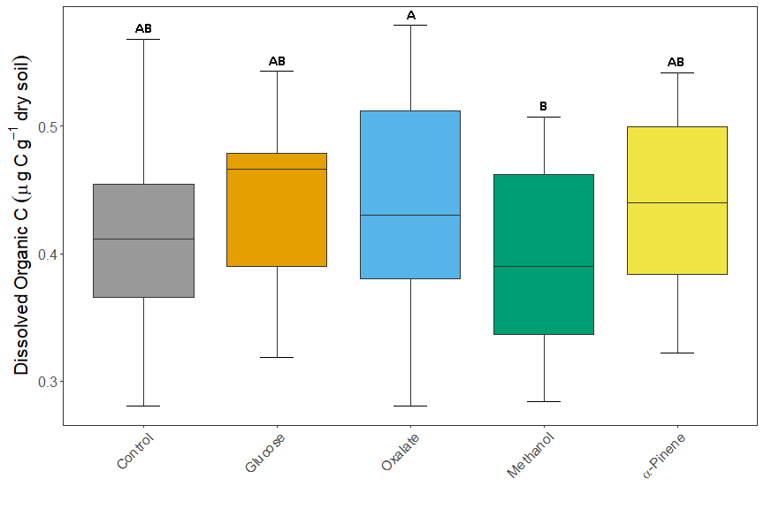
Supplemental Figure 2: Simpson Diversity for the carbon source x soil moisture effect (A), and the carbon source effect (BDisplayed on boxplots are the median, the two hinges of the box represent the interquartile range, and the whiskers extend 1.5 * interquartile range, outlying points are plotted individually. Different letters denote statistically significant treatment effects based on pairwise comparisons adjusted using Tukey’s test., alpha = 0.1.

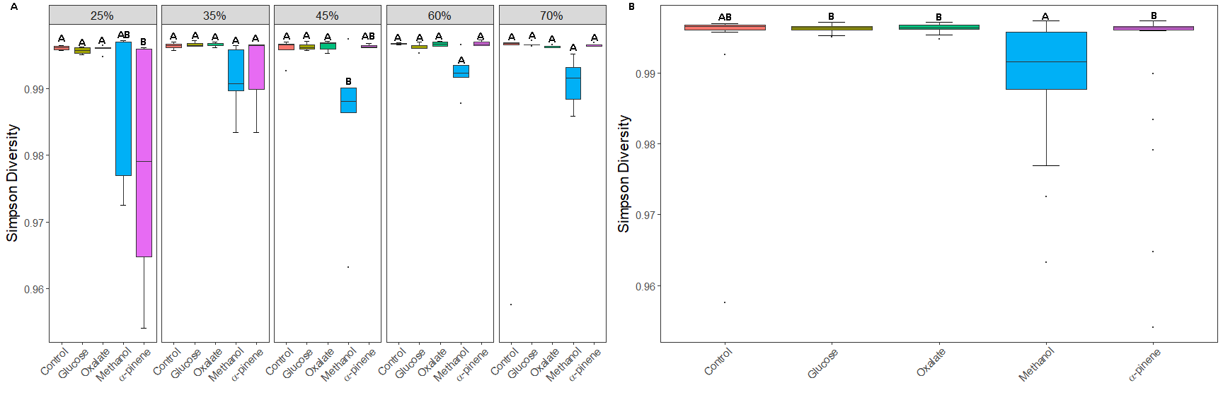

Supplemental Figure 3 The phyla retained in the best-subsets multiple regression, and that had significant C amendment interaction with moisture for microbial activity. Dendrograms on heat maps reflect similarity of relative abundance patterns of phyla between carbon treatments (complete-linkage clustering) - they do not reflect phylogenetic relationships.

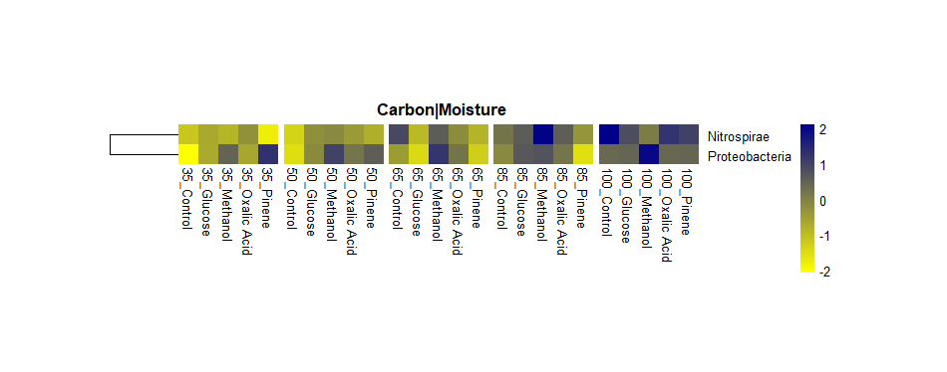

Supplemental Figure 4: The most abundant families found in each of phyla retained in the best-subsets multiple regression, and that had significant C amendment effects for microbial activity (A), and total extractable N (B). Dendrograms on heat maps reflect similarity of relative abundance patterns of phyla between carbon treatments (complete-linkage clustering) - they do not reflect phylogenetic relationships.

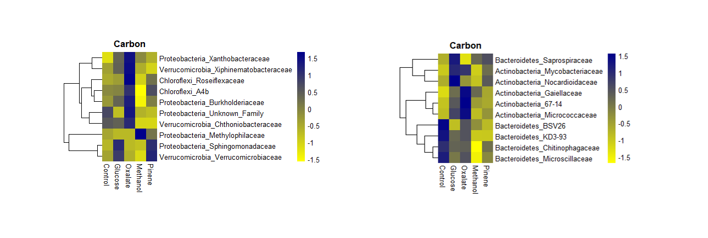

Supplemental Table 1: The top 8 families with greater than 0.1% abundance from the phyla that were retained in the best-subsets multiple regression models; * P < 0.1, ** P < 0.05, N.S. (Not significant) P > 0.1.
Phyla | Family | Relative Abundance | Carbon | Carbon X Moisture
Actinobacteria | Gaiellaceae | 0.0083 | * | **
 | 67-14 | 0.0071 | ** | N.S.
 | Mycobacteriaceae | 0.0063 | ** | **
 | Nocardioidaceae | 0.0058 | ** | N.S.
 | Solirubrobacteraceae | 0.0046 | N.S. | N.S.
 | Micrococcaceae | 0.0043 | ** | N.S.
 | Micromonosporaceae | 0.0039 | N.S. | N.S.
 | Pseudonocardiaceae | 0.0025 | N.S. | N.S.
Bacteroidetes | Chitinophagaceae | 0.0433 | ** | **
 | Microscillaceae | 0.0193 | ** | **
 | env.OPS_17 | 0.0081 | N.S. | N.S.
 | Flavobacteriaceae | 0.0075 | N.S. | **
 | Saprospiraceae | 0.0063 | ** | N.S.
 | AKYH767 | 0.0059 | N.S. | N.S.
 | KD3-93 | 0.0013 | ** | **
 | BSV26 | 0.0012 | * | N.S.
Chloroflexi | A4b | 0.0022 | * | **
 | Roseiflexaceae | 0.0014 | ** | N.S.
Proteobacteria | Xanthobacteraceae | 0.0672 | * | N.S.
 | Nitrosomonadaceae | 0.0439 | N.S. | N.S.
 | Methylophilaceae | 0.0317 | ** | **
 | Burkholderiaceae | 0.0289 | ** | **
 | SC-I-84 | 0.0145 | N.S. | N.S.
 | Unknown_Family | 0.0145 | * | N.S.
 | Steroidobacteraceae | 0.0132 | N.S. | N.S.
 | Sphingomonadaceae | 0.0114 | ** | **
Verrucomicrobia | Chthoniobacteraceae | 0.0371 | ** | *
 | Pedosphaeraceae | 0.0293 | N.S. | N.S.
 | Xiphinematobacteraceae | 0.0047 | ** | N.S.
 | Opitutaceae | 0.0034 | N.S. | *
 | Verrucomicrobiaceae | 0.0013 | ** | N.S.
 | Rubritaleaceae | 0.0011 | N.S. | N.S.

