Patient 1
AKT11: c.49G>A(p.Glu17Lys)
VAF (identified through NGS)=22.03%
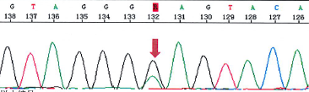

Patient 2
AKT11: c.49G>A(p.Glu17Lys)
VAF (identified through NGS)=11.16%
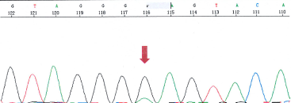

Patient 3
AKT11: c.49G>A(p.Glu17Lys)
VAF (identified through NGS)=9.93%
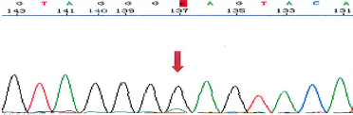

Patient 4
AKT11: c.49G>A(p.Glu17Lys)
VAF (identified through NGS)=20.57%
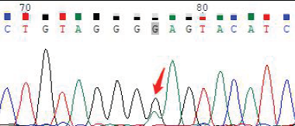

Patient 5
PIK3CA: c.1357G>A(p.Glu453Lys)
VAF (identified through NGS)=11.10%
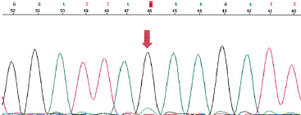

Patient 6
PIK3CA: c.1624G>A(p.Glu542Lys)
VAF (identified through NGS)= 24.48%
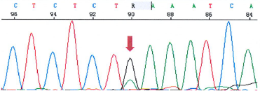

Patient 7
PIK3CA: c.1624G>A(p.Glu542Lys)
VAF (identified through NGS)= 17.15%
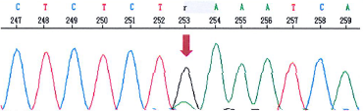

Patient 8
PIK3CA: c.1624G>A(p.Glu542Lys)
VAF (identified through NGS)= 20.95%
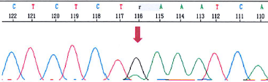

Patient 9
PIK3CA: c.1624G>A(p.Glu542Lys)
VAF (identified through NGS)= 25.63%
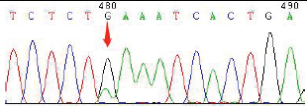

Patient 10
PIK3CA: c.1624G>A(p.Glu542Lys)
VAF (identified through NGS)= 17.10%
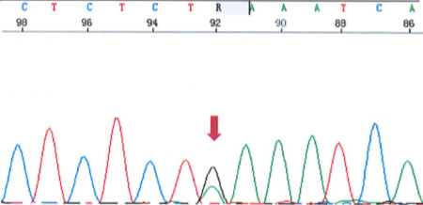

Patient 11
PIK3CA: c.1624G>A(p.Glu542Lys)
VAF (identified through NGS)= 27.58%
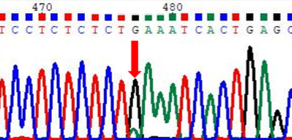

Patient 12
PIK3CA: c.1633G>A(p.Glu545Lys)
VAF (identified through NGS)= 19.11%
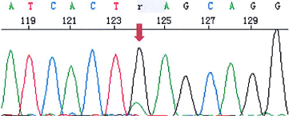

Patient 13
PIK3CA: c.1633G>A(p.Glu545Lys)
VAF (identified through NGS)= 27.31%
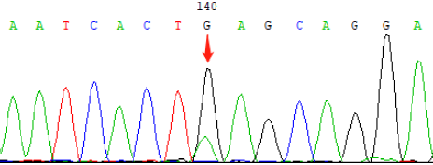

Patient 14
PIK3CA: c.1636C>A(p.Gln546Lys)
VAF (identified through NGS)= 24.50%
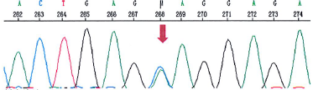

Patient 15
PIK3CA: c.3139C>T(p.His1047Tyr)
VAF (identified through NGS)= 18.94%
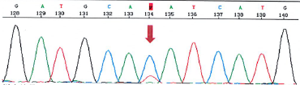

Patient 16
PIK3CA: c.3140A>G(p.His1047Arg)
VAF (identified through NGS)= 23.29%
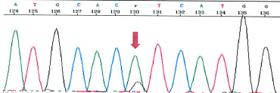

Patient 17
PIK3CA: c.3140A>G(p.His1047Arg)
VAF (identified through NGS)= 17.79%
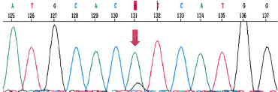

Patient 18
PIK3CA: c.3140A>G(p.His1047Arg)
VAF (identified through NGS)= 21.45%
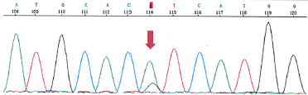

Patient 19
PIK3CA: c.3140A>G(p.His1047Arg)
VAF (identified through NGS)= 25.57%
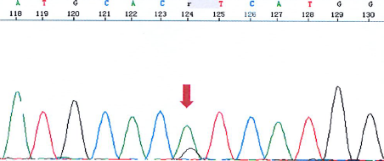

Patient 20
PIK3CA: c.3140A>G(p.His1047Arg)
VAF (identified through NGS)= 10.36%
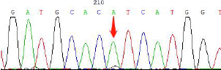

Patient 21
PIK3CA: c.3140A>G(p.His1047Arg)
VAF (identified through NGS)= 20.03%
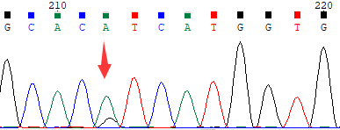

Patient 22
PIK3CA: c.3140A>G (p.His1047Arg)
VAF (identified through NGS)=15.82%
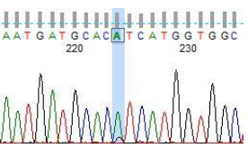

Patient 23
PIK3CA: c.3140A>G(p.His1047Arg)
VAF (identified through NGS)= 33.38%
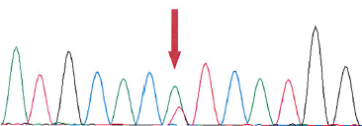

Patient 24
PIK3CA: c.3140A>G(p.His1047Arg)
VAF (identified through NGS)= 18.99%
