- Supplementary data

NADPH oxidase 4 signaling in a ventilator-induced lung injury mouse model

Sang Hoon Lee, Mi Hwa Shin, Ah Young Leem, Su Hwan Lee, Kyung Soo Chung, Young Sam Kim, Moo Suk Park

Division of Pulmonology, Department of Internal Medicine, Institute of Chest Diseases, Severance Hospital, Yonsei University College of Medicine, Seoul, Republic of Korea

Fig S1. Time table for NOX4 inhibitor treatment in the high tidal volume group

In the VILI model, mice were tracheostomized, and the ventilator was maintained for 5 h in the supine position with 24 mL/kg volume, 0 cmH₂O PEEP, 100/min respiration rate, and 0.21 inspired oxygen fraction.

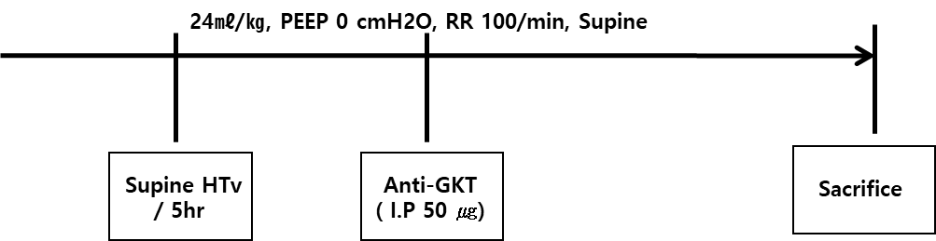
Fig S2. Potential mechanisms by which NOX4 inhibition attenuates VILI. Our study suggests that NOX4 inhibition decreases VILI through EphA2, PI3K-r, and Nrf2 signaling.
VILI, ventilator-induced lung injury

