Supplementary data

Fig S1. Time table for NOX4 inhibitor treatment in the high tidal volume group

In the VILI model, mice were tracheostomized, and the ventilator was maintained for 5 h in the supine position with 24 mL/kg volume, 0 cmH₂O PEEP, 100/min respiration rate, and 0.21 inspired oxygen fraction.

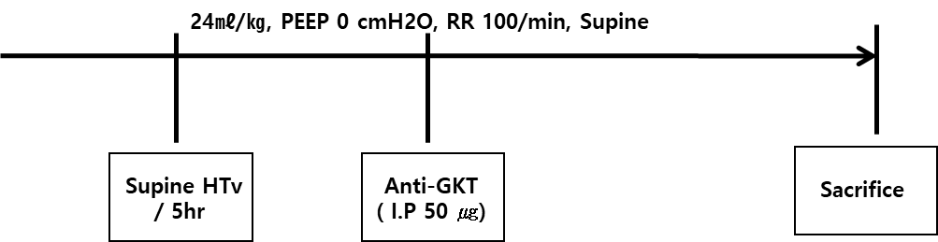
Fig S2. Potential mechanisms by which NOX4 inhibition attenuates VILI. Our study suggests that NOX4 inhibition decreases VILI through EphA2, PI3K-r, and Nrf2 signaling.
VILI, ventilator-induced lung injury

