Supplementary Materials
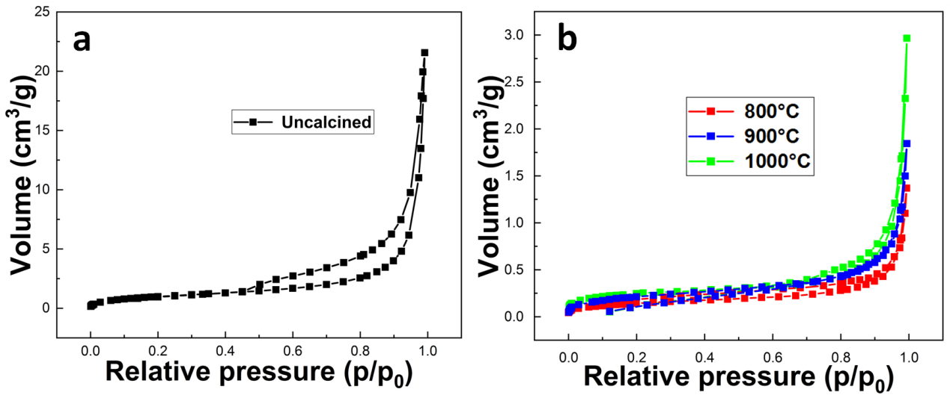
Fig. S1. Adsorption and desorption isotherms of (a) uncalcined; (b) calcined at 800, 900 and 1000 °C CSCs.

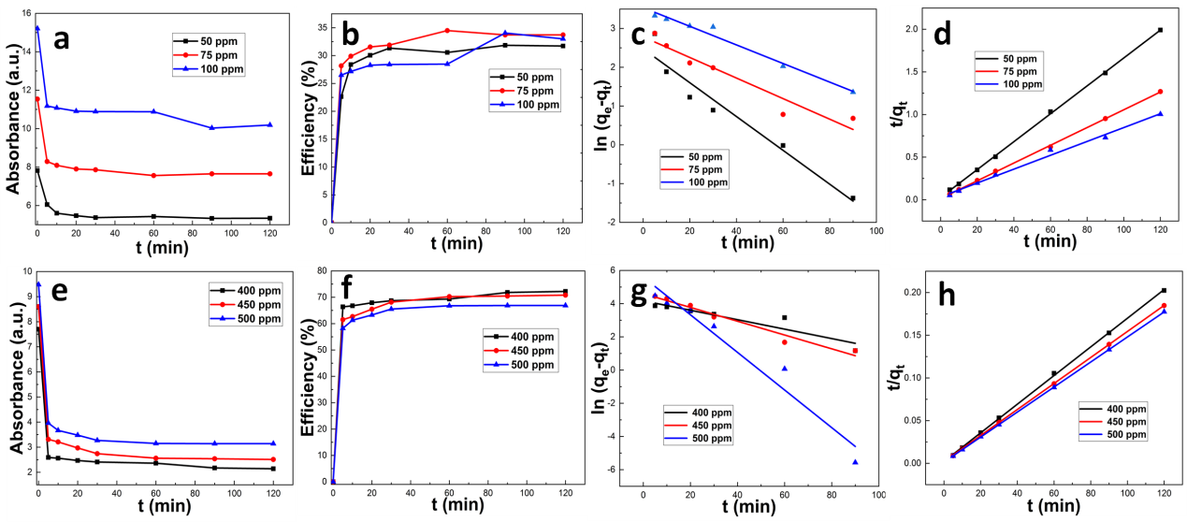
Fig. S2. Adsorption experiments of MB (a-d) and CR (e-h) on clam shell at 1000 °C: (a), (e) adsorption at different concentrations; (b), (f) adsorption rates at different concentrations; (c), (g) pseudo first order kinetics; (d), (h) pseudo second order kinetics.

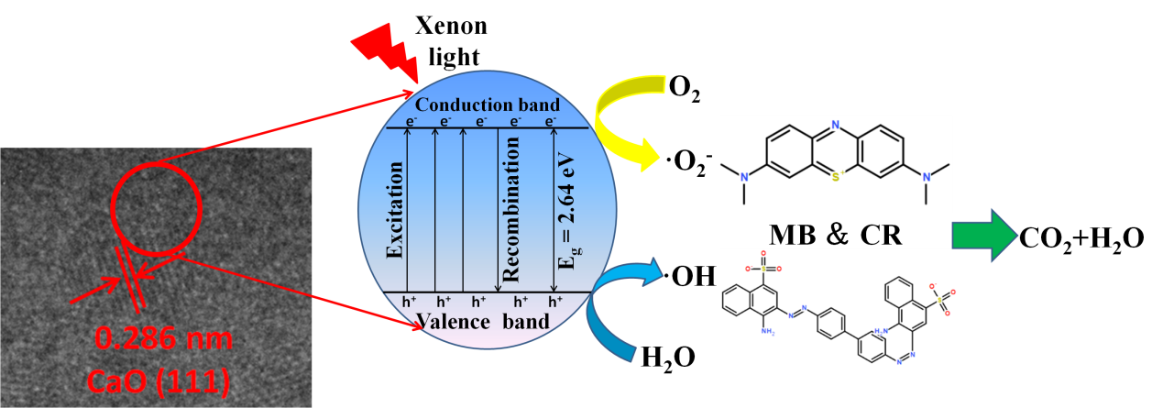
Fig. S3. Mechanism scheme of photocatalytic degradation of dyes by CSC.

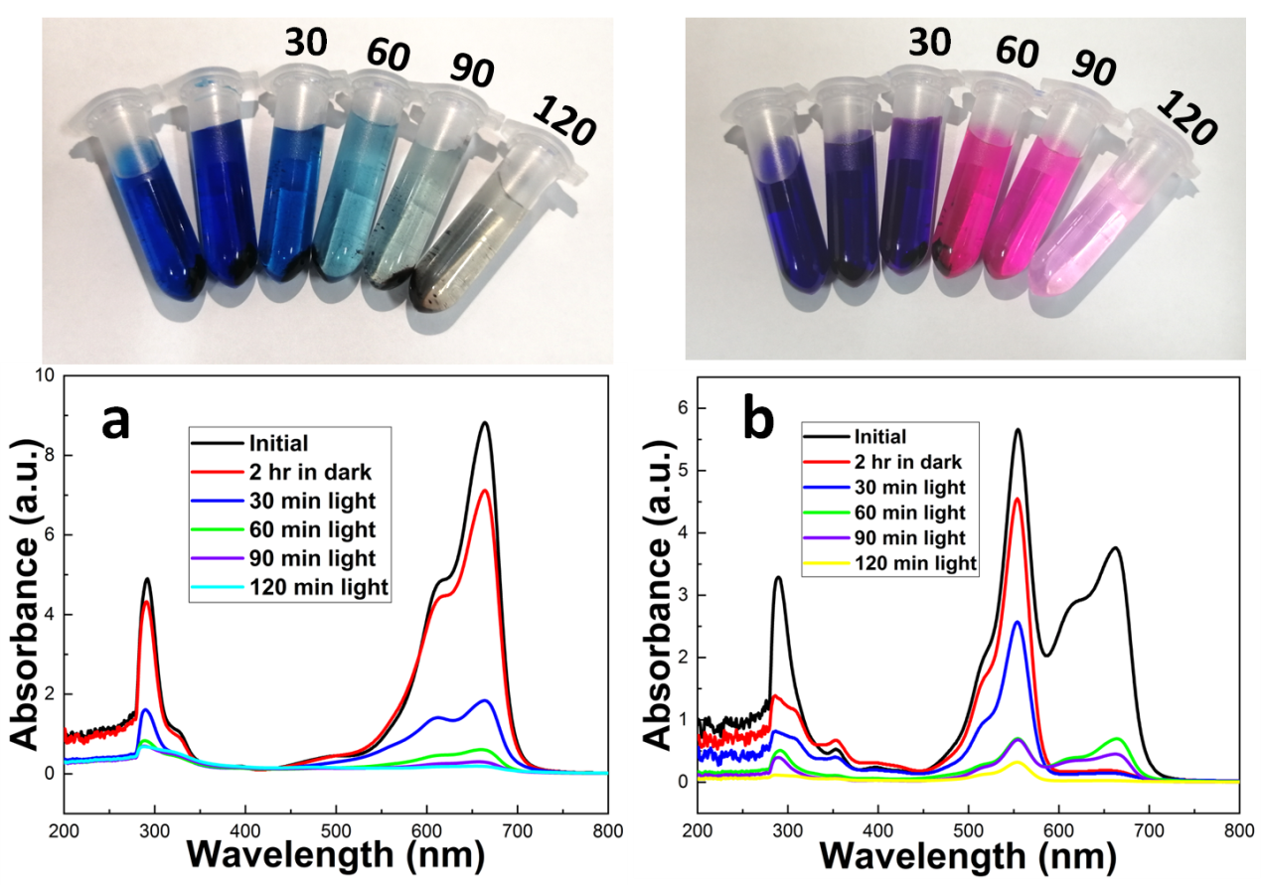
Fig. S4. Photodegradation of a mixed dye by clam shell powder at 1000 °C, (a) binary system (100ppm MB + 100ppm CR), (b) ternary system (75ppm MB + 75ppm CR + 75ppm Rh B).

Table S1. Texture characteristics of uncalcined and calcined CSCs.
Sample | S_{BET} (m² g⁻¹) | V_{tot} (cm³ g⁻¹) | Average pore diameter (nm)
Uncalcined | 3.76 | 0.010 | 10.98
800°C | 0.51 | 0.001 | 6.28
900°C | 0.76 | 0.001 | 6.33
1000°C | 0.97 | 0.002 | 6.77

Table S2. Best fit kinetic parameters for adsorption of MB and CR onto clam shell calcined at 1000 °C.
Dye |  | Pseudo-first-order |  |  | Pseudo-second-order
 | Values | q_{e} (mg g⁻¹) | k₁ (min⁻¹)  ×10⁻³ | R² | q_{e} (mg g⁻¹) | k₂ (g mg⁻¹)  (min⁻¹) ×10⁻³ | R²
MB | 50 ppm | 11.88 | 43.63 | 0.928 | 61.09 | 10.20 | 0.999
 | 75 ppm | 16.17 | 26.53 | 0.902 | 95.97 | 7.88 | 0.999
 | 100 ppm | 34.32 | 23.99 | 0.974 | 123.0 | 1.96 | 0.990
CR | 400 ppm | 64.81 | 28.44 | 0.825 | 595.2 | 1.33 | 0.999
 | 450 ppm | 99.89 | 21.55 | 0.956 | 657.8 | 1.12 | 0.999
 | 500 ppm | 269.7 | 11.33 | 0.943 | 680.2 | 1.05 | 0.999

