Supplementary Material
Transcriptome analysis revealed growth phase-associated changes of a centenarian-originated probiotic Bifidobacterium animalis subsp. lactis A6

Hui Wang¹, Jieran An¹, Chengfei Fan¹, Zhengyuan Zhai^{1, 2}, Hongxing Zhang³, Yanling Hao^{1, 2*}

¹Key Laboratory of Functional Dairy, Co-constructed by Ministry of Education and Beijing Municipality, College of Food Science and Nutritional Engineering, China Agricultural University, Beijing, China
²Beijing Advanced Innovation Center for Food Nutrition and Human Health, College of Food Science and Nutritional Engineering, China Agricultural University, Beijing, China
³Department of Food Science, Beijing University of Agriculture, 7 Bei Nong Road, Changping District, Beijing 102206, China

*Corresponding author: Yanling Hao
E-mail: haoyl@cau.edu.cn
Present address: College of Food Science and Nutritional Engineering, China Agricultural University, 17 Qing Hua East Road, Hai Dian District, Beijing, 100083, China

Table S1 The number of reads before and after the trimming step.
Sample name | Raw reads | Clean reads | clean bases | Q20(%) | Q30(%) | GC content (%)
A6log1 | 23311618 | 23261948 | 3.49G | 98.58 | 95.71 | 60.6
A6log2 | 19689878 | 19652184 | 2.95G | 98.53 | 95.58 | 60.54
A6log3 | 22553776 | 22508958 | 3.38G | 98.49 | 95.52 | 60.54
A6log4 | 23882120 | 23526324 | 3.53G | 98.23 | 94.72 | 61.04
A6WD2 | 23893390 | 23835722 | 3.58G | 98.29 | 94.88 | 59.87
A6WD3 | 23501046 | 23447790 | 3.52G | 98.38 | 95.08 | 60.05
A6WD4 | 21352442 | 21096818 | 3.16G | 98.15 | 94.5 | 60.75

Table S2 The information of reads mapping to the reference genome.
Sample name | A6log1 | A6log2 | A6log3 | A6log4 | A6WD2 | A6WD3 | A6WD4
Total reads | 23261948 | 19652184 | 22508958 | 23526324 | 23835722 | 23447790 | 21096818
Total mapped | 23115123 (99.37%) | 19531490 (99.39%) | 22330874 (99.21%) | 23392844 (99.43%) | 23605032 (99.03%) | 23247112 (99.14%) | 20996723 (99.53%)
Multiple mapped | 464994  (2%) | 338173 (1.72%) | 447809 (1.99%) | 305964 (1.3%) | 642864 (2.7%) | 585452 (2.5%) | 309065 (1.46%)
Uniquely mapped | 22650129 (97.37%) | 19193317 (97.67%) | 21883065 (97.22%) | 23086880 (98.13%) | 22962168 (96.34%) | 22661660 (96.65%) | 20687658 (98.06%)

Table S3 Genes differentially expressed at the transcriptional level in B. lactis A6 during the stationary phase compared to the exponential phase ª.
Gene_ID | Gene |  | Protein_ID | Fold Change (FC)^{b} |  |  | Description^{c}
Carbohydrate transport and metabolism
BAA6_1092 |  |  | WP_039700917.1 |  | -5.37 |  | putative glucose uptake permease
BAA6_0481 |  |  | WP_004268765.1 |  | 5.18 |  | galactoside symporter
BAA6_0050 |  |  | WP_012619616.1 |  | 3.17 |  | MFS transporter
BAA6_1585 |  |  | WP_042994610.1 |  | 3.11 |  | MalG-type ABC sugar transport system permease component
BAA6_1587 |  |  | WP_004218962.1 |  | 2.72 |  | sugar binding protein of ABC transporter system
BAA6_0517 |  |  | WP_004219354.1 |  | 2.45 |  | putative sugar transporter solute-binding protein
BAA6_0518 |  |  | WP_044059192.1 |  | 1.89 |  | putative binding protein-dependent transporter
BAA6_1415 |  | cebG | WP_004219192.1 |  | 3.37 |  | carbohydrate ABC transporter permease
BAA6_1416 |  | cbpA | WP_004219191.1 |  | 5.6 |  | cellobiose phosphorylase
BAA6_0488 |  |  | WP_004268778.1 |  | -2.27 |  | MalE-type ABC sugar transport system substrate-binding protein
BAA6_0491 |  |  | WP_004268783.1 |  | -2.10 |  | sugar ABC transporter permease
BAA6_1555 |  |  | WP_004219253.1 |  | -3.20 |  | MalG-type ABC sugar transport system permease component
BAA6_1548 |  |  | WP_004219261.1 |  | -2.01 |  | putative sugar ABC transport system membrane protein
BAA6_1549 |  |  | WP_004219260.1 |  | -2.46 |  | putative sugar ABC transport system membrane protein
BAA6_0968 |  | xfp | WP_004217768.1 |  | -1.97 |  | Xylulose-5-phosphate/fructose-6-phosphate phosphoketolase
BAA6_0838 |  | tkt | WP_004217933.1 |  | -2.07 |  | transketolase
BAA6_0839 |  | tal | WP_004217932.1 |  | -2.19 |  | transaldolase
BAA6_1489 |  |  | WP_004219087.1 |  | -2.49 |  | PfkB family sugar kinase[ribose kinase]
BAA6_0794 |  | rpe | WP_004217990.1 |  | -1.54 |  | ribulose-phosphate 3-epimerase
BAA6_0298 |  | gpi | WP_004268405.1 |  | -1.72 |  | glucose-6-phosphate isomerase
BAA6_0431 |  | pgM | WP_004268650.1 |  | -1.76 |  | phosphoglucomutase
BAA6_0846 |  |  | WP_004217924.1 |  | -2.38 |  | triosephosphate isomerase
BAA6_1161 |  | gap | WP_004218695.1 |  | -1.61 |  | Glyceraldehyde-3-phosphate dehydrogenase
BAA6_0847 |  | pgk | WP_004217923.1 |  | -1.72 |  | phosphoglycerate kinase
BAA6_0756 |  | pgm | WP_004218045.1 |  | -2.81 |  | phosphoglycerate mutase
BAA6_0753 |  |  | WP_004218048.1 |  | -2.77 |  | glucosyl-3-phosphoglycerate phosphatase
BAA6_0939 |  |  | WP_004217812.1 |  | -2.29 |  | phosphoglycerate mutase
BAA6_1012 |  | eno | WP_004269110.1 |  | -1.76 |  | enolase
BAA6_0979 |  | pyk | WP_004269104.1 |  | -1.73 |  | pyruvate kinase
BAA6_0329 |  | ldh2 | WP_004268463.1 |  | -3.11 |  | lactate dehydrogenase
BAA6_1078 |  | pfl | WP_004217631.1 |  | -4.14 |  | formate acetyltransferase
BAA6_0969 |  | pat | WP_004217766.1 |  | -3.44 |  | phosphate acetyltransferase
BAA6_0970 |  | ackA | WP_004269103.1 |  | -1.67 |  | acetate kinase
BAA6_0061 |  |  | WP_004219336.1 |  | 1.91 |  | alpha-L-arabinofuranosidase
BAA6_0062 |  | araB | WP_004219337.1 |  | 2.93 |  | L-ribulokinase
BAA6_0063 |  | araD | WP_004219338.1 |  | 4.36 |  | L-ribulose-5-phosphate 4-epimerase
BAA6_0064 |  | araA | WP_004219339.1 |  | 3.38 |  | L-arabinose isomerase
BAA6_0525 |  | xylB | WP_004219345.1 |  | 2.00 |  | xylulose kinase
BAA6_1351 |  | galK | WP_004218283.1 |  | -3.10 |  | galactokinase
BAA6_0274 |  | lacZ | WP_004268361.1 |  |  | -1.69 | beta-galactosidase
BAA6_0523 |  | xyn | WP_004219346.1 |  | 2.64 |  | endo-1,4-β-xylanase
Amino acids uptake and biosynthesis
BAA6_0566 |  | oppA | WP_004218801.1 |  | 5.63 |  | oligopeptide transporter substrate-binding protein
BAA6_0567 |  | oppB | WP_004218802.1 |  | 2.10 |  | ABC transporter, oligopeptide transporter permease component
BAA6_0568 |  | oppC | WP_004218803.1 |  | 2.02 |  | ABC transporter, oligopeptide transporter permease component
BAA6_0570 |  | oppF | WP_004218805.1 |  | 2.93 |  | ABC transporter, oligopeptide transporter ATPase component
BAA6_1193 |  | dppD | WP_004218656.1 |  | 5.65 |  | ABC transporter, dipeptide transporter ATPase component
BAA6_1194 |  | dppC | WP_012619827.1 |  | 4.62 |  | ABC transporter, dipeptide transporter permase component
BAA6_1269 |  |  | WP_004218550.1 |  | -3.09 |  | peptide ABC transporter permease
BAA6_1270 |  |  | WP_004218548.1 |  | -2.15 |  | ATP binding protein of ABC transporter for Glu/Asp
BAA6_0681 |  | gluB | WP_004218145.1 |  | -1.99 |  | ABC-type amino acid transport system periplasmic component
BAA6_0682 |  | gluC | WP_004218144.1 |  | -2.58 |  | ABC-type amino acid transport system permease component
BAA6_0683 |  | gluD | WP_004218142.1 |  | -2.48 |  | permease protein of ABC transporter for glutamate
BAA6_0680 |  | gluA | WP_004218146.1 |  | -2.15 |  | ATP-binding protein of ABC transporter for glutamate
BAA6_1082 |  | MetI | WP_004217625.1 |  | -3.99 |  | ABC-type amino acid transport system permease component
BAA6_1083 |  | MetN | WP_004217623.1 |  | -1.83 |  | ATP binding protein of ABC transporter
BAA6_0186 |  |  | WP_004268977.1 |  | 1.6 |  | dipeptidase
BAA6_0230 |  |  | WP_004219304.1 |  | 2.0 |  | dipeptidase
BAA6_0261 |  |  | WP_004268336.1 |  | -1.51 |  | aspartate aminotransferase [aspartate biosynthesis]
BAA6_0881 |  | metE | WP_004217882.1 |  | -1.57 |  | homocysteine methyltransferase [methionine biosynthesis]
BAA6_1150 |  | pheA | WP_004218708.1 |  | -2.22 |  | bifunctional chorismate mutase/prephenate dehydratase [tyrosine and phenylalanine biosynthesis]
BAA6_0731 |  | argF | WP_004218077.1 |  | -4.87 |  | ornithine carbamoyltransferase [arginine biosynthesis]
BAA6_0733 |  | argG | WP_004218073.1 |  | -15.45 |  | argininosuccinate synthase [arginine biosynthesis]
BAA6_0734 |  | argH | WP_004218072.1 |  | -4.68 |  | argininosuccinate lyase [arginine biosynthesis]
BAA6_1052 |  | proC | WP_004217670.1 |  | -3.02 |  | pyrroline-5-carboxylate reductase [proline biosynthesis]
Peptidoglycan biosynthesis
BAA6_0562 |  | glmS | WP_004269062.1 |  | -2.03 |  | D-fructose-6-phosphate amidotransferase
BAA6_1325 |  | glmM | WP_004269221.1 |  | -1.75 |  | phosphoglucosamine mutase
BAA6_0751 |  | glmU | WP_004218050.1 |  | -3.00 |  | bifunctional protein glmU
BAA6_1199 |  | murC | WP_004218652.1 |  | -2.55 |  | UDP-N-acetylmuramate--L-alanine ligase
BAA6_1202 |  | murD | WP_004218648.1 |  | -1.94 |  | UDP-N-acetylmuramoyl-L-alanine-D-glutamate ligase
BAA6_1204 |  | murF | WP_004218644.1 |  | -1.53 |  | UDP-N-acetylmuramoyl-tripeptide--D-alanyl-D- alanine ligase
BAA6_1612 |  | murJ | WP_004218997.1 |  | -1.62 |  | putative peptidoglycan lipid II flippase
BAA6_0083 |  |  | WP_004218373.1 |  | -1.71 |  | transpeptidase
BAA6_0084 |  |  | WP_004218375.1 |  | -2.01 |  | Bacterial cell division membrane protein
BAA6_0550 |  | ftsQ | WP_004218773.1 |  | -3.41 |  | cell division protein FtsQ
BAA6_1198 |  | ftsQ | WP_012619828.1 |  | -2.61 |  | cell division protein FtsQ
BAA6_1201 |  | ftsW | WP_004218649.1 |  | -2.71 |  | cell division protein FtsW
Acid tolerance response
BAA6_0572 |  | cysK | WP_004218807.1 |  | 6.30 |  | cystathionine beta-synthase
BAA6_0947 |  | metC | WP_077385089.1 |  | 2.72 |  | cystathionine beta-lyase
BAA6_0010 |  | gdhA | WP_004219034.1 |  | 2.67 |  | glutamate dehydrogenase
BAA6_0643 |  | serB | WP_004218899.1 |  | 1.8 |  | phosphoserine phosphatase SerB [serine biosynthesis]
BAA6_0708 |  | glnA1 | WP_004218110.1 |  | -6.23 |  | glutamine synthetase 1 [glutamine biosynthesis]
BAA6_1220 |  | glnA2 | WP_004218616.1 |  | -1.89 |  | glutamine synthetase 2 [glutamine biosynthesis]
BAA6_0174 |  | livK | WP_004218478.1 |  | 3.1 |  | BCAAs transport system substrate-binding protein
BAA6_0283 |  | ilvB | WP_014482615.1 |  | 2.31 |  | acetolactate synthase 1 catalytic subunit
BAA6_0146 |  | ilvC | WP_004218445.1 |  | 3.17 |  | ketol-acid reductoisomerase [isoleucine biosynthesis]
BAA6_0370 |  | groES | WP_004268536.1 |  | 1.20 |  | co-chaperone GroES
BAA6_0665 |  | groEL | WP_004218937.1 |  | 1.56 |  | chaperonin GroEL
BAA6_1543 |  | dnaK | WP_004219269.1 |  | 1.20 |  | molecular chaperone DnaK
BAA6_0675 |  | clpE | WP_004218154.1 |  | 1.65 |  | ATP-dependent Clp protease ATP-binding subunit
BAA6_1072 |  | clpP1 | WP_004217639.1 |  | 1.55 |  | ATP-dependent Clp protease proteolytic subunit
BAA6_1073 |  | clpP2 | WP_035136458.1 |  | 3.19 |  | ATP-dependent Clp protease proteolytic subunit 2
Adhesion
BAA6_0205 |  | tadZ | WP_004218511.1 |  | 9.37 |  | Flp pilus assembly protein tadZ
BAA6_0206 |  | tadA | WP_004268985.1 |  | 6.50 |  | Flp pilus assembly protein ATPase component
BAA6_0207 |  | tadB | WP_004218513.1 |  | 12.05 |  | Flp pilus assembly protein
BAA6_0208 |  | tadC | WP_004218514.1 |  | 9.48 |  | Flp pilus assembly protein
BAA6_0211 |  | tadE | WP_004218516.1 |  | 8.60 |  | pseudopilin TadE
BAA6_0212 |  | tadF | WP_004218517.1 |  | 8.14 |  | pseudopilin TadF
BAA6_0224 |  | tadV | WP_004219310.1 |  | 1.65 |  | prepilin peptidase
ª Selected genes which were discussed in the Results and discussion section.
^{b} Fold change in gene or protein expression. The minus number means downregulated change.
^{c} Functions were assigned from the KEGG pathways for B. lactis A6.

Table S4 Alignment of amino acid sequences of tad pili in B. lactis A6 compared with B. breve UCC2003 by SnapGene software (version 5.3) in a local alignment (Smith-Waterman) module.
Gene number |  | Gene name | BLAST results
A6 | UCC2003 |  | length | Identity | Similarity | Gap
BAA6_0205 | Bbr_0132 | tadZ | 280 | 38.93% | 56.43% | 11.07%
BAA6_0206 | Bbr_0133 | tadA | 327 | 59.33% | 70.03% | 0.00%
BAA6_0207 | Bbr_0134 | tadB | 206 | 39.32% | 48.06% | 16.02%
BAA6_0208 | Bbr_0135 | tadC | 168 | 41.07% | 57.14% | 17.86%
BAA6_0210 | Bbr_0136 | flp | 84 | 58.33% | 76.19% | 4.76%
BAA6_0211 | Bbr_0137 | tadE | 103 | 38.83% | 51.46% | 0.00%
BAA6_0212 | Bbr_0138 | tadF | 117 | 34.19% | 52.99% | 5.93%
BAA6_0933 | Bbr_0901 | tadV | 159 | 36.48% | 55.97% | 5.03%
BAA6_0224 | Bbr_0901 | tadV | 135 | 25.19% | 37.78% | 5.93%

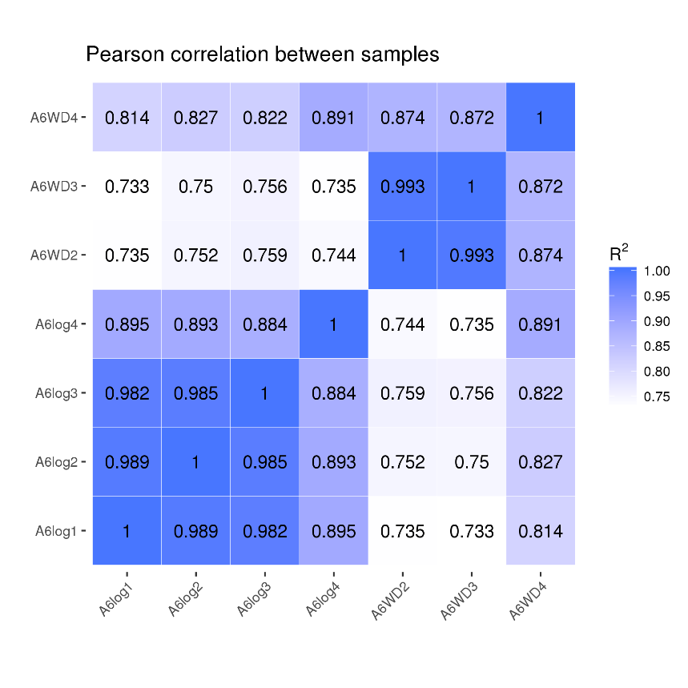
Fig. S1. Pearson correlation between samples. A6log: B. lactis A6 strain collected at the exponential phase with OD₆₀₀ around 0.6~0.8 during growth (n=4). A6WD: B. lactis A6 strain collected at the stationary phase with OD₆₀₀ around 4.0~4.2 during growth (n=3).

Fig. S2. Histogram of gene ontology (GO) and scatter plot of KEGG pathway enrichment of differentially expressed genes (DEGs). The most enriched 30 GO terms of regulated genes is shown in Column 1, while mainly metabolic pathway enrichment of regulated genes is shown in Column 2. (A) and (B) indicates the up-regulated biological processes or metabolic pathways, conversely, (c) and (d) indicates the down-regulated biological processes or metabolic pathways. Asterisk (*) indicates a significantly enriched process during the stationary phase compared with the log phase.

Fig. S3. Graphical representation of DAP-type peptidoglycan biosynthesis of B. lactis A6 in the stationary phase compared to the log phase. Fru-6P, fructose-6-phosphate; GlcN-6P, glucosamine-6-phosphate; D-GlcN-1P, glucosamine-1-phosphate; GlcNAc-1P, N-acetylglucosamine-1-phosphate; UDP-GlcNAc, uridine diphosphate-N-acetylglucos-amine; UDP-MurNAc, UDP-N-acetylmuramate; Und-PP, undercaprenyl diphosphate; GlmU, N-acetylglucosamine-1-phosphate uridyltransferase; MurC, UDP-N-acetylmuramate L-alanine ligase; MurD, UDP-N-acetylmuramoylalanine D-glutamate ligase; MurF, UDP-N-acetylmuramoyl-tripeptide D-alanyl-D-alanine ligase. Arrows and characters in black and green color represent genes which were un-changed and down-regulated, respectively. Partial structural formulas are referenced from the KEGG pathway (https://www.kegg.jp/kegg/pathway.html).

