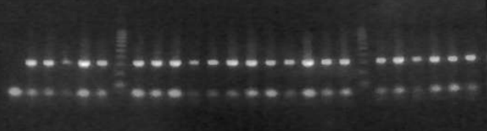
1 2 3 4 5 6 7 8 9 10 11 12 13 14 15 16 17 18 19 20 21 22 23 24 25 26

Appendix 1a: PCR identification of An. gambiae complex, Lane/L/ (7 & 20) = ladder (1000bp), the band of each ladder = 100bp; L1 = negative control; L2 = positive control (lab reared An. arabiensis); L3-6, 8-12 and 21- 26 = An. arabiensis. Gel condition = 2% agarosel gel with Etbr.

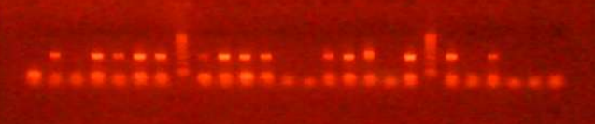
1 2 3 4 5 6 7 8 9 10 11 12 13 14 15 16 17 18 19 20 21 22 23 24 25 26

Appendix 1b: PCR identification of An. gambiae complex, Lane/L/ (8 & 20) = ladder (1000bp), the band of each ladder = 100bp; L1 = negative control; L2 = positive control (lab reared An. arabiensis); L3, 13,14,18,22, 24 -26 = Unamplified; L4-7, 9-12, 15-17, 19, 21, 23 = An. arabiensis. Gel condition = 2% agarosel gel with Etbr.

