Addendum

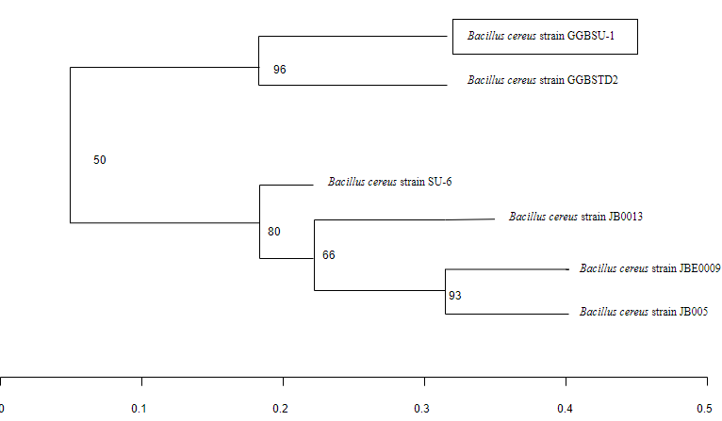
Plate 1A: Phylogenetic relationship of Bacillus cereus strain GGBSU-1 (Musa and Ikhajigbe, 2021).

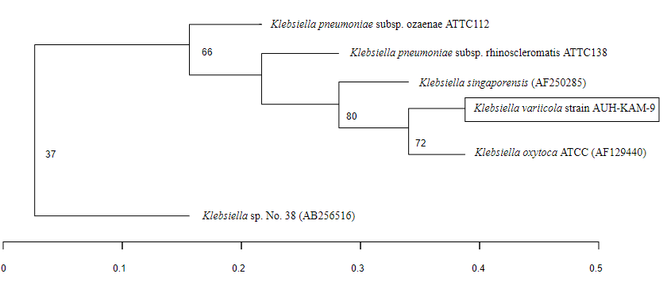
Plate 1B: Phylogenetic relationship of Klebsiella variicola strain AUH-KAM-9 (Musa and Ikhajigbe, 2021).

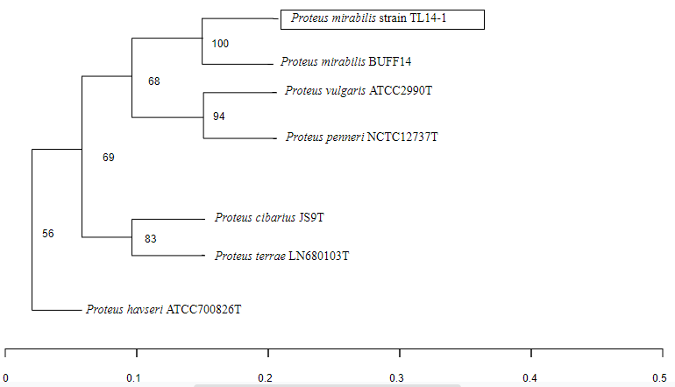
Plate 1C: Phylogenetic relationship of Proteus mirabilis strain TL14-1 (Musa and Ikhajigbe, 2021).

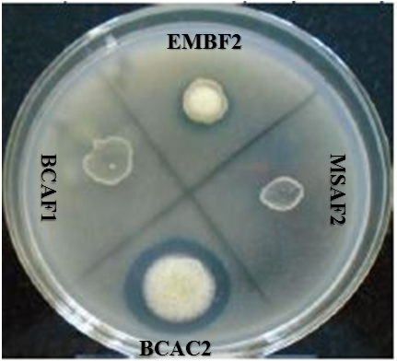
Plate 2: PSB showing efficiency in solubilization of insoluble phosphate by forming holo-zone (Musa and Ikhajigbe, 2021).

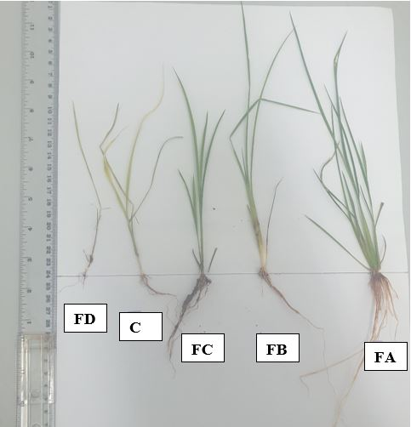
{“0

Plate 3: Rice seedling morphology at 2 weeks after rhizo-inoculation (30 days after sowing).

