Supplementary Figures:
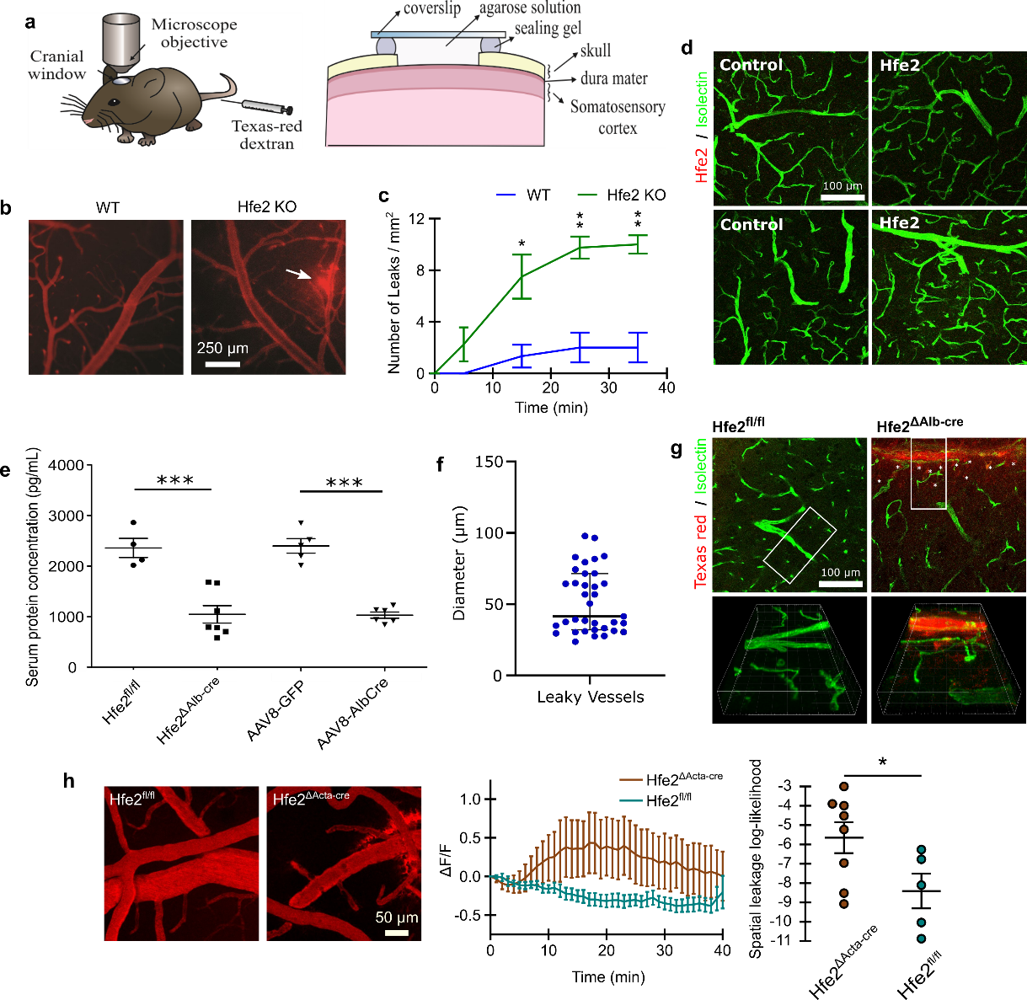
Extended Data Fig. 1 | Fluorescent imaging of BBB disruption in Hfe2 KO mice. a, A schematic of widefield imaging procedure and cranial window. b, Representative widefield BBB leakage patterns of TR-dextran in wild type and Hfe2 KO mice. c, Quantification of the number of BBB leaks observed in wild type and Hfe2 KO mice over time (mean ± s.e.m., unpaired t-test, replicates WT n=3 and Hfe2 KO n=4). d, Absence of Hfe2 within brain tissue of WT mice; confirmed with confocal imaging. Control images correspond to secondary anti-body incubation without Hfe2 primary antibody. e, Serum concentration of Hfe2 quantified with ELISA in Hfe2^{fl/fl} n=4, Hfe2^{∆Alb-cre} n=7, AAV8-GFP n=5, and AAV8-AlbCre n=6. f, Diameter of vessels where TR-dextran leakage was observed. g, Confocal image of TR-dextran accumulation with endothelium counterstain. h, Representative in-vivo multiphoton images of TR-dextran at 40mins time-point (scale bar, 50 µm). The normalized extravascular fluorescence (ΔF/F) intensity was plotted over time and the groups differences were assessed with spatial leakage log-likelihood (mean ± s.e.m.; unpaired t-tests and repeated measures factorial ANOVA (rendered as approximate unpaired t-test), respectively; Hfe2^{fl/fl} n=5, Hfe2^{ΔActa-cre} n=8). *P<0.05, **P<0.01, ***P<0.001.

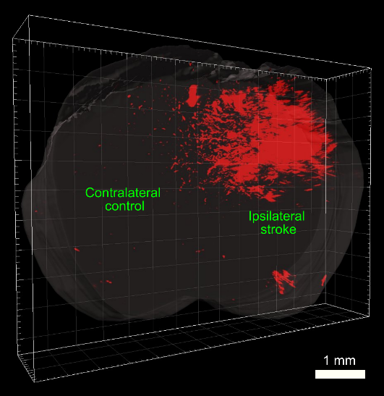
Extended Data Fig. 2 | Light sheet imaging of BBB breakdown associated with MCAO. The leakage 70 kDa dextran conjugated dye 24 hours after middle cerebral artery occlusion. Ipsilateral side corresponds to side of occluded artery.

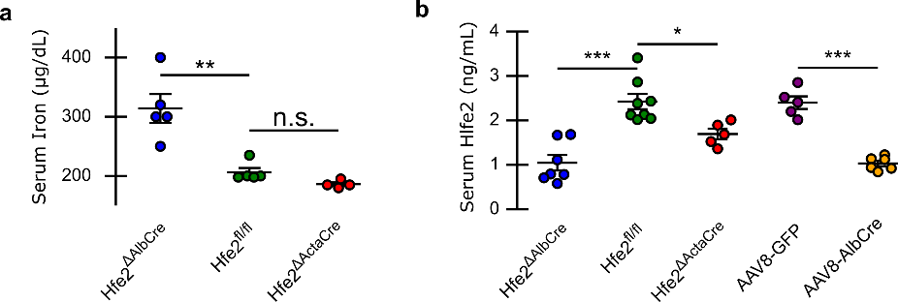
Extended Data Fig. 3 | Hfe2-muscle specific KO mice have normal serum iron and reduced Hfe2. a, Serum iron levels in liver- and muscle-specific knock-outs quantified by optical density using iron detection kit (VWR, 75878-098) (mean ± s.e.m., unpaired t-tests, replicates Hfe2^{∆Alb-cre} n=5, Hfe2^{fl/fl} n=5, and Hfe2^{∆Acta-cre} n=4). b, Reduced serum Hfe2 in liver- and muscle-specific knock-out quantified with Quantikine ELISA kit (R&D, MRGMCO) (mean ± s.e.m., unpaired t-test, replicates Hfe2^{∆Alb-cre} n=7, Hfe2^{fl/fl} n=8, Hfe2^{∆Acta-cre} n=5, AAV8-GFP n=5, and AAV8-AlbCre n=6). *P<0.05, **P<0.01, ***P<0.001.
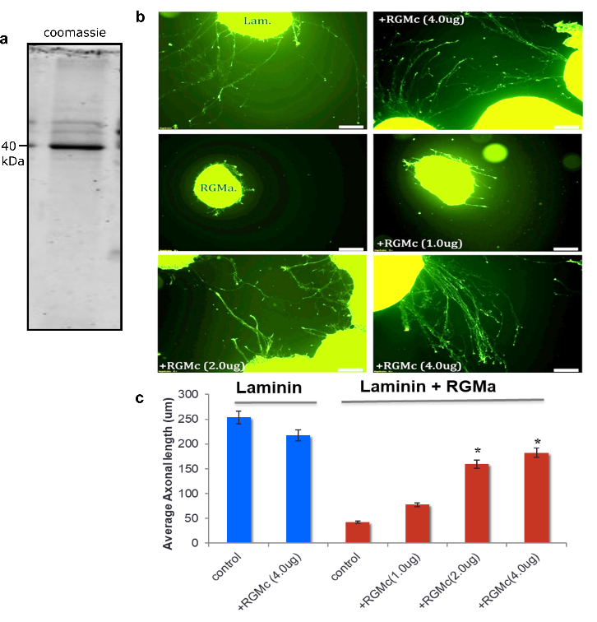
Extended Data Fig. 4 | Effect of Hfe2 (RGMc) on axonal grown in retinal explants. a, Coomassie stain of RGMc purity. b, Laminin fluorescent labeling of neurons. c, Quantification of axonal length from laminin labelling. Retinal explants were grown on laminin with and without RGMa. Hfe2 was added to the medium at various concentrations (PBS was control). Axons are shorter on laminin + RGMa when compared to Laminin on its own. When RGMc is added to the medium axons appear longer and seem to overcome the RGMa inhibition. Quantification indicates Hfe2 significantly reduces the RGMa induced inhibition of growing axons. (*P<0.001).

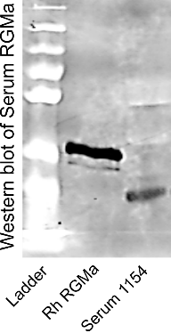
Extended Data Fig. 5 | RGMa Western Blot in human serum. Rhesus Monkey (Rh) RGMa was cloned with a myc-His Tag on its C-terminal part, expressed in HEK-293 cells, purified on Ni-agarose, and used as a positive control. RhRGMa and human serum (serum 1154) were loaded and blotted with an anti-RGMa antibody. This shows the presence of RGMa at ~30 kDa in human serum.
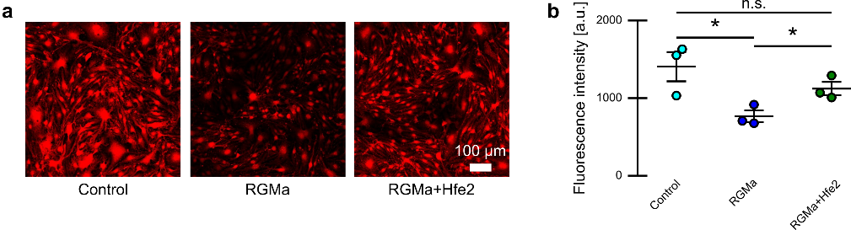
Extended Data Fig. 6 | PDGF-B ICC levels. a, Confocal imaging of PDGF-B in cultured endothelial cells in the presence of vehicle, RGMa, and RGMa+Hfe2. b, Quantification of fluorescent intensity between control, RGMa, and RGMa+Hfe2. *P<0.05.

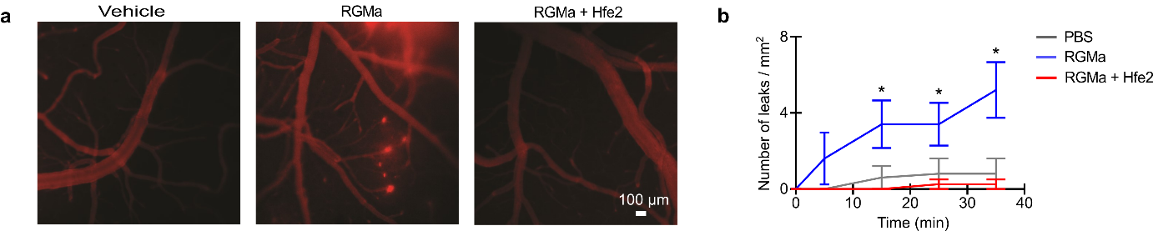
Extended Data Fig. 7 | Protection from RGMa induced BBB disruption by Hfe2. a, Representative widefield BBB leakage patterns of TR-dextran in vehicle, RGMa, and RGMa + Hfe2 treated mice. b, Quantification of the number of BBB leaks observed in vehicle, RGMa, and RGMa + Hfe2 treated mice over time (mean ± s.e.m., replicates PBS n=5, RGMa n=5, and RGMa+Hfe2 n=4). *P<0.05.

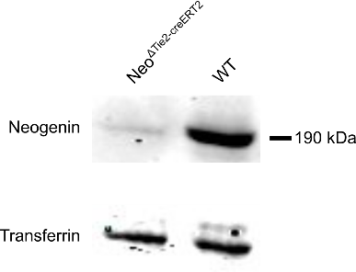
Extended Data Fig. 8 | Inducible knockout of Neogenin expression in endothelial cells. Western blot of Neogenin and Transferrin receptor (reference) in Neo^{ΔTie2-creERT2} mice with (TAM+) and without (TAM-, wide-type) tamoxifen.
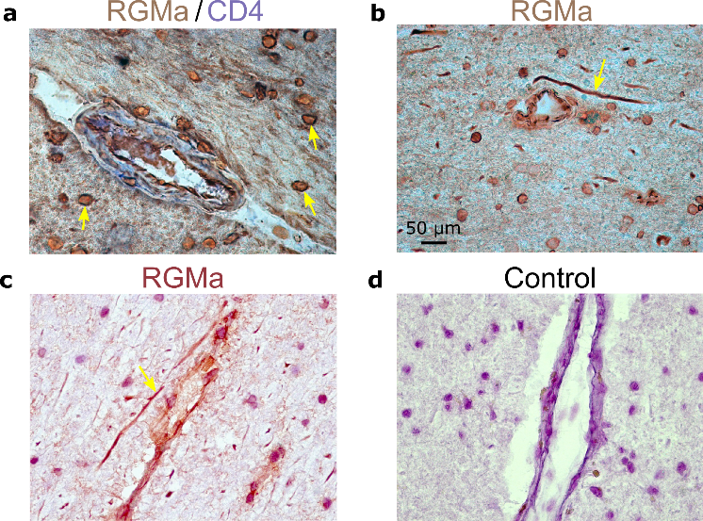
Extended Data Figure 9 | Expression of RGMa in MS lesions. Brain sections from autopsy material of MS patients were stained against RGMa. a, RGMa (red deposits) co-localizes with endothelial cells (arrows) with CD4⁺ cells (marker of inflammation, blue deposits, arrowheads) in an MS plaque. RGMa was observed in MS plaques in perivascular and parenchymal areas and in normal appearing white matter. b, The blood vessel in the middle shows EC staining and staining of inflammatory cells infiltrating the arterial wall. In addition, RGMa immunostained axons (arrow) were found. c, RGMa is found on inflammatory cells infiltrating the wall of the blood vessel seen in normal appearing white matter. In addition, RGMa immunostained axons (arrow) and positive inflammatory cells are seen. d, Control of the immunoperoxidase reaction is negative. H&E was used for counterstaining in C and D. H&E is used to stain endothelial cells.

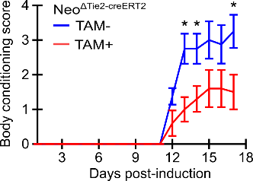
Extended Data Fig. 10 | Effect of endothelial neogenin expression on EAE progression. Body conditioning scores are shown for days post-EAE induction for Neo^{ΔTie2-creERT2} mice with tamoxifen (TAM+) and without tamoxifen (TAM-) administration. Mice were sacrificed on day 18.
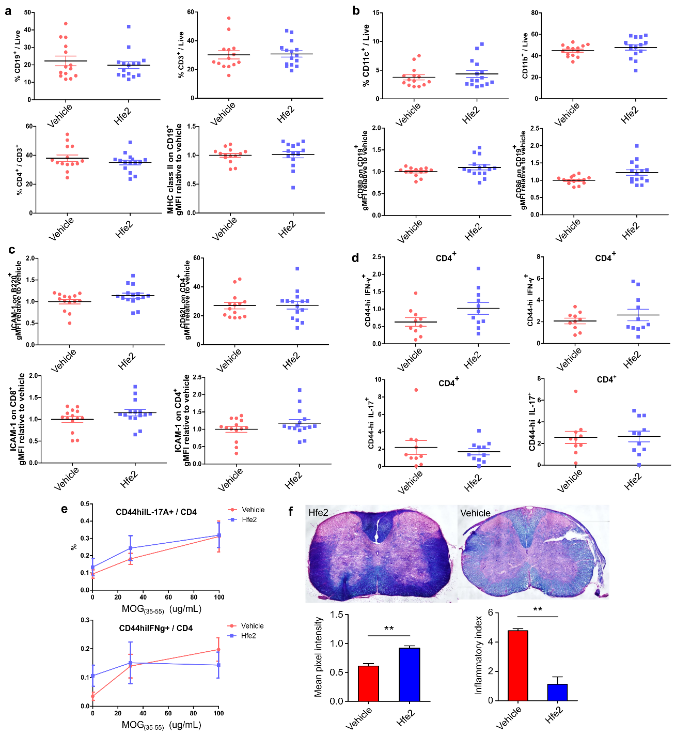
Extended Data Fig. 11 | No immunological effect from protein derived treatments. a-e, Mice were induced with EAE and splenocytes were harvested 10 days post induction (n=15). a, Soluble Hfe2 has no effect on naïve immune cell populations. Splenocytes were harvested and stained as described. No difference was observed in the percentage of B cells, T cells, or MHC II on B cells in Hfe2-treated versus vehicle-treated animals. b, Soluble Hfe2 treatment has no effect on naïve antigen-presenting cells. Splenocytes were analyzed for the percentage of CD11c (dendritic cell), CD11b (myeloid cell). Soluble Hfe2 does not impact the activation of B cells, as seen using co-activation markers CD80 on B cells, CD86 on B cells. c, Soluble Hfe2 treatment has no effect on the adhesion properties of naïve T and B cells. Splenocytes were analyzed for their levels of ICAM-1 expression on B cell, ICAM-1 expression on CD8+ T cells, ICAM-1 and CD62L expression in CD4+T cells. d, Soluble Hfe2 has no effect on activated immune cells. Splenocytes were harvested and stimulated using PMA and Ionomycin and analyzed for the expression of activated CD4+T cells secreting IL-17A or IFN-γ. Draining lymph nodes (caudal, sciatic, lumbar) cells were also analyzed as described. e, Soluble Hfe2 has no effect on antigen-specific immune cells. CD4+T cell proliferation was measured using CFSE incorportion in splenocytes treated with 0 or 30ug/mL of MOG(35-55), levels of IL17 and IFN-γ in splenocytes pulsed with 0, 30, or 100μg/mL MOG(35-55) were analyzed. f, Soluble Hfe2 treatment reduces the number of cellular infiltrates and the extent of de-myelination in EAE-induced mice. Mice induced with EAE were trans-cardially perfused 18 days post induction and stained with H&E in combination with Luxol fast blue. Soluble Hfe2-treated mice show less de-myelinating foci in cervical spinal cord sections of EAE-induced mice. Soluble Hfe2-treated mice possess: a greater mean pixel intensity of Luxol fast blue staining compared to vehicle-treated animals and a decreased inflammatory index (mean ± s.e.m., unpaired t-tests, n=6 per group). *P<0.05, **P<0.01.

Multimedia files:
Supplementary Video 1. Multi-photon imaging of brain blood vessels and meninges. Blood vessel in a wild-type mouse are labelled with 70kDa dextran conjugated Texas red. Collagen fibers tracts within the dura matter can be seen using second-harmonic generation (SHG) imaging. Scale bar is 50 µm.
Supplementary Video 2. Hfe2-deficient mice displays severe BBB disruption. Representative in-vivo multiphoton imaging of TR-dextran leakage over 40 min in Hfe2^{fl/fl}, Hfe2^{Δalb-cre}, AAV8-GFP, and AAV8-Alb-cre mice. Corresponds to Fig. 1c. Red channel indicates regions excluded due to blood vessel labeling, green channel indicates fluorescent signal from TR-dextran, and circular blue region indicates region used for background compensation.
Supplementary Video 3. Hfe2 and RGMa have opposite effects on BBB integrity. Representative in-vivo multiphoton imaging of TR-dextran leakage over 40 min in RGMa and RGMa+Hfe2 treated brains. Corresponds to Fig. 4b. Same color correspondence as Supplementary Video 2.
Supplementary Video 4. RGMa disrupts BBB through Neogenin receptor. Representative in-vivo multiphoton imaging of TR-dextran leakage over 40 min in Neo^{ΔTie2-creERT2} mice with (TAM+) and without (TAM-, wide-type) tamoxifen administration. Corresponds to Fig. 5d. Same color correspondence as Supplementary Video 2.

