Supplemental Material

This appendix presents additional information

Supplement to: A simple and interpretable severe intraventricular hemorrhage prediction model for extremely low birth weight infants using machine learning

Corresponding author

Felipe Yu Matsushita, MD – felipe.matsushita@hc.fm.usp.br
Department of Pediatrics,
Instituto da Criança, Faculty of Medicine, University of São Paulo
Av. Dr. Enéas Carvalho de Aguiar, 647
São Paulo, São Paulo, Brazil, 05403901
ORCID: 0000-0002-5106-7497

Supplementary material
eFigure 1. Decision-tree model
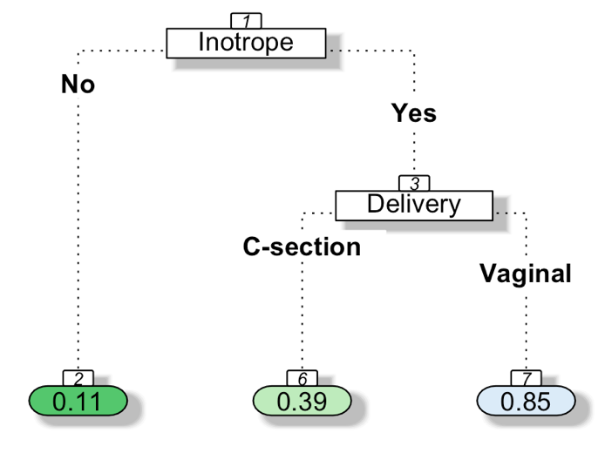
Variables included in the decision tree: Inotropic therapy and C-section delivery. Number in node represents percentage of event to occur inside the corresponding group. Percentage of sIVH in patients without inotropic necessity = 11%. Percentage of sIVH in patients with inotropic necessity and vaginal delivery = 85%.

eTable 1. Stepwise logistic regression using all features
Feature | Odds Ratio | 95% CI | P value
5-minute APGAR score | 0.815 | 0.646 – 1.021 | 0.075
Delivery | 0.153 | 0.041 – 0.5262 | 0.003
Antenatal corticoid | 0.448 | 0.146 – 1.302 | 0.145
Highest pCO2 | 1.031 | 1.003 – 1.062 | 0.031
Inotrope | 6.787 | 2.39 – 21.13 | <0.001

eFigure 2. Decision-tree model
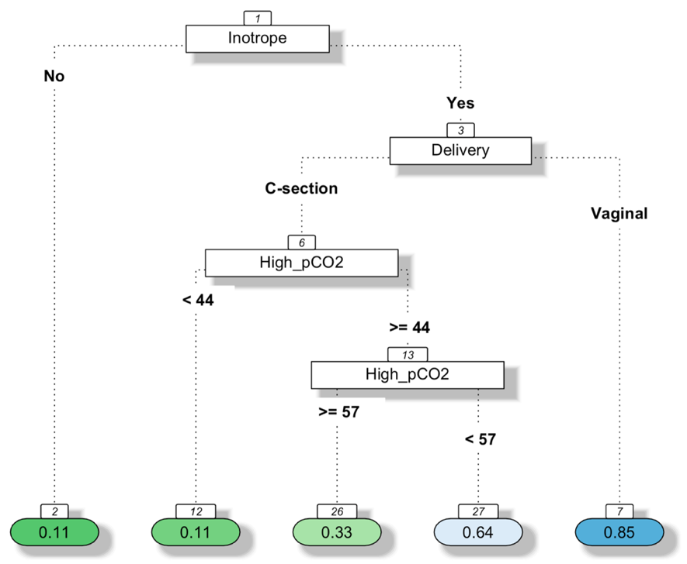
Variables included in decision model: delivery type, highest pCO2, and inotropic therapy. Number in node represents percentage of event to occur inside the corresponding group. Percentage of sIVH in patients with inotropic necessity and vaginal delivery = 85%. Percentage of sIVH in patients with inotropic necessity, c-section delivery and highest pCO2 lower than 44mmHg = 11%.

eFigure 3. Correlation matrix analyzing all variables
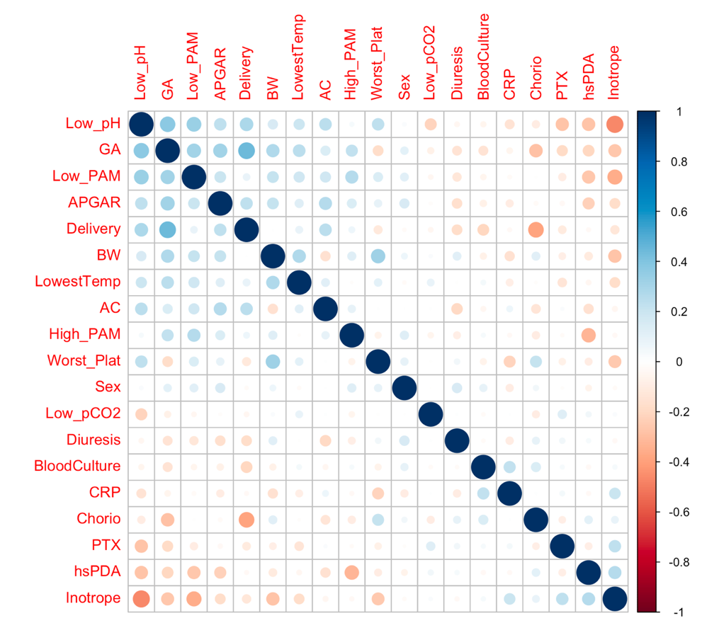

eTable 2. Logistic regression after correlation matrix (AIC 115.4 / AUC 0.739)
Features | Odds Ratio | 95% CI | P value
Lowest pH | 0.009 | 0.00003 – 1.963 | 0.092
Gestational age | 0.835 | 0.543 – 1.252 | 0.390
Lowest mean blood pressure | 1.051 | 0.887 – 1.250 | 0.557
5-minute APGAR score | 0.574 | 0.388 – 0.795 | 0.002
Delivery | 0.029 | 0.002 – 0.245 | 0.002
Birth weight | 1.009 | 1.003 – 1.015 | 0.002
Lowest temperature | 1.255 | 0.565 – 2.842 | 0.575
Antenatal corticoid | 0.851 | 0.211 – 3.455 | 0.818
Highest mean blood pressure | 0.939 | 0.863 – 1.012 | 0.119
Worst Platelet | 0.980 | 0.962 – 0.994 | 0.016
Gender | 0.507 | 0.134 – 1.760 | 0.294
Lowest pCO2 | 1.030 | 0.946 – 1.124 | 0.491
Diuresis | 0.922 | 0.570 – 1.458 | 0.731
Positive Blood Culture | 0.084 | 0.002 – 1.938 | 0.145
C-reactive protein | 0.970 | 0.924 – 1.011 | 0.178
Chorioamnionitis | 0.280 | 0.027 – 2.389 | 0.260
Pneumothorax | 0.085 | 0.002 – 1.753 | 0.131
hsPDA | 0.602 | 0.104 – 3.355 | 0.558
Inotrope | 33.44 | 6.04 – 299.6 | <0.001

eFigure 4. Decision-tree model
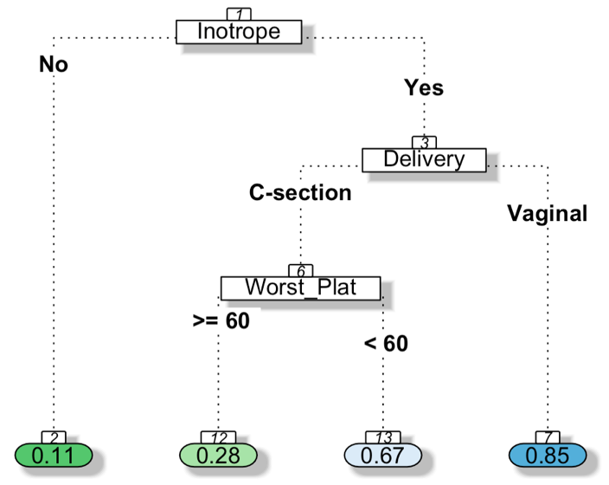
Variables included in decision tree model: 5-minute APGAR score, delivery, birth weight, worst platelet, and inotropic therapy. Number in node represents percentage of event to occur inside the corresponding group. Percentage of sIVH in patients without inotropes = 11%. Percentage of sIVH in patients with inotropic therapy necessity, c-section delivery and platelet lower than 60.000mm3 = 67%.

eTable 3. Stepwise logistic regression after correlation matrix (AIC 101 / AUC 0.768)
Feature | Odds Ratio | 95% CI | P value
Lowest pH | 0.035 | 0.0005 – 2.100 | 0.110
5-minute APGAR score | 0.637 | 0.481 – 0.818 | <0.001
Delivery | 0.048 | 0.007 – 0.248 | <0.001
Birth Weight | 1.006 | 1.002 – 1.011 | 0.003
Worst Platelet | 0.983 | 0.968 – 0.996 | 0.019
Positive Blood Culture | 0.063 | 0.002 – 1.112 | 0.068
Inotrope | 10.92 | 3.06 – 47.98 | <0.001

eTable 4. Logistic regression using confirmed important variables using Boruta algorithm
Feature | Odds Ratio | 95% CI | P value
Lowest pH | 6.51 | 0.00008 - 10619 | 0.749
Inotrope | 6.53 | 1.87 – 25.7 | 0.004
Gestational age | 0.938 | 0.695 – 1.245 | 0.666
Highest pCO2 | 1.04 | 0.989 – 1.10 | 0.132
Lowest base excess | 0.941 | 0.750 – 1.172 | 0.595
Delivery | 0.153 | 0.03 – 0.60 | 0.008
Fluid bolus | 1.003 | 0.829 – 1.234 | 0.971
Lowest diastolic blood pressure | 0.969 | 0.789 – 1.160 | 0.749
Lowest mean blood pressure | 1.049 | 0.871 – 1.283 | 0.619

eFigure 5. Decision-tree model
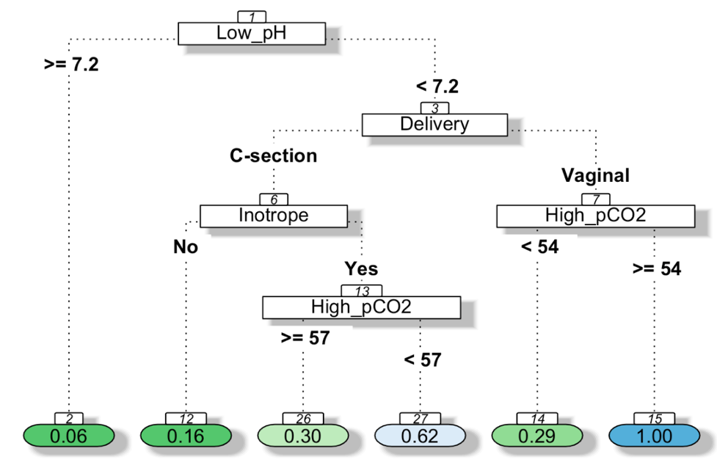
Variables included in decision tree model: Lowest pH, inotropic therapy, gestational age, highest pCO2, Lowest base excess, delivery, fluid bolus necessity, lowest mean blood pressure, and lowest diastolic blood pressure. Number in node represents percentage of event to occur inside the corresponding group. Percentage of sIVH in patients with pH > 7.2 = 6%. Percentage of sIVH in patients with pH < 7.2, vaginal delivery and pCO2 > 54mmhg = 100%.

eFigure 6. Decision-tree model
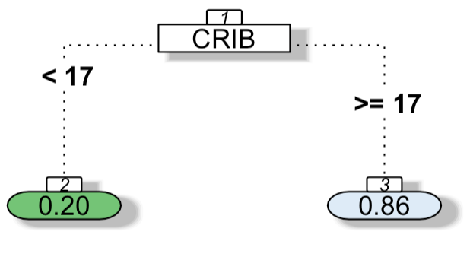
Variable included in decision tree model: CRIB II score. Number in node represents percentage of event to occur inside the corresponding group. Percentage of sIVH in patients with CRIB score < 17 = 20%. Percentage of sIVH in patients with CRIB score equal or higher than 17 = 86%.

eFigure 7. Decision-tree model
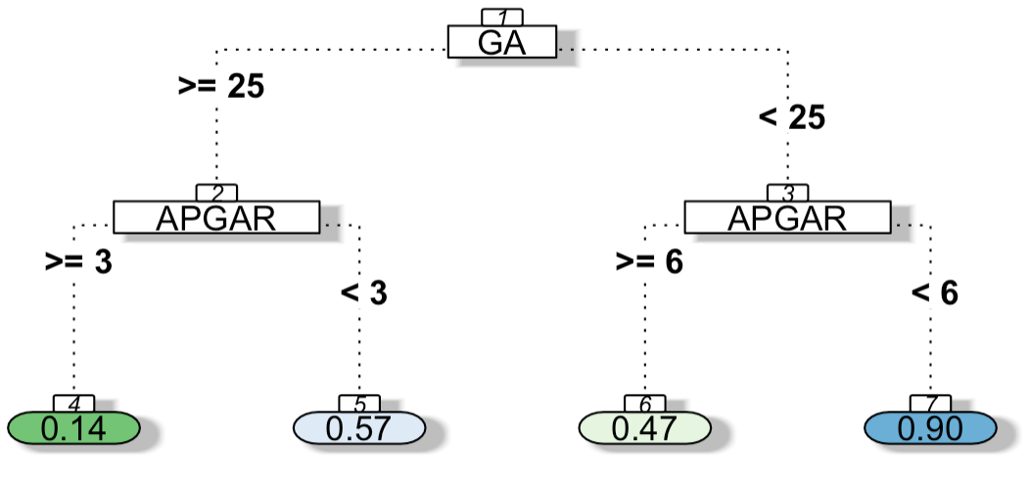
Variable included in decision tree model: Gestational age, mechanical ventilation antenatal corticoid, 5-minute APGAR, birth weight, cesarean section, male gender. Number in node represents percentage of event to occur inside the corresponding group. Percentage of sIVH in patients with gestational age equal or greater than 25 weeks and 5-minute APGAR score < 3 = 57%.

