Additional file 1
1.1 Stages of blood clotting capacity test
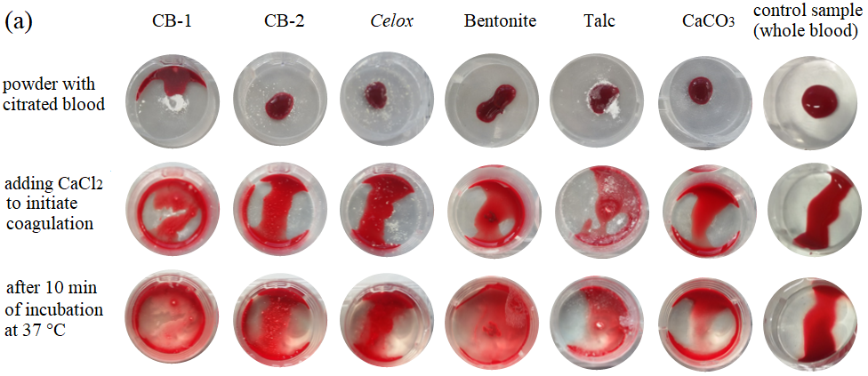
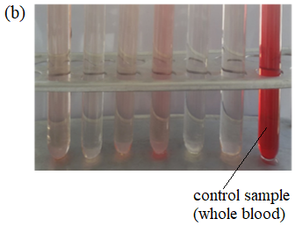
(a) Visual observation of surface wettability through stages; (b) corresponding aqueous solutions used to measure haemoglobin absorbance at 540 nm. From left to right: CB-1, CB-2, Celox, bentonite, talc, CaCO₃ and control sample.

1.2 Notes for visual inspection of clots
Visual inspection of the samples after blood clotting test
Name | Visual inspection
 | Citrated samples | Samples after adding 0.025M CaCl₂ and incubation for 10 min
CB-1 | any immediate absorption of a fluid | complete infiltration
CB-2 | infiltrates a portion of a total blood volume | swelling
Celox | infiltrates a portion of a total blood volume | swelling
CaCO₃ | complete infiltration | complete infiltration
Bentonite | complete infiltration | complete immediate infiltration, forming a specific wad in a middle of sample
Talc | any immediate absorption of a fluid | poor infiltration

1.3 Dynamic rheological testing
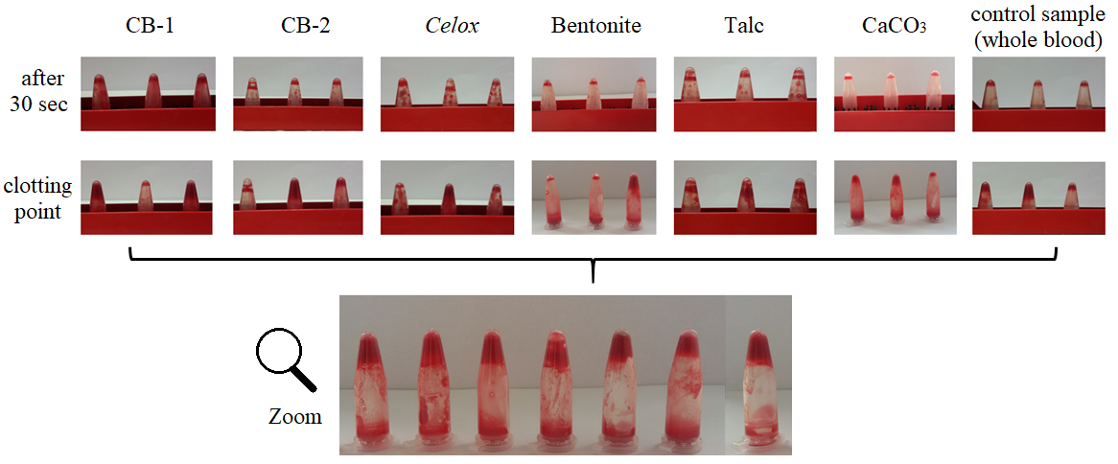
Observation of clot formation during dynamic rheological experiment, n=3, as described by Periayah [22]

