Supplementary Information

Fabrication of Black In2O3 with Dense Oxygen Vacancy through Dual Functional Carbon Doping for Enhancing Photothermal CO2 Hydrogenation

Yuhang Qi, Jiawei Jiang, Xichen Liang,Shuxin Ouyang,* Wenbo Mi,* Lei Zhao, Shangbo Ning, Jinhua Ye

**Computational Methods and Details**

The first-principles calculations on Carbon doped In2O3 (C-In2O3)are performed using Vienna *ab* initio simulation package (VASP), with the generalized gradient approximation (GGA) for the exchange and correlation function by Perdew, Burke and Ernzerhof (PBE).1-3 Kohn-Sham single-particle wave functions are expanded in the plane wave basis set with a kinetic energy cutoff at 400 eV. A Monkhorst-Pack 4×4×4 k-point grid is adopted to sample the Brillouin zone. The energy and force convergence criteria are 10-5 eV and 0.01 eV/Å, respectively. Formation energy calculations are performed to investigate the energetic stability using the equation , where ,  and  represent the energy of the C doped system, the energy of the pure In2O3 and the chemical potential of single atom, respectively. Hybrid functional (HSE06) is used to predict the band structure and formation energy accurately.4 Bond-valence sum (BVS) is calculated to estimate the ionic valence. 5-7

According to previous researches 8, 9, a 2×2×1 k-point grid generated by the Monkhorst−Pack method are found to give converged results for the CO2 reaction on C-In2O3(110) surface calculations. The C-In2O3(110) surface is created based on the optimized bulk unit cell, while placing the defect site at the center of the surface. In all surface calculations, the bottom two layers of C-In2O3 are frozen at their equilibrium bulk positions, whereas the top two layers together with the adsorbates are allowed to relax. The forces on all unconstrained atoms are ≤0.03 eV/Å. Gibbs free energy calculations are performed by the equation , where , , and  represent the adsorption energy, zero-point vibration energy, room temperature and entropy change, respectively. Among them, the equation of adsorption energy calculation is , where  and  represent the energy of C-In2O3(110) surface and adsorbate, respectively.

**Supplementary Tables**

Table S1. Performance comparison of different photocatalysts for CO2 hydrogenation. 10-26

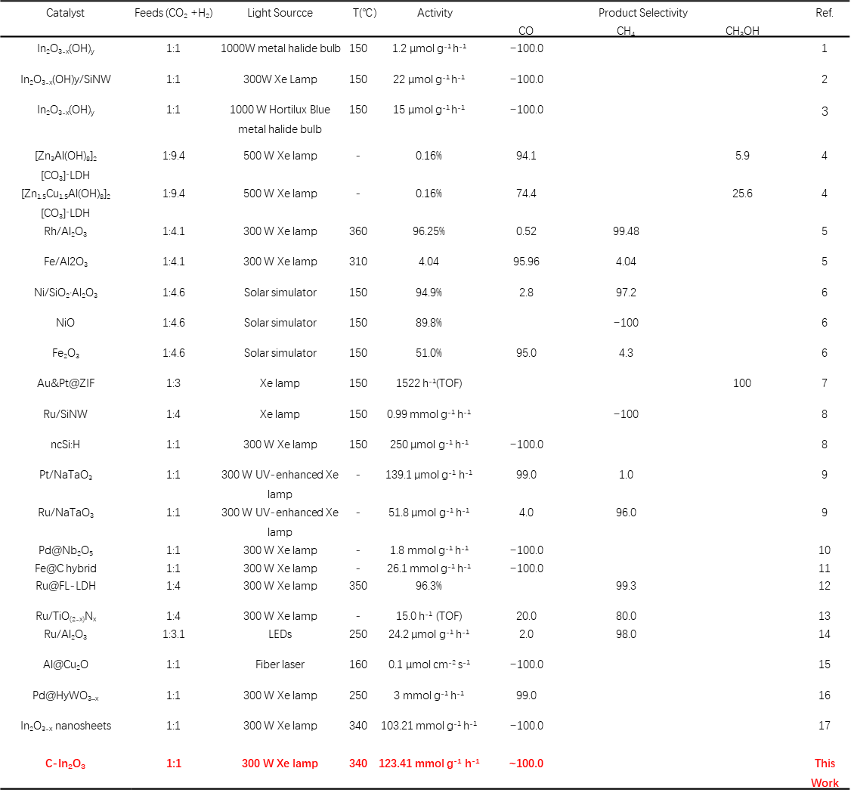

Table S2 Energetic properties and geometry structures of the C-In2O3-x systems, includingformation energy *E*f, bond length *l* and ionic valence *V*.

|  |  |  |  |  |  |  |
| --- | --- | --- | --- | --- | --- | --- |
| System | *E*f (eV) | *l*In-In (Å) | *l*In-O (Å) | *V*In | *V*O | *V*C |
| pure | - | 3.33~3.35 | 2.13~2.22 | +2.83~2.86 | -1.89 | - |
| Ovac | 4.98 | 3.30~3.46 | 2.10~2.29 | +2.18~2.86 | -1.83~1.93 | - |
| Cs-O | 11.42 | 3.30~3.45 | 2.12~2.30 | +2.23~2.89 | -1.82~1.93 | +0.04 |
| Cs-InA | 12.11 | 3.22~3.40 | 2.12~2.27 | +2.68~2.84 | -1.48~1.95 | +2.08 |
| Cs-InB | 8.29 | 3.24~3.48 | 2.06~2.60 | +2.57~2.91 | -1.38~1.98 | +3.12 |
| Ci | 7.59 | 3.09~3.47 | 2.10~2.41 | +2.40~2.95 | -1.83~2.26 | +2.52 |
| Ci+Ovac | 3.10 | 3.19~3.46 | 2.10~2.29 | +2.11~2.91 | -1.78~2.03 | +0.68 |

Table S3. Local structure parameters around In estimated by EXAFS analysis

|  |  |  |  |  |  |  |
| --- | --- | --- | --- | --- | --- | --- |
| **Sample** | **Path** | **C.N.** | **R (Å)** | **σ2×103 (Å2)** | **ΔE (eV)** | **R factor** |
| In2O3 standard | In-O | 6* | 2.16±0.01 | 6.4±1.0 | 0.7±1.0 | 0.009 |
| In-In | 6* | 3.36±0.01 | 6.8±0.6 | 1.1±1.1 |
| C-In2O3-x | In-O | 2.4±0.3 | 2.18±0.01 | 2.6±2.5 | 6.8±1.0 | 0.019 |
| In-In | 2.6±0.8 | 3.35±0.02 | 3.8±3.4 | 4.1±1.6 |

Table S4. Elemental analysis of carbon content

|  |  |
| --- | --- |
| **Sample** | **Carbon [wt. %]** |
| Vo-poor In2O3 | 0.03 % |
| Vo-rich In2O3 | 0.04 % |
| C-In2O3-1 | 0.32 % |
| C-In2O3-2 | 0.65 % |
| C-In2O3-3 | 0.96 % |
| C-In2O3-4 | 1.76 % |
| C-In2O3-5 | 2.69% |

Table S5.Calculated electronic energy, zero-point energy, and entropy of each molecule and CO2 RR intermediate.

|  |  |  |  |  |
| --- | --- | --- | --- | --- |
| System | Species | *E*DFT (eV) | *E*ZPE (eV) | -*TS* (eV) |
| - | CO2 | -23.02 | 0.31 | -0.65 |
| - | H2 | -6.78 | 0.27 | -0.42 |
| - | CO | -14.79 | 0.14 | -0.67 |
| - | H2O | -14.23 | 0.58 | -0.65 |
| pure | * | -425.67 | - | - |
| (CO2+2H)* | -456.23 | 0.83 | -0.06 |
| (COOH+H)* | -457.08 | 0.99 | -0.18 |
| CO*+H2O | -455.32 | 0.79 | -0.80 |
| Ovac | * | -418.31 | - | - |
| (CO2+2H)* | -448.83 | 0.70 | -0.06 |
| (COOH+H)* | -448.45 | 0.83 | -0.18 |
| CO*+H2O | -448.33 | 0.80 | -0.80 |

**Supplementary Figures**

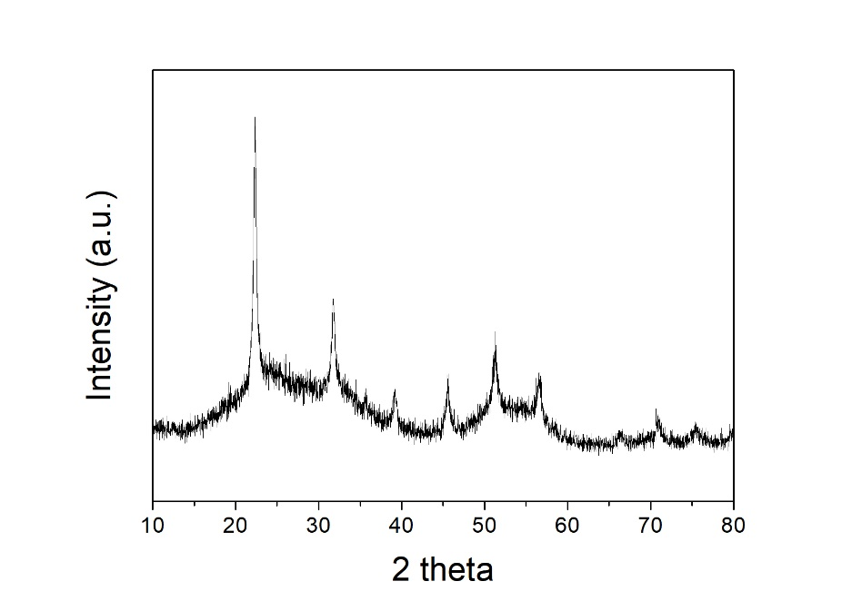

Figure S1. XRD patterns of C-In(OH)3 nano partials.

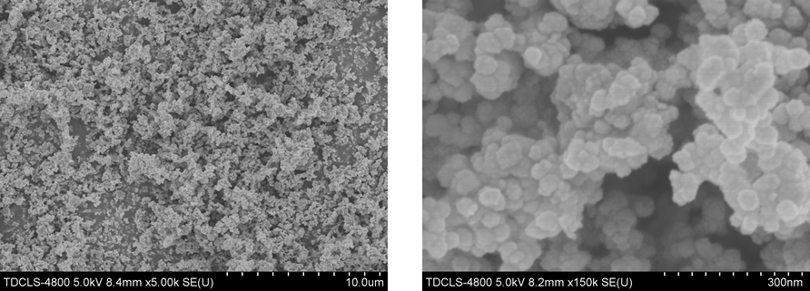



Figure S2. SEM images of C-In(OH)3 nano partials.

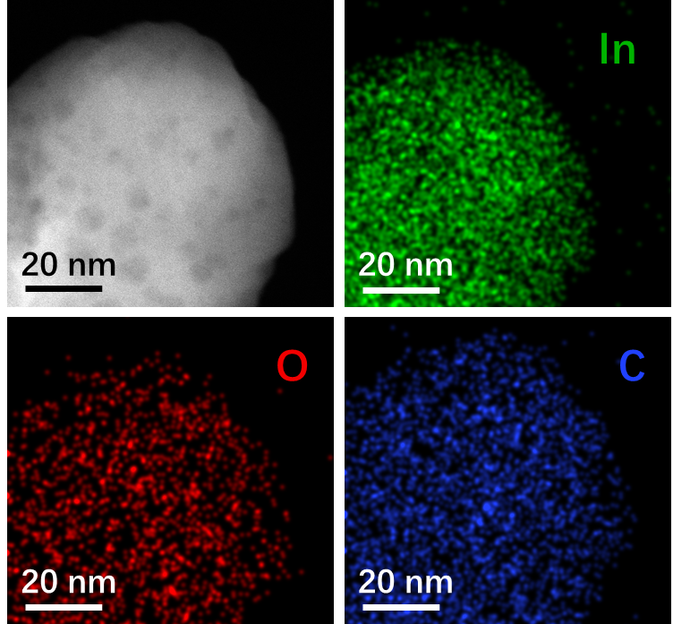

Figure S3. EDS elemental mapping profiles of C-In2O3-x.

**Supporting information discussion:** In order to further verify the distributed carbon element in the C-In2O3-x, the elemental mapping is performed that the presence of the carbonaceous matters is homodispersed and exists in heterogeneous interfaces. And, decomposed gaseous water and the random nucleation-growth behaviors on the substrate make for nanoholes.

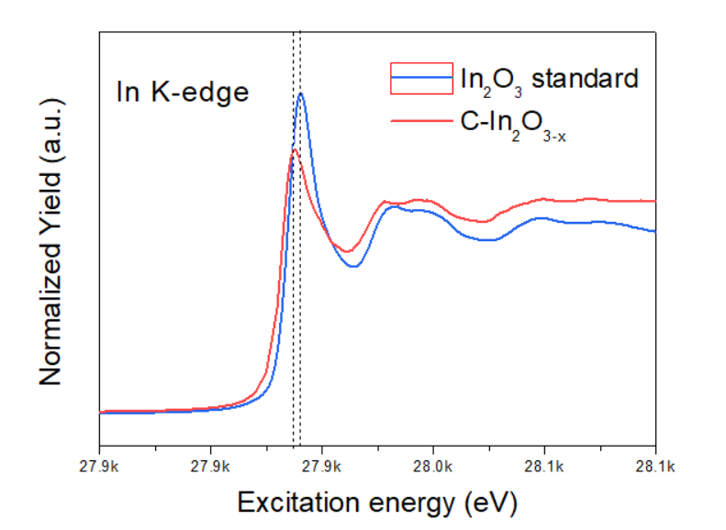

Figure S4. Normalized In K-edge XANES spectra of C-In2O3-x

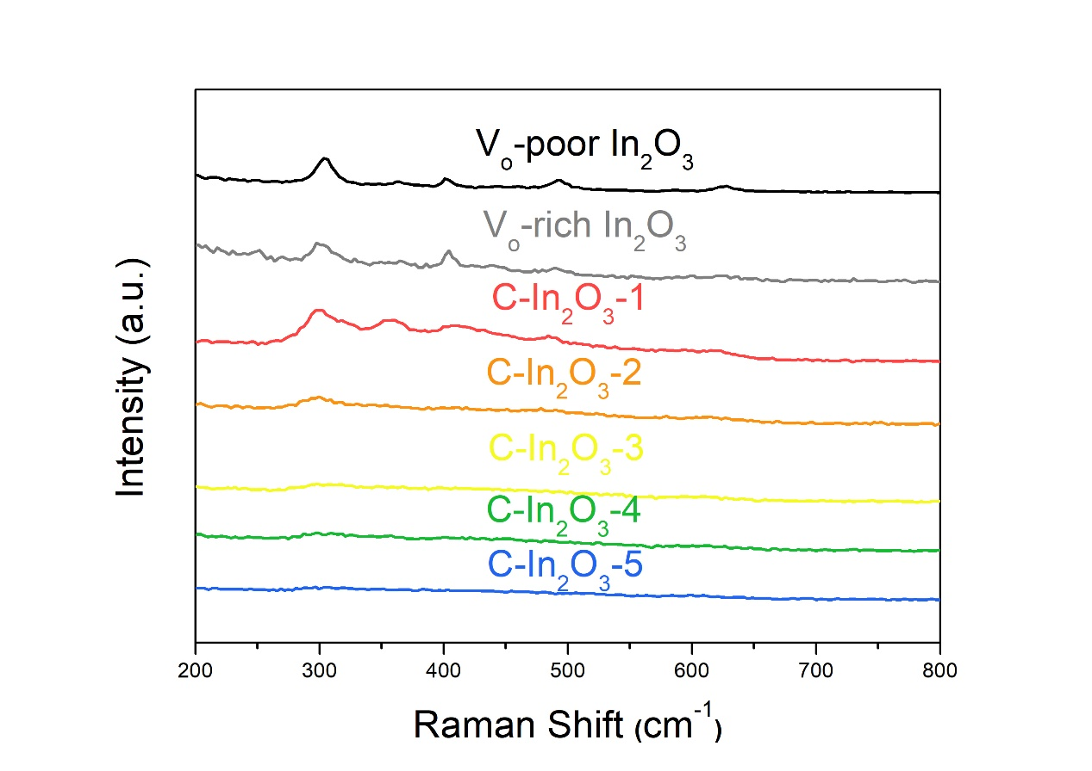

Figure S5. Raman spectrum of different carbon content of In2O3.

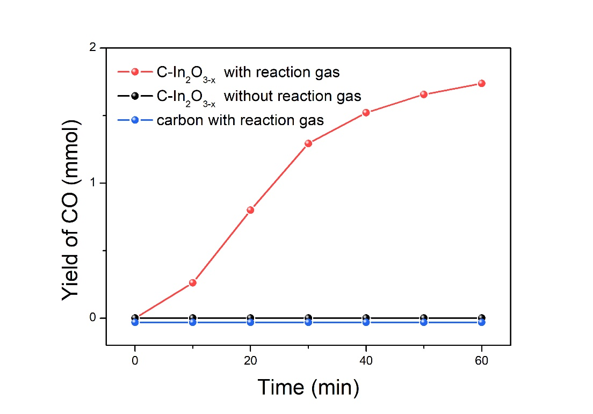

Figure S6. The CO production rates of C-In2O3-x with and without reaction gas and only carbon with reaction gas.

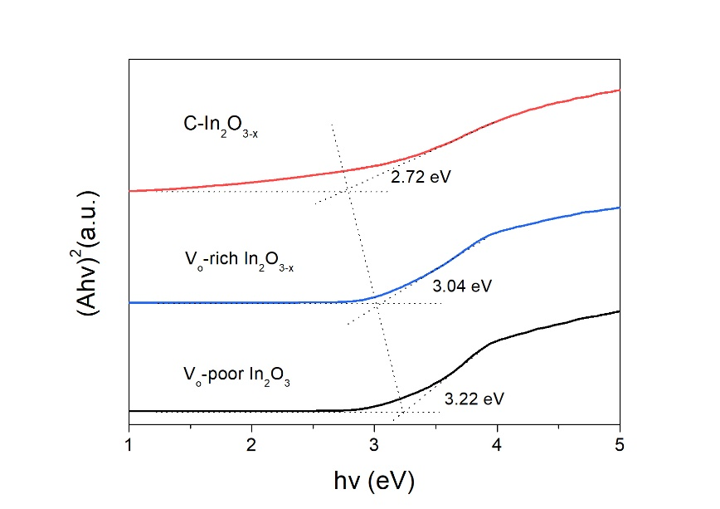

Figure S7. Band gap of V-poor In2O3, Vo-rich In2O3-x and C-In2O3-x.

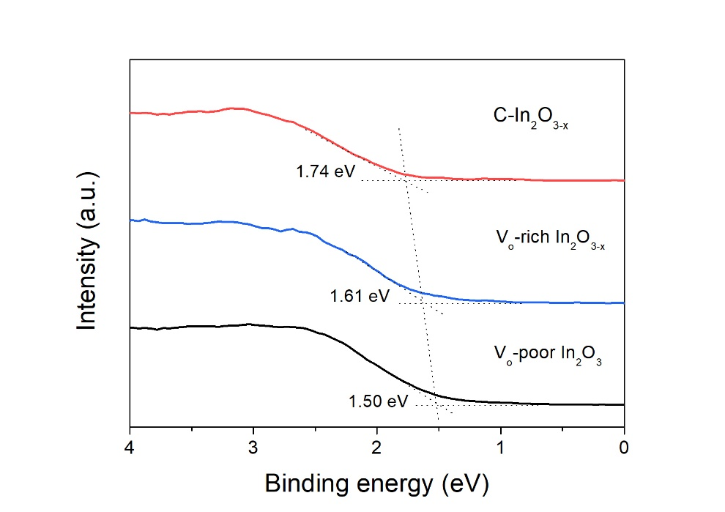

Figure S8. Valence band XPS spectra of Vo-poor In2O3, Vo-rich In2O3-x and C-In2O3-x.

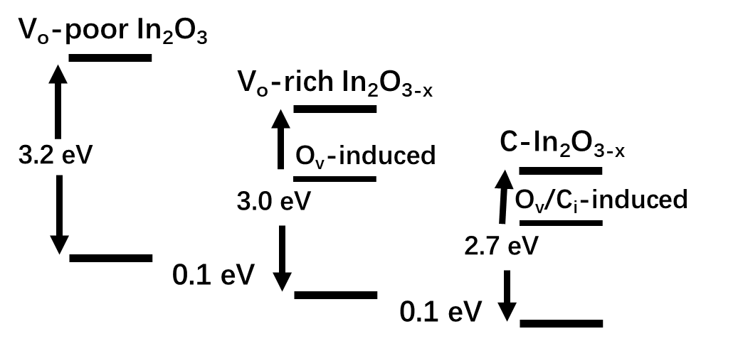

Figure S9. Schematic illustration of the DOS.

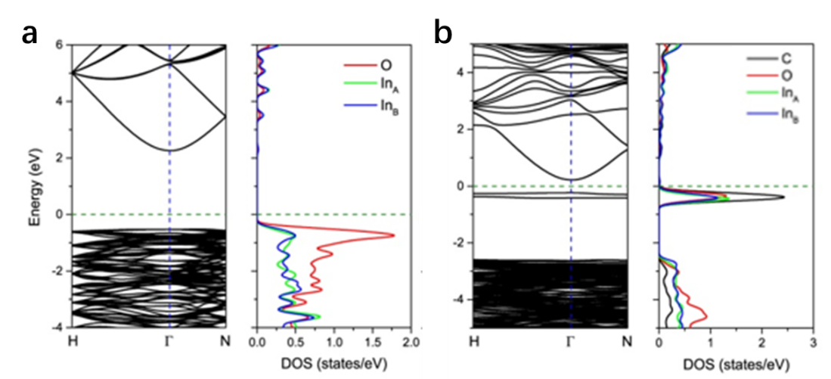

Figure S10. Calculated band structure and density of states for a) prefect In2O3 and b) In2O3 with one C atom interstitial and one O atom vacancy

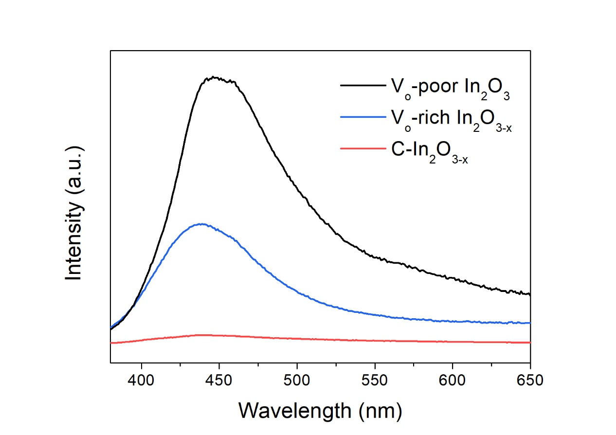

Figure S11. The PL spectrumof Vo-poor In2O3, Vo-rich In2O3-x and C-In2O3-x.

**Supplementary Discussion:** The photoluminescence (PL) spectrum was tested. The emission peak at 450 nm for Vo-poor In2O3 could be mainly ascribed to the recombination of the photogenerated hole with the two-electron-trapped O-vacancy, while the blue-shifted peak at 440 nm for the Vo-rich In2O3-x could be mainly attributed to the recombination of the photogenerated hole with the single-electron-trapped O-vacancy.

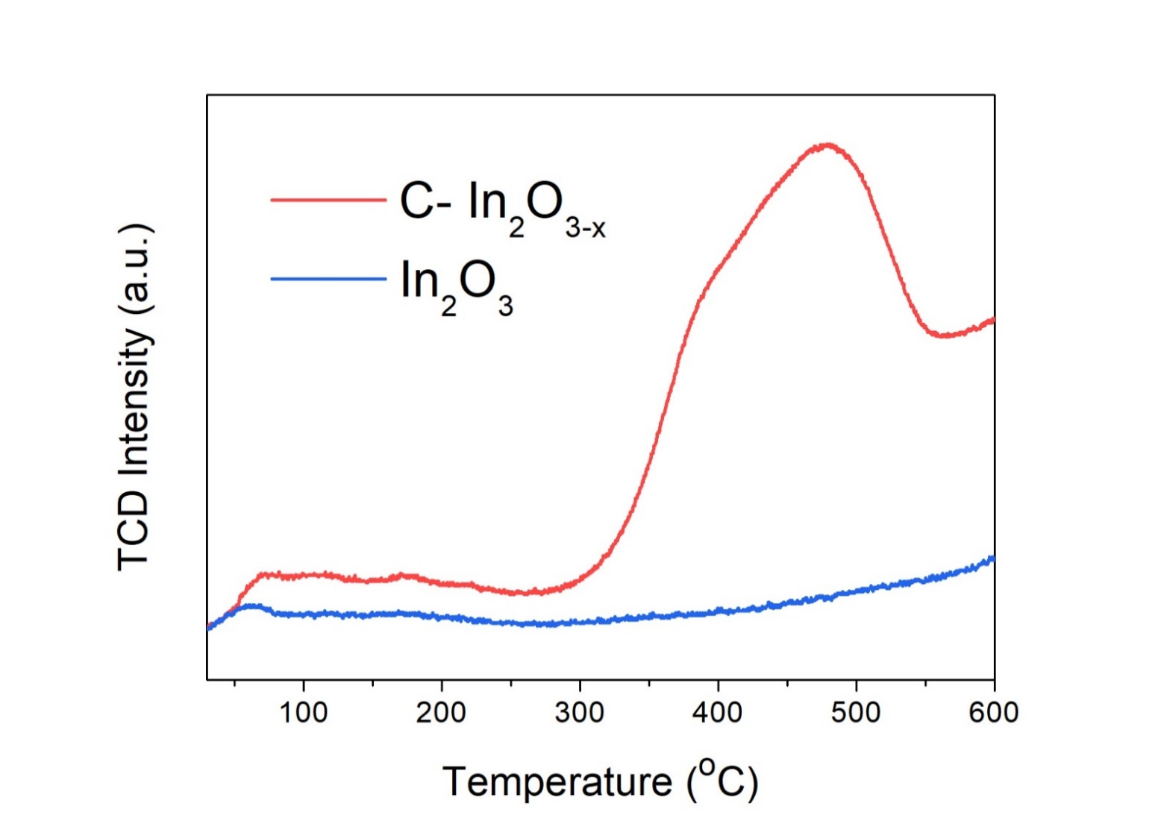

Figure S12. CO2-TPD profiles of C-In2O3 with and without active sites via calcination treatment.

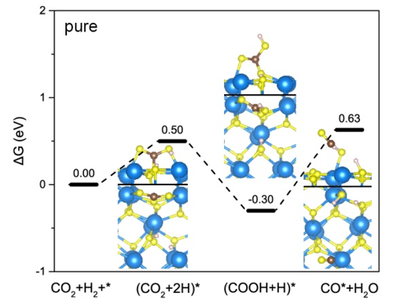

Figure S13. Gibbs free energy profile for CO2 reaction with the coadsorbed H atoms on the In2O3 (110) surface.

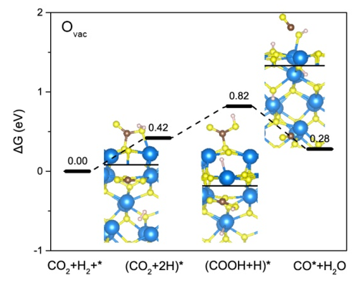

Figure S14. Gibbs free energy profile for CO2 reaction with the coadsorbed H atoms on the In2O3 (110) surface with oxygen vacancy.

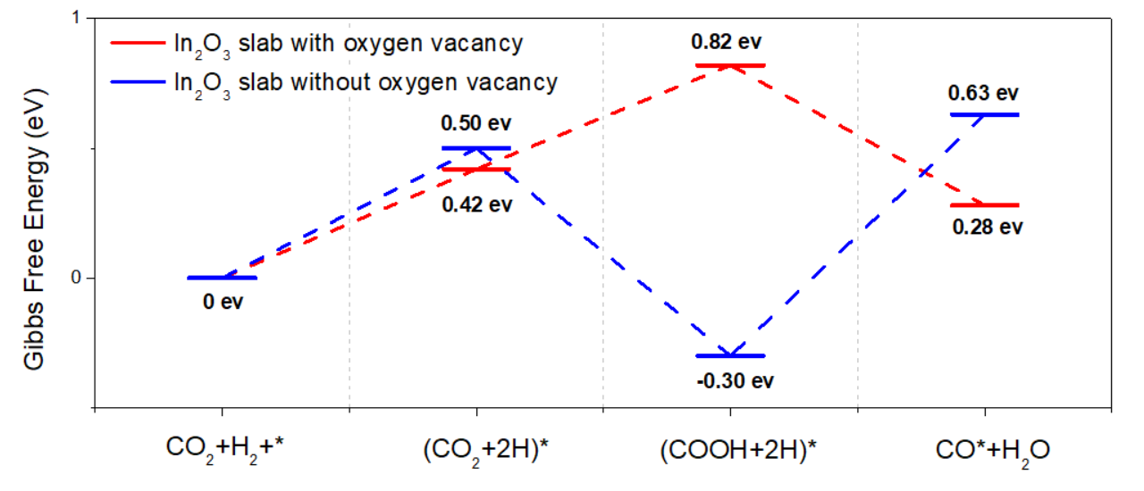

**Figure S15.** Gibbs free energy profile for CO2 reduction reaction on the In2O3 (110) surface.

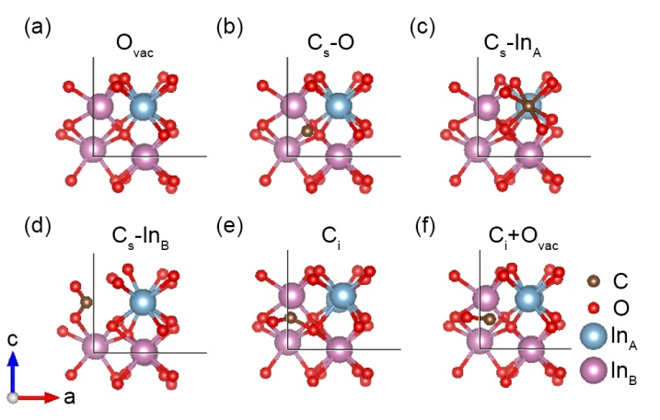

**Figure S16.** Relaxed local defect structures of (a) one O atom vacancy, (b) one O atom substituted by C atom, (c) one InA atom substituted by C atom, (d) one InB atom substituted by C atom, (e) one C atom interstitial and (f) one C atom interstitial with one O atom vacancy.

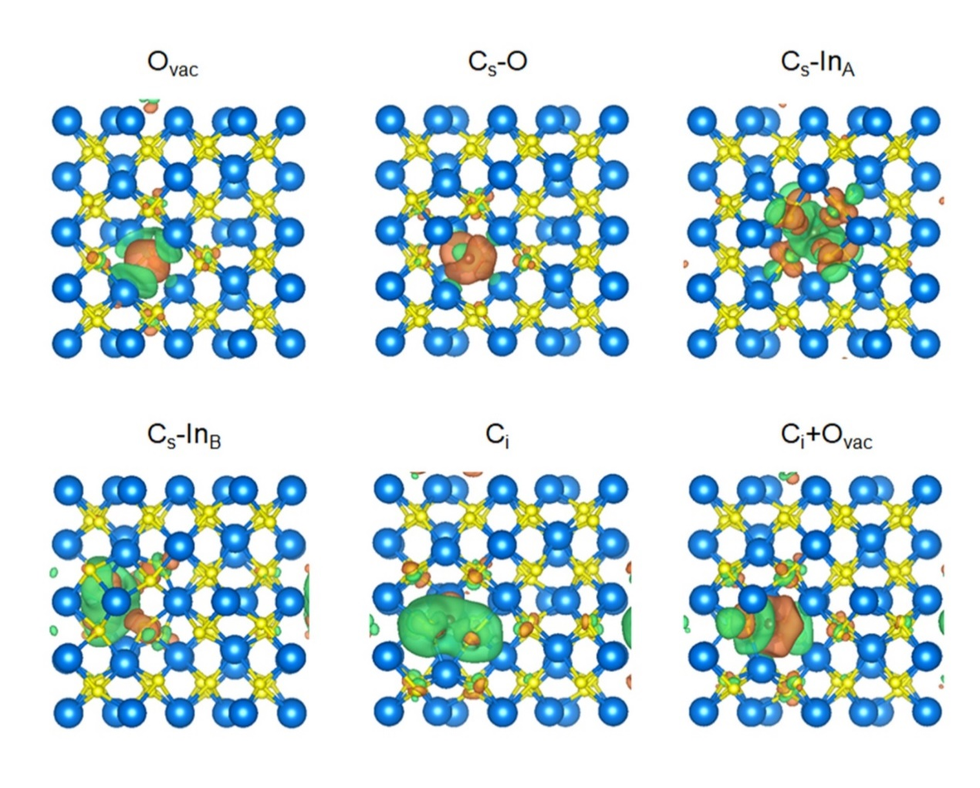

**Figure 17.** Side views of charge difference density of C doped In2O3 systems. The isosurface value is 3 e nm-3. Yellow and blue regions represent net charge gain and loss, respectively.

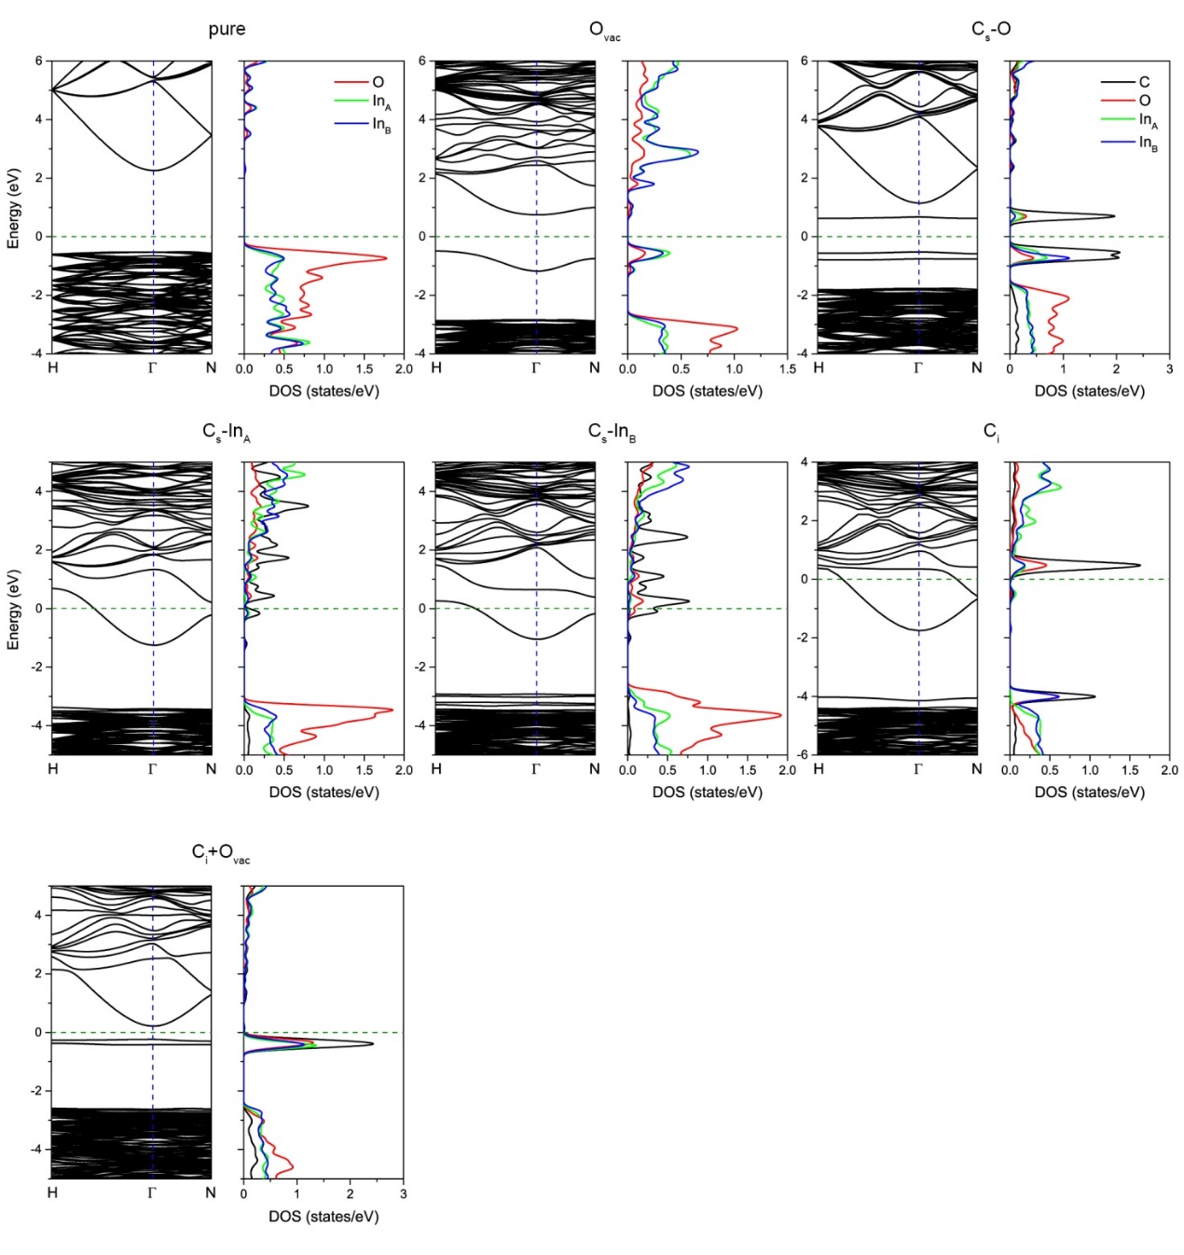

**Figure S18.** Band structures and projected density of states of C doped In2O3 systems. Fermi level is set to zero.

**References**

1. Kresse, G. & Furthmuller, J. Efficient iterative schemes for ab initio total-energy calculations using a plane-wave basis set. *Physical Review B* **54**, 11169-11186 (1996).

2. Kresse, G. & Joubert, D. From ultrasoft pseudopotentials to the projector augmented-wave method. *Physical Review B* **59**, 1758-1775 (1999).

3. Perdew, J.P., Burke, K. & Ernzerhof, M. Generalized gradient approximation made simple. *Physical Review Letters* **77**, 3865-3868 (1996).

4. Krukau, A.V., Vydrov, O.A., Izmaylov, A.F. & Scuseria, G.E. Influence of the exchange screening parameter on the performance of screened hybrid functionals. *J Chem Phys* **125**, 224106 (2006).

5. Brown, I.D. & Altermatt, D. Bond-Valence Parameters Obtained from a Systematic Analysis of the Inorganic Crystal-Structure Database. *Acta Crystallogr B* **41**, 244-247 (1985).

6. Brese, N.E. & Okeeffe, M. Bond-Valence Parameters for Solids. *Acta Crystallogr B* **47**, 192-197 (1991).

7. Brown, I.D. Chemical and Steric Constraints in Inorganic Solids. *Acta Crystallogr B* **48**, 553-572 (1992).

8. Ye, J.Y., Liu, C.J. & Ge, Q. DFT Study of CO2 Adsorption and Hydrogenation on the In2O3 Surface. *J Phys Chem C* **116**, 7817-7825 (2012).

9. Ye, J.Y., Liu, C.J., Mei, D.H. & Ge, Q.F. Active Oxygen Vacancy Site for Methanol Synthesis from CO2 Hydrogenation on In2O3(110): A DFT Study. *Acs Catal* **3**, 1296-1306 (2013).

10. He, L. et al. Spatial Separation of Charge Carriers in In2O3-x(OH)y Nanocrystal Superstructures for Enhanced Gas-Phase Photocatalytic Activity. *Acs Nano* **10**, 5578-5586 (2016).

11. Hoch, L.B. et al. Nanostructured Indium Oxide Coated Silicon Nanowire Arrays: A Hybrid Photothermal/Photochemical Approach to Solar Fuels. *Acs Nano* **10**, 9017-9025 (2016).

12. Hoch, L.B. et al. The Rational Design of a Single-Component Photocatalyst for Gas-Phase CO2 Reduction Using Both UV and Visible Light. *Adv Sci* **1**, 1400013 (2014).

13. Ahmed, N., Shibata, Y., Taniguchi, T. & Izumi, Y. Photocatalytic conversion of carbon dioxide into methanol using zinc-copper-M(III) (M=aluminum, gallium) layered double hydroxides. *J Catal* **279**, 123-135 (2011).

14. Meng, X.G. et al. Photothermal Conversion of CO2 into CH4 with H2 over Group VIII Nanocatalysts: An Alternative Approach for Solar Fuel Production. *Angew Chem Int Edit* **53**, 11478-11482 (2014).

15. Zhang, W.B. et al. Integration of Photothermal Effect and Heat Insulation to Efficiently Reduce Reaction Temperature of CO2 Hydrogenation. *Small* **13**,1602583 (2017).

16. O'Brien, P.G. et al. Photomethanation of Gaseous CO2 over Ru/Silicon Nanowire Catalysts with Visible and Near-Infrared Photons. *Adv Sci* **1** ,1400001 (2014).

17. Li, M. et al. Highly efficient and stable photocatalytic reduction of CO2 to CH4 over Ru loaded NaTaO3. *Chem Commun* **51**, 7645-7648 (2015).

18. Jia, J. et al. Visible and Near-Infrared Photothermal Catalyzed Hydrogenation of Gaseous CO2 over Nanostructured Pd@Nb2O5. *Adv Sci* **3** ,1600189 (2016).

19. Zhang, H.B. et al. Surface-Plasmon-Enhanced Photodriven CO2 Reduction Catalyzed by Metal-Organic-Framework-Derived Iron Nanoparticles Encapsulated by Ultrathin Carbon Layers. *Adv Mater* **28**, 3703-3710 (2016).

20. Ren, J. et al. Targeting Activation of CO2 and H2 over Ru-Loaded Ultrathin Layered Double Hydroxides to Achieve Efficient Photothermal CO2 Methanation in Flow-Type System. *Adv Energy Mater* **7** ,1601657 (2017).

21. Lin, L.L. et al. The visible-light-assisted thermocatalytic methanation of CO2 over Ru/TiO2-XNX. *Appl Catal B-Environ* **204**, 440-455 (2017).

22. Zhang, X. et al. Product selectivity in plasmonic photocatalysis for carbon dioxide hydrogenation. *Nat Commun* **8**, 1-9 (2017).

23. Robatjazi, H. et al. Plasmon-induced selective carbon dioxide conversion on earth-abundant aluminum-cuprous oxide antenna-reactor nanoparticles. *Nat Commun* **8** ,1-10 (2017).

24. Sastre, F., Puga, A.V., Liu, L.C., Corma, A. & Garcia, H. Complete Photocatalytic Reduction of CO2 to Methane by H2 under Solar Light Irradiation. *J Am Chem Soc* **136**, 6798-6801 (2014).

25. Li, Y.F. et al. Pd@HyWO3-x Nanowires Efficiently Catalyze the CO2 Heterogeneous Reduction Reaction with a Pronounced Light Effect. *Acs Appl Mater Inter* **11**, 5610-5615 (2019).

26. Qi, Y. et al. Photoinduced Defect Engineering: Enhanced Photothermal Catalytic Performance of 2D Black In2O3-x Nanosheets with Bifunctional Oxygen Vacancies. *Adv Mater* **32**, 1903915 (2019).