Supplementary materials
Table S1 Composition and nutrient levels of the basal diets
Items (%) | Day 1-21 | Day 22-42
Ingredients
Corn | 56.44 | 55.90
Soybean meal(43% CP） | 32.11 | 31.49
Dicalcium phosphate | 1.64 | 1.32
Limestone | 1.40 | 1.32
NaCl | 0.30 | 0.30
DL-Met (98%) | 0.21 | 0.10
Multimineral * | 0.15 | 0.15
Multivitamin † | 0.15 | 0.15
Choline chloride (60%) | 0.10 | 0.10
Soybean oil | 3.16 | 4.94
Phytase (10000 IU/g ) | 0.01 | 0.01
L-Lys-H2SO4 (70%) | 0.11 | 0.00
Zeolite powder | 0.22 | 0.22
corn gluten meal | 4.00 | 4.00
SUM | 100.00 | 100.00
Nutrient and energy concentration ‡
Metabolisable energy（kcal/kg） | 2950 | 3050
Crude protein | 21 | 20
Ca | 1.0 | 0.9
P | 0.64 | 0.58
STTD P | 0.46 | 0.42
Lys | 1.1 | 1.0
Met | 0.89 | 0.77
Thr | 0.78 | 0.76
Trp | 0.22 | 0.22
* Supplied the following per kg complete feed: Cu, 8 mg; Zn, 75 mg; Fe, 80 mg; Mn, 100 mg; Se, 0·15 mg; I, 0·35 mg.
† Supplied the following per kg complete feed: retinyl acetate, 24 mg; cholecalciferol, 6 mg; menadione, 2·65 mg; thiamine, 2 mg; riboflavin, 6 mg; cyanocobalamin, 0·025 mg; α-tocopheryl acetate, 20 mg; biotin, 0·0325 mg; folic acid, 1·25 mg; pantothenic acid, 12 mg; niacin, 50 mg.
‡ Calculated value.
Table S2 Primers used for quantitative real-time PCR
Target genes | Primer sequence (5' to 3')
TNF-α | F:ATGAACCCTCCGCAGTACTC
 | R:AAGAGGCCACCACACGACA
IL-1β | F:CCTGTCTCTGTCCCTACCCCCTA
 | R:GTCAACGGGTGTGCTGCAGGAAC
IL-8 | F:CCAAGCACACCTCTCTTCCA
 | R:GCAAGGTAGGACGCTGGTAA
TGF-β | F:ATGTGTTCCGCTTTAACGTGTC
 | R:GCTGCTTTGCTATATGCTCATC
IFN-γ | F:GCTCCCGATGAACGACTTGA
 | R:TGTAAGATGCTGAAGAGTTCATTCG
TLR2 | F:GGGGCTCACAGGCAAAATC
 | R:AGCAGGGTTCTCAGGTTCACA
TLR4 | F:AGTCTGAAATTGCTGAGCTCAAAT
 | R:GCGACGTTAAGCCATGGAAG
MyD88 | F:GAAGTTGGGCCACGACTACCT
 | R:TTGCACTTGACCGGAATCAGC
NF-κB | F:TGACCGCCAATAGCTTGTCC
 | R:ACAGCTAAATGCAATGCCGTTC
JAK1 | F:TGCACCGTGACTTAGCAGCAAG
 | R:TCTGAATCAAGCATTCTGGAGCATACC
JAK2 | F:TCGCTATGGCATTATTCG
 | R:GTGGGGTTTGGTCCTTTT
JAK3 | F:GCATCCGCCGCCGTGTTG
 | R:AGCACCGCAGCCTCTCCAG
STAT1 | F:TAAAGAGGGAGCAATCAC
 | R:ATCAGGGAAAGTAACAGC
STAT6 | F:GCAACCTCTACCCCAACA
 | R:TCCCTTTCGCTTTCCACT
iNOs | F:TGGGTGGAAGCCGAAATA
 | R:GTACCAGCCGTTGAAAGGAC
ZO-1 | F:CTTCAGGTGTTTCTCTTCCTCCTC
 | R:CTGTGGTTTCATGGCTGGATC
Occludin | F:ACGGCAGCACCTACCTCAA
 | R:GGGCGAAGAAGCAGATGAG
Claudin-2 | F:CTGCTCACCCTCATTGGA
 | R:AACTCACTCTTGGGCTTCTG
β-actin | F:AGACATCAGGGTGTGATGGTTGGT
 | R:TGGTGACAATACCGTGTTCAATGG
F, forward; R, reverse. TNF-α, tumor necrosis factor alpha; IL-1β, interleukin 1 beta; IL-8, interleukin 8; TGF-β, transforming growth factor beta; IFN-γ, interferon gamma; TLR-2, toll-like receptor 2; TLR-4, toll-like receptor 4; MyD88, myeloiddifferentiationfactor88; NF-κB, nuclear factor kappa B; JAK1, Janus kinase 1; JAK2, Janus kinase 2; JAK3, janus kinase 3; STAT1, signal transducers and activators of transcription 1; STAT6, signal transducers and activators of transcription 6; iNOS, inducible nitric oxide synthase; ZO-1, zonula occludens 1.
Table S3 Good's coverage estimators of C. perfringens challenge and dietary EA levels treatments
Dietary EA levels | 0 mg/kg |  | 500 mg/kg
C. perfringens challenge | - | + | - | + | SEM
Good's coverage | 0.9976 | 0.9980 | 0.9976 | 0.9979 | 0.00007766
All values are expressed as the means (n=5 in EAXCP Group, n = 6 in the other three groups).
Table S4 Effect of C. perfringens challenge and dietary EA levels on alpha diversity of cecal microbiota
Dietary EA levels | 0 mg/kg |  | 500 mg/kg |  |  | P-values
C. perfringens challenge | - | + | - | + | SEM | C. perfringens challenge | Dietary EA level | Interaction
Observed species | 715.33 | 728.33 | 780.00 | 762.20 | 12.052 | 0.9182 | 0.0459* | 0.5123
Shannon | 5.77 | 5.87 | 5.96 | 6.39 | 0.099 | 0.2241 | 0.0465* | 0.4608
Chao1 | 1200.58 | 987.58 | 1043.61 | 996.84 | 65.301 | 0.3489 | 0.5914 | 0.5462
Simpson | 0.94 | 0.94 | 0.93 | 0.96 | 0.005 | 0.1841 | 0.4753 | 0.0836
ACE | 813.03 | 802.70 | 870.52 | 836.73 | 14.425 | 0.4505 | 0.1265 | 0.6866
All values are expressed as the means (n=5 in EAXCP Group, n = 6 in the other three groups).* Significant main effect (P<0.05) of C. perfringens challenge or dietary EA level.
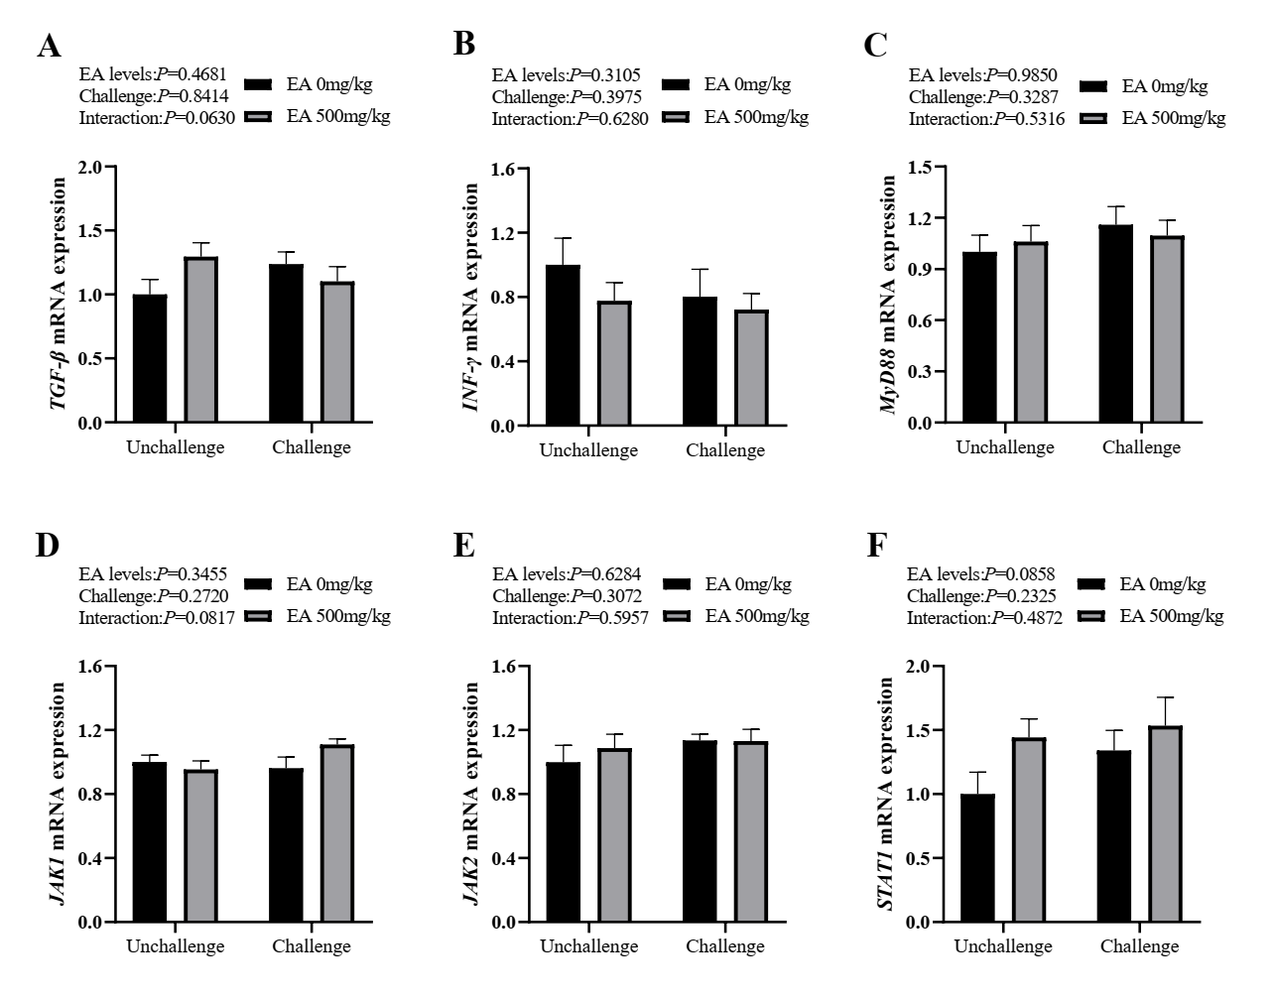
Fig. S1 Effect of C. perfringens challenge and dietary EA levels on relative mRNA expression of jejunal inflammation-related pathway and cytokine genes in jejunal mucosa of broilers at day 42. (A and B) The relative mRNA expressions of transforming growth factor-β (TGF-β) and interferon γ (IFN-γ). (C) The relative mRNA expression of myeloiddifferentiationfactor88 (MyD88). (D, E, and F) The relative mRNA expression of Janus kinase 1 (JAK1), Janus kinase 2 (JAK2), and signal transducers and activators of transcription 1 (STAT1). Unchallenged, birds without C. perfringens infection; challenged, birds with C. perfringens infection. Values are means (n = 6) with their standard errors represented by vertical bars.
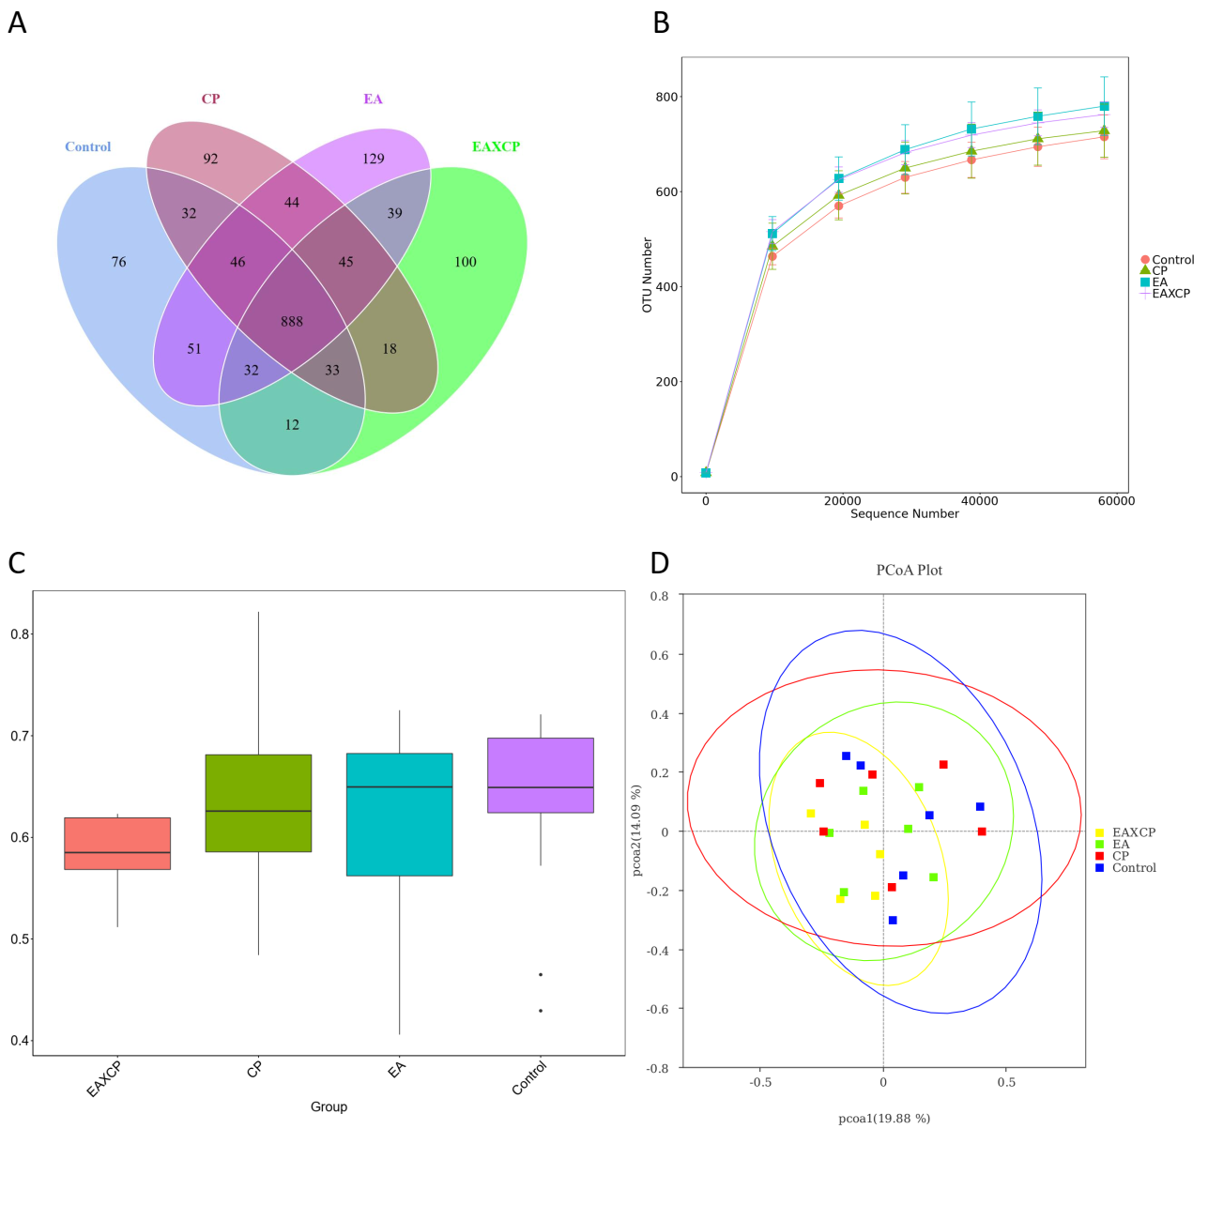
Fig. S2 The quality of sequencing data and beta diversity of cecal microbiota. (A) Venn diagram of the OTUs. (B) The rarefaction curve analysis of the microbial species. (C and D) Box plot and principal co-ordinates analysis (PCoA) plot of beta diversity. All values are expressed as the means (n=5 in EAXCP Group, n = 6 in the other three groups).

Fig.S3 The most abundant (top 10) phyla and genus of cecal microbiota. (A) The most abundant (top 10) phyla of cecal microbiota. (B) The most abundant (top 10) genus of cecal microbiota. (C, D, E, F, and G) The relative abundance of Firmicutes, Desulfobacterota, Campilobacterota, Elusimicrobia, and [Ruminococcus]_ torques_group.

