Additional File 1
Irradiation pretreatment enhances the therapeutic efficacy of platelet-membrane-
camouflaged antitumor nanoparticles
Yin Chen^{1#}, Xue Shen^{2#}, Songling Han¹, Tao Wang¹, Jianqi Zhao¹ , Yongwu He^{1, 3}, Shilei Chen¹, Shengqi Deng², Cheng Wang^{1*} and Junping Wang^{1*}
¹ State Key Laboratory of Trauma, Burns and Combined Injury, Institute of Combined Injury
of PLA, Chongqing Engineering Research Center for Nanomedicine, College of Preventive
Medicine, Third Military Medical University, Chongqing, 400038, China
² Sichuan Industrial Institute of Antibiotics, Chengdu University, Chengdu, 610106, China
³ College of Materials Science and Engineering, Hebei University of Engineering, Handan,
056038, China
# These authors contributed equally to this work.
* Corresponding authors.
Junping Wang, wangjunping@tmmu.edu.cn; Cheng Wang, wangctmmu@126.com.

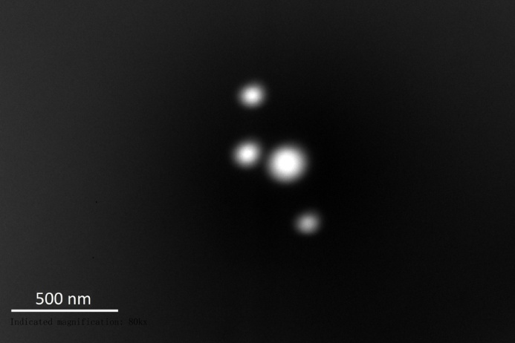
Additional File 1. TEM image of PINPs. The morphology of the PINPs was obtained by TEM (Tecnai G2 F20 U-TWIN, FEI, Hillsboro, OR, US). The scale is 500 nm.

