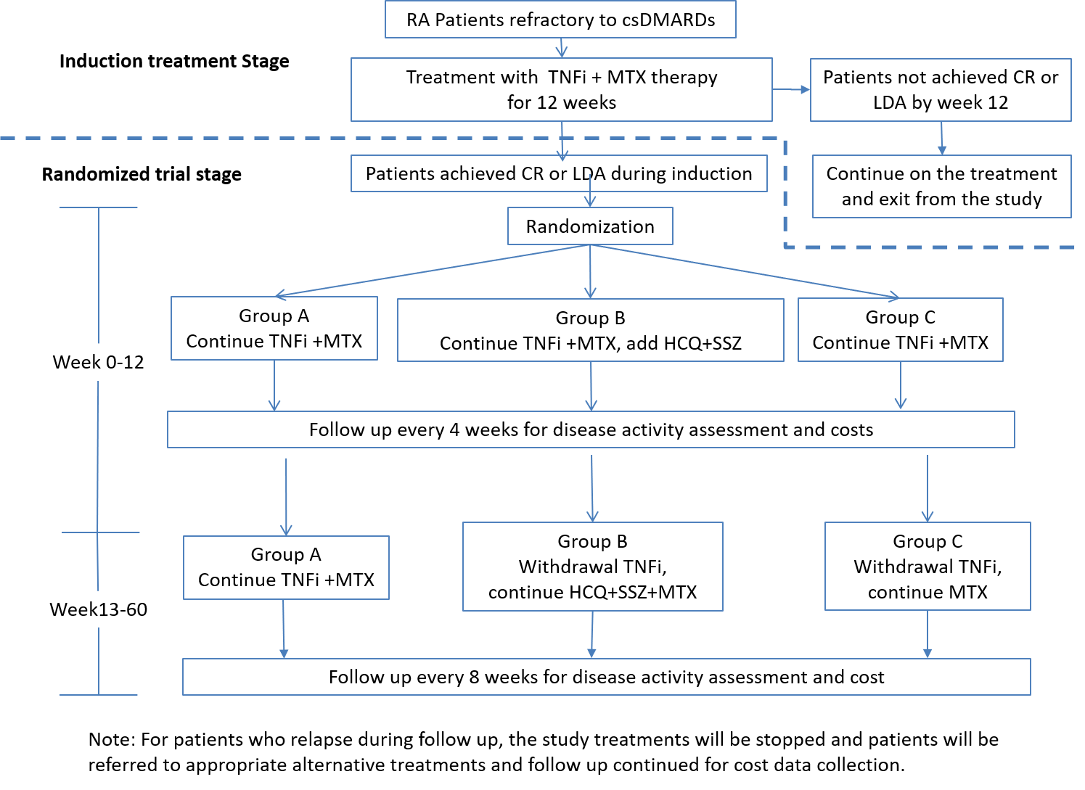
Figure S1. The flow-chart of the study.
Note: For patients who relapsed during follow up, the study treatment was stopped and patients were referred to appropriate alternative treatments and followed up for cost data collection. csDMARDs: conventional synthetic disease-modifying antirheumatic drugs; MTX: methotrexate; CR: clinical remission; LDA: low disease activity; HCQ: hydroxychloroquine; SSZ: sulfasalazine.

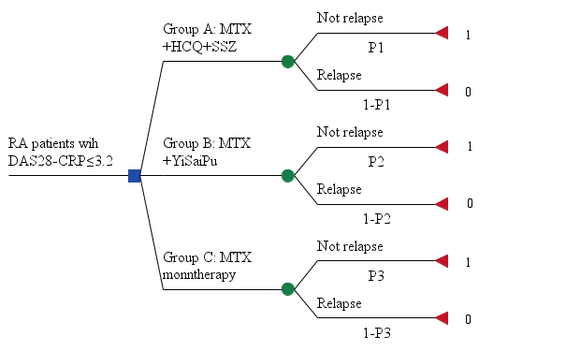
Figure S2. The decision tree model of the study. RA: Rheumatoid Arthritis; MTX: methotrexate; HCQ: hydroxychloroquine; SSZ: sulfasalazine.

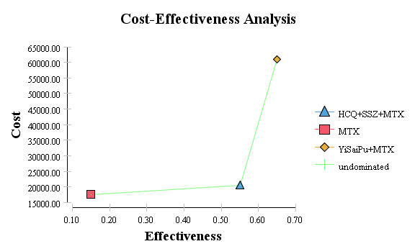
B

A

Figure S3. Direct cost-effectiveness analysis (A) and total cost-effectiveness analysis (B) . MTX: methotrexate; HCQ: hydroxychloroquine; SSZ: sulfasalazine.
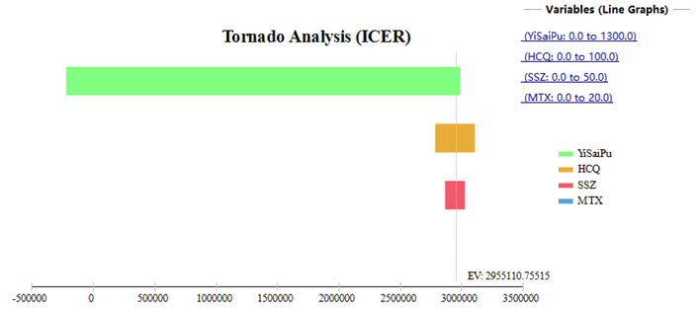
Figure S4. tornado chart of one-way sensitivity analysis of cost of each drug. MTX: methotrexate; HCQ: hydroxychloroquine; SSZ: sulfasalazine.

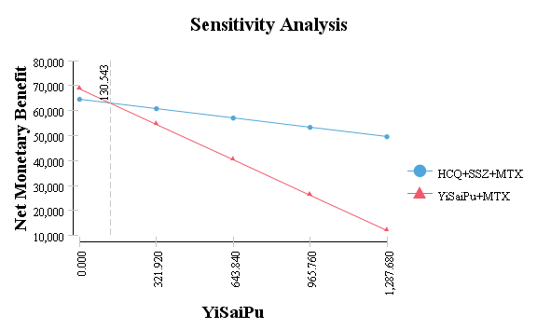
Figure S5. One-way sensitivity analysis of cost of TNFi of net monetary benefit of utility. MTX: methotrexate; HCQ: hydroxychloroquine; SSZ: sulfasalazine.
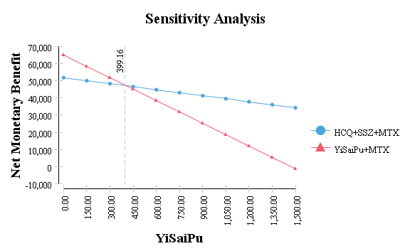
Figure S6. One-way sensitivity analysis of cost of YiSaiPu of net monetary benefit of effectiveness. MTX: methotrexate; HCQ: hydroxychloroquine; SSZ: sulfasalazine.

