Supplementary Material
Material and Methods
Ex vivo MRI
To minimize artifact on QSM maps, we selected three subjects with the least hemorrhage for ex vivo imaging. Before imaging, excess paraffin was subsequently cut away from each sample which was then removed from its embedding cassette using a scalpel (Supplementary figure 1-A). The sample was then placed on a 3D printed loading stage and lowered into a 20 mm NMR tube (Supplementary figure 1-B). The stage served the dual purpose of aiding the mobility of the sample in and out of the imaging tube, as well as acting as a buffer between the NMR tube glass and sample. The magnetic susceptibility of the sample was closer to that of the stage than the glass of the NMR tube, which served to limit MRI artifact during imaging. The tube was then placed into a larger 25-mm NMR tube (Supplementary figure 1-C, C) and subsequently inserted into a wide-bore vertical-bore 9.4T micro-imaging system (Bruker Inc.) through the stack at the top of the system (E). TurboRARE imaging was aquired with the follow parameters: TR = 2500 msec², TE= 30 msec, slice thickness = 0.5 mm, flip angle (FA) = 90, averages = 6. Additional imaging included 3D multiecho GRE (TR = 50 msec², TE= 1.58/2.89/4.2/5.51/6.82/8.13/9.44/10.75/12.06/13.37 msec, slice thickness = 0.2 mm, flip angle (FA) = 15, averages = 6).
To maintain the sample’s temperature a ~60ºC, the gradient insert was heated using the built-in water-based heater and was set to its warmest setting at 49ºC. The sample was further warmed by an additional heater water bath where the water was circulated in the gap between the 20 and 25-mm NMR tubes (D) around the sample using two peristaltic pumps at a rate of 200ml/min. Temperature of the water around the sample was monitored using a fiber-optic temperature sensor (Small Animal instruments Inc.). Temperature of water-bath was adjusted until the sample’s temperature stabilized at ~60ºC to ensure paraffin melt.
Supplementary figure 1. 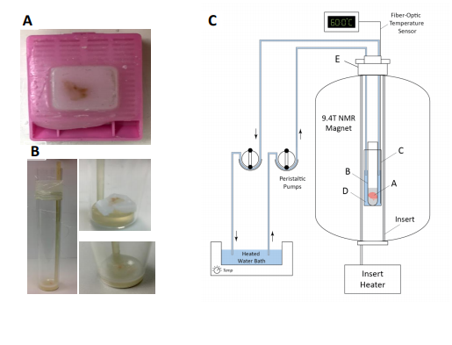

Table -1
Parameter (Unit) | Value
Requested pixel size | 0.3
Nuclear Parameters
Background radius (µm) | 8
Sigma | 1
Area (Min, Max) (µm²) | 10, 400
Intensity threshold | 0.12
Cell expansion (µm) | 3
DAB intensity threshold | variable

