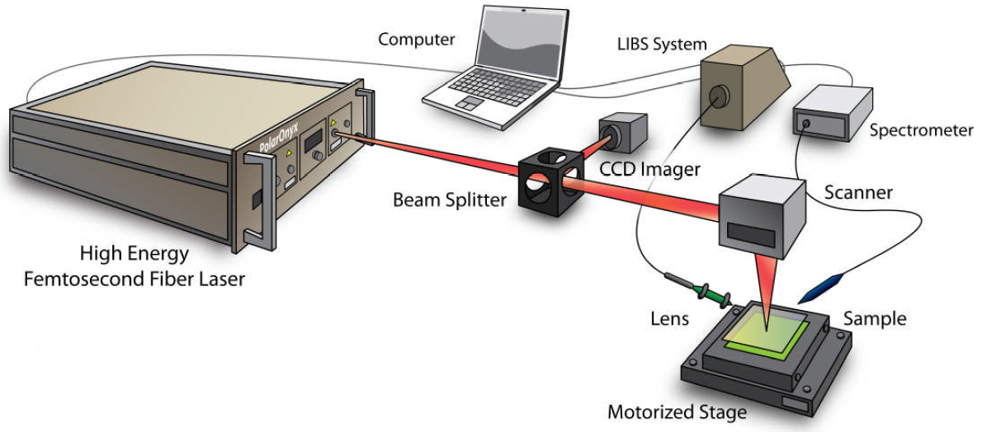
Supplementary Fig. 1. Schematic illustration of a femtosecond pulsed laser powder bed fusion additive manufacturing process ¹.

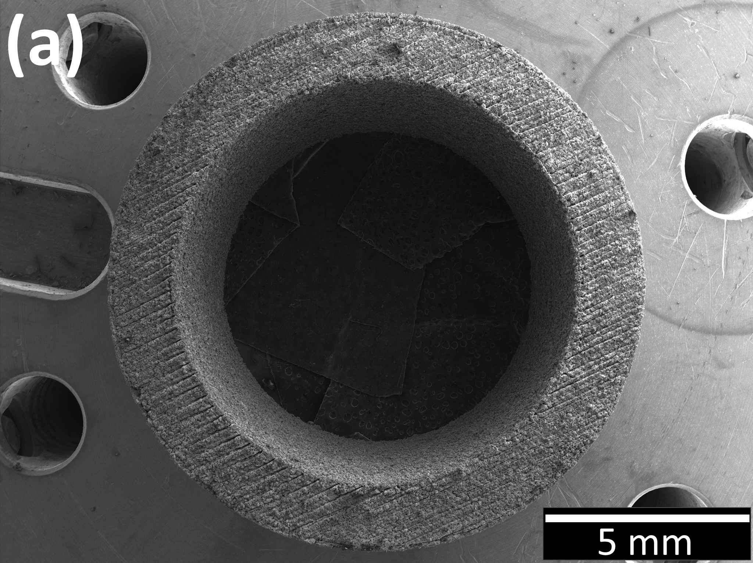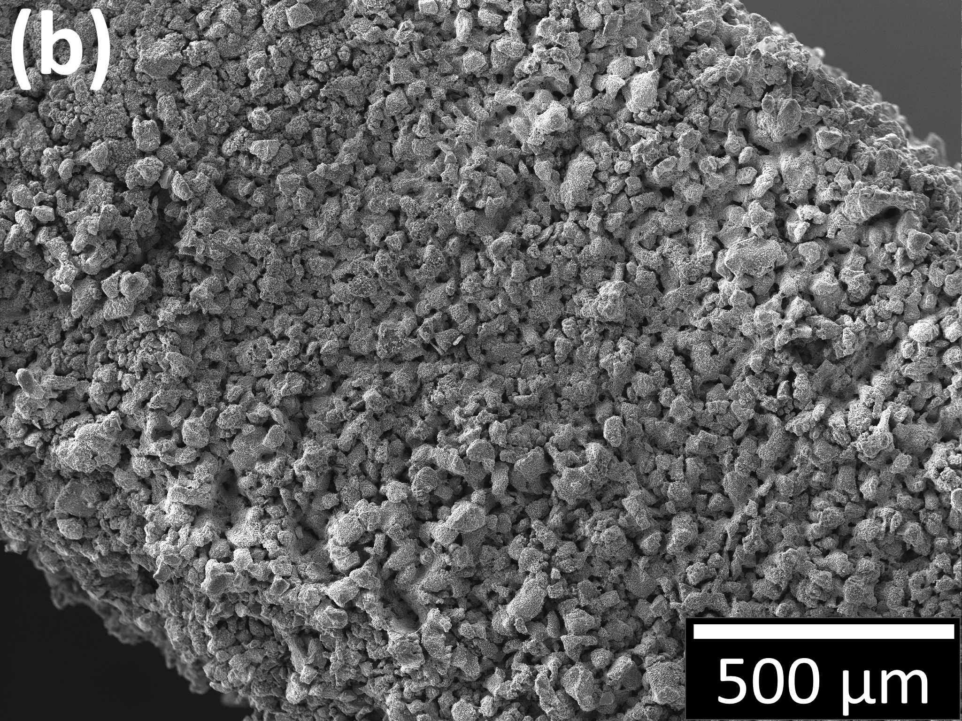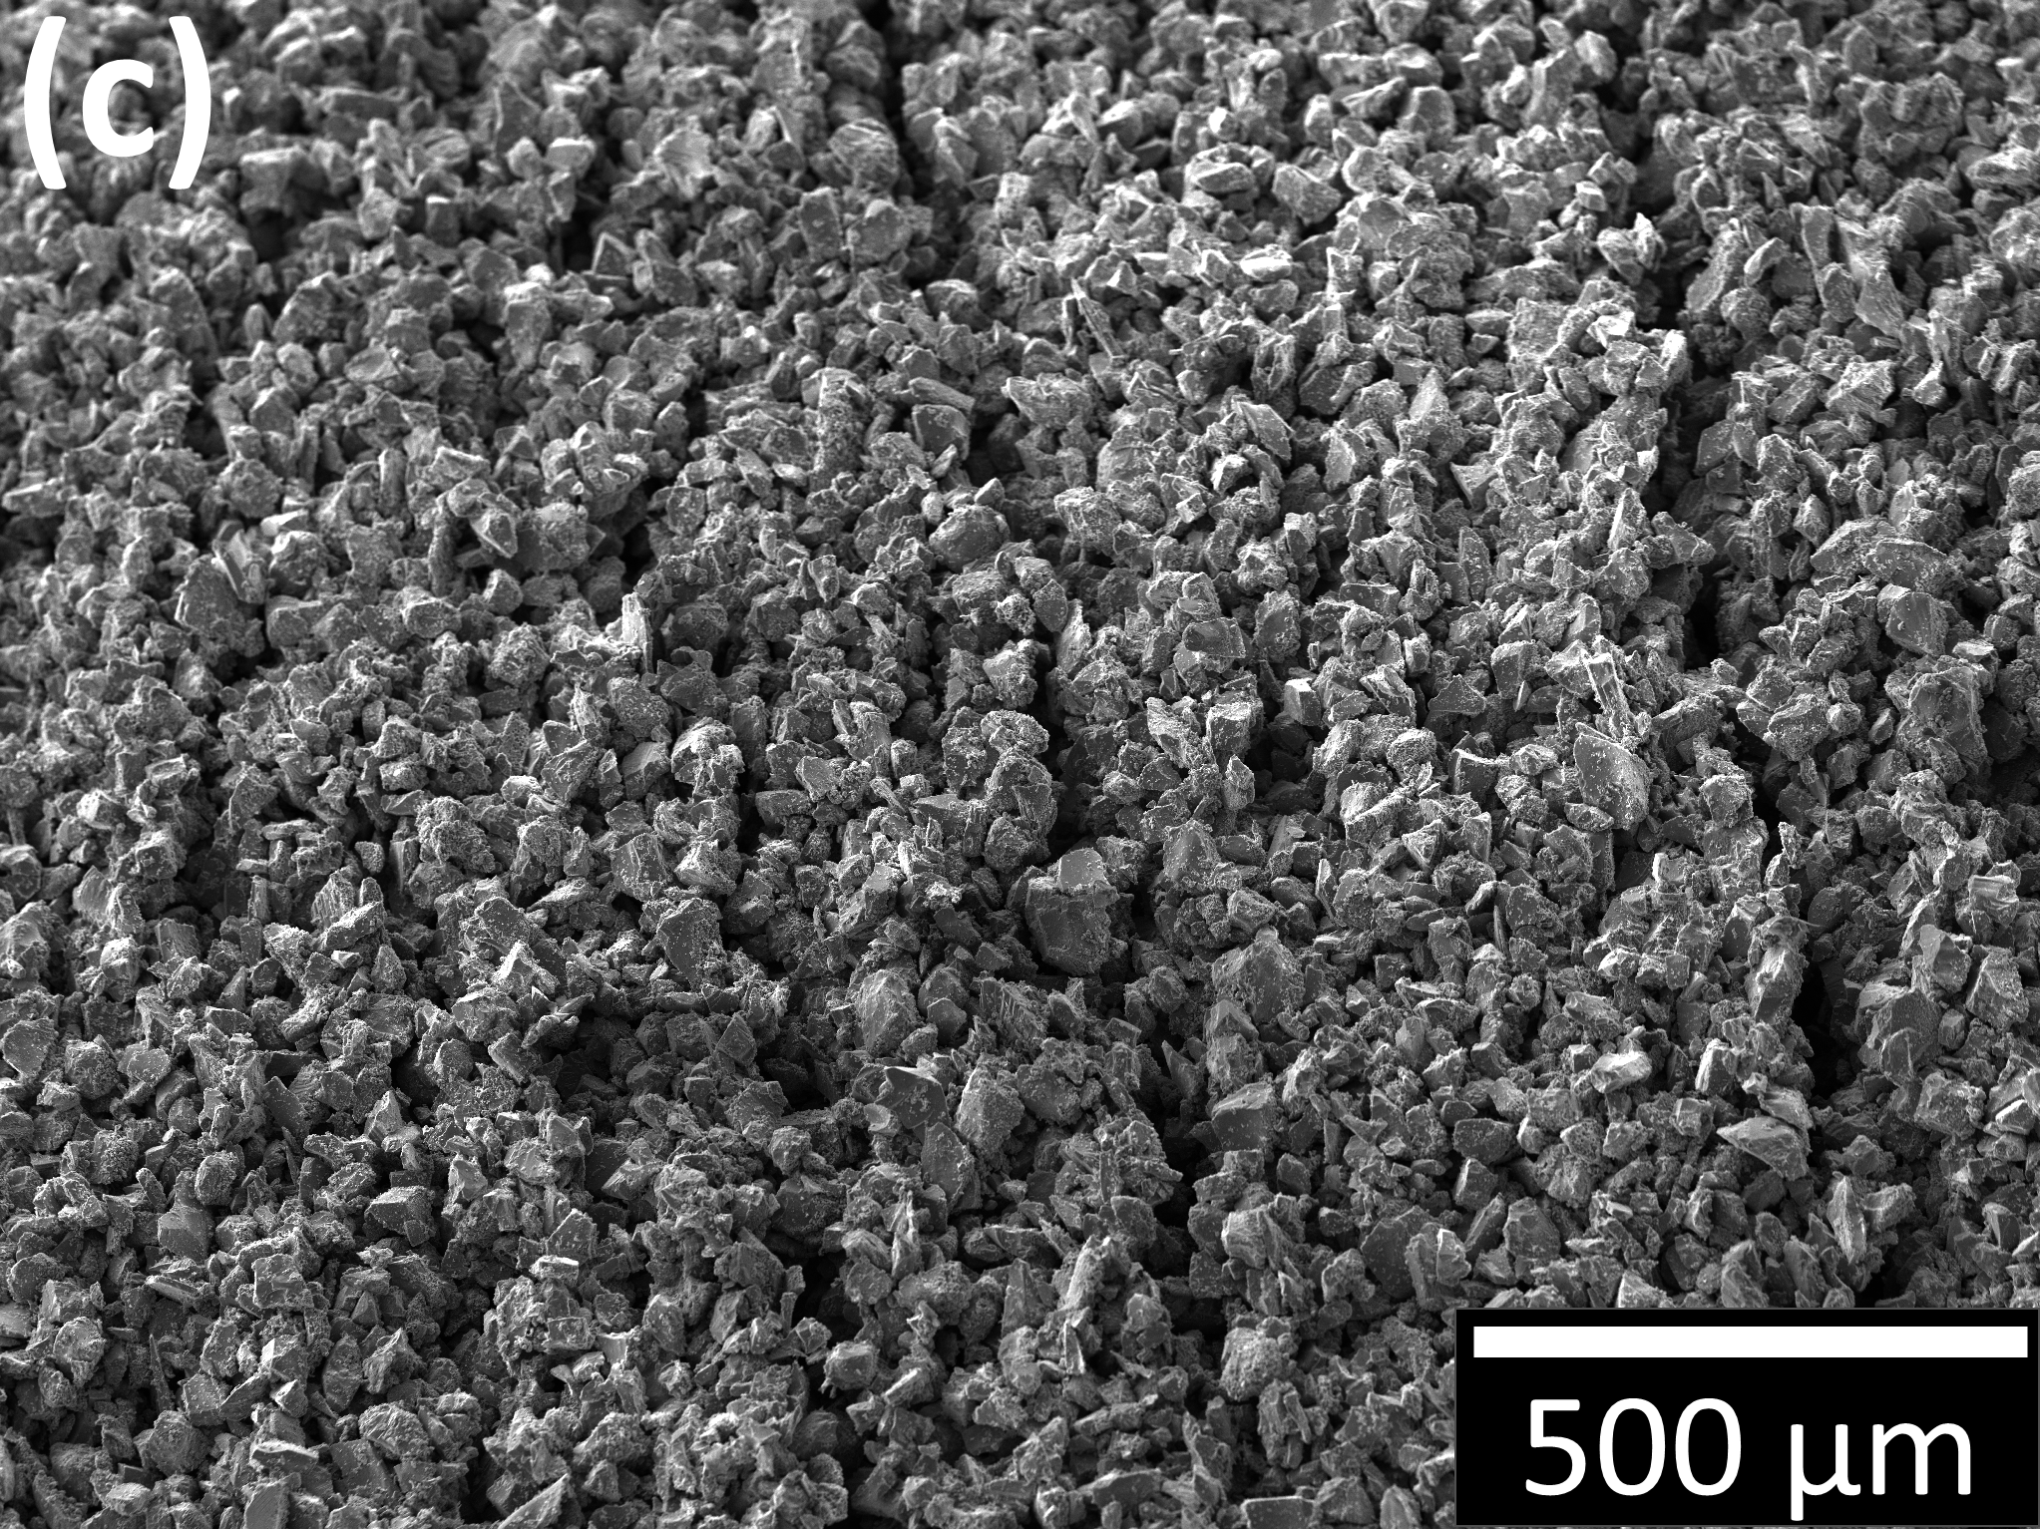
Supplementary Fig. 2. SEM images of a pulsed LPBF-sintered AM object, a SiC tube: (a) top view and (b) side view.

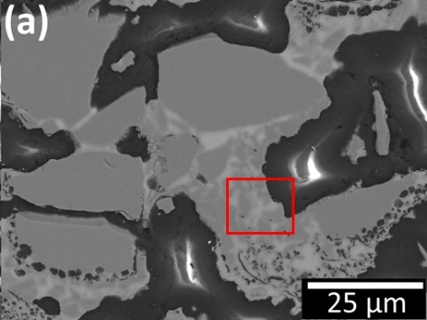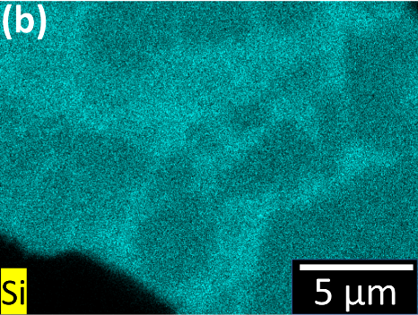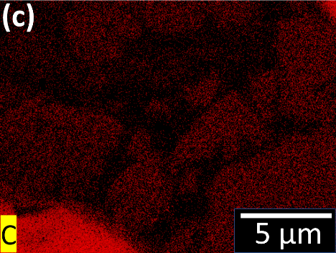
Supplementary Fig. 3. a SEM-BSE image of polished cross-section of laser-sintered part. Corresponding SEM-EDS maps of elemental distribution at higher magnification for b silicon and c carbon.
Supplementary Table 1. Different process parameter sets were used to fabricate 12 SiC tubes.
 | Print | Power Type | Laser Power [W] | Scanning Speed [mm/s]
A | 1 | 1 | 125 W |  | 200
 | 2 |  |  |  | 250
 | 3 |  |  |  | 300
B | 1 | 1 | 150 W |  | 200
 | 2 |  |  |  | 250
 | 3 |  |  |  | 300
C | 1 | 2 | 125 W |  | 200
 | 2 |  |  |  | 250
 | 3 |  |  |  | 300
D | 1 | 2 | 150 W |  | 200
 | 2 |  |  |  | 250
 | 3 |  |  |  | 300

Supplementary Table 2. A comparison of bulk densities and porosities determined by various techniques. Immersion density and bulk density were determined by the buoyancy method and the caliper method, respectively. The theoretical density of SiC (3.21 g/cm³) was assumed in deriving porosity.
Specimen  ID | Mass  [g] | Bulk Density [g/cm³] | Immersion Density [g/cm³] | Total Porosity  [%] | Open Porosity [%] | Closed Porosity [%]
A1 | 1.03 | 1.54 | 2.85 | 52.0 | 40.8 |  | 11.2
A2 | 1.05 | 1.53 | 2.83 | 52.3 | 40.4 |  | 11.8
A3 | 1.01 | 1.52 | 2.88 | 52.6 | 42.3 |  | 10.2
B1 | 1.03 | 1.58 | 2.82 | 50.7 | 38.6 |  | 12.1
B2 | 1.04 | 1.58 | 2.82 | 50.7 | 38.6 |  | 12.1
B3 | 0.95 | 1.58 | 2.87 | 50.7 | 40.1 |  | 10.5
C1 | 0.98 | 1.50 | 2.86 | 53.2 | 42.3 |  | 10.9
C2 | 0.98 | 1.53 | 2.85 | 52.3 | 41.1 |  | 11.2
C3 | 0.96 | 1.52 | 2.84 | 52.6 | 41.1 |  | 11.5
D1 | 0.97 | 1.61 | 2.88 | 49.8 | 39.5 |  | 10.2
D2 | 0.97 | 1.57 | 2.88 | 51.0 | 40.8 |  | 10.2
D3 | 0.98 | 1.58 | 2.84 | 50.7 | 39.2 |  | 11.5

1. Retrived from Polaronyx. http://www.polaronyx.com/applications.php.

