Fig. S1. Germination rate (%) with respect to time (h).

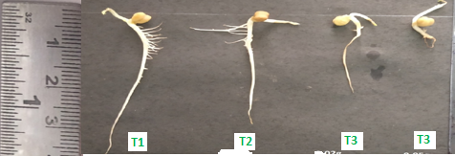
Fig. S2. Variation of root and shoot length after 10 days.

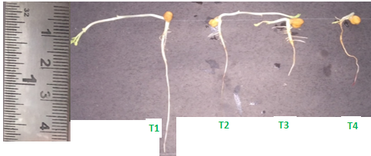
Fig. S3. Variation of root and shoot length after 15 days.

Fig. S4. Root morphology under different treatments.

