Supplementary Information

Direct detection of coupled proton and electron transfers in human manganese superoxide dismutase

Jahaun Azadmanesh,¹ William E. Lutz,² Leighton Coates,^{3,} Kevin L. Weiss,⁴ and Gloria E. O. Borgstahl^{1,2}

¹Department of Biochemistry and Molecular Biology, 985870 Nebraska Medical Center, Omaha, NE 68198-5870, USA
²Eppley Institute for Cancer and Allied Diseases, 986805 Nebraska Medical Center, Omaha, NE 68198-6805, USA
³Second Target Station, Oak Ridge National Laboratory, 1 Bethel Valley Road, Oak Ridge, TN 37831, USA
⁴Neutron Scattering Division, Oak Ridge National Laboratory, 1 Bethel Valley Road, Oak Ridge, TN 37831, USA

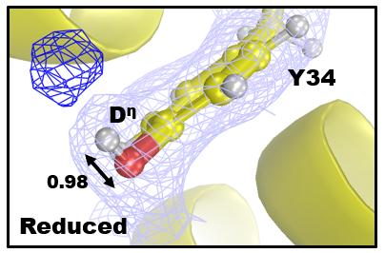
Figure S1. Residual density for the hydroxyl group of Tyr34 in Mn²⁺SOD of chain B. Light blue 2|F_{o}|-|F_{c}| nuclear density displayed at 1.0 σ. Dark blue omit |F_{o}|-|F_{c}| difference density is displayed at 2.0 σ. Bond length in Å is given.

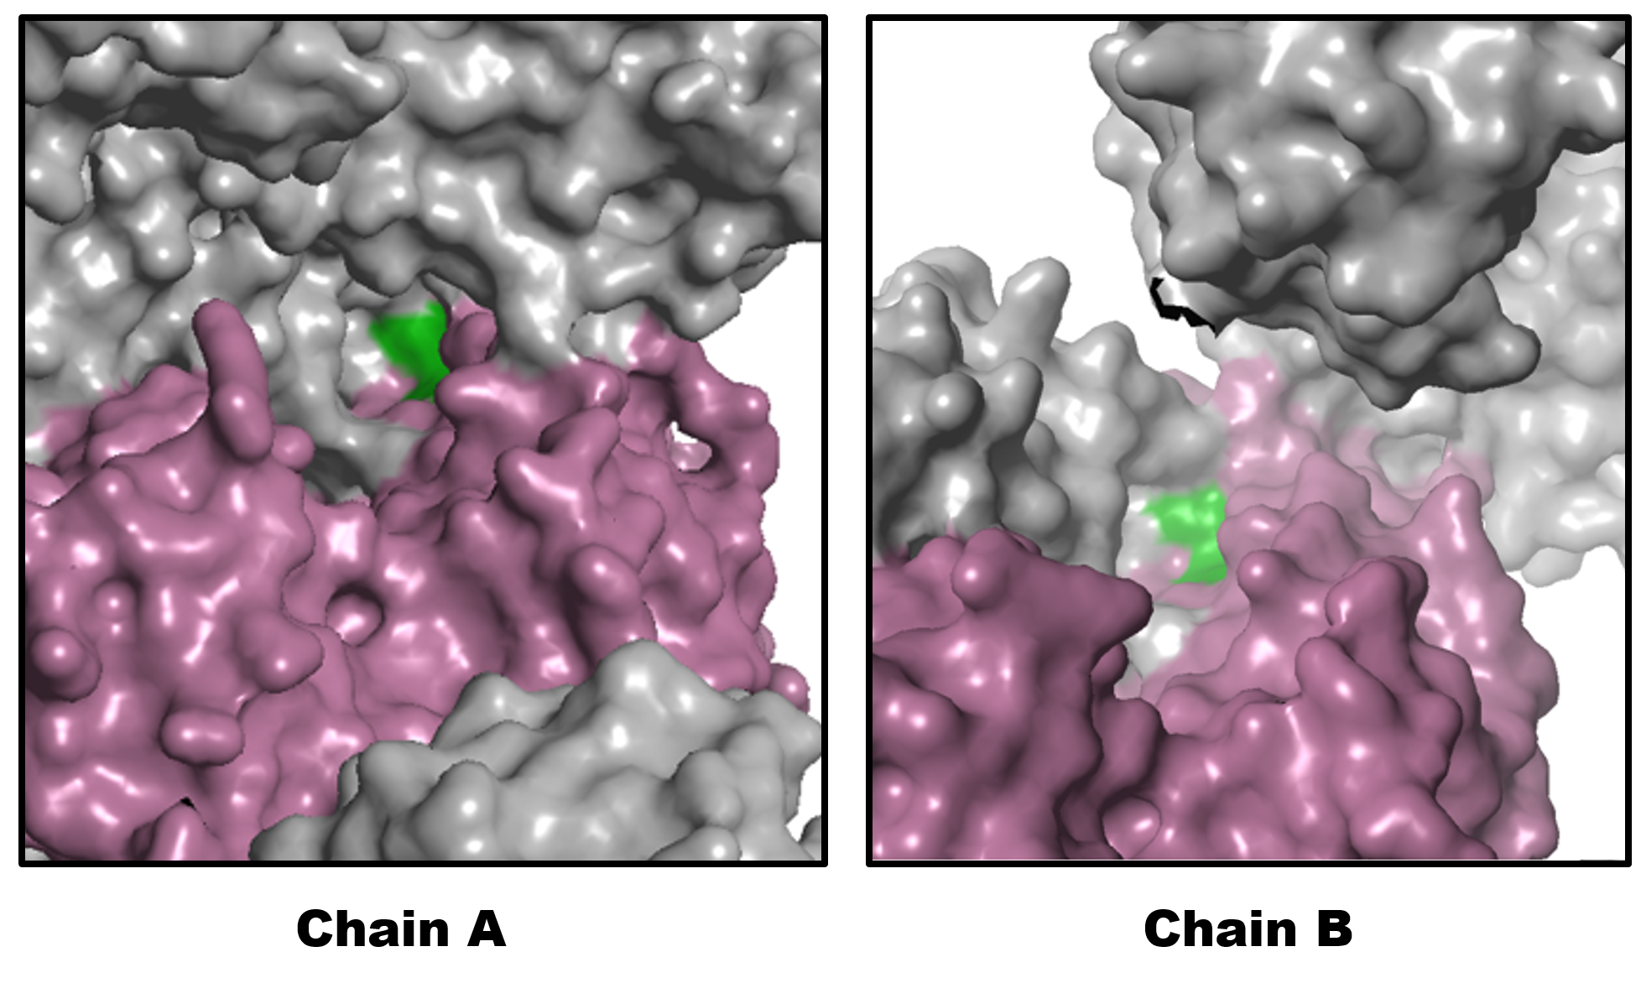
Figure S2. Solvent accessibility differences between chains of the asymmetric AB dimer for P6₁22 MnSOD. Magenta depicts the surfaces of the chain for the asymmetric unit and green depicts the surfaces leading to the active site of the chain. Grey depicts the surfaces of symmetry generated asymmetric AB dimers.

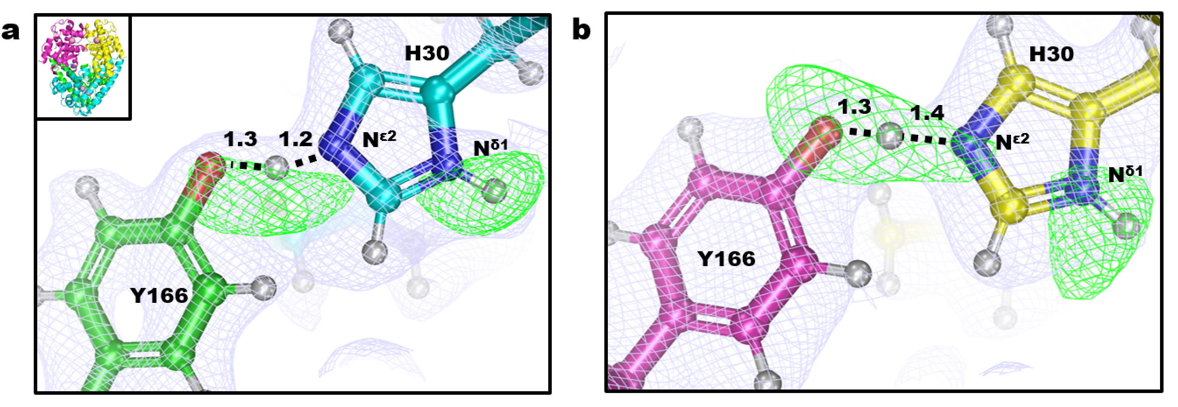
Figure S3. Protonation states of His30 and Tyr166 for Mn²⁺SOD. Light blue 2|F_{o}|-|F_{c}| nuclear density displayed at 1.0 σ. Green omit |F_{o}|-|F_{c}| difference density is displayed at 2.5 σ. The inset of (a) shows the tetrameric assembly. Numbers are distances in Å.

Table S1. Gln143 bonding character from CLPO analysis. Numbers are calculated bond order.
 | Five-Coordinate Mn³⁺  Y166(-)H30(ε)Y34(-) | Five-Coordinate Mn³⁺  Y166(H)H30(δ)Y34(-) | Six-Coordinate Mn²⁺  Y166(H)H30(δ)Y34(-) | Five-Coordinate Mn²⁺  Y166(H)H30(δ)Y34(H)
N^{ε2}-C^{ε1} | 1.36 | 1.37 | 1.56 | 1.52
O^{ε1}-C^{ε1} | 1.45 | 1.45 | 1.30 | 1.33

Table S2. Charge and energy interactions of donor-acceptor CLPO analysis.
Trp123 N^{ε1} Lone Pair → Trp123 C^{ε2}-C^{δ2} π*-bond
State | Donor Occupancy  (e⁻) | Charge Transfer (e⁻) | Acceptor Occupancy (e⁻) | Energy Stabilization (kcal/mol)
Five-Coordinate Mn²⁺  Y166(H)H30(δ)Y34(H) | 1.58 | 0.15 | 0.52 | ↓ 13.52
Gln143 N^{ε2} Lone pair → WAT1 O-H σ*-bond
State | Donor Occupancy  (e⁻) | Charge Transfer (e⁻) | Acceptor Occupancy (e⁻) | Energy Stabilization (kcal/mol)
Six-Coordinate Mn²⁺  Y166(H)H30(δ)Y34(-) | 1.81 | 0.14 | 0.15 | ↓ 0.46
Five-Coordinate Mn²⁺  Y166(H)H30(δ)Y34(H) | 1.78 | 0.17 | 0.18 | ↓ 1.39

Table S3. Percent covalence of shared hydrogen atoms in SSHBs bonds from CLPO analysis.
 | Five-Coordinate Mn³⁺  Y166(-)H30(ε)Y34(-) |  | Five-Coordinate Mn³⁺  Y166(H)H30(δ)Y34(-) |  | Six-Coordinate Mn²⁺  Y166(H)H30(δ)Y34(-) |  | Five-Coordinate Mn²⁺  Y166(H)H30(δ)Y34(H)
(Gln143)N^{ε2}-H-O(WAT1) | N^{ε2} | O | N^{ε2} | O | N^{ε2} | O | N^{ε2} | O
 | 0.92 | 0.08 | 0.92 | 0.08 | 0.29 | 0.71 | 0.36 | 0.64
(Tyr166)O^{η}-H-N^{ε2}(His30) | O^{η} | N^{ε2} | O^{η} | N^{ε2} | O^{η} | N^{ε2} | O^{η} | N^{ε2}
 | 0.20 | 0.80 | 0.77 | 0.23 | 0.76 | 0.24 | 0.79 | 0.21
(Tyr34)O^{η}-H-O(WAT2) | O^{η} | O | O^{η} | O | O^{η} | O | O^{η} | O
 | 0.15 | 0.85 | 0.23 | 0.77 | 0.20 | 0.80 | 0.90 | 0.10
(His30)N^{δ1}-H-O(WAT2) | N^{δ1} | O | N^{δ1} | O | N^{δ1} | O | N^{δ1} | O
 | 0.14 | 0.86 | 0.89 | 0.11 | 0.88 | 0.12 | 0.92 | 0.08

Table S4. Active Site Bond Lengths of MnSOD Neutron Structures
 | Mn³⁺SOD |  | Mn²⁺SOD
Mn Covalent Bonds (Å) | A | B | A | B
Mn-N^{ε2}(H26) | 2.07 | 2.07 | 2.26 | 2.10
Mn-N^{ε2}(H74) | 2.13 | 2.12 | 2.19 | 2.25
Mn-O^{ε2}(D159) | 1.95 | 1.94 | 2.44 | 2.15
Mn-N^{ε2}(H163) | 2.06 | 2.14 | 2.23 | 2.21
Mn-O(WAT1) | 1.78 | 1.76 | 2.12 | 2.22
Mn-O(OL) | - | - | 1.82 | -

Table S5. Data collection and refinement statistics
Data Collection Statistics
 | Neutron |  | X-ray
 | Oxidized | Reduced | Oxidized | Reduced
PDB Code | 7KKS | 7KKW | 7KKU | 7KLB
Diffraction Source | MaNDi |  | Rigaku FR-E SuperBright
Temperature (K) | 296
Space group | P6₁22
a, b, c (Å) | 81.30, 81.30, 241.840 | 81.33, 81.33, 242.880 | 81.14, 81.14, 241.63 | 81.13, 81.13, 242.12
α, β, γ (°) | 90, 90, 120
Wavelengths (Å) | 2-4 |  | 1.5418
No. of images | 8 | 8 | 180 | 280
Exposure time | 48 h | 48 h | 60 s | 60 s
No. of unique reflections | 24556 | 21719 | 31815 | 25718
Total No. of reflections | 196496 | 155817 | 248673 | 194364
Resolution range (Å) | 14.64-2.20 (2.28-2.20) | 14.65-2.30 (2.38-2.30) | 50.00-2.02 (2.07-2.02) | 50.00-2.16 (2.20-2.16)
Multiplicity | 8.0 (6.1) | 7.2 (5.7) | 7.8 (3.5) | 7.6 (4.1)
I/σ(I) | 7.0 (3.40) | 6.2 (3.3) | 8.3 (2.0) | 4.8 (2.0)
R_{merge} | 0.284 (0.314) | 0.277 (0.294) | - | -
R_{meas} | - | - | 0.291 (0.610) | .459 (.683)
CC _{1/2} | 0.935 (0.275) | 0.943 (0.319) | 0.950 (0.730) | 0.804 (0.638)
R_{pim} | 0.101 (0.129) | 0.102 (0.124) | 0.082 (0.320) | 0.140 (0.326)
Data completeness (%) | 98.83 (98.83) | 98.94 (99.16) | 100.0 (100.0) | 97.5 (95.5)
Refinement Statistics
R_{work} | 0.2565 | 0.2493 | 0.2166 | 0.2075
R_{free} | 0.2817 | 0.3021 | 0.2517 | 0.2544
No. of atoms  Protein including D  Solvent  Mn | 6606  6228  376  2 | 6556  6222  332  2 | 3291  3162  127  2 | 3284  3168  98  2
R.m.s. deviations  Bond lengths (Å)  Bond angles (°) | 0.093  0.78 | 0.092  0.64 | 0.002  0.47 | 0.006  0.98
Average B-factor  Protein  Water  Mn | 33.62  30.51  25.3 | 30.57  29.19  23.53 | 28.23  30.64  17.00 | 33.82  31.91  24.30

Supplementary Methods
Data processing and refinement. X-ray refinement was performed by removing all non-protein entities in the starting model of 5VF9¹, simple molecular replacement through rigid-body refinement, and subsequent restrained-positional refinement. With COOT², the protein model was manually fit into |F_{o}|-|F_{c}| peaks as needed and refined first. New solvent structure and Mn atoms were manually modeled into |F_{o}|-|F_{c}| density. As D atoms were manually added during iterations of neutron refinement, the stereochemistry weight scale was manually adjusted due to the increased number of atoms at sensitive stereochemical positions. Loose Mn-coordination restraints were derived from the Mn²⁺SOD X-ray structure and applied to the Mn²⁺SOD neutron model, whereas the Mn³⁺SOD neutron model used restraints derived from our own DFT calculations. In both cases, the R-free value was improved with the application of these restraints.
Computational Details. Computations from the NWChem 6.8 software package utilized an extra-fine integration grid quadrature known to provide high precision with restricted open-shell John-Sham (ROKS) treatment³⁻⁵. The geometry optimizations implemented the B3LYP exchange-correlation functional dispersion corrected according to Becke and Johnson damping (DFT-D3-BJ)^{6,7}. Optimizations were first performed in the gas phase until electron density converged to an energy difference of < 0.0627 kcal/mol between macro iterations. A less strict threshold was used for the solution phase due to its significant increase in computational load. There was no notable difference when optimizations began directly in the solution phase other than longer computational times. The nearest three water molecules found in the neutron structure counterparts, representative of the ordered solvent found at the active site, were included in the QM models in addition to the Mn-ligated solvent.
Solvation model. The COSMO solvation model treats solvent as an implicit dielectric continuum (i.e. many solvent molecules need not be explicitly modeled in the QM system). The charge distribution of the continuum is derived using a scaled-conductor boundary condition between the cavity surface and solvent⁸. The inclusion of several explicit solvent molecules in combination with an implicit solvent model to model explicitly known hydrogen bonds increases the accuracy of energy calculations⁹. In the case of the present QM system, the explicit water molecules utilized are representative of the ordered solvent found experimentally in the neutron structures and other published X-ray structures¹.

References
1 Azadmanesh, J., Trickel, S. R. & Borgstahl, G. E. O. Substrate-analog binding and electrostatic surfaces of human manganese superoxide dismutase. J. Struct. Biol. 199, 68-75, doi:10.1016/j.jsb.2017.04.011 (2017).
2 Emsley, P. & Cowtan, K. Coot: model-building tools for molecular graphics. Acta Cryst. D 60, 2126-2132, doi:10.1107/S0907444904019158 (2004).
3 Papas, B. N. & Schaefer III, H. F. Concerning the precision of standard density functional programs: Gaussian, Molpro, NWChem, Q-Chem, and Gamess. Comput. Theor. Chem. 768, 175-181 (2006).
4 Wheeler, S. E. & Houk, K. N. Integration Grid Errors for Meta-GGA-Predicted Reaction Energies: Origin of Grid Errors for the M06 Suite of Functionals. J. Chem. Theory Comput. 6, 395-404, doi:10.1021/ct900639j (2010).
5 Valiev, M. et al. NWChem: A comprehensive and scalable open-source solution for large scale molecular simulation. Comput. Phys. Commun. 181, 1477-1489 (2010).
6 Grimme, S., Ehrlich, S. & Goerigk, L. Effect of the damping function in dispersion corrected density functional theory. J. Comput. Chem. 32, 1456-1465, doi:10.1002/jcc.21759 (2011).
7 Becke, A. D. Becke's three parameter hybrid method using the LYP correlation functional. J. Chem. Phys. 98, 5648 (1993).
8 Klamt, A. Conductor-like Screening Model for Real Solvents: A New Approach to the Quantitative Calculation of Solvation Phenomena. J. Phys. Chem. 99, 2224-2235 (1995).
9 Zhang, S., Baker, J. & Pulay, P. A reliable and efficient first principles-based method for predicting pK(a) values. 1. Methodology. J. Phys. Chem. A 114, 425-431, doi:10.1021/jp9067069 (2010).

