Figure S6 Synteny analysis of HMs genes between each gramineae specie and rice
Figure S6-1 Synteny analysis of HMs genes between T. aestivum and rice

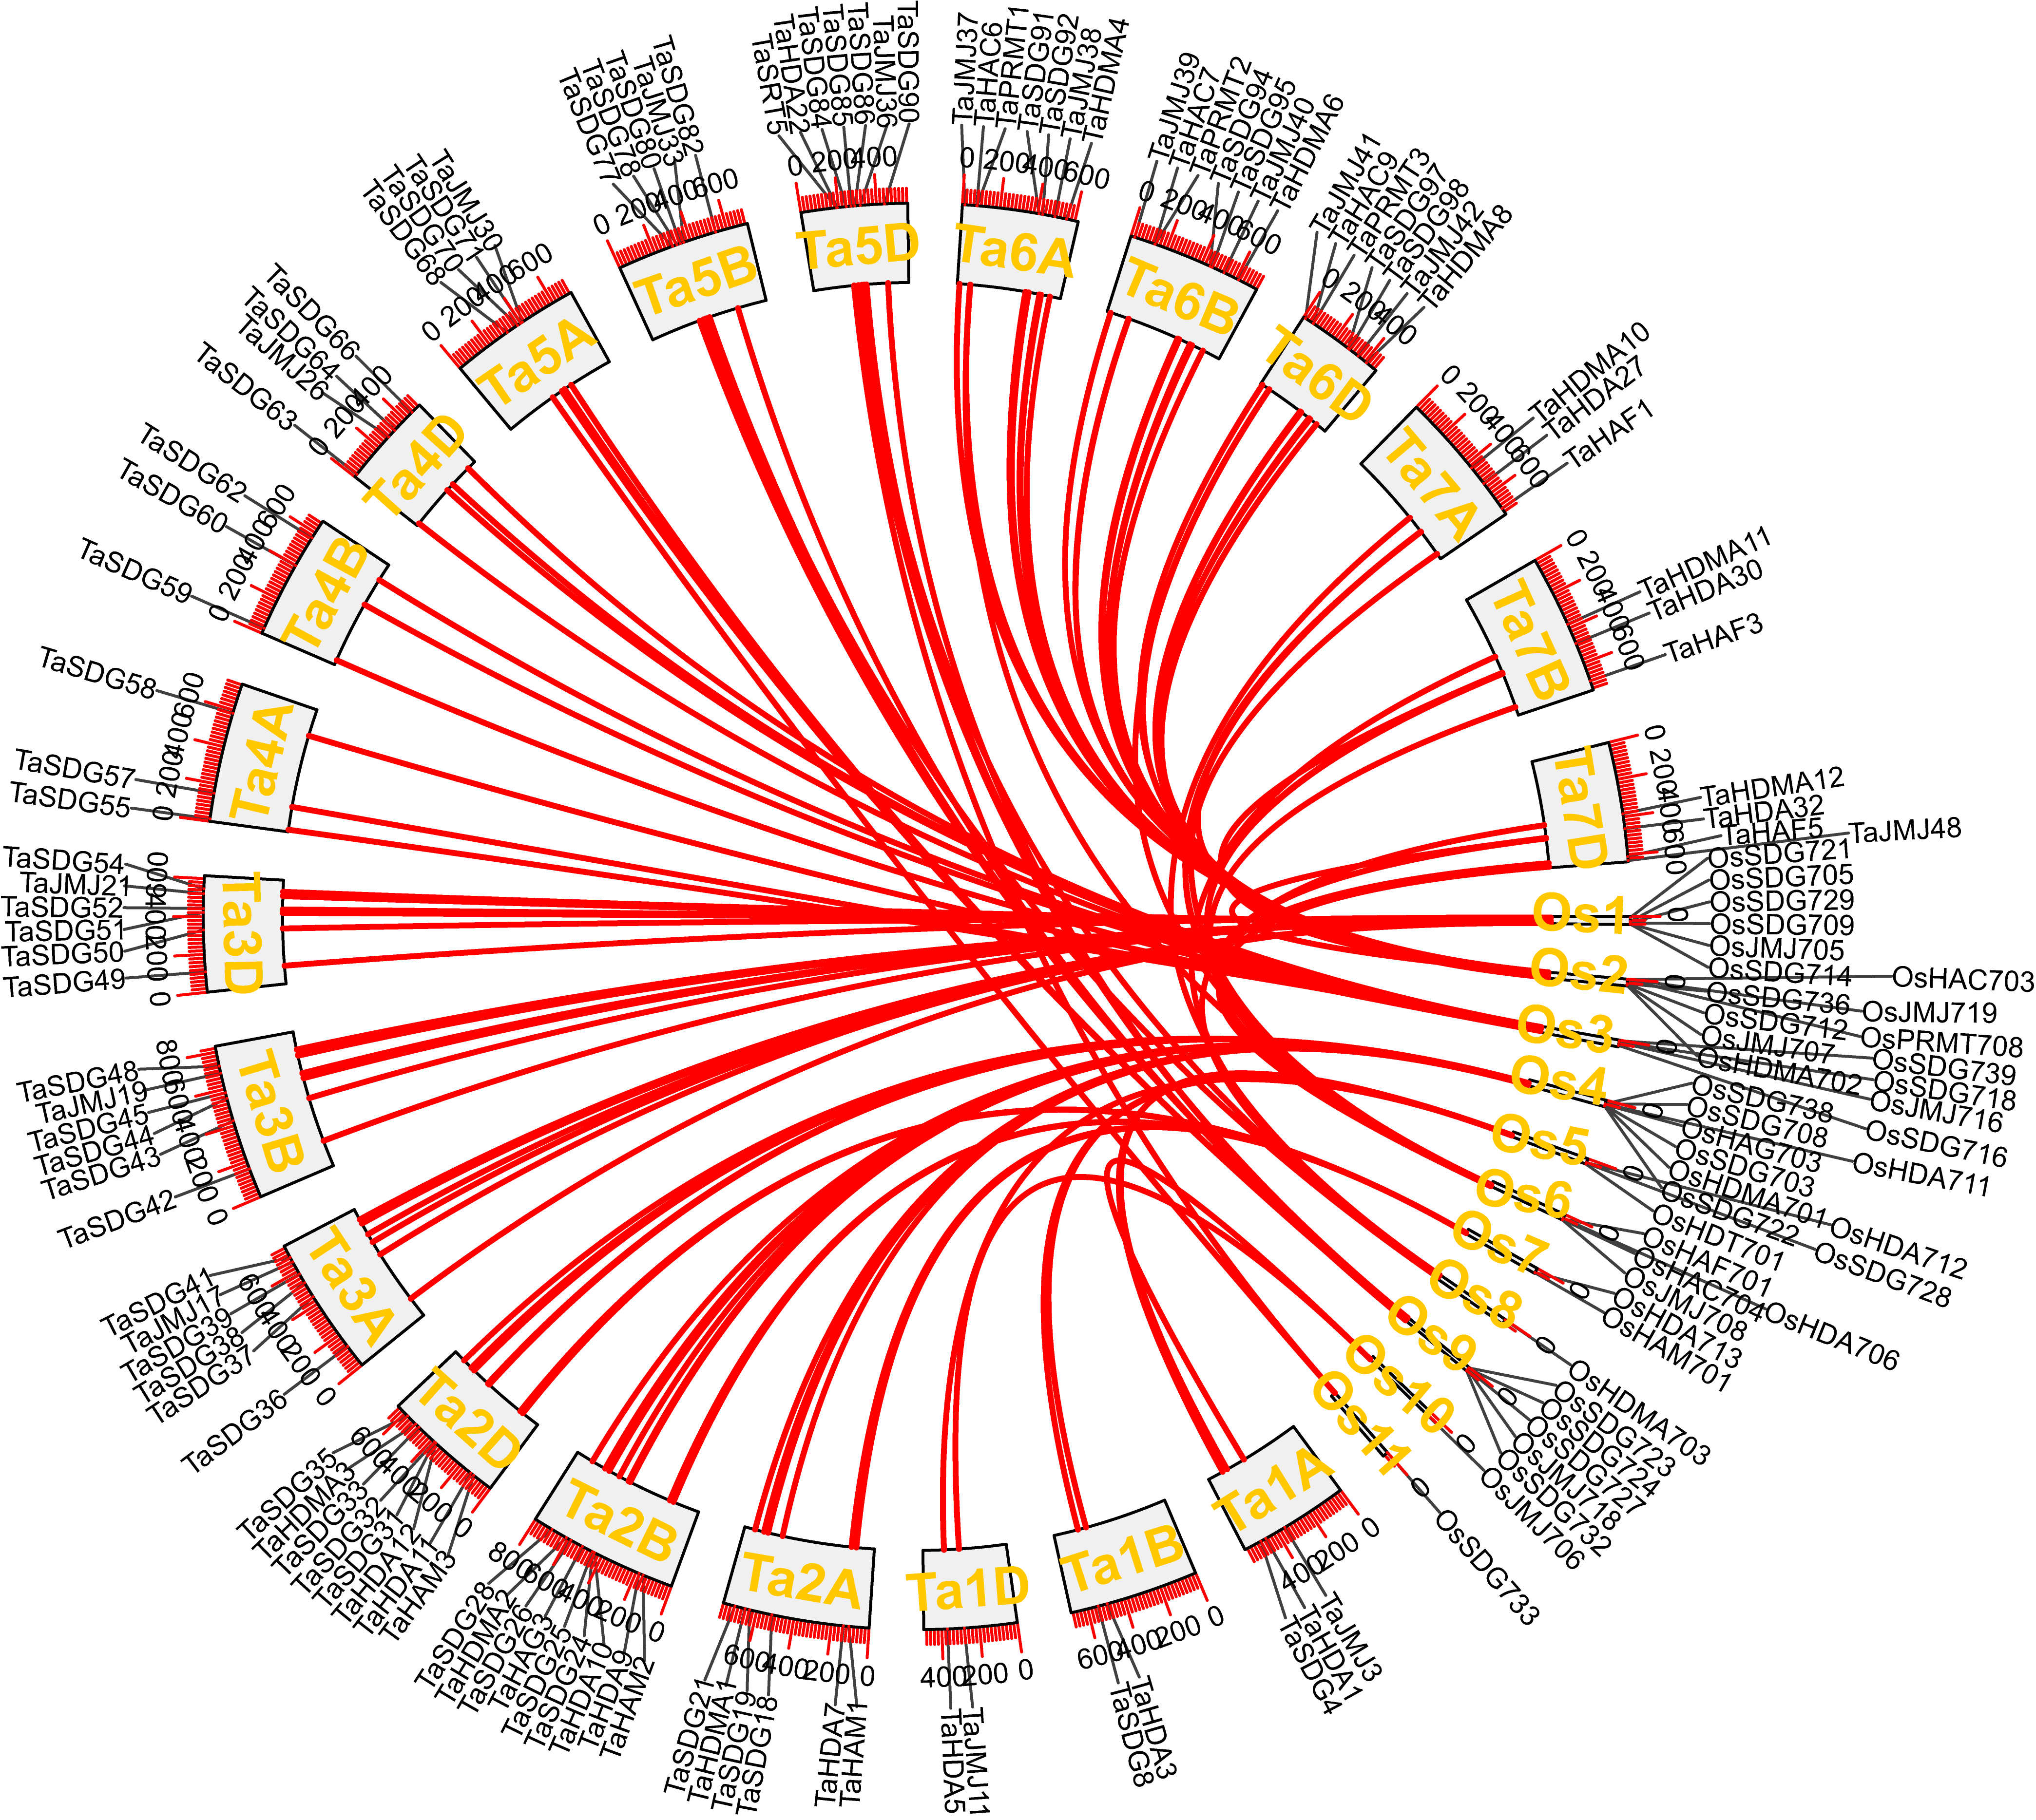

Figure S6-2 Synteny analysis of HMs genes between H. vulgare and rice
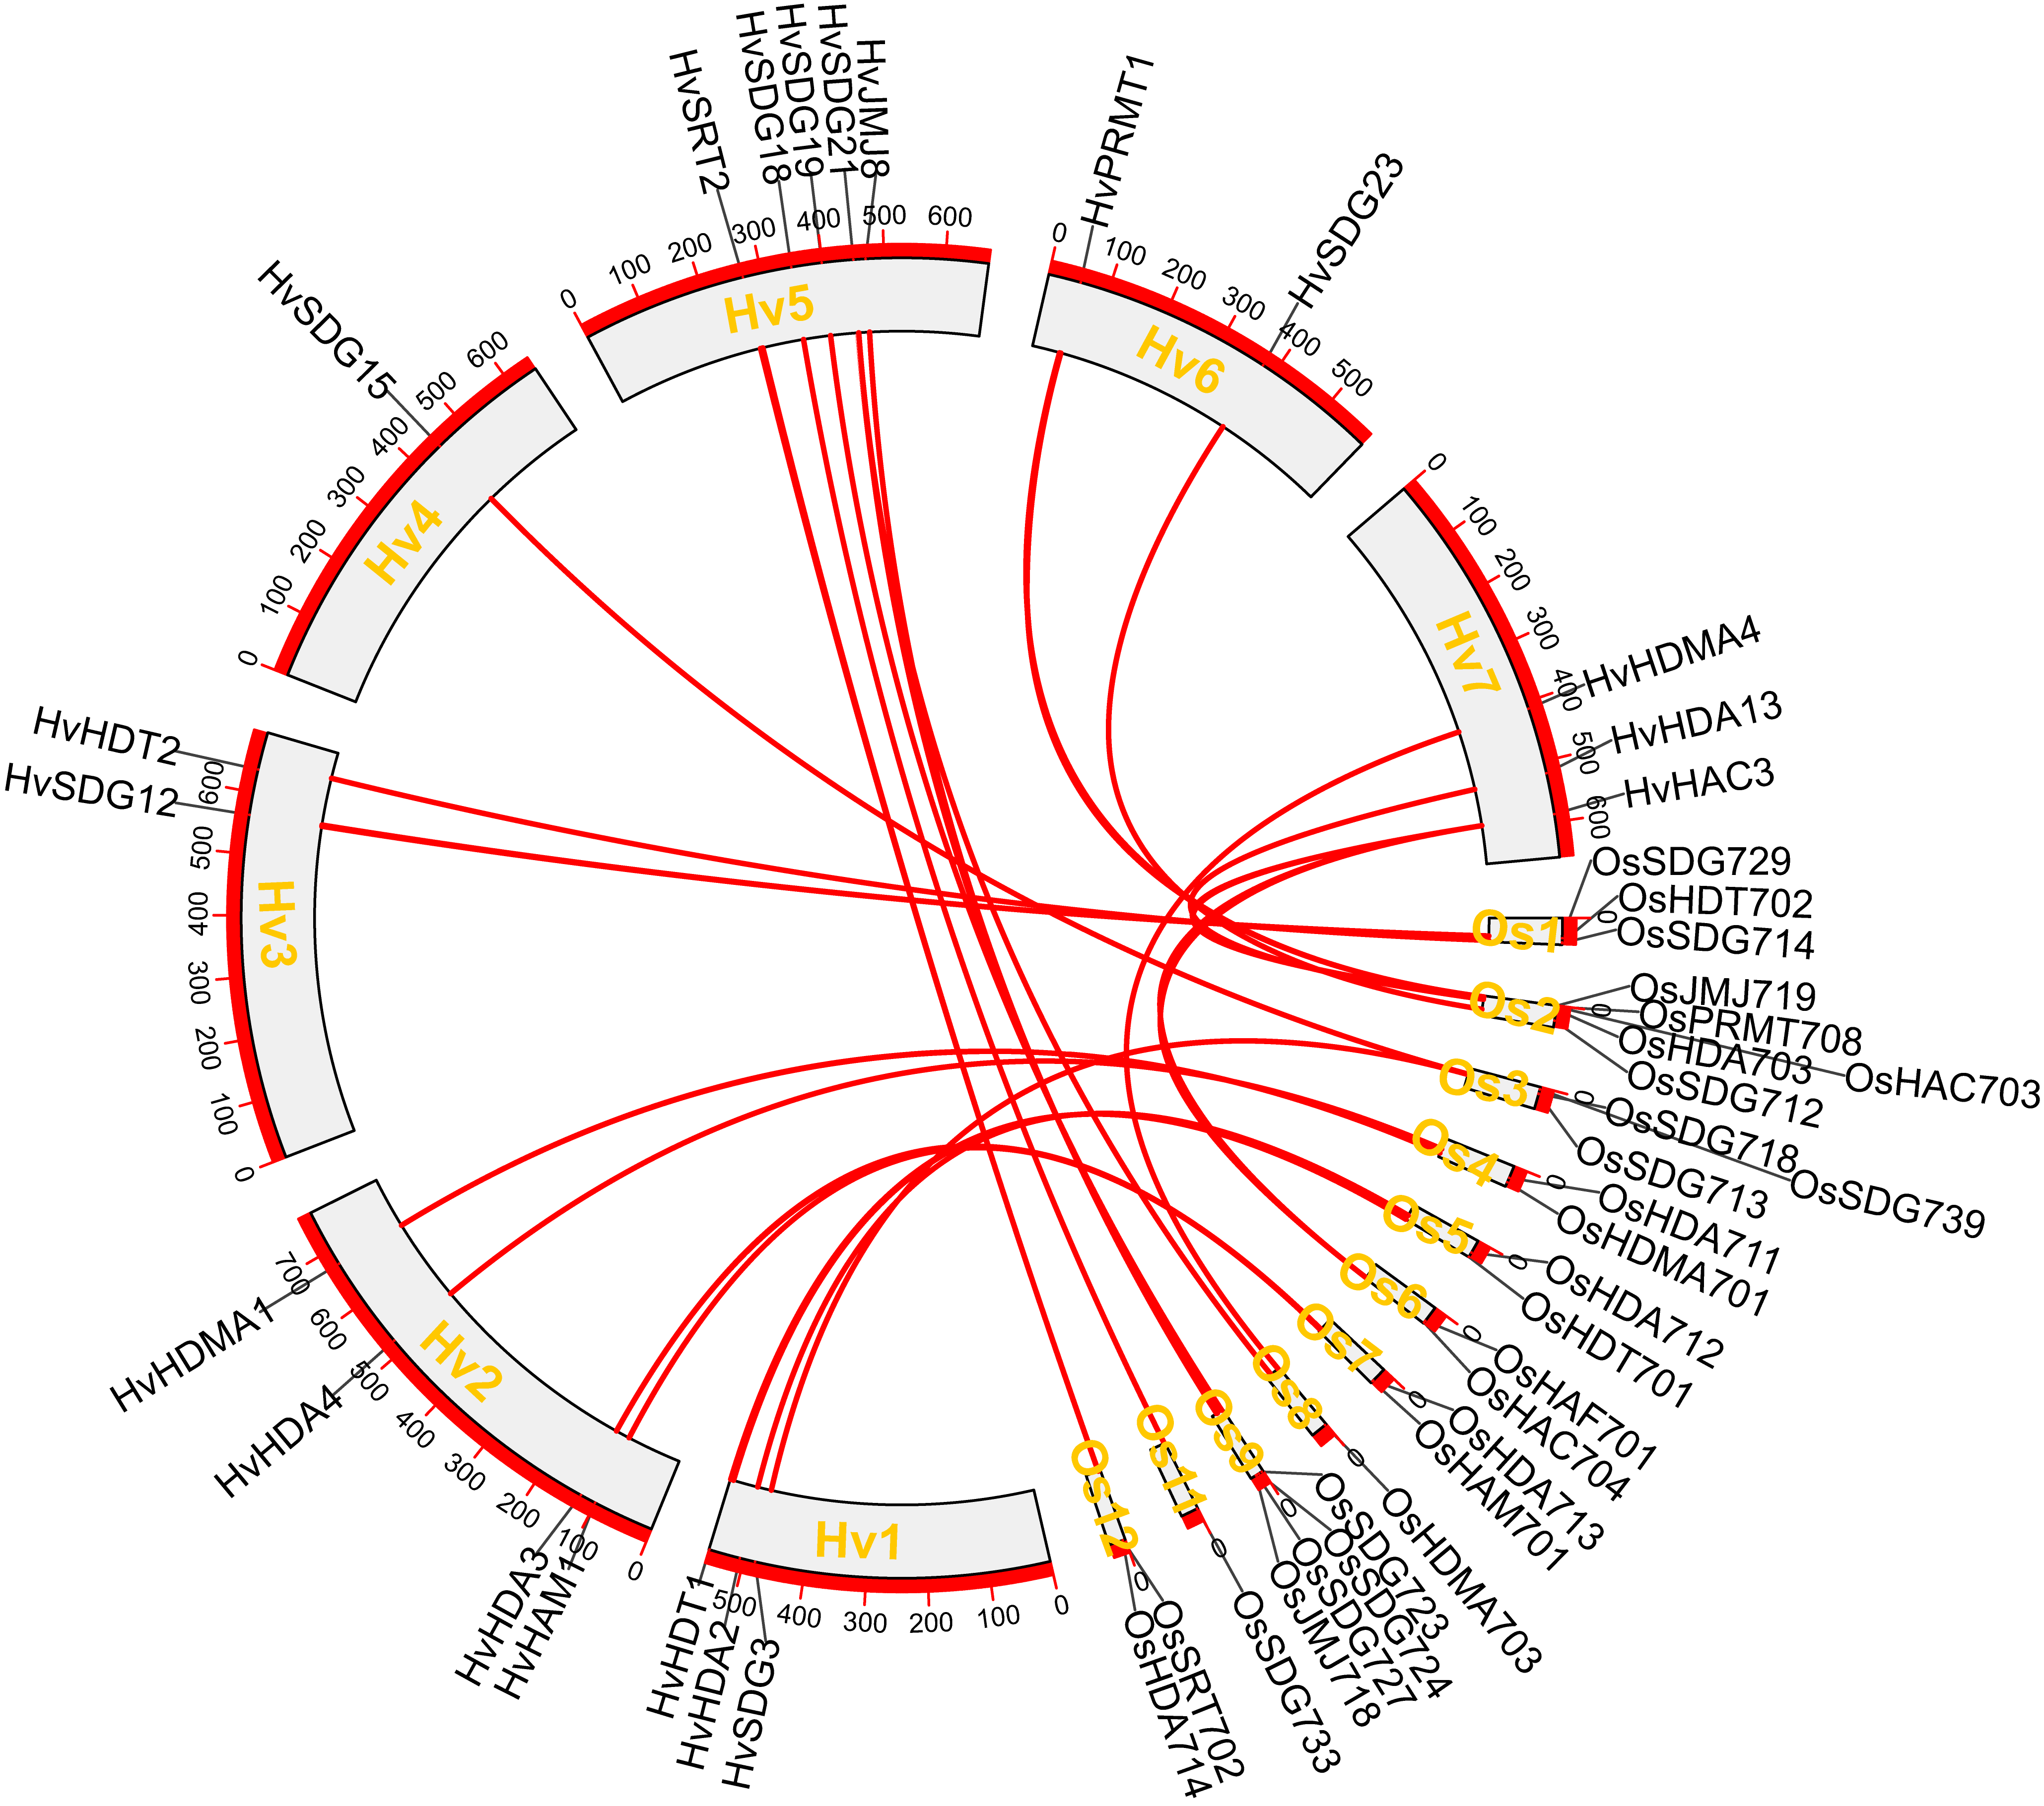
Figure S6-3 Synteny analysis of HMs genes between S. bicolor and rice
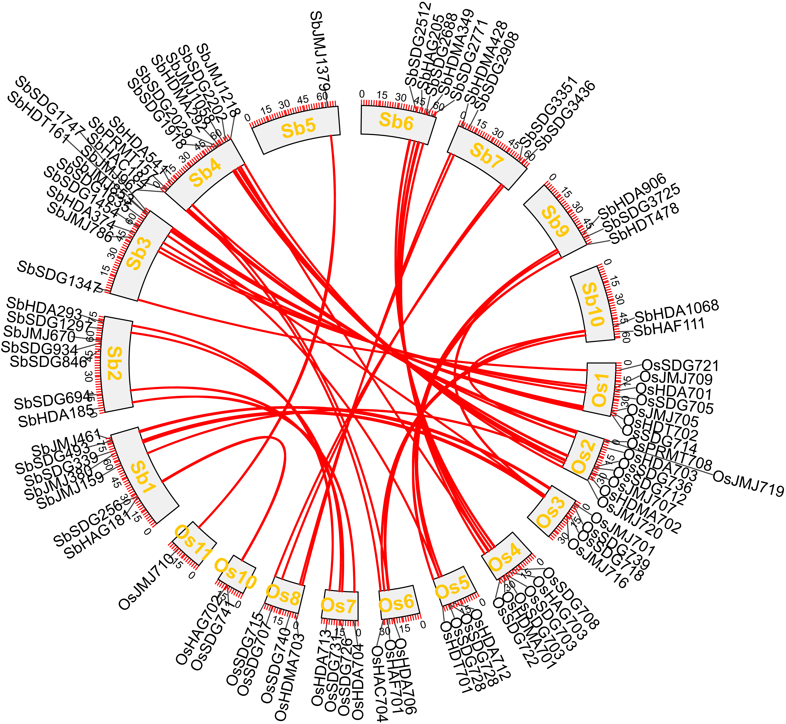
Figure S6-4 Synteny analysis of HMs genes between S. viridis and rice
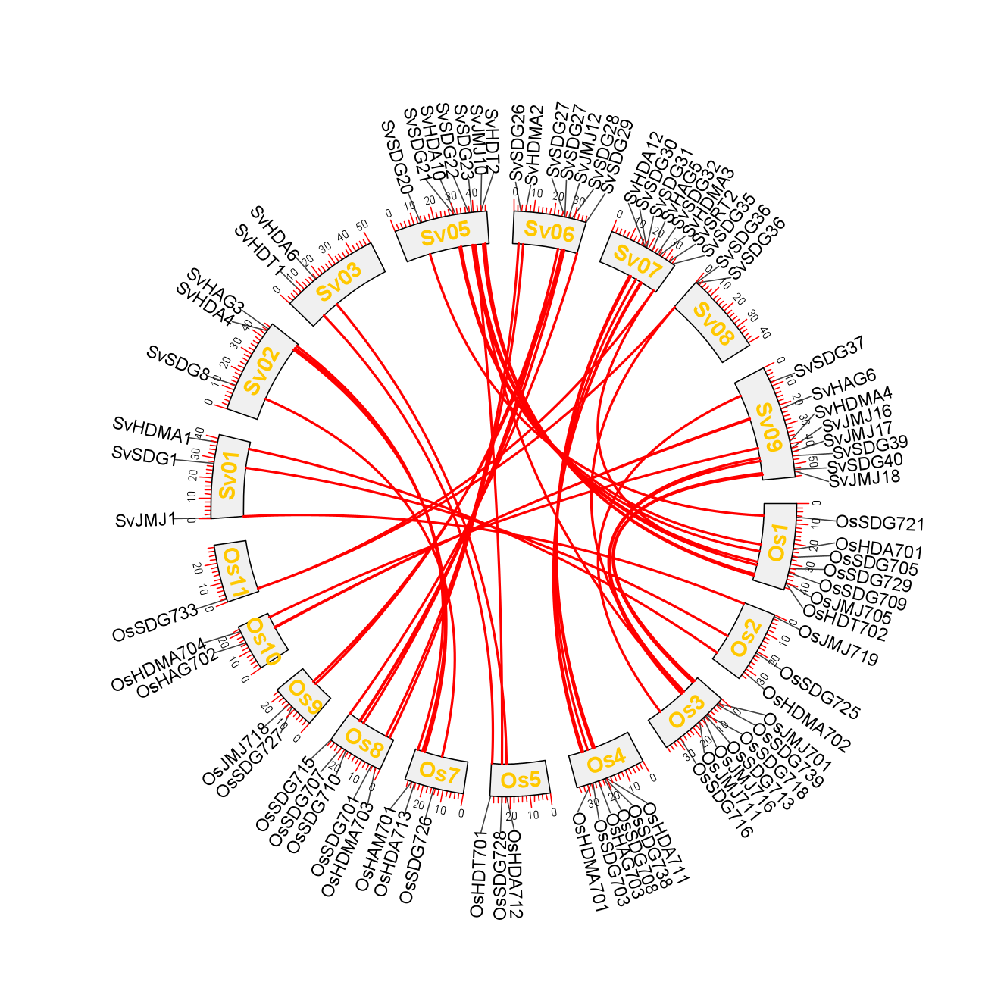
Figure S6-5 Synteny analysis of HMs genes between S. italic and rice

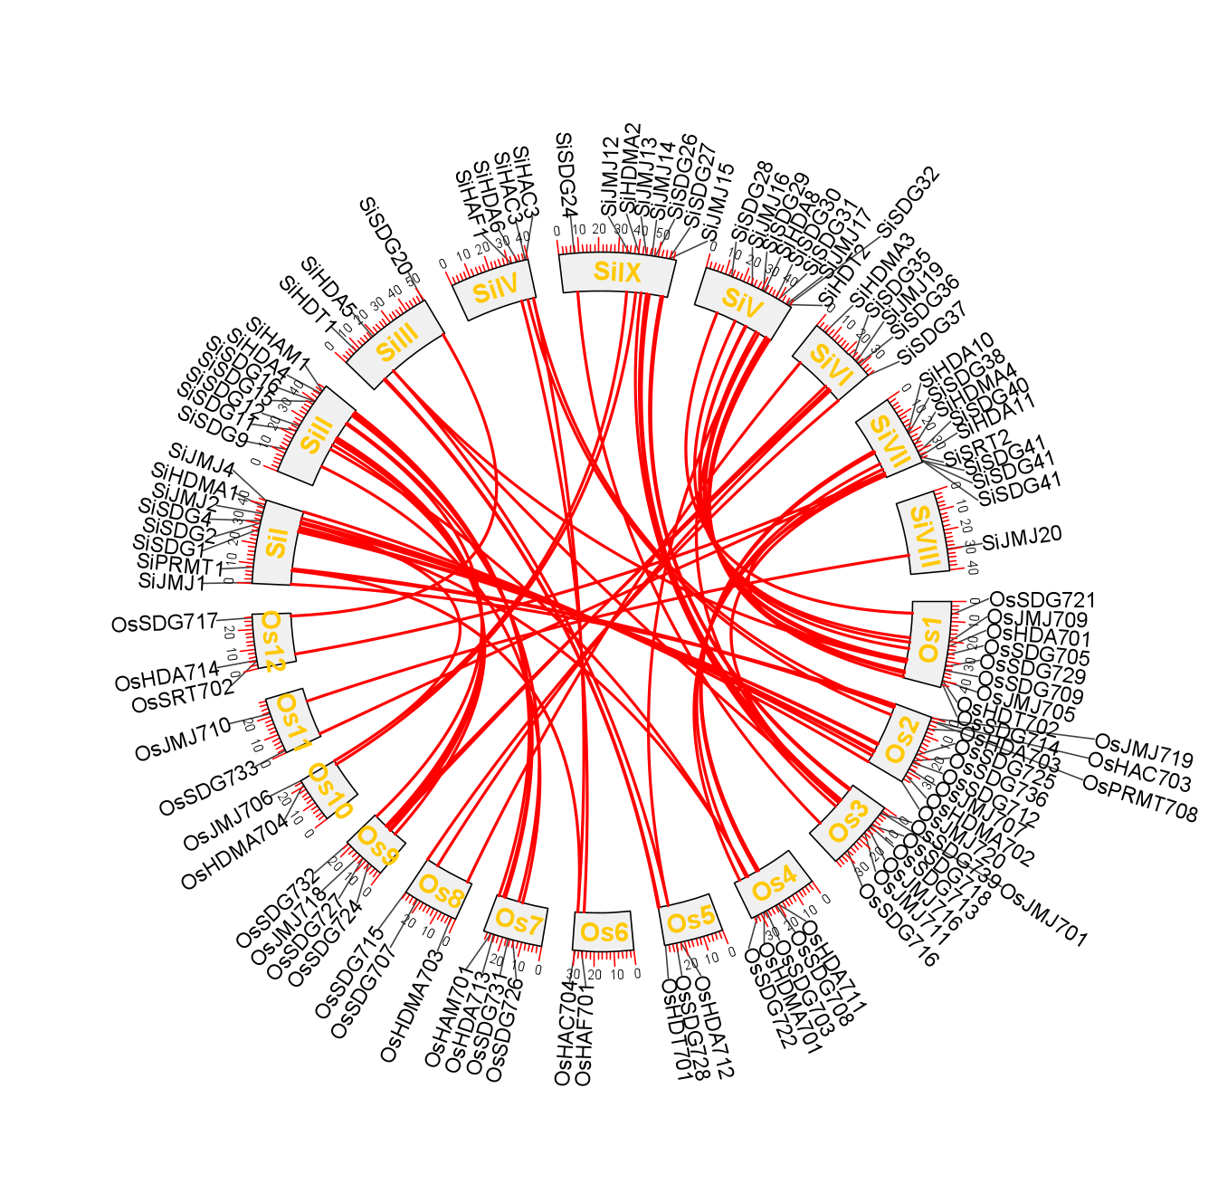
Figure S6-6 Synteny analysis of HMs genes between Z. mays and rice

