Figure S8 Gene structure analysis of HM genes.
Figure S8-1 Gene structure analysis of TaSDG and TaPRMT genes.

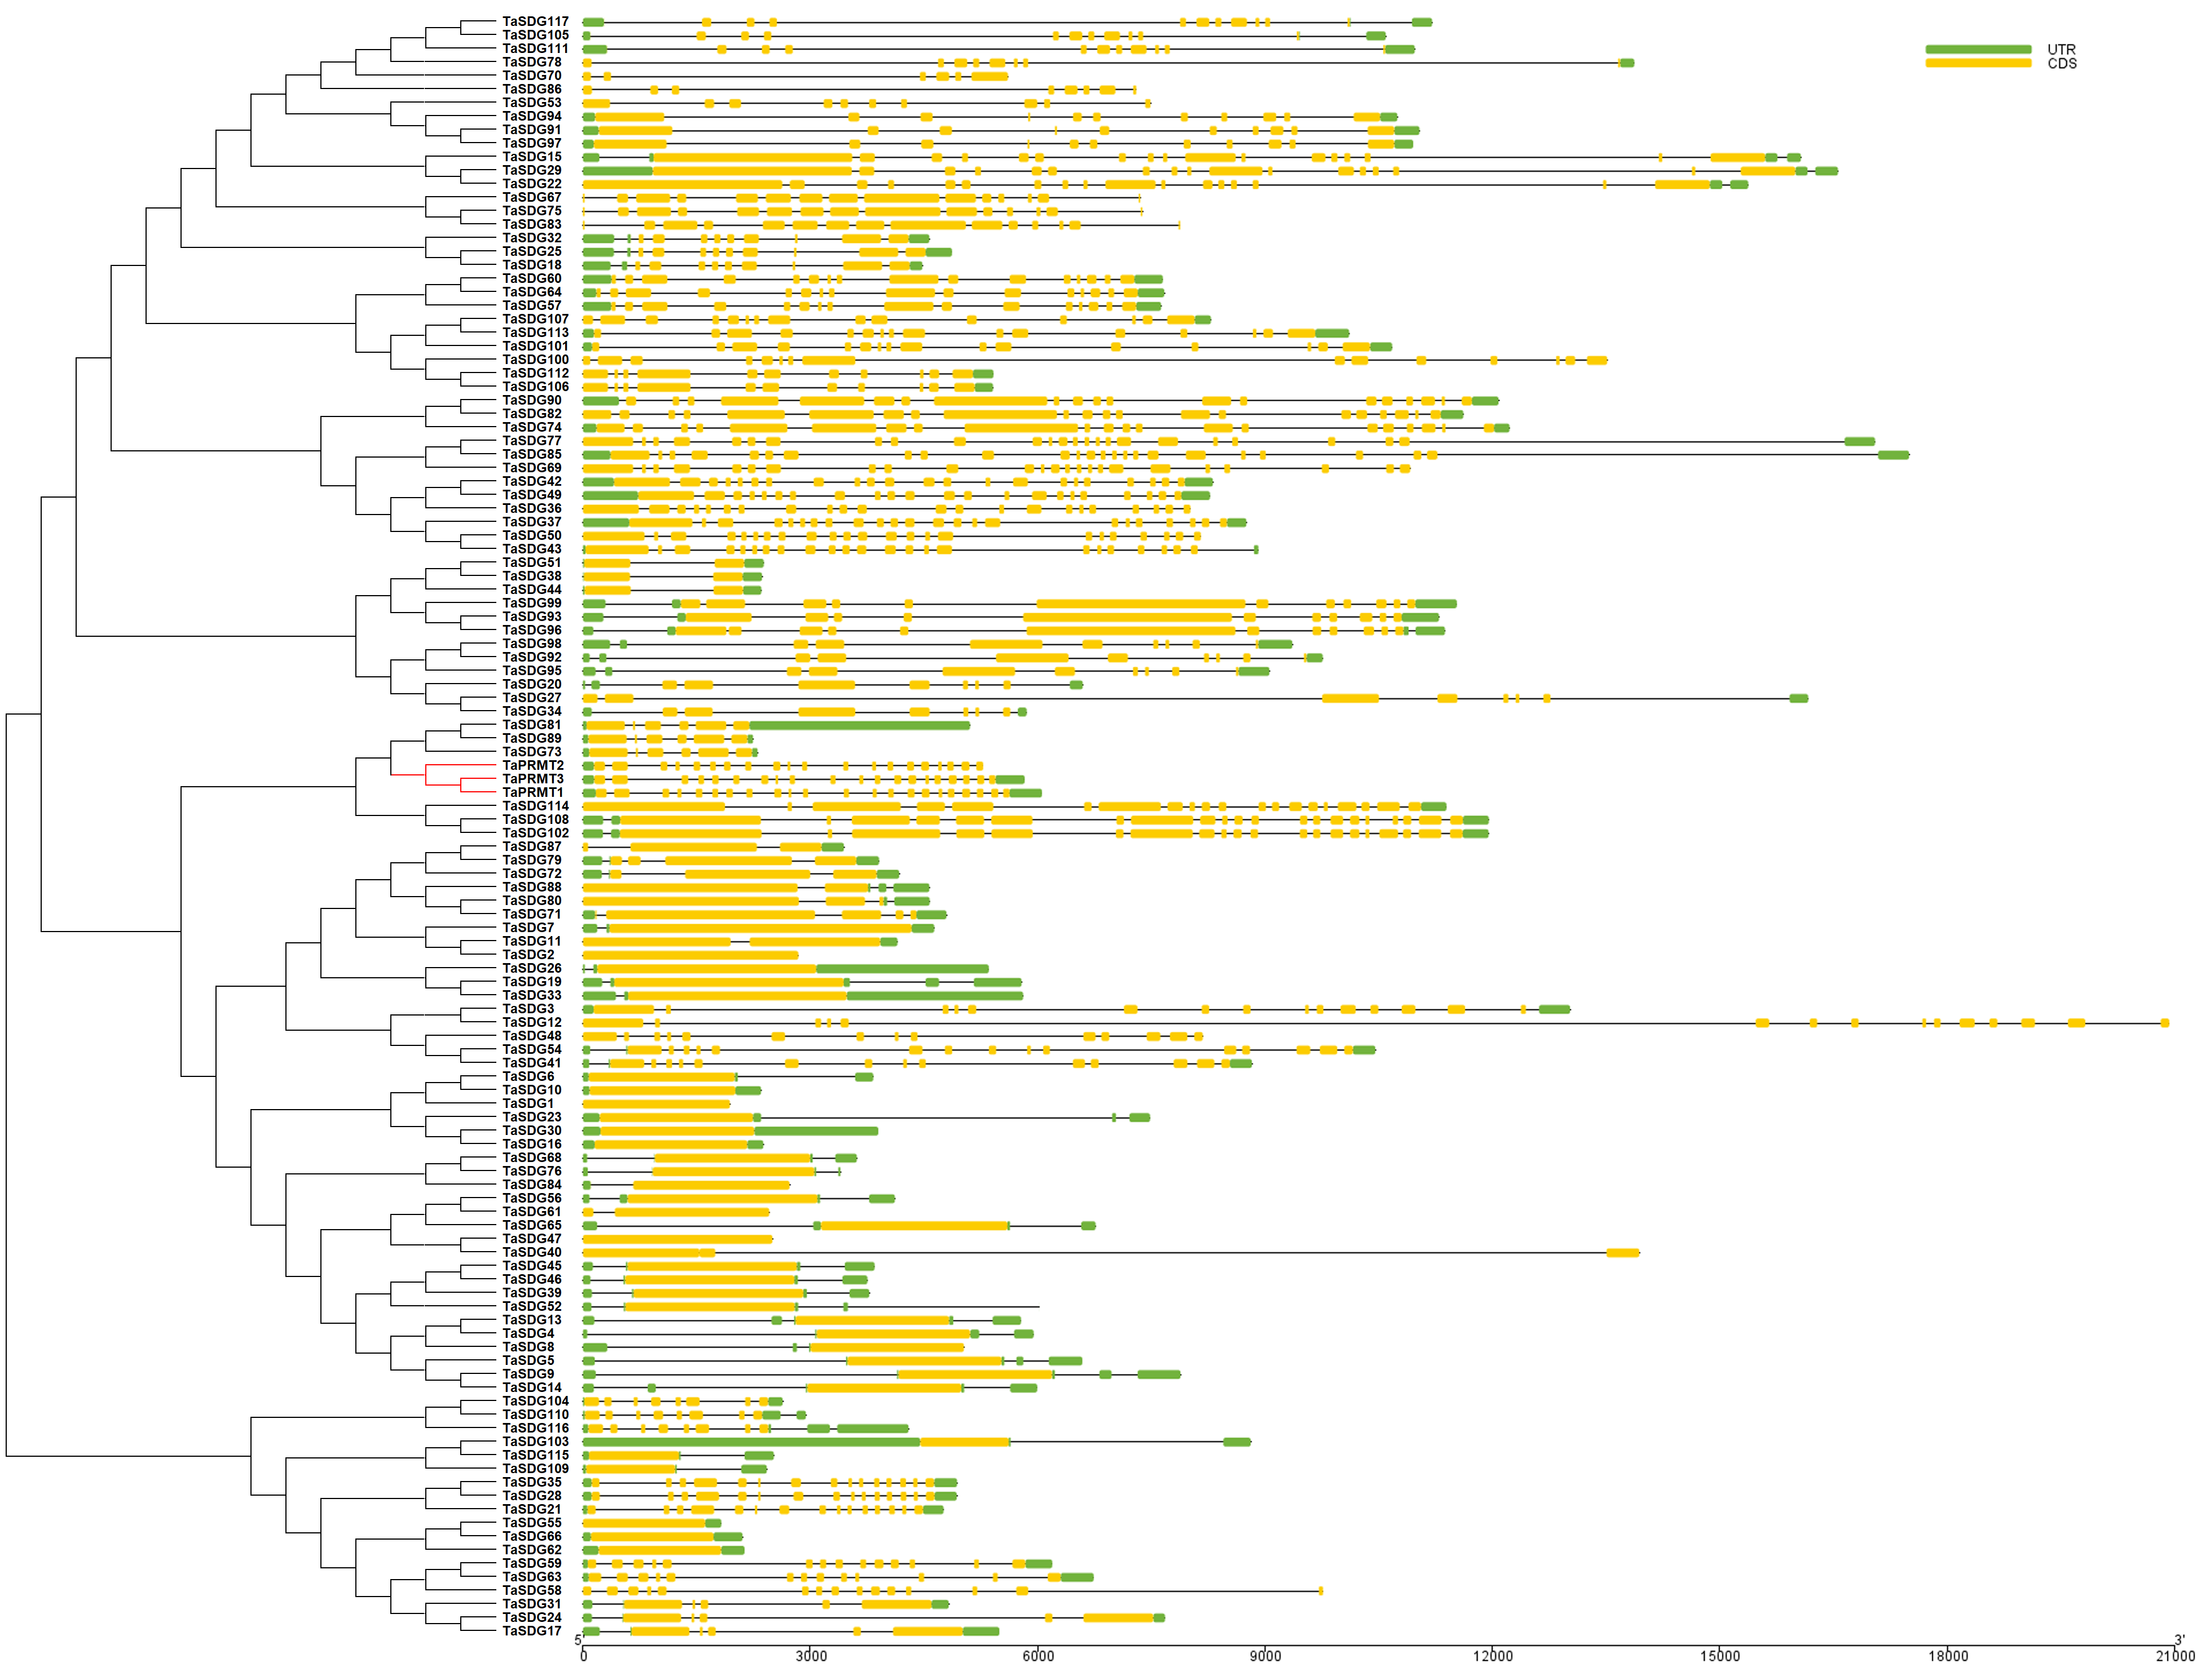
Figure S8-2 Gene structure analysis of TaHDMA and TaJMJ genes.

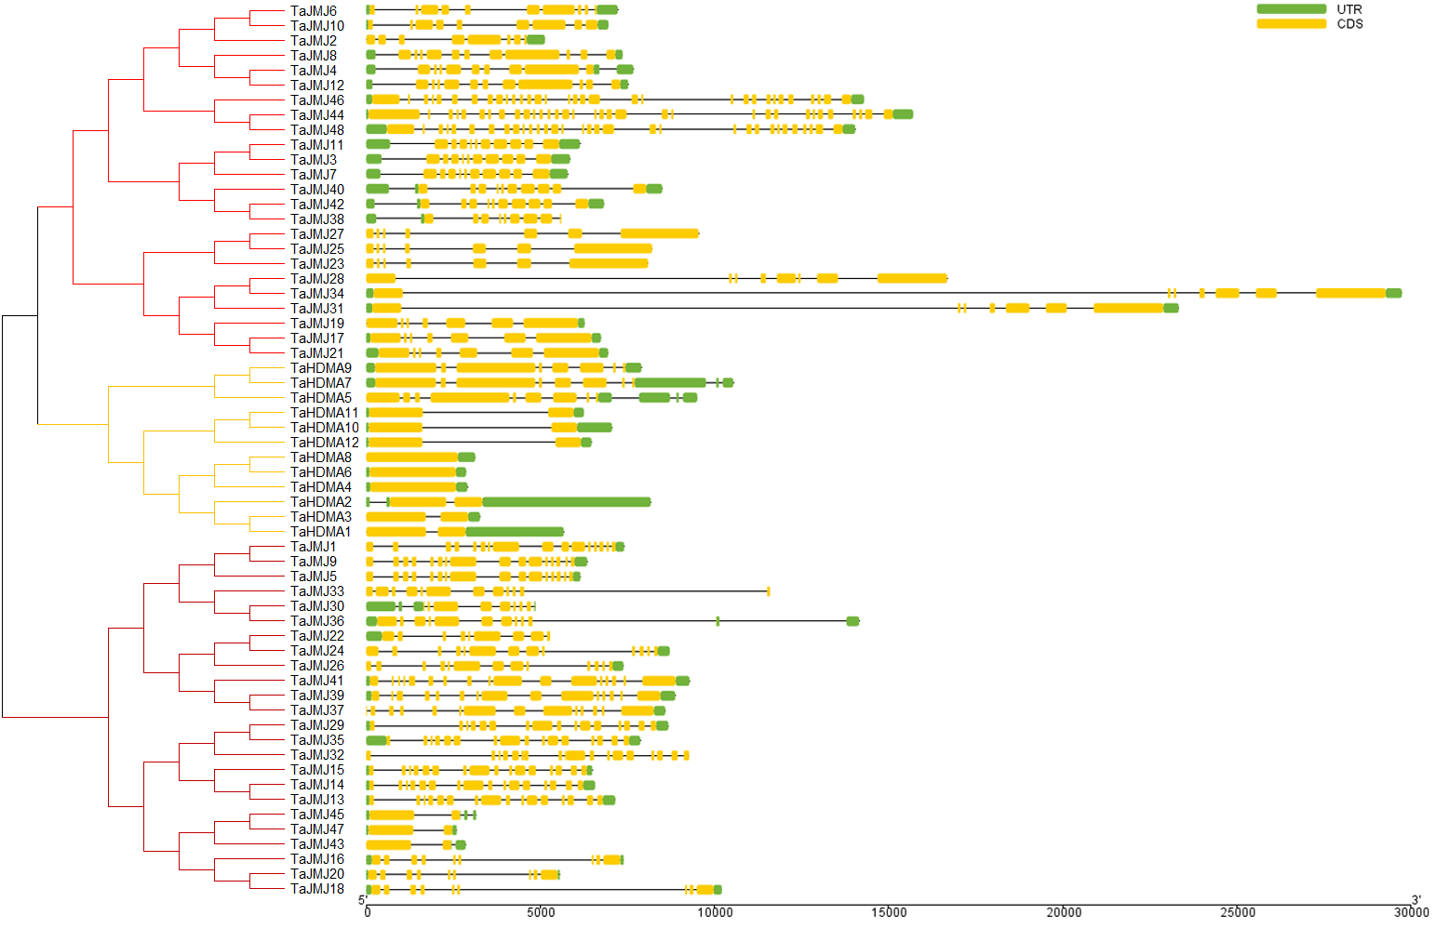
Figure S8-3 Gene structure analysis of TaHAG, TaHAM, TaHAC and TaHAF genes.

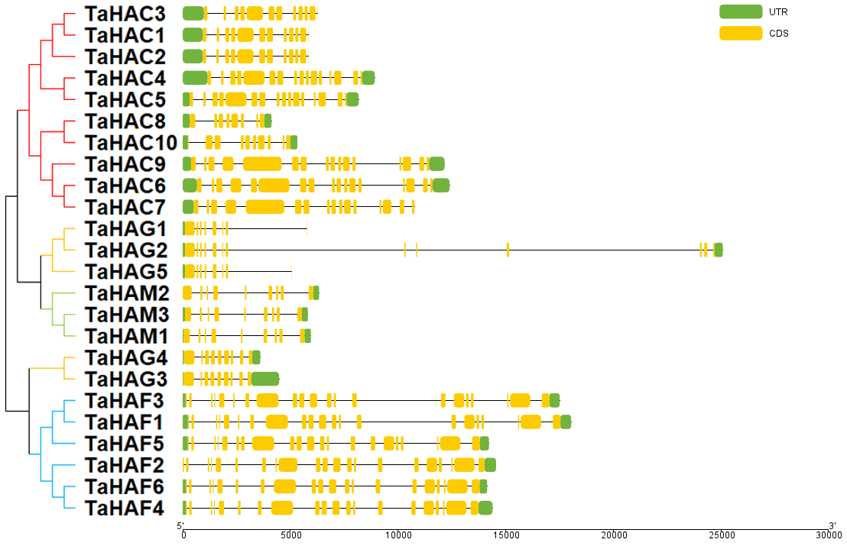
Figure S8-4 Gene structure analysis of TaHDA, TaSRT and TaHDT genes.

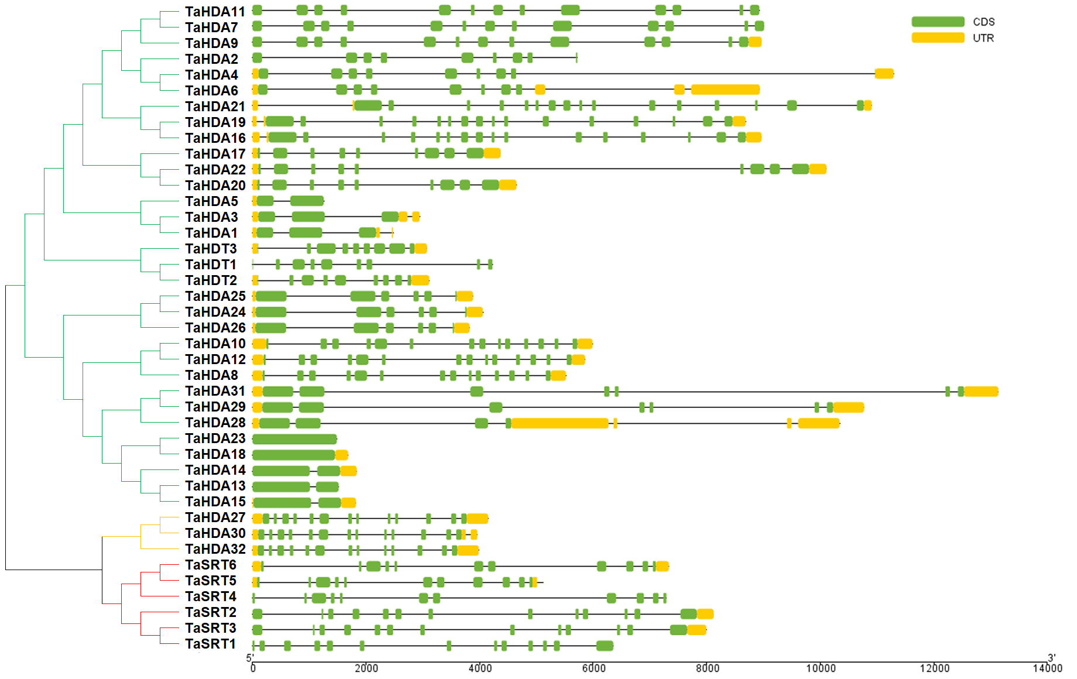
Figure S8-5 Gene structure analysis of HvSDG and HvPRMT genes.

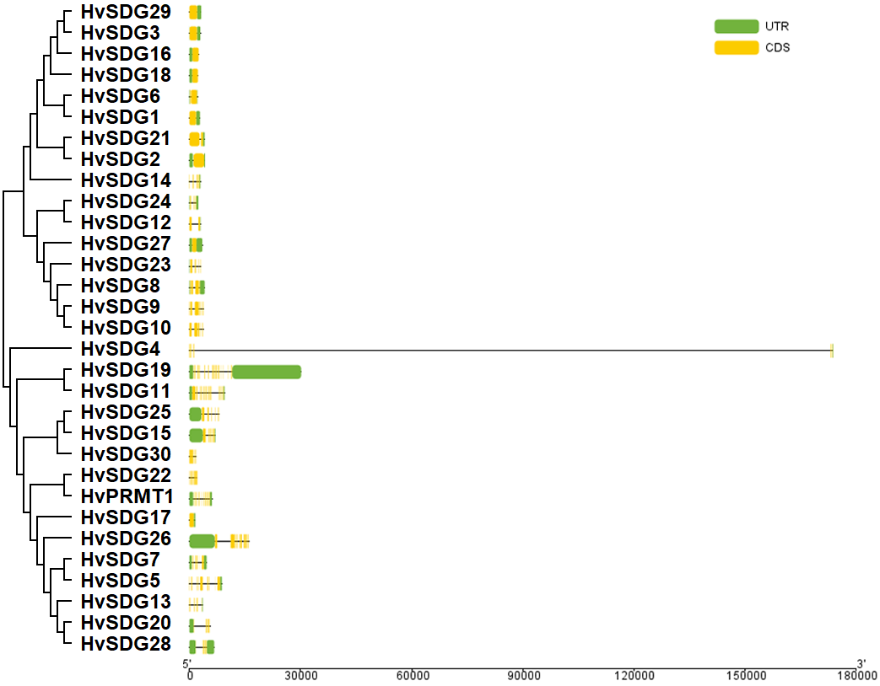
Figure S8-6 Gene structure analysis of HvHDMA and HvJMJ genes.

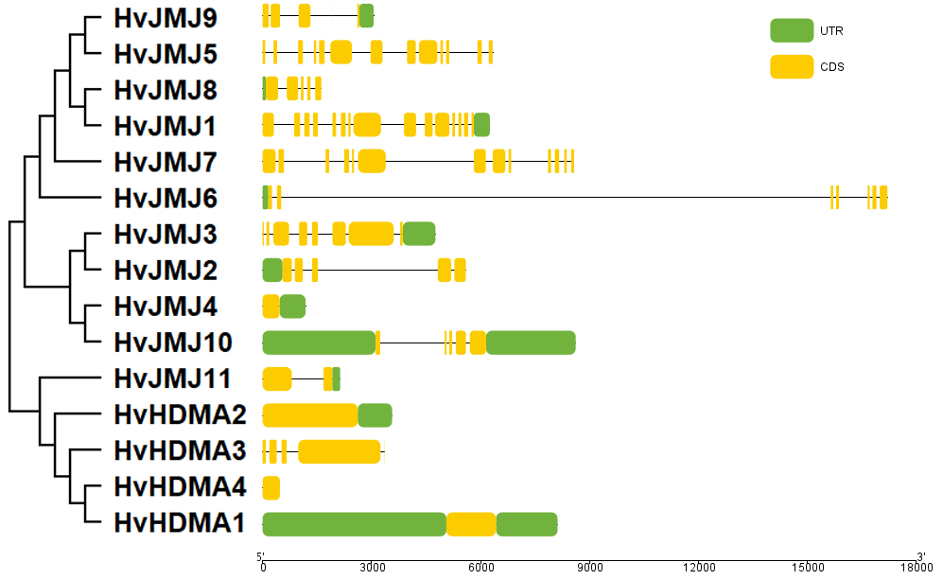
Figure S8-7 Gene structure analysis of HvHAG, HvHAM, HvHAC and HvHAF genes.

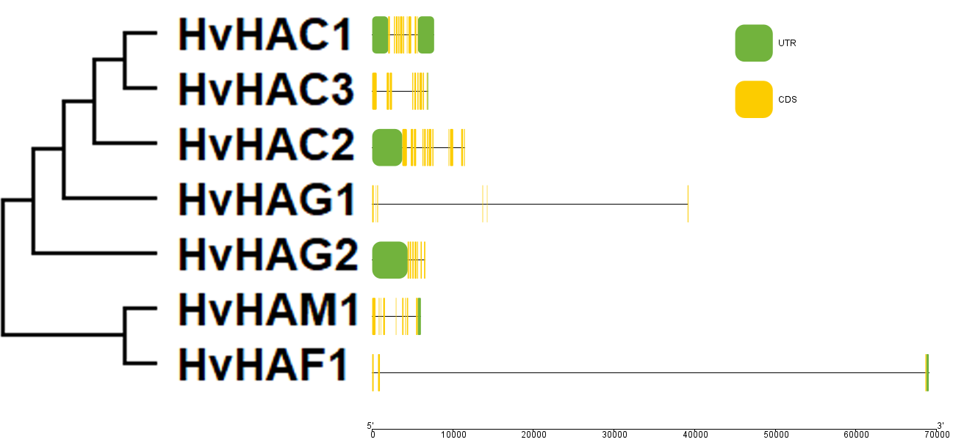
Figure S8-8 Gene structure analysis of HvHDA, HvSRT and HvHDT genes.

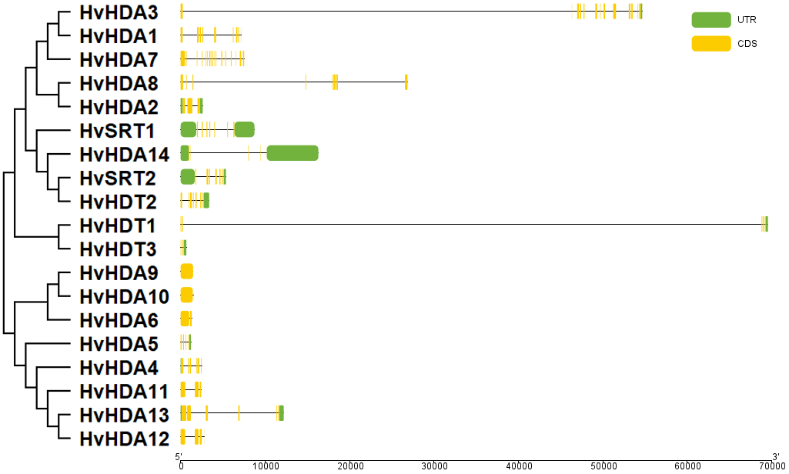
Figure S8-9 Gene structure analysis of SbSDG and SbPRMT genes.

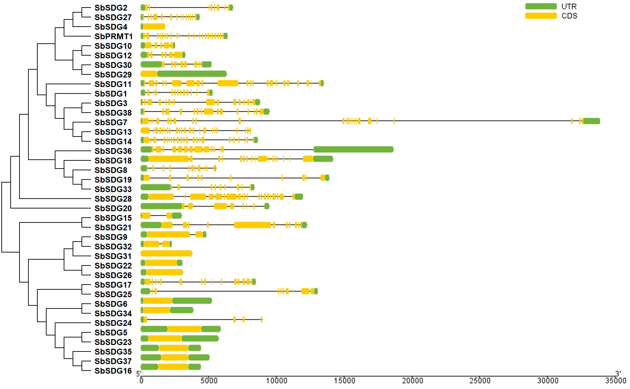
Figure S8-10 Gene structure analysis of SbHDMA and SbJMJ genes.

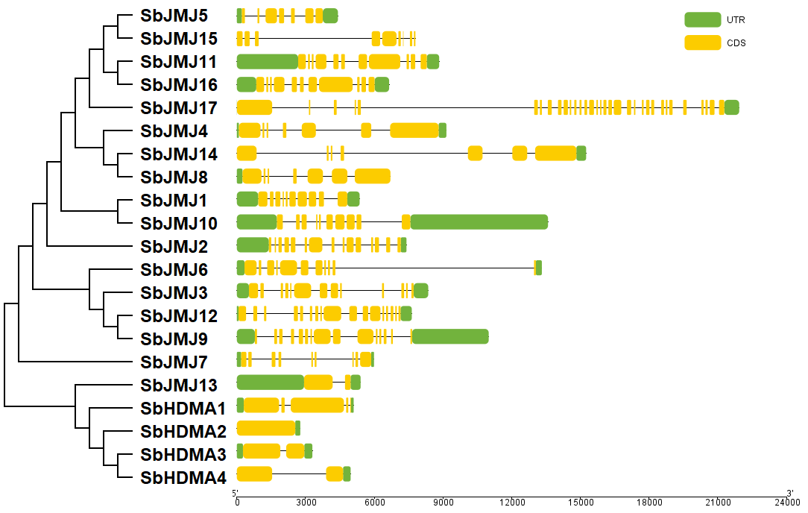
Figure S8-11 Gene structure analysis of SbHAG, SbHAM, SbHAC and SbHAF genes.

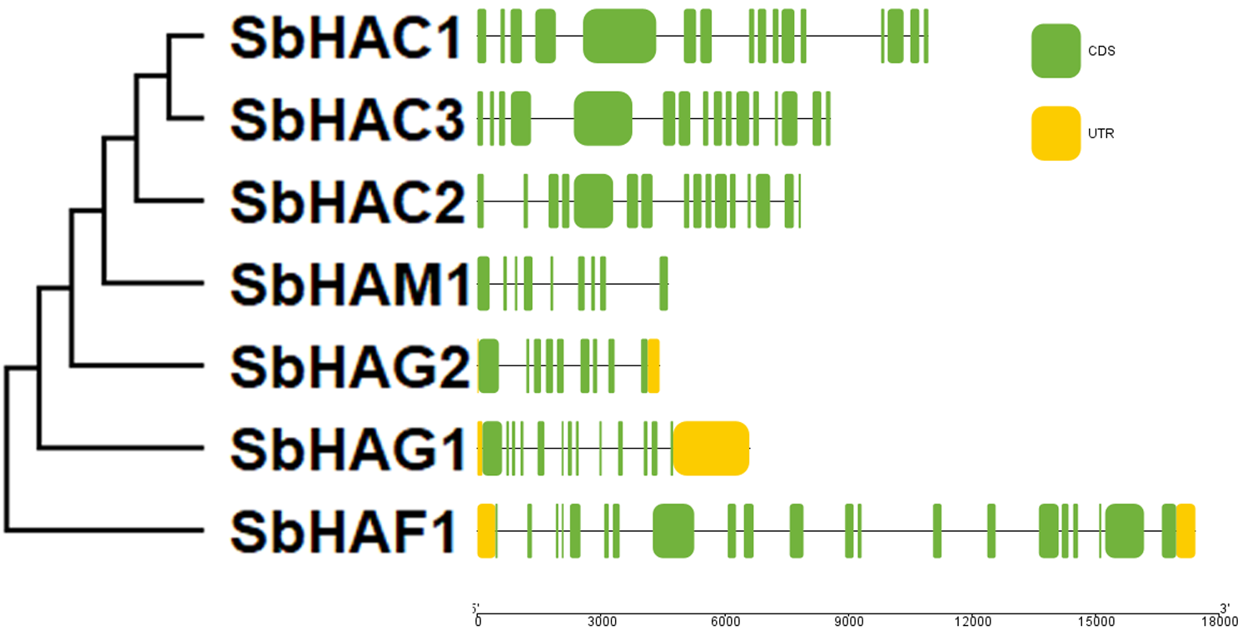
Figure S8-12 Gene structure analysis of SbHDA, SbSRT and SbHDT genes.

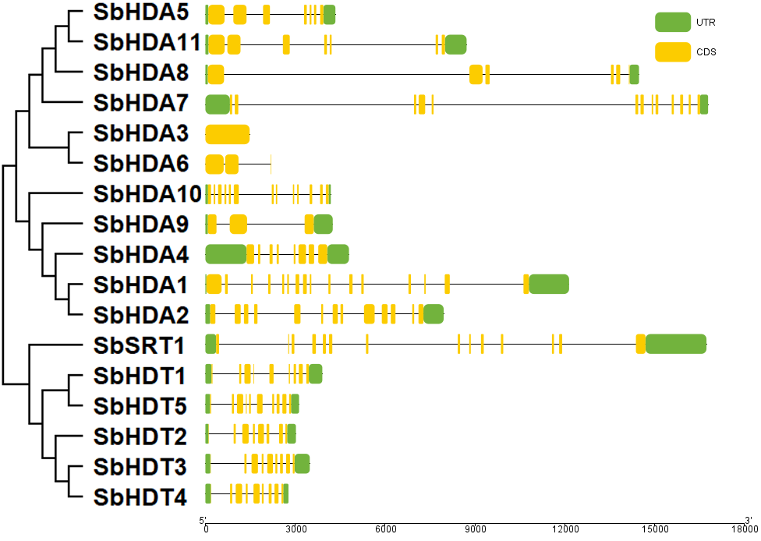
Figure S8-13 Gene structure analysis of SvSDG and SvPRMT genes.

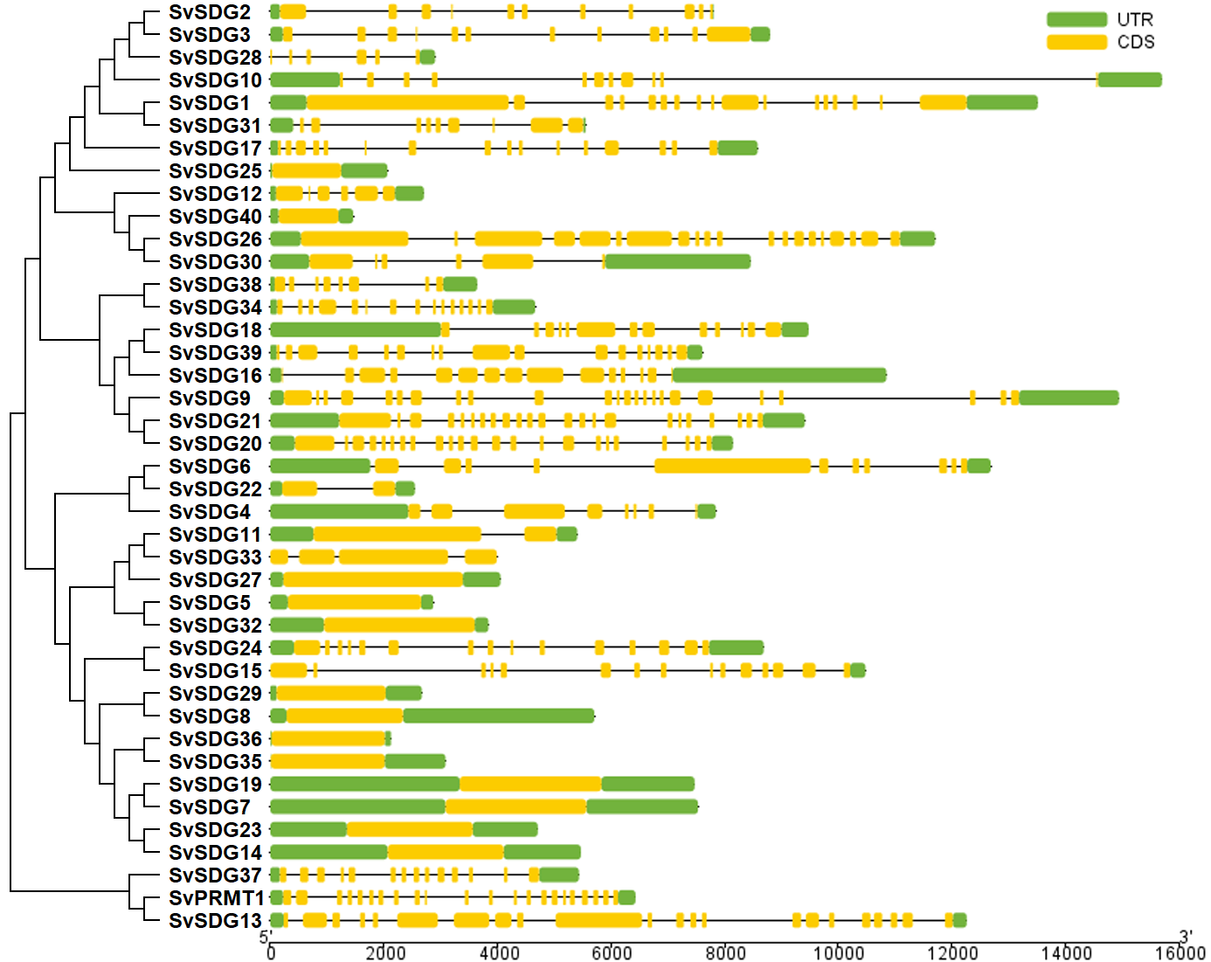
Figure S8-14 Gene structure analysis of SvHDMA and SvJMJ genes.

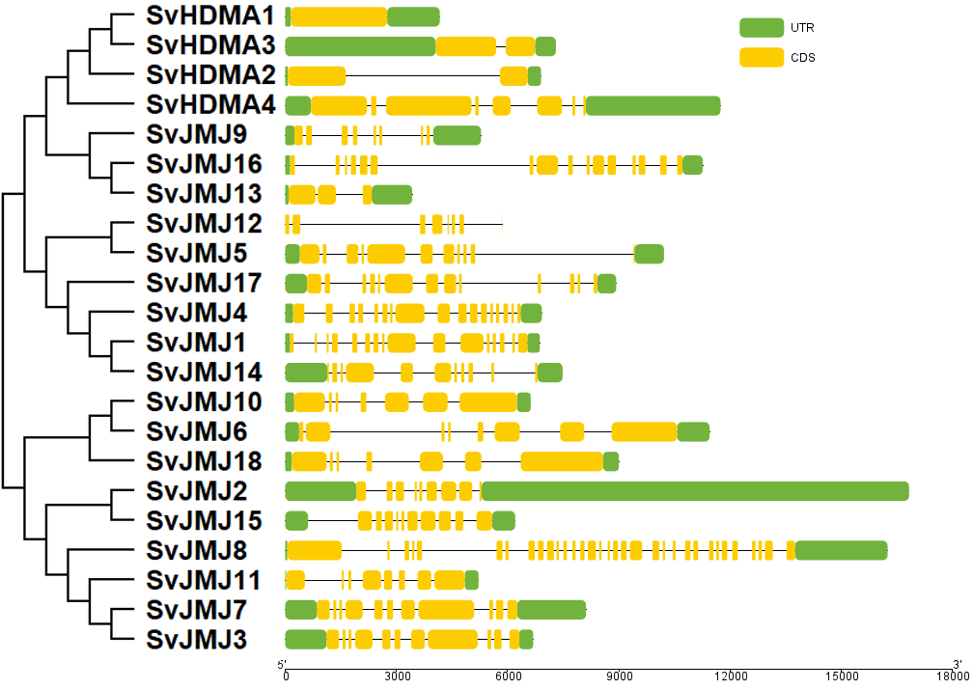
Figure S8-15 Gene structure analysis of SvHAG, SvHAM, SvHAC and SvHAF genes.

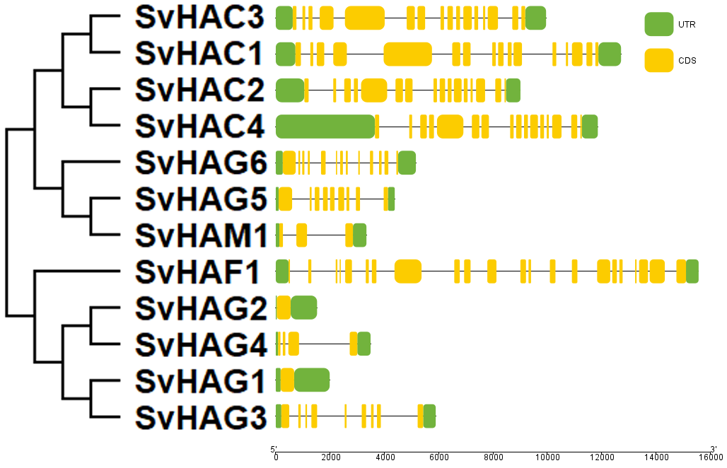
Figure S8-16 Gene structure analysis of SvHDA, SvSRT and SvHDT genes.

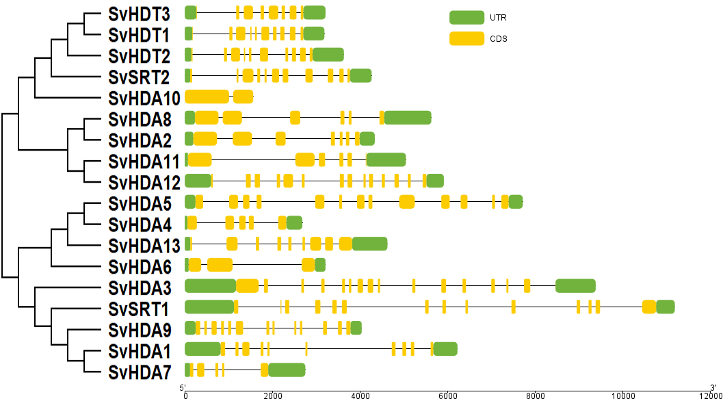
Figure S8-17 Gene structure analysis of SiSDG and SiPRMT genes.

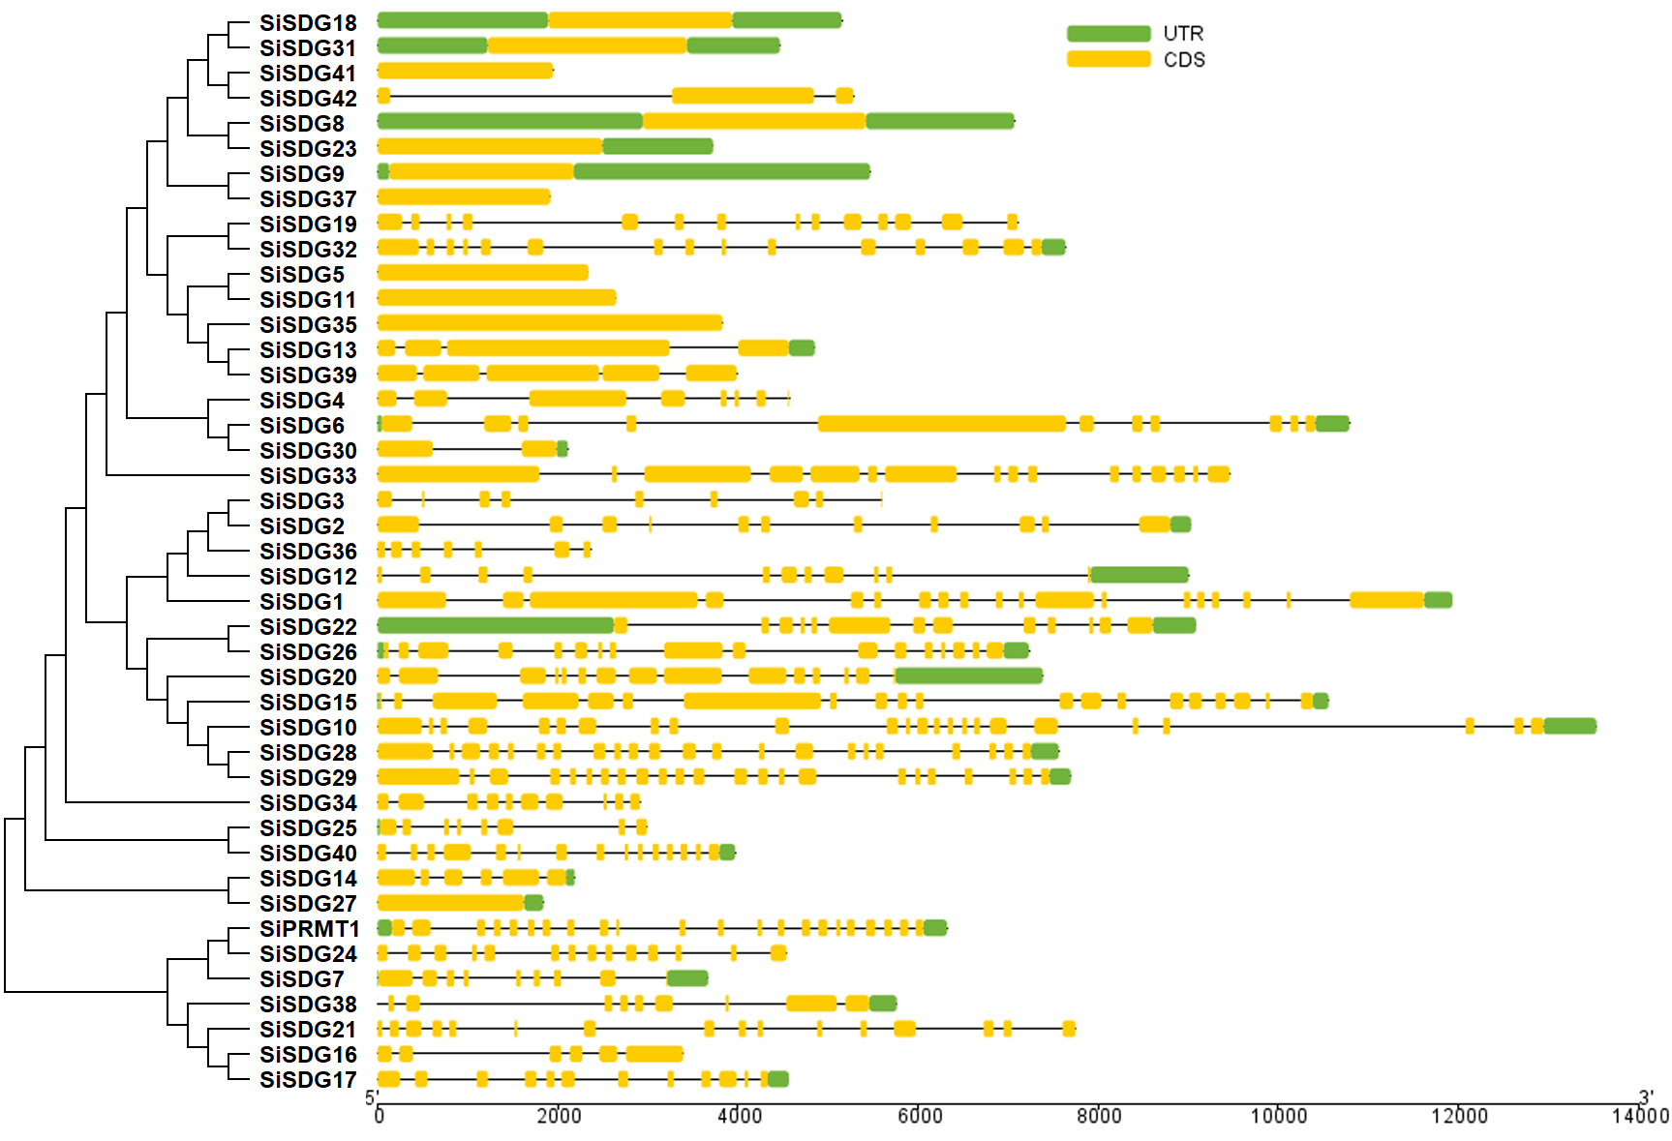
Figure S8-18 Gene structure analysis of SiHDMA and SiJMJ genes.

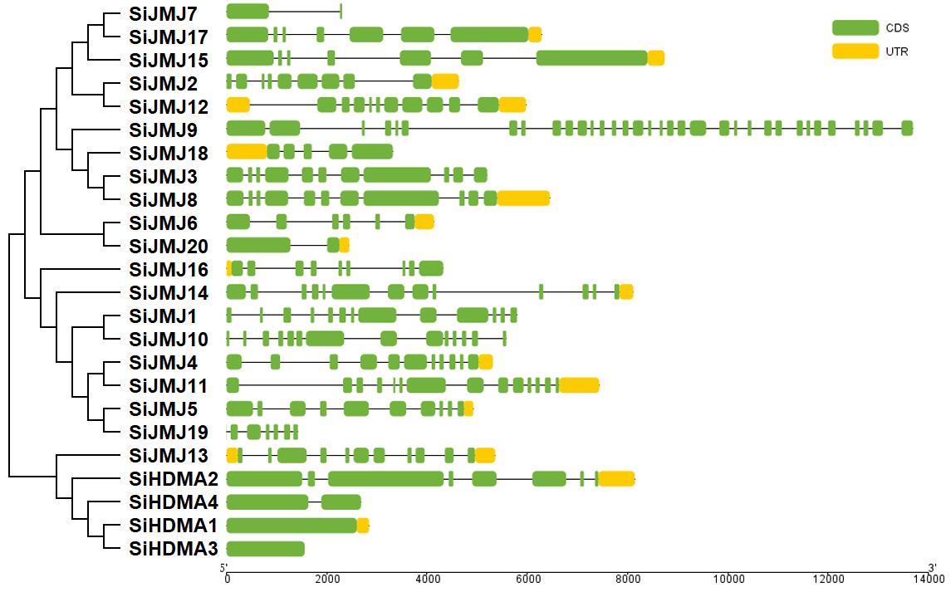
Figure S8-19 Gene structure analysis of SiHAG, SiHAM, SiHAC and SiHAF genes.

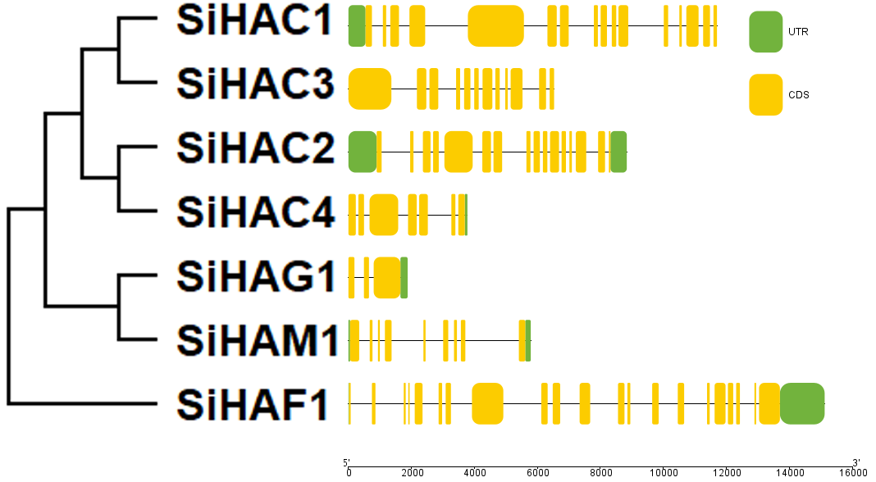
Figure S8-20 Gene structure analysis of SiHDA, SiSRT and SiHDT genes.

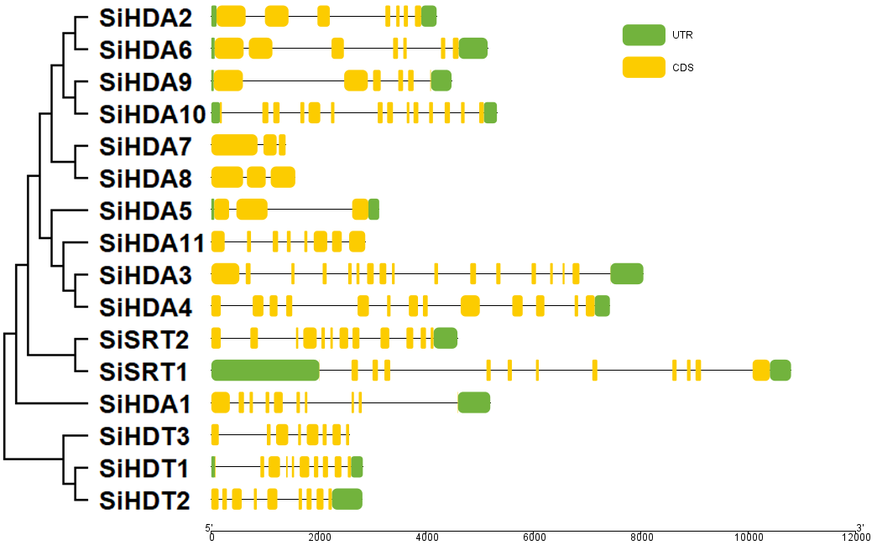
Figure S8-21 Gene structure analysis of ZmSDG and ZmPRMT genes.

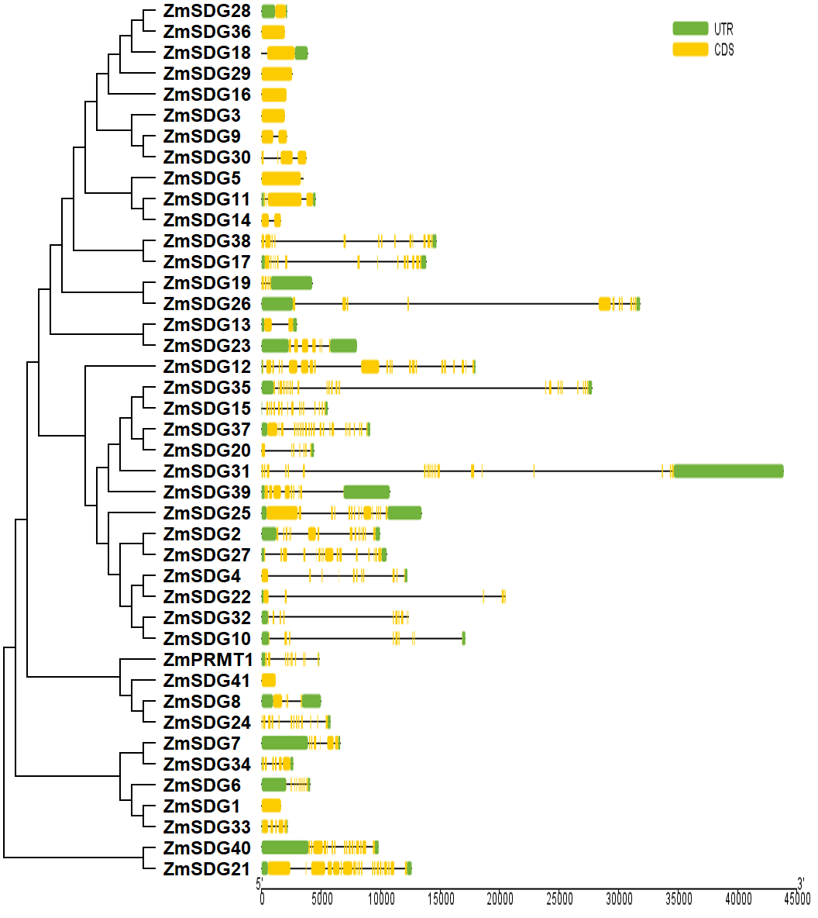
Figure S8-22 Gene structure analysis of ZmHDMA and ZmJMJ genes.

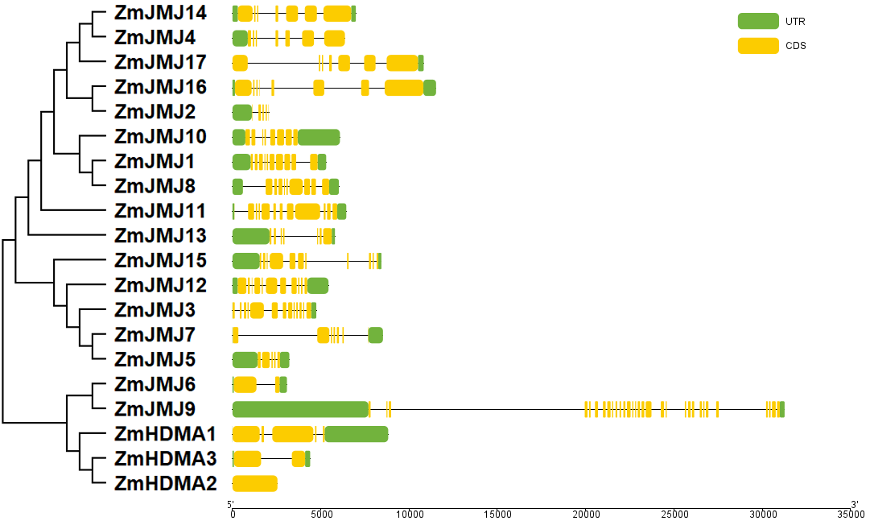
Figure S8-23 Gene structure analysis of ZmHAG, ZmHAM, ZmHAC and ZmHAF genes.

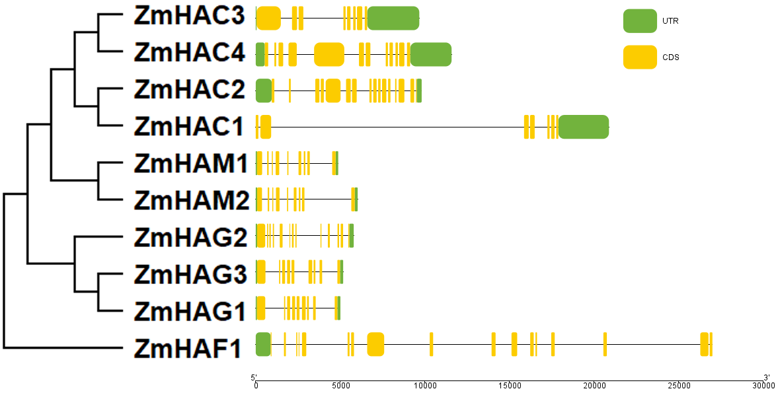
Figure S8-24 Gene structure analysis of ZmHDA, ZmSRT and ZmHDT genes.

