Phytochemical investigation and evaluation of Anti-microbial activities of some indigenous Artemisia spp. of Ethiopia: Rapid method of isolation artemisinin from Artemisia annua
Seid Mohammed¹* ²Aman Dekabo and ¹Tilahun Hailu
¹Adama Science and Technology University, Ethiopia
²Program of Applied Chemistry
E-mail: seid.mohammed@astu.edu.et
*Author for correspondence: Seid Mohammed Ebu
Head of Department*
School of Applied Natural Science
Mobile (Current and Home): +251-912-223580*
Address (current and Home): Adama Science and Technology University, Oromia, Ethiopia*
Running Title: Full research article

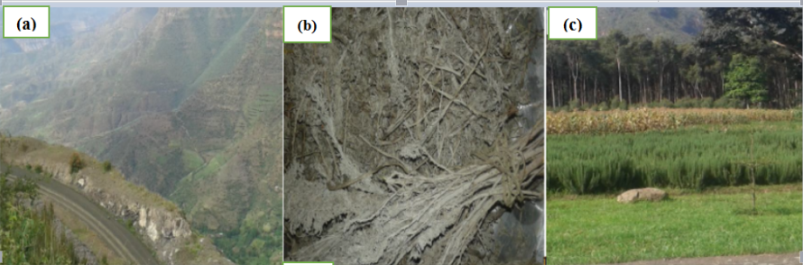
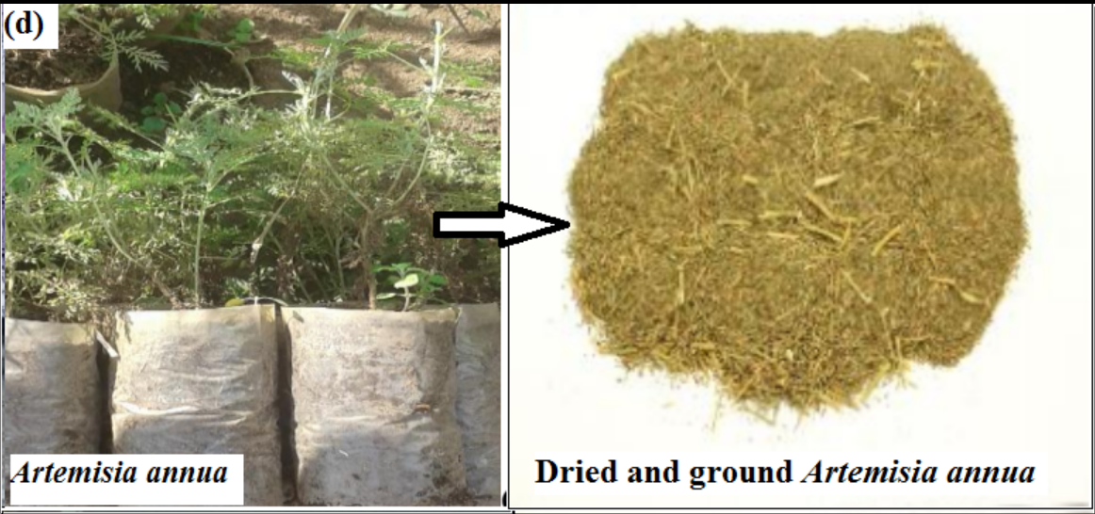

Fig. S1: (a) Bale Robe (Enidato Gasera)- is area where Artemisia absinthium (Arity) was collected. (b) Artemisia absinthium (c) Wondogenet Agricultural research center, area where Exotic A. annua, Artemisia absinthium and other Ethiopian endogenous medicinal plants were collected. (d) Dried and ground A. annua.

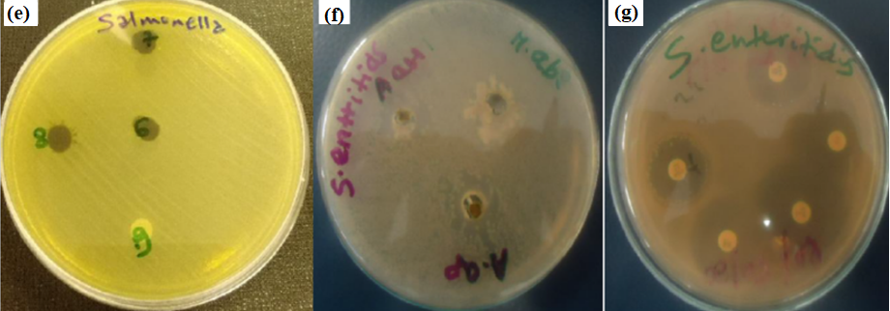

Fig. S2: (a) Zone of inhibition was detected for negative control. (b) Considerable amount of zone of inhibition was detected for test extract of Artemisia species especially with very clear zone of inhibition due to A.ap. (c) Acceptable zone of inhibitions were also detected for some impregnated antibiotics.

