Appendix A : Adapted Developmental Language Test Illustrations Picture C Picture D
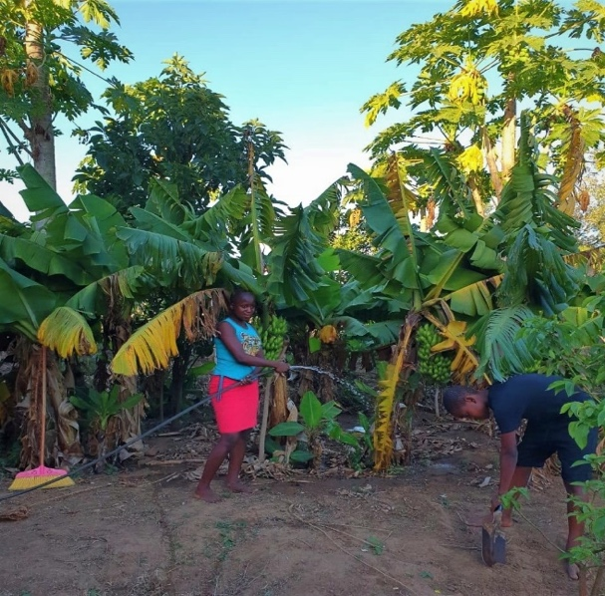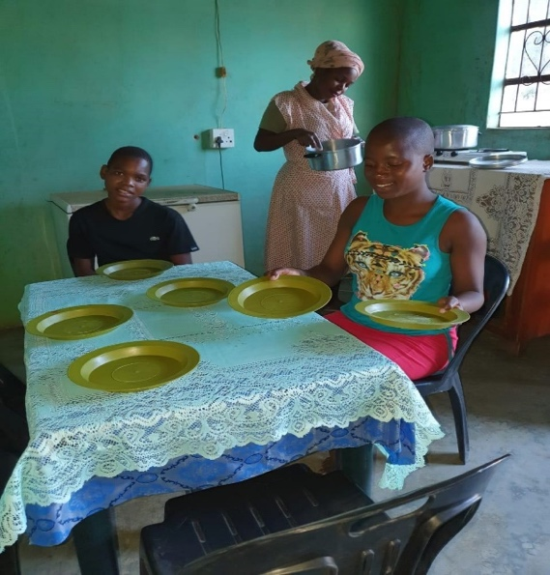
Picture A Picture B
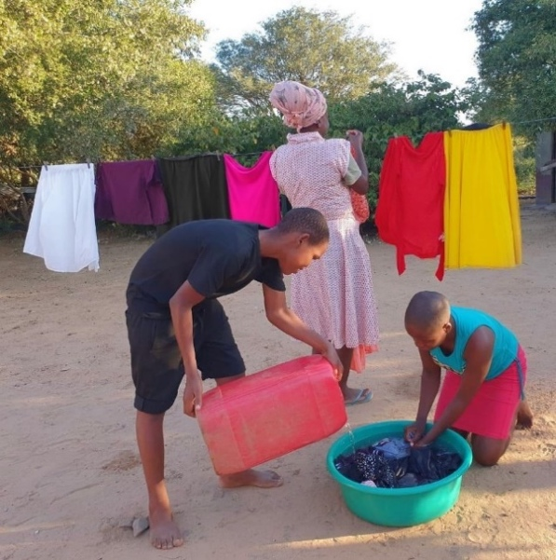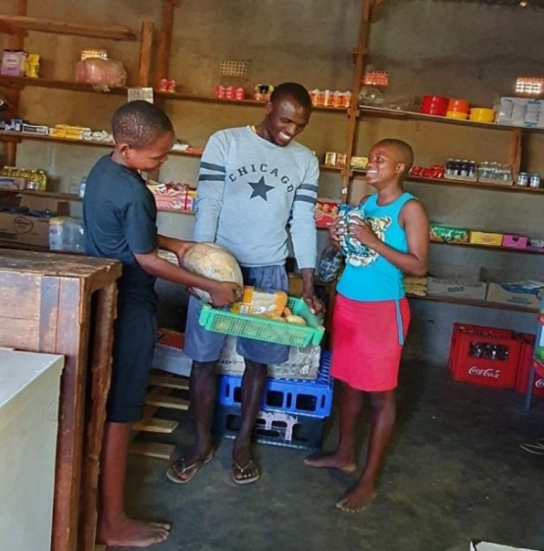

APPENDIX B: Developmental Language test (Complete version Adapted for Ingwavuma)
SECTION A
Purpose: Establish rapport &introduce the narrative
- Instruction: Can you sing a song you like or say your favourite nursery rhyme?
Unalo iculo olithandayo esingalicula ndawonye noma umlolozelo esingawusho sobabili?
Item | Description | Score
1  Song | Song or rhyme production. | 2 | 1 | 0
 |  | song or rhyme clear with enjoyment | sings but lacks clarity | unable to perform
- Instruction: Show all pictures to the child then proceed with questions:
Akubuke lezizithombe. Lona umndeni wakwa Mthembu. Kukhona ubaba Kanye nomama, kuthiwa umama nonkosikazi Mthembu nomfana obizwa ngokuthi uThemba nentombazane ebizwa ngokuthi uNosipho.

Item | Description | Score
2. Names | a. Can you tell me who the people in our story are and what their names are?  Ungasho ukuthi bangobani labantu? nokuthi bangobani amagama abo? | 3 | 2 | 1 | 0
 |  | All characters & their names correct | all people correct, some names correct | some people, and some names correct | No response
SECTION A TOTAL SCORE:___/5

SECTION B
Picture A:

Item | Description | Score
3.1  Follows 2- and 3- part commands | a. Please show me Mrs Mthembu, then show me Nosipho and lastly show me Themba  Ngikhombisa umama Mthembu, bese ungikhombisa uNosipho, ugcine ngokungikhombisa uThemba. | 3 | 2 | 1 | 0
 |  | all correct | all shown, but order incorrect | Two people shown in correct order | No response

3.2  WH Q | Bakuphi? (where are they?) | 1 | 0
 | Benzani? (what are they doing?) | 1 | 0
 | Bakwenzelani lokho? (why are they doing that?) | 1 | 0
 | Ubani owasha/ oshuka izingubo? (who is washing the clothes?) | 1 | 0
 | Uzineka kuphi unkosikazi Ndaba izingubo? (where is she going to hang the clothes?) | 1 | 0
 | Ukwenzelani lokho? (why is she hanging them there and not on the tree?) | 1 | 0

3.3  Recognizes  colors | Ungangikhombisa into emnyama esithombeni? (show me something black) | 1 | 0
 | Ungangikhombisa into e orange? (Show me something orange) | 1 | 0
 | Ungangikhombisa into emhlophe? ( show me something white) | 1 | 0
 | Bumbala muni utshani? (what colour is grass?) | 1 | 0
 | Uwumbala onjani lamaplate? (What colour are the plates?) | 1 | 0

3.4  Counting 1-15 | Counting to 15. | 3 | 2 | 1 | 0
 |  | counts to 15 | counts to 10 | counts to 5 | less than 5/ NR

SECTION B TOTAL SCORE:_____/17

SECTION C

Picture B
Item | Description |  | Score
4.1 Identify object by name | Ngikhombisa ifosholo (Show me the spade) |  | 1 | 0
 | Ngikhombisa umshanelo (Show me the broom) |  | 1 | 0
 | Ngikhombisa amahlamvu/ amacembe (Show me leaves) |  | 1 | 0
4.2 Understand object function | Ubambeni/uphetheni uNosipho? (What is Nosipho carrying?) |  | 1 | 0
 | Eyokwenzani? (What is it for?) |  | 1 | 0
 | uyasiza yini umshanelo ensimini? ( Can you use a broom in the garden?) |  | 1 | 0
 | Yini enye onganisela ngayo engadini? (What ese can you use to water plants) |  | 1 | 0
 | Elokwenzani ifosholo? (What is the spade used for?) |  | 1 | 0
4.3 Understands differences in meaning OPPOSITES |  | Ubani omile ubani obheke phansi? (Who is standing up and who is looking down?) | 1 | 0
 |  | ungikhombise isibhakabhaka (Show me what is above?/sky) | 1 | 0
 | 1 | Ngikhombise inhlabathi (Show me the ground/ what is below?/ ground) | 1 | 0
 |  | Ngikhombise isihlahla esifishane (Show me a short tree) | 1 | 0
 |  | Ngikhombise isihlahla eside (Show me a tall tree) | 1 | 0
 |  | Sinaziphi isithelo isihlahla esiseduze kuka Nosipho? (What fruit is hanging from the tree?) | 1 | 0

SECTION C TOTAL SCORE:_____/14

SECTION D

Picture C
Item | Description | Score
5.1  Fruit & vegetables Naming | Yiziphi izithelo ozaziyo noma akhona ensimini ekhaya?  (Can you tell me all the names of fruit you know/ have at home?) | 3 | 2 | 1 | 0
 |  | more than 4 correct | more than 2 correct | 1 correct | None offered
5.2  Fruit/ Vegetable Differentiation | Yimaphi amanye ama veji owaziyo noma akhona ensimini ekhaya?  (Can you tell me all the names of Vegetables you know? Or have at home) | 3 | 2 | 1 | 0
 |  | more than 4 correct | more than 2 correct | 1 correct | None offered
5.3  Spontaneous  Narratives | Uke waya esitolo kothenga? Ngitshele/ngixoxele ngako.  (Have you been to the shops or market? Can you tell me about it?)  (Prompts if necessary: Uye kuphi? Waya nobani? Nafika kanjani esetolo? Nathengani? | 3 | 2 | 1 | 0
 |  | Unprompted, 3 details | Prompted 3 details | Prompted less than 3 details | No response/ cannot relate
SECTION D TOTAL SCORE: /9

SECTION E

Picture D
Item | Description | Score
6.1. Counting OBJECTS | Zingakhi izitsha ozibonayo etafuleni? | 1 |  |  |  | 0
 |  | Correct |  |  |  | Incorrect
6.2. Associating  Colours | Awumbala onjani amapuleti futhi kukhona yini omunye enye into ewumbala ofana nawo?  (What colour are the plates and what else in this room looks like them?) | 2 |  | 1 |  |  |  | 0
 |  | Both answers correct |  | 1 answer correct |  |  |  | Both answers wrong
6.3.  Inferencing | Ucabanga ukuthi lomndeni uzokwenzani manje? (What do you think the family is going to do next) | 2 |  | 1 |  |  |  | 0
 |  | Answer makes sense, future tense |  | Answer correct tense incorrect |  |  |  | Answer incorrect
6.4.  Narratives | Ability to retell the whole story  Ungangixoxela indaba yonke ngabakwenzile abakwa Mthembu ngomgqibelo ekuseni? | 4 | 3 |  | 2 |  | 1 |  | 0
 |  | 4 events | 3 events |  | 2 events |  | 1 event |  | Could not tell the story

TOTAL SCORE SECTION E:____/9
Overall Total : ________/54

