Age
196 responses
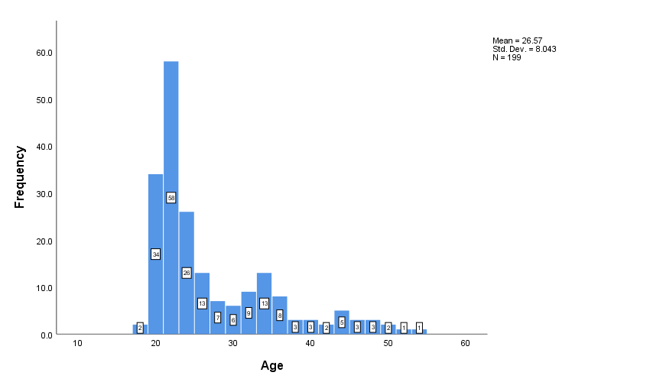
Out of 196 responses
- The minimum age is 18 years. The average age is 26 years

Profession
196 responses
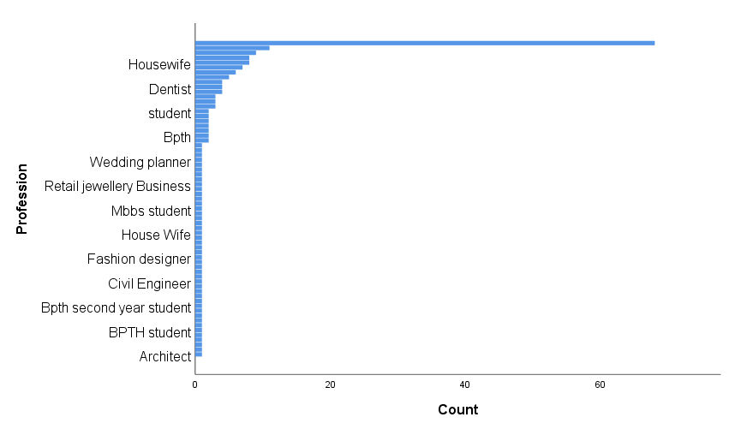

Out of 196 responses

- Maximum number of participants are Students. Max number is 68

Gender
196 responses

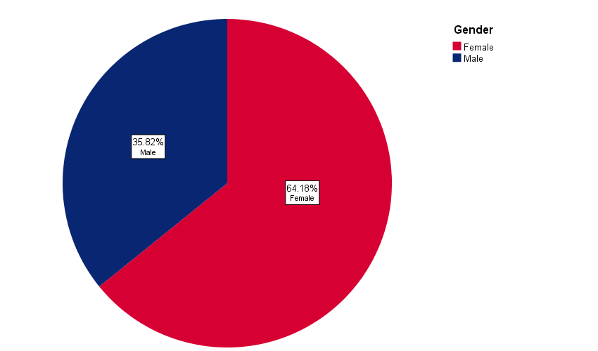
Out of 196 responses

- Total no of responses 196
- 35.82 % are male
- 64.18 % are female

Are you willing to participate in this study?
196 responses

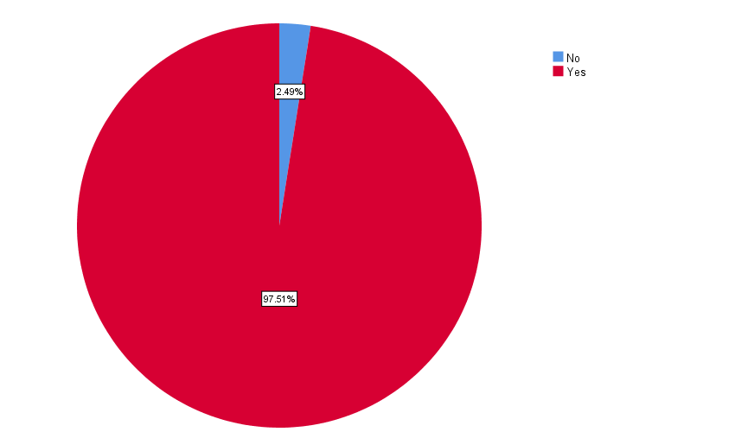

Out of 196 responses

- 2.49 % participants said No
- 97.51 % participants said Yes

Did your work schedule and daily routine change during lockdown?
196 responses

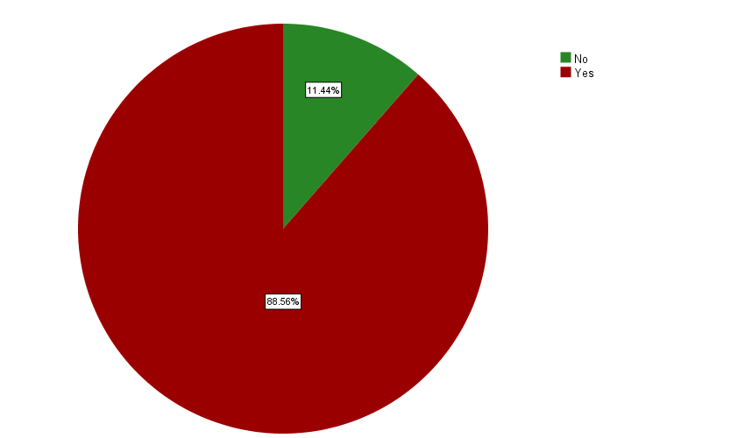

Out of 196 responses

- 11.4 % participants said No
- 88.56 % participants said Yes

I feel tense, nervous, restless or agitated?
196 responses

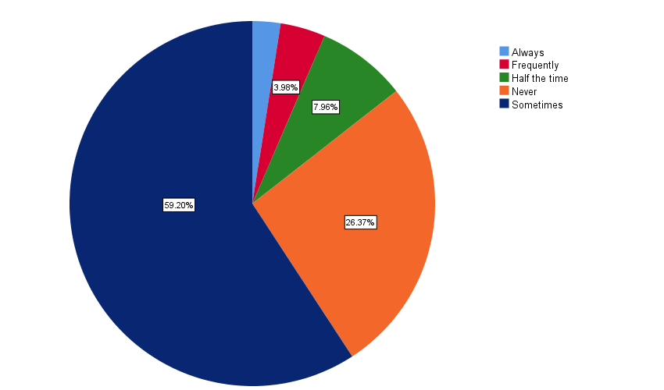
Out of 196 responses

- 3.98% participants said Frequently
- 7.96 % participants said Half the time
- 26.37 % participants said Never
- 59.20 % participants said Sometimes
- 2.49 % participants said Always

I feel afraid for no apparent reason
196 responses

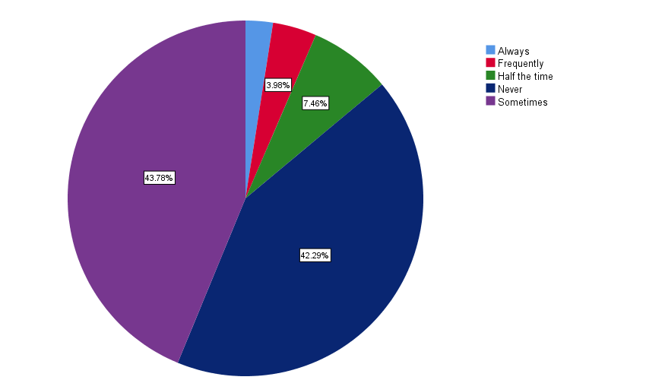
Out of 196 responses

- 3.98% participants said Frequently
- 7.46 % participants said Half the time
- 43.78 % participants said Never
- 59.20 % participants said Sometimes
- 16.91 % participants said Always

I worry about bad things that might happen to me or those I care about
196 responses
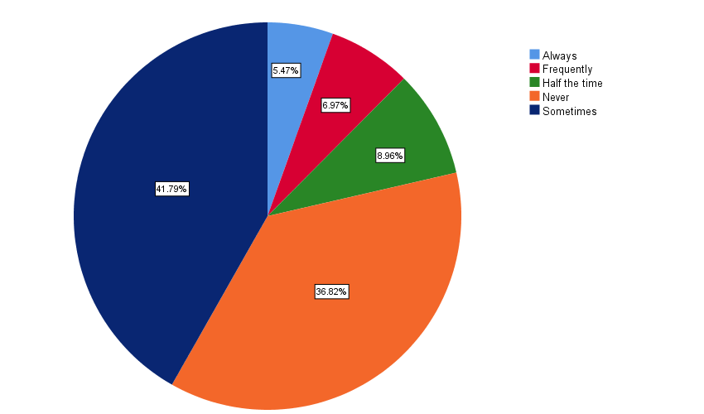
Out of 196 responses

- 6.97% participants said Frequently
- 8.96 % participants said Half the time
- 36.82 % participants said Never
- 41.79 % participants said Sometimes
- 5.47 % participants said Always

I have difficulty falling asleep, staying asleep or waking up early
196 responses
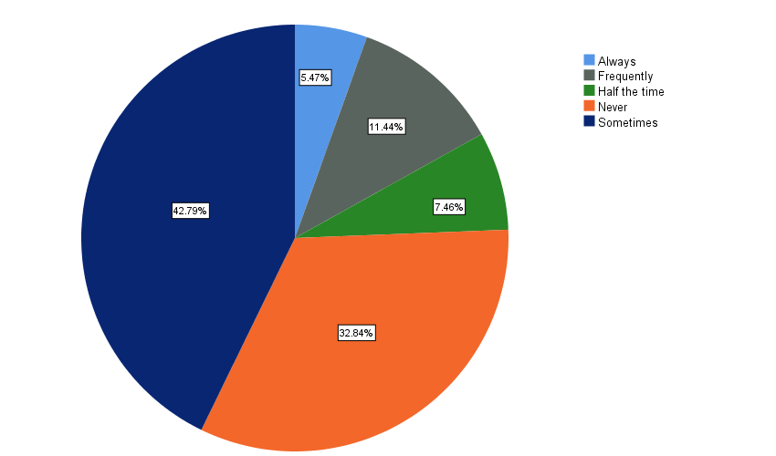

Out of 196 responses

- 11.44% participants said Frequently
- 7.46 % participants said Half the time
- 32.84 % participants said Never
- 42.79 % participants said Sometimes
- 5.47 % participants said Always

I have difficulty eating too much, too little or digesting my food
196 responses

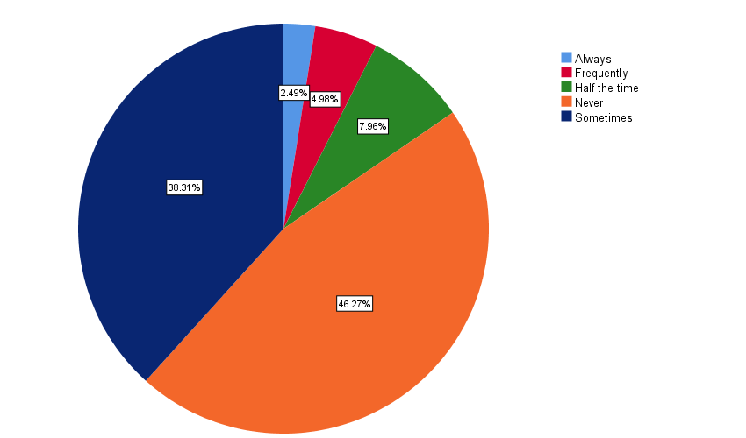

Out of 196 responses

- 4.98% participants said Frequently
- 7.96 % participants said Half the time
- 46.27 % participants said Never
- 38.31 % participants said Sometimes
- 2.49 % participants said Always

I wish I knew a way to make myself more relaxed
196 responses

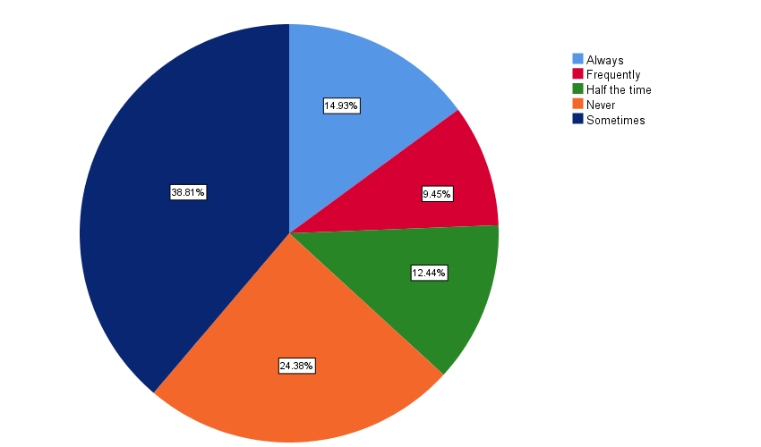

Out of 196 responses

- 9.45% participants said Frequently
- 12.44 % participants said Half the time
- 24.38 % participants said Never
- 38.81 % participants said Sometimes
- 14.93 % participants said Always

I have difficulty with my concentration, memory of thinking
196 responses

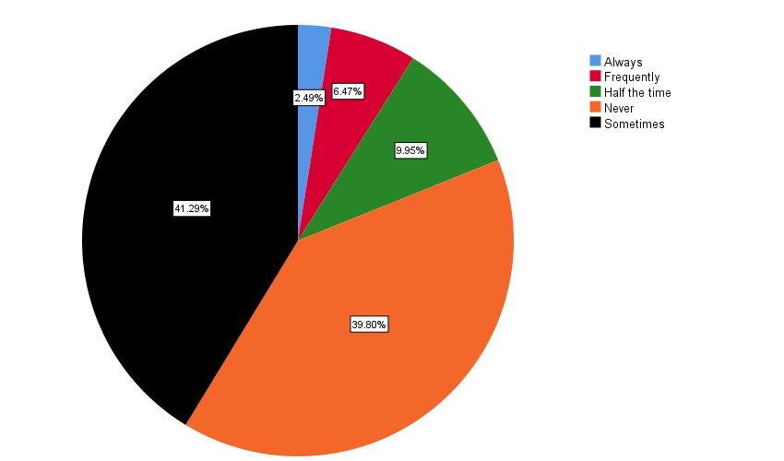

Out of 196 responses

- 6.47% participants said Frequently
- 9.95 % participants said Half the time
- 39.80 % participants said Never
- 41.29 % participants said Sometimes
- 2.49 % participants said Always

I would say I am anxious much of the time
196 responses
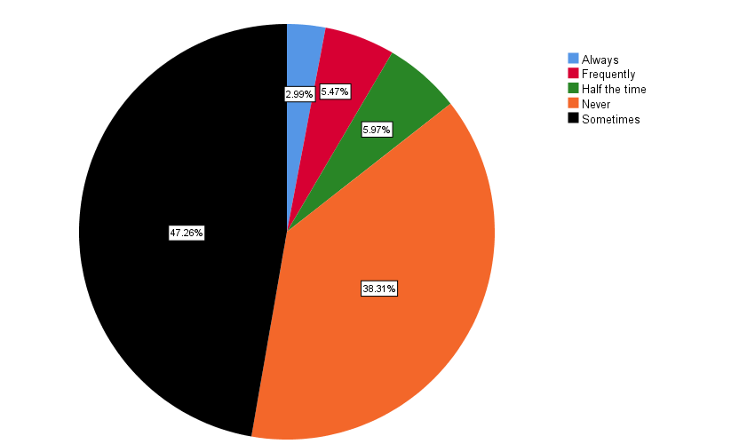
Out of 196 responses

- 5.47% participants said Frequently
- 5.97 % participants said Half the time
- 38.31 % participants said Never
- 47.26 % participants said Sometimes
- 2.99 % participants said Always

From time to time, I have experienced a racing heartbeat, cold hands or feet, dry mouth, sweating, tight muscle difficulty
196 responses
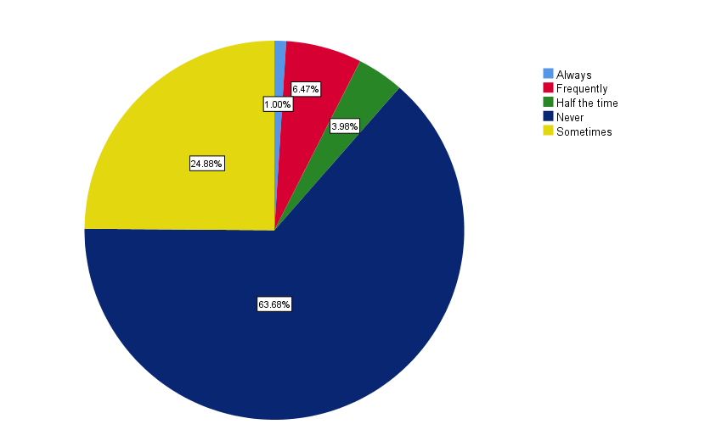

Out of 196 responses

- 6.47% participants said Frequently
- 3.98 % participants said Half the time
- 63.68 % participants said Never
- 24.88 % participants said Sometimes
- 1.00 % participants said Always

I wish I could be as relaxed with myself as other seems to be
196

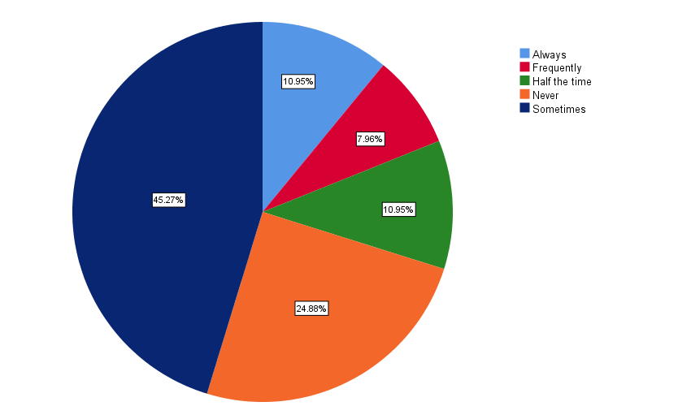

Out of 196 responses

- 7.96% participants said Frequently
- 10.95 % participants said Half the time
- 24.88 % participants said Never
- 45.27 % participants said Sometimes
- 10.95 % participants said Always

I have difficulty falling asleep
196 responses

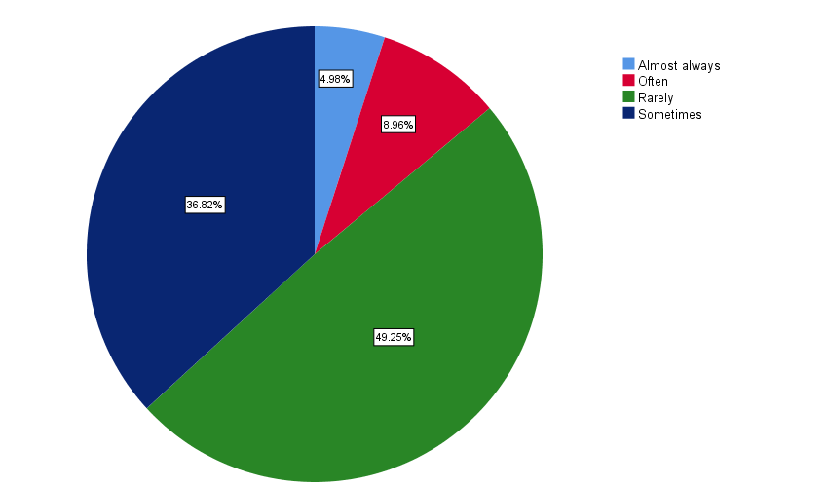

Out of 196 responses

- 4.98% participants said Almost Always
- 8.96 % participants said Often
- 49.25 % participants said Rarely
- 36.82 % participants said Sometimes

I fall into a deep sleep
196 responses

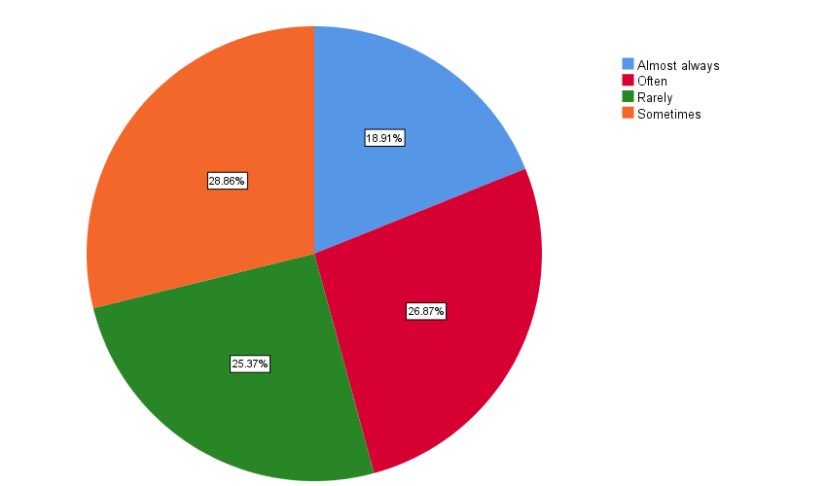
Out of 196 responses

- 18.91% participants said Almost Always
- 26.87 % participants said Often
- 25.37 % participants said Rarely
- 28.86 % participants said Sometimes

I wake while sleeping
196 responses
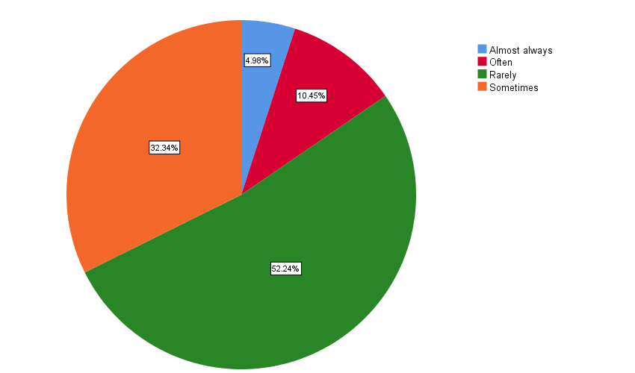

Out of 196 participants
- 4.98 % participants said Almost Always
- 10.45 % participants said Often
- 52.24 % participants said Rarely
- 32.34 % participants said Sometimes

I toss and turn
196 responses
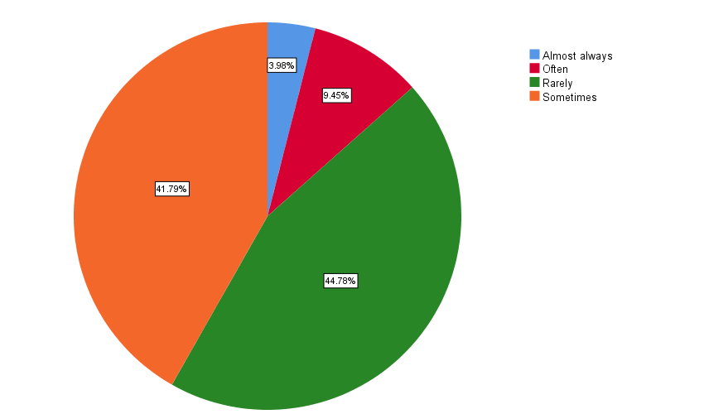

Out of 196 responses

- 3.98 % participants said Almost Always
- 9.45 % participants said Often
- 44.78 % participants said Rarely
- 41.79 % participants said Sometimes

I never go back to sleep after awakening during sleep
196 responses

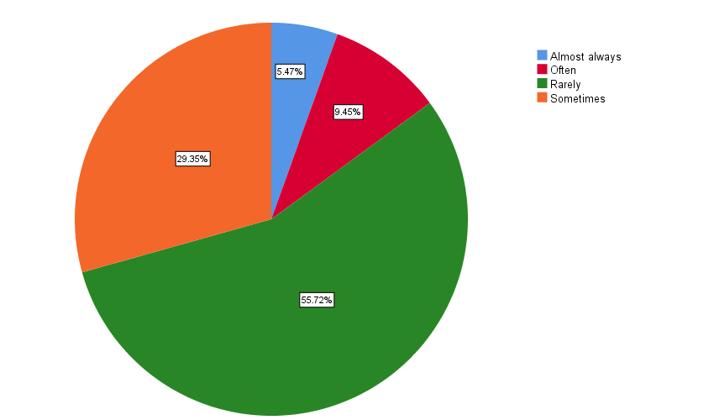

Out of 196 responses

- 5.47 % participants said Almost Always
- 9.45 % participants said Often
- 55.72 % participants said Rarely
- 29.35 % participants said Sometimes

I feel refreshed after sleep
196 responses
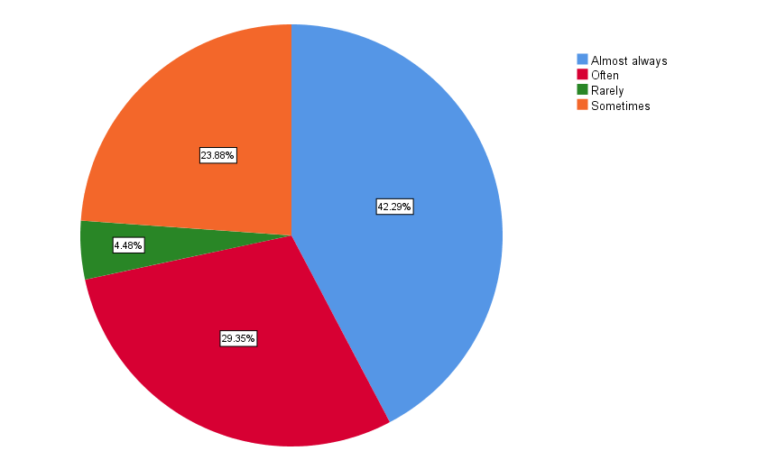
Out of 196 responses

- 42.29 % participants said Almost Always
- 29.35 % participants said Often
- 4.48 % participants said Rarely
- 23.88 % participants said Sometimes

I feel unlikely to sleep after sleep
196 responses

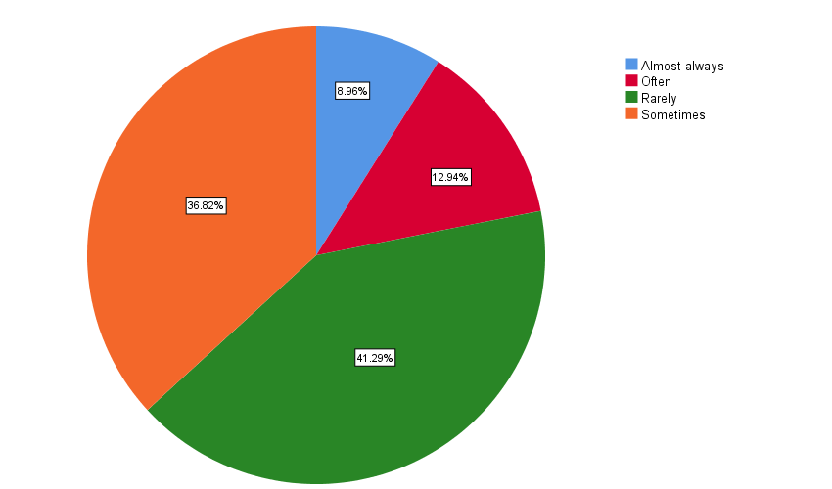

Out of 196 responses

- 8.96 % participants said Almost Always
- 12.94 % participants said Often
- 41.29 % participants said Rarely
- 36.82 % participants said Sometimes

Poor sleep gives me headache
196 responses

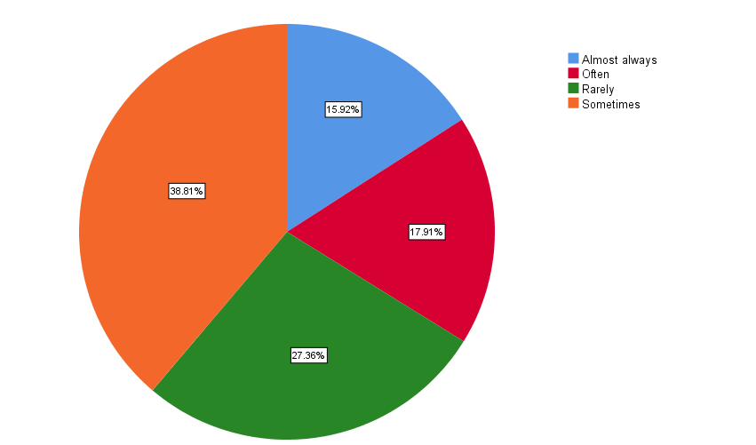

Out of 196 responses

- 15.92 % participants said Almost Always
- 17.91 % participants said Often
- 27.36 % participants said Rarely
- 38.81 % participants said Sometimes

Poor sleeps make me irritated
196 responses

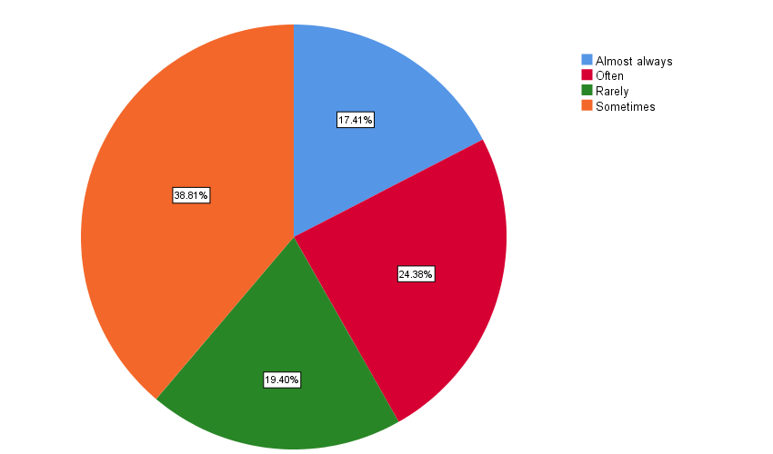
Out of 196 responses

- 17.41 % participants said Almost Always
- 24.38 % participants said Often
- 19.40 % participants said Rarely
- 38.81 % participants said Sometimes

I would like to sleep more after waking up
196 responses

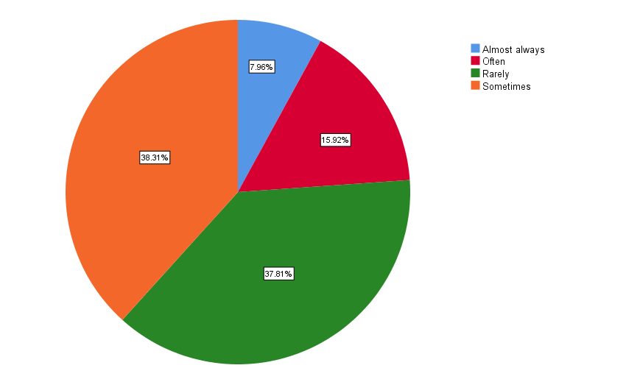

Out of 196 responses

- 7.96 % participants said Almost Always
- 15.92 % participants said Often
- 37.81 % participants said Rarely
- 38.31 % participants said Sometimes

My sleep hours are enough
196 responses
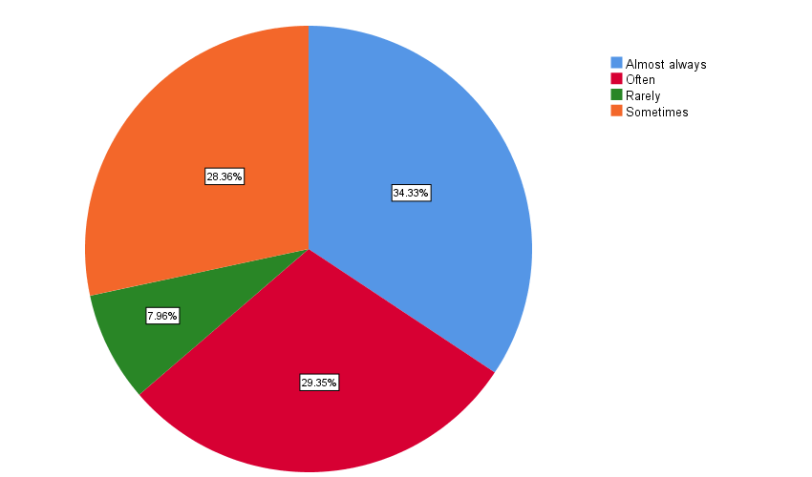

Out of 196 responses

- 34.33 % participants said Almost Always
- 29.35 % participants said Often
- 7.96 % participants said Rarely
- 28.36 % participants said Sometimes

Poor sleeps make me lose my appetite
196 responses
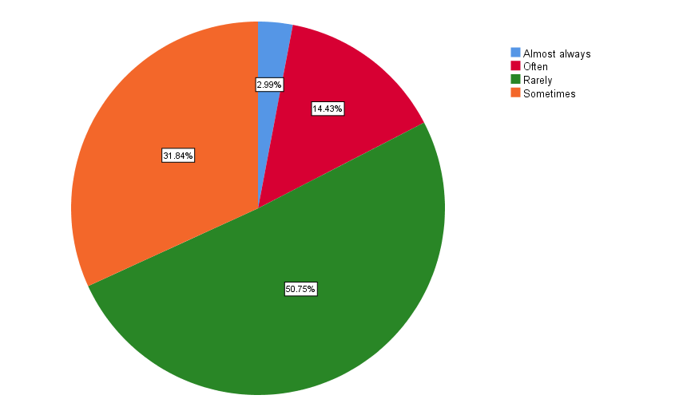

Out of 196 responses

- 2.99 % participants said Almost Always
- 14.43 % participants said Often
- 50.75 % participants said Rarely
- 31.84 % participants said Sometimes

Poor sleeps makes hard for me to thin
196 responses
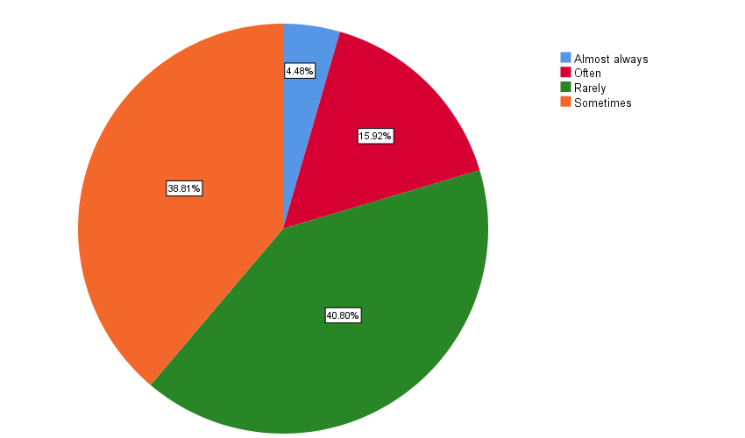
Out of 196 responses

- 4.48 % participants said Almost Always
- 15.92 % participants said Often
- 40.80 % participants said Rarely
- 38.81 % participants said Sometimes

I feel vigorous after sleep
196 responses

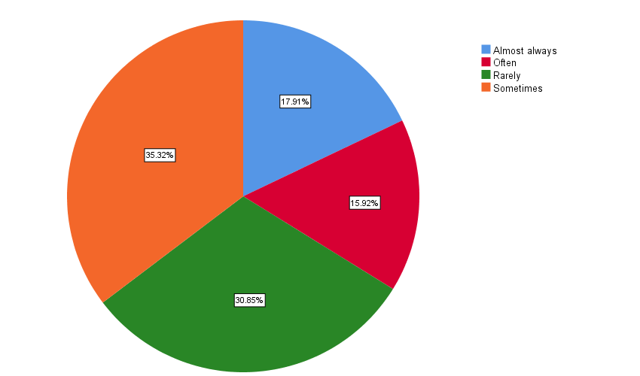

Out of 196 responses

- 17.91 % participants said Almost Always
- 15.92 % participants said Often
- 30.85 % participants said Rarely
- 35.32 % participants said Sometimes

Poor sleep makes me loose interest in work or others
196 responses

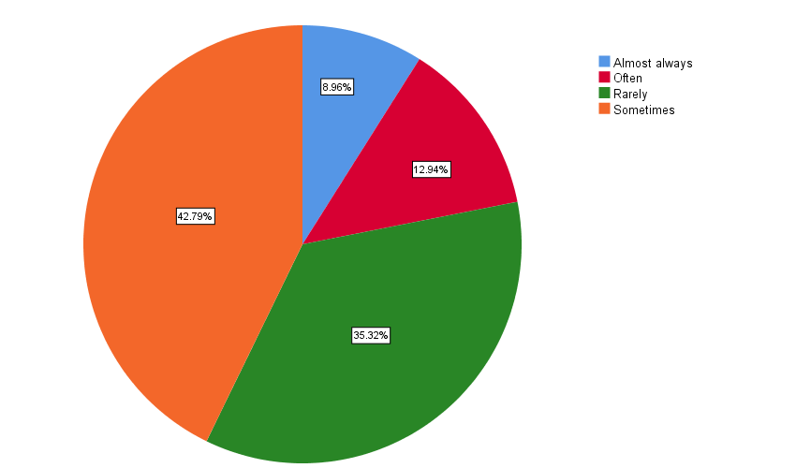

Out of 196 responses

- 8.96 % participants said Almost Always
- 12.94 % participants said Often
- 35.32 % participants said Rarely
- 42.79 % participants said Sometimes

My fatigue is relieved after sleep
196 responses

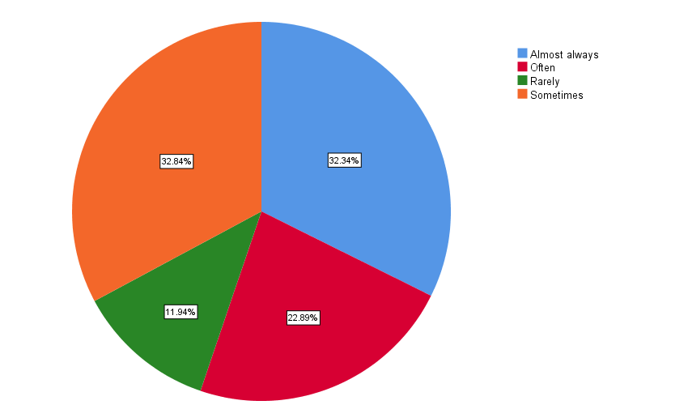

Out of 196 responses

- 32.34 % participants said Almost Always
- 22.89 % participants said Often
- 11.94 % participants said Rarely
- 32.84 % participants said Sometimes

Poor sleeps causes me to make mistake at work
196 responses

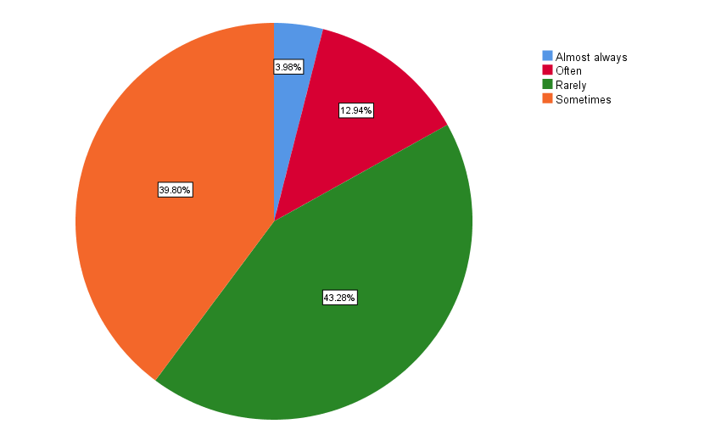

Out of 196 responses

- 3.98 % participants said Almost Always
- 12.94 % participants said Often
- 43.28 % participants said Rarely
- 39.80 % participants said Sometimes

I am satisfied with my sleep
196 responses

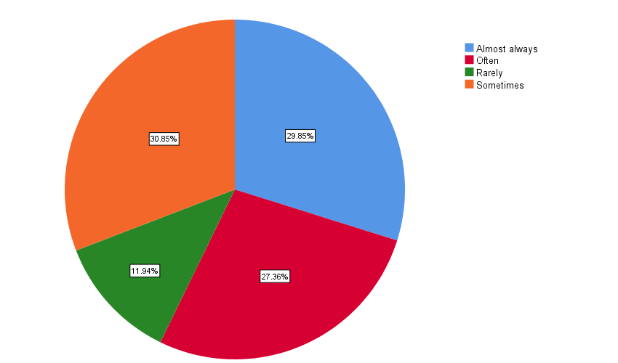

Out of 196 responses

- 29.85 % participants said Almost Always
- 27.36 % participants said Often
- 11.94 % participants said Rarely
- 30.85 % participants said Sometimes

Poor sleep makes me forget things more easily
196 responses

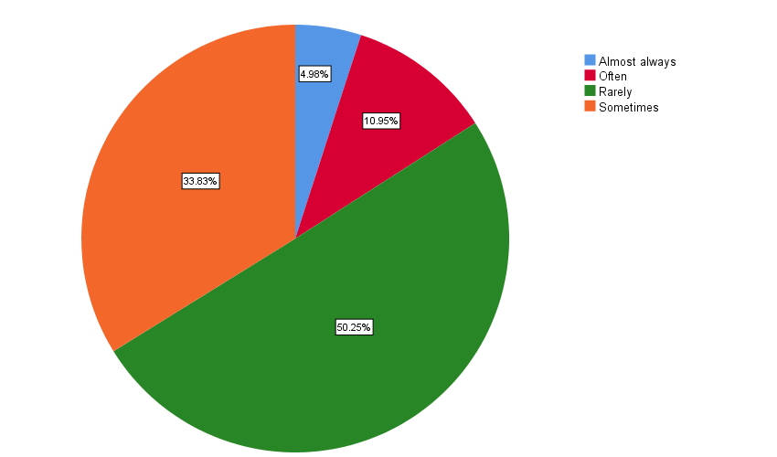

Out of 196 responses

- 4.98 % participants said Almost Always
- 10.95 % participants said Often
- 50.25 % participants said Rarely
- 33.83 % participants said Sometimes

Poor sleep makes it hard to concentrate at work
196 responses

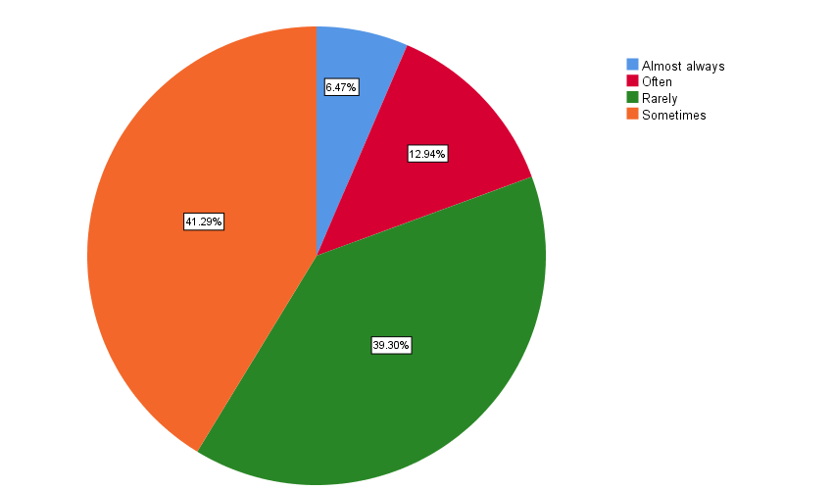

Out of 196 responses

- 6.47 % participants said Almost Always
- 12.94 % participants said Often
- 39.30 % participants said Rarely
- 41.29 % participants said Sometimes

Sleepiness interferes with my daily life
196 responses

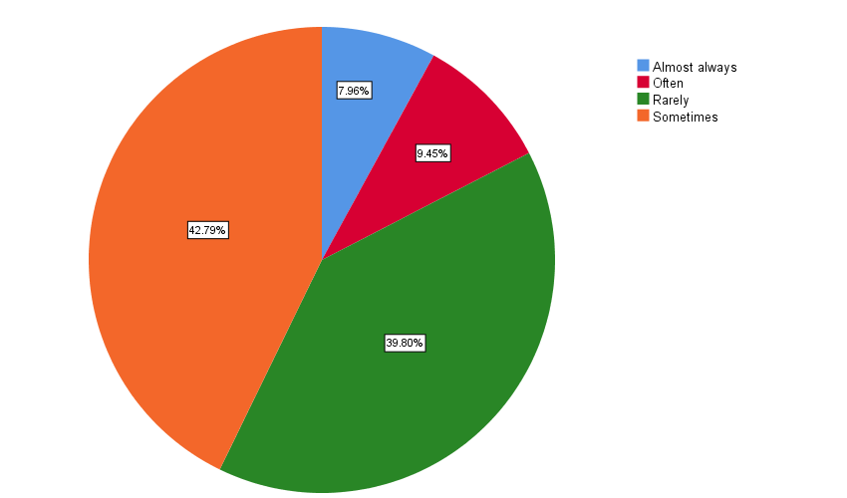

Out of 196 responses

- 7.96 % participants said Almost Always
- 9.45 % participants said Often
- 39.80 % participants said Rarely
- 42.79 % participants said Sometimes

Poor sleep makes me lose desire in all the things
196 responses
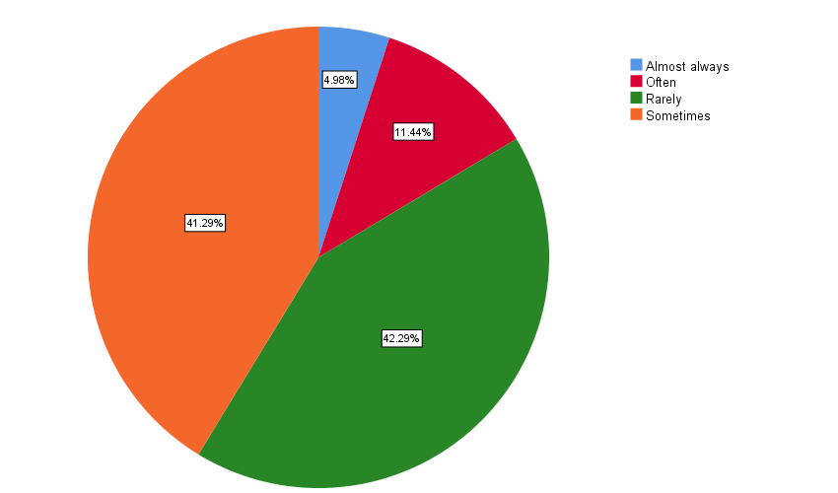

Out of 196 responses

- 4.98 % participants said Almost Always
- 11.44 % participants said Often
- 42.29 % participants said Rarely
- 41.29 % participants said Sometimes

I have difficulty getting out of the bed
196 responses
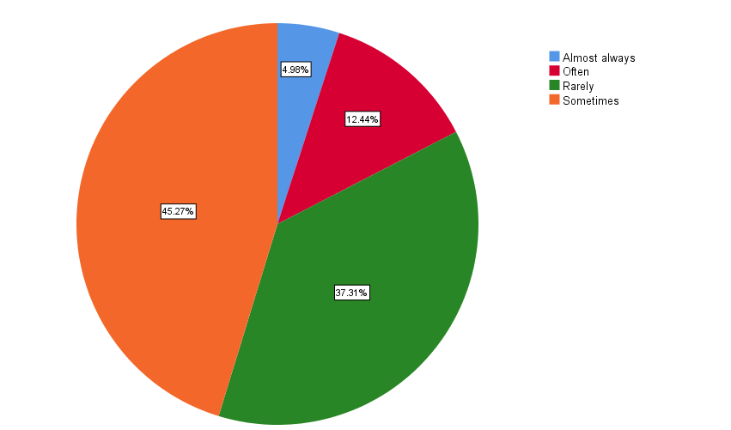

Out of 196 responses

- 4.98 % participants said Almost Always
- 12.44 % participants said Often
- 37.31 % participants said Rarely
- 45.27 % participants said Sometimes

Poor sleep makes me easily tired at work
196 responses
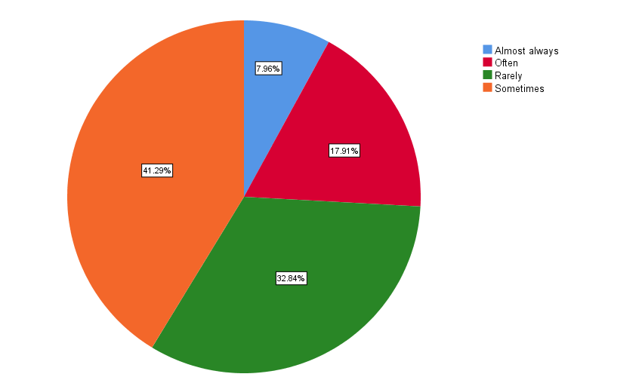

Out of 196 responses

- 7.96 % participants said Almost Always
- 17.91 % participants said Often
- 32.84 % participants said Rarely
- 41.29 % participants said Sometimes

I have a clear head after sleep
196 responses

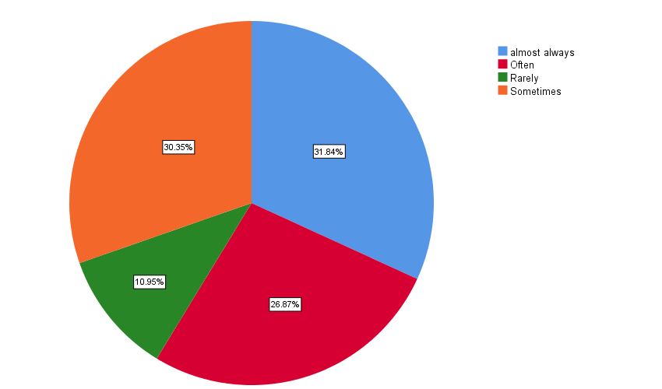

Out of 196 responses

- 31.84 % participants said Almost Always
- 26.97 % participants said Often
- 10.95 % participants said Rarely
- 30.35 % participants said Sometimes

Poor sleep makes my life painful
196 responses
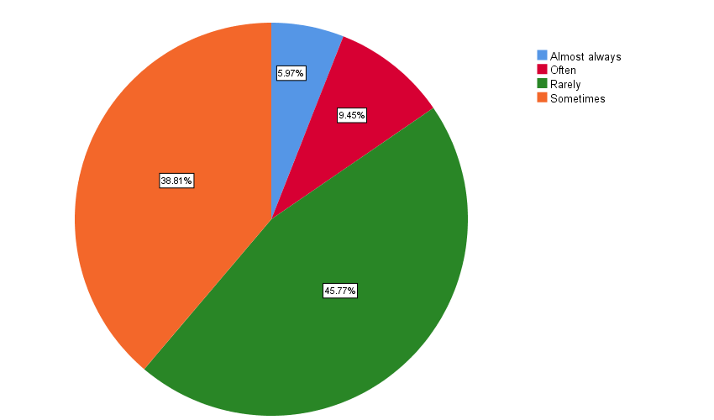

Out of 196 responses

- 5.97 % participants said Almost Always
- 9.45 % participants said Often
- 45.77 % participants said Rarely
- 38.81 % participants said Sometimes

