Natural Hazards
Electronic supplementary material to
Retrospective study of FinDer algorithm during the 2019, Ridgecrest earthquake sequence
Wei Huang^{1*}
* Correspondence:
Wei Huang
hwcxr2008@126.com
¹Institute of Engineering Mechanics, China Earthquake Administration, Harbin, China
¹Present address: No. 29 Xuefu Road, Harbin, Heilongjiang 150080, China

We investigate the retrospective real time alert performance of FinDer during 2019 , Ridgecrest earthquake sequence, which includes 8 events with magnitude M ≥ 5.0. In this issue, we explore the potential reliability of FinDer algorithm to generate alerts for early warning purpose. As an important supplement to the main text, this file contains temporal results of finite source solution for M_{w}6.4 and M_{w} 5.4 events. Applying different choices of alert criteria, the classification performance for three main events including M_{w} 7.1, M_{w}6.4 and M_{w} 5.4 events and the total earthquake sequence, empirical cumulative distribution as a function of warning time for three main events.

FIGURE CAPTIONS
Fig. A1 Retrospective alert performance for M_{w}6.4 Ridgecrest, California earthquake without data processing and alert transmission latency. (a)-(f), FinDer detects the event 3.5 s after origin time and updates source parameters estimates in 0.5 s interval for about 13.5 s; The black lines show the optimum line-source model determined by FinDer at certain point of time. The yellow star marks the epicenter. We use squares to denote sites that would have been alerted since the maximum predicted ground motion intensities has overcome the alert threshold of MMI_{alert} = 3.5 using the GMPEs of BA08 (Boore et al., 2008; Atkinson and Boore, 2011) and the GMICE of Wald et al. (1999) assuming rock condition. The triangles are sites that have not yet received alert.
Fig. A2 Follows the Fig. A1, FinDer performance for the M_{w}5.4 event without data processing and alert transmission latency.
Fig. A3 (a)-(d), Real-time alert classification results for the three respective events and the total earthquake sequence by applying the alert criterion of MMI_{alert} = 2.5, 3.5, and 4.5, the damage threshold is equivalent to the corresponding alert threshold. Each site is colored according to the warning time; Quadrants are classified as true positive (TP), true negative (TN), false positive (FP), or false negative (FN). The bars at the bottom show the factions of case for true and false alerts; Blue lines in figure (d) give 5th, 50th, and 95th percentiles in intensity bins of observed MMI intensity.
Fig. A4 Follows Fig. A3, but the damage threshold is set to MMI 4.5.
Fig. A5 (a)-(c), Empirical cumulative distribution functions (CDF) as a function of warning times for sites that should have been alerted in different ground motion intensity bins (2.5:1:9.5) for three respective events. The results are shown for three different alert threshold, the damage threshold is equivalent to the corresponding alert threshold. The distribution curves are colored to the observed peak ground motion for corresponding intensity bin. The legend in each figure gives the number of correctly alerted sites and the total recorded sites in each bin.
Fig. A6 (a)- (c), Follows Figure A5, but the damage threshold is set to MMI 4.5.

FIGURES
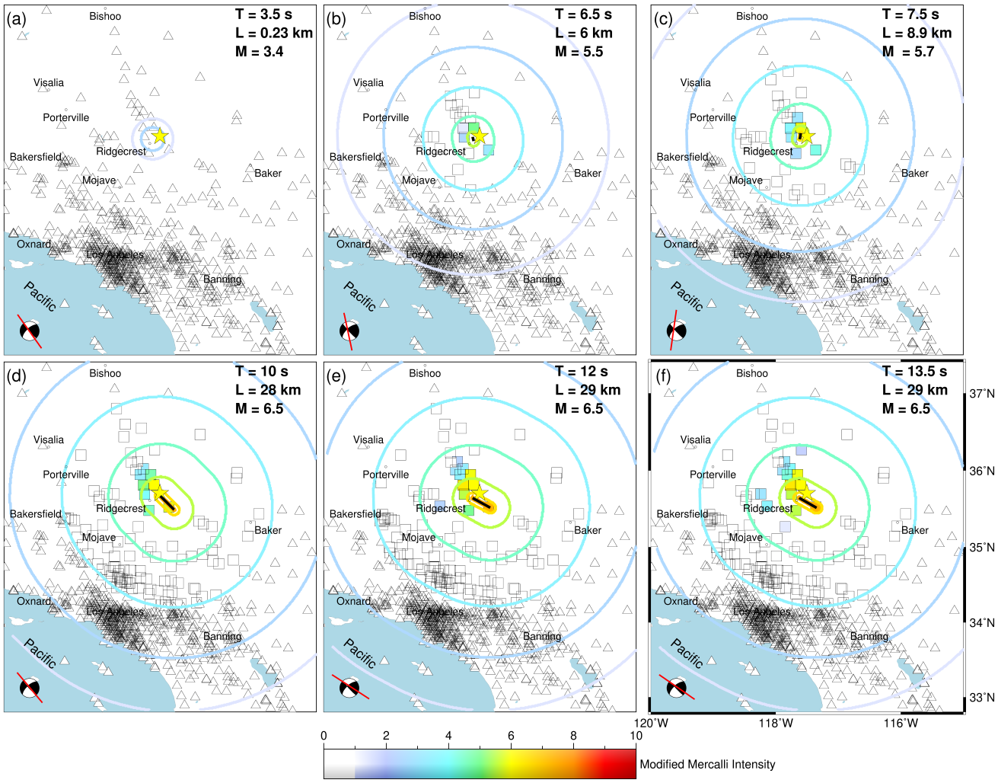
Fig. A1 Retrospective alert performance for M_{w}6.4 Ridgecrest, California earthquake without data processing and alert transmission latency. (a)-(f), FinDer detects the event 3.5 s after origin time and updates source parameters estimates in 0.5 s interval for about 13.5 s; The black lines show the optimum line-source model determined by FinDer at certain point of time. The yellow star marks the epicenter. We use squares to denote sites that would have been alerted since the maximum predicted ground motion intensities has overcome the alert threshold of MMI_{alert} = 3.5 using the GMPEs of BA08 (Boore et al., 2008; Atkinson and Boore, 2011) and the GMICEs of Wald et al. (1999) assuming rock condition. The triangles are sites that have not yet received alert.
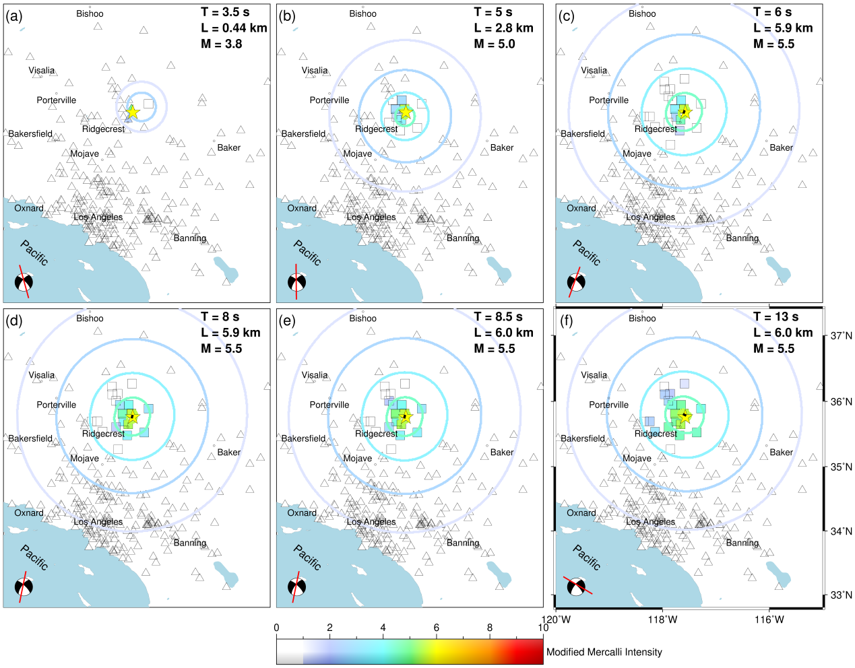
Fig. A2 Follows the Fig. A1, FinDer performance for the M_{w}5.4 event without data processing and alert transmission latency.

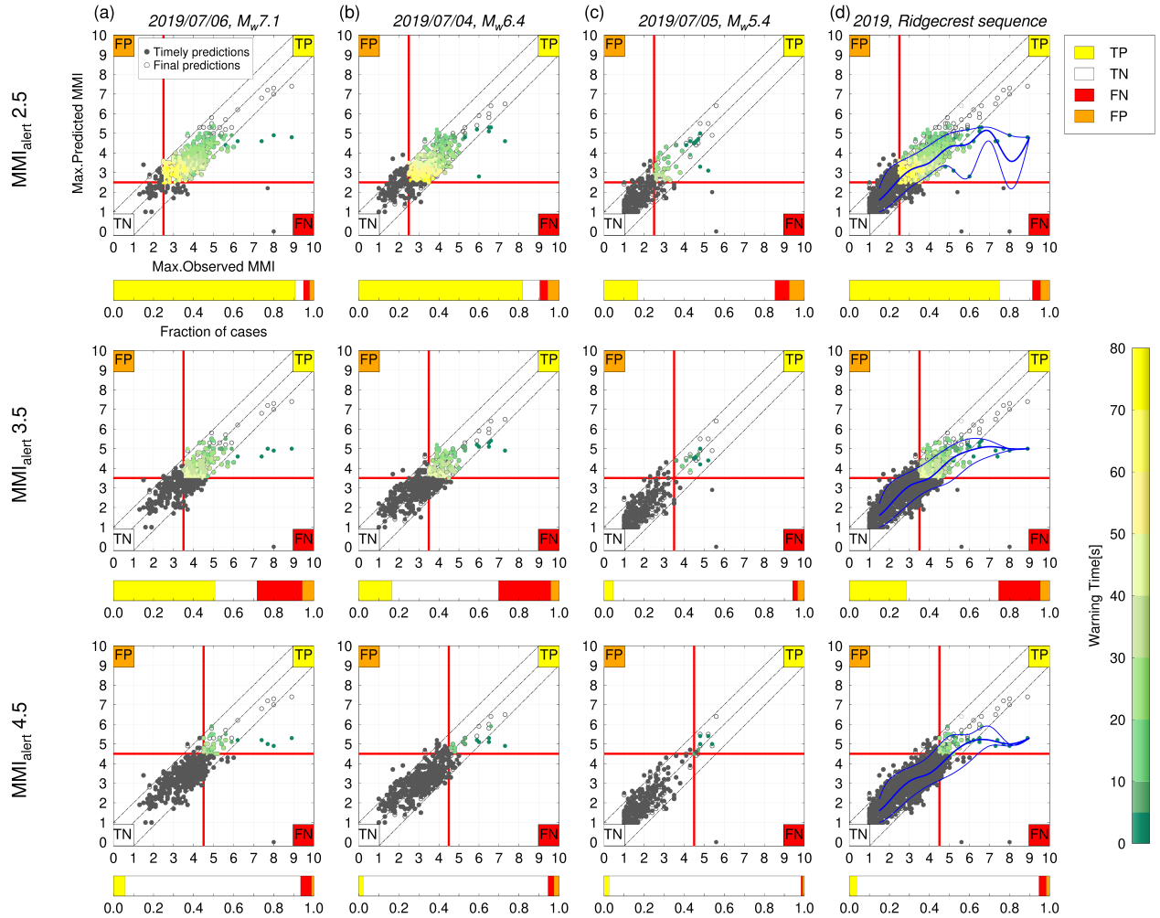
Fig. A3 (a)-(d), Real-time alert classification results for the three respective events and the total earthquake sequence by applying the alert criterion of MMI_{alert} = 2.5, 3.5, and 4.5, the damage threshold is equivalent to the corresponding alert threshold. Each site is colored according to the warning time; Quadrants are classified as true positive (TP), true negative (TN), false positive (FP), or false negative (FN). The bars at the bottom show the factions of case for true and false alerts; Blue lines in figure (d) give 5th, 50th, and 95th percentiles in intensity bins of observed MMI intensity.

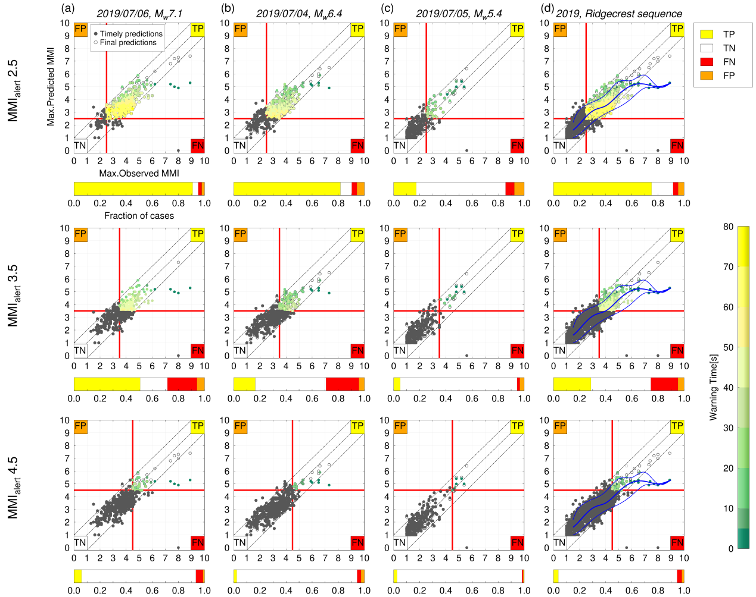
Fig. A4 Follows Fig. A3, but the damage threshold is set to MMI 4.5.

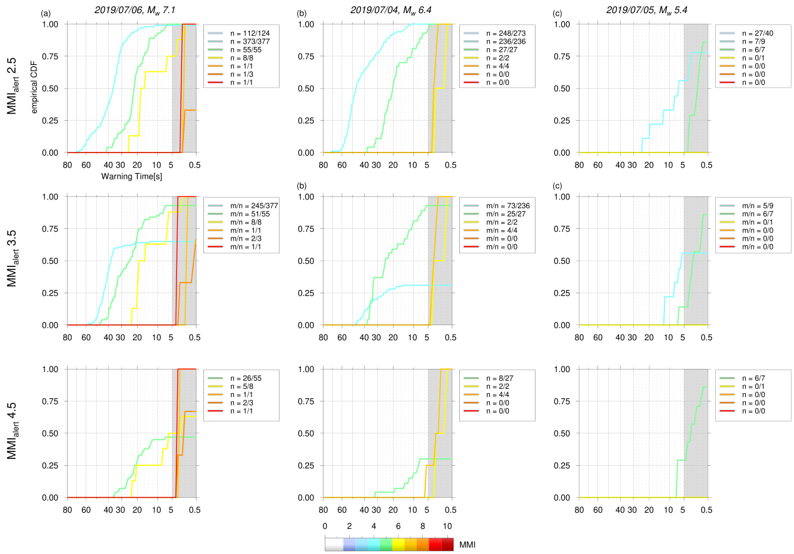
Fig. A5 (a)-(c), Empirical cumulative distribution functions (CDF) as a function of warning times for sites that should have been alerted in different ground motion intensity bins (2.5:1:9.5) for three respective events. The results are shown for three different alert threshold, the damage threshold is equivalent to the corresponding alert threshold. The distribution curves are colored to the observed peak ground motion for corresponding intensity bin. The legend in each figure gives the number of correctly alerted sites and the total recorded sites in each bin.

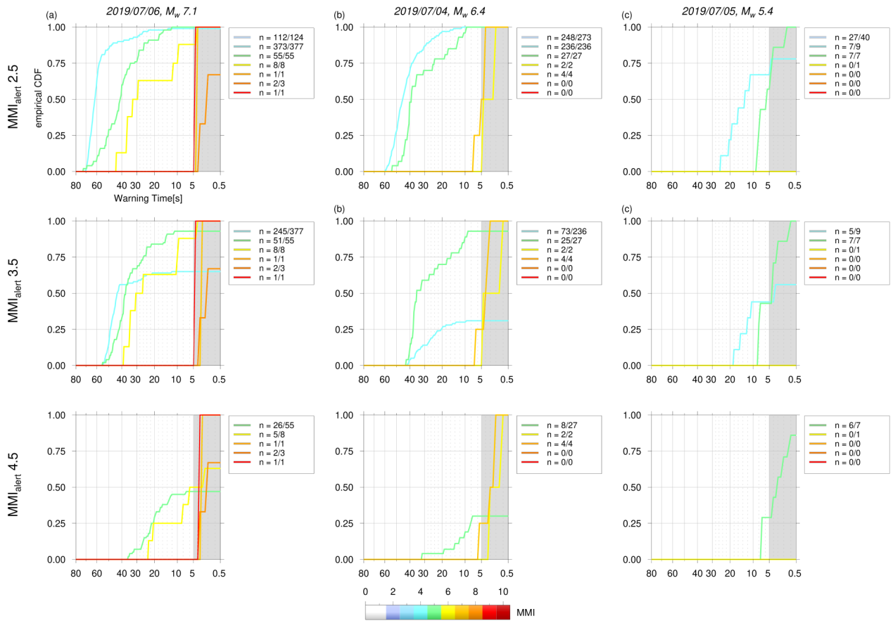
Fig. A6 (a)-(c), Follows Fig. A5, but the damage threshold is set to MMI 4.5.

