Viscosity-sensitive emission of anionic hydrogen-bonded urea-derivative–acetate-ion complexes and their aggregation-induced emission enhancement

Masaki Takahashi*, Nozomu Ito, Hayato Ninagawa, Kohei Yazaki, Yoshihisa Sei, and Makoto Obata

Table of Contents:
1. Materials....................................................................................................... S2
2. Syntheses..................................................................................................... S2
3. Supplementary Tables and Figures (Tables S1–S11 and Figures S1-S23). S4
4. Supplementary References........................................................................ S37

- Materials
All chemicals were purchased from Kanto Kagaku Co., Ltd., TCI chemicals, or
Sigma-Aldrich, and used without further purification. Solvents for spectroscopic studies were of spectroscopic grade. Tetrabutylammonium acetate was purchased from Sigma-Aldrich.

- Syntheses
Synthesis of 1,8-bis(4’-anilino)naphthalene¹
A solution of 1,8-diiodonaphthalene (490 mg, 1.29 mmol), 4-aminophenylboronic acid pinacol ester (726 mg, 3.31 mmol), trans-(Cy₂NH)₂Pd(OAc)₂ (195 mg, 0.332 mmol), and NaOH (239 mg, 5.98 mmol) was stirred in 9 mL of an ethanol:toluene:water (1:1:1) solution at 95 °C under N₂ for 24 h. The resulting mixture was allowed to reach room temperature before undergoing celite filtration. The resulting reaction mixture was extracted with ethyl acetate three times and washed with water and brine. The separated organic layer was dried with anhydrous Na₂SO₄ and the solvent was removed under reduced pressure. The residue was purified via silica-gel column chromatography using an ethyl acetate:ethanol = 95:5 solution as the eluent to yield the product as a brown viscous liquid (266 mg, 0.857 mmol, 67% yield).

Synthesis of p-2urea
A solution of 1,8-bis(4’-anilino)naphthalene (195 mg, 0.628 mmol) and 4-tert-butylphenyl isocyanate (339 mg, 1.93 mmol) was stirred into 20 mL of tetrahydrofuran:N,N-dimethylformamide (3:1) at room temperature under N₂ for 4 h. The resulting mixture was extracted with ethyl acetate three times and washed with water and brine. The separated organic layer was dried with anhydrous Na₂SO₄, and the solvent was removed under reduced pressure. The residue was collected by filtration and washed with acetone to yield p-2urea as a white powder (316 mg, 0.478 mmol, 75% yield). ¹H NMR (500 MHz, DMSO-d₆): δ 8.40 (d, 10 Hz, 4H), 8.00 (d, 9.5 Hz, 2H), 7.59 (t, 15.5 Hz, 2H), 7.38 (d, 8Hz, 2H), 7.29 (d, 9.0 Hz, 4H), 7.23 (d, 7 Hz 4H), 7.07 (d, 8.5 Hz,4H), 6.85 (d, 8.5 Hz, 4H), 1.24 (s,18H) ppm; ¹³C NMR (500 MHz, DMSO-d₆): δ 152.54, 144.10, 139.96, 137.72, 137.22, 136.32, 135.43, 130.72, 129.81, 128.79, 128.24, 125.43, 118.23, 116.83, 34.00, 31.42 ppm. Single crystals of p-2urea for single-crystal X-ray diffraction analysis were obtained by vapour diffusion of diethyl ether into a DMSO solution.

Synthesis of 1,8-bis(3’-anilino)naphthalene
A solution of 1,8-diiodonaphthalene (490 mg, 1.29 mmol), 3-aminophenylboronic acid pinacol ester (726 mg, 3.31 mmol), trans-(Cy₂NH)₂Pd(OAc)₂ (194 mg, 0.330 mmol), and NaOH (250 mg, 6.25 mmol) were stirred into 9 mL of an ethanol:toluene:water (1:1:1) solution at 95 °C under N₂ for 24 h. The resulting mixture was allowed to reach room temperature and then underwent celite filtration. The resulting reaction mixture was extracted with ethyl acetate three times and washed with water and brine. The separated organic layer was dried with anhydrous Na₂SO₄ and the solvent was removed under reduced pressure. The residue was purified via silica-gel column chromatography using an ethyl acetate:ethanol = 95:5 solution as the eluent to yield the product as a brown viscous liquid (270 mg, 0.869 mmol, 67% yield). This material was used in the following step without further purification.

Synthesis of m-2urea
A solution of 1,8-bis(3’-anilino)naphthalene (234 mg, 0.754 mmol) and 4-tert-butylphenyl isocyanate (253 mg, 1.45 mmol) was stirred into 7.2 mL of dehydrated tetrahydrofuran at 76 °C under N₂ overnight. After the solvent was removed under reduced pressure, the residue was collected by filtration and washed with acetone to yield m-2urea as a white powder (290 mg, 0.438 mmol, 58% yield). ¹H NMR (500 MHz, DMSO-d₆): δ8.46 (s, 1H), 8.31 (s, 1H), 8.22 (s, 2H), 8.06 (d, J = 8.2 Hz, 2H), 7.62 (t, J = 7.8 Hz, 2H), 7.43 (d, J = 6.9 Hz, 2H), 7.34 (d, J = 8.5 Hz, 2H), 7.27 (d, J = 8.5 Hz, 2H), 7.13-7.19 (m, 5H), 7.00-6.93 (m, 4H), 6.90 (s, 1H), 6.83 (t, J = 7.7 Hz, 1H), 6.76 (d, J = 6.7 Hz, 1H), 6.56 (d, J = 7.5 Hz, 1H), 1.25 (s, 9H), 1.23 (s, 9H) ppm; ¹³C NMR (500 MHz, DMSO-d₆): δ152.86, 152.81, 144.45, 144.24, 143.32, 140.44, 138.90, 138.81, 137.61, 137.43, 135.59, 130.95, 130.84, 128.96, 127.98, 127.72, 125.83, 125.80, 125.59, 122.98, 122.87, 120.20, 119.70, 118.58, 118.38, 116.07, 34.34, 34.27, 31.72 ppm; HRMS (ESI) exact mass calculated for [M]+ (C₄₄H₄₄N₄O₂) requires m/z 660.3464, found m/z 660.3459.

p-1urea was synthesised by following the method reported in our previous paper².

- Supplementary Tables and Figures

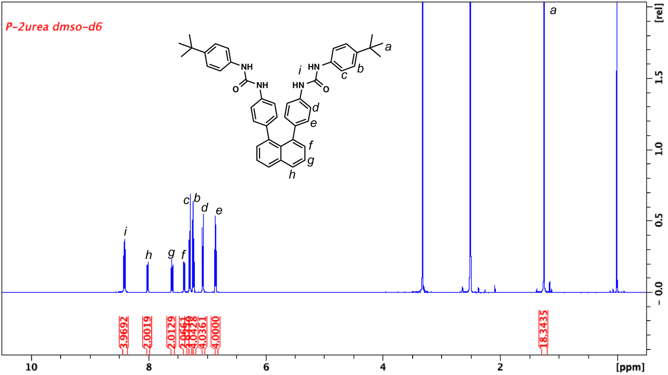
Supplementary Figure 1. ¹H NMR spectrum of p-2urea in DMSO-d₆.

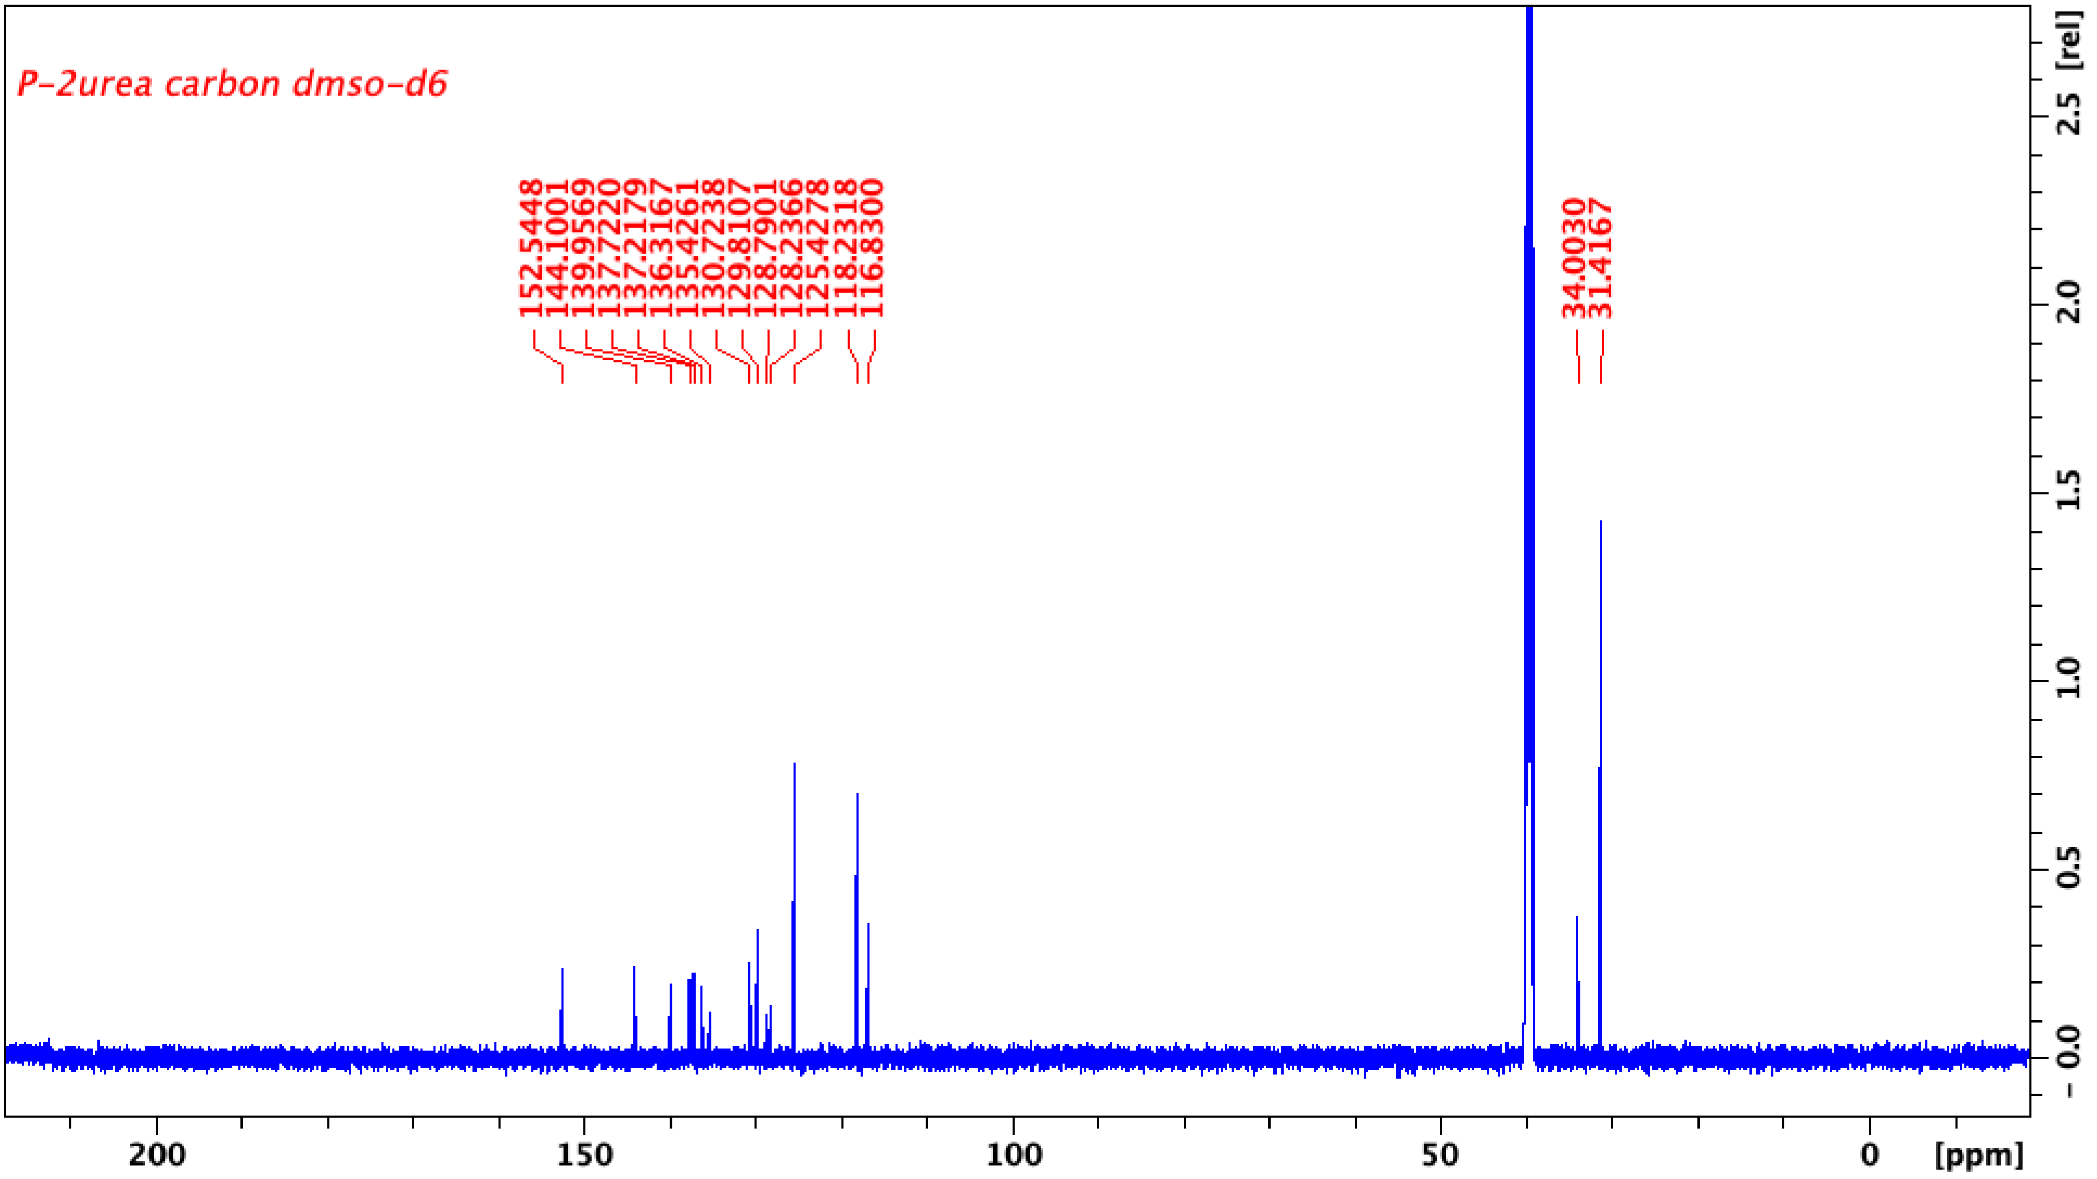
Supplementary Figure 2. ¹³C NMR spectrum of p-2urea in DMSO-d₆.

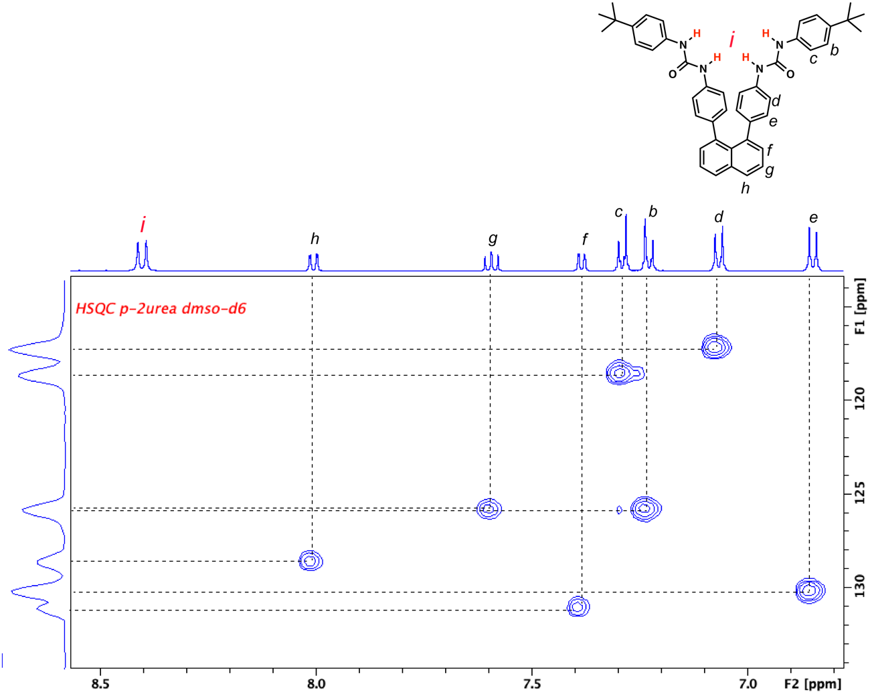
Supplementary Figure 3. Heteronuclear single quantum correlation (HSQC) spectrum of p-2urea in DMSO-d₆.
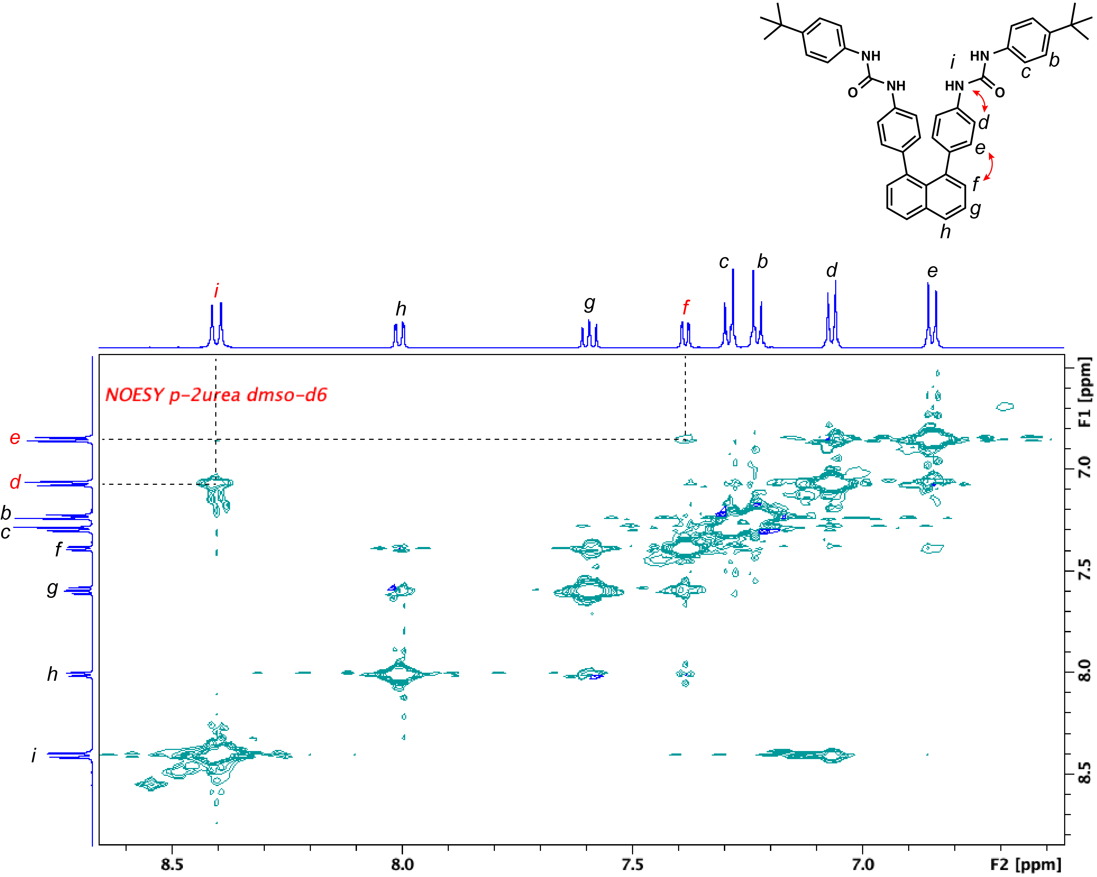
Supplementary Figure 4. Nuclear Overhauser effect spectroscopy (NOESY) results for p-2urea in DMSO-d₆.

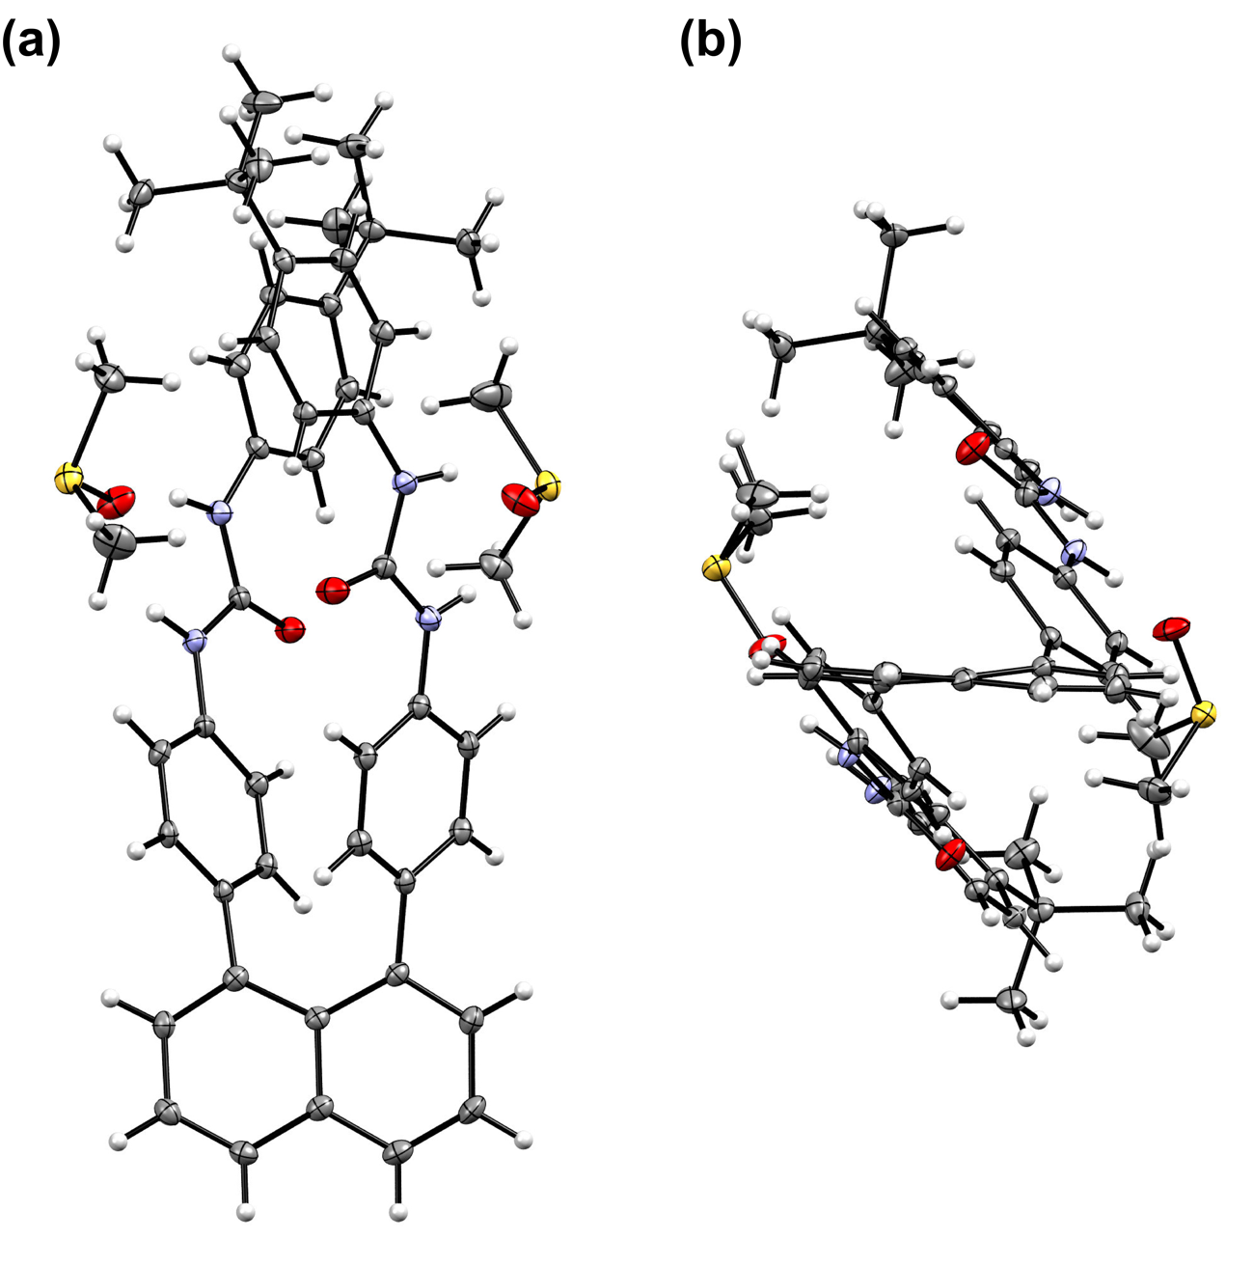
Supplementary Figure 5. (a) Top and (b) side views of the molecular structure of p-2urea hydrogen-bonded to the S=O groups of DMSO. Thermal ellipsoids are drawn at the 50% probability level.

Supplementary Table 1. Crystal data and structure refinement for p-2urea
Chemical formula Sum | C₄₈H₅₆N₄O₂
Formula weight | 817.08 g/mol
Temperature | 90 K
Crystal system | Orthorhombic
Space group | Pna2₁
a | 21.163(3) Å
b | 15.142(4) Å
c | 13.580(2) Å
α | 90°
β | 90°
γ | 90°
Volume | 4351.9(12) Å³
Z | 4
Reflection | 25690
Unique reflection | 9232
Goodness-of-fit on F² | 1.042
Final R indices [I > 2σ(I)], R1, wR2 | R1 = 0.0439, wR2 = 0.1260
R indices (all data), R1, wR2 | R1 = 0.0468, wR2 = 0.1288

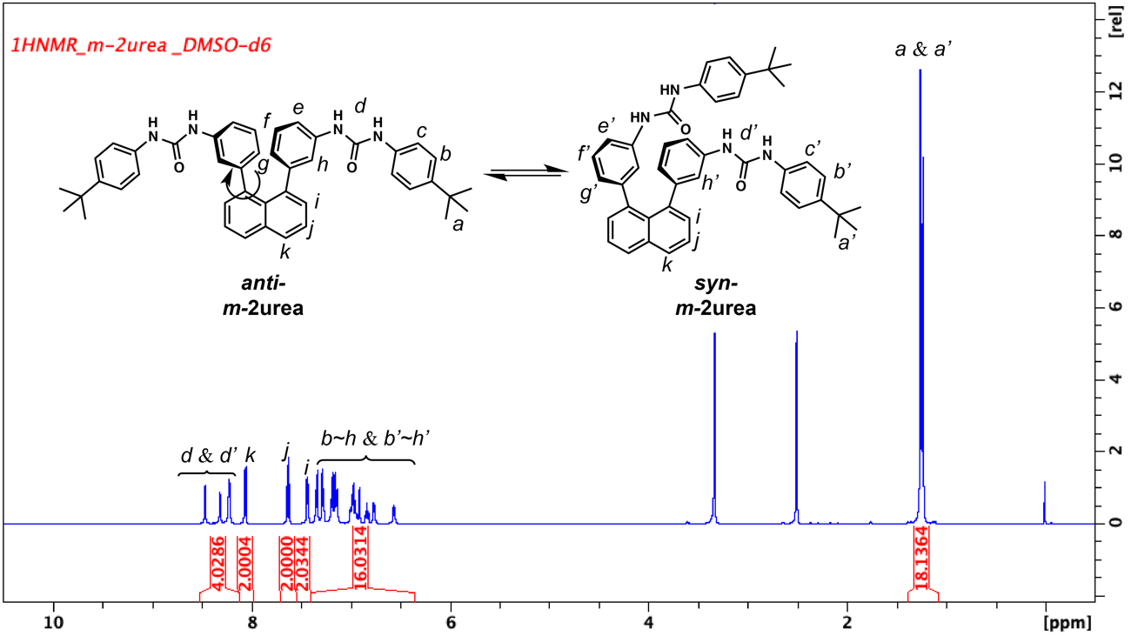
Supplementary Figure 6. ¹H NMR spectrum of m-2urea in DMSO-d₆.

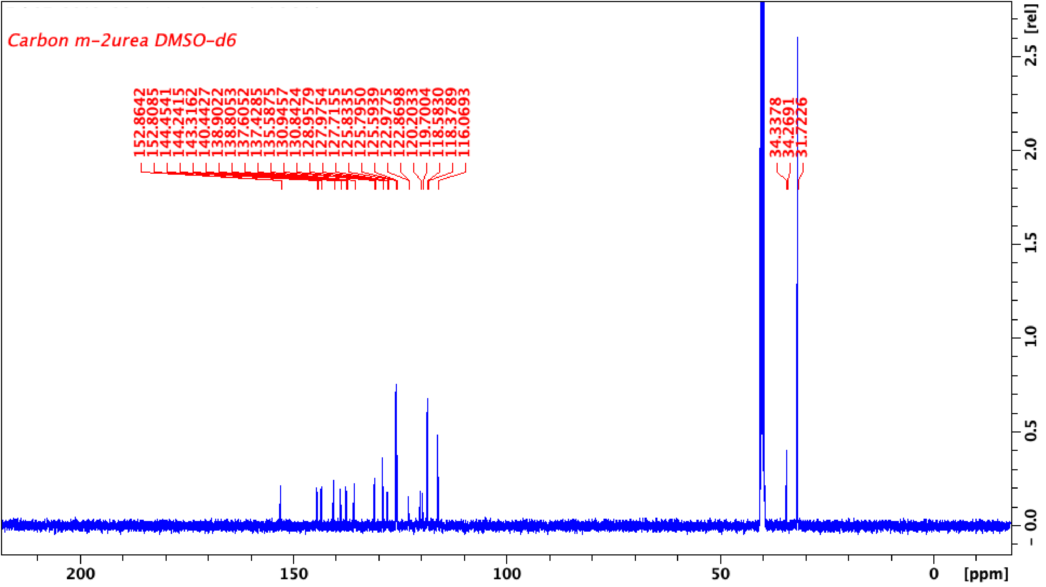
Supplementary Figure 7. ¹³C NMR spectrum of m-2urea in DMSO-d₆.

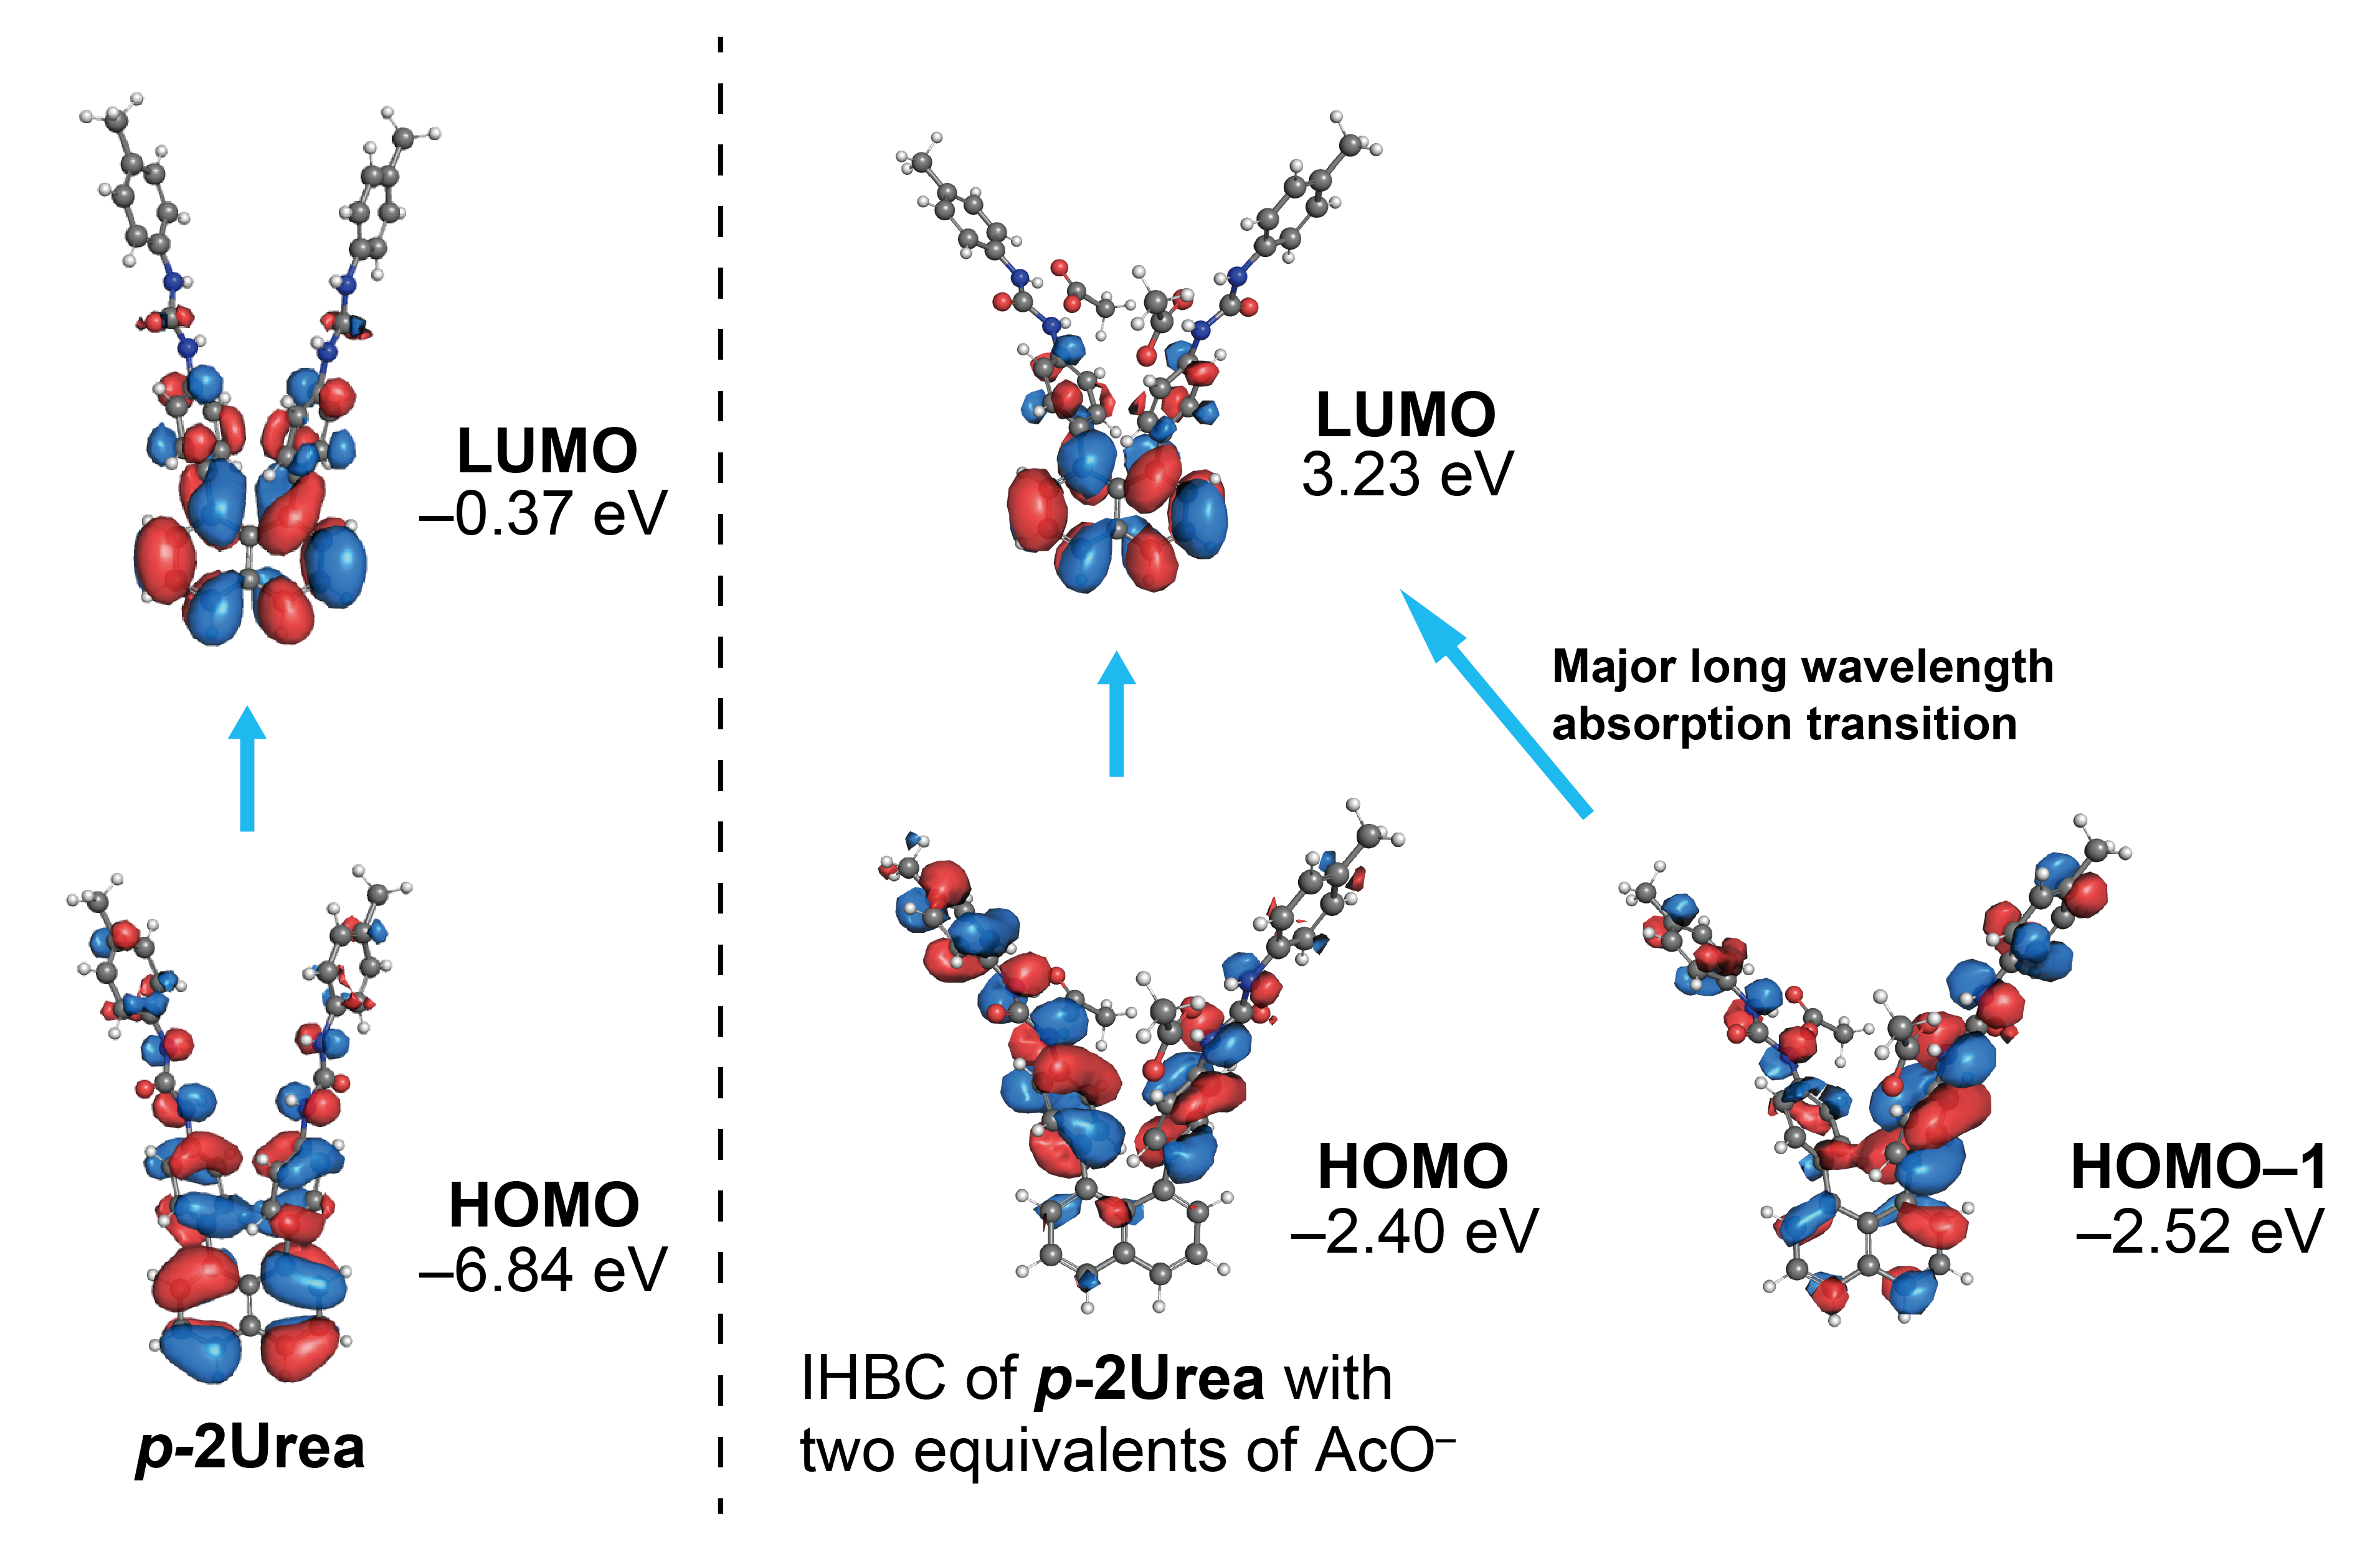
Supplementary Figure 8. Frontier molecular orbital amplitude plots of the HOMO and LUMO of p-2urea (left) and the complex of p-2urea with two equivalents of AcO– (right). The geometry of p-2urea was first optimised at the B3LYP/6-31G (d, p) before TF-DFT excitation energy calculation were carried out at the CAM-B3LYP/6-31G+ (d) level of theory. The geometry of the complex of p-2urea with two equivalents of AcO– was first optimised at the CAM-B3LYP/6-31G+ (d) level of theory before TD-DFT excitation energy calculations were carried out at the CAM-B3LYP/6-31G+ (d) level.

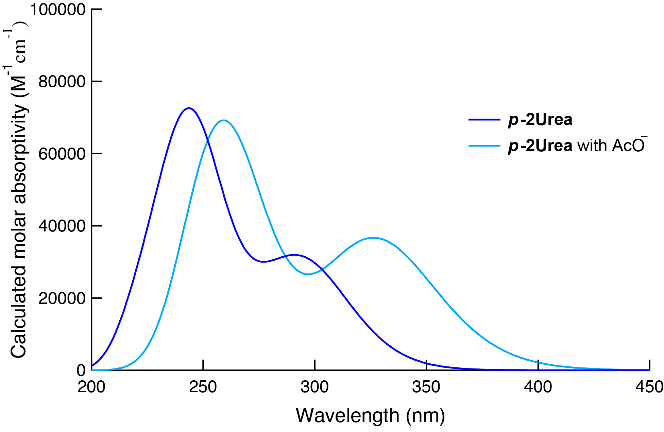
Supplementary Figure 9. Calculated absorption spectrum of p-2urea and p-2urea with two equivalents of AcO–.

Supplementary Table 2. Calculated excitation energies and oscillator strengths from the ground state, with orbital configuration contributions, for the ground-state optimised geometry of p-2urea
Excited state | Transition energy / eV | Oscillator strength f | Configuration and percentage contributionª
S₁ | 4.193 (295 nm) | 0.6383 | HOMO→LUMO (85.1%)
S₂ | 4.352 (285 nm) | 0.1230 | HOMO−1→LUMO (54.0%)
S₃ | 4.434 (280 mm) | 0.0109 | HOMO−1→LUMO (20.4%)
S₄ | 4.744 (261 nm) | 0.0340 | HOMO−1→LUMO (41.4%)
S₅ | 4.805 (258 nm) | 0.001 | HOMO−1→LUMO+1 (58.4%)
ªPercentages for the single-particle contributions (y %) to the vertical excited states were calculated using the following expression:
,
where x_{i} is the single-particle transition corresponding to a given vertical excited state.

Supplementary Table 3. Calculated excitation energies and oscillator strengths from the ground-state, with orbital configuration contributions, for the ground-state optimised geometry of p-2urea with two equivalents of AcO–
Excited state | Transition energy / eV | Oscillator strength f | Configuration and percentage contributionª
S₁ | 3.704 (335 nm) | 0.2356 | HOMO→LUMO (69.6%)
S₂ | 3.805 (326 nm) | 0.6503 | HOMO−1→LUMO (64.8%)
S₃ | 4.237 (293 nm) | 0.0776 | HOMO−1→LUMO+3 (33.7%)
S₄ | 4.613 (269 nm) | 0.3360 | HOMO→LUMO+3 (54.6%)
S₅ | 4.660 (266 nm) | 0.1118 | HOMO→LUMO+8 (10.5%)
ªThe percentages were calculated using the expression given in the footnote of Supplementary Table 2.

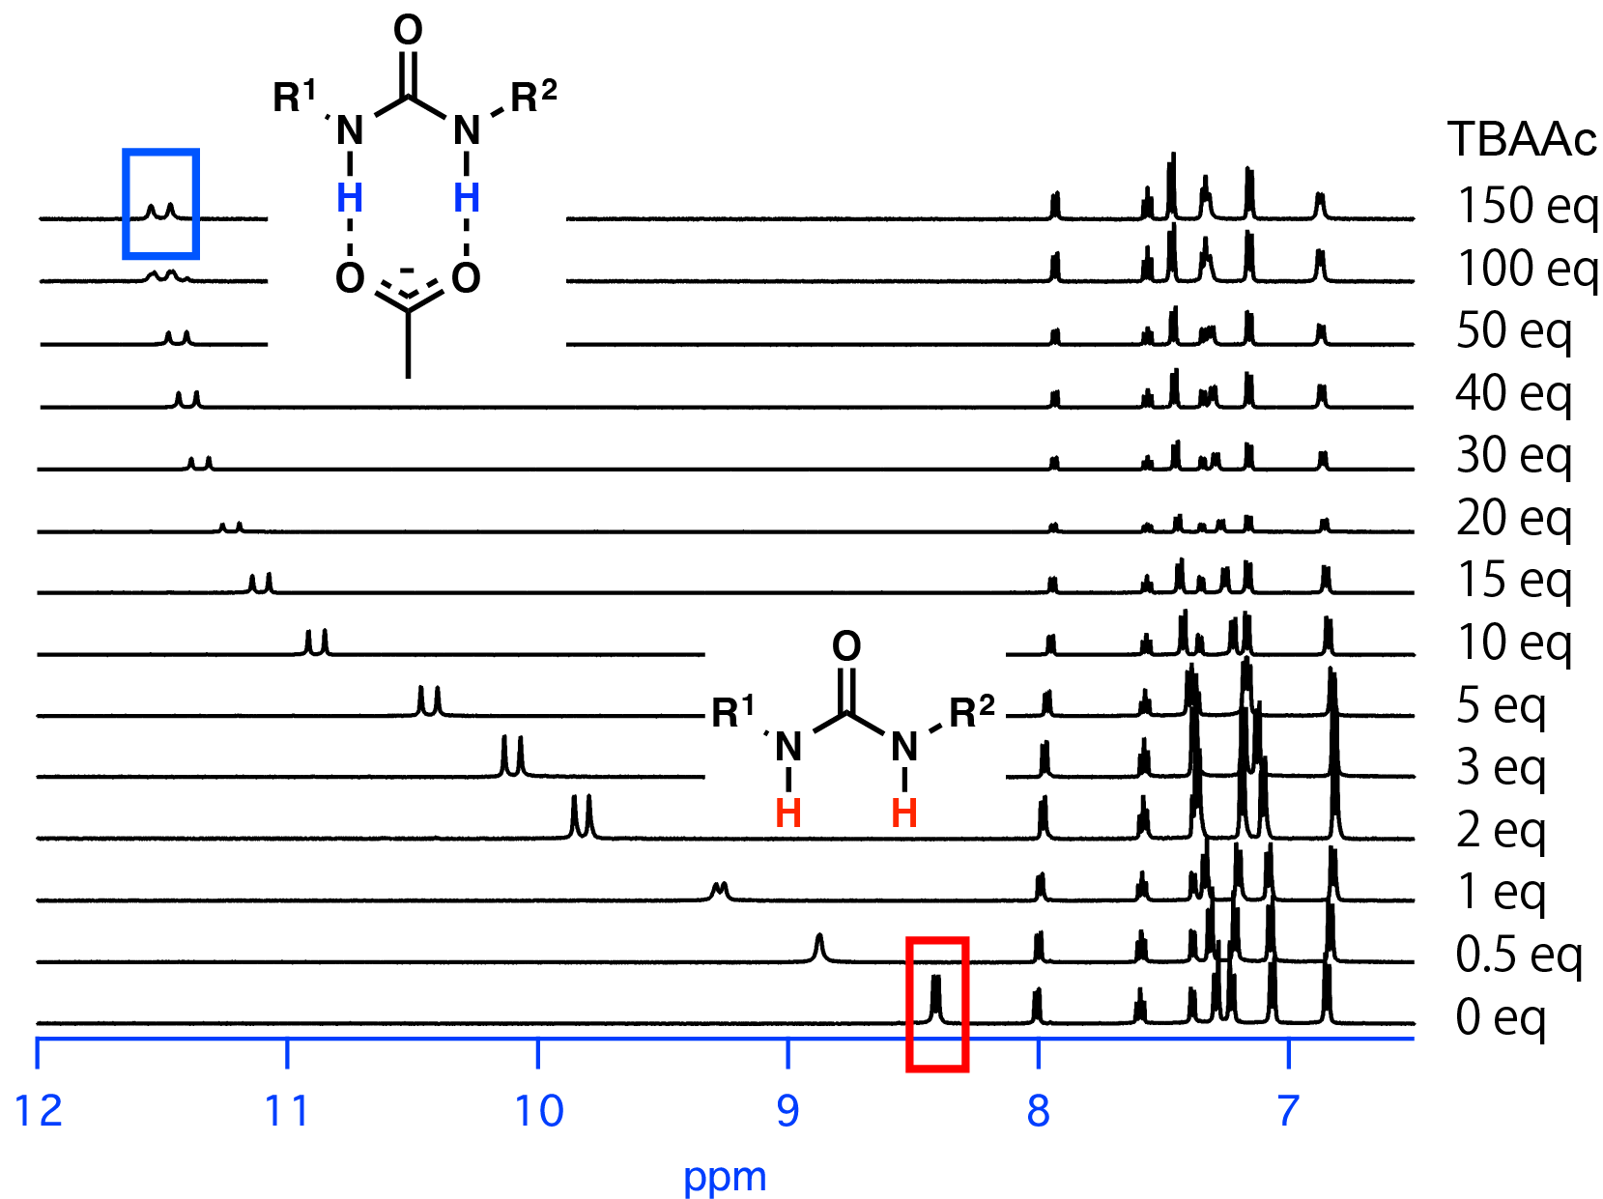
Supplementary Figure 10. ¹H NMR spectra acquired over the course of titrating a solution of p-2urea (2.0 mM) with tetrabutylammonium acetate (TBAAc) in DMSO-d₆.

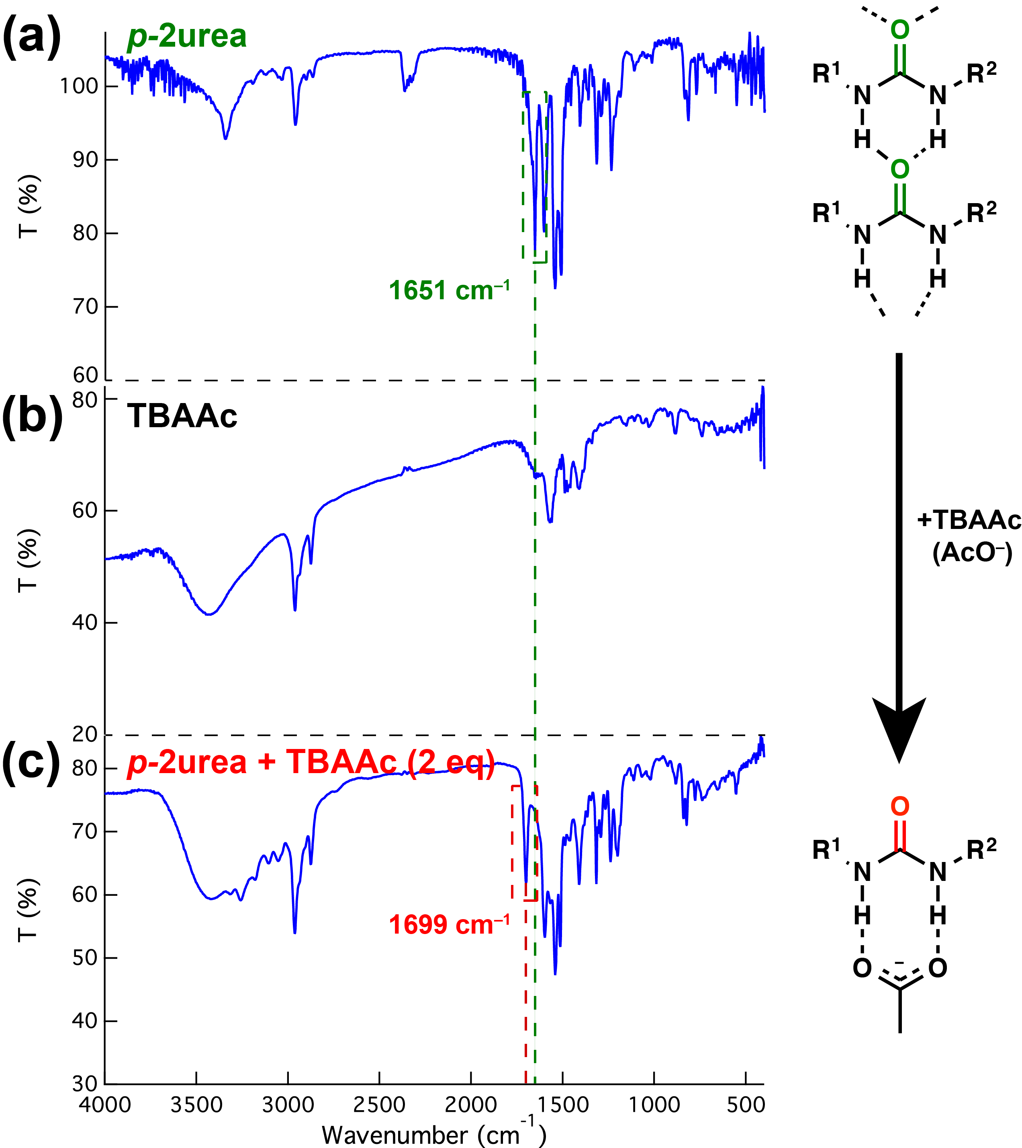
Supplementary Figure 11. FT-IR spectra of p-2urea and p-2urea–acetate-ion complex in solid-state. (a) FT-IR spectra of TBAAc. (b) FT-IR spectra of p-2urea. (c) FT-IR spectra of the mixture of p-2urea and TBAAc.

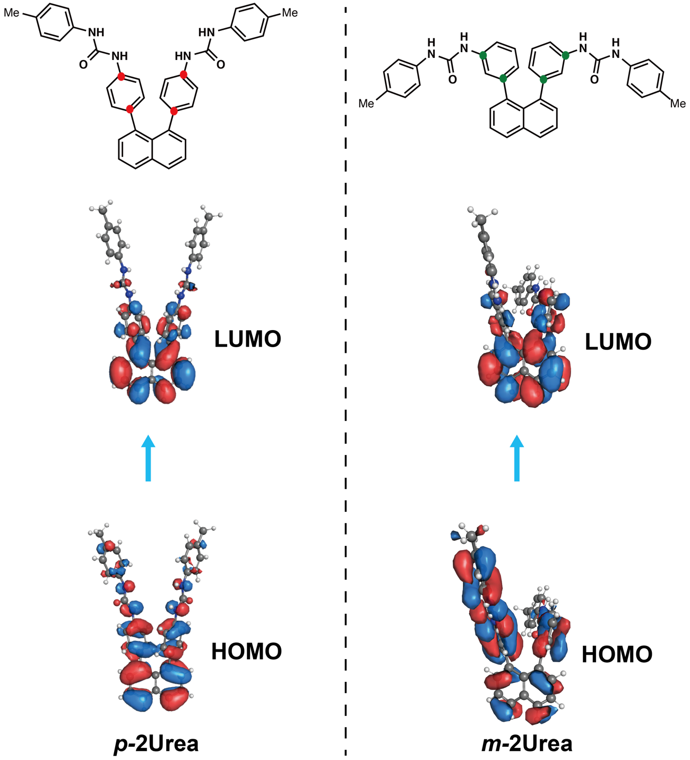
Supplementary Figure 12. Frontier molecular orbital amplitude plots of the HOMOs and LUMOs of p-2urea (left) and m-2urea (right). The geometry was first optimised at the B3LYP/6-31G (d, p) level of theory before TD-DFT excitation energy calculations were carried out at the CAM-B3LYP/6-31G+ (d) level.

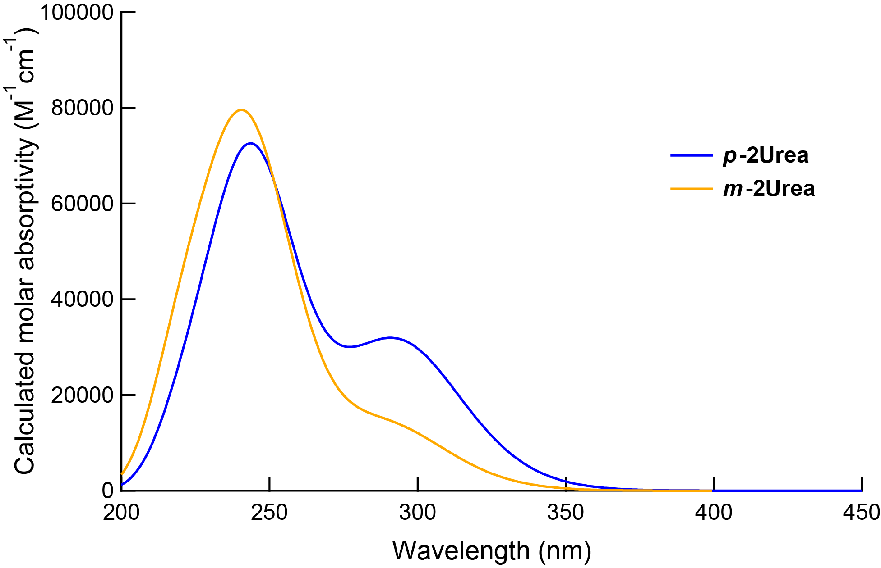
Supplementary Figure 13. Calculated absorption spectra of p-2urea and m-2urea.

Supplementary Table 4. Calculated excitation energies and oscillator strengths from the ground state, with orbital configuration contributions, for the ground-state optimised geometry of m-2urea
Excited state | Transition energy / eV | Oscillator strength f | Configuration and percentage contributionª
S₁ | 4.267 (291 nm) | 0.3153 | HOMO→LUMO (51.3%)
S₂ | 4.427 (280 nm) | 0.0056 | HOMO−6→LUMO (31.6%)
S₃ | 4.662 (266 nm) | 0.0061 | HOMO→LUMO (22.1%)
S₄ | 4.779 (259 nm) | 0.0338 | HOMO→LUMO+4 (26.2%)
S₅ | 4.819 (257 nm) | 0.0092 | HOMO−1→LUMO+2 (20.4%)
ªThe percentages were calculated using the expression given in the footnote of Supplementary Table 2.

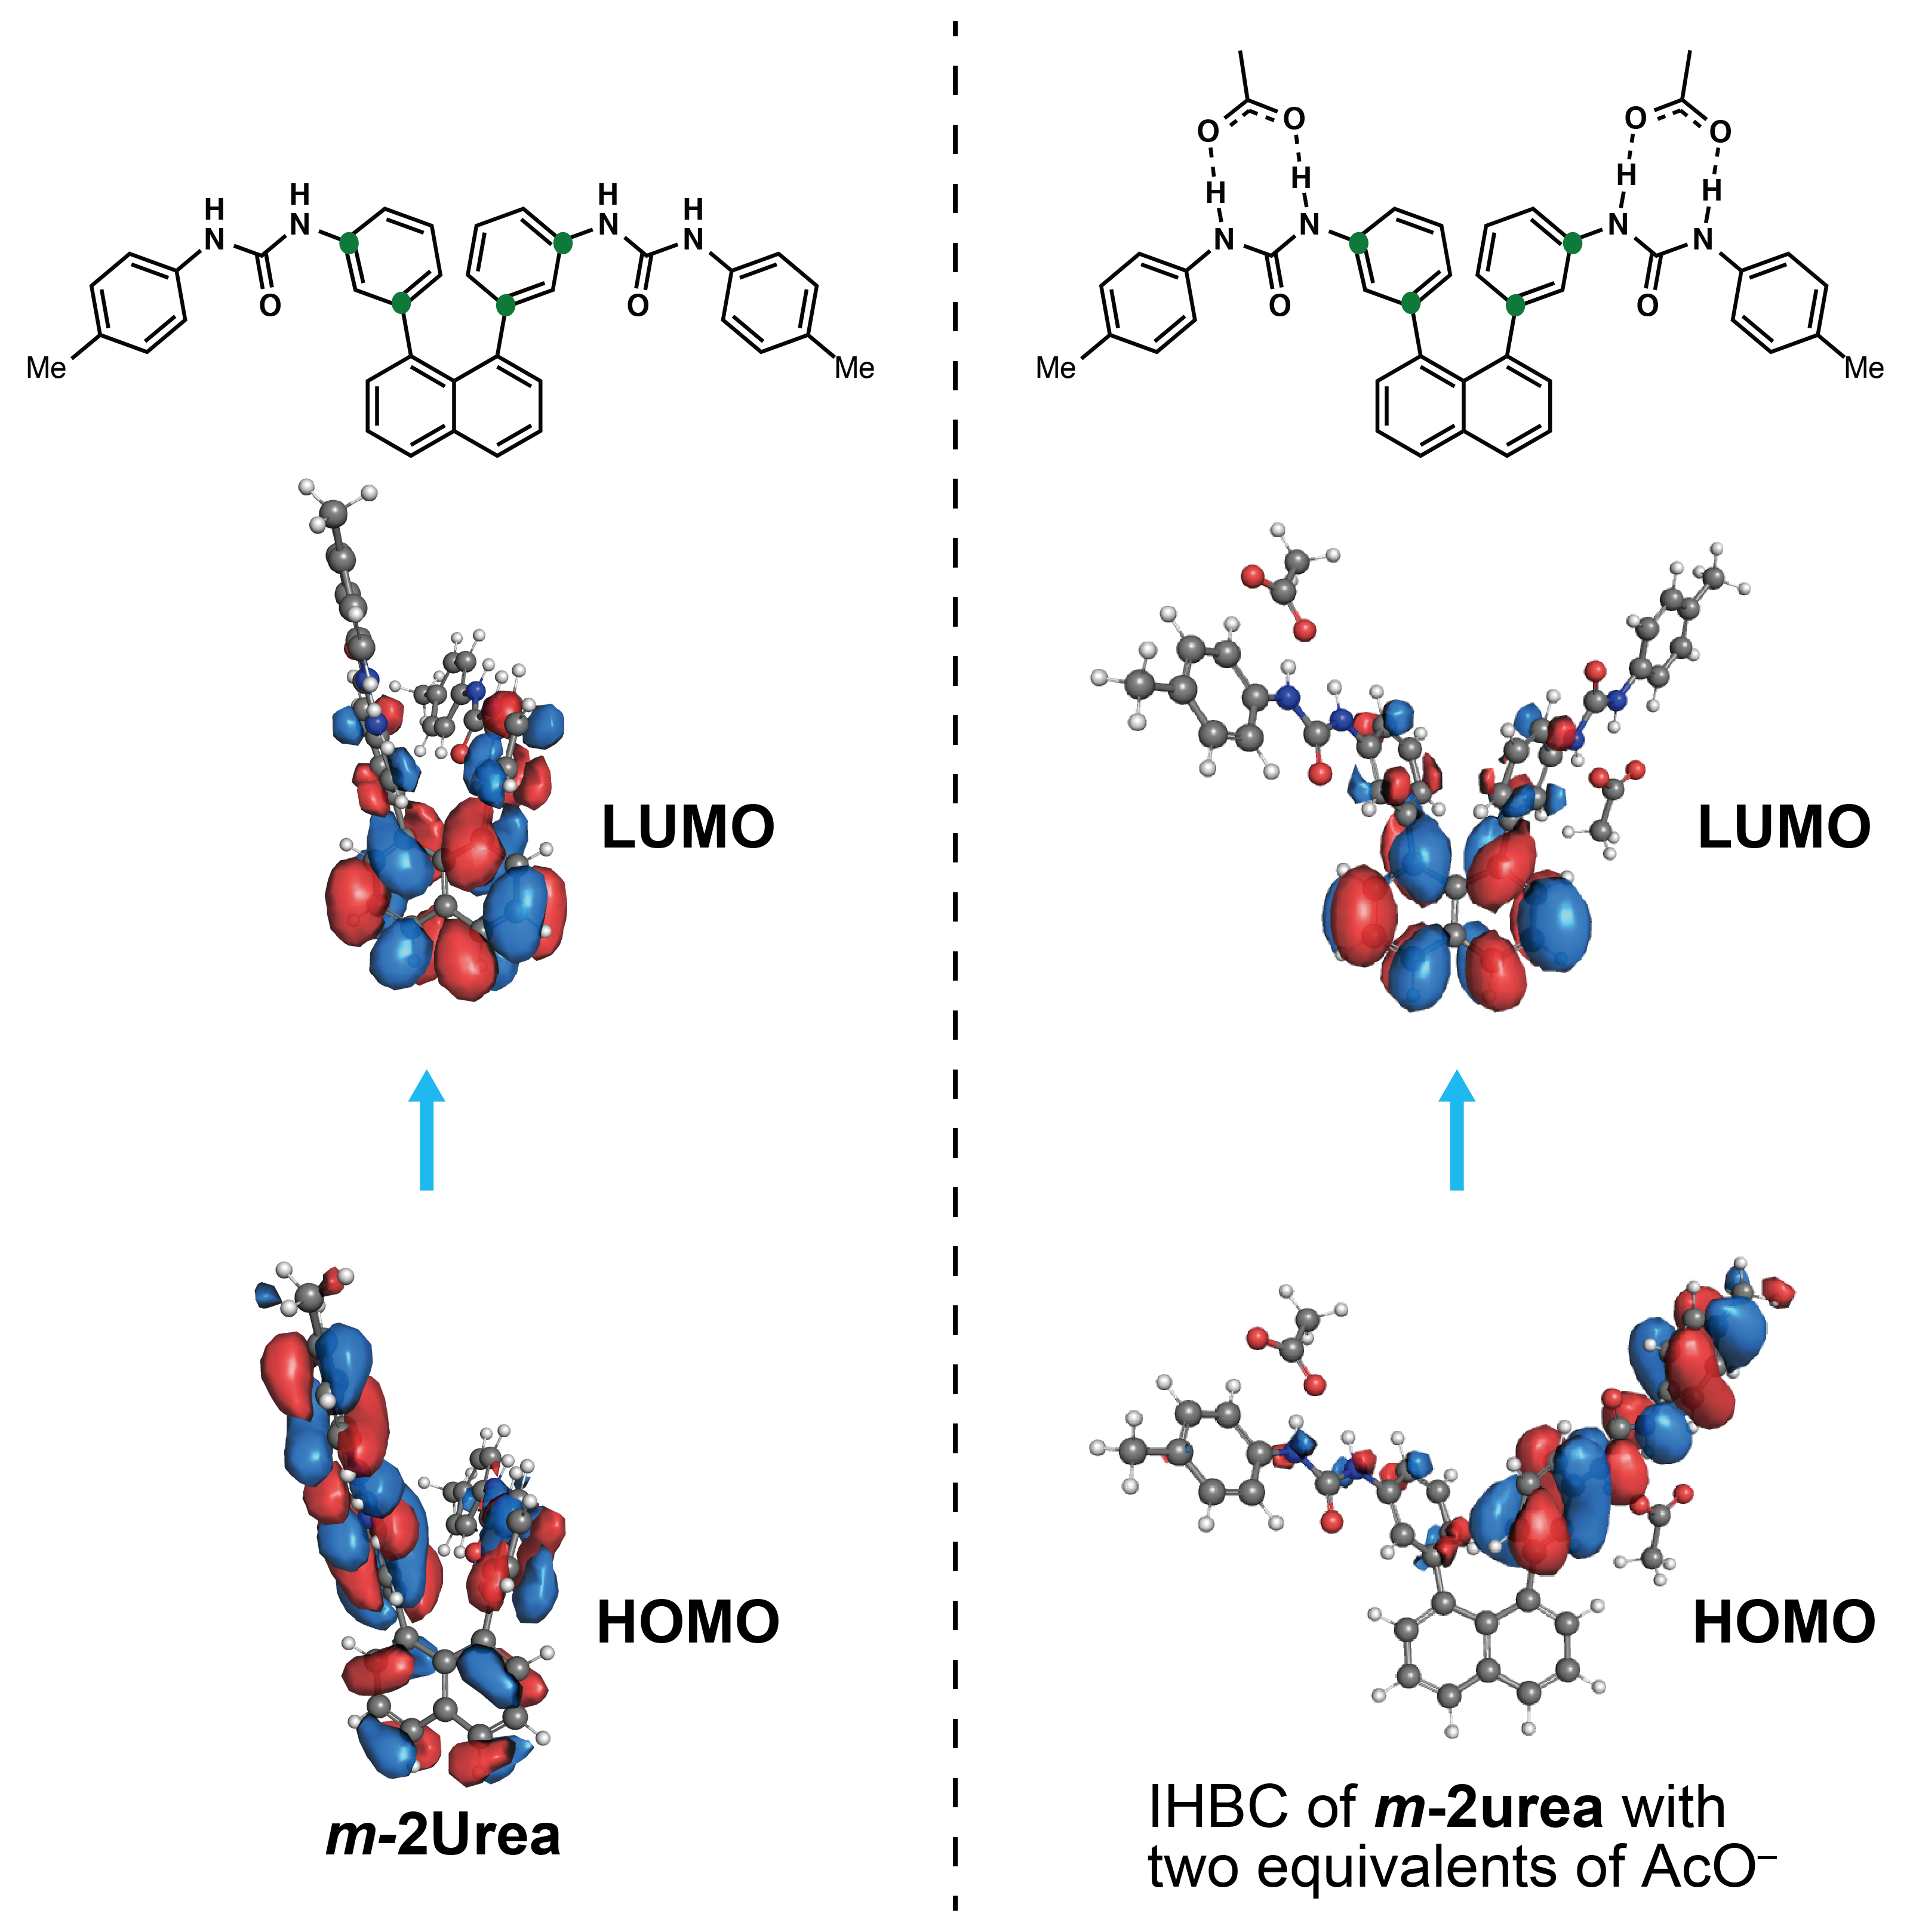
Supplementary Figure 14. Frontier molecular orbital amplitude plots of the HOMO and LUMO of m-2urea (left) and the complex of m-2urea with two equivalents of AcO– (right). The geometry of m-2urea was first optimised at the B3LYP/6-31G (d, p) level of theory before TD-DFT excitation energy calculations were carried out at the CAM-B3LYP/6-31G+ (d) level. The geometry of the complex of m-2urea with two equivalents of AcO– was first optimised at the CAM-B3LYP/6-31G+ (d) level of theory before TD-DFT excitation energy calculations were carried out at the CAM-B3LYP/6-31G+ (d) level.

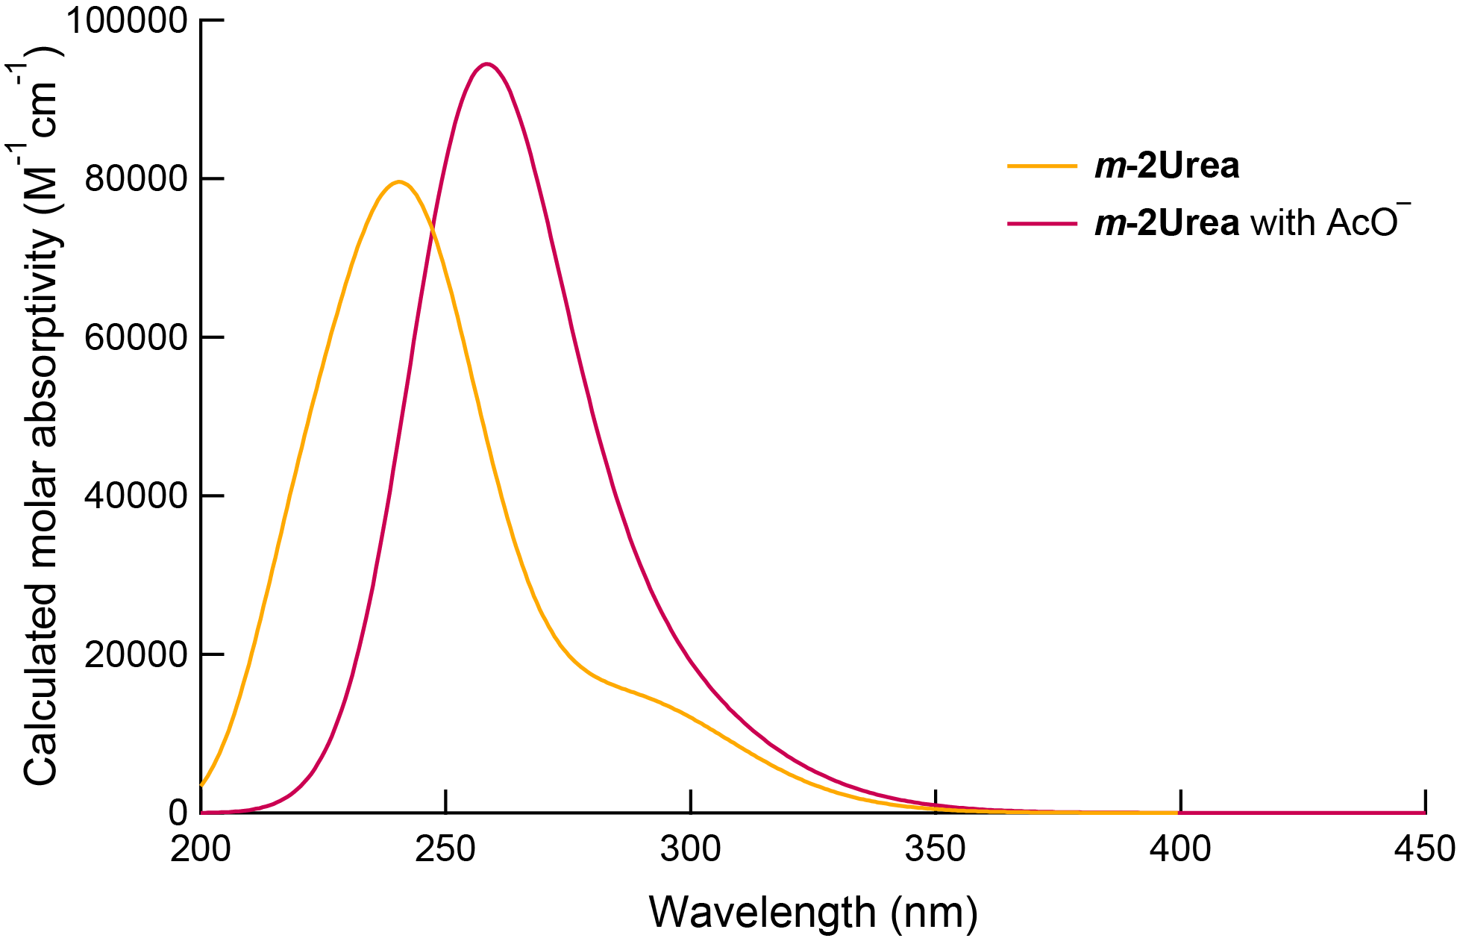
Supplementary Figure 15. Calculated absorption spectra of m-2urea and m-2urea with two equivalents of AcO–.

Supplementary Table 5. Calculated excitation energies and oscillator strengths from the ground state, with orbital configuration contributions, for the ground-state optimised geometry of the complex m-2urea and two equivalents of AcO–
Excited state | Transition energy / eV | Oscillator strength f | Configuration and percentage contributionª
S₁ | 4.054 (306 nm) | 0.0173 | HOMO→LUMO (49.2%)
S₂ | 4.120 (301 nm) | 0.1214 | HOMO−1→LUMO (43.6%)
S₃ | 4.328 (286 nm) | 0.2277 | HOMO−6→LUMO (71.0%)
S₄ | 4.458 (278 nm) | 0.0300 | HOMO−6→LUMO+4 (31.3%)
S₅ | 4.761 (260 nm) | 0.1138 | HOMO−11→LUMO (30.9%)
ªThe percentages were calculated using the expression given in the footnote of Supplementary Table 2.

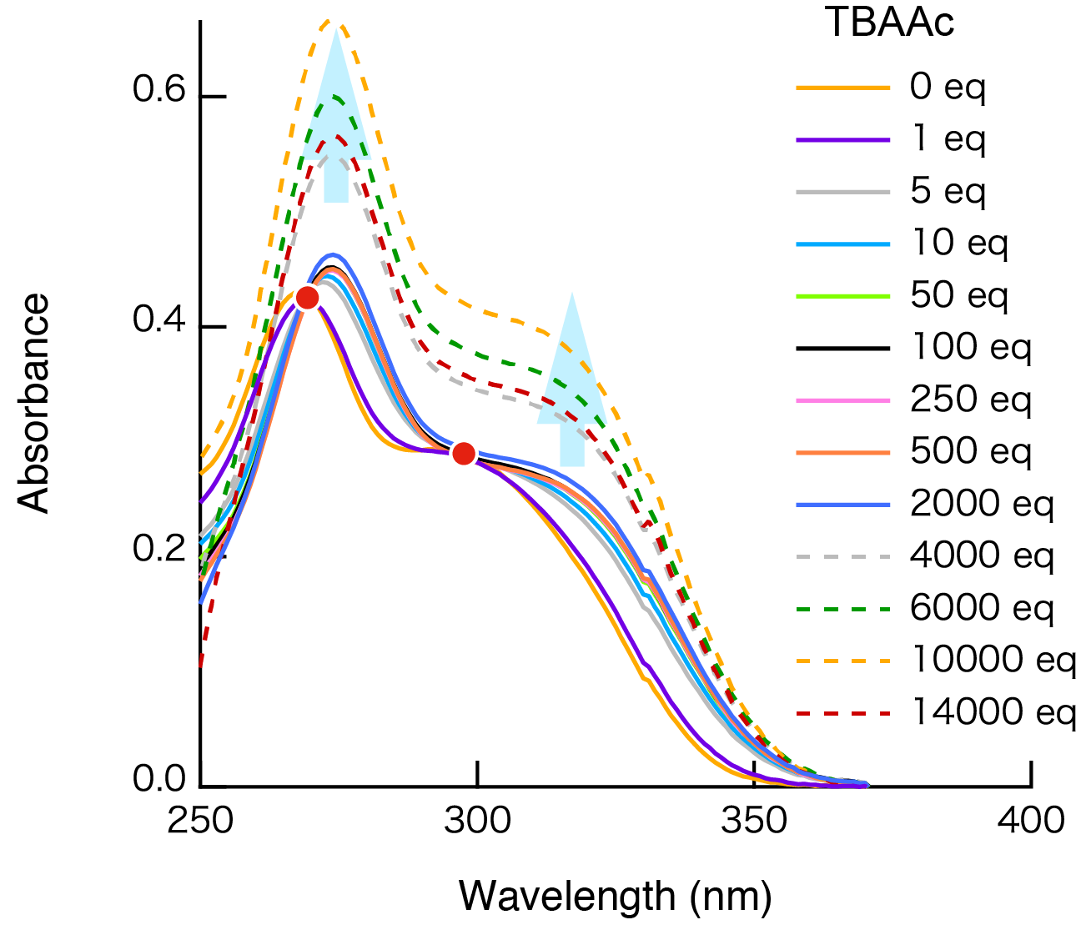
Supplementary Figure 16. Absorbance spectra of p-1urea in the absence and presence of TBAAc.

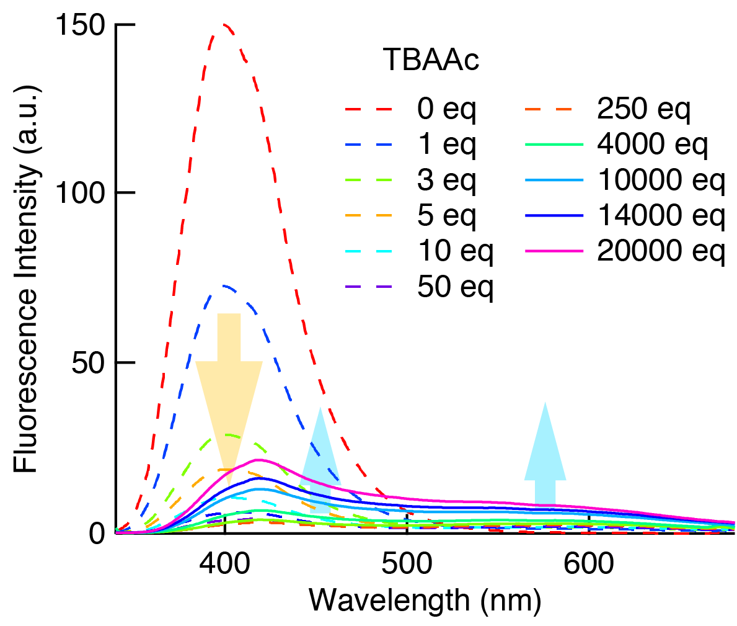
Supplementary Figure 17. Fluorescence spectra of a DMSO solution of p-1urea (150 µM, λ_{ex} = 336 nm) in the absence and presence of various equivalents of TBAAc.

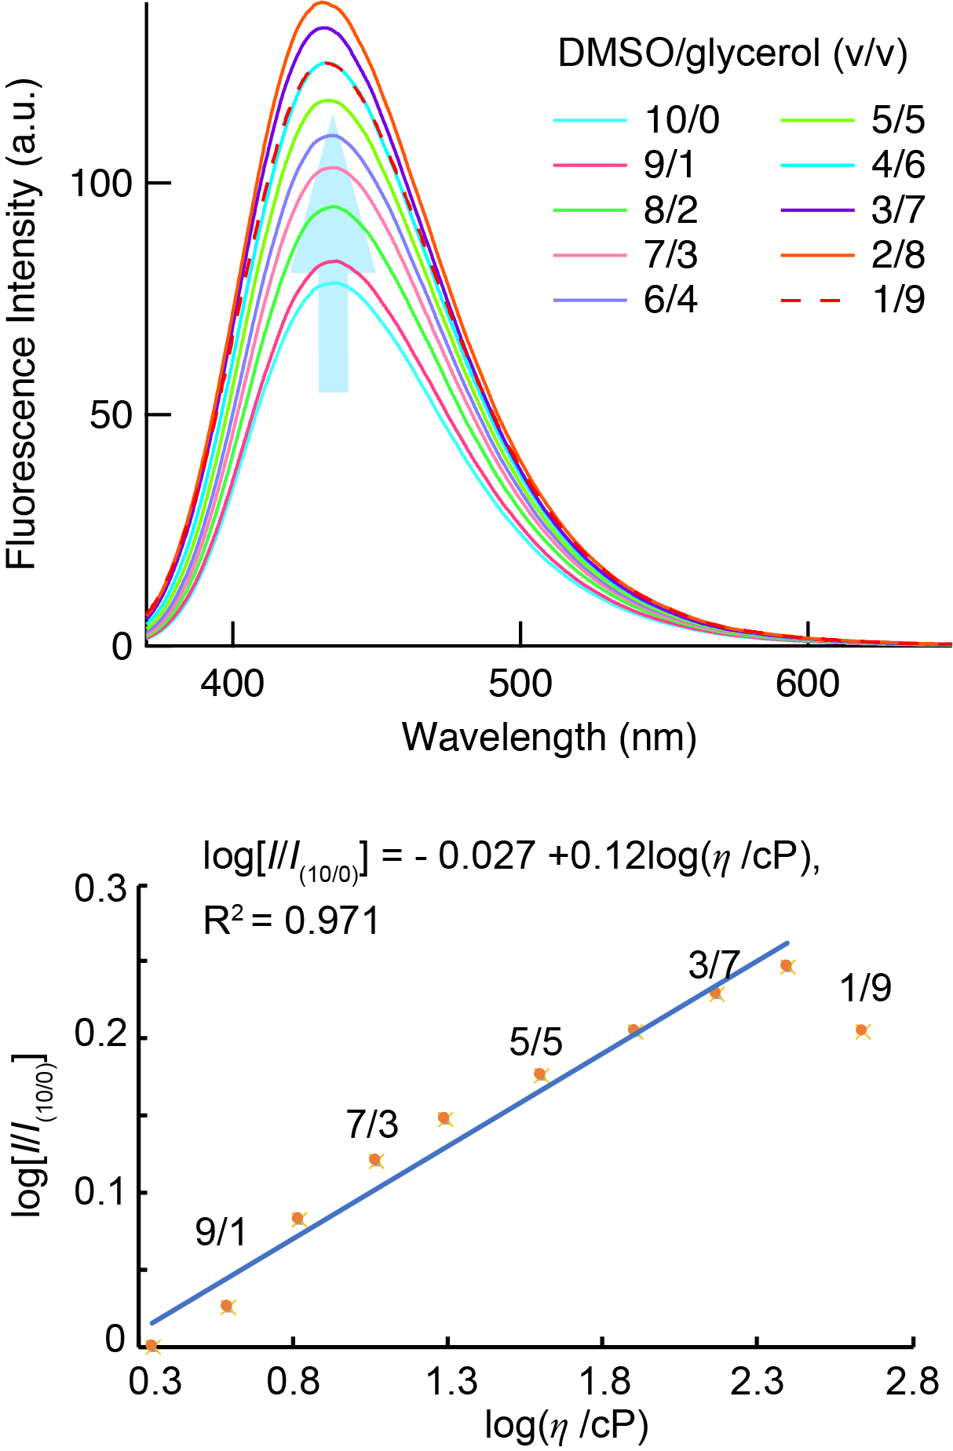
Supplementary Figure 18. Viscosity-sensitivity of the p-2urea complex and fluorescence intensity. (a) Fluorescence spectra of p-2urea in mixed solvents with different fractions of glycerol [DMSO/glycerol (v/v) = 10/0, 9/1, 8/2, 7/3, 6/4, 5/5, 4/6, 3/7, 2/8, and 1/9]. (b) Linear relationship between log(I/I_{(v/v)}) and log(η /cP) in mixtures of DMSO and glycerol ([p-2urea] = 1.5 µM, λ_{ex} = 359 nm).

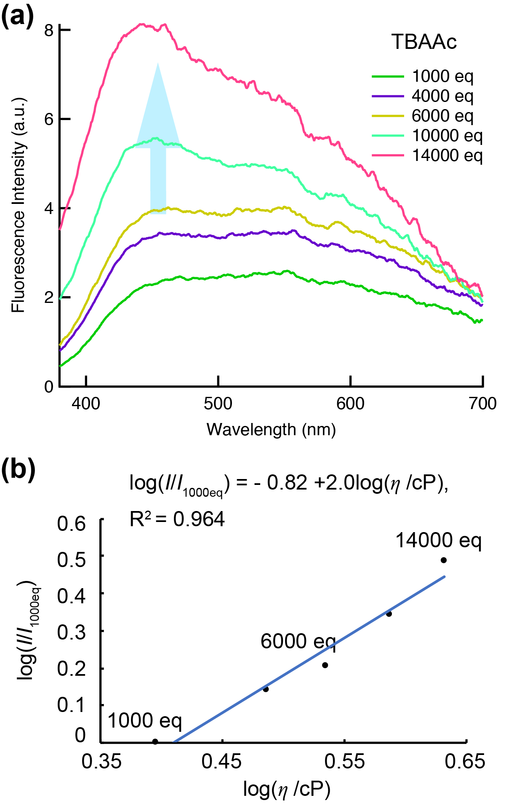
Supplementary Figure 19. (a) Fluorescence spectra of m-2urea (150 µM, λ_{ex}= 332 nm) with the addition of various excess amounts of TBAAc in DMSO. (b) Log–log plot of the ratio of fluorescence intensities at 470.5 nm as a function of solvent viscosity.

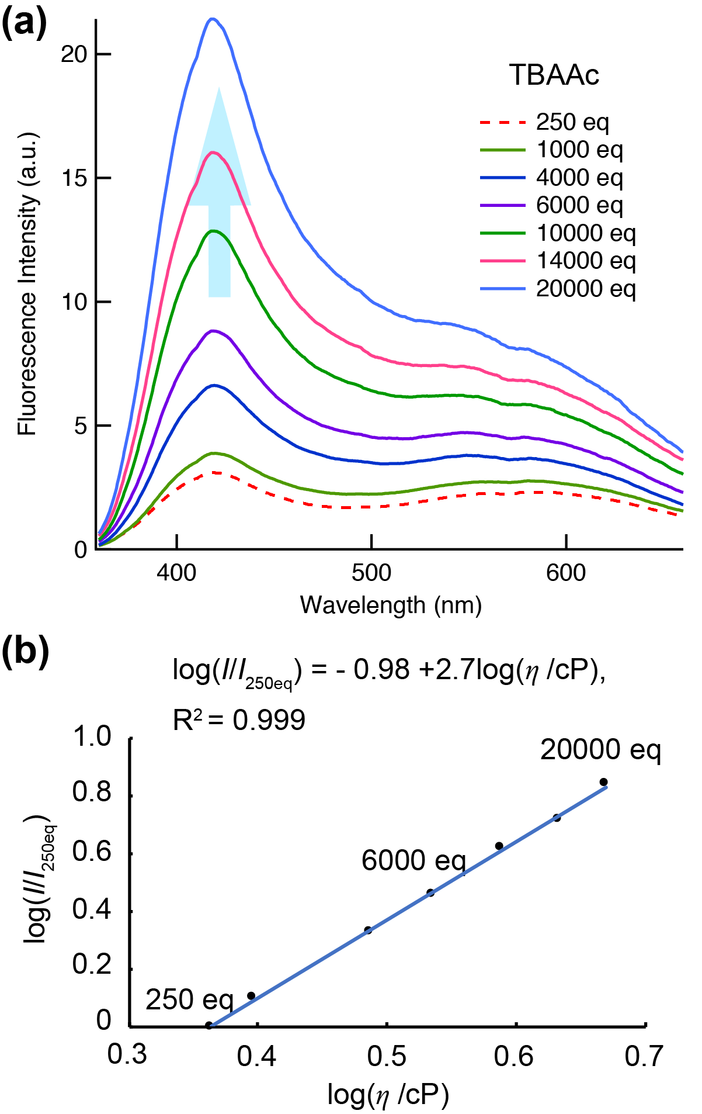
Supplementary Figure 20. (a) Fluorescence spectra of p-1urea (150 µM, λ_{ex}= 336 nm) with the addition of various excess amounts of TBAAc in DMSO. (b) Log–log plot of the ratio of fluorescence intensities at 418 nm as a function of solvent viscosity.

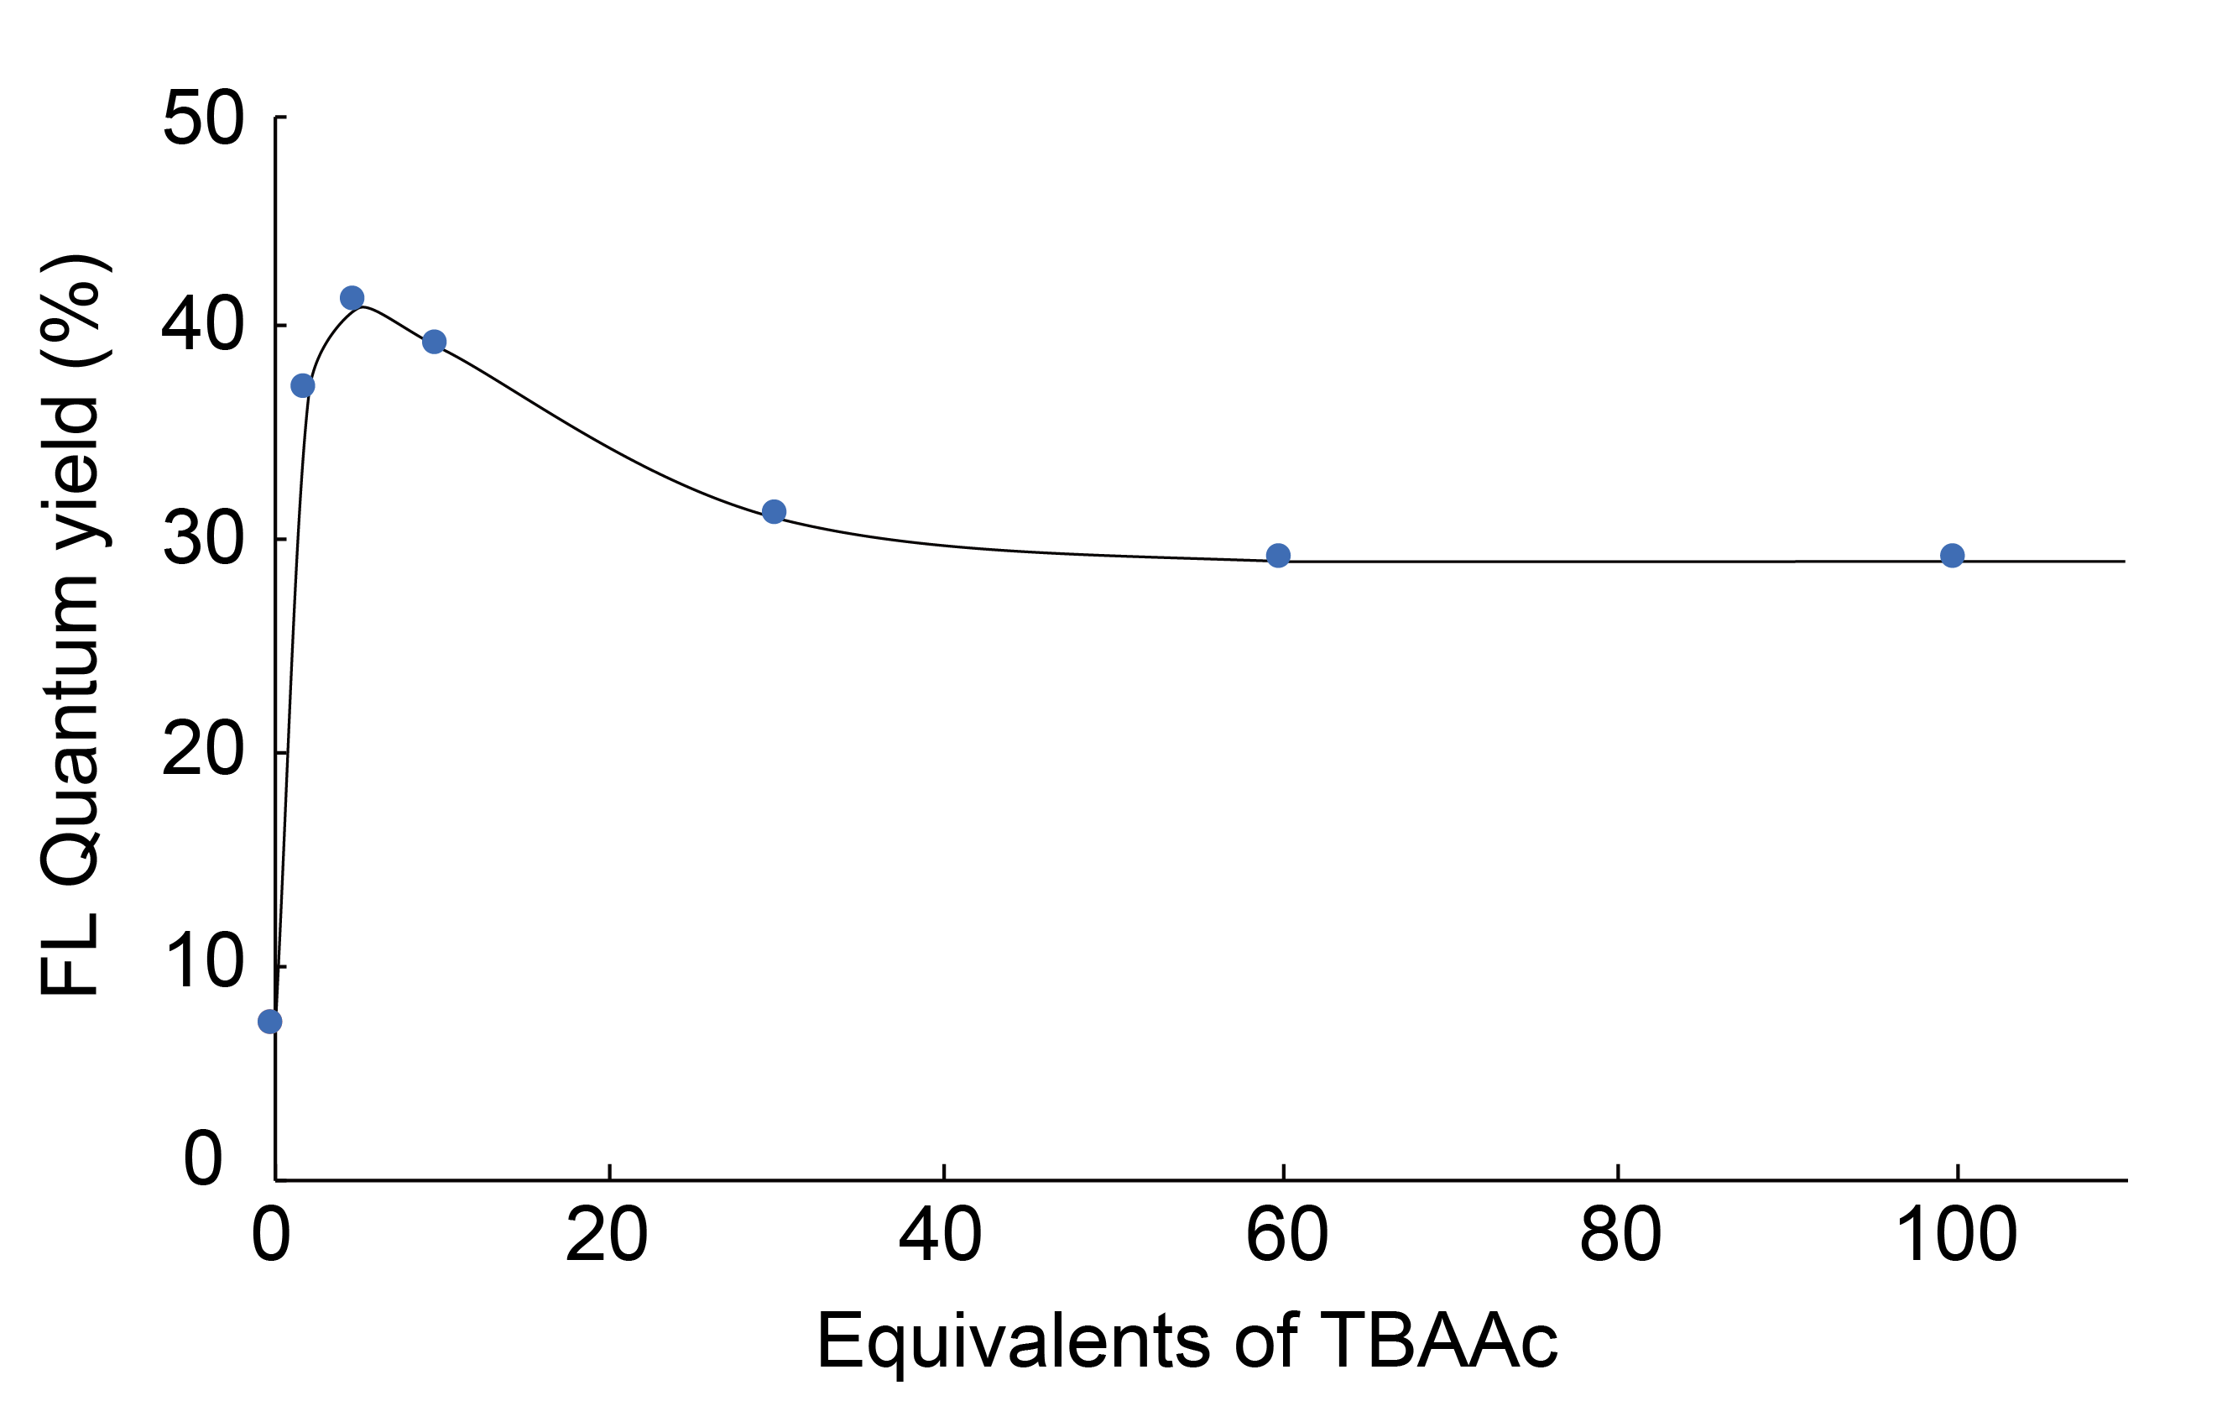
Supplementary Figure 21. Fluorescence quantum yields of p-2urea powders in the presence of various amounts of TBAAc and in its absence.

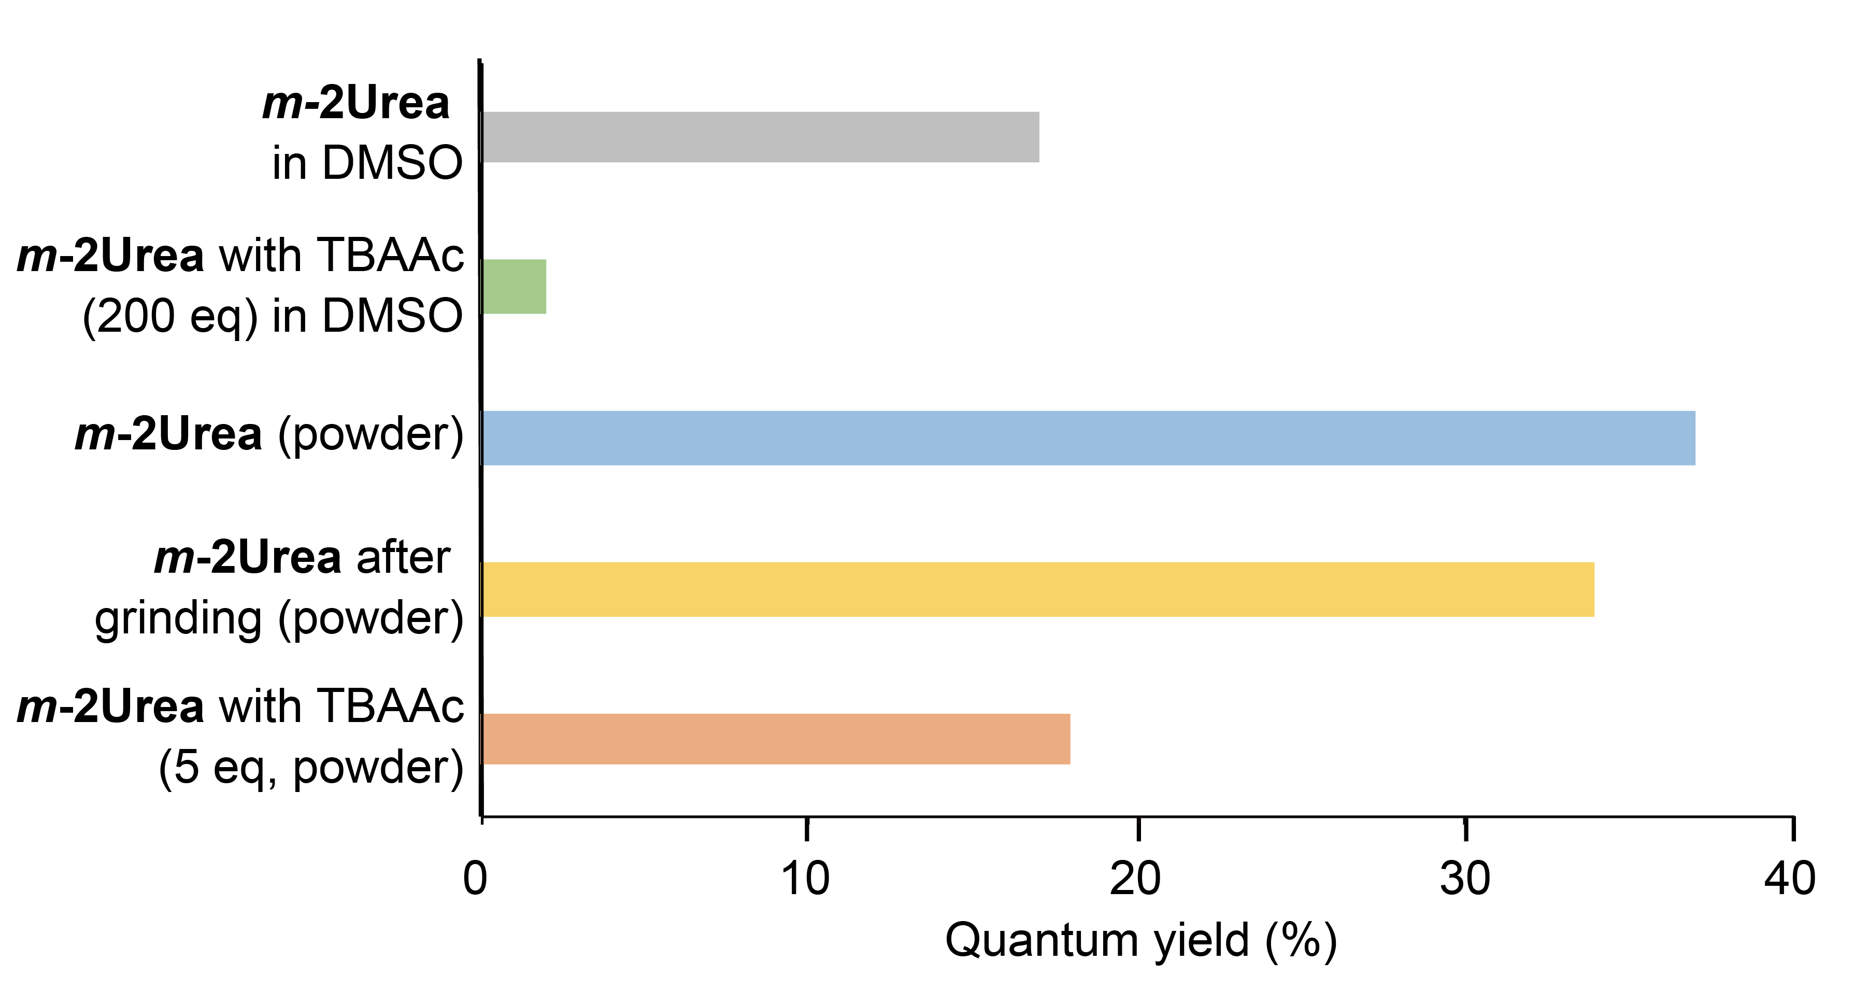
Supplementary Figure 22. Absolute fluorescence quantum yields of m-2urea powder and m-2urea–DMSO solution in the absence and presence of TBAAc.
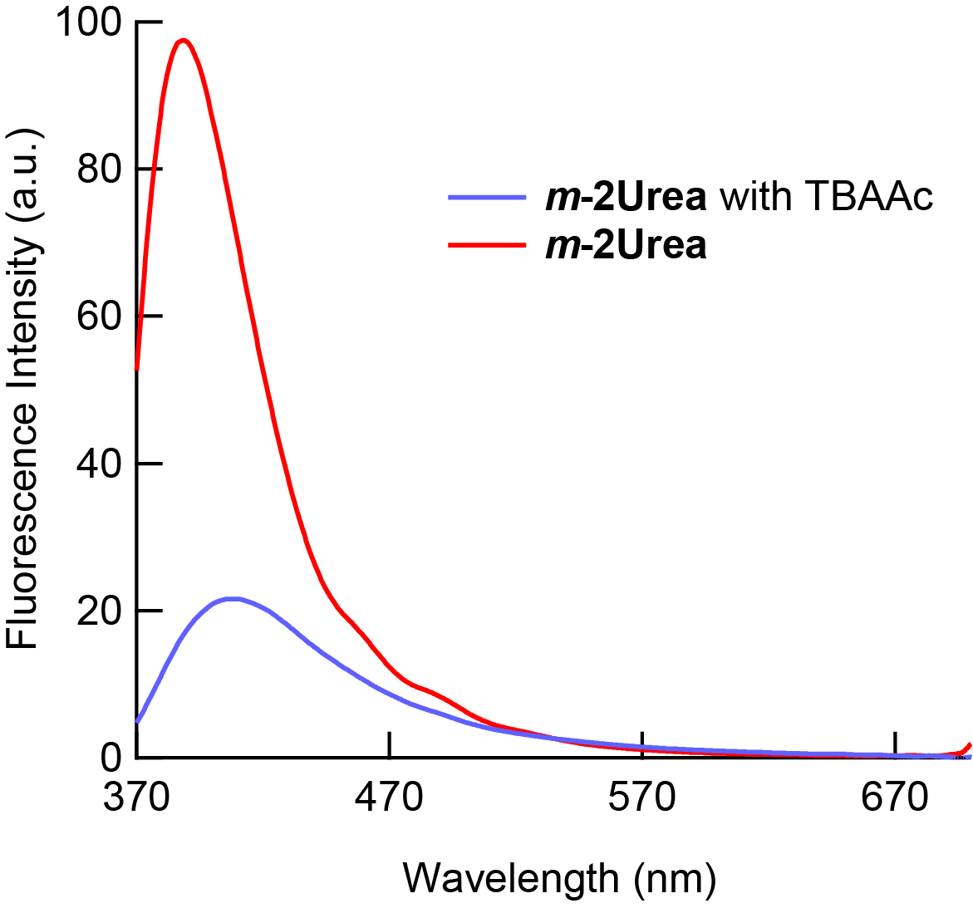
Supplementary Figure 23. Solid-state fluorescence spectra of m-2urea in the presence and absence of 5 equiv of TBAAc when excited at 323 nm.

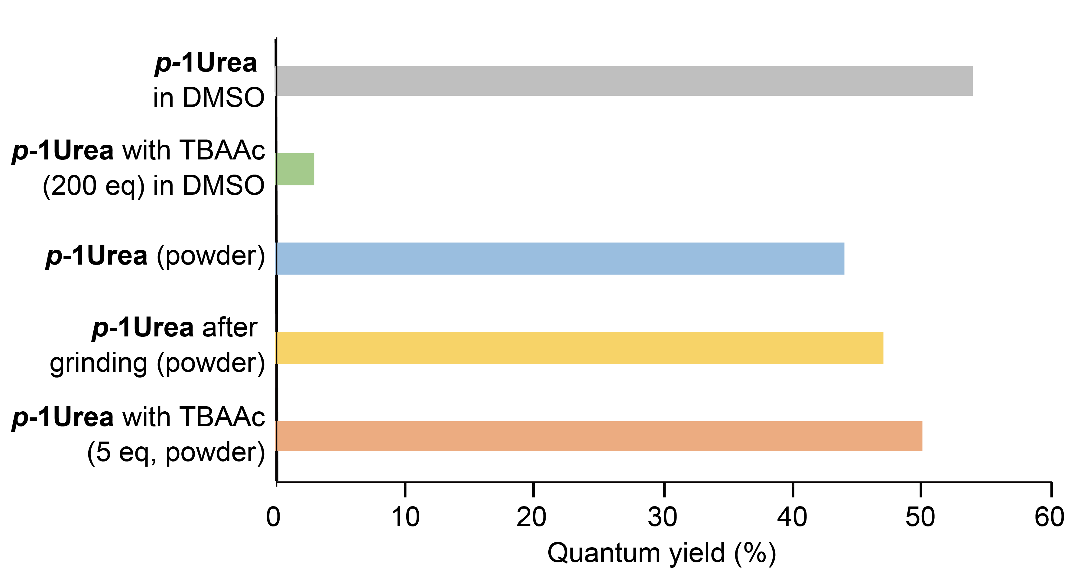
Supplementary Figure 24. Absolute fluorescence quantum yields of p-1urea powder and p-1urea–DMSO solution in the absence and presence of TBAAc.

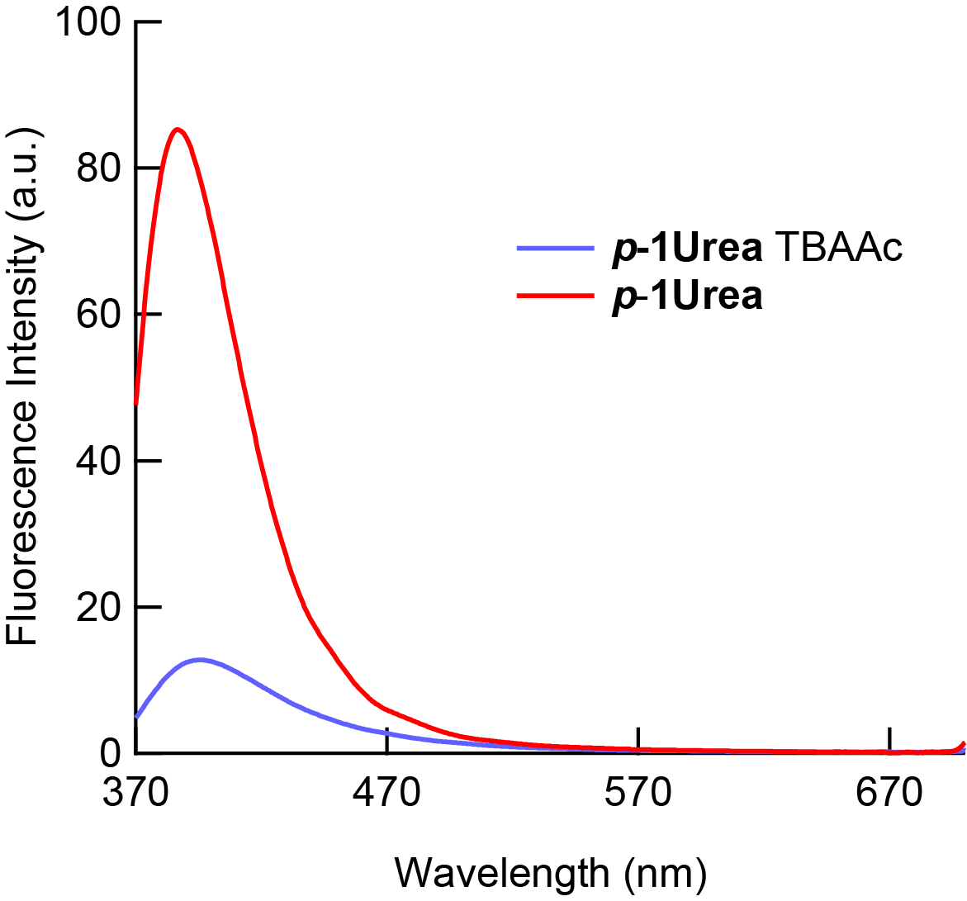
Supplementary Figure 25. Solid-state fluorescence spectra of p-1urea in the presence and absence of 5 equiv of TBAAc when excited at 323 nm.
Table S6. Structure of p-2urea, S₀ [DFT/B3LYP/6-31G (d, p), E_{sp} = -1836.90938116 hartree].
atom | x[Å] | y[Å] | z[Å]
C | -7.70735 | -4.82948 | 0.69874
H | -7.03939 | -3.4336 | -1.56866
C | -6.35664 | -4.29338 | 0.28748
C | -6.18357 | -3.60848 | -0.92147
C | -5.22278 | -4.48247 | 1.08574
H | -5.32238 | -5.0058 | 2.03377
C | -4.93405 | -3.14058 | -1.31401
H | -4.83326 | -2.60649 | -2.25683
C | -3.9602 | -4.02387 | 0.71248
C | -3.80607 | -3.34317 | -0.50407
H | -3.10088 | -4.18111 | 1.34766
H | -2.62942 | -2.40704 | -1.88753
N | -2.57544 | -2.84056 | -0.9776
C | -1.34027 | -2.86159 | -0.34656
O | -1.14645 | -3.34512 | 0.76153
H | -0.62448 | -1.85281 | -1.99405
N | -0.3479 | -2.27559 | -1.12004
H | 1.04188 | -3.18386 | 1.05419
C | 1.00514 | -2.06549 | -0.7839
C | 1.61847 | -2.58459 | 0.365
H | -2.65939 | 2.32257 | 1.84522
H | -4.86987 | 2.4879 | 2.19089
H | -0.6449 | 1.8116 | 1.9728
C | 1.77216 | -1.29561 | -1.67341
H | 1.31397 | -0.8987 | -2.57688
C | 2.96074 | -2.30225 | 0.61013
H | 1.30062 | 0.88135 | 2.56699
C | -4.96022 | 3.07185 | 1.27703
H | 3.41791 | -2.69679 | 1.51328
H | -7.07122 | 3.33763 | 1.51477
C | 1.75917 | 1.28238 | 1.66555
N | -0.36598 | 2.2462 | 1.10538
N | -2.59442 | 2.80707 | 0.96211
C | -6.207 | 3.55275 | 0.8913
H | 3.66757 | 0.42628 | 2.11427
C | 3.09739 | 1.02018 | 1.40758
C | 3.10804 | -1.025 | -1.41171
C | 0.99024 | 2.04917 | 0.7749
C | -3.82173 | 3.3251 | 0.4967
C | 3.73039 | -1.50698 | -0.25069
C | -1.35326 | 2.85629 | 0.34435
C | 3.72057 | 1.50782 | 0.24935
C | 1.6041 | 2.5739 | -0.37121
C | -6.36666 | 4.30126 | -0.28114
H | 3.67687 | -0.42865 | -2.11744
O | -1.15104 | 3.38097 | -0.74332
C | -3.9623 | 4.07015 | -0.68329
C | 2.94886 | 2.30002 | -0.61245
C | 5.18239 | -1.28301 | 0.0071
C | 5.17459 | 1.29282 | -0.00429
C | -7.71465 | 4.85061 | -0.68376
H | 1.02635 | 3.17218 | -1.06027
C | -5.22225 | 4.54052 | -1.0505
H | 5.4405 | -3.39047 | 0.16047
C | 5.8367 | 0.00689 | 0.00232
H | 5.42056 | 3.40179 | -0.15679
C | 5.93347 | 2.445 | -0.16358
C | 5.94767 | -2.43063 | 0.16856
H | -3.0949 | 4.26601 | -1.29639
H | 3.40646 | 2.69888 | -1.5135
C | 7.33831 | 2.42297 | -0.25897
C | 7.28135 | 0.01122 | 0.00434
C | 7.35209 | -2.40018 | 0.26785
H | -5.31129 | 5.11384 | -1.97025
C | 7.99965 | 1.22724 | -0.13964
H | 7.88659 | 3.35283 | -0.37712
C | 8.00653 | -1.20048 | 0.15034
H | 7.90562 | -3.32671 | 0.3876
H | 9.08552 | 1.18742 | -0.15155
H | 9.0921 | -1.15412 | 0.16533
H | -8.52055 | -4.2084 | 0.31045
H | -7.80633 | -4.87086 | 1.7877
H | -7.86786 | -5.84703 | 0.32012
H | -8.52983 | 4.21122 | -0.33105
H | -7.80223 | 4.9381 | -1.77101
H | -7.88248 | 5.85072 | -0.26404

Table S7. Structure of m-2urea, S₀ [DFT/B3LYP/6-31G (d, p), E_{sp} = -1836.90833149 hartree].
atom | x[Å] | y[Å] | z[Å]
C | -1.62002 | -3.20337 | 2.54228
C | -2.15578 | 4.48958 | -2.75003
C | -2.06926 | 5.4232 | -1.74863
C | -1.5207 | 5.08233 | -0.48447
C | -1.06354 | 3.73803 | -0.22415
C | -1.04869 | 2.81841 | -1.33748
C | -1.429 | 6.08056 | 0.52102
C | -0.93075 | 5.78174 | 1.76371
C | -0.5784 | 4.45092 | 2.06331
C | -0.66338 | 3.42791 | 1.12893
C | -0.34812 | 1.49892 | -1.35114
C | -0.44541 | 2.04753 | 1.65552
C | 0.70645 | 1.74549 | 2.39668
C | 0.86096 | 0.48022 | 2.96012
C | -0.12049 | -0.49001 | 2.79172
C | -1.28219 | -0.19632 | 2.05954
C | -1.44707 | 1.07904 | 1.50574
C | -1.01628 | 0.33415 | -1.7578
C | -0.31473 | -0.86424 | -1.86705
C | 1.04831 | -0.94409 | -1.58394
C | 1.7228 | 0.2169 | -1.17843
C | 1.02008 | 1.42576 | -1.07571
O | 3.70943 | -1.96059 | -1.04623
C | 10.17418 | -3.30011 | 0.24741
C | 7.63939 | -0.4566 | -0.04735
C | 8.83273 | -1.14929 | 0.12896
C | 8.88558 | -2.5444 | 0.02508
C | 7.69075 | -3.21137 | -0.26954
C | 6.48338 | -2.5387 | -0.45065
C | 6.44922 | -1.14081 | -0.33852
N | 5.28283 | -0.36424 | -0.49866
C | 4.00293 | -0.79282 | -0.82671
N | 3.10087 | 0.25942 | -0.87685
H | -1.59874 | 2.49937 | -3.36821
H | -2.5872 | 4.74556 | -3.71307
H | -2.42021 | 6.44001 | -1.90279
H | -1.76626 | 7.08587 | 0.28334
H | -0.85452 | 6.54651 | 2.53087
H | -0.28836 | 4.19763 | 3.07832
H | 1.48101 | 2.49672 | 2.51693
H | 0.01384 | -1.47967 | 3.22272
H | -2.08409 | 0.36449 | -1.9446
H | -0.83923 | -1.76445 | -2.17509
H | 1.58764 | -1.87614 | -1.66496
H | 1.54751 | 2.32926 | -0.77864
H | 7.63156 | 0.62848 | 0.03719
H | 9.73921 | -0.5911 | 0.34965
H | 7.69731 | -4.2946 | -0.36524
H | 5.57618 | -3.07622 | -0.68449
H | 5.43377 | 0.63 | -0.4128
H | 3.42787 | 1.16804 | -0.58333
H | 11.04569 | -2.69223 | -0.01451
H | 10.2099 | -4.2146 | -0.35257
H | 10.29001 | -3.59751 | 1.29756
H | 1.75592 | 0.24159 | 3.52727
H | -2.34944 | 1.30496 | 0.95809
N | -2.24089 | -1.22377 | 1.94297
C | -3.36916 | -1.25801 | 1.13339
H | -1.99136 | -2.07329 | 2.42755
N | -4.04059 | -2.46801 | 1.22865
C | -5.21963 | -2.86781 | 0.56423
H | -3.66451 | -3.16404 | 1.85537
C | -5.69372 | -4.16216 | 0.8265
C | -5.93461 | -2.05271 | -0.32551
C | -6.85119 | -4.63233 | 0.21493
H | -5.15364 | -4.80542 | 1.51866
C | -7.57564 | -3.83543 | -0.67958
H | -7.1958 | -5.63845 | 0.44044
C | -7.09144 | -2.5457 | -0.92707
H | -5.58415 | -1.05185 | -0.53043
H | -7.63385 | -1.89724 | -1.61101
C | -8.81403 | -4.35644 | -1.36937
H | -9.32473 | -5.10952 | -0.76137
H | -8.57061 | -4.82637 | -2.33086
H | -9.52587 | -3.55113 | -1.57493
O | -3.73464 | -0.32776 | 0.42672

Table S8. Structure of p-1urea, S₀ [DFT/B3LYP/6-31G (d, p), E_{sp} = -1111.41232386 hartree].
atom | x[Å] | y[Å] | z[Å]
H | -0.42735 | 1.84713 | 1.82129
H | -2.81227 | 1.30192 | 1.63949
C | -0.73808 | 1.00883 | 1.20076
H | -3.5658 | -2.75336 | 0.86683
H | -5.92912 | -3.4946 | 0.80647
C | -2.08938 | 0.70399 | 1.09336
H | 1.70727 | 1.43218 | 1.28209
C | -4.33525 | -2.05241 | 0.55721
C | -5.68357 | -2.47242 | 0.53373
H | 5.94793 | 2.02004 | 1.35623
H | 3.78285 | 1.48259 | 1.13683
N | 1.57524 | 0.62444 | 0.69146
C | 0.2292 | 0.24253 | 0.53016
C | -2.52958 | -0.37782 | 0.31316
C | 6.21247 | 1.18211 | 0.71394
N | 3.87172 | 0.67806 | 0.53397
C | -3.96732 | -0.75671 | 0.23161
C | -6.67673 | -1.58765 | 0.18795
H | 8.30983 | 1.59526 | 0.83802
C | 7.55014 | 0.9404 | 0.41865
H | -7.7185 | -1.89718 | 0.18073
C | 2.70866 | 0.02617 | 0.1535
C | -0.19118 | -0.84383 | -0.25174
C | 5.20324 | 0.36151 | 0.18812
C | -1.55004 | -1.13585 | -0.34599
C | -4.98625 | 0.17585 | -0.16935
C | -6.35737 | -0.2526 | -0.17457
H | 0.54232 | -1.439 | -0.7754
O | 2.68054 | -0.95913 | -0.57105
C | 7.9312 | -0.12461 | -0.40625
H | -1.86082 | -1.97308 | -0.96413
C | 5.56486 | -0.70797 | -0.64394
C | -7.37057 | 0.66648 | -0.56012
H | 9.81267 | -1.11073 | 0.02454
C | -4.70023 | 1.5016 | -0.60056
H | -8.40441 | 0.3308 | -0.55073
C | 9.38499 | -0.40764 | -0.70158
H | 9.98726 | 0.50518 | -0.66158
C | 6.91171 | -0.93087 | -0.92569
H | 4.797 | -1.34373 | -1.05959
C | -7.05763 | 1.94857 | -0.94695
C | -5.706 | 2.36407 | -0.97656
H | 7.17199 | -1.76292 | -1.57556
H | 9.51228 | -0.8513 | -1.69375
H | -7.84276 | 2.63874 | -1.24153
H | -5.45932 | 3.36907 | -1.3066
H | -3.66783 | 1.82815 | -0.64639

Table S9. Structure of p-2urea with two equivalents of AcO–, S₀ [DFT/CAM-B3LYP/6-31G+ (d), E_{sp} = -2292.88700236 hartree].
atom | x[Å] | y[Å] | z[Å]
C | 8.69305 | -5.54101 | 2.25067
H | 8.33751 | -4.7094 | -0.33413
C | 7.73418 | -4.50038 | 1.72593
C | 7.67696 | -4.19334 | 0.36118
C | 6.86911 | -3.81051 | 2.57053
H | 6.88426 | -4.0229 | 3.63858
C | 6.79907 | -3.24498 | -0.13774
H | 6.77215 | -3.0179 | -1.20373
C | 5.97474 | -2.85039 | 2.09709
C | 5.92987 | -2.55852 | 0.72964
H | 5.31383 | -2.32543 | 2.77276
H | 5.13547 | -1.51748 | -0.88512
N | 5.07308 | -1.62577 | 0.14428
C | 4.19029 | -0.78386 | 0.77269
O | 4.02889 | -0.71635 | 1.99098
H | 3.75832 | -0.15214 | -1.12058
N | 3.49904 | -0.00883 | -0.14133
H | 2.50019 | 0.85855 | 2.2507
C | 2.66453 | 1.07658 | 0.12002
C | 2.22609 | 1.45902 | 1.39506
H | -4.94359 | -2.26836 | 0.98171
H | -6.15989 | -4.10475 | 1.41088
H | -3.92 | -0.6184 | 1.13917
C | 2.25125 | 1.84347 | -0.98096
H | 2.56478 | 1.54543 | -1.97809
C | 1.46897 | 2.61509 | 1.54921
H | -3.1094 | 1.34486 | 1.87421
C | -6.16195 | -4.37052 | 0.35686
H | 1.15521 | 2.89894 | 2.55084
H | -7.3241 | -6.13718 | 0.65986
C | -2.76976 | 1.60109 | 0.87152
N | -3.66598 | -0.48669 | 0.14625
N | -4.85821 | -2.41351 | -0.02993
C | -6.81483 | -5.5142 | -0.07389
H | -2.02982 | 3.51665 | 1.44827
C | -2.16551 | 2.822 | 0.62371
C | 1.4878 | 2.9853 | -0.80833
C | -3.0026 | 0.69964 | -0.17949
C | -5.48617 | -3.53746 | -0.55234
C | 1.10408 | 3.41842 | 0.46645
C | -4.1534 | -1.43789 | -0.71247
C | -1.78459 | 3.20251 | -0.66988
C | -2.57503 | 1.03956 | -1.46909
C | -6.82839 | -5.88407 | -1.42248
H | 1.21998 | 3.57757 | -1.67887
O | -3.9975 | -1.43657 | -1.93356
C | -5.49014 | -3.898 | -1.90601
C | -1.98778 | 2.27993 | -1.697
C | 0.5611 | 4.79164 | 0.65295
C | -1.4177 | 4.61816 | -0.94614
C | -7.55533 | -7.12245 | -1.88596
H | -2.72376 | 0.34102 | -2.28036
C | -6.1531 | -5.0535 | -2.31414
H | 2.02768 | 5.16733 | 2.1443
C | -0.46974 | 5.37432 | -0.16837
H | -2.91059 | 4.71055 | -2.45452
C | -2.18722 | 5.28341 | -1.88249
C | 1.24082 | 5.60663 | 1.53912
H | -4.97119 | -3.27172 | -2.61795
H | -1.68026 | 2.53276 | -2.70927
C | -2.14702 | 6.68359 | -2.03376
C | -0.55722 | 6.8021 | -0.21541
C | 1.02785 | 6.99794 | 1.5998
H | -6.13542 | -5.31223 | -3.37159
C | -1.38983 | 7.43296 | -1.17546
H | -2.77642 | 7.16229 | -2.77972
C | 0.18773 | 7.5916 | 0.6982
H | 1.59014 | 7.59706 | 2.31148
H | -1.41131 | 8.5198 | -1.21145
H | 0.0745 | 8.67279 | 0.66451
H | 8.48931 | -6.5324 | 1.82599
H | 8.62149 | -5.62886 | 3.34034
H | 9.73429 | -5.29466 | 2.00632
H | -7.29262 | -7.99732 | -1.27898
H | -7.30943 | -7.35676 | -2.92719
H | -8.64519 | -7.00301 | -1.82546
C | 5.50284 | -1.34043 | -3.45705
O | 4.79753 | -0.86009 | -2.51249
C | 5.17347 | -0.80704 | -4.85555
O | 6.41136 | -2.18572 | -3.33797
O | -4.38891 | 0.46065 | 3.66132
H | 5.26703 | 0.28444 | -4.86662
H | 4.1323 | -1.04355 | -5.10108
H | 5.83574 | -1.24274 | -5.60803
C | -5.52053 | -1.30292 | 4.81944
C | -4.82826 | -0.70122 | 3.59045
H | -5.56378 | -0.57998 | 5.63791
H | -4.97444 | -2.19492 | 5.1461
H | -6.53443 | -1.62293 | 4.554
O | -4.75639 | -1.47003 | 2.57684

Table S10. Structure of m-2urea with two equivalents of AcO–, S₀ [DFT/CAM-B3LYP/6-31G+ (d), E_{sp} = -2292.89572959 hartree].
atom | x[Å] | y[Å] | z[Å]
C | 1.9452 | 4.48262 | -1.11213
C | 1.8771 | 5.88601 | -1.0555
C | 0.75293 | 6.47609 | -0.55436
C | -0.3107 | 5.68874 | -0.04529
C | -0.2243 | 4.25405 | -0.02261
C | 0.93821 | 3.65958 | -0.6425
C | -1.46224 | 6.35796 | 0.44029
C | -2.51076 | 5.65191 | 0.95587
C | -2.41143 | 4.25297 | 1.05424
C | -1.30891 | 3.54331 | 0.61513
C | 1.15158 | 2.20621 | -0.91568
C | -1.34637 | 2.08432 | 0.93822
C | -0.33809 | 1.47845 | 1.68644
C | -0.47836 | 0.14742 | 2.06858
C | -1.61483 | -0.57457 | 1.73613
C | -2.64637 | 0.02837 | 1.00094
C | -2.49303 | 1.35871 | 0.59681
C | 0.22915 | 1.44914 | -1.64215
C | 0.53908 | 0.13695 | -1.97719
C | 1.75414 | -0.4454 | -1.62647
C | 2.69331 | 0.30979 | -0.9138
C | 2.36882 | 1.62727 | -0.56115
O | 4.00949 | -2.25209 | -1.46998
C | 9.84178 | -5.49594 | -0.69922
C | 8.05137 | -2.20805 | 0.03983
C | 9.02257 | -3.19315 | -0.03266
C | 8.77213 | -4.43356 | -0.63144
C | 7.49983 | -4.64171 | -1.15629
C | 6.50204 | -3.66867 | -1.0982
C | 6.77007 | -2.4354 | -0.49458
N | 5.85092 | -1.39247 | -0.37482
C | 4.56101 | -1.34718 | -0.84388
N | 3.95394 | -0.1479 | -0.52424
H | 2.8059 | 4.01794 | -1.58143
H | 2.69943 | 6.48275 | -1.44066
H | 0.64871 | 7.55843 | -0.53483
H | -1.488 | 7.44398 | 0.38894
H | -3.40112 | 6.15695 | 1.3205
H | -3.21586 | 3.70106 | 1.52862
H | 0.54999 | 2.03648 | 1.96396
H | -1.718 | -1.61204 | 2.04297
H | -0.72209 | 1.88029 | -1.93607
H | -0.18594 | -0.45642 | -2.52785
H | 1.98648 | -1.4658 | -1.89585
H | 3.0941 | 2.20593 | 0.00565
H | 8.26708 | -1.24775 | 0.5086
H | 10.00527 | -2.98889 | 0.38998
H | 7.26753 | -5.59466 | -1.62943
H | 5.52119 | -3.85267 | -1.51411
H | 6.18051 | -0.53505 | 0.10491
H | 4.54056 | 0.5202 | -0.01853
H | 10.72803 | -5.14658 | -1.24428
H | 9.47395 | -6.39346 | -1.20839
H | 10.17823 | -5.79844 | 0.30071
H | 0.31247 | -0.33522 | 2.63595
H | -3.27928 | 1.81796 | 0.01464
N | -3.77335 | -0.75081 | 0.72791
C | -4.94896 | -0.36182 | 0.11557
H | -3.76857 | -1.7022 | 1.10428
N | -5.87784 | -1.37179 | 0.12635
C | -7.16754 | -1.35379 | -0.40675
H | -5.58388 | -2.2413 | 0.6097
C | -7.93872 | -2.51625 | -0.2248
C | -7.72967 | -0.27563 | -1.09894
C | -9.22788 | -2.58409 | -0.727
H | -7.50702 | -3.35814 | 0.31709
C | -9.80612 | -1.51616 | -1.42362
H | -9.80071 | -3.49709 | -0.571
C | -9.03045 | -0.37309 | -1.59358
H | -7.14693 | 0.62363 | -1.24187
H | -9.44618 | 0.47854 | -2.13029
C | -11.21158 | -1.60914 | -1.9653
H | -11.94359 | -1.79038 | -1.16788
H | -11.31514 | -2.42821 | -2.68844
H | -11.50014 | -0.68249 | -2.47352
O | -5.13282 | 0.75345 | -0.3752
C | 7.2053 | 1.55451 | 1.2844
O | 8.27582 | 0.92122 | 1.36356
O | 6.12185 | 1.13199 | 0.76622
C | 7.14825 | 2.97677 | 1.8524
H | 6.86613 | 3.67892 | 1.06013
H | 8.11206 | 3.26862 | 2.27717
H | 6.37242 | 3.03404 | 2.62366
H | -3.8571 | -4.99031 | 3.52869
C | -4.17706 | -5.45104 | 2.58764
H | -4.70621 | -6.38438 | 2.7957
H | -3.2714 | -5.66113 | 2.0085
C | -5.06768 | -4.47456 | 1.81337
O | -4.52958 | -3.35659 | 1.52747
O | -6.22793 | -4.82474 | 1.5208

Table S11. Structure of p-1urea with one equivalent of AcO–, S₀ [DFT/CAM-B3LYP/6-31G+ (d), E_{sp} = -1339.32176345 hartree].
atom | x[Å] | y[Å] | z[Å]
H | 0.65889 | 1.9352 | -0.62529
H | 3.08651 | 1.54084 | -0.7598
C | 1.05782 | 0.93254 | -0.50058
H | 4.12473 | -2.25694 | -2.11469
H | 6.53226 | -2.76271 | -2.41234
C | 2.42108 | 0.70269 | -0.56803
H | -1.39357 | 1.2153 | -0.33923
C | 4.85521 | -1.76322 | -1.48066
C | 6.22764 | -2.04358 | -1.65663
H | -5.62526 | 1.37672 | -0.0386
H | -3.45894 | 1.02711 | -0.15634
N | -1.19152 | 0.2024 | -0.2158
C | 0.1586 | -0.12712 | -0.27518
C | 2.9546 | -0.58529 | -0.42182
C | -5.8167 | 0.31891 | 0.11802
N | -3.45699 | -0.00243 | -0.0182
C | 4.41128 | -0.85191 | -0.54533
C | 7.16773 | -1.3998 | -0.89714
H | -7.93372 | 0.56227 | 0.24575
C | -7.11032 | -0.14952 | 0.27888
H | 8.22794 | -1.5977 | -1.03542
C | -2.251 | -0.65795 | -0.02126
C | 0.67982 | -1.42107 | -0.12848
C | -4.724 | -0.5662 | 0.15397
C | 2.05291 | -1.62988 | -0.20779
C | 5.38111 | -0.19445 | 0.28525
C | 6.76768 | -0.46518 | 0.09171
H | 0.00344 | -2.24496 | 0.04793
O | -2.12553 | -1.87495 | 0.13212
C | -7.38028 | -1.5074 | 0.48158
H | 2.43447 | -2.64063 | -0.08214
C | -4.97824 | -1.92742 | 0.35605
C | 7.72444 | 0.19475 | 0.90772
H | -9.41461 | -1.7775 | -0.22095
C | 5.01321 | 0.70021 | 1.32714
H | 8.77879 | -0.01435 | 0.74169
C | -8.79439 | -2.00373 | 0.65539
H | -9.28272 | -1.54276 | 1.52307
C | -6.29037 | -2.37239 | 0.51514
H | -4.15048 | -2.62129 | 0.3864
C | 7.33566 | 1.06888 | 1.88842
C | 5.9606 | 1.31499 | 2.10555
H | -6.46032 | -3.43648 | 0.67092
H | -8.81587 | -3.08865 | 0.80303
H | 8.07914 | 1.56498 | 2.50638
H | 5.65192 | 1.99106 | 2.89781
H | 3.96094 | 0.88495 | 1.50881
O | -1.48041 | 2.95965 | -0.57255
C | -2.64847 | 3.43553 | -0.54725
C | -2.77717 | 4.94478 | -0.74752
H | -2.18794 | 5.46666 | 0.01383
H | -3.82041 | 5.26349 | -0.69037
H | -2.36094 | 5.2194 | -1.72268
O | -3.70475 | 2.77194 | -0.37368

- Supplementary References
1. Ghosn, M. W. & Wolf, C. Stereocontrolled photodimerization with congested 1,8-bis(4'-anilino)naphthalene templates. J. Org. Chem. 75, 6653-6659 (2010).
2. Takahashi, M., Enami, Y., Ninagawa, H., Obata, M., A novel approach to white-light emission using a single fluorescent urea derivative and fluoride. New J. Chem. 43, 3265-3268 (2019).

