Supplementary materials
Table 1. AIC values for models describing accuracy using sampling density (n) and either ρ, range from a variogram (ran), or Pearson’s correlation coefficient (cor).
Model | ΔAIC | Weight | Variable | β ± SE
Gridded Samples
IDW
R² ~ n + ρ | 0 | 0 | N  ρ | 0.0094 ± 6.16x10⁻⁴  0.71 ± 0.011
R² ~ n + ran | 1507 | 0 | N  Range | 0.0099 ± 6.67x10⁻⁴  -2.67x10⁻⁶ ± 9.69x10⁻⁸
R² ~ n + cor | Failed to converge
Universal Kriging
R² ~ n + ρ | 0 | 1 | N  ρ | 9.15x10⁻³ ± 6.65x10⁻⁴  0.77 ± 0.011
R² ~ n + ran | 1584 | 0 | N  Range | 8.40x10⁻³ ± 7.36x10⁻⁴  -2.88x10⁻⁶ ± 9.94x10⁻⁸
R² ~ n + cor | 1636 | 0 | N  Cor | 8.42x10⁻³ ± 7.39x10⁻⁴  -1.15x10⁻⁷ ± 4.37x10⁻⁹
Nearest Neighbor
R² ~ n + ρ | 0 | 1 | N  ρ | 0.01 ± 6.11 x 10⁻⁴  0.77 ± 0.01
R² ~ n + ran | 1752 | 0 | N  Range | 9.61x10⁻¹ ± 6.80x10⁻⁴  -2.63x10⁻⁶ ± 9.68x10⁻⁸
R² ~ n + cor | Failed to converge
Random Samples
Inverse Distance Weighting
R² ~ n + ρ | 0 | 1 | N  ρ | 0.86 ± 0.01  -3.09x10⁻⁶ ± 0.01
R² ~ n + ran | 2058 | 0 | N  Range | 7.60x10⁻³ ± 6.23x10⁻⁴  -3.09x10⁻⁶ ± 9.61x10⁻⁸
R² ~ n + cor | Failed to converge
Universal Kriging
R² ~ n + ρ | 0 | 1 | N  ρ | 0.019 ± 6.01x10⁻⁴  0.26 ± 9.94x10⁻³
R² ~ n + ran | 504 | 0 | N  Range | 1.71x10⁻² ± 6.13x10⁻⁴  -1.45x10⁻⁶ ± 9.73x10⁻⁸
R² ~ n + cor | 516 | 0 | N  Cor | 1.71x10⁻² ± 6.13x10⁻⁴  -8.52x10⁻⁸ ± 4.34x10⁻⁹
Nearest Neighbor
R² ~ n + ρ | 0 | 1 | N  ρ | 0.01 ± 5.83x10⁻⁴  0.90 ± 0.011
R² ~ n + ran | 2231 | 0 | N  Range | 8.90x10⁻³ ± 6.74x10⁻⁴  3.01x10⁻⁶ ± 9.61x10⁻⁸
R² ~ n + cor | Failed to converge

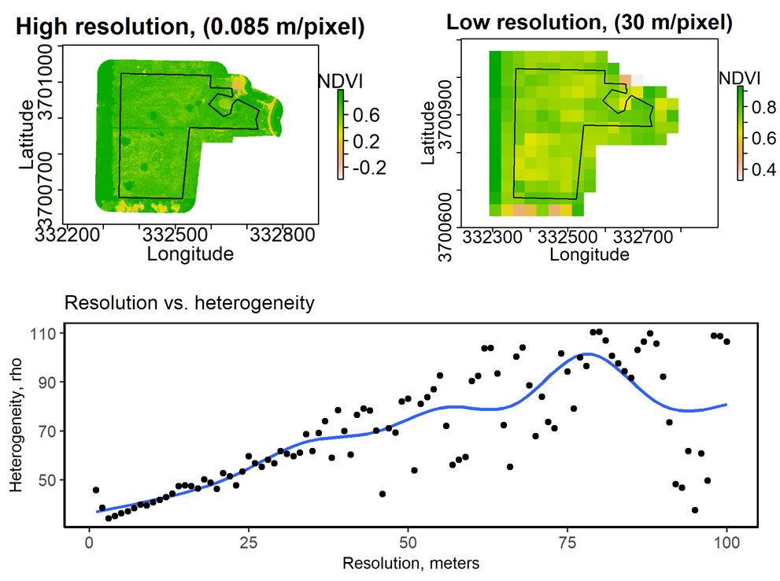
Figure 1: An NDVI map of the pasture in Mississippi State, Mississippi, USA at an 0.085 m and 30 m resolution (top). The relationship between heterogeneity and resolution are also shown (bottom).

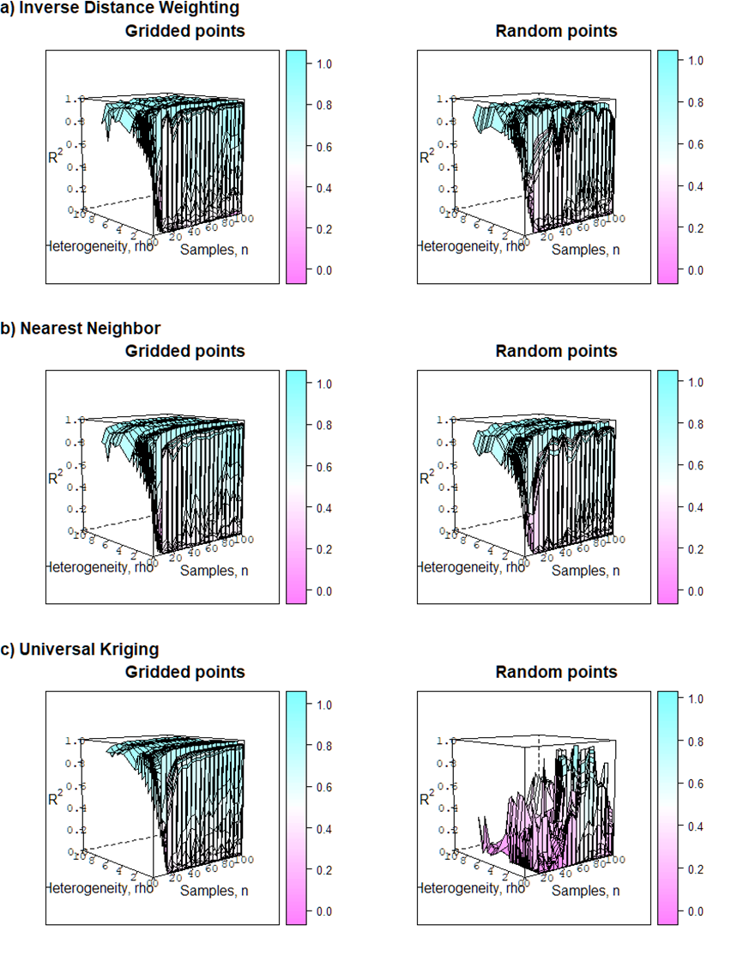
Figure 2: Raw values for accuracy (R²) of a) Inverse Distance Weighting, b) Nearest Neighbor, and c) Universal Kriging interpolation at increasing sample densities and landscape heterogeneities (with 0 being more heterogeneous) using a gridded or random sampling strategy.
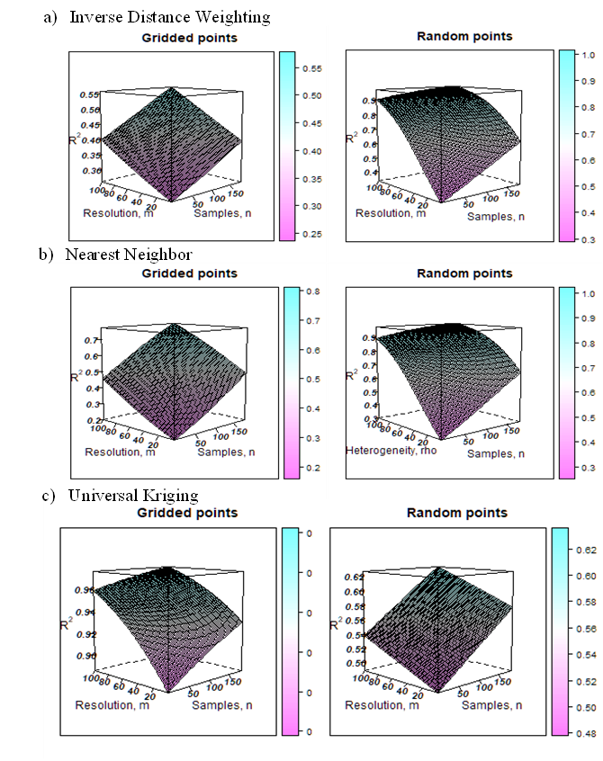

Figure 3: Accuracy (R²) of a) Inverse Distance Weighting, b) Nearest Neighbor, and c) Universal Kriging interpolation of NDVI values at increasing sample densities and decreasing landscape resolution using a gridded or random sampling strategies.
Table 2. Accuracy (R²) for Inverse distance weighting using uniform gridded sampling strategy. Across all cells, standard error values range between 0.0002-0.006.
 | ρ
n | 0 | 2 | 4 | 6 | 8 | 10
10 | 0.27 ± 0.007 | 0.6 ± 0.0078 | 0.86 ± 0.005 | 0.96 ± 0.0021 | 0.99 ± 0.00074 | 1 ± 0.00023
15 | 0.28 ± 0.007 | 0.61 ± 0.0071 | 0.87 ± 0.0046 | 0.96 ± 0.002 | 0.99 ± 7e-04 | 1 ± 0.00022
20 | 0.28 ± 0.007 | 0.62 ± 0.0065 | 0.87 ± 0.0043 | 0.97 ± 0.0019 | 0.99 ± 0.00066 | 1 ± 0.00021
25 | 0.29 ± 0.006 | 0.63 ± 0.0059 | 0.88 ± 0.004 | 0.97 ± 0.0018 | 0.99 ± 0.00062 | 1 ± 2e-04
30 | 0.3 ± 0.006 | 0.64 ± 0.0053 | 0.88 ± 0.0037 | 0.97 ± 0.0017 | 0.99 ± 0.00059 | 1 ± 0.00019
35 | 0.31 ± 0.006 | 0.65 ± 0.0049 | 0.89 ± 0.0035 | 0.97 ± 0.0016 | 0.99 ± 0.00056 | 1 ± 0.00018
40 | 0.32 ± 0.006 | 0.66 ± 0.0044 | 0.89 ± 0.0032 | 0.97 ± 0.0015 | 0.99 ± 0.00053 | 1 ± 0.00017
45 | 0.34 ± 0.006 | 0.67 ± 0.0041 | 0.89 ± 0.0031 | 0.97 ± 0.0014 | 0.99 ± 0.00051 | 1 ± 0.00016
50 | 0.35 ± 0.006 | 0.68 ± 0.0039 | 0.9 ± 0.0029 | 0.97 ± 0.0014 | 0.99 ± 0.00048 | 1 ± 0.00015
55 | 0.36 ± 0.006 | 0.69 ± 0.0038 | 0.9 ± 0.0028 | 0.97 ± 0.0013 | 0.99 ± 0.00046 | 1 ± 0.00015
60 | 0.37 ± 0.006 | 0.7 ± 0.0038 | 0.91 ± 0.0027 | 0.98 ± 0.0012 | 0.99 ± 0.00044 | 1 ± 0.00014
65 | 0.38 ± 0.006 | 0.71 ± 0.0039 | 0.91 ± 0.0027 | 0.98 ± 0.0012 | 0.99 ± 0.00042 | 1 ± 0.00013
70 | 0.39 ± 0.006 | 0.72 ± 0.0041 | 0.91 ± 0.0026 | 0.98 ± 0.0012 | 0.99 ± 0.00041 | 1 ± 0.00013
75 | 0.4 ± 0.007 | 0.73 ± 0.0043 | 0.92 ± 0.0026 | 0.98 ± 0.0011 | 0.99 ± 0.00039 | 1 ± 0.00012
80 | 0.41 ± 0.0069 | 0.74 ± 0.0046 | 0.92 ± 0.0026 | 0.98 ± 0.0011 | 1 ± 0.00038 | 1 ± 0.00012
85 | 0.42 ± 0.0074 | 0.75 ± 0.0049 | 0.93 ± 0.0026 | 0.98 ± 0.0011 | 1 ± 0.00036 | 1 ± 0.00011
90 | 0.43 ± 0.0079 | 0.76 ± 0.0052 | 0.93 ± 0.0026 | 0.98 ± 0.001 | 1 ± 0.00035 | 1 ± 0.00011
95 | 0.45 ± 0.0085 | 0.77 ± 0.0055 | 0.93 ± 0.0026 | 0.98 ± 0.001 | 1 ± 0.00034 | 1 ± 0.00011
100 | 0.46 ± 0.0091 | 0.78 ± 0.0058 | 0.93 ± 0.0027 | 0.98 ± 0.001 | 1 ± 0.00033 | 1 ± 1e-04

Table 3 Accuracy (R²) ± standard error for Inverse distance weighting using random sampling strategy.
 | ρ
n | 0 | 2 | 4 | 6 | 8 | 10
10 | 0.2 ± 0.0056 | 0.58 ± 0.0074 | 0.88 ± 0.0041 | 0.98 ± 0.0013 | 1 ± 0.00032 | 1 ± 7.4e-05
15 | 0.2 ± 0.0054 | 0.59 ± 0.0068 | 0.89 ± 0.0038 | 0.98 ± 0.0012 | 1 ± 3e-04 | 1 ± 7e-05
20 | 0.21 ± 0.0052 | 0.6 ± 0.0062 | 0.89 ± 0.0035 | 0.98 ± 0.0011 | 1 ± 0.00029 | 1 ± 6.7e-05
25 | 0.22 ± 0.005 | 0.61 ± 0.0056 | 0.9 ± 0.0033 | 0.98 ± 0.0011 | 1 ± 0.00027 | 1 ± 6.4e-05
30 | 0.23 ± 0.0048 | 0.62 ± 0.0051 | 0.9 ± 0.003 | 0.98 ± 0.001 | 1 ± 0.00026 | 1 ± 6.1e-05
35 | 0.23 ± 0.0047 | 0.63 ± 0.0047 | 0.9 ± 0.0029 | 0.98 ± 0.00096 | 1 ± 0.00025 | 1 ± 5.8e-05
40 | 0.24 ± 0.0046 | 0.64 ± 0.0043 | 0.91 ± 0.0027 | 0.98 ± 0.00091 | 1 ± 0.00024 | 1 ± 5.6e-05
45 | 0.25 ± 0.0045 | 0.65 ± 0.004 | 0.91 ± 0.0026 | 0.98 ± 0.00087 | 1 ± 0.00023 | 1 ± 5.3e-05
50 | 0.26 ± 0.0045 | 0.66 ± 0.0038 | 0.92 ± 0.0024 | 0.98 ± 0.00083 | 1 ± 0.00022 | 1 ± 5.1e-05
55 | 0.27 ± 0.0045 | 0.67 ± 0.0037 | 0.92 ± 0.0024 | 0.98 ± 8e-04 | 1 ± 0.00021 | 1 ± 4.9e-05
60 | 0.28 ± 0.0046 | 0.68 ± 0.0037 | 0.92 ± 0.0023 | 0.98 ± 0.00077 | 1 ± 2e-04 | 1 ± 4.7e-05
65 | 0.28 ± 0.0048 | 0.69 ± 0.0038 | 0.92 ± 0.0022 | 0.99 ± 0.00074 | 1 ± 0.00019 | 1 ± 4.5e-05
70 | 0.29 ± 0.0051 | 0.7 ± 0.004 | 0.93 ± 0.0022 | 0.99 ± 0.00072 | 1 ± 0.00019 | 1 ± 4.3e-05
75 | 0.3 ± 0.0054 | 0.71 ± 0.0042 | 0.93 ± 0.0022 | 0.99 ± 7e-04 | 1 ± 0.00018 | 1 ± 4.2e-05
80 | 0.31 ± 0.0058 | 0.72 ± 0.0045 | 0.93 ± 0.0022 | 0.99 ± 0.00068 | 1 ± 0.00017 | 1 ± 4e-05
85 | 0.32 ± 0.0062 | 0.72 ± 0.0048 | 0.94 ± 0.0022 | 0.99 ± 0.00066 | 1 ± 0.00017 | 1 ± 3.9e-05
90 | 0.33 ± 0.0067 | 0.73 ± 0.0052 | 0.94 ± 0.0022 | 0.99 ± 0.00065 | 1 ± 0.00016 | 1 ± 3.7e-05
95 | 0.34 ± 0.0072 | 0.74 ± 0.0055 | 0.94 ± 0.0022 | 0.99 ± 0.00064 | 1 ± 0.00016 | 1 ± 3.6e-05
100 | 0.35 ± 0.0078 | 0.75 ± 0.0058 | 0.94 ± 0.0022 | 0.99 ± 0.00062 | 1 ± 0.00015 | 1 ± 3.5e-05

Table 4 Accuracy (R²) ± standard error for Nearest neighbor interpolation using gridded sampling strategy.
 | ρ
n | 0 | 2 | 4 | 6 | 8 | 10
10 | 0.22 ± 0.0063 | 0.56 ± 0.0079 | 0.86 ± 0.005 | 0.97 ± 0.0019 | 0.99 ± 0.00057 | 1 ± 0.00016
15 | 0.22 ± 0.006 | 0.58 ± 0.0072 | 0.87 ± 0.0046 | 0.97 ± 0.0018 | 0.99 ± 0.00053 | 1 ± 0.00015
20 | 0.23 ± 0.0058 | 0.59 ± 0.0066 | 0.87 ± 0.0042 | 0.97 ± 0.0016 | 0.99 ± 0.0005 | 1 ± 0.00014
25 | 0.24 ± 0.0056 | 0.6 ± 0.006 | 0.88 ± 0.0039 | 0.97 ± 0.0015 | 0.99 ± 0.00047 | 1 ± 0.00013
30 | 0.25 ± 0.0055 | 0.62 ± 0.0054 | 0.88 ± 0.0036 | 0.97 ± 0.0014 | 0.99 ± 0.00045 | 1 ± 0.00012
35 | 0.26 ± 0.0053 | 0.63 ± 0.0049 | 0.89 ± 0.0034 | 0.97 ± 0.0014 | 0.99 ± 0.00042 | 1 ± 0.00012
40 | 0.27 ± 0.0052 | 0.64 ± 0.0045 | 0.89 ± 0.0031 | 0.98 ± 0.0013 | 0.99 ± 0.0004 | 1 ± 0.00011
45 | 0.29 ± 0.0051 | 0.65 ± 0.0042 | 0.9 ± 0.003 | 0.98 ± 0.0012 | 0.99 ± 0.00038 | 1 ± 0.0001
50 | 0.3 ± 0.0051 | 0.66 ± 0.0039 | 0.9 ± 0.0028 | 0.98 ± 0.0011 | 1 ± 0.00036 | 1 ± 0.000099
55 | 0.31 ± 0.0051 | 0.68 ± 0.0038 | 0.91 ± 0.0027 | 0.98 ± 0.0011 | 1 ± 0.00034 | 1 ± 0.000094
60 | 0.32 ± 0.0053 | 0.69 ± 0.0038 | 0.91 ± 0.0026 | 0.98 ± 0.001 | 1 ± 0.00032 | 1 ± 0.000089
65 | 0.33 ± 0.0055 | 0.7 ± 0.0039 | 0.92 ± 0.0025 | 0.98 ± 0.001 | 1 ± 0.00031 | 1 ± 0.000085
70 | 0.34 ± 0.0058 | 0.71 ± 0.0041 | 0.92 ± 0.0025 | 0.98 ± 0.00096 | 1 ± 0.00029 | 1 ± 0.000081
75 | 0.35 ± 0.0061 | 0.72 ± 0.0044 | 0.92 ± 0.0025 | 0.98 ± 0.00092 | 1 ± 0.00028 | 1 ± 0.000077
80 | 0.37 ± 0.0066 | 0.73 ± 0.0046 | 0.93 ± 0.0024 | 0.98 ± 0.00089 | 1 ± 0.00027 | 1 ± 0.000074
85 | 0.38 ± 0.007 | 0.74 ± 0.0049 | 0.93 ± 0.0024 | 0.98 ± 0.00086 | 1 ± 0.00026 | 1 ± 0.00007
90 | 0.39 ± 0.0076 | 0.75 ± 0.0052 | 0.93 ± 0.0024 | 0.99 ± 0.00084 | 1 ± 0.00025 | 1 ± 0.000067
95 | 0.4 ± 0.0082 | 0.76 ± 0.0055 | 0.94 ± 0.0024 | 0.99 ± 0.00081 | 1 ± 0.00024 | 1 ± 0.000064
100 | 0.42 ± 0.0088 | 0.77 ± 0.0058 | 0.94 ± 0.0024 | 0.99 ± 0.00079 | 1 ± 0.00023 | 1 ± 0.000061

Table 5 Accuracy (R²) ± standard error for Nearest Neighbor interpolation using random sampling strategy.
 | ρ
n | 0 | 2 | 4 | 6 | 8 | 10
10 | 0.16 ± 0.0049 | 0.54 ± 0.0076 | 0.88 ± 0.0043 | 0.98 ± 0.0013 | 1 ± 0.0003 | 1 ± 0.000063
15 | 0.17 ± 0.0048 | 0.55 ± 0.007 | 0.88 ± 0.004 | 0.98 ± 0.0012 | 1 ± 0.00028 | 1 ± 0.000059
20 | 0.18 ± 0.0046 | 0.57 ± 0.0064 | 0.89 ± 0.0037 | 0.98 ± 0.0011 | 1 ± 0.00026 | 1 ± 0.000056
25 | 0.19 ± 0.0045 | 0.58 ± 0.0058 | 0.89 ± 0.0034 | 0.98 ± 0.001 | 1 ± 0.00025 | 1 ± 0.000053
30 | 0.19 ± 0.0044 | 0.59 ± 0.0053 | 0.9 ± 0.0031 | 0.98 ± 0.00098 | 1 ± 0.00023 | 1 ± 0.00005
35 | 0.2 ± 0.0043 | 0.6 ± 0.0048 | 0.9 ± 0.0029 | 0.98 ± 0.00092 | 1 ± 0.00022 | 1 ± 0.000048
40 | 0.21 ± 0.0042 | 0.61 ± 0.0044 | 0.91 ± 0.0028 | 0.98 ± 0.00087 | 1 ± 0.00021 | 1 ± 0.000045
45 | 0.22 ± 0.0042 | 0.63 ± 0.0041 | 0.91 ± 0.0026 | 0.98 ± 0.00083 | 1 ± 0.0002 | 1 ± 0.000043
50 | 0.23 ± 0.0042 | 0.64 ± 0.0039 | 0.91 ± 0.0025 | 0.98 ± 0.00079 | 1 ± 0.00019 | 1 ± 0.000041
55 | 0.24 ± 0.0042 | 0.65 ± 0.0038 | 0.92 ± 0.0024 | 0.99 ± 0.00075 | 1 ± 0.00018 | 1 ± 0.000039
60 | 0.24 ± 0.0044 | 0.66 ± 0.0038 | 0.92 ± 0.0023 | 0.99 ± 0.00072 | 1 ± 0.00017 | 1 ± 0.000037
65 | 0.25 ± 0.0046 | 0.67 ± 0.0039 | 0.92 ± 0.0022 | 0.99 ± 0.00069 | 1 ± 0.00016 | 1 ± 0.000036
70 | 0.26 ± 0.0048 | 0.68 ± 0.0041 | 0.93 ± 0.0022 | 0.99 ± 0.00066 | 1 ± 0.00016 | 1 ± 0.000034
75 | 0.27 ± 0.0052 | 0.69 ± 0.0043 | 0.93 ± 0.0022 | 0.99 ± 0.00064 | 1 ± 0.00015 | 1 ± 0.000033
80 | 0.28 ± 0.0055 | 0.7 ± 0.0046 | 0.93 ± 0.0022 | 0.99 ± 0.00062 | 1 ± 0.00015 | 1 ± 0.000031
85 | 0.29 ± 0.006 | 0.71 ± 0.005 | 0.94 ± 0.0021 | 0.99 ± 0.0006 | 1 ± 0.00014 | 1 ± 0.00003
90 | 0.3 ± 0.0065 | 0.72 ± 0.0053 | 0.94 ± 0.0021 | 0.99 ± 0.00058 | 1 ± 0.00013 | 1 ± 0.000029
95 | 0.31 ± 0.007 | 0.73 ± 0.0056 | 0.94 ± 0.0021 | 0.99 ± 0.00057 | 1 ± 0.00013 | 1 ± 0.000027
100 | 0.33 ± 0.0076 | 0.74 ± 0.006 | 0.95 ± 0.0021 | 0.99 ± 0.00055 | 1 ± 0.00012 | 1 ± 0.000026

Table 6 Accuracy (R²) ± standard error for Universal Kriging interpolation using gridded sampling strategy.
 | ρ
n | 0 | 2 | 4 | 6 | 8 | 10
10 | 0.24 ± 0.0073 | 0.59 ± 0.0087 | 0.87 ± 0.0051 | 0.97 ± 0.0018 | 0.99 ± 0.00055 | 1 ± 0.00015
15 | 0.24 ± 0.007 | 0.6 ± 0.008 | 0.88 ± 0.0046 | 0.97 ± 0.0017 | 0.99 ± 0.00052 | 1 ± 0.00014
20 | 0.25 ± 0.0067 | 0.61 ± 0.0072 | 0.88 ± 0.0043 | 0.97 ± 0.0016 | 0.99 ± 0.00049 | 1 ± 0.00013
25 | 0.26 ± 0.0064 | 0.62 ± 0.0065 | 0.89 ± 0.0039 | 0.97 ± 0.0015 | 0.99 ± 0.00046 | 1 ± 0.00013
30 | 0.27 ± 0.0061 | 0.63 ± 0.0059 | 0.89 ± 0.0036 | 0.97 ± 0.0014 | 0.99 ± 0.00044 | 1 ± 0.00012
35 | 0.28 ± 0.0059 | 0.64 ± 0.0053 | 0.89 ± 0.0034 | 0.98 ± 0.0013 | 0.99 ± 0.00041 | 1 ± 0.00012
40 | 0.29 ± 0.0057 | 0.66 ± 0.0048 | 0.9 ± 0.0032 | 0.98 ± 0.0013 | 0.99 ± 0.00039 | 1 ± 0.00011
45 | 0.3 ± 0.0055 | 0.67 ± 0.0044 | 0.9 ± 0.003 | 0.98 ± 0.0012 | 1 ± 0.00037 | 1 ± 0.0001
50 | 0.31 ± 0.0054 | 0.68 ± 0.0041 | 0.91 ± 0.0028 | 0.98 ± 0.0011 | 1 ± 0.00036 | 1 ± 0.0001
55 | 0.32 ± 0.0054 | 0.69 ± 0.0039 | 0.91 ± 0.0027 | 0.98 ± 0.0011 | 1 ± 0.00034 | 1 ± 0.000095
60 | 0.33 ± 0.0055 | 0.7 ± 0.0039 | 0.91 ± 0.0026 | 0.98 ± 0.001 | 1 ± 0.00033 | 1 ± 0.000091
65 | 0.34 ± 0.0056 | 0.7 ± 0.004 | 0.92 ± 0.0026 | 0.98 ± 0.001 | 1 ± 0.00031 | 1 ± 0.000087
70 | 0.35 ± 0.0059 | 0.71 ± 0.0041 | 0.92 ± 0.0025 | 0.98 ± 0.00098 | 1 ± 0.0003 | 1 ± 0.000084
75 | 0.36 ± 0.0063 | 0.72 ± 0.0044 | 0.92 ± 0.0025 | 0.98 ± 0.00095 | 1 ± 0.00029 | 1 ± 0.00008
80 | 0.37 ± 0.0067 | 0.73 ± 0.0047 | 0.93 ± 0.0025 | 0.98 ± 0.00092 | 1 ± 0.00028 | 1 ± 0.000077
85 | 0.38 ± 0.0072 | 0.74 ± 0.005 | 0.93 ± 0.0025 | 0.98 ± 0.0009 | 1 ± 0.00027 | 1 ± 0.000074
90 | 0.39 ± 0.0078 | 0.75 ± 0.0054 | 0.93 ± 0.0025 | 0.98 ± 0.00088 | 1 ± 0.00026 | 1 ± 0.000072
95 | 0.4 ± 0.0084 | 0.76 ± 0.0057 | 0.94 ± 0.0025 | 0.99 ± 0.00086 | 1 ± 0.00025 | 1 ± 0.000069
100 | 0.41 ± 0.009 | 0.77 ± 0.0061 | 0.94 ± 0.0026 | 0.99 ± 0.00084 | 1 ± 0.00025 | 1 ± 0.000067

Table 7 Accuracy (R²) ± standard error for Universal kriging interpolation using random sampling strategy.
 | ρ
n | 0 | 2 | 4 | 6 | 8 | 10
10 | 0.047 ± 0.0019 | 0.076 ± 0.0026 | 0.12 ± 0.0045 | 0.19 ± 0.0083 | 0.28 ± 0.014 | 0.39 ± 0.021
15 | 0.051 ± 0.0019 | 0.082 ± 0.0026 | 0.13 ± 0.0046 | 0.2 ± 0.0085 | 0.3 ± 0.014 | 0.41 ± 0.021
20 | 0.056 ± 0.002 | 0.09 ± 0.0026 | 0.14 ± 0.0046 | 0.22 ± 0.0087 | 0.31 ± 0.015 | 0.43 ± 0.021
25 | 0.061 ± 0.002 | 0.097 ± 0.0026 | 0.15 ± 0.0047 | 0.23 ± 0.009 | 0.33 ± 0.015 | 0.46 ± 0.021
30 | 0.066 ± 0.0021 | 0.11 ± 0.0026 | 0.16 ± 0.0048 | 0.25 ± 0.0092 | 0.36 ± 0.015 | 0.48 ± 0.021
35 | 0.072 ± 0.0021 | 0.11 ± 0.0026 | 0.18 ± 0.0048 | 0.27 ± 0.0094 | 0.38 ± 0.015 | 0.5 ± 0.021
40 | 0.078 ± 0.0022 | 0.12 ± 0.0026 | 0.19 ± 0.0049 | 0.28 ± 0.0096 | 0.4 ± 0.016 | 0.52 ± 0.021
45 | 0.085 ± 0.0023 | 0.13 ± 0.0026 | 0.21 ± 0.005 | 0.3 ± 0.0098 | 0.42 ± 0.016 | 0.55 ± 0.021
50 | 0.092 ± 0.0023 | 0.15 ± 0.0026 | 0.22 ± 0.0051 | 0.32 ± 0.01 | 0.44 ± 0.016 | 0.57 ± 0.02
55 | 0.1 ± 0.0025 | 0.16 ± 0.0027 | 0.24 ± 0.0053 | 0.34 ± 0.01 | 0.46 ± 0.016 | 0.59 ± 0.02
60 | 0.11 ± 0.0026 | 0.17 ± 0.0028 | 0.25 ± 0.0055 | 0.36 ± 0.011 | 0.49 ± 0.016 | 0.61 ± 0.02
65 | 0.12 ± 0.0028 | 0.18 ± 0.0029 | 0.27 ± 0.0058 | 0.38 ± 0.011 | 0.51 ± 0.016 | 0.64 ± 0.019
70 | 0.13 ± 0.003 | 0.2 ± 0.0032 | 0.29 ± 0.0061 | 0.41 ± 0.011 | 0.53 ± 0.016 | 0.66 ± 0.019
75 | 0.14 ± 0.0033 | 0.21 ± 0.0035 | 0.31 ± 0.0064 | 0.43 ± 0.011 | 0.56 ± 0.016 | 0.68 ± 0.018
80 | 0.15 ± 0.0036 | 0.23 ± 0.0039 | 0.33 ± 0.0069 | 0.45 ± 0.012 | 0.58 ± 0.016 | 0.7 ± 0.018
85 | 0.16 ± 0.004 | 0.24 ± 0.0044 | 0.35 ± 0.0073 | 0.47 ± 0.012 | 0.6 ± 0.016 | 0.71 ± 0.017
90 | 0.17 ± 0.0045 | 0.26 ± 0.0049 | 0.37 ± 0.0079 | 0.5 ± 0.012 | 0.62 ± 0.016 | 0.73 ± 0.017
95 | 0.19 ± 0.005 | 0.28 ± 0.0056 | 0.39 ± 0.0084 | 0.52 ± 0.013 | 0.64 ± 0.016 | 0.75 ± 0.016
100 | 0.2 ± 0.0056 | 0.3 ± 0.0062 | 0.41 ± 0.009 | 0.54 ± 0.013 | 0.66 ± 0.015 | 0.77 ± 0.016

