Supporting Information
Failure mode engineered high-energy-absorption metamaterials with biomimetic hierarchical microstructures and artificial grain boundaries

- Supporting figures and tables
In this section, the supporting figures and tables described in the main text of the paper is provided.
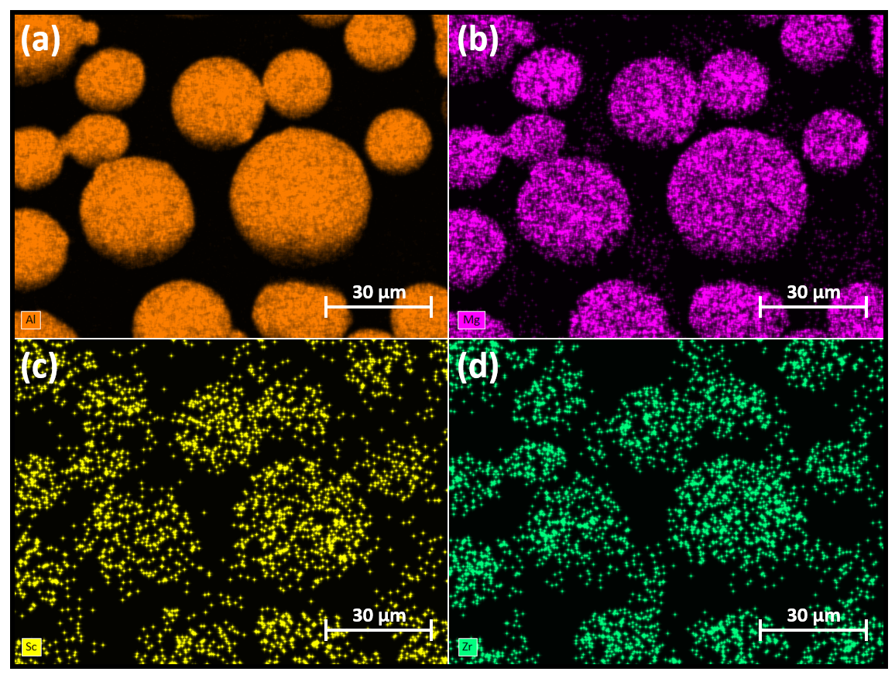
Figure S1. Element distributions of AlMgScZr powder measured by SEM: (a) Al; (b) Mg; (c) Sc; (d) Zr.
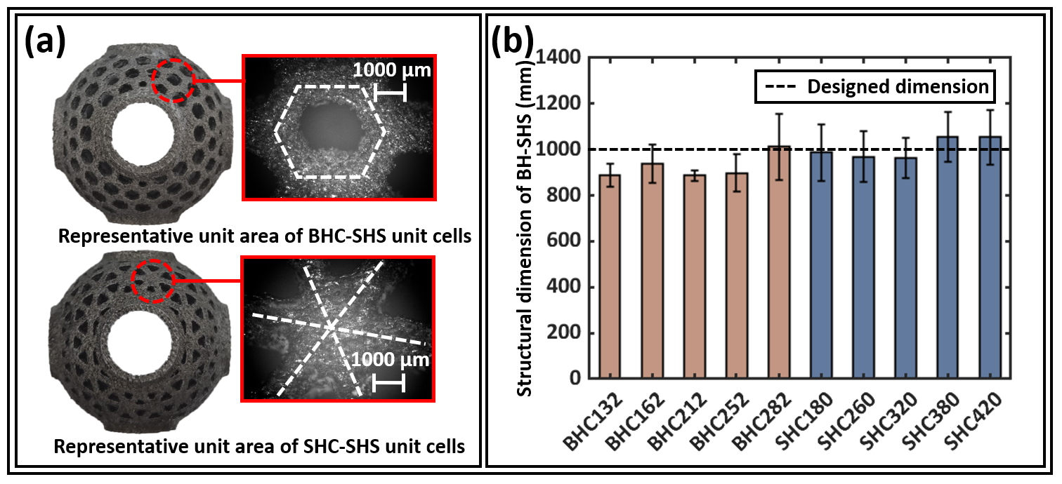
Figure S2. Representative unit areas and beam thicknesses of BH-SHS unit cells fabricated by SLM: (a) optical microscope images of representative unit areas for the BHC-SHS and SHC-SHS unit cells; and (b) the experimentally measured beam thicknesses for the BHC-SHS and SHC-SHS unit cells.
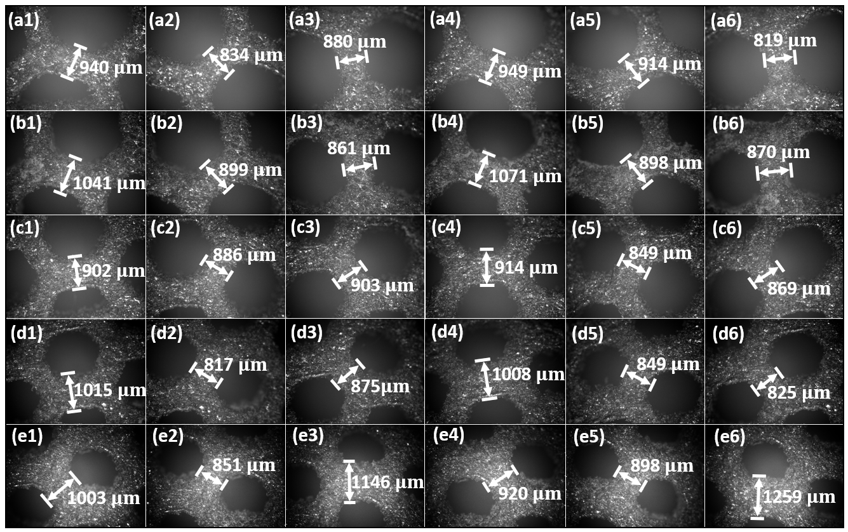
Figure S3. Optical microscope measurement of the beam thickness from representative unit areas for BHC-SHS unit cells: (a1-a6) BHC132; (b1-b6) BHC162; (c1-c6) BHC212; (d1-d6) BHC252; and (e1-e6) BHC282.
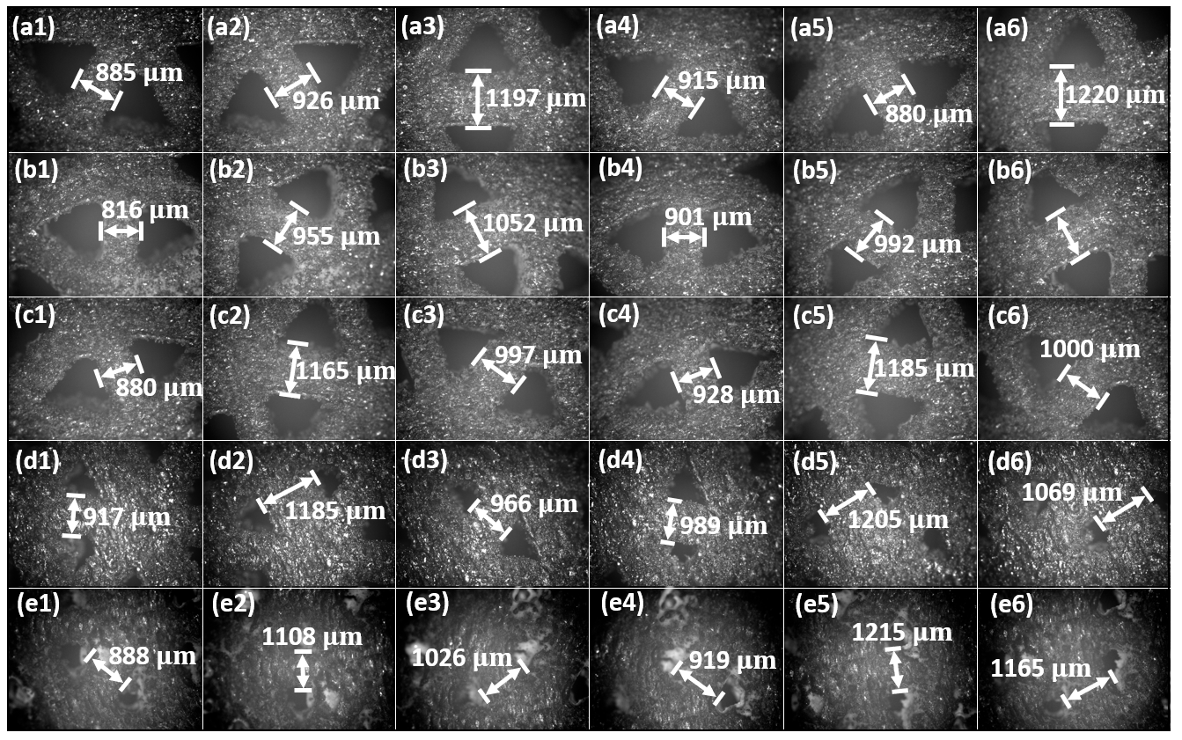
Figure S4. Optical microscope images of the beam thickness from the representative unit areas for the SHC-SHS unit cells: (a1-a6) SHC180; (b1-b6) SHC260; (c1-c6) SHC320; (d1-d6) SHC380; and (e1-e6) SHC420.
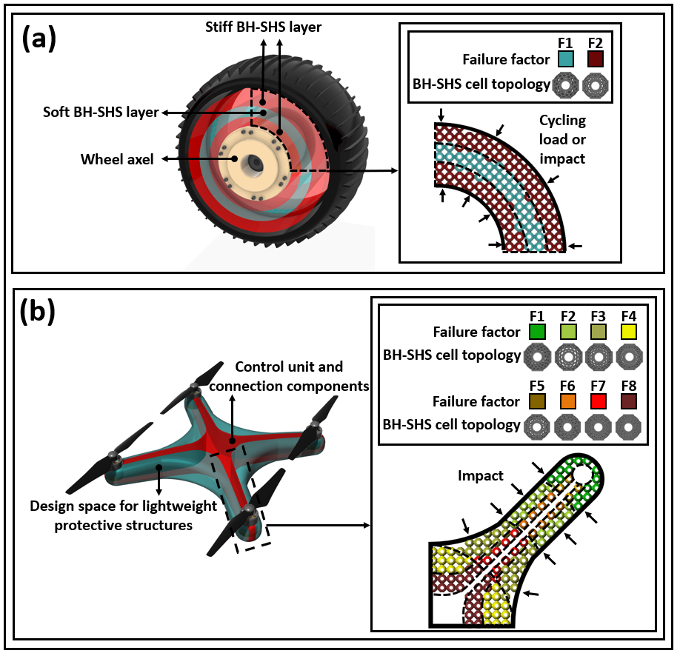
Figure S5. Additional case studies for applying BH-SHS lattice structures and failure mode engineering method in aerospace industries: (a) a space rover wheel with protective damage deflection design using BH-SHS infills; and (b) a quadradrone with impact-resistant BH-SHS infills.
Table S1. Summary of the design parameter values for the BH-SHS unit cells.
Design parameter | Selected range
Beam thickness [mm] | 1
Shell thickness [mm] | 1
Topological density for BHC-SHS unit cells | 132 ~ 282
Topological density for SHC-SHS unit cells | 180 ~ 420

Table S2. Material composition of AlMgScZr powder.
Material | Weighted percentage [%]
Al | 93.6
Mg | 4.7
Sc | 0.79
Zr | 0.32
Mn | 0.59

Table S3. Dimensions of the specimen.
Specimen # | Diameter 1 [mm] | Diameter 2 [mm] |  | Diameter 3 [mm] | Average diameter [mm] | Standard deviation of diameter [mm] | Gauge length of extensometer [mm]
1 | 5 |  | 4.97 | 4.97 | 4.98 | 0.01 | 20
2 | 4.99 |  | 4.97 | 4.97 | 4.98 | 0.01
3 | 4.97 |  | 4.97 | 4.99 | 4.98 | 0.01

Table S4. Standard deviations of the experimentally measured mechanical properties for different unit cell topologies.
Topology | First wavy strength [MPa] | Secondary wavy strength [MPa] | Relative density [%] | Density [kg/$m^{3}$] | EAC  [$×$10⁴ J/$m^{3}$]
BHC132 | 0.11 | 0.04 | 0.24 | 3.10 | 1.53
BHC162 | 0.07 | 0.02 | 0.12 | 1.49 | 4.20
BHC212 | 0.01 | 0.02 | 0.11 | 1.29 | 5.85
BHC252 | 0.09 | 0.10 | 0.19 | 2.20 | 1.72
BHC282 | 0.06 | 0.01 | 0.09 | 1.06 | 0.27
SHC180 | 0.20 | NA | 0.08 | 0.99 | 3.14
SHC260 | 0.09 | NA | 0.14 | 1.66 | 17.07
SHC320 | 0.04 | NA | 0.06 | 0.75 | 16.55
SHC380 | 0.04 | NA | 0.07 | 0.86 | 10.57
SHC420 | 0.04 | NA | 0.08 | 0.90 | 3.46

Table S5. Compressive stages of the BHC-G1/2 and SHC-G1/2 lattice unit cells at different strain values.
BHC-G1/2 | G1 |  |  |  |  | G2
 | Compressive stage | Substage | F1 | F2 | F3 | Compressive stage | Substage | F1 | F2 | F3
 | $$I_{1}$$ | 1-2 | $$I$$ | - | - | $$I_{1}$$ | 1-2 | I | - | -
 |  | 2-3 | $$II$$ | - | - |  | 2-3 | II | - | -
 | $$I_{2}$$ | 3-5 | $$III$$ | $$I$$ | - | $$I_{2}$$ | 3-4 | III | I | -
 |  | 5-6 | $$III$$ | $$II$$ | $$I$$ |  | 4-5 | III | I | I
 | $$II$$ | 6-7 | $$IV$$ | $$III$$ | $$II$$ |  | 5-6 | III | II | II
 |  | 7-8 | $$IV$$ | $$IV$$ | $$III$$ | $$II$$ | 6-7 | IV | III | III
 |  | 8-9 | $$IV$$ | $$IV$$ | III-IV |  | 7-8 | IV | III-IV | III-IV
 | $$III$$ | 9- | $$IV$$ | $$IV$$ | $$IV$$ | $$III$$ | 8- | IV | IV | IV
SHC-G1/2 | G1 |  |  |  |  | G2
 | Compressive stage | Substage | F1 | F2 | F3 | Compressive stage | Substage | F1 | F2 | F3
 | $$I_{1}$$ | 1-2 | I-II | - | - | $$I_{1}$$ | 1-2 | I | - | -
 |  | 2-3 | III | I | - |  | 2-3 | II | I | -
 | $$I_{2}$$ | 3-4 | III | II | I | $$I_{2}$$ | 3-4 | III | I | -
 |  | 4-5 | III | III | II |  | 4-5 | III | II | I
 | $$II$$ | 5-6 | III | III | III |  | 5-6 | III | III | II
 |  | 6-7 | IV | IV | III | $$II$$ | 6-7 | III | III | III
 |  | 7-8 | IV | IV | III-IV |  | 7-8 | IV | III | III
 | $$III$$ | 8- | IV | IV | IV |  | 8-9 | IV | IV | III-IV
 |  |  |  |  |  | $$III$$ | 9- | IV | IV | IV

Table S6. Compressive stages of the CHC-SHS lattice unit cells at different strain values.
Compressive stage | Substage | BHC-SHS unit cells |  |  | SHC-SHS unit cells
 |  | F1 | F2 | F3 | F1 | F2 | F3
$$I_{1}$$ | 1-2 | I | - | - | - | - | -
 | 2-3 | II | - | - | I | - | -
$$I_{2}$$ | 3-4 | III | I | - | II | - | -
 | 4-5 | III | I | - | III | I | -
 | 5-6 | IV | II-III | I | III | I | I
II | 6-7 | IV | III | II | III | II | II
 | 7-8 | IV | III | III | IV | III | II
 | 8-9 | IV | IV | IV | IV | III | III
 | 9-10 | IV | IV | IV | IV | III-IV | III-IV
III | 10- | IV | IV | IV | IV | IV | IV

- Supporting videos
In this section, the supporting videos mentioned in the main text of the paper is provided. Specifically, the simulation videos of two distinctive failure modes for the BH-SHS unit cells are provided in Video S1 and Video S2. Video S3 to Video S7 delivers the progressing compressive curves and their corresponding experimental compressive recordings for BHC-G1/2, SHC-G1/2, and CHC-SHS lattice structures, respectively.

Video S1. A1-A2-B failure mode simulation.
Video S2. B1-B2-A failure mode simulation.
Video S3. Experimental compressive curve and video of BHC-G1 lattice structure.
Video S4. Experimental compressive curve and video of BHC-G2 lattice structure.
Video S5. Experimental compressive curve and video of SHC-G1 lattice structure.
Video S6. Experimental compressive curve and video of SHC-G2 lattice structure.
Video S7. Experimental compressive curve and video of CHC-SHS lattice structure.

