Supplementary material

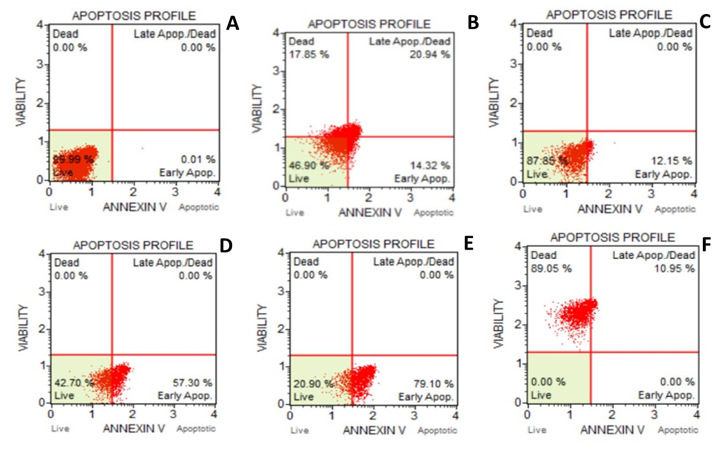

Figure S1. Analysis of apoptosis in a flow cytometer, of 8 dpf zebrafish (Danio rerio) larvae cells. A.Negative control (E3 medium), B. Positive Control (2% EtOH), C. 0.03 mg L⁻¹ D. 0.3125 mg L⁻¹, E. 3.125 mg L⁻¹ F. 6.25 mg/L of 100% MeOH extract from K. veneficum supernatant. The amount expressed in μg L⁻¹ corresponds to the concentration of the total KmTxs analysed by HPLC-MS and expressed as KmTx-2 equivalent.

