Graphical abstract:

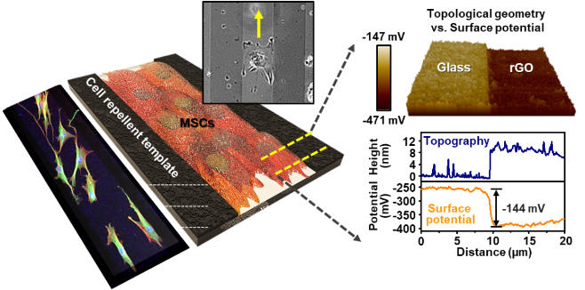
Stem cell culture platform, based on an anisotropic combination of spatial topography and surface potential, provides an opportunity for phenomenal interaction for mesenchymal stem cells by constructing differentially separated regions. Without supplying a transforming growth factor, the spatially aligned MSCs were organized and differentiated into smooth muscle cells upon the specific crosstalk between cells.

