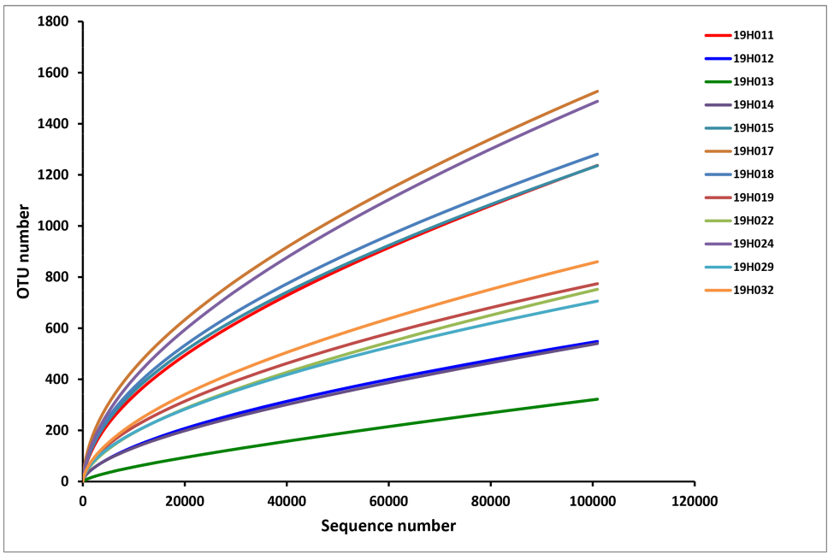
Supplementary Fig. S1 Rarefaction curve of twelve upland rice seed samples (OTU = 0.03). Rarefaction curves present the relationship between the number of samples and bacterial species richness in OTUs.

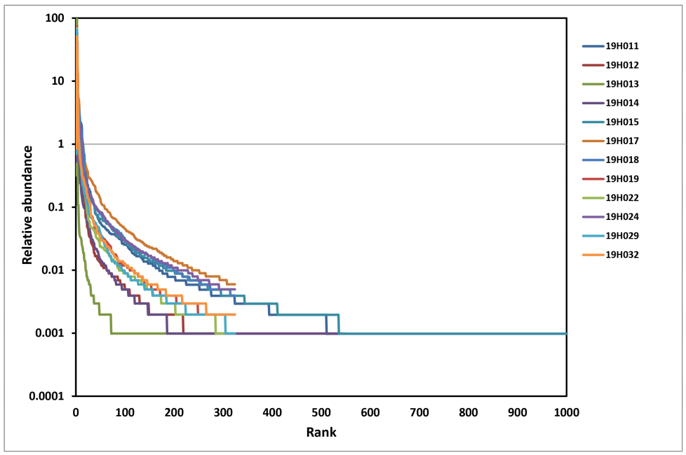
Supplementary Fig. S2 Rank abundance curve of twelveupland rice seed samples (OTU = 0.03). The rank abundance curve is used to observe the richness and evenness of species.

Supplementary Table S1 Statistics of the upland rice seed samples
Sample | Read number | Minlength | Maxlength | Average Length
19H011_1 | 35895 | 341 | 541 | 434
19H011_2 | 39306 | 384 | 505 | 434
19H011_3 | 44421 | 375 | 503 | 434
19H012_1 | 43402 | 403 | 503 | 434
19H012_2 | 42974 | 370 | 522 | 434
19H012_3 | 44082 | 411 | 528 | 434
19H013_1 | 52729 | 411 | 502 | 434
19H013_2 | 57624 | 422 | 503 | 434
19H013_3 | 56246 | 424 | 503 | 434
19H014_1 | 51076 | 386 | 503 | 434
19H014_2 | 57090 | 386 | 503 | 434
19H014_3 | 56272 | 367 | 503 | 434
19H015_1 | 53287 | 310 | 542 | 434
19H015_2 | 59182 | 370 | 503 | 434
19H015_3 | 59601 | 383 | 546 | 434
19H017_1 | 60583 | 367 | 503 | 434
19H017_2 | 61327 | 305 | 505 | 434
19H017_3 | 60219 | 341 | 520 | 434
19H018_1 | 61706 | 402 | 503 | 434
19H018_2 | 62303 | 387 | 502 | 434
19H018_3 | 45562 | 341 | 503 | 434
19H019_1 | 63962 | 397 | 503 | 434
19H019_2 | 61915 | 356 | 541 | 434
19H019_3 | 58244 | 359 | 503 | 434
19H022_1 | 59542 | 330 | 503 | 434
19H022_2 | 66125 | 379 | 503 | 434
19H022_3 | 68867 | 396 | 504 | 434
19H024_1 | 67326 | 395 | 504 | 434
19H024_2 | 67618 | 384 | 534 | 434
19H024_3 | 68542 | 390 | 505 | 434
19H029_1 | 68776 | 422 | 549 | 434
19H029_2 | 62790 | 412 | 503 | 434
19H029_3 | 55811 | 389 | 502 | 434
19H032_1 | 72736 | 411 | 504 | 434
19H032_2 | 72521 | 411 | 503 | 434
19H032_3 | 70047 | 395 | 540 | 434

Supplementary Table S2 Statistical results of the alpha-diversity of endophytic bacteria in each sample before the sample is repeated without addition
Sample | OTUs | ACE | Chao | Shannon | Simpson
19H011_1 | 638 | 2244.849 | 1610.154 | 2.451886 | 0.264118
19H011_2 | 646 | 1834.232 | 1371.846 | 2.622823 | 0.214491
19H011_3 | 648 | 2378.157 | 1370.161 | 2.404326 | 0.272852
19H012_1 | 260 | 921.1201 | 595.8333 | 1.200866 | 0.496871
19H012_2 | 315 | 1158.301 | 796.0286 | 1.457118 | 0.398514
19H012_3 | 256 | 901.3217 | 653.8333 | 1.361228 | 0.429259
19H013_1 | 155 | 1579.414 | 584.4 | 0.393423 | 0.842405
19H013_2 | 139 | 1201.96 | 635.3636 | 0.349258 | 0.849197
19H013_3 | 112 | 1700.36 | 476.0909 | 0.297555 | 0.868767
19H014_1 | 272 | 1198.418 | 1060.667 | 1.298489 | 0.398397
19H014_2 | 260 | 1274.988 | 813.0435 | 1.28728 | 0.400868
19H014_3 | 272 | 911.7981 | 598.7568 | 1.288443 | 0.401985
19H015_1 | 755 | 2282.966 | 1600.815 | 2.547999 | 0.240513
19H015_2 | 396 | 2037.948 | 1262.563 | 1.280187 | 0.570363
19H015_3 | 718 | 2213.745 | 1580.966 | 2.514651 | 0.225515
19H017_1 | 723 | 2225.284 | 1619.78 | 2.716699 | 0.186833
19H017_2 | 998 | 3254.527 | 2368.196 | 3.088863 | 0.180601
19H017_3 | 685 | 2030.187 | 1485.413 | 2.760536 | 0.179811
19H018_1 | 667 | 2113.219 | 1373 | 2.604757 | 0.191493
19H018_2 | 674 | 2079.689 | 1548.079 | 2.605142 | 0.194408
19H018_3 | 735 | 2370.94 | 1722.841 | 2.75305 | 0.157466
19H019_1 | 425 | 1304.205 | 799 | 1.599329 | 0.45486
19H019_2 | 411 | 1397.239 | 1009.523 | 1.464879 | 0.488971
19H019_3 | 389 | 1123.081 | 683.0448 | 1.429507 | 0.514438
19H022_1 | 388 | 1278.852 | 879.6327 | 1.540694 | 0.447724
19H022_2 | 389 | 1223.895 | 952.1667 | 1.666564 | 0.379105
19H022_3 | 365 | 1612.899 | 853.25 | 1.414622 | 0.48997
19H024_1 | 735 | 2505.95 | 1608.979 | 2.081407 | 0.389308
19H024_2 | 805 | 2454.842 | 1771.697 | 2.478629 | 0.280399
19H024_3 | 803 | 2948.619 | 1896.093 | 2.239791 | 0.35721
19H029_1 | 373 | 1289.267 | 820.8571 | 1.641382 | 0.376878
19H029_2 | 364 | 1280.773 | 939.1667 | 1.651003 | 0.373221
19H029_3 | 378 | 1334.556 | 886.3182 | 1.645488 | 0.382678
19H032_1 | 424 | 1415.856 | 1077.4 | 1.571993 | 0.374198
19H032_2 | 452 | 1380.318 | 946.1 | 1.755205 | 0.33483
19H032_3 | 477 | 1837.946 | 1280.72 | 1.69051 | 0.351358

Supplementary Table S3 Statistical results of some endophytic OTUs in upland rice seed samples
Name | Total | Elements
19H011 19H012 19H013 19H014 19H015 19H017 19H018 19H019 19H022 19H024 19H029 19H032 | 39 | Otu05587 Otu00531 Otu03043 Otu00020  Otu00102 Otu01185 Otu01476 Otu01992  Otu01029 Otu04494 Otu00021 Otu00222  Otu01322 Otu02651 Otu05023 Otu00344  Otu01522 Otu01118 Otu04285 Otu00437  Otu02121 Otu00136 Otu04103 Otu01053  Otu00063 Otu01172 Otu00082 Otu02451  Otu03680 Otu00137 Otu01420 Otu00036  Otu00309 Otu00861 Otu03742 Otu00345  Otu01896 Otu02920 Otu02951
Note：Only the coexisting OTU statistical results of 12 upland rice seed samples were listed in the table. For detailed results, please contact the author.

