Przewalski's horses will leave one defined 'pile' in a single defecation event.
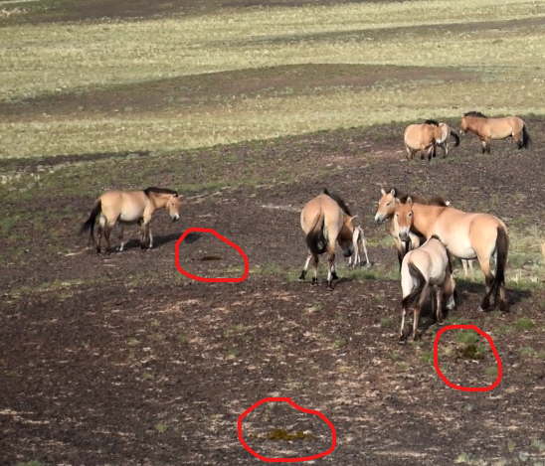

We used tweezers to break up fresh feces and separated the larvae from the feces.
