Supplementary Information for

Tandem electrocatalytic N₂ fixation via concerted proton-electron transfer

Pablo Garrido-Barros, Joseph Derosa, Matthew J. Chalkley† & and Jonas C. Peters*

Division of Chemistry and Chemical Engineering, California Institute of Technology; Pasadena, CA 91125, USA.

†Present address: Department of Pharmaceutical Chemistry, University of California, San Francisco, CA, USA

Correspondence to: jpeters@caltech.edu

Table of Contents:

2 S1. Electrochemical set-up for CPC experiments

3-4 S2. Kinetic analysis from cyclic voltammetry

5-11 S3. Ammonia quantification

12-14 S4. Electrocatalysis using W(N₂)₂ under original conditions

15-20 S5. Optimization of N₂RR conditions using W(N₂)₂

21-31 S6. Control experiments for electrocatalytic N₂RR

32-34 S7. Protonation of W(N₂)₂

35-37 S8. Mechanistic analysis via Cyclic Voltammetry

38-44 S9. Chemical CPET reactions

45-55 S10. Electrochemical analysis of N₂RR catalysts

56-57 S11. References

S1. Electrochemical set-up for CPC experiments:

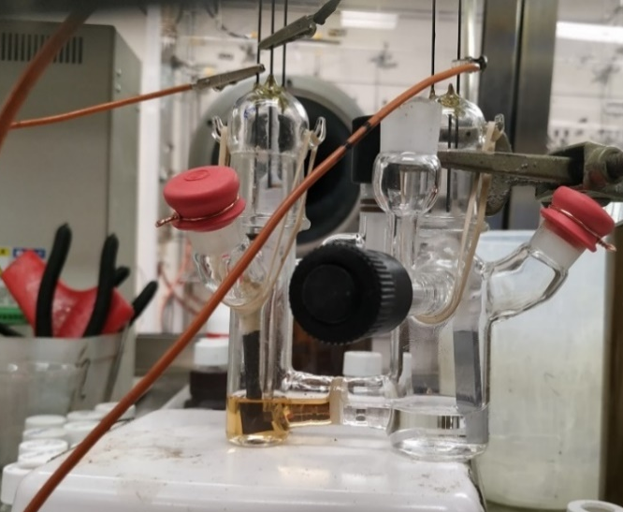
Figure S1. Gas-tight, two-compartment electrochemical cell set up employed in the CPC experiments. It is composed of two Kontes valves, two 14/24 necks closed by septa fastened with copper-wire, and two 24/40 necks for the incorporation of the electrodes that are connected to the potentiostat leads via crossing tungsten wires.
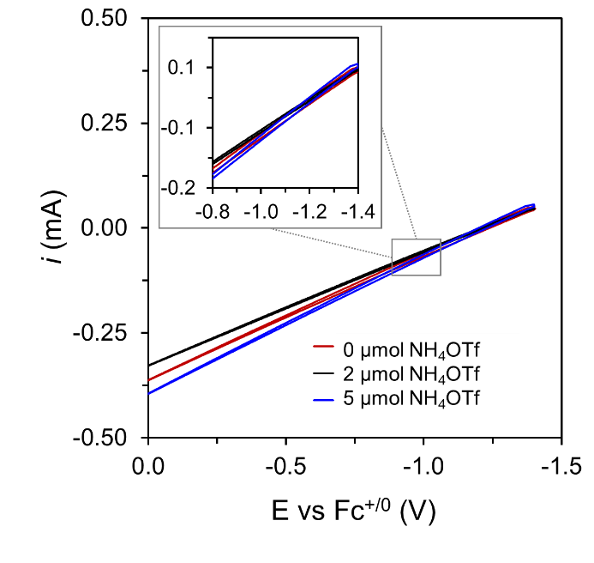
Figure S2. CVs of the Zn electrode employed as sacrificial counter electrode in the CPC experiments in 0.2 M [TBA][BF₄] THF solution containing different concentrations of NH₄OTf and 50 mM TsOH, using a GC plate counter electrode to determine maximum operating current densities.

S2. Kinetic analysis from cyclic voltammetry:
For kinetic analysis via cyclic voltammetry, a multielectron/multiproton electrocatalytic process can be simplified to an EC_{cat} mechanism involving an electrode-mediated electron transfer process (E) coupled to a catalytic chemical reaction (C_{cat}), which will reflect a convolution of the elementary chemical steps of catalysis.¹ For an EC_{cat} process under pure kinetic conditions, an ideal S-shape response would be obtained featuring a current intensity in the catalytic plateau (i_{cat}) described by Eq. S1. In this equation, n_{e} is the number of electrons involved in the catalytic cycle, F is the Faraday constant, S is the area of the electrode, D_{cat} is the diffusion coefficient of the catalyst and k_{obs} is the observed kinetic constant of the catalytic process which will reflect a convolution of the kinetically relevant steps of catalysis and will follow a mathematical expression depending on the rate law. Therefore, the intensity of the catalytic plateau should increase linearly with the concentration of the catalysts, C_{cat}⁰, and with the square root of k_{obs} that in turns incorporate the concentration of the substrates involved in the rate determining steps.
$i_{cat}= n_{e}FSC_{cat}^{0}\sqrt{D_{cat}} \sqrt{k_{obs}}$ (Eq. S1)
In the present case of tandem catalysis, each of the coupled catalytic cycles (CPET and N₂RR) will provide a catalytic current according to Eq. S1 that will depend on their specific mechanism. Although the multielectron/multiproton character of this overall process and the interplay between both catalytic cycles complicate obtaining an exact analytical solution, the overall observed current will be a convolution of the current for each of the catalytic cycles.
For a proposed mechanism where the mediator reduces certain intermediates of the N₂RR cycle via a rate determining CPET, with the rest of electron transfers happening at the electrode, the expression for the catalytic current due to CPET is going to depend linearly on the concentration of the mediator ([Co]) and on the square root of the W catalyst concentration ([W]), Eq. S3. At the same time, the catalytic current associated to the N₂RR cycle, assuming that the intermediates can be reduced by the CPET mediator or directly at the electrode followed by further protonation TsOH in solution, the observed catalytic current will increase linearly with [W] and with k_{obs}(N₂RR)^{1/2}, Eq. S4, which in turn will have a positive dependence on [Co] due to a rate limiting CPET, and possibly on [TsOH], according to the relative rate of protonation steps, Eq. S5.
$i_{obs}=i_{cat}\left(CPET\right)+i_{cat}(N_{2}RR)$ (Eq. S2)
$i_{cat}(CPET)=FS[Co]\sqrt{D_{Co}} \sqrt{k_{CPET}[W]}$ (Eq. S3)

$i_{cat}(N_{2}RR)= n_{e}FS[W]\sqrt{D_{Co}} \sqrt{k_{obs}(N_{2}RR)}$ (Eq. S4)

$k_{obs}(N_{2}RR)=f(\left[Co\right],\left[TsOH\right])$ (Eq. S5)
In order to obtain preliminary information about the rate law for the tandem catalytic process and support our proposals, we have examined how changes in the concentration of the different components affect the behavior of the i_{cat} during CV experiments. Herein, we are evaluating i_{cat} as the maximum current of the electrocatalytic wave obtained from background corrected CVs as its behavior approached the S-shape expected from an ideal electrocatalytic response in the pure kinetic regime (vide infra).
The kinetic isotope effect, KIE, can be determined by evaluating k_{obs} for the reaction in the presence of protio-acid, TsOH, and deutero-acid, TsOD and comparing them as in Eq. S6. As aforementioned, the complications in obtaining the mathematical expression for this tandem electrocatalytic system preclude calculation of meaningful k_{obs} values. However, as deducted from Eq. S1, i_{cat} is proportional to the square root of k_{obs} for a simplified EC_{cat} mechanism describing our more complex system, so we have estimated a value for KIE from the ratio between the i_{cat} values observed in the presence of each acid.
$KIE=\frac{k_{obs} ({}_{}^{1}H)}{k_{obs} ({}_{}^{2}H)}=\frac{{\left[i_{cat} \left({}_{}^{1}H\right)\right]}^{2}}{{[i_{cat} \left({}_{}^{2}H\right)]}^{2}}$ (Eq. S6)

S3. Ammonia quantification via ¹H-NMR

S3.1 ¹H-NMR quantification:

Sample preparation for quantification via ¹H-NMR methods involves extracting the solid NH₄Cl after work up with 0.5 mL of 1 mM TMB in d₆-DMSO. To this solution, 10 μL of 8 M H₂SO₄ solution in d₆-DMSO were added (0.2 M final concentration) to ensure constant acidic conditions of the resulting sample and minimize variations due to different proton activities of the resulting sample.^{2,3}
Despite its high selectivity for NH₄⁺ detection, ¹H-NMR spectroscopy has proven to be challenging for accurate quantification due to the interplay between d1, T1 and the proton exchange-induced loss of coherence in determining the intensity of the NMR peak, and their different response to changes in the sample concentration and proton concentration.² This can cause absolute, quantitative NMR (qNMR), based on direct integration with respect to an internal standard with a known concentration, frequently result in over- or underestimation of the total NH₄⁺.³ Therefore, ¹H-NMR analysis of NH₄⁺ via relative quantification using a calibration curve and an internal standard is preferred as a reliable method for fast determination.
We have employed this method using TMB as an internal standard. In order to obtain a calibration curve, a stock solution of NH₄Cl (1mg/mL) in 1 mM TMB in d₆-DMSO solution was prepared. From that stock solution, different volume aliquots were diluted with the same 1 mM TMB in d₆-DMSO solution up to a total volume of 0.5 mL, resulting in standard samples with differing concentrations of NH₄Cl. To each of those solutions, 10 μL of 8 M H₂SO₄ in d₆-DMSO were added to obtain a constant and controlled proton concentration in the final sample, preventing possible errors in the calibration associated with different degrees of acidity in different samples. ¹H-NMR spectra of these standard samples afforded the calibration curve via integration of the 4 protons of the NH₄⁺ peak (N_{NH4+}) in the range 7.3-6.9 ppm relative to the 3 aryl protons of TMB (N_{TMB}) at around 6.1 ppm according to Eq. S7, where I, C, and N are the integral, concentration and number of protons respectively for each component.
$C_{{NH}_{4}^{+}}=\frac{I_{{NH}_{4}^{+}}N_{TMB}}{I_{TMB}N_{{NH}_{4}^{+}}}C_{TMB}$ (Eq. S7)
¹H-NMR spectra obtained from the standard samples are shown in Figure S3 and S5 and resulting calibration plots are shown in Figure S4 and S6. Two calibration plots were prepared using two different concentrations of internal standard (TMB) of 1 mM and 5 mM respectively. A similar procedure was followed to prepare the calibration plot for ¹⁵NH₄⁺ used in the ¹⁵N₂ labelled experiments, and the results are shown in Figure S7 and S8. In both cases, a reliable linear fit was obtained with R² > 0.99.

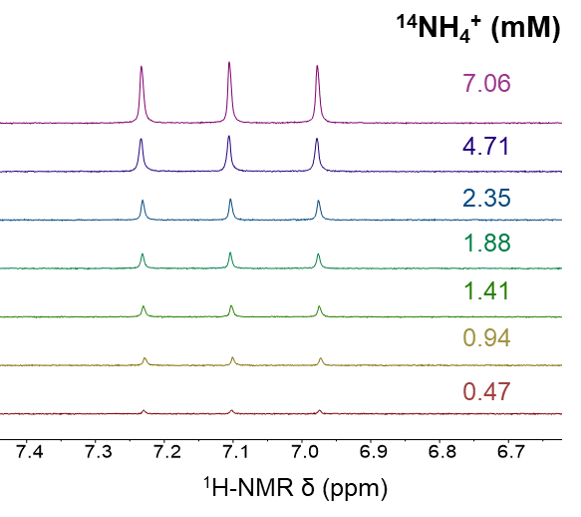
Figure S3. ¹H-NMR spectra of standard samples containing different concentrations of NH₄Cl in 1mM TMB d₆-DMSO solution.
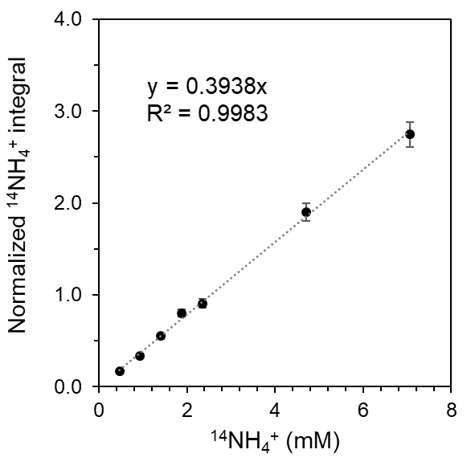
Figure S4. Calibration curve according to Eq. S7 for the ¹H-NMR spectra of standard ¹⁴NH₄Cl samples presented in Figure S3. The normalized integral was obtained by integration of the triplet in the 7.3-6.9 ppm region corresponding to the 4 protons of ¹⁴NH₄⁺ relative to the integration of the singlet at 6.1 ppm corresponding to the 3 aryl protons of TMB (1 mM concentration). For each concentration point, an average of 3 independent measurements is shown together with the error bars.

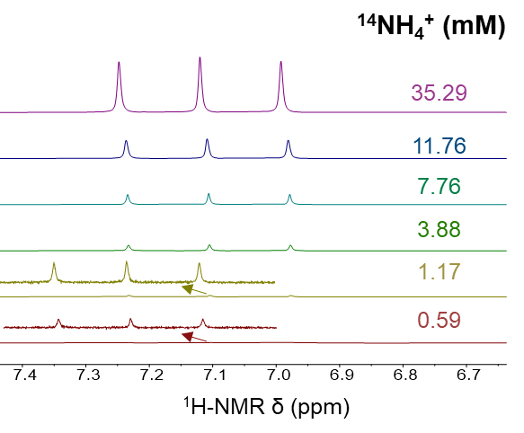
Figure S5. ¹H-NMR spectra of standard samples containing different concentrations of NH₄Cl in 5mM TMB d₆-DMSO solution. For the spectra of 1.17 and 0.59 mM NH₄Cl, a magnification of the NH₄⁺ peaks is included.
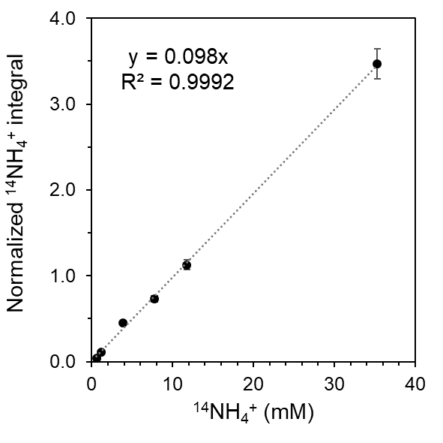
Figure S6. Calibration curve according to Eq. S7 for the ¹H-NMR spectra of standard ¹⁴NH₄Cl samples presented in Figure S5. The normalized integral was obtained by integration of the triplet in the 7.3-6.9 ppm region corresponding to the 4 protons of ¹⁴NH₄⁺ relative to the integration of the singlet at 6.1 ppm corresponding to 3 aryl protons of TMB (5 mM concentration). For each concentration point, an average of 3 independent measurements is shown together with the error bars.

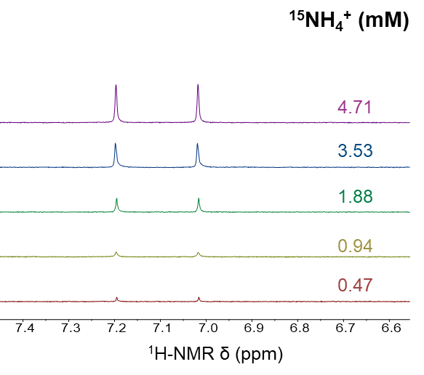
Figure S7. ¹H-NMR spectra of standard samples containing different concentrations of ¹⁵NH₄Cl in 1mM TMB d₆-DMSO solution.
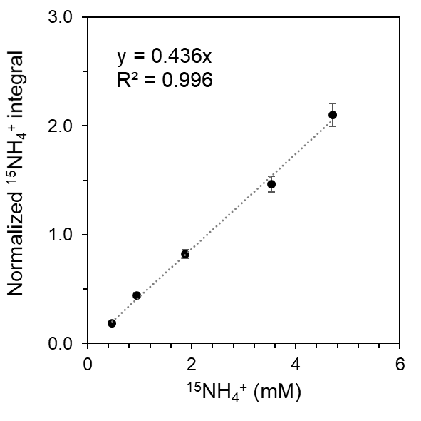
Figure S8. Calibration curve according to Eq. S7 for the ¹H-NMR spectra of standard ¹⁵NH₄Cl samples presented in Figure S7. The normalized integral was obtained by integration of the doublet in the 7.3-6.9 ppm region corresponding to the 4 protons of ¹⁵NH₄⁺ relative to the integration of the singlet at 6.1 ppm corresponding to 3 aryl protons of TMB (1 mM concentration). For each concentration point, an average of 3 independent measurements is shown together with the error bars.
Several methodologies have also been reported to minimize issues associated with absolute NH₄⁺ quantification via an internal standard, which consider variables from sample preparation to internal standard selection and specific ¹H-NMR sequences in order to improve the accuracy and detection limit. One promising approach is based on selective excitation of protons from the NH₄⁺, as reported by Jaramillo and coworkers.⁴ They employ the Frequency-Selective pulse Gradient Spin Echo (selgspe) sequence that selectively excite the protons with NMR signals in a small region centered where the NH₄⁺ appear (~7.1 ppm). While this method still involves longer acquisition times than the NMR method described previously based on calibration plots, it minimizes the proton solvent signals as one of the primary challenges for NH₄⁺ detection and generates strong NH₄⁺ signals, thereby providing one of the highest sensitivities for quantitation. The concentration of NH₄Cl was determined by integration of the area below the NH₄⁺ peaks compared to that of the internal standard. We employed TMB which is compatible for quantification via both previous calibration plots and this selective excitation method as shown in Figure S9 due to the proximity of the three aryl peaks of TMB to the NH₄⁺ region. Calculation of the concentration of standard samples of NH₄Cl was performed by both direct quantitative integrations relative to the internal standard (Figure S11) and by generation of a calibration plot (Figure S10). As evidenced by the results, this method offers a means for both absolute quantification via direct comparison to the internal standard peak added in known concentration and quantification by the use of the calibration curve. Results from application of this method were consistent with those obtained from the previous approach.
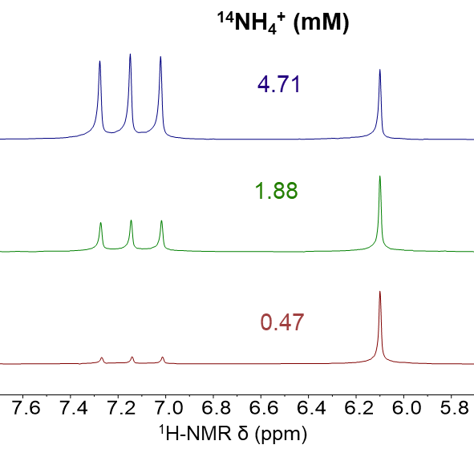

Figure S9. ¹H-NMR spectra of standard samples containing different concentrations of NH₄Cl in 1mM TMB d₆-DMSO solutions using Frequency-Selective pulse Gradient Spin Echo.

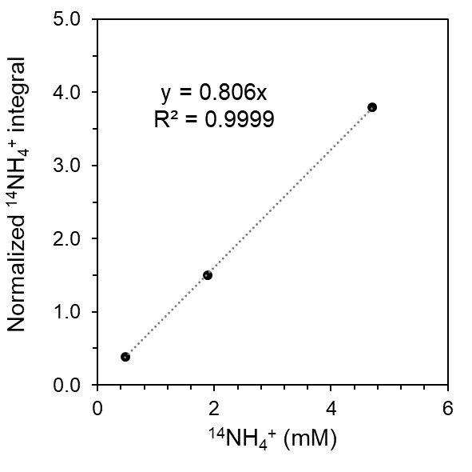
Figure S10. Calibration curve according to Eq. S7 for the ¹H-NMR spectra of standard ¹⁴NH₄Cl samples presented in Figure S9. The normalized integral was obtained by integration of the triplet in the 7.3-6.9 ppm region corresponding to the 4 protons of ¹⁴NH₄⁺ relative to the integration of the singlet at 6.1 ppm corresponding to 3 aryl protons of TMB (1 mM concentration).
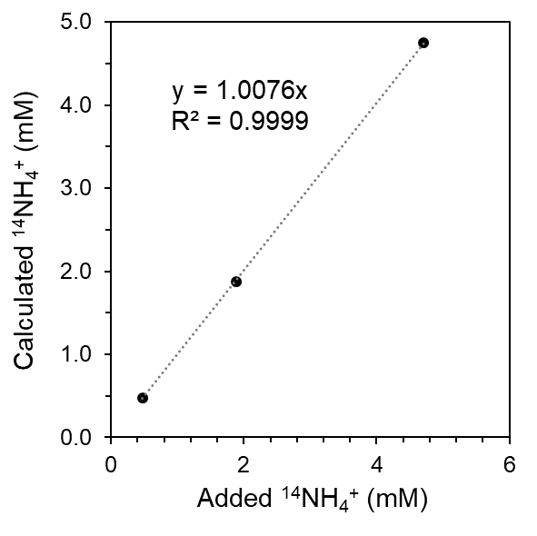
Figure S11. Plot of the calculated NH₄⁺ amount via absolute quantification with internal standard versus the amount of NH₄Cl added to the sample. The high correlation with R² > 0.99 reflects the adequacy of this method for direct quantitative NMR determination of NH₄⁺.

S3.2 Faradaic Efficiency:
The Faradaic efficiency (FE) was calculated considering the total charge passed during the CPC experiments (Q), the number of electrons involved in the formation of one molecule of NH₃ (n_{e} = 3), the Faraday constant (F) and the mols of NH₃ produced (N_{NH3}), following Eq. 8:
$$FE=\frac{N_{NH3}}{\frac{Q}{n_{e}F}} (Eq. 8)$$
S4. Electrocatalysis using W(N₂)₂ under original conditions
As reported by Becker and coworkers,⁵ previous attempts experiments to render the W(N₂)₂ system electrocatalytic for N₂RR by CPC in the presence of acid employed glassy carbon as a working electrode, among other electrodes, THF as solvent, [TBA][BF₄] as electrolyte (TBA = tetra-N-butylammonium) and tosic acid (TsOH) as proton source. We performed control electrocatalytic experiments using related conditions so as to compare results from the tandem CPET-N₂RR approach presented in this work, with these previous approaches.
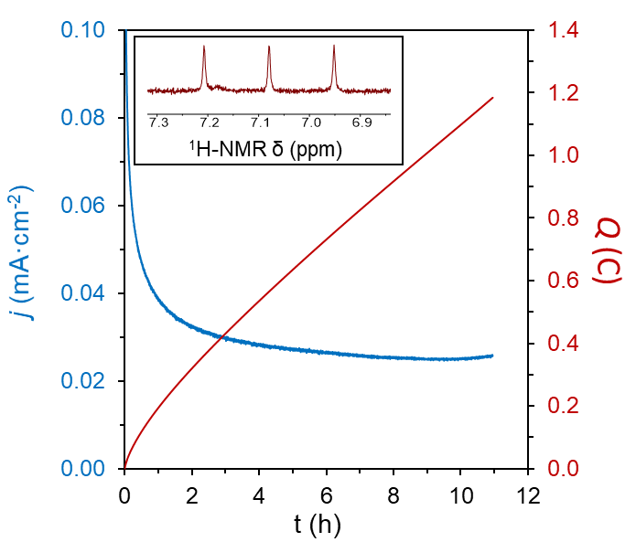
Figure S12. Current and charge profile for a CPC at −1.35 V vs Fc^{+/0} in 0.2 M [TBA][BF₄] THF solution containing 0.05 mM Co(III,N)⁺, 0.05 mM W(N₂)₂ and 5 mM TsOH, using a GC plate working electrode. Inset: Quantification of generated NH₃ via ¹H-NMR spectroscopy.

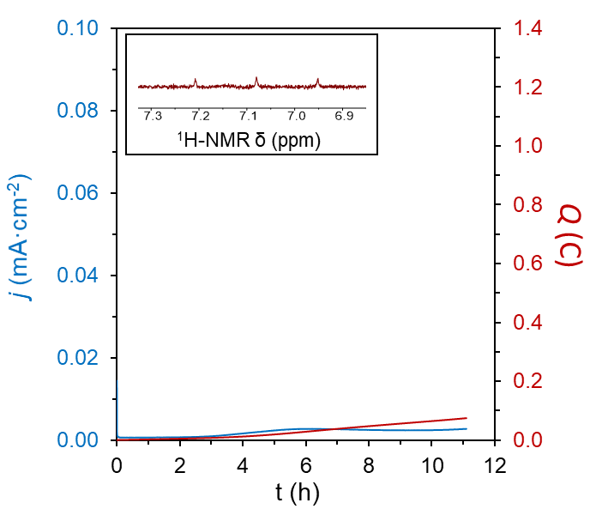

Figure S13. Current and charge profile for a CPC at −1.35 V vs Fc^{+/0} in 0.2 M [TBA][BF₄] THF solution containing 0.05 mM W(N₂)₂ and 5 mM TsOH, using a GC plate working electrode. Inset: Quantification of generated NH₃ via ¹H-NMR spectroscopy.
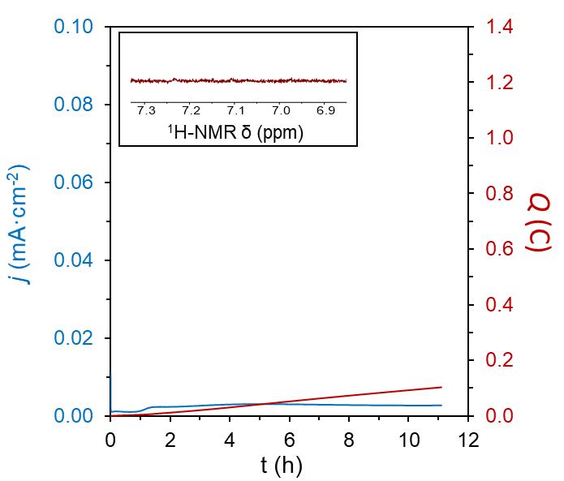
Figure S14. Current and charge profile for a CPC at −1.35 V vs Fc^{+/0} in 0.2 M [TBA][BF₄] THF solution containing and 5 mM TsOH, using a GC plate working electrode. Inset: Quantification of generated NH₃ via ¹H-NMR spectroscopy.

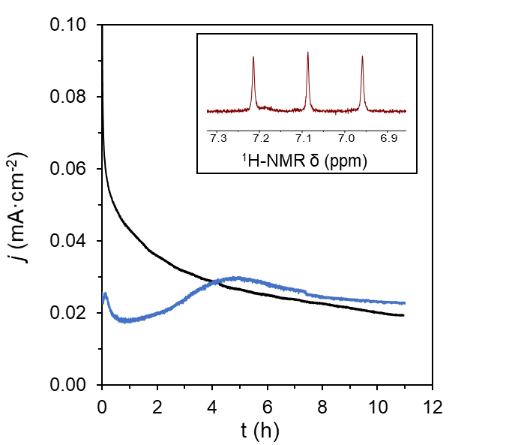
Figure S15. Current and charge profile for two consecutive CPC at −1.35 V vs Fc^{+/0} in 0.2 M [TBA][BF₄] THF solution containing initially 0.05 mM Co(III,N)⁺, 0.05 mM W(N₂)₂ and 5 mM TsOH, using a GC plate working electrode. After the first CPC (black trace), an extra 100 equiv of TsOH were added through a septum as a concentrated THF solution, and the second CPC was initiated (blue trace). Inset: Quantification of generated NH₃ via ¹H-NMR spectroscopy.
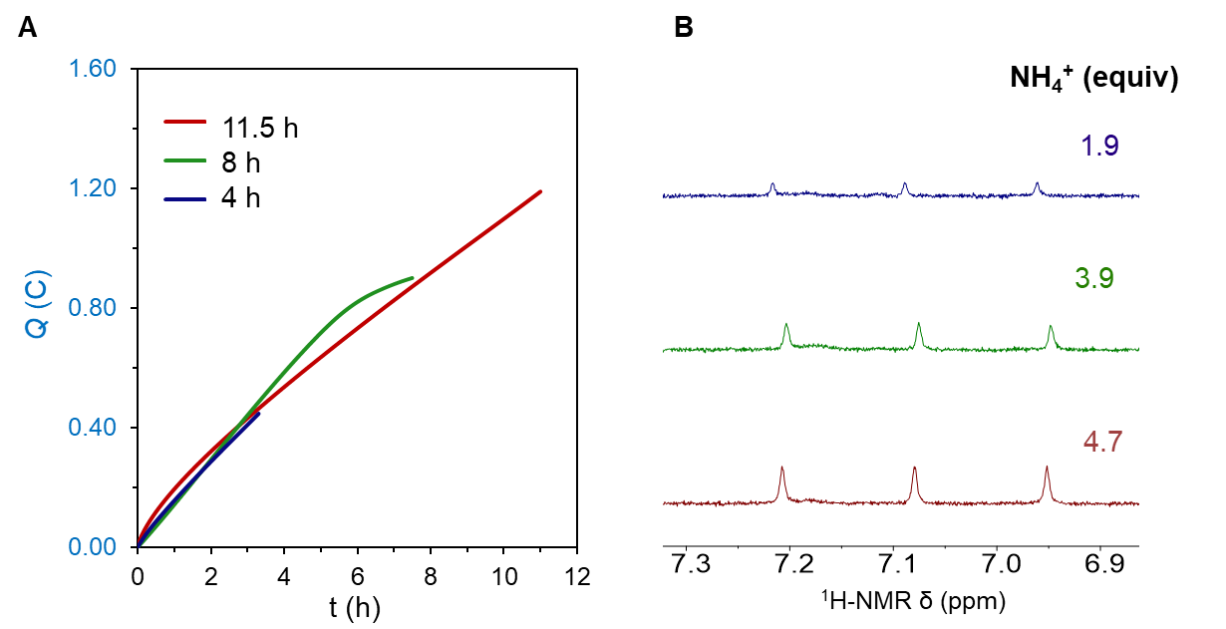
Figure S16. (A) Charge profile for three different CPC at −1.35 V vs Fc^{+/0} in 0.2 M [TBA][BF₄] THF solution containing 0.05 mM Co(III,N)⁺, 0.05 mM W(N₂)₂ and 5 mM TsOH, using a GC plate working electrode. The three CPC experiments were stopped at different times to confirm that the produced NH₃ is coming from the electrocatalytic process. (B) Quantification of generated NH₃ via ¹H-NMR spectroscopy.

S5. Optimization of N₂RR conditions using W(N₂)₂:

Following initial confirmation of N₂RR by our tandem approach using conditions originally employed in previous reports by Becker and coworkers,⁵ we canvassed different conditions to optimize the production of ammonia. These conditions included the use of different working electrodes, acid concentrations, electrolytes, solvent, and surface areas for the working electrode, as they may influence in electrocatalytic processes in general, and in previous attempts to electrochemical and chemical N₂RR by W and Mo complexes in particular.

Working electrode: GC electrode was initially employed by Becker and coworkers in their electrochemical studies of W(N₂)₂ system.⁵ However, as previously explored by our group, BDD can attenuate the background hydrogen evolution reaction at the surface of the electrode in the presence of TsOH. This is shown in Figure S17, where CV of both electrodes in the presence of acid are plotted, obtaining comparatively higher background currents with GC. Consistently higher equiv of NH₃ and Faradaic efficiencies were obtained when BDD was used in the CPC experiments compared to GC (entry 1 and 2 in Table S1).

Acid concentration: The acid concentration has a direct influence on background electrocatalytic HER at the electrode, as shown in Figure S18. As demonstrated by entry 2-5 in Table S1, increasing the acid concentration increases the total production of ammonia, as expected from a higher availability of H⁺, but the Faradaic efficiency drops as a consequence of the relative rate of background HER, increasing more than the rate of N₂RR.

Electrolyte: Initial studies toward electrocatalytic N₂RR using W(N₂)₂ and analogous Mo(N₂)₂ species employed [TBA][BF₄] electrolyte. However, it has been shown that protonation of W(N₂)₂ using HBF₄ generates the corresponding (F)W(NNH₂)₂ hydrazido complex due to abstraction of a F⁻ anion; this species requires a very strong cathodic potential to reduce it and features slow F⁻ dissociation required to proceed in the N₂RR cycle;^{5,6} under our catalytic conditions with [TBA][BF₄] and TsOH, this species is also formed (Figure S19). Moreover, M(X)(N₂) species (X = Cl⁻, I⁻) can further disproportionate to form the decomposition product M(X)₂ whose reduction to initial M(N₂)₂ requires a strongly reducing potential.⁷ Therefore, we have explored other electrolytes featuring weak coordinating anions to prevent those issues. Furthermore, we have considered the Li⁺ salts of those anions as they generally feature high conductivity, and the use of Lewis acids has been shown to have favorable effect in the further activation of N₂RR intermediates.⁸ One of the electrolytes fulfilling both aspects, also employed in the initial work by Picket and coworkers, is [Li][ClO₄], featuring a very high conductivity and with a ClO₄⁻ anion that is very weakly coordinating. However, it is also known that ClO₄⁻ can lead to the oxidation of reduced W and Mo complexes resulting in the formation of off cycle, oxo species. This has been further corroborated under our conditions in the presence of tosic acid by ³¹P-NMR and UV-vis (Fig S20 and S21).⁹ Therefore, we studied electrolytes based on non-coordinating and chemically inert anions such as OTf⁻, NTf₂⁻ and BAr^{F}₄⁻. In the case of [Li][OTf], the resulting conductivity of the electrolyte solution is very low, potentially due to formation of ion pairs in solutions that prevent ionic conductivity as previously studied.¹⁰ In contrast, [Na][BAr^{F}₄] and [Li][NTf₂] lead to highly conductive electrolytes with very similar CV responses of the in situ formed hydrazido species (OTs)W(NNH₂)₂, with redox potentials of around −2.0 V vs Fc^{+/0}, 200 mV lower than in the case of (F)W(NNH₂)₂ (Figure S22). Our studies showed higher and more efficient production of ammonia using [Na][BAr^{F}₄] (entry 9 in Table S1), and especially with [Li][NTf₂] (entry 11 in Table S1).
Solvent: We have previously found that DME is more resistant to degradation than THF in acidic conditions and have consistently found that ammonia production, in terms of equiv produced and Faradaic efficiency, is increased in DME by comparison (entry 11 and 12 in Table S1).

Catalyst:electrode surface ratio: In order to optimize the electrode/catalyst interphase, minimize the time of CPC, and increase the catalytic current, the use of a high surface area electrode was pursued. We explored the use of GC foam as a high surface area electrode. To minimize the potential consumption of ammonia due to the oxidation process at the counter electrode the concentration of catalyst was further lowered to 0.01 mM, leading to relatively lower catalytic currents. In this case, a higher number of equiv are obtained (entry 16 in Table S1) per catalyst, highlighting the potential benefit of larger electrode/catalyst interfaces, shorter electrolysis times, and lower catalyst concentrations.

Table S1. Conditions explored for the CPC experiments together with the NH₃ produced and FE.
Entry | Working Electrode | Solvent | Electrolyte | [W] (mM) | [Co] (mM) | [TsOH] (mM) | NH₃ (equiv/W) | FE (%)
1 | GC | THF | [TBA][BF₄] | 0.05 | 0.05 | 5.0 | 4.7 | 17.8
2 | BDD | THF | [TBA][BF₄] | 0.05 | 0.05 | 5.0 | 5.6 | 20.5
3 | BDD | THF | [TBA][BF₄] | 0.05 | 0.05 | 2.5 | 4.6 | 33.2
4 | BDD | THF | [TBA][BF₄] | 0.05 | 0.05 | 10.0 | 6.5 | 9.4
5 | BDD | THF | [TBA][BF₄] | 0.05 | 0.05 | 25.0 | 7.2 | 5.2
6 | BDD | THF | [TBA][BF₄] | 0.05 | 0.13 | 5.0 | 6.7 | 24.3
7 | BDD | THF | [TBA][BF₄] | 0.05 | 0.25 | 5.0 | 7.0 | 25.5
8 | BDD | THF | [Li][ClO₄] | 0.05 | 0.05 | 5.0 | 6.5 | 23.4
9 | BDD | THF | [Na][BAr^{F}₄] | 0.05 | 0.05 | 5.0 | 8.7 | 31.3
10 | BDD | THF | [Li][OTf] | 0.05 | 0.05 | 5.0 | 7.3 | 26.4
11 | BDD | THF | [Li][NTf₂] | 0.05 | 0.05 | 5.0 | 10.0 | 36.3
12 | BDD | DME | [Li][NTf₂] | 0.05 | 0.05 | 5.0 | 11.5 | 45.1
13 | BDD | DME | [Li][NTf₂] | 0.05 | 0.05 | 10.0 | 15.3 | 27.7
14 | BDD | DME | [Li][NTf₂] | 0.05 | 0 | 5.0 | 0.8 | 3.0
15 | BDD | DME | [Li][NTf₂] | 0 | 0.05 | 5.0 | - | -
16 | GC foam | DME | [Li][NTf₂] | 0.01 | 0.01 | 5.0 | 39.5 | 42.9
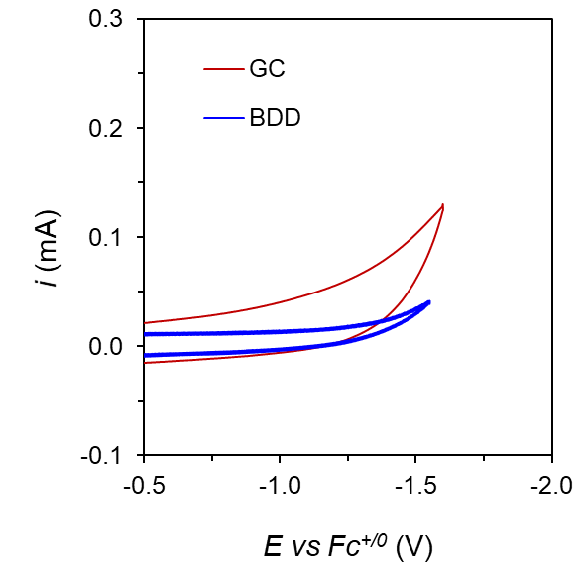
Figure S17. CV at 100 mV·s⁻¹ in 0.2 M [TBA][BF₄] THF solution containing and 50 mM TsOH, using either a GC (red) or a BDD (blue) plate working electrode.
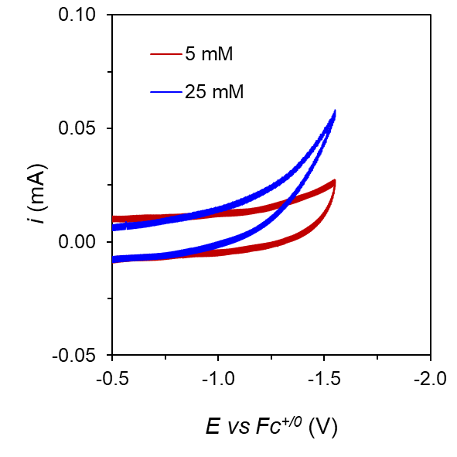
Figure S18. CV at 100 mV·s⁻¹ in 0.2 M [TBA][BF₄] THF solution containing different concentrations of TsOH and using a BDD plate working electrode. The increase of current with TsOH concentration reflects an increase in the background HER, which in turn has an influence in the Faradaic efficiency obtained from CPC experiments.

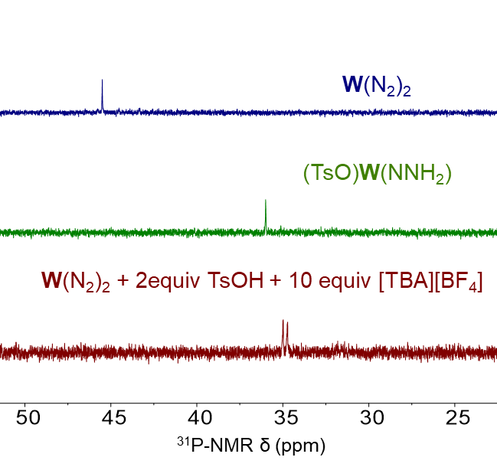
Figure S19. ³¹P-NMR spectra of a THF solution containing W(N₂)₂ (blue trace), (OTs)W(NNH₂)⁺ (green trace), and W(N₂)₂ with 2 equiv of TsOH and 10 equiv [TBA][BF₄] as the electrolyte (red trace). The latter shows that protonation of the W(N₂)₂ in the presence of BF₄⁻ leads to a hydrazido species distinct from (OTs)W(NNH₂)⁺. The doublet resonance observed is diagnostic for a fluoride complex and this result is hence most consistent with the formation of the known complex (F)W(NNH₂)⁺ instead of (OTs)W(NNH₂)⁺.¹¹

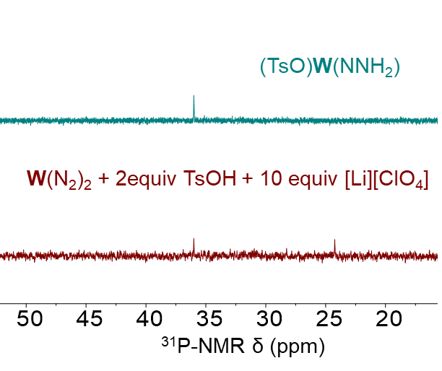
Figure S20. ³¹P-NMR spectra of a THF solution containing (OTs)W(NNH₂)⁺ (blue trace) and W(N₂)₂ with 2 equiv of TsOH and 10 equiv [Li][ClO₄] (red trace). The latter shows the partial formation of (OTs)W(NNH₂)⁺, together with a second species that we tentatively assign to a previously reported W-trans-dioxo species, based on a previous report.⁹ This experiment underscores that perchlorate can be non-innocent during electrocatalysis with [Li][ClO₄] as the electrolyte.

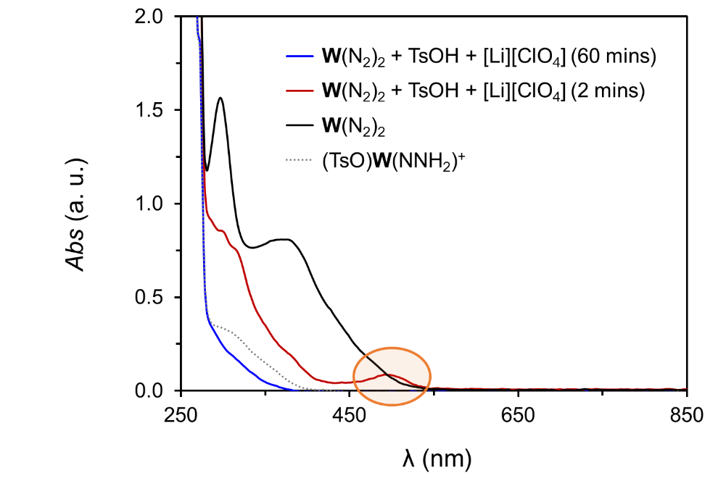
Figure S21. UV-vis spectra of a THF solution containing 0.05 mM (OTs)W(NNH₂)⁺ (dashed gray trace), 0.05 mM W(N₂)₂ (black trace), and 0.05 mM W(N₂)₂ with 2 equiv of TsOH, and 10 equiv [Li][ClO₄] after 2 mins (red trace) and 60 mins (blue trace) of reaction. The absorption band at around 500 nm in the red trace supports the formation of the W-oxo species, consistent with literature reports,⁹ which is unstable and disappears after 60 min of reaction time, leading to lower concentrations of the hydrazido species as compared with a UV-vis sample containing a similar initial concentration of pure (OTs)W(NNH₂)⁺ in THF (grey trace). This experiment underscores that perchlorate can be non-innocent during electrocatalysis with [Li][ClO₄] as the electrolyte.
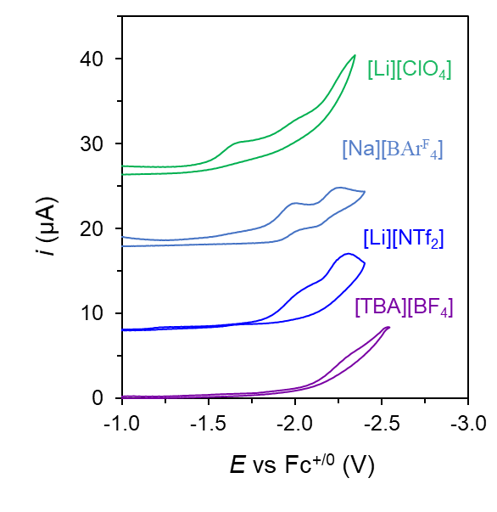
Figure S22. CV at 100 mV·s⁻¹ of a THF solution containing 0.05 mM W(N₂)₂ and 2 equiv of TsOH for the in situ formation of (TsO)W(NNH₂)⁺ using different electrolytes. A BDD disk was used as the working electrode.
S6. Control experiments for electrocatalytic N₂RR:

In order to verify that the produced ammonia derives solely from the electrocatalytic reduction of N₂ by the tandem co-catalytic system, several CPC control experiments were performed to evaluate any possible source of NH₃ contamination, or any other N-containing species as the substrate, for the generation of NH₃. In addition, the content of other N-containing impurities like N₂O, NO_{x}, NO₂⁻ and NO₃⁻, were probed quantitatively using appropriate analytical methods. These results, summarized below, unequivocally verify atmospheric N₂ as the substrate.
S6.1. Control experiment under Argon atmosphere:
The electrochemical cell was set up as in a typical experiment in a N₂-filled glove box containing the two co-catalysts, the electrolyte solution, the acid, and the three electrodes. Subsequently, the gas-tight cell was brought outside the box and both compartments were bubbled with Argon gas through the septa for 30 mins in order to displace all the N₂. After that time, a CPC was run at −1.35 V vs Fc^{+/0} as usual (Figure 23). When the CPC was finished, excess of tosic acid (100 equiv dissolved in 1 mL of DME) was added through the septa with a syringe in order to quench all possible free ammonia in solution as NH₄⁺. Subsequently, the cell was placed in a dry ice/acetone bath at −78 ºC to condense possible evaporated ammonia in the headspace. After 10 min at this temperature, the electrochemical cell was brought to room temperature and allowed to stir for another 10 min in the presence of the excess acid. Finally, the cell was opened, and the electrolyte solution was treated as previously described for quantification of ammonia. The total ammonia produced during this experiment was below 0.1 equiv (< 10 nmol). This experiment provides evidence against contamination of NH₃ in the electrochemical set up, as well as the absence of any other N-containing species that can act as an N-source for the generation of ammonia upon reduction, such as the [Li][NTf₂], or NO₂⁻ or NO₃⁻ in the electrolyte solution.
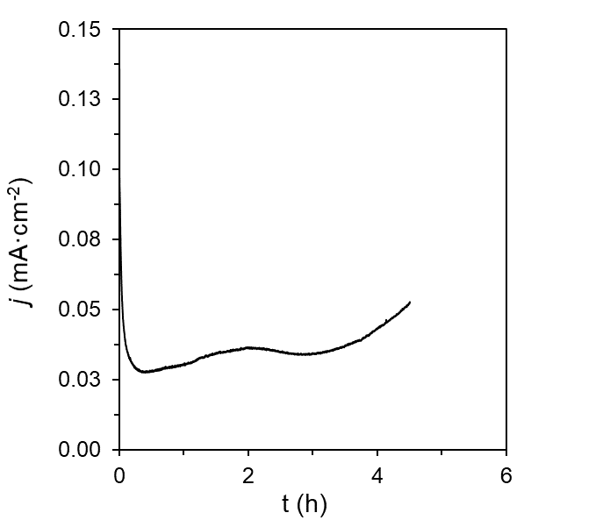
Figure S23. Current profile for a CPC at −1.35 V vs Fc^{+/0} in 0.1 M [Li][NTf₂] DME solution containing 0.05 mM Co(III,N)⁺, 0.05 mM W(N₂)₂ and 5 mM TsOH, under Argon atmosphere using a BDD plate working electrode.
S6.2 Control experiment using ¹⁵N₂ atmosphere:
The electrochemical cell was set up as in a typical experiment in a N₂-filled glove box containing the two co-catalysts, the electrolyte solution, the acid, and the three electrodes. The gas-tight cell was brought outside the box and both compartments were bubbled with Argon gas through the septa for 30 mins in order to make sure all the ¹⁴N₂ was displaced, as evidenced in previous control experiment under Argon atmosphere. Subsequently, the cell was then bubbled with ¹⁵N₂ for 5 mins to substitute the Ar, and then left to equilibrate for 5 more mins under the ¹⁵N₂ atmosphere. After that time, a CPC was run at −1.35 V vs Fc^{+/0} using the typical procedure (Figure S24). When the CPC was finished, an excess of tosic acid (twice as much as theoretical ¹⁵NH₃ produced) was added through the septa with a syringe in order to quench all possible free ¹⁵NH₃ in solution as ¹⁵NH₄⁺. Subsequently, the cell was placed in a dry ice/acetone bath at −78 ºC in order to condense possible evaporated ammonia in the headspace. After 10 min at this temperature, the electrochemical cell was brought to room temperature and allowed to stir for another 10 min in the presence of the excess acid. Finally, the cell was opened, and the electrolyte solution was treated as previously described for quantification of ammonia. This experiment provides evidence against contamination of ¹⁴NH₃ in the electrochemical set up, as well as the absence of any other N-containing species that could act as N-source for the generation of ammonia upon reduction such as N₂O, NO_{x} gasses in the gas supply, or [Li][NTf₂], NO₂⁻, or NO₃⁻ in the electrolyte solution.

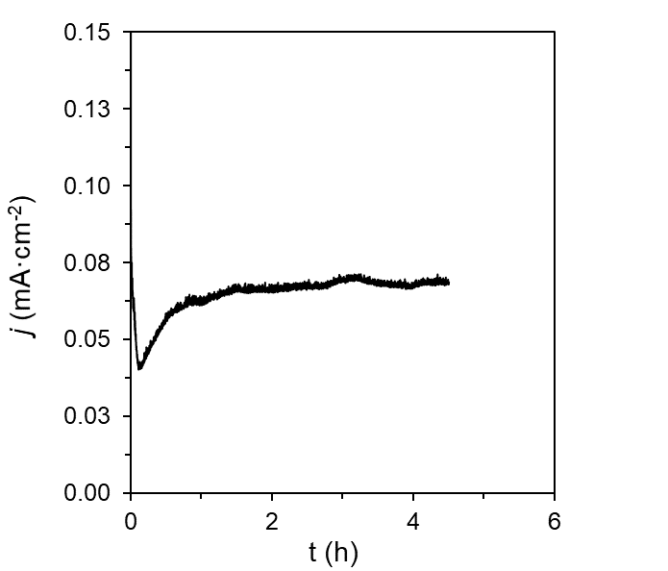
Figure S24. Current profile for a CPC at −1.35 V vs Fc^{+/0} in 0.1 M [Li][NTf₂] DME solution containing 0.05 mM Co(III,N)⁺, 0.05 mM W(N₂)₂ and 5 mM TsOH, under ¹⁵N₂ atmosphere using a BDD plate working electrode.

S6.3 Control experiment in the absence of catalysts:
In order to further support that the source of produced ammonia is the electrochemical reduction of N₂ by the tandem co-catalytic system, instead of any NH₃ contamination or direct reduction of N₂O, NO_{x}, [Li][NTf₂], NO₂⁻ or NO₃⁻ at the electrode, a CPC was also performed in the absence of Co(III,N)⁺ and W(N₂)₂ (Figure S25).
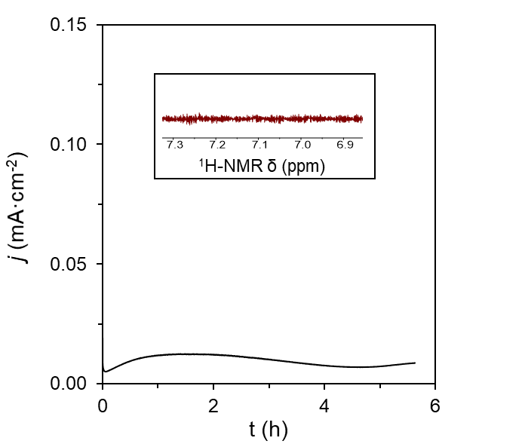

Figure S25. Current profile for a CPC at −1.35 V vs Fc^{+/0} in 0.1 M [Li][NTf₂] DME solution containing 5 mM TsOH, under ¹⁴N₂ atmosphere using a BDD plate working electrode. Inset: Quantification of NH₃ via ¹H-NMR under previous conditions.

S6.4 Quantification of N₂O impurities in the N₂ gas supply via GC-TCD:
The content of N₂O in the N₂ gas supplies for both ¹⁴N₂ and ¹⁵N₂ was determined by gas chromatography coupled to a thermal conductivity detector (GC-TCD). The method employed included a detector temperature of 250 ºC, inlet temperature of 150 ºC, and an oven maximum temperature of 275 ºC. Calibration of the N₂O signal was performed by injecting pure N₂O gas and a standard mixture of N₂ containing 1 ppm of N₂O using a gas-tight Hamilton syringe. Under these conditions, an N₂O signal appears at a retention time of 6.8 mins.
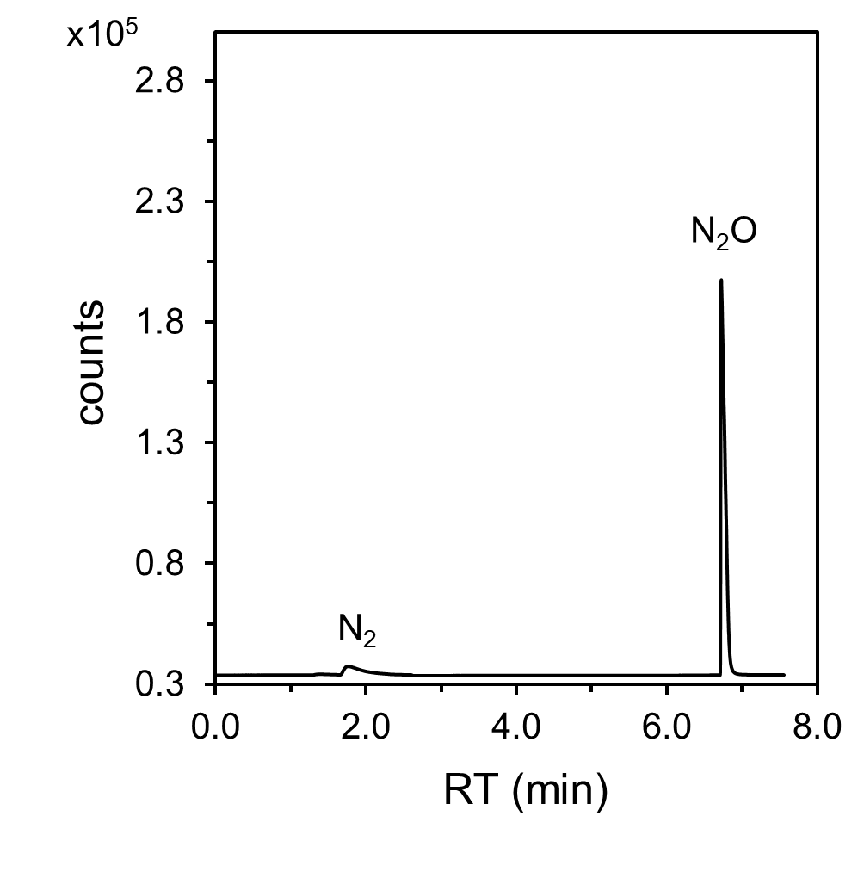
Figure S26. Gas chromatogram of an injection of N₂O gas for determination of the retention time. The peak at around 1.8 mins correspond to trace N₂ gas.
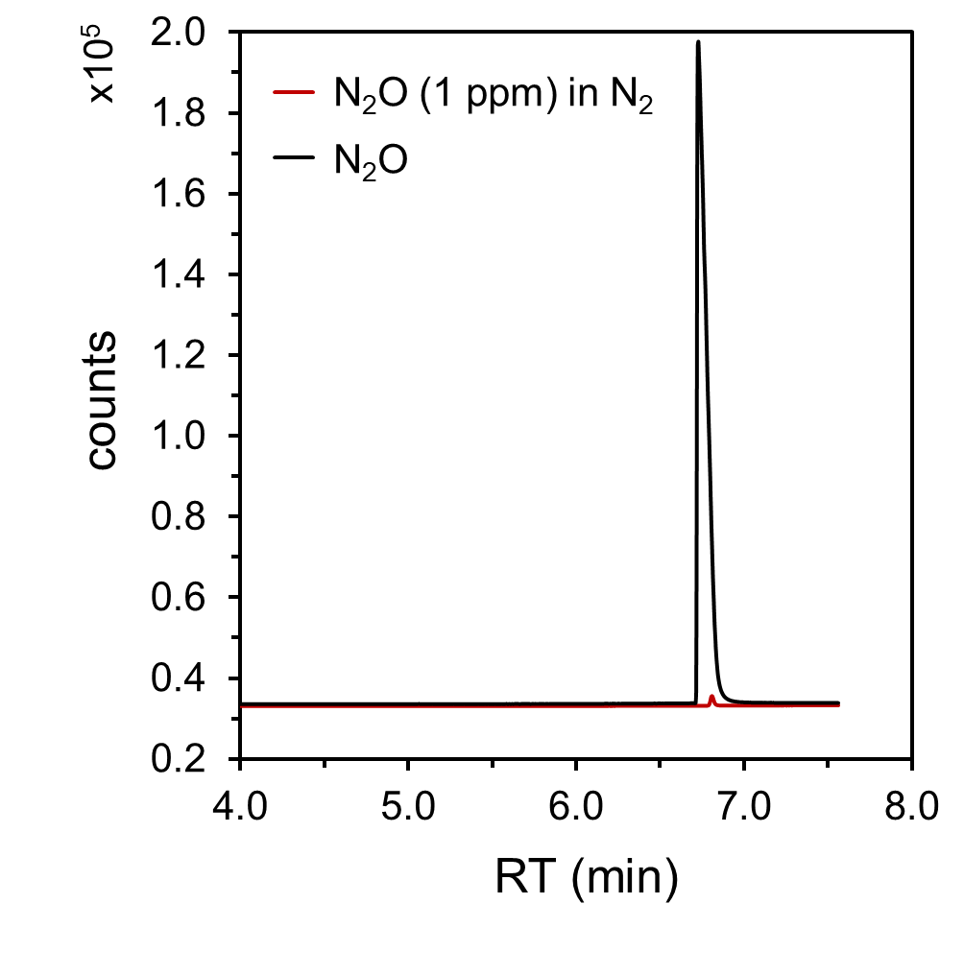
Figure S27. Gas chromatogram of an injection of N₂O gas (black trace) and a mixture of N₂ with 1 ppm of N₂O for calibration of the area.
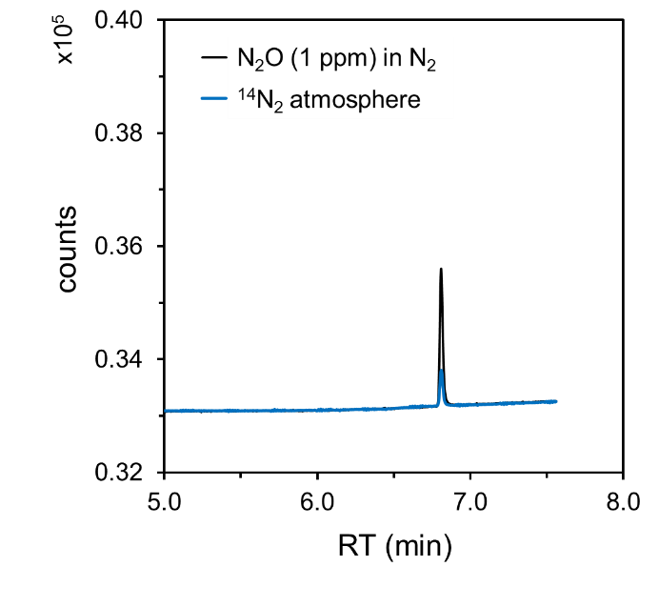
Figure S28. Gas chromatogram of an injection of a mixture of N₂ with 1 ppm of N₂O (black trace) and the ¹⁴N₂ gas from the glove box employed for the N₂RR experiments (blue trace).

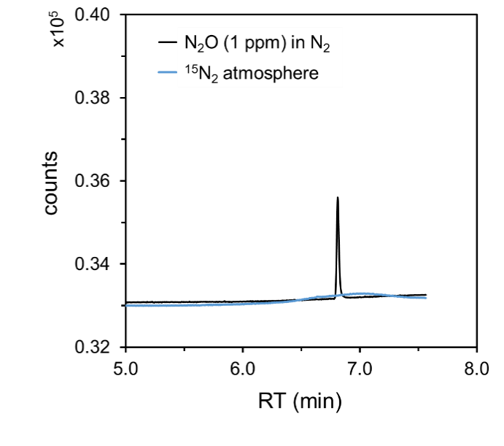
Figure S29. Gas chromatogram of an injection of a mixture of N₂ with 1 ppm of N₂O (black trace) and the ¹⁵N₂ gas from the gas cylinder employed for the control N₂RR experiment (blue trace).

S6.5 Quantification of NO_{x} impurities in the N₂ gas supply via the Griess method:
Determination of the NO_{x} impurities in the gas supplies was performed by their conversion to NO₂⁻ and NO₃⁻ in basic media and quantification of the latter by the Griess method.¹² Specifically, the electrochemical cell exposed to either ¹⁴N₂ or ¹⁵N₂ atmosphere employed in the N₂RR experiments was filled with 6 mL of 0.1 M KOH aqueous solution left stirring over 2 h. Any NO_{x} impurity is assumed to be quantitatively converted into NO₂⁻ or NO₃⁻ in this basic solution, and these compounds can in turn be quantified using the Griess spectrophotometric method with the color development solutions described in Methods. This was done by sampling 500 μL of the KOH trap solution and adding 500 μL of a 0.1 M HCl aqueous solution, 25 μL of the sulphanilamide solution and 25 μL of the N-1-naphtylethylenediamine dihydrochloride solution. The resulting mixture was incubated for 20 min at room temperature and subsequently the UV-vis spectrum was obtained in a 1 cm quartz cuvette. Absorption at 550 nm enables evaluation of the NO₂⁻ content upon calibration. For the calibration plots, standard solutions containing different concentrations of NaNO₂ in 0.1 M KOH were subjected to the same color development procedure. For quantification of NO₃⁻, the solution used in the quantification of NO₂⁻ was reacted with 50 μL of a vanadium(III) chloride (VCl₃) solution in 6 M aqueous HCl and incubated at 60 ºC during 25 mins in order to quantitatively reduce the NO₃⁻ to NO₂⁻. After that time, the solution was brought to room temperature and the absorption spectrum was again obtained for evaluation of the band at 550 nm. No significant content of NO_{x} impurities was found in either ¹⁴N₂ or ¹⁵N₂ gas supplies corresponding to the amounts of NH₃ produced in this work, supporting N₂ as the sole source of NH₃.
Calibration plots were performed for both NO₂⁻ and NO₃⁻ using their corresponding sodium salts as standard samples and preparing solutions in a range of relevant concentrations. Both calibration plots were linear with R² > 0.99, and the regression lines were employed for direct, quantitative determination of the NO₂⁻ and NO₃⁻ content in the different samples to analyze.
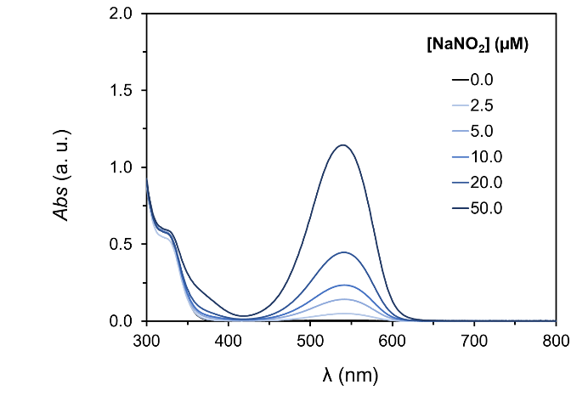
Figure S30. UV-vis spectra of solutions containing different concentrations of NaNO₂ for calibration purposes subjected to the previously described protocol for quantification based on the Griess method.

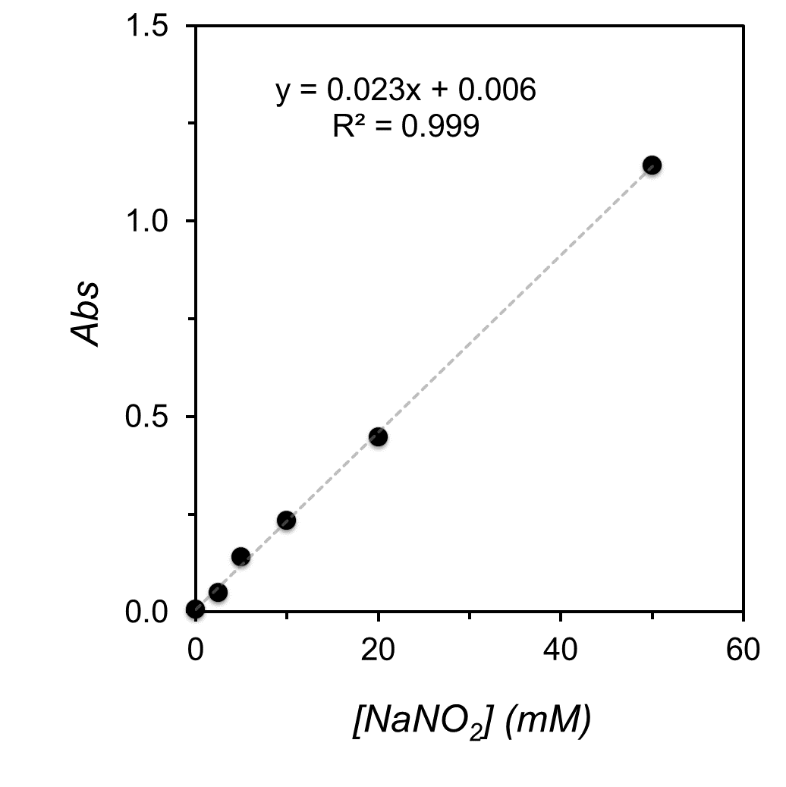
Figure S31. Calibration plot of the Griess analysis for NO₂⁻ with the corresponding linear regression.

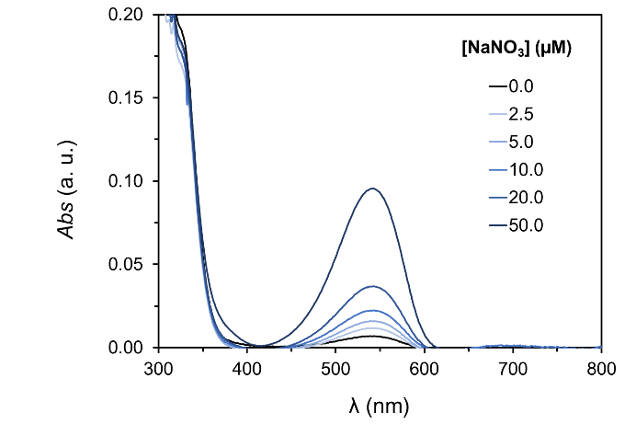

Figure S32. UV-vis spectra of solutions containing different concentrations of NaNO₃ for calibration purposes subjected to the previously described protocol for quantification based on the Griess method.

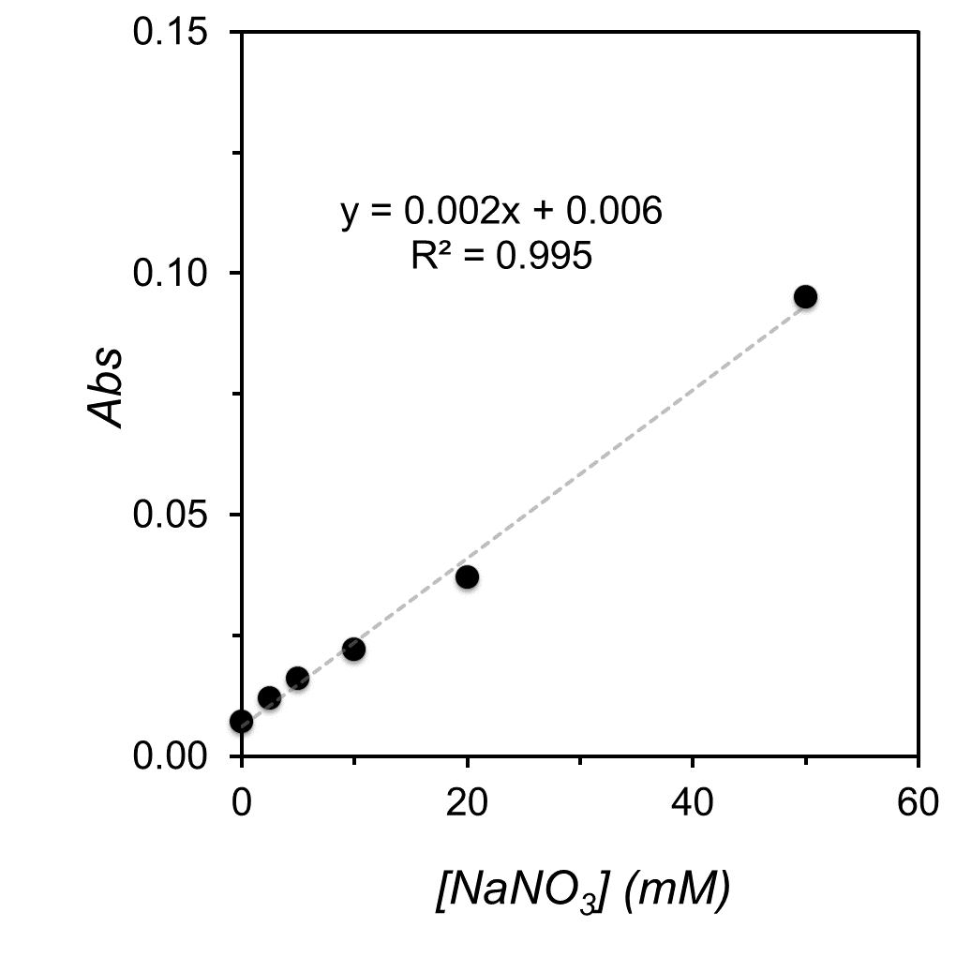
Figure S33. Calibration plot of the Griess analysis for NO₃⁻ with the corresponding linear regression.

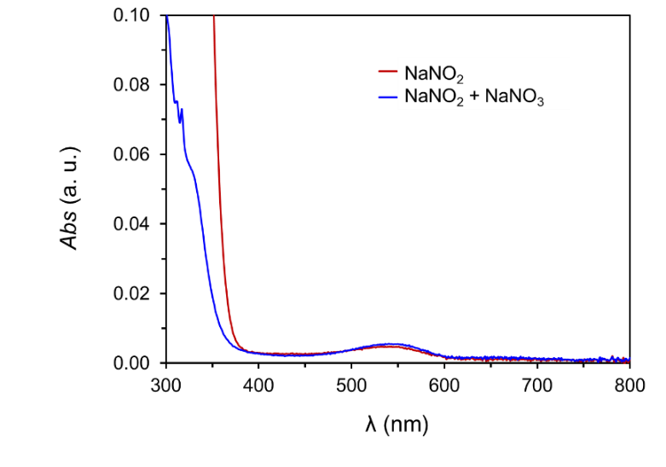
Figure S34. UV-vis spectra for the Griess analysis of a 0.1 M KOH solution exposed to the ¹⁴N₂ gas employed in the N₂RR CPC experiments for the determination of the NO₂⁻ and NO₃⁻ deriving from NO_{x} impurities. The content of NO₂⁻ + NO₃⁻ is below 0.2 nmol based on the calibration plots.

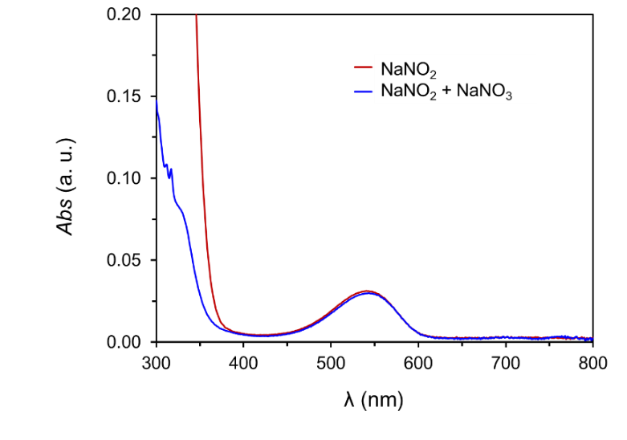
Figure S35. UV-vis spectra for the Griess analysis of a 0.1 M KOH solution exposed to the ¹⁵N₂ gas employed in the control N₂RR CPC experiments for the determination of the NO₂⁻ and NO₃⁻deriving from NO_{x} impurities. The content of NO₂⁻ + NO₃⁻ is below 2.1 nmol based on the calibration plots.

S6.6 Quantification of NO₂⁻ and NO₃⁻ impurities in the electrolyte via Griess method:
The content of NO₂⁻ and NO₃⁻ impurities in the electrolyte solution was also determined using the Griess method and the calibration plots previously obtained. For that, THF and DME solutions containing either 0.2 M [TBA][BF₄] or 0.1 M [Li][NTf₂] and 5 mM TsOH were prepared under ¹⁴N₂ atmosphere in a glove box following similar procedure as in the CPC experiments. The solution was stirred for 2 h and the Griess method was performed as detailed above. The amount of NO₂⁻ or NO₃⁻ impurities were trace from the electrolyte solutions and insignificant relevant to the amounts of NH₃ produced in this work, supporting along with other controls that N₂ as the sole source of NH₃ produced.
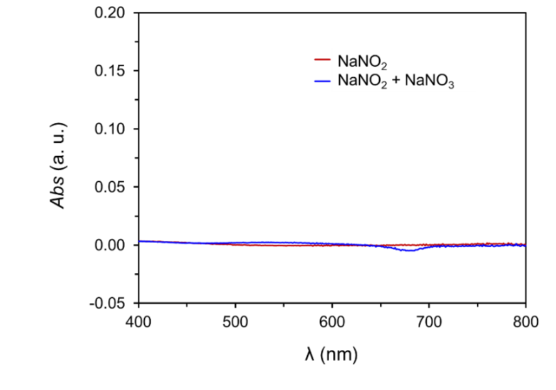
Figure S36. UV-vis spectra for the Griess analysis of a THF solution containing 0.2 M [TBA][BF₄] and 5 mM TsOH, as employed in the CPC experiments, for the determination of the NO₂⁻ (red trace) and NO₃⁻ (blue trace). The content of NO₂⁻ + NO₃⁻ is below 0.1 nmol based on the calibration plots.
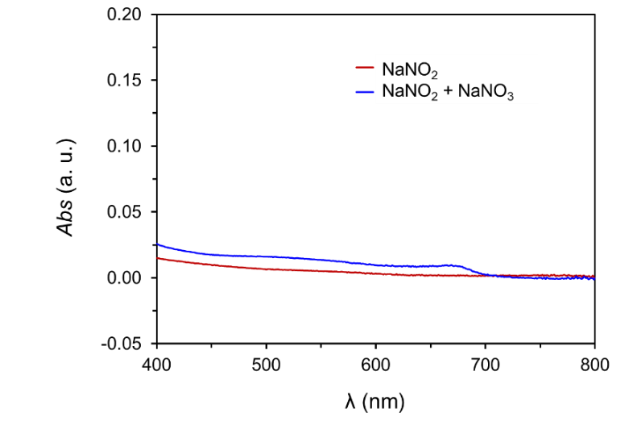
Figure S37. UV-vis spectra for the Griess analysis of a THF solution containing 0.1 M [Li][NTf₂] and 5 mM TsOH, as employed in the CPC experiments, for the determination of the NO₂⁻ (red trace) and NO₃⁻ (blue trace). The content of NO₂⁻ + NO₃⁻ is below 0.1 nmol based on the calibration plots.
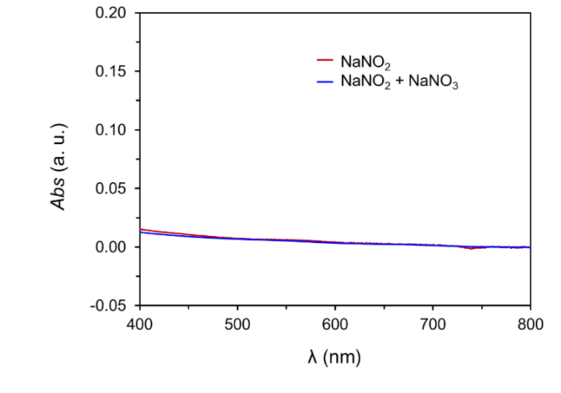
Figure S38. UV-vis spectra for the Griess analysis of a DME solution containing 0.1 M [Li][NTf₂] and 5 mM TsOH, as employed in the CPC experiments, for the determination of the NO₂⁻ (red trace) and NO₃⁻ (blue trace). The content of NO₂⁻ + NO₃⁻ is below 0.1 nmol based on the calibration plots.

S7. Protonation of W(N₂)₂:

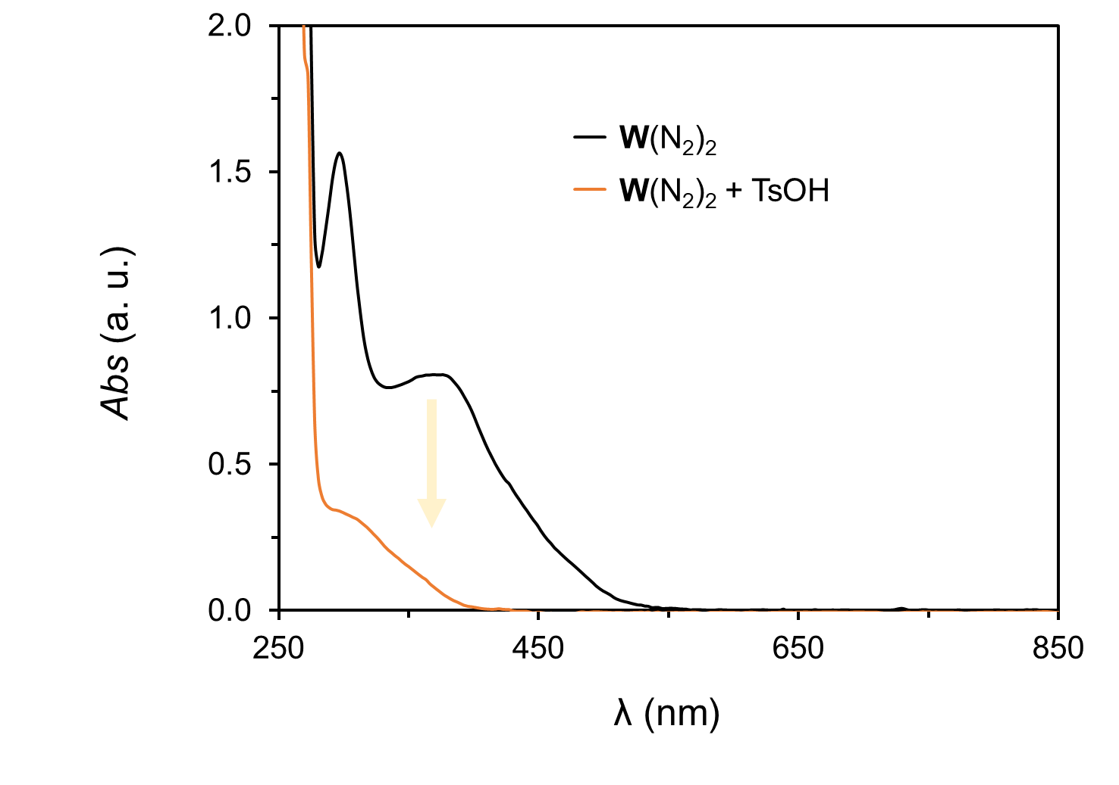
Figure S39. UV-vis spectra of a THF solution containing 0.05 mM W(N₂)₂ before (black trace) and after (yellow trace) addition of 100 equiv of TsOH for the quantitative formation of the hydrazido intermediate (TsO)W(NNH₂)⁺.
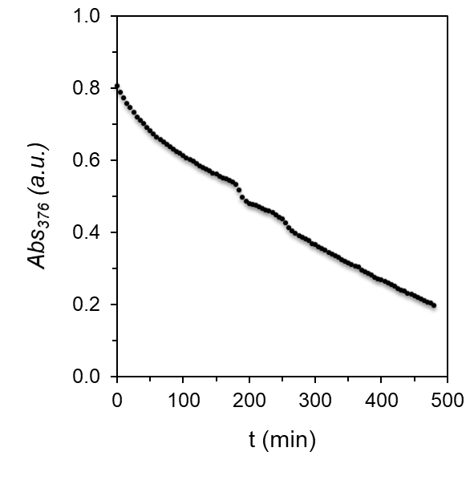
Figure S40. Time evolution of the absorption at 376 nm of a THF solution containing 0.05 mM W(N₂)₂ after addition of 100 equiv of TsOH for the quantitative formation of the hydrazido intermediate (TsO)W(NNH₂)⁺.

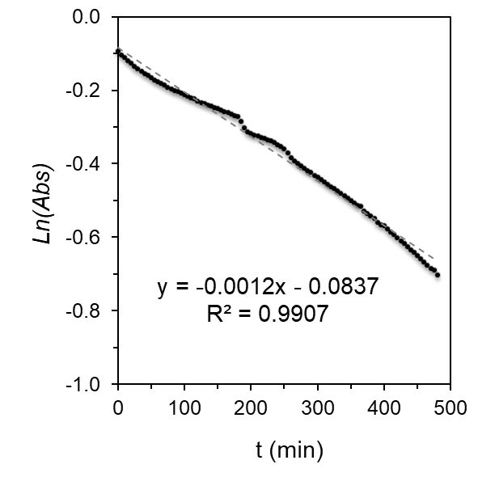
Figure S41. Plot of the natural logarithm of the absorption at 376 nm versus time of a THF solution containing 0.05 mM W(N₂)₂ after addition of 100 equiv of TsOH for the quantitative formation of the hydrazido intermediate (TsO)W(NNH₂)⁺. The plot reflects a pseudo first order reaction with a k_{obs} of 0.0012 min⁻¹ for the protonation of the dinitrogen complex, consistent with previous work studying these protonation steps.¹³

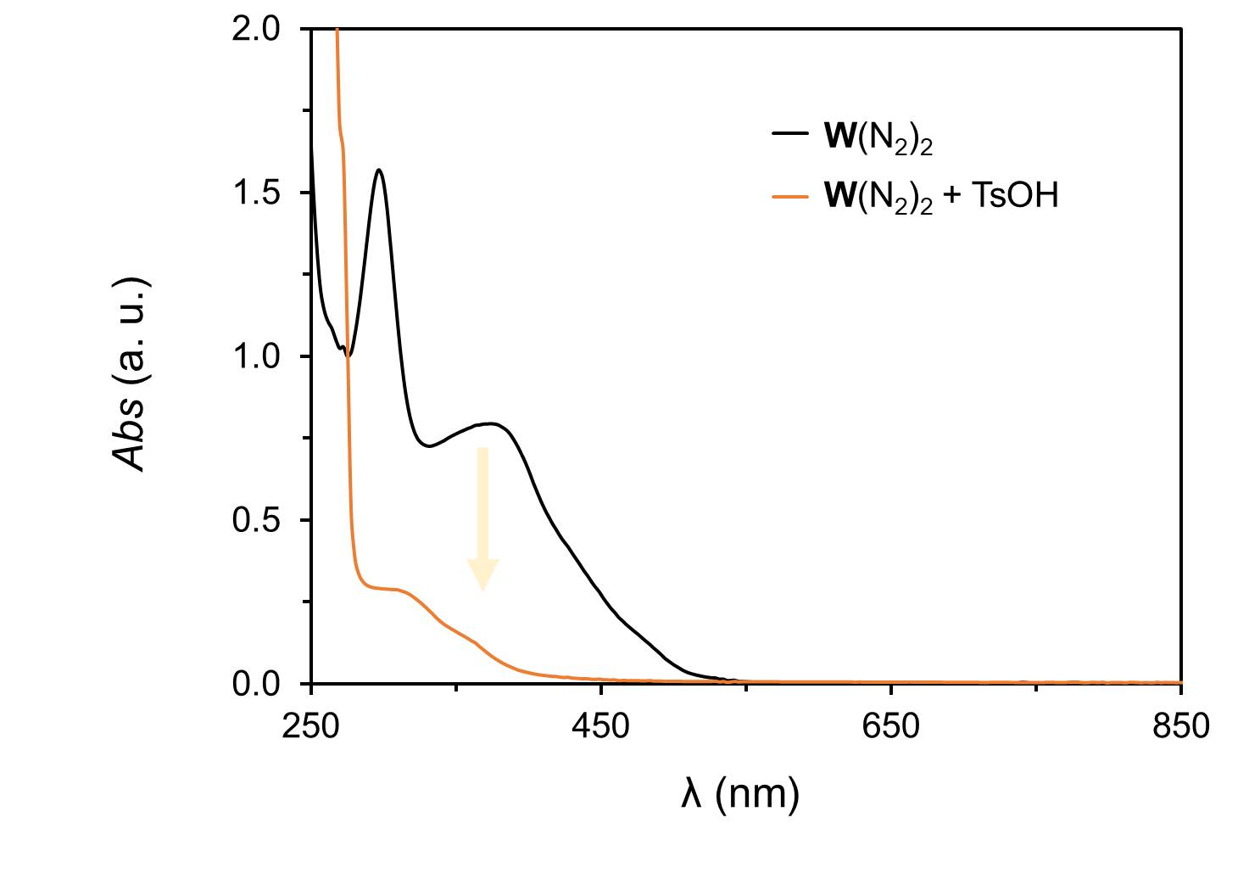
Figure S42. UV-vis spectra of a THF solution containing 0.1 M [Li][NTf₂] and 0.05 mM W(N₂)₂ before (black trace) and after (yellow trace) addition of 100 equiv of TsOH for the quantitative formation of the hydrazido intermediate (TsO)W(NNH₂)⁺.

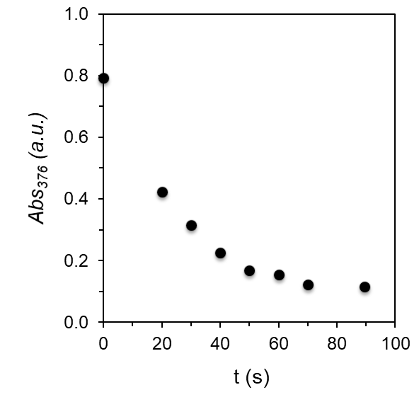
Figure S43. Time evolution of the absorption at 376 nm of a THF solution containing 0.1 M [Li][NTf₂] and 0.05 mM W(N₂)₂ after addition of 100 equiv of TsOH for the quantitative formation of the hydrazido intermediate (TsO)W(NNH₂)⁺.

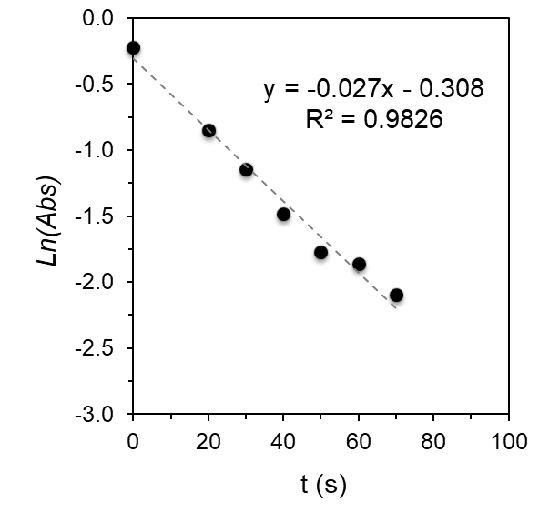
Figure S44. Plot of the natural logarithm of the absorption at 376 nm versus time of a THF solution containing 0.1 M [Li][NTf₂], 0.05 mM W(N₂)₂ after addition of 100 equiv of TsOH for the quantitative formation of the hydrazido intermediate (TsO)W(NNH₂)⁺. The plot reflects a pseudo first order reaction with a k_{obs} of 0.027 s⁻¹ for the protonation of the dinitrogen complex, consistent with its influence in the overall rate of catalysis and the observed partial order in acid. The faster rate than observed with [TBA][BF₄] is consistent with a potential role of the [Li][NTf₂] in activating the dinitrogen complex and/or stabilizing the hydrogen bonded intermediates.¹⁴
S8. Chemical CPET reactions:

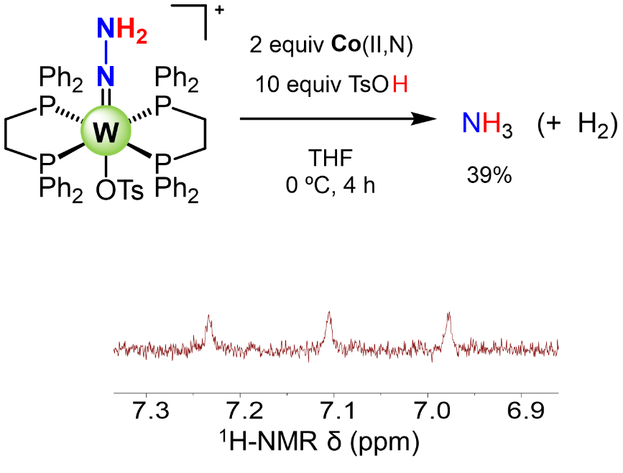
Figure S45. Chemical reaction of 0.5 mM (TsO)W(NNH₂)⁺ in THF with 2 equiv Co(II,N) in the presence of excess acid and the corresponding ¹H-NMR spectrum after work up for the quantification of NH₃ produced. These results show the capability of Co(II,NH)⁺, formed after rapid protonation of Co(II,N), to reduce the (TsO)W(NNH₂)⁺ intermediate, leading to the formation of ammonia.
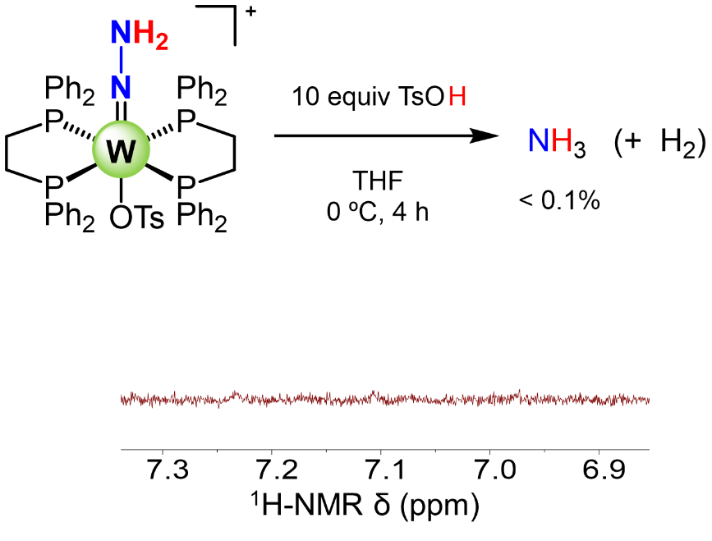
Figure S46. Chemical reaction of 0.5 mM (TsO)W(NNH₂)⁺ in THF with excess acid in the absence of the Co(II,N) mediator and the corresponding ¹H-NMR spectrum after work up for the quantification of NH₃ produced (< 3%). These results show the absence of significant reactivity between the (TsO)W(NNH₂)⁺ intermediate and acid leading to the formation of ammonia. The trace NH₃ observed my arise from a disproportionation reaction, for example where a tungsten complex serves as a source of electrons.¹⁵
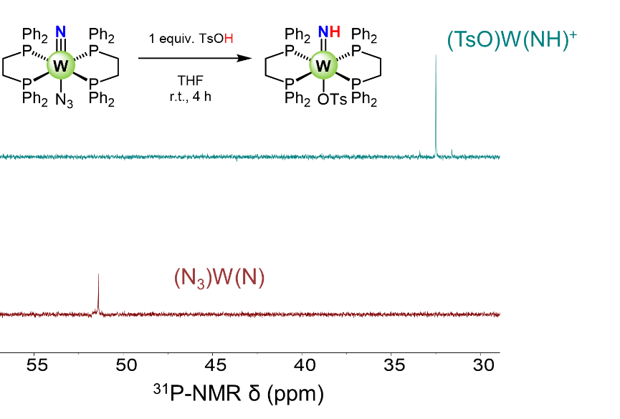
Figure S47. ³¹P-NMR spectrum of 0.5 mM (N₃)W(N) in THF before (red trace) and after (blue trace) addition of 1 equiv TsOH, showing the formation of the imido intermediate (X)W(NH)⁺ (X = OTs or N₃).

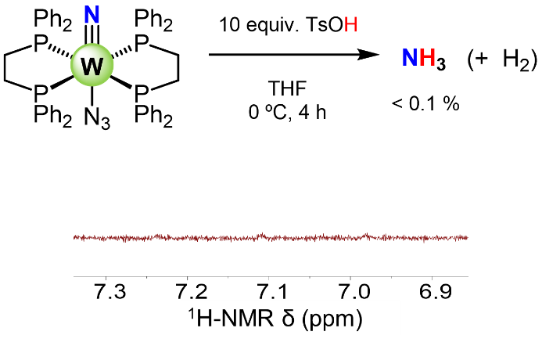
Figure S48. Chemical reaction of 0.5 mM (N₃)W(N) in THF with excess acid in the absence of the Co(II,N) mediator and the corresponding ¹H-NMR spectrum after work up for the quantification of NH₃ produced (< 3%). These results show the absence of significant reactivity between the (TsO)W(NH)⁺ intermediate, formed by in situ protonation of (N₃)W(N), and acid leading to the formation of ammonia. The trace NH₃ observed my arise from a disproportionation reaction, for example where a tungsten complex serves as a source of electrons. ¹⁵

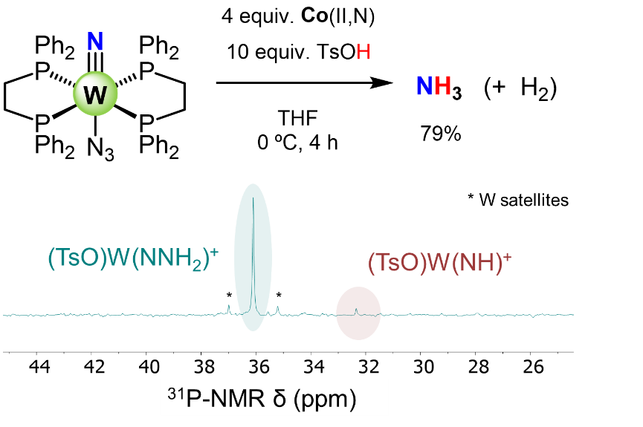
Figure S49. Chemical reaction of 0.5 mM (N₃)W(N) in THF with 4 equiv Co(II,N) in the presence of excess acid and the corresponding ³¹P-NMR spectrum. The TsOH was added prior to the addition of Co(II,N) for the formation of (TsO)W(NH)⁺. These results evidence the capability of Co(II,NH)⁺, formed after rapid protonation of Co(II,N), to reduce the (TsO)W(NH)⁺ intermediate, formed by in situ protonation of (N₃)W(N), towards formation of ammonia, and regeneration of W(N₂)₂, which then undergoes protonation with the excess of acid to form (TsO)W(NNH₂)⁺.

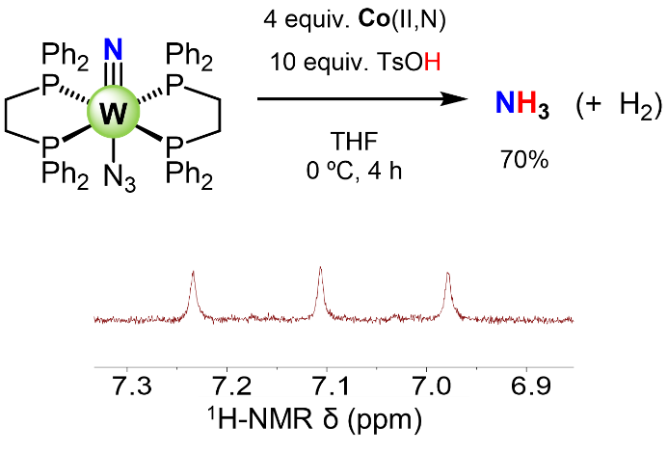

Figure S50. Chemical reaction of 0.5 mM (N₃)W(N) in THF with 4 equiv Co(II,N) in the presence of excess acid and the corresponding ¹H-NMR spectrum after work up for the quantification of NH₃ produced. The TsOH was added previous to the addition of Co(II,N) for the formation of (TsO)W(NH)⁺. These results show the capability of Co(II,NH)⁺, formed after rapid protonation of Co(II,N), to reduce the (TsO)W(NH)⁺ intermediate (formed by previous protonation of (N₃)W(N)) towards formation of ammonia.
S9. Mechanistic analysis via cyclic voltammetry:

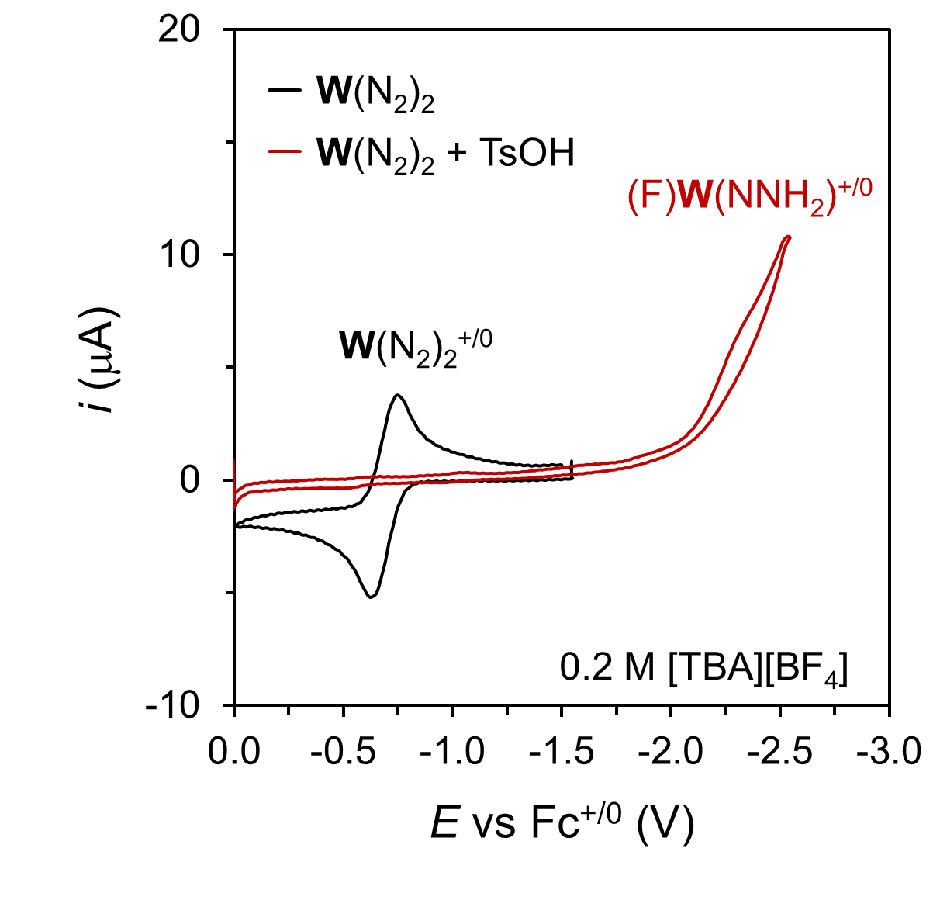
Figure S51. CV at 100 mV·s⁻¹ of a 0.2 M [TBA][BF₄] THF solution containing 0.5 mM W(N₂) before (black trace) and after (red trace) addition of 2 equiv of TsOH showing the formation of (F)W(NNH₂)⁺.
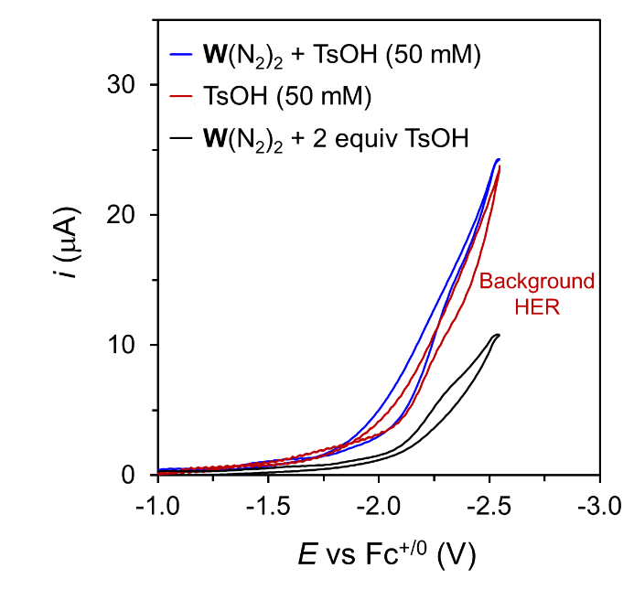
Figure S52. CV at 100 mV·s⁻¹ of a 0.2 M [TBA][BF₄] THF solution containing 0.5 mM W(N₂) and 2 equiv of TsOH (black trace), 0.5 mM W(N₂) and 50 mM TsOH (blue trace), and only 50 mM TsOH (red trace). These results show the similar electrochemical response with excess TsOH in the presence and absence of W(N₂) consistent with dominant electrocatalytic HER mediated by the electrode under these conditions.

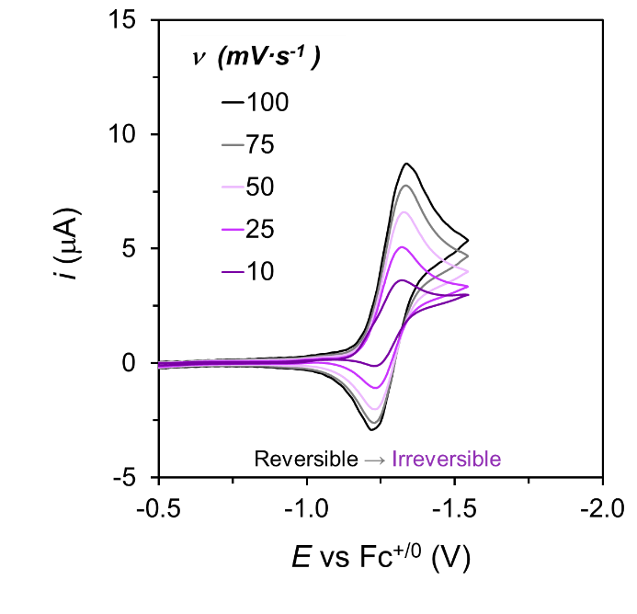
Figure S53. Variable scan rate CVs of a 0.2 M [TBA][BF₄] THF solution containing 0.5 mM Co(III,N)⁺, 0.5 mM W(N₂) and 50 mM TsOH showing how at the slower scan rates the reversibility decreases, consistent with a catalytic process coupled to the reduction of in situ generated Co(III,NH)²⁺ to Co(II,NH)⁺.
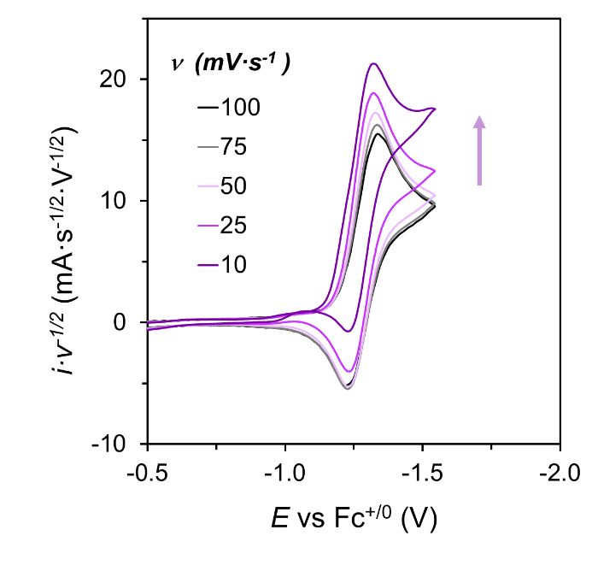
Figure S54. CVs normalized by the scan rate of a 0.2 M [TBA][BF₄] THF solution containing 0.5 mM Co(III,N)⁺, 0.5 mM W(N₂) and 50 mM TsOH. These results show how at slower scan rates the reversibility decreases and the normalized current increases, consistent with a catalytic process coupled to the reduction of in situ generated Co(III,NH)²⁺ to Co(II,NH)⁺.

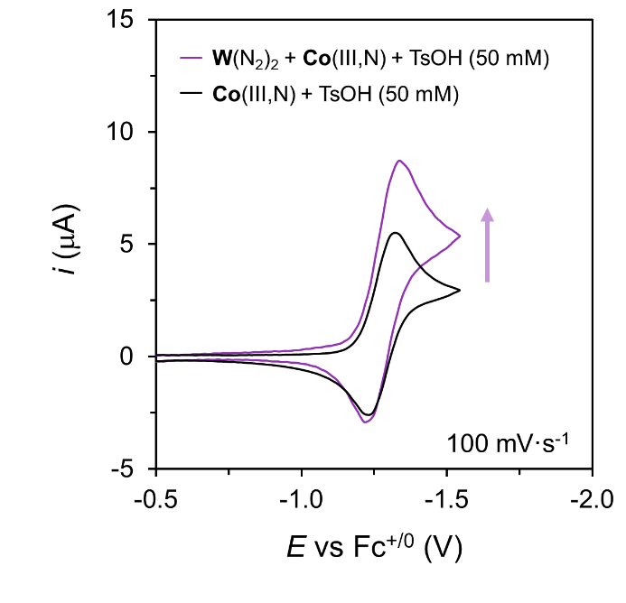
Figure S55. CVs at 100 mV·s⁻¹ of a 0.2 M [TBA][BF₄] THF solution containing 0.5 mM Co(III,N)⁺ and 50 mM TsOH with (purple trace) and without (black trace) 0.5 mM W(N₂). These results show the increase in the current associated with the reduction of Co(III,NH)²⁺ to Co(II,NH)⁺, consistent with tandem electrocatalysis.

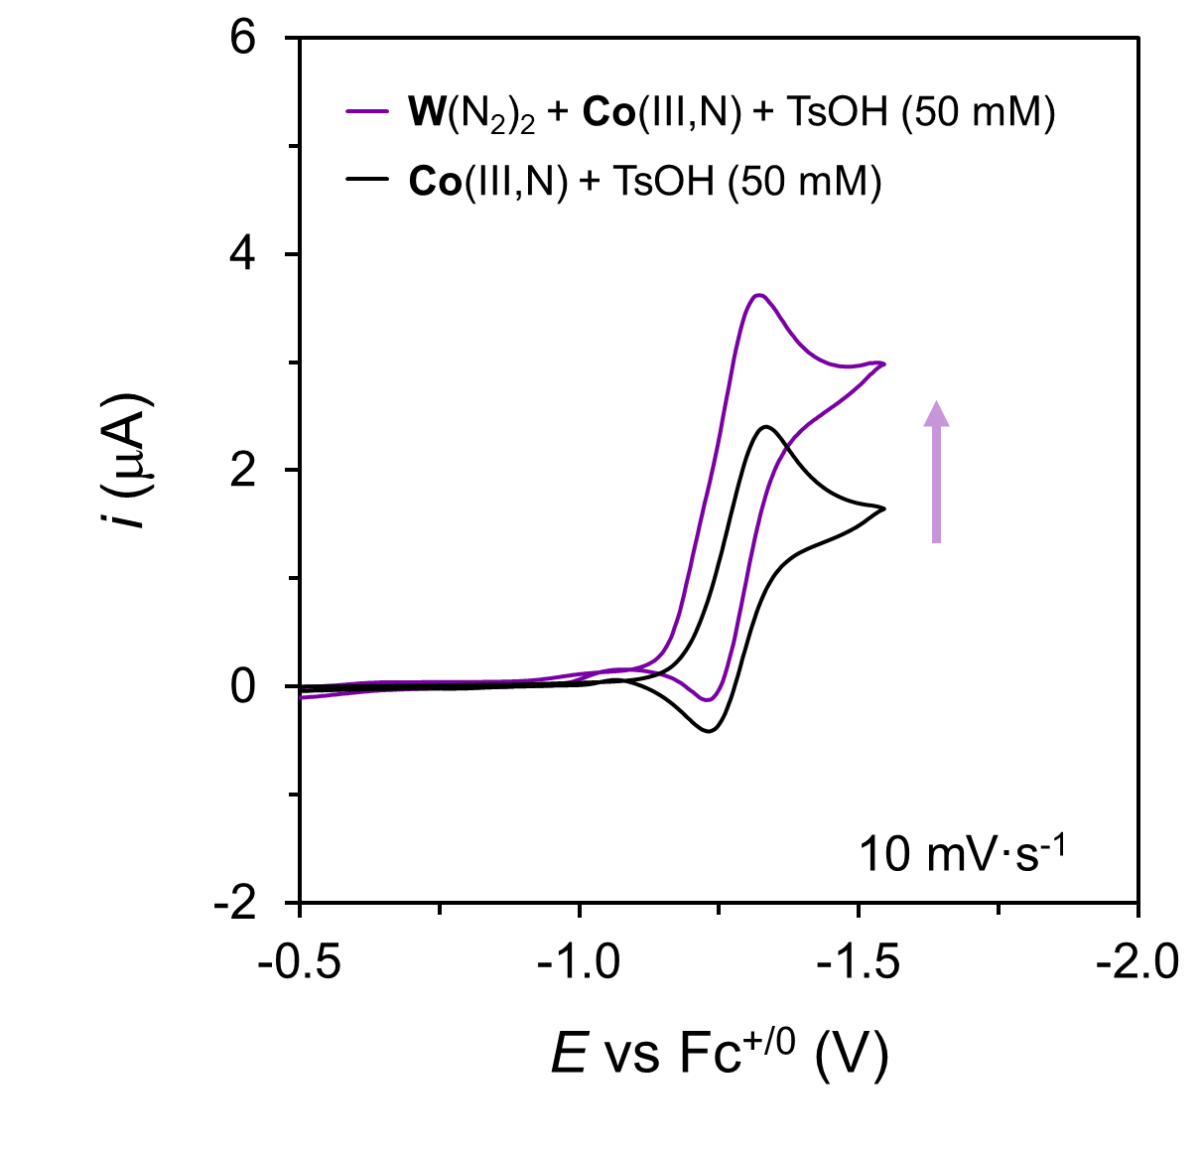
Figure S56. CVs at 10 mV·s⁻¹ of a 0.2 M [TBA][BF₄] THF solution containing 0.5 mM Co(III,N)⁺ and 50 mM TsOH with (purple trace) and without (black trace) 0.5 mM W(N₂). These results show an increase in the current associated with the reduction of Co(III,NH)²⁺ to Co(II,NH)⁺, consistent with tandem electrocatalysis.
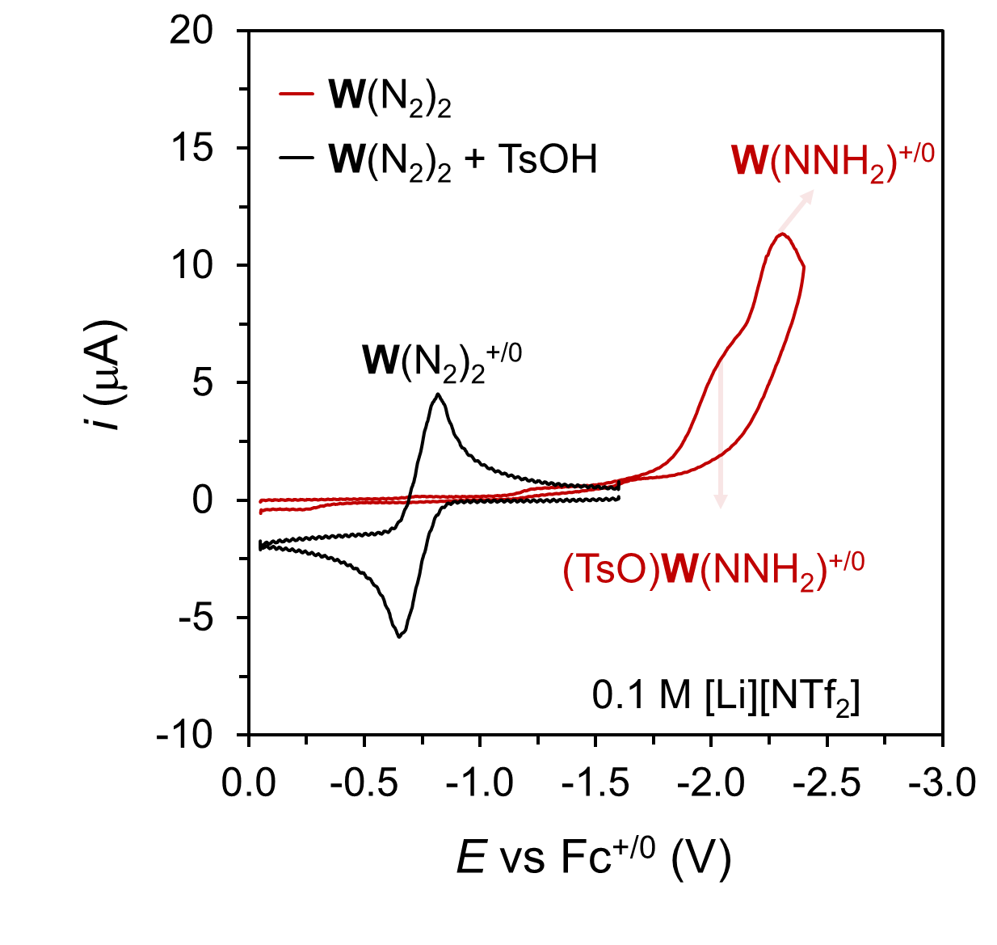
Figure S57. CV at 100 mV·s⁻¹ of a 0.1 M [Li][NTf₂] THF solution containing 0.5 mM W(N₂) before (black trace) and after (red trace) addition of 2 equiv of TsOH, showing the formation of (OTs)W(NNH₂)⁺.

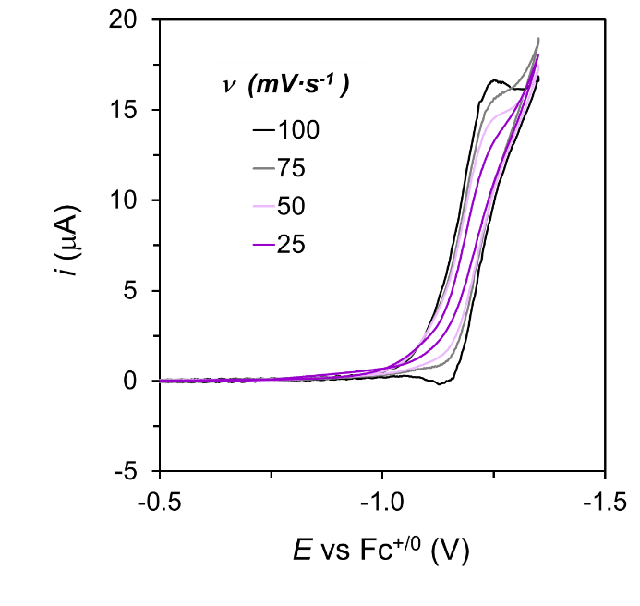
Figure S58. Variable scan rates CVs of a 0.1 M [Li][NTf₂] THF solution containing 0.5 mM Co(III,N)⁺, 0.5 mM W(N₂) and 50 mM TsOH, showing an irreversible electrocatalytic response as compared to the one electron wave of Co(III,NH)⁺. The irreversibility increases as the scan rate decreases.

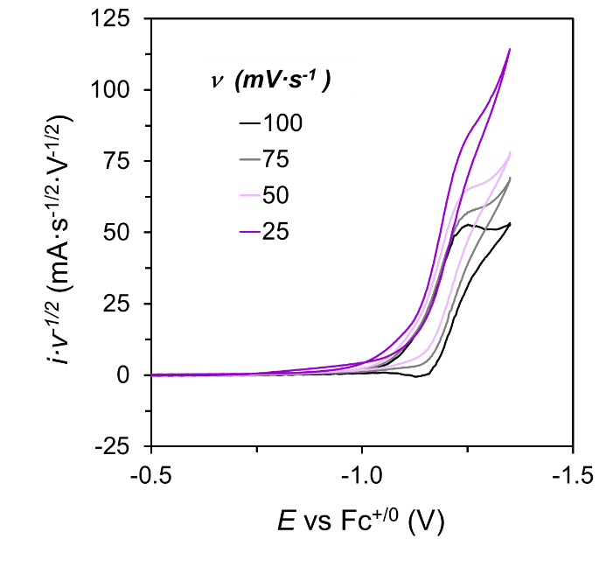
Figure S59. CVs normalized by the scan rate of a 0.1 M [Li][NTf₂] THF solution containing 0.5 mM Co(III,N)⁺, 0.5 mM W(N₂) and 50 mM TsOH. These results show that at slower scan rates the reversibility decreases and the normalized current increases, consistent with a catalytic process coupled to the reduction of in situ generated Co(III,NH)²⁺ to Co(II,NH)⁺.

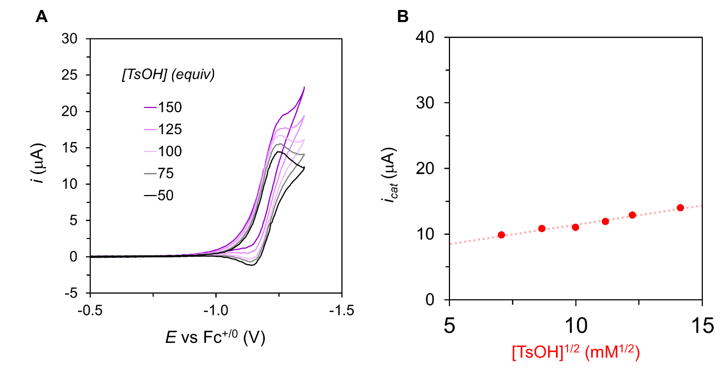
Figure S60. (A) CVs at 100 mV·s⁻¹ of a 0.1 M [Li][NTf₂] THF solution containing 0.5 mM Co(III,N)⁺, 0.5 mM W(N₂) and increasing concentrations of TsOH, evidencing a partial positive order in acid for the electrocatalytic process. (B) Dependence of the catalytic current extracted from background corrected CVs with the concentration of TsOH, reflecting the partial positive order in acid of the electrocatalytic process.

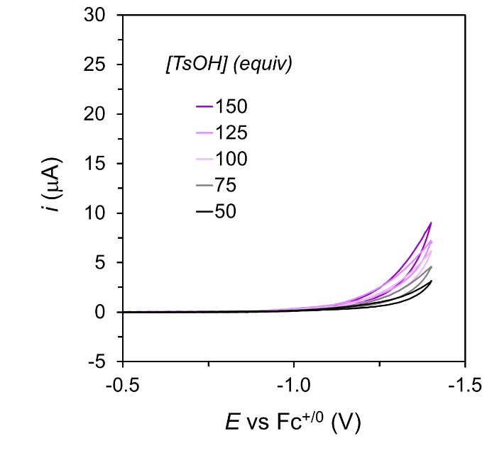
Figure S61. Background CVs at 100 mV·s⁻¹ of a 0.1 M [Li][NTf₂] THF solution containing increasing concentrations of TsOH, showing an increase in the background HER electrocatalysis mediated by the electrode.

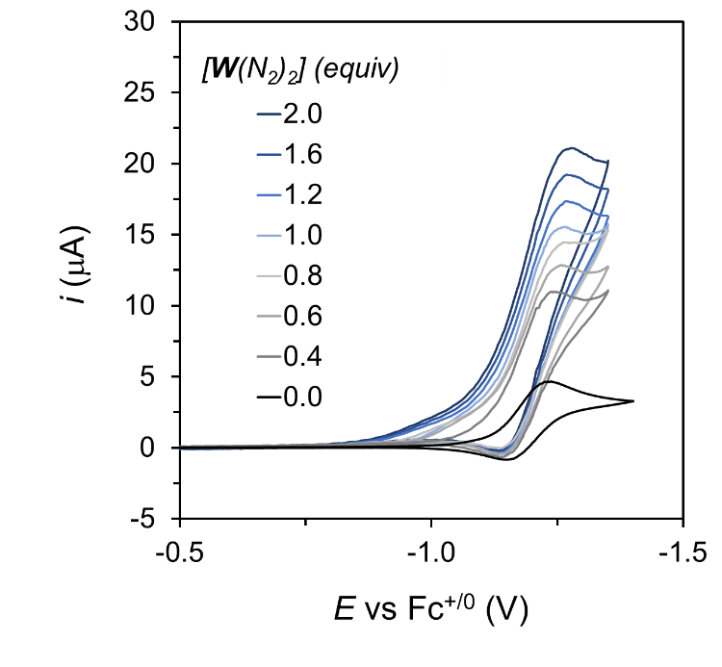
Figure S62. CVs at 100 mV·s⁻¹ of a 0.1 M [Li][NTf₂] THF solution containing 0.5 mM Co(III,N)⁺, 50 mM TsOH and increasing concentrations of W(N₂), evidencing a partial positive order in W(N₂) for the electrocatalytic process.
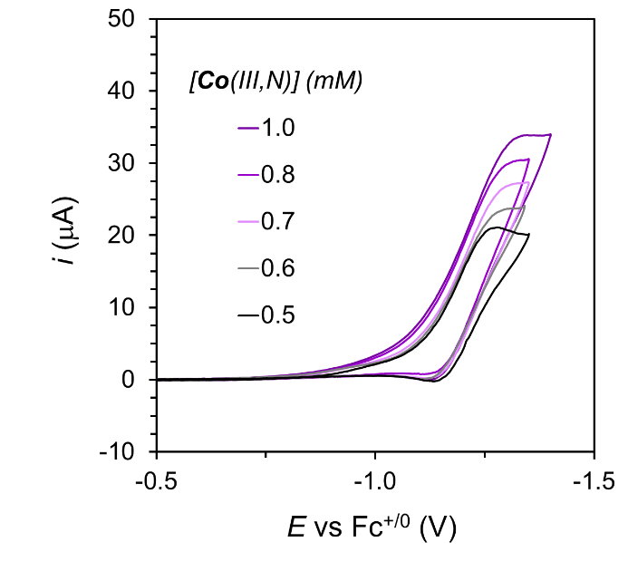
Figure S63. CVs at 100 mV·s⁻¹ of a 0.1 M [Li][NTf₂] THF solution containing 0.5 mM W(N₂), 50 mM TsOH and increasing concentrations of Co(III,N)⁺, evidencing a partial positive order in Co(III,N)⁺ for the electrocatalytic process.

S10. Electrocatalysis with N₂RR catalysts:

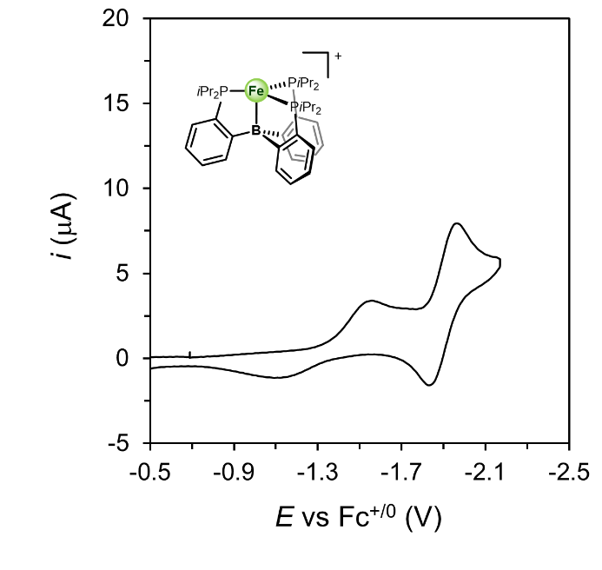
Figure S64. CV at 100 mV·s⁻¹ of a 0.1 M [Li][NTf₂] THF solution containing 0.5 mM [(TPB)Fe][BAr^{F}₄], showing the subsequent, reversible, one-electron reduction to Fe(N₂) (complex 6) and Fe(N₂)⁻, at around −1.3 V and −2 V vs Fc^{+/0}, respectively.

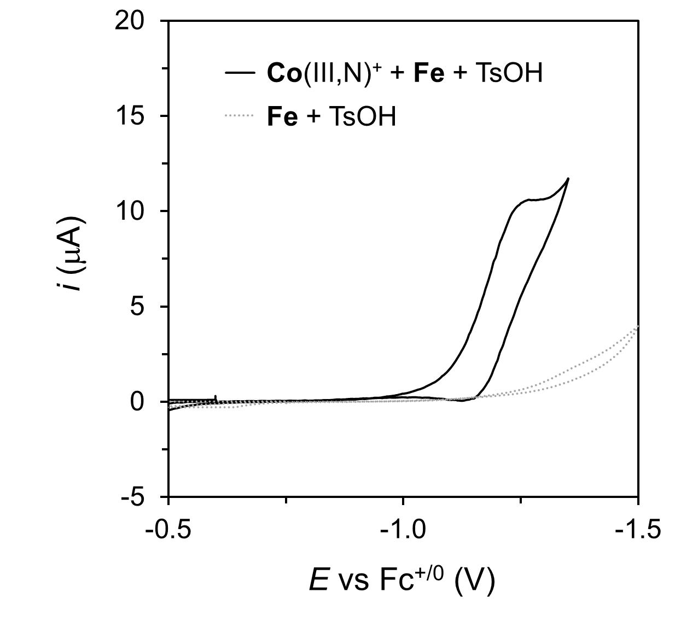
Figure S65. CV at 100 mV·s⁻¹ of a 0.1 M [Li][NTf₂] THF solution containing 0.5 mM [(TPB)Fe][BAr^{F}₄] and 50 mM TsOH with (black trace) and without (gray trace) 0.5 mM Co(III,N)⁺.
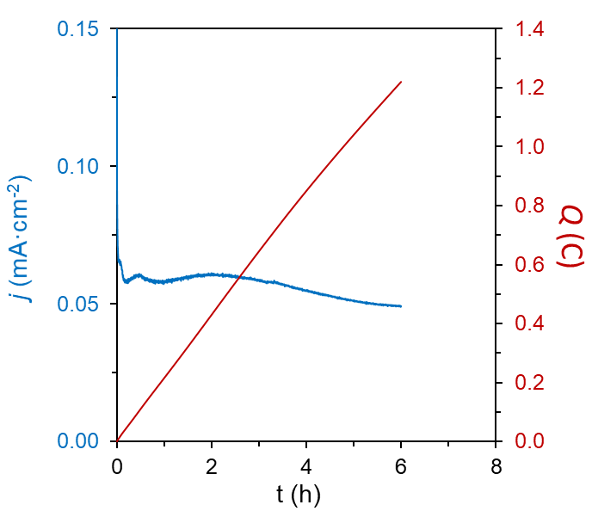
Figure S66. Current and charge profile for a CPC at −1.35 V vs Fc^{+/0} in 0.1 M [Li][NTf₂] DME solution containing 0.05 mM Co(III,N)⁺, 0.05 mM [(TPB)Fe][BAr^{F}₄] and 5 mM TsOH, using a BDD plate working electrode.

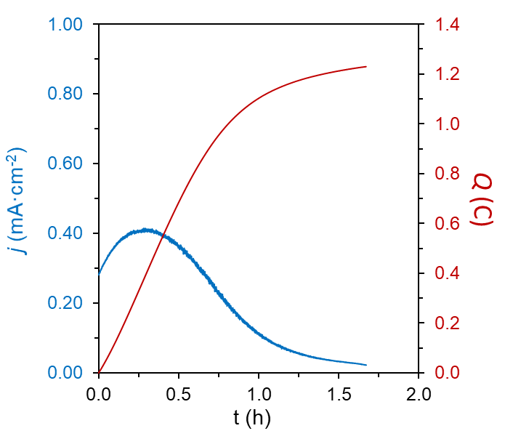
Figure S67. Current and charge profile for a CPC at −1.45 V vs Fc^{+/0} in 0.1 M [Li][NTf₂] DME solution containing 0.05 mM Co(III,N)⁺, 0.05 mM [(TPB)Fe][BAr^{F}₄] and 5 mM TsOH, using a BDD plate working electrode.
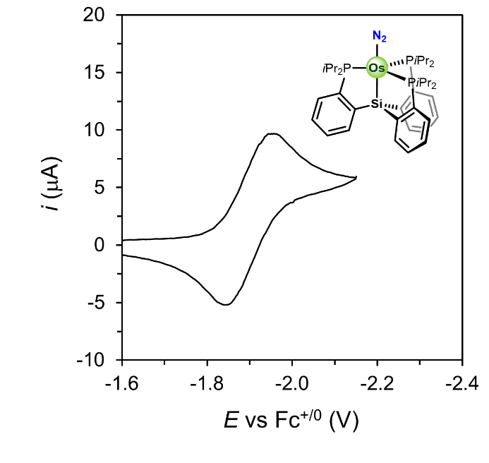
Figure S68. CV at 100 mV·s⁻¹ of a 0.1 M [Li][NTf₂] THF solution containing 0.5 mM Os(N₂) complex 5 showing the reversible, one-electron reduction to Os(N₂)⁻ at around −1.9 V vs Fc^{+/0}.

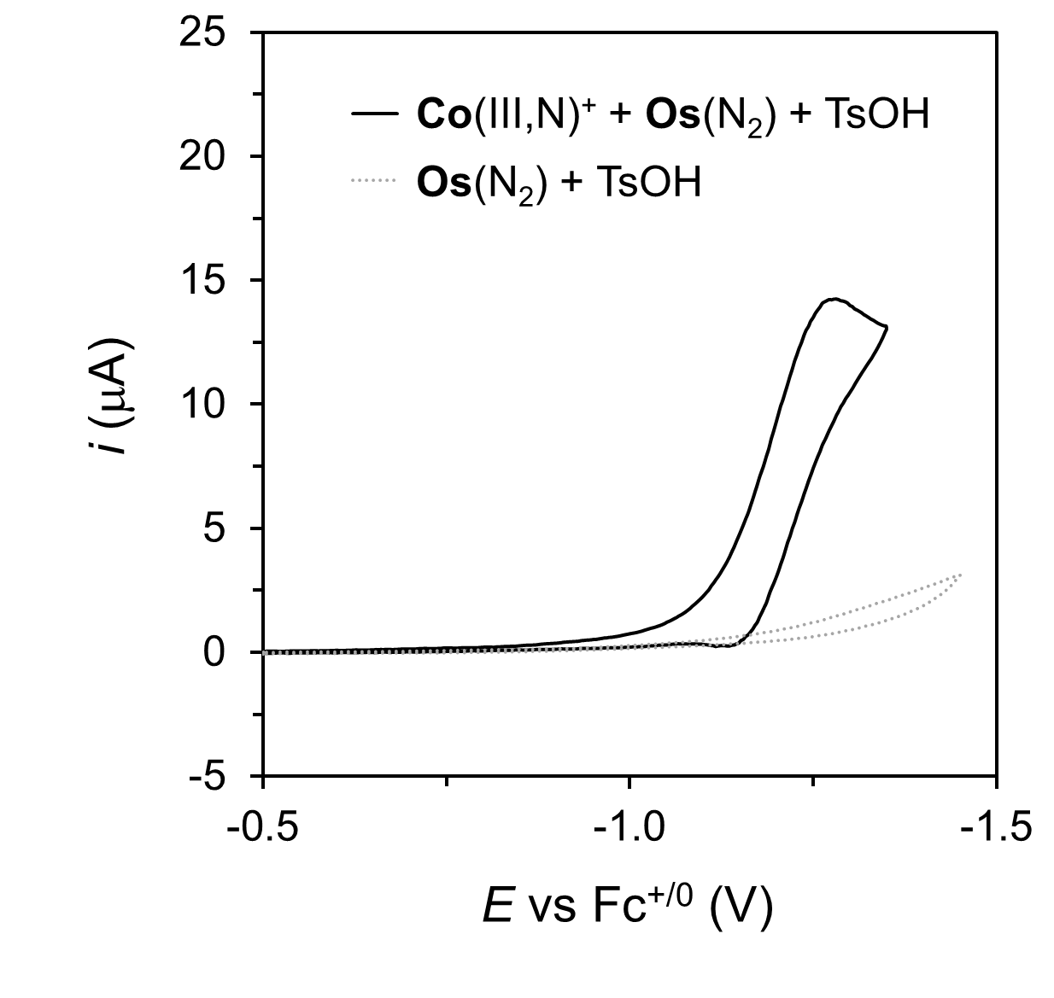
Figure S69. CV at 100 mV·s⁻¹ of a 0.1 M [Li][NTf₂] THF solution containing 0.5 mM Os(N₂) and 50 mM TsOH with (black trace) and without (gray trace) 0.5 mM Co(III,N)⁺.
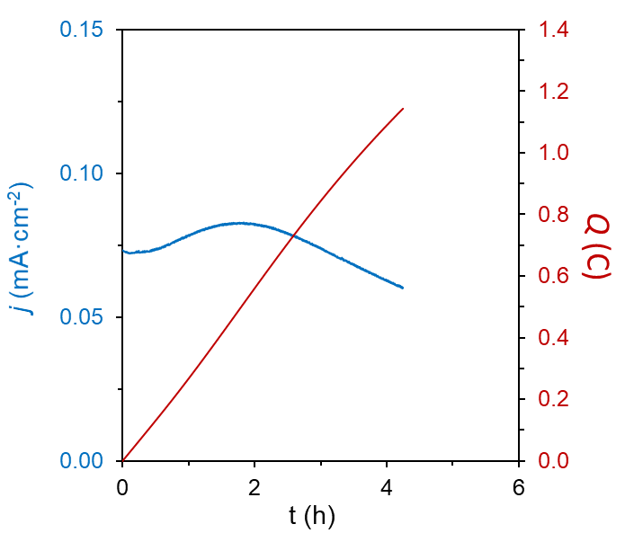
Figure S70. Current and charge profile for a CPC at −1.35 V vs Fc^{+/0} in 0.1 M [Li][NTf₂] DME solution containing 0.05 mM Co(III,N)⁺, 0.05 mM Os(N₂) and 5 mM TsOH, using a BDD plate working electrode.
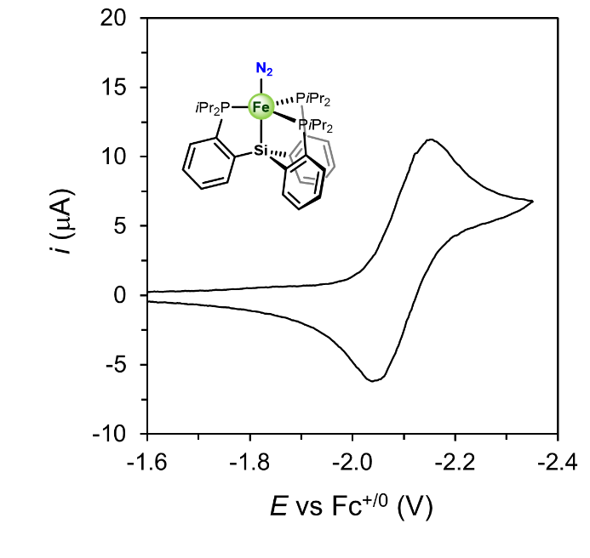
Figure S71. CV at 100 mV·s⁻¹ of a 0.1 M [Li][NTf₂] THF solution containing 0.5 mM (SiP₃)Fe(N₂) complex 7 showing the reversible, one-electron reduction to (SiP₃)Fe(N₂)⁻ at around −2.1 V vs Fc^{+/0}.

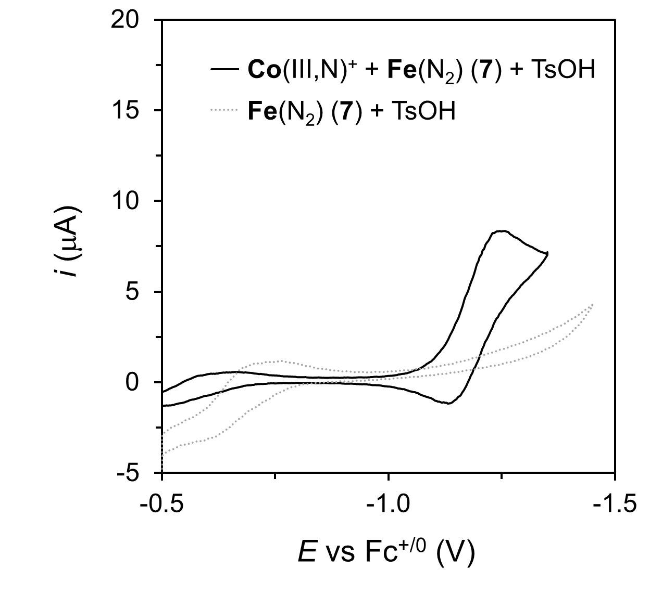
Figure S72. CV at 100 mV·s⁻¹ of a 0.1 M [Li][NTf₂] THF solution containing 0.5 mM (SiP₃)Fe(N₂) and 50 mM TsOH with (black trace) and without (gray trace) 0.5 mM Co(III,N)⁺.

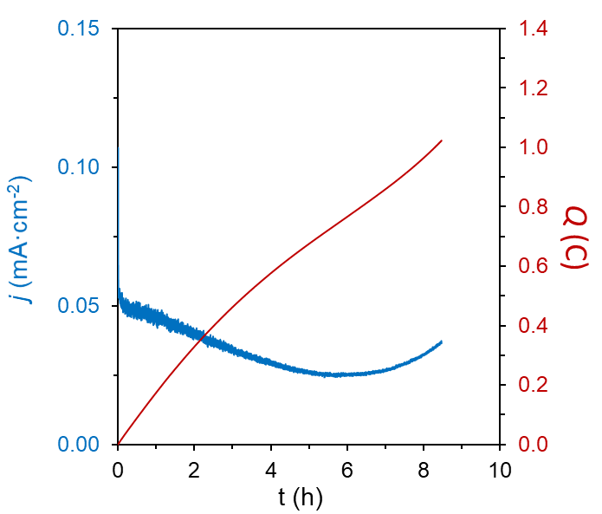
Figure S73. Current and charge profile for a CPC at −1.35 V vs Fc^{+/0} in 0.1 M [Li][NTf₂] DME solution containing 0.05 mM Co(III,N)⁺, 0.05 mM Fe(N₂) and 5 mM TsOH, using a BDD plate working electrode.
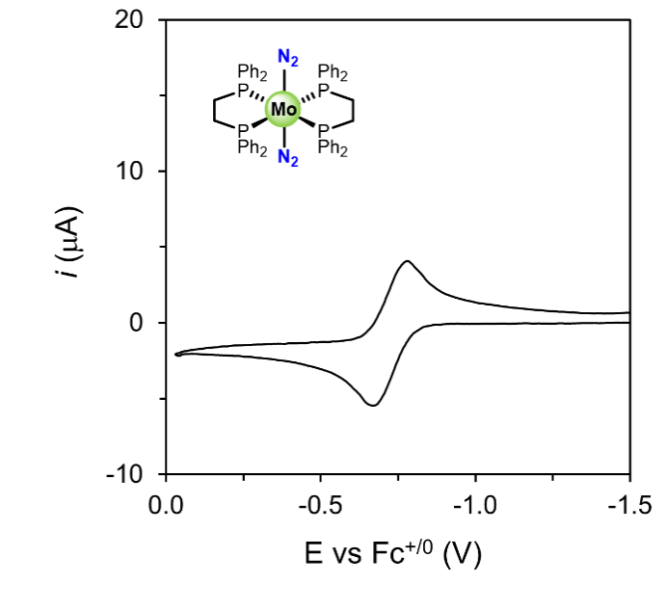
Figure S74. CV at 100 mV·s⁻¹ of a 0.1 M [Li][NTf₂] THF solution containing 0.5 mM the Mo(N₂)₂ complex 1 showing a reversible, one-electron redox couple at around −0.7 V vs Fc^{+/0}.

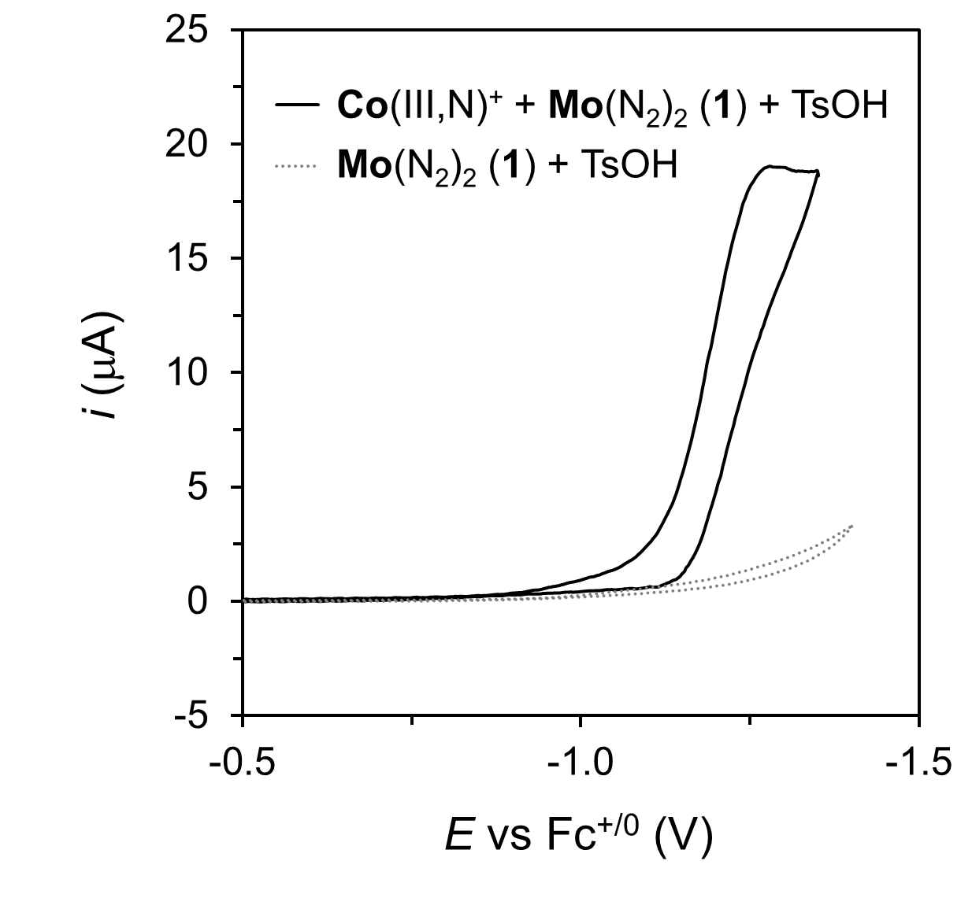
Figure S75. CV at 100 mV·s⁻¹ of a 0.1 M [Li][NTf₂] THF solution containing 0.5 mM of the Mo(N₂)₂ complex 1 and 50 mM TsOH with (black trace) and without (gray trace) 0.5 mM Co(III,N)⁺.
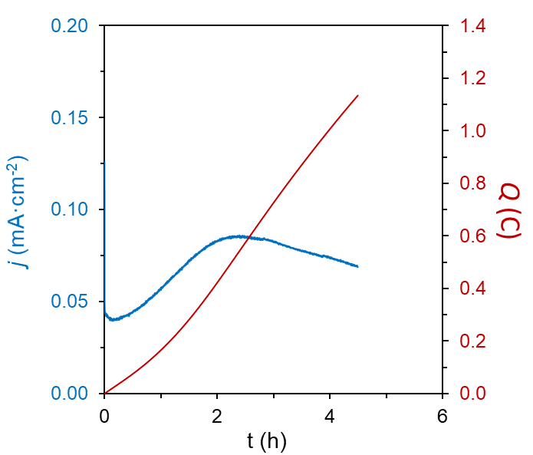
Figure S76. Current and charge profile for a CPC at −1.35 V vs Fc^{+/0} in 0.1 M [Li][NTf₂] DME solution containing 0.05 mM Co(III,N)⁺, 0.05 mM Mo(N₂)₂ complex 1 and 5 mM TsOH, using a BDD plate working electrode.
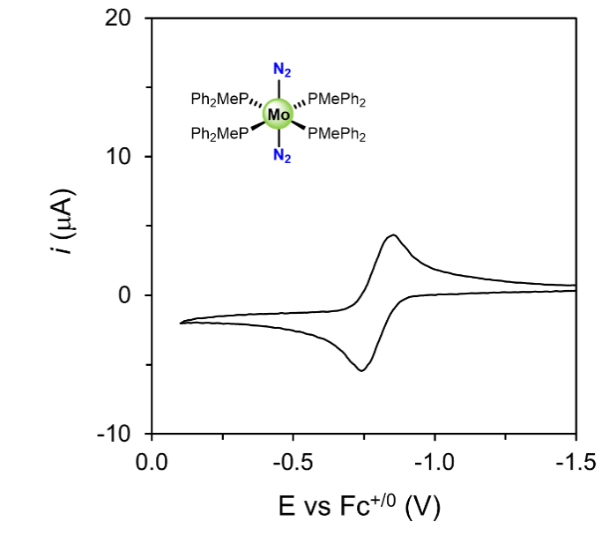
Figure S77. CV at 100 mV·s⁻¹ of a 0.1 M [Li][NTf₂] THF solution containing 0.5 mM the Mo(N₂)₂ complex 2 showing a reversible, one-electron redox couple at around −0.6 V vs Fc^{+/0}.

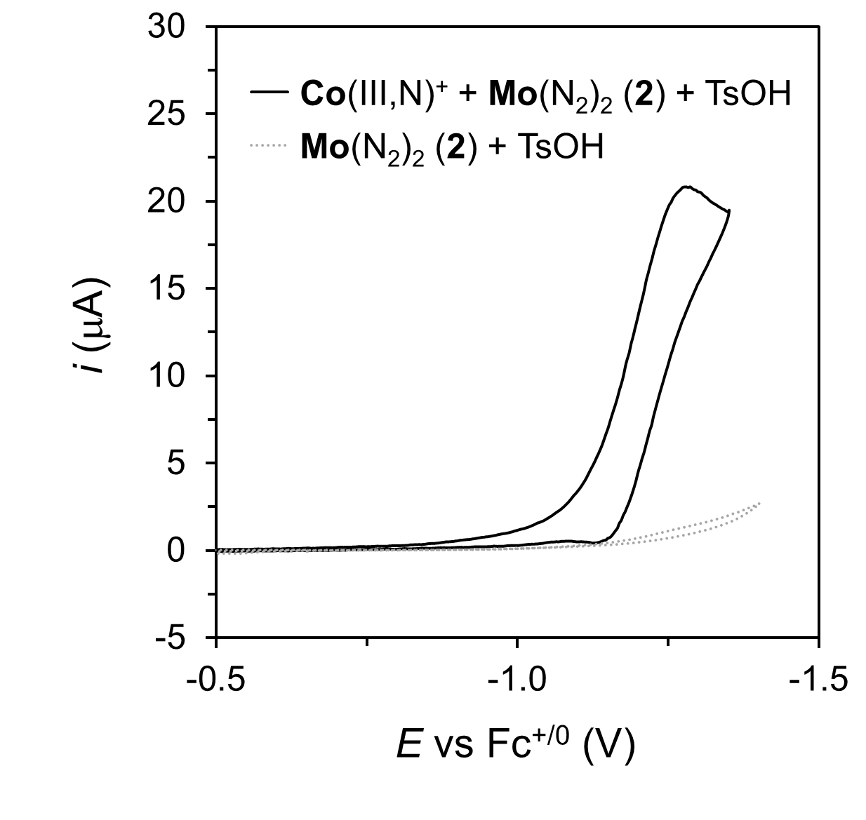
Figure S78. CV at 100 mV·s⁻¹ of a 0.1 M [Li][NTf₂] THF solution containing 0.5 mM of the Mo(N₂)₂ complex 2 and 50 mM TsOH with (black trace) and without (gray trace) 0.5 mM Co(III,N)⁺.

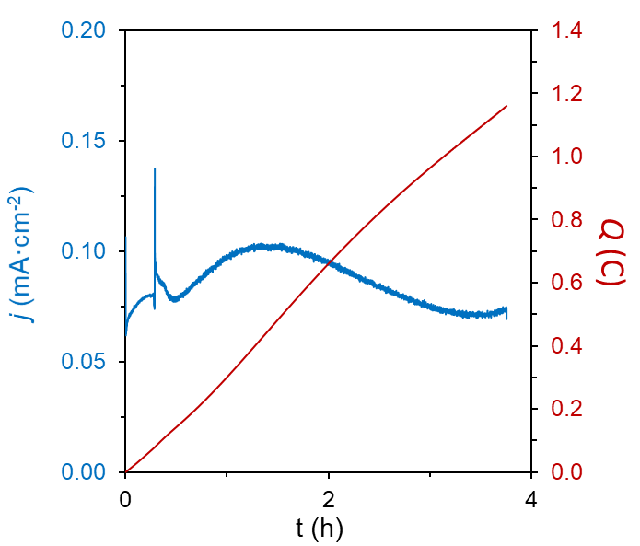
Figure S79. Current and charge profile for a CPC at −1.35 V vs Fc^{+/0} in 0.1 M [Li][NTf₂] DME solution containing 0.05 mM Co(III,N)⁺, 0.05 mM Mo(N₂)₂ complex 2 and 5 mM TsOH, using a BDD plate working electrode.

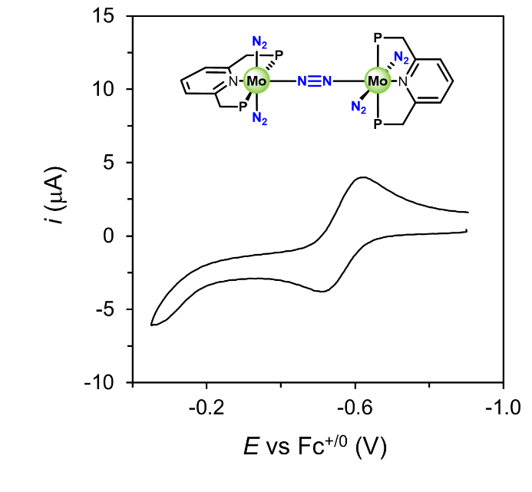
Figure S80. CV at 100 mV·s⁻¹ of a 0.1 M [Li][NTf₂] THF solution containing 0.5 mM the Mo complex 3 showing a reversible, one-electron redox couple at around −0.6 V vs Fc^{+/0}.

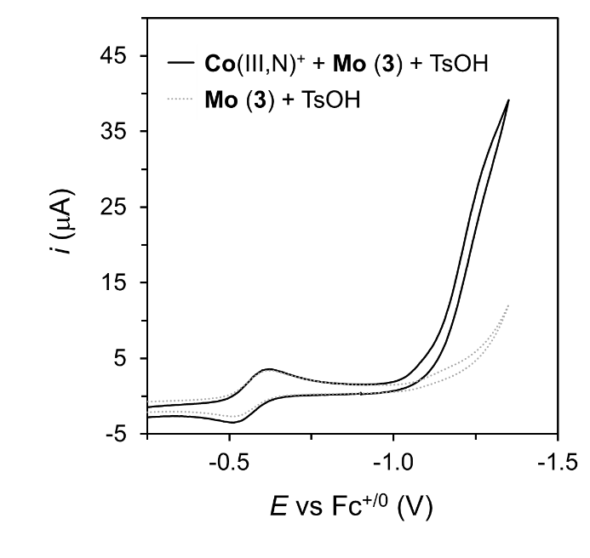
Figure S81. CV at 100 mV·s⁻¹ of a 0.1 M [Li][NTf₂] THF solution containing 0.5 mM of the Mo complex 3 and 50 mM TsOH with (black trace) and without (gray trace) 0.5 mM Co(III,N)⁺.

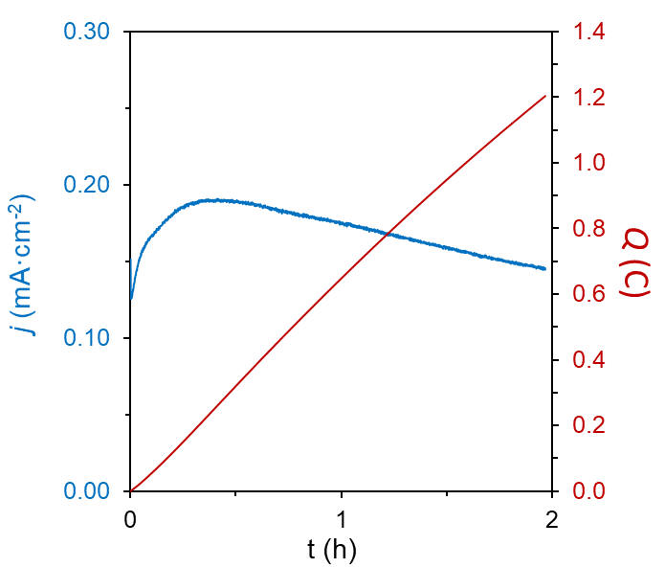

Figure S82. Current and charge profile for a CPC at −1.35 V vs Fc^{+/0} in 0.1 M [Li][NTf₂] DME solution containing 0.05 mM Co(III,N)⁺, 0.05 mM Mo complex 3 and 5 mM TsOH, using a BDD plate working electrode.

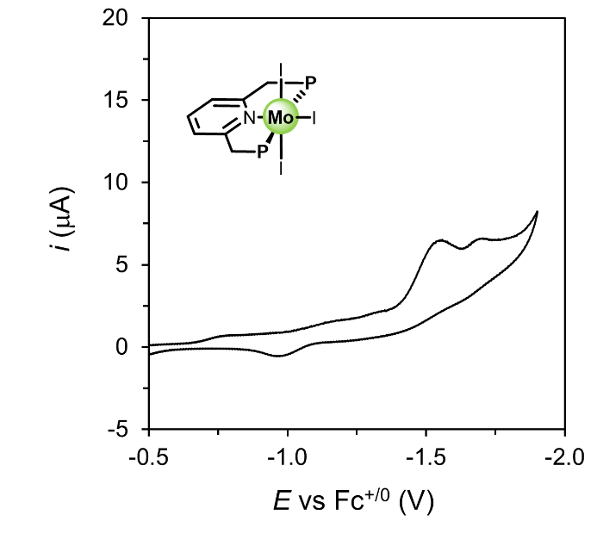
Figure S83. CV at 100 mV·s⁻¹ of a 0.1 M [Li][NTf₂] THF solution containing 0.5 mM the Mo complex 4 showing two irreversible, one-electron reduction waves below −1.5 V vs Fc^{+/0}.

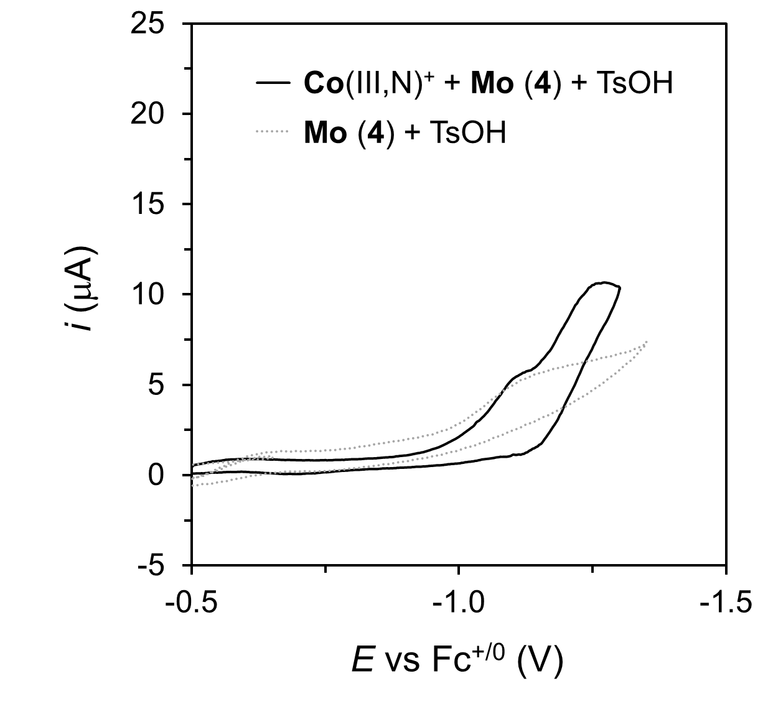
Figure S84. CV at 100 mV·s⁻¹ of a 0.1 M [Li][NTf₂] THF solution containing 0.5 mM of the Mo complex 4 and 50 mM TsOH with (black trace) and without (gray trace) 0.5 mM Co(III,N)⁺.

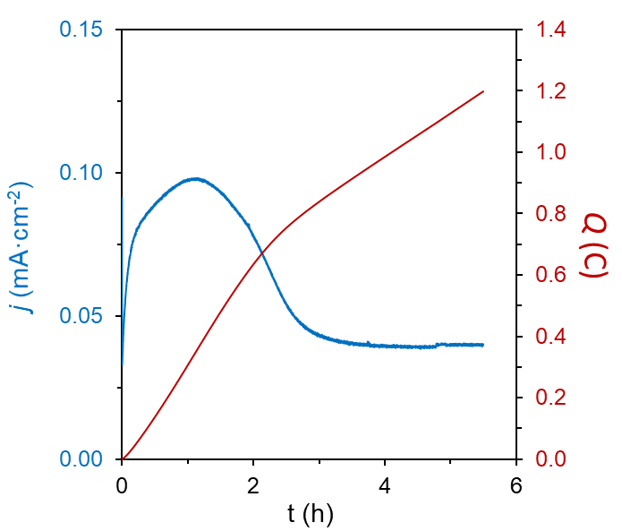

Figure S85. Current and charge profile for a CPC at −1.35 V vs Fc^{+/0} in 0.1 M [Li][NTf₂] DME solution containing 0.05 mM Co(III,N)⁺, 0.05 mM Mo complex 4 and 5 mM TsOH, using a BDD plate working electrode.

S11. References:

1. Costentin, C. & Savéant, J.-M. Multielectron, multistep molecular catalysis of electrochemical reactions: benchmarking of homogeneous catalysts. ChemElectroChem 1, 1226–1236 (2014).
2. Hodgetts, R. Y. et al. Refining universal procedures for ammonium quantification via rapid ¹H NMR analysis for dinitrogen reduction studies. ACS Energy Lett. 5, 736–741 (2020).
3. Kolen, M., Smith, W. A. & Mulder, F. M. Accelerating ¹H NMR detection of aqueous ammonia. ACS Omega 6, 5698–5704 (2021).
4. Nielander, A. C. et al. A Versatile method for ammonia detection in a range of relevant electrolytes via direct nuclear magnetic resonance techniques. ACS Catal. 9, 5797–5802 (2019).
5. Becker, J. Y. & Avraham (Tsarfaty), S. Nitrogen fixation: Part III. Electrochemical reduction of hydrazido (-NNH₂) Mo and W complexes. Selective formation of NH₃ under mild conditions. J. Electroanal. Chem. Interf. Electrochem. 280, 119–127 (1990).
6. Pickett, C. J., Ryder, K. S. & Talarmin, J. Electron-transfer reactions in nitrogen fixation. Part 2. The electrosynthesis of ammonia: identification and estimation of products. J. Chem. Soc., Dalton Trans. 7, 1453–1457 (1986).
7. Al-Salih, T. I. & Pickett, C. J. Electron-transfer reactions in nitrogen fixation. Part 1. The electrosynthesis of dinitrogen, hydride, isocyanide, and carbonyl complexes of molybdenum: intermediates, mechanisms, and energetics. J. Chem. Soc., Dalton Trans. 1255–1264 (1985).
8. Geri, J. B., Shanahan, J. P. & Szymczak, N. K. Testing the push–pull hypothesis: Lewis acid augmented N₂ activation at iron. J. Am. Chem. Soc. 139, 5952–5956 (2017).
9. Bendix, J. & Bøgevig, A. Synthesis and characterization of a stable trans-dioxo tungsten(IV) complex and series of mono-oxo molybdenum(IV) and tungsten(IV) complexes. structural and electronic effects of π-bonding in trans-[M(O)(X)(dppe)₂]^{+/0} systems. Inorg. Chem. 37, 5992–6001 (1998).
10. Xu, K. Nonaqueous liquid electrolytes for lithium-based rechargeable batteries Chem. Rev. 104, 4303–4418 (2004).
11. Lehnert, N. & Tuczek, F. The reduction pathway of end-on coordinated dinitrogen. I. Vibrational spectra of Mo/W–N₂, –NNH, and –NNH₂ complexes and quantum chemistry assisted normal coordinate analysis. Inorg. Chem. 38, 1659–1670 (1999).
12. Suryanto, B. H. R. et al. Nitrogen reduction to ammonia at high efficiency and rates based on a phosphonium proton shuttle. Science 372, 1187 (2021).
13. A. Henderson, R. The mechanism of formation of hydrazido(2—)- and hydrido-complexes by the reaction of dinitrogen complexes with acids in tetrahydrofuran. J. Chem. Soc., Dalton Trans. 0, 917–925 (1982).
14. Kireev, N. V. et al. Steric and acidity control in hydrogen bonding and proton transfer to trans-W(N₂)₂(dppe)₂. Inorg. Chem. 57, 1656–1664 (2018).
15. Chatt, J., Pearman, A. J. & Richards, R. L. Conversion of dinitrogen in its molybdenum and tungsten complexes into ammonia and possible relevance to the nitrogenase reaction. J. Chem. Soc., Dalton Trans.1852-1860 (1977).

