A protocol to generate SPH-OminiCMV-Ents mESCs

Ni Gao, Jing Hu, Haibo Zhou, Hui Yang

Ni Gao
Institute of Neuroscience, State Key Laboratory of Neuroscience, Key Laboratory of Primate Neurobiology, CAS Center for Excellence in Brain Science and Intelligence Technology, Shanghai Research Center for Brain Science and Brain-Inspired Intelligence, Shanghai Institutes for Biological Sciences, Chinese Academy of Sciences, Shanghai 200031, China;
College of Life Sciences, University of Chinese Academy of Sciences, Beijing 100049, China

Jing Hu
Institute of Neuroscience, State Key Laboratory of Neuroscience, Key Laboratory of Primate Neurobiology, CAS Center for Excellence in Brain Science and Intelligence Technology, Shanghai Research Center for Brain Science and Brain-Inspired Intelligence, Shanghai Institutes for Biological Sciences, Chinese Academy of Sciences, Shanghai 200031, China;

Haibo Zhou (hbzhou@ion.ac.cn)
Institute of Neuroscience, State Key Laboratory of Neuroscience, Key Laboratory of Primate Neurobiology, CAS Center for Excellence in Brain Science and Intelligence Technology, Shanghai Research Center for Brain Science and Brain-Inspired Intelligence, Shanghai Institutes for Biological Sciences, Chinese Academy of Sciences, Shanghai 200031, China;

Hui Yang (huiyang@ion.ac.cn)
Institute of Neuroscience, State Key Laboratory of Neuroscience, Key Laboratory of Primate Neurobiology, CAS Center for Excellence in Brain Science and Intelligence Technology, Shanghai Research Center for Brain Science and Brain-Inspired Intelligence, Shanghai Institutes for Biological Sciences, Chinese Academy of Sciences, Shanghai 200031, China;

Method Article
Keywords: Low-abundant genes, lncRNAs, Ents, CRISPR
DOI:
Subject areas：Biotechnology, Cell biology
License: This work is licensed under a CC BY 4.0 License.

Abstract:
Detection of genetic information in the natural context is essential to understand the biological principles. However, the ability to sense the activity of endogenous genes is limited for conventional tools. Here, we developed a highly programmable sgRNA switch system (Ents) that enables detection of endogenous genes and lncRNAs, even with very low expression level. This protocol is related to the publication “Endogenous promoter-driven sgRNA for monitoring the expression of low-abundant genes and lncRNAs” in Nature Cell Biology.

Introduction
Manipulation of endogenous genetic information is crucial to understand the basic principles of biological systems. However, approaches to maniplulate endogenous information are limited, especially for the low-abundant genes and long non-coding RNAs (lncRNAs). Previous studies have shown that lncRNAs could play essential roles in various biological processes¹⁻⁴. Nevertheless, functional characterization of a large population of lncRNAs remains challenging, mainly due to their low expression levels⁵⁻⁷.
Here, we developed an endogenous transcription-gated switch (Ents) by driving sgRNAs expression under an endogenous promoter. When Ents is paired with the highly-sensitive reporter, we could detect the activity of endogenous protein coding genes and lncRNAs faithfully in living cells, including genes with very low expression levels (< 0.001, relative to Gapdh, qPCR analysis). This system bypasses the procedure of identifying efficient sensor-actuator pairs, and offers virtually an unlimited number of highly effective triggers. We showed that this system could be applied to monitor the dynamic changes of genes with different expression levels in mouse ESCs (mESCs), providing a powerful platform to detect the information of various genetic elements in the natural context. In this protocol, we described detailed procedures for generating Ents system in mESCs.

Reagents
General Reagents
EmbryoMax DMEM (Milipore)
Fetal Bovine Serum (Gibco)
Non-essential AA (NEAA) (Milipore)
Nucleosides (Milipore)
Penicillin-Streptomycin (Gibco)
L-Glutamine (Milipore)
2-Mercaptoethanol (Milipore)
PD0325901 (Selleck)
CHIR99021 (Selleck)
Mouse LIF (Milipore)
DPBS (Gibco)
0.05% Trypsin-EDTA (Thermo Fisher Scientific)
Lipofectamine3000 (Invitrogen)
OPTI-MEM (Reduced serum Medium) (Gibco)
Phanta Max Super-Fidelity DNA Polymerase (Vazyme)
6-wells plate (Corning)
12-wells plate (Corning)
24-wells plate (Corning)
96-wells plate (Corning)

Plasmids
Plasmid1: CAG-scFv-NLS-P65-HSF1-Flag-WPRE-PolyA-CAG-dCas9-HA-10xGCN4-Flag-WPRE-PolyA-PGK-PuroR-PolyA (SPH)
Plasmid2: 3 x TS-miniCMV-mCherry (OminiCMV-mCherry)
Plasmid3: tRNA-sgRNA- tRNA (one sgRNA or sgRNA Array) (sgRNA precursor)

Cells
Mouse Embryonic Stem Cells

Equipments
Cell culture incubator with 5% CO2, 37 °C
Clean bench
Microscope (Olympus)
Centrifuge (Eppendorf)
Water bath
Moflo XDP (Beckman Coulter)
MoFloAstrios EQ (Beckman Coulter)
C1000 Touch Thermal Cycler (Bio-Rad)
Olympus FV3000

Procedures
Generate SPH-OminiCMV cell line
Day 1
Seed mESCs on 6-well plate, using LIF-supplemented medium.
Day 2
Co-transfect 1 μg SPH (resistant to puromycin), 1 μg OminiCMV-mCherry and 0.6 μg PBase using Lipofectamine 3000.
Replace with 2 ml LIF-supplemented medium 12 hours after transfection.
Day 4
Digest mESCs with 0.05% trypsin for 4 minutes at 37 °C, inactivate trypsin and centrifuge at 1000 rpm for 3 min, then seed mESCs to new 6-well plates and treat with puromycin (InvivoGen, final concentration 1 μg/ml) for 4~5 days.
Day 8
Digest mESCs with 0.05% trypsin for 4 minutes at 37 °C, inactivate trypsin and centrifuge at 1000 rpm for 3 min, then seed mESCs to new 6-well plate.
Day 10
Digest mESCs with 0.05% trypsin and prepare for FACS into 96-well plates.
Day 14~15
Remove single colonies from 96-well plates to 24-well plates. Confirm SPH-OminiCMV positive colonies by transient transfection of sgRNAs and PCR analysis (SPH Primers: forward (5′-GCTTCCCTGAATCCGGGCTG -3′) and reverse (5′- TGGCTCTGGCCCCTAGCTC-3′); OminCMV primers: forward (5′- GGAGGCCTATATAAGCAGAGC -3′) and reverse (5′-ACAAAGGCATTAAAGCAGCGTA-3′).

Generate sgRNA precursor cell line
Day 1
Seed SPH-OminiCMV mESCs on 12-well plates, using LIF-supplemented medium.
Day 2
Co-transfect 0.5 μg SaKKHCas9-GFP-sgRNA and 1 μg SpCas9 sgRNA precursor using Lipofectamine 3000 (Life Technologies).
As previously described, Homology-Mediated End Joining (HMEJ) or homology recombination (HR) strategy (800 bp homology arm) was used to insert the sgRNA precursor, as previously described⁸.
Replace with 1 ml LIF-supplemented medium 12 hours after transfection.
Day 4
Digest mESCs with 0.05% trypsin and prepare for FACS, and sort positive cells, then seed GFP positive cells into 12-well plates.
Day 8
Digest mESCs with 0.05% trypsin, then seed mESCs to new 12-well plates.
Day 18
Sort single cells into 96-well plates by FACS, successful insertion of the sgRNA precursor is determined by PCR.
Day 22
Remove single colonies from 96-well plates to 24-well plates. Confirm sgRNA precursor positive colonies by PCR analysis.
Day 27
Measure the fluorescent intensity of SPH-OminiCMV-Ents colonies by FACS, and take the fluorescence images under a confocal microscope (Olympus FV3000).

Troubleshooting
Please use SaKKHCas9 to insert the SpCas9 sgRNA precursor.

Time Taken
Around one and a half months.

Anticipated Results
We could faithfully detect the activity of endogenous genes and lncRNAs.

References
1. Guttman, M. & Rinn, J.L. Modular regulatory principles of large non-coding RNAs. Nature 482, 339-346 (2012).
2. Kretz, M. et al. Control of somatic tissue differentiation by the long non-coding RNA TINCR. Nature 493, 231-235 (2013).
3. Sauvageau, M. et al. Multiple knockout mouse models reveal lincRNAs are required for life and brain development. Elife 2, e01749 (2013).
4. Bester, A.C. et al. An Integrated Genome-wide CRISPRa Approach to Functionalize lncRNAs in Drug Resistance. Cell 173, 649-664 e620 (2018).
5. Cabili, M.N. et al. Localization and abundance analysis of human lncRNAs at single-cell and single-molecule resolution. Genome Biol 16, 20 (2015).
6. Chen, L. et al. Tissue Expression Difference between mRNAs and lncRNAs. Int J Mol Sci 19 (2018).
7. Azlan, A., Obeidat, S.M., Yunus, M.A. & Azzam, G. Systematic identification and characterization of Aedes aegypti long noncoding RNAs (lncRNAs). Sci Rep 9, 12147 (2019).
8. Yao, X. et al. Homology-mediated end joining-based targeted integration using CRISPR/Cas9. Cell Res 27, 801-814 (2017).

Acknowledgement: We thank FACS facility Lijuan Quan, Haiyan Wu and Songlin Qian in ION and Optical Imaging facility Yonghong Wang, Yumei Zhang, Xuxin Chen, Dan Xiang and Qian Hu. This work was supported by Basic Frontier Scientific Research Program of Chinese Academy of Sciences From 0 to 1 original innovation project (ZDBS-LY-SM001), R&D Program of China (2017YFC1001300 and 2018YFC2000100), CAS Strategic Priority Research Program (XDB32060000), National Natural Science Foundation of China (31871502, 31925016, 91957122, 31901047), Shanghai Municipal Science and Technology Major Project (2018SHZDZX05), Shanghai City Committee of Science and Technology Project (18411953700, 18JC1410100, 19XD1424400), and International Partnership Program of Chinese Academy of Sciences (153D31KYSB20170059).

Figures

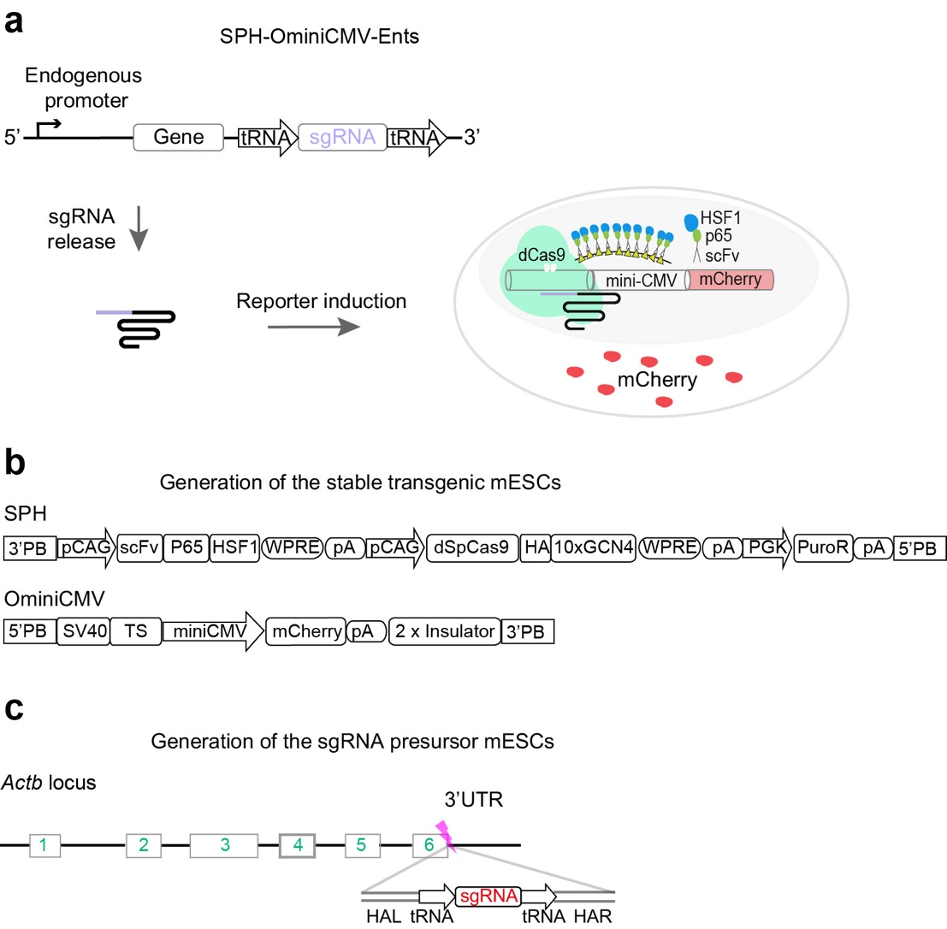
Fig. 1. Design of the SPH-OminiCMV-Ents system. a, Schematic showing detection of endogenous gene expression using SPH-OminiCMV-Ents. The sgRNA is released by the endogenous processing mechanism, and then induce the expression downstream mCherry. b, Vectors to generate SPH-OminiCMV transgenic mESCs. c, Schematic showing insertion of an sgRNA precursor in the 3’UTR of Actb locus.

