Appendix I – 3C library preparation

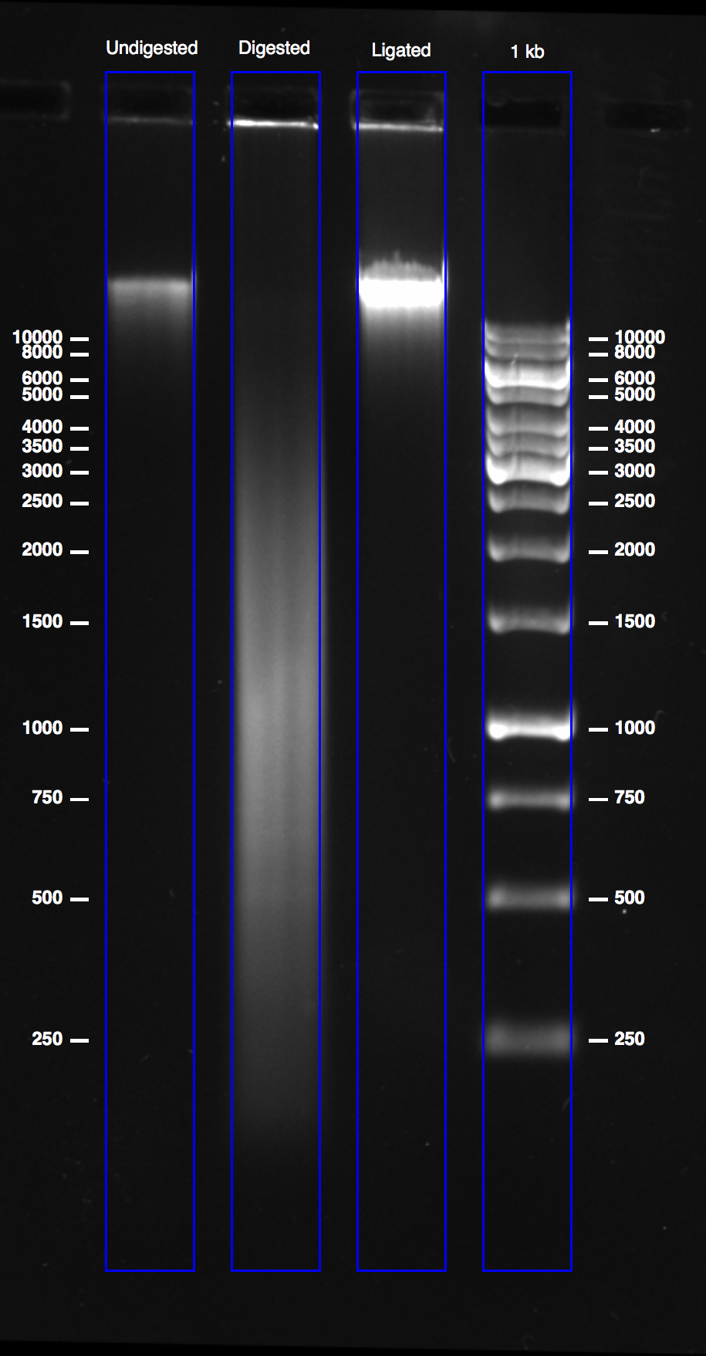

Figure 1. Quality control of 3C libraries. DNA gel electrophoresis (1% agarose gel) of undigested chromatin (Control 1), digested chromatin (Control 2) and the ligated 3C library.

Appendix II – Sonication and addition of Illumina sequencing adaptors

Matching indices

NEBNext Primer Set 1: 1, 2, 3, 4, 5, 6, 7, 8, 9, 10, 11, 12
NEBNext Primer Set 2: 13, 14, 15, 16, 18, 19, 20, 21, 22, 23, 25, 27
Nimblegen HE-Oligo Kit A: 2, 4, 5, 6, 7, 12, 13, 14, 15, 16, 18, 19
Nimblegen HE-Oligo Kit B: 1, 3, 8, 9, 10, 11, 20, 21, 22, 23, 25, 27

Agilent ScreenTape assessments

A Sonication
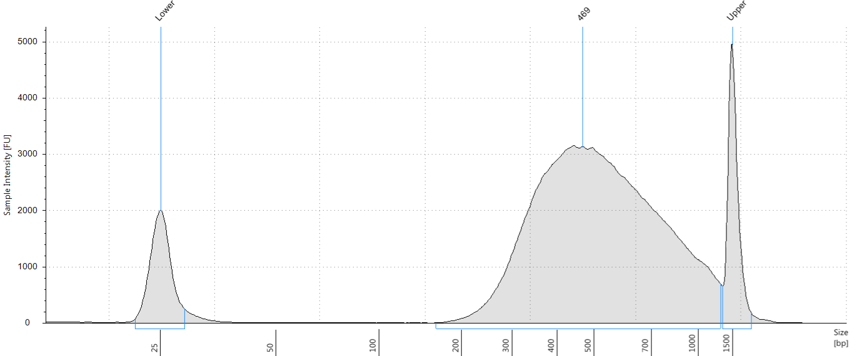
B Adapter ligation
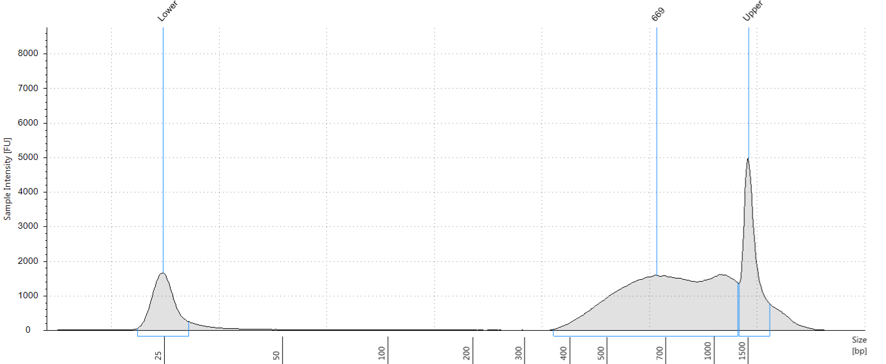
C PCR amplification and indexing
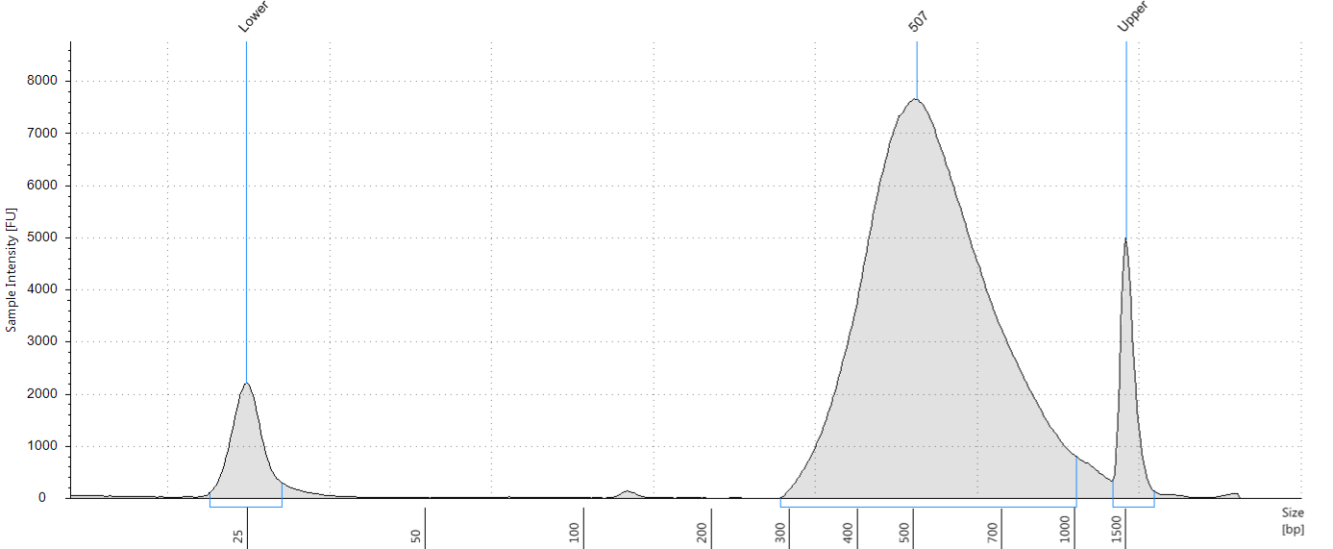

Figure 2. Assessment of processed 3C libraries after (A) sonication, (B) adapter ligation, (C) PCR amplification and indexing using the Agilent Tapestation (D1000).
Appendix III – Capture enrichment

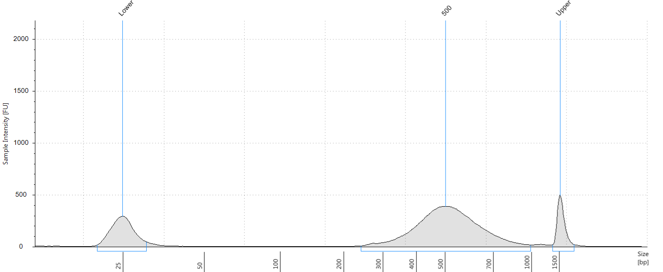

Figure 3. Assessment of Tri-C libraries after capture enrichment using the Agilent Tapestation (D1000).

