IMBA - Institute of Molecular Biotechnology GmbH
Dr. Bohr-Gasse 3
1030 Vienna, Austria
Telephone: + 43-1-79 044-4887
Telefax: + 43-1-79 044-110
E-Mail: office@haplobank.at
www.haplobank.at

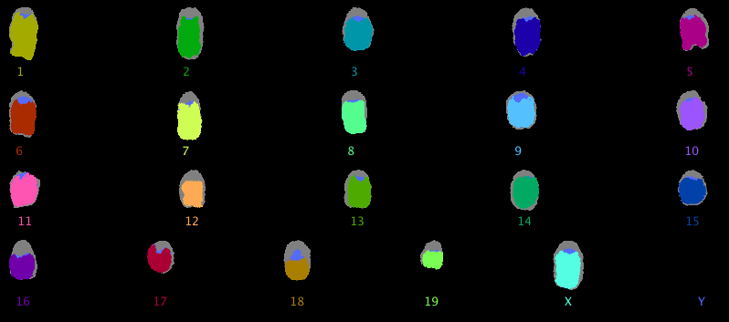

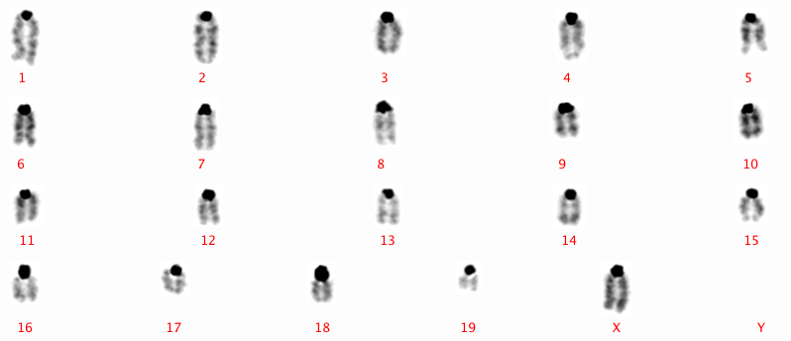

Contents
1. Haplobank – a general overview 2
2. Haplobank Website 3
2.1. How to register 3
2.2. How to order 3
2.3. How to choose a clone 3
3. Shipment 5
4. Payment 5
5. Abbreviations 6
6. Cell culture 7
6.1. Materials and Methods 7
6.2. Media Preparation 8
7. Culture and passaging of AN3-12 haploid ES cells and the derived clones 9
7.1. Thawing 9
7.2. Passaging 9
7.3. Picking of Colonies 10
7.4. Freezing cells into Cryovials 10
7.5. Haploid cells (1n) FACS sorting 11
7.6. Infection of mESC with Lenti- or Retroviral Constructs 12
7.7. Gene trap flipping in pool 13
7.8. Electroporation of mESC 13
8 Differentiation methods 15
8.1 Neural Differentiation 15
8.2 3D Embryoid Body (EB) formation 15
8.2 Angiogenic Differentiation 16
8.2 Keratinocyte Differentiation 16
8.2 Teratoma assays 16
9 PCR methods 17
9.1 Barcode PCR: To Confirm the Identity of Individual Clones 17
9.2 Integration PCR: To Confirm the Genomic Integration Site of Gene Trap Cassettes 17
9.3 Inversion PCR: To Confirm the Inversion of the Splice Acceptor upon Cre/Flp Expression 20
9.4 Inverse PCR: To Map Genomic Integration Sites of Gene Trap Vectors 22

Haplobank – a general overview
Haplobank is a database of haploid mouse embryonal stem cells that contain defined genetic mutations. These cell lines are ideally suited to identify specific target molecules in molecular pathways as well as for analysis of mechanism of action in drug development. As a non-commercial cell bank Haplobank provides these cell lines against a contribution to costs to the academic and industrial research community all around the world. In addition, Haplobank offers to perform screens on haploid mESC libraries to identify genes which are involved for example in the uptake of drugs.
Using optimized mutagenesis systems (Figure 1), we launched Haplobank, a repository of homozygous targeted ES cell lines for functional genomics. In order to perform a high-throughput screen, we streamlined and automated cell culture, DNA preparation, and deep sequencing protocols using a Hamilton robotic platform. The Haplobank team has picked a total of 124,128 clones and processed them for integration site analyses. Our optimized 4D pooling/iPCR/NGS approach allows us to retrieve the information on genomic integration sites in about 81% of clones, which translates to 100,351 fully annotated clones. We hit a combined total of 16,970 genes when we count clones with either single or multiple gene trap insertions (intragenic: Intron, ncExon, 1Intron, 5'UTR, CDS). Taking only those clones, which carry a single gene trap, we hit 11703 unique genes.
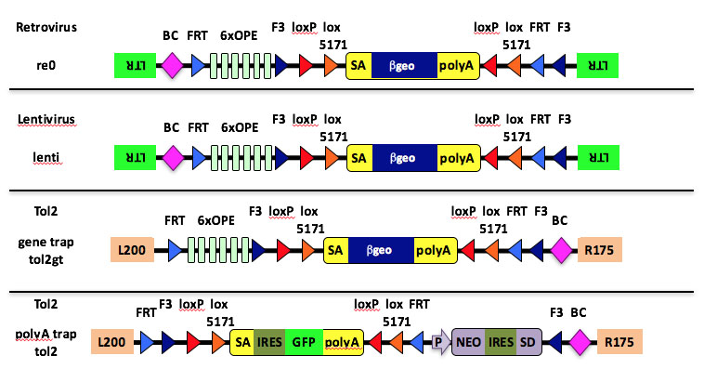
Figure 1. Schematic figure of the different gene traps used for mESC clone generation
LTR: long terminal repeat, BC: barcode, OPE: osteopontin enhancer elements, loxP/lox5171: heterotypic Cre recombinase target sequences, FRT/F3: heterotypic FLPe recombinase target sequences, SA: splice acceptor, βgeo: β-galactosidase/neomycinposphotransferase fusion gene, polyA: polyadenylation sequence, L200: tol2 transposon sequence, R175: tol2 transposon sequence, IRES: internal ribosomal entry site, GFP: green fluorescent protein, P: a constitutive promoter of the mouse RNA polymerase II gene, NEO: neomycin resistance protein, SD: splice donor
Since 2013, the Haplobank team has expanded and distributed over 1,000 clones to researchers from the collection for diverse projects as e.g. cardiomyocyte differentiation or sprouting angiogenesis. Recently, Haplobank did a screen with a big player in the pharmaceutical industry and contributed to a EU funded project focused on viral infection pathways.
These new technologies open the possibility to combine the power of a haploid genome with pluripotency of embryonic stem cells to uncover fundamental developmental and biological processes in defined cell types at the genomic level.
The haploid ES cell library is in part financed and supported by Nestle and Novartis.

Haplobank Website
Please register to setup an account, before you place an order via the Haplobank

How to register
Click ‘Register ‘, fill in the registration form and submit.
You will receive an MTA form by e-mail.

Print, and get it signed by an authorized person.

Scan and return the form to us by email.

Your account will be activated within three working days.

You will receive a confirmation email shortly.

How to order
Log into HAPLOBANK website using your user name & password.
Search for the haploid cell clone and/or gene of interest by entering a gene name, synonym or cell ID
For a more detailed search, use the ’Advanced Search Form.’
To submit your order, click ‘check out’ and provide your credit card information.
You will receive an email confirmation with the invoice attached in PDF format.
Please send us the MTA you received after registration: fill in Annex 1 (Cell ID of the clones you ordered; for wildtype cells use AN3-12 as the Cell ID) and Annex 2 (description of the experiments you want to use the ES cell lines for). It should be signed by a legal representative of your institute. You (or your supervisor) will be the recipient scientist and send a pdf copy to office@haplobank.at. You can review all your ordered haploid cell clones in your Order History.

How to choose a clone
To find a clone that fit your needs you can browse in the haploid library or use the search function and search for a specific gene. It is also possible to click on “Refine Search” and to filter for a specific mutation (Intron, Upstream, etc.), orientation of the genetrap, the mutagen, the RPKM or for PerfectGT.
You will get a list of all possible clones that meet all the relevant requirements. In this list you can see grey and blue shaded lines. The grey shaded lines flag clones which carry more than one genetrap. The clones which carry a single genetrap are flagged in blue.
In this view you can see the most important information which help you to choose the clone that will fit your needs the best.
Gene: the gene where the genetrap is inserted. If you click on the gene name you will be forwarded to the Gene Details of the regarding gene on the MGI website (http://www.informatics.jax.org).
Mutation: Site of mutagen integration: disruptive (1Intron, Intron, 5'UTR, CDS, and ncExon) or non-disruptive (Upstream, InterDown, InterUp). Move the mouse over each feature for detailed information or see FAQs for priorities regarding several assigned features.
- 1Intron: integration in first intron of the annotated transcript
- Intron: one of the introns of the annotated transcript, excluding the first intron (which is annotated as 1Intron)
- 5’UTR: 5’ UTR of the annotated transcript
- CDS: coding sequence of the annotated transcript
- ncExon: non-coding exon of a nc-RNA
- Upstream: region 2000bp upstream of the annotated transcription start site
- InterUp/InterDown: intergenic region upstream/downstream. The upstream and downstream region of a gene is the region between the gene of interest and the neighboring gene, which is not covered by one of the other features.
Relative Orientation: Insertion of the genetrap cassette: sense means disruptive, anti-sense non-disruptive. Genetrap cassettes can be inverted.
Mutagen: System used to mutagenize the cells (Retrovirus, Lentivirus, Tol2).
Genomic Location: concrete location in the genome where the genetrap cassette is integrated. If you click on the genomic location you will be forwarded to the UCSC Genome Browser (http://genome-euro.ucsc.edu) where the location within the transcript is shown.
RPKM: Reads per Kilobase per Million mapped reads: a method to quantify gene expression. RNA sequencing data is normalized for total read length and the number of sequencing reads.
PerfectGT: A yellow star means that the integration site is predicted with high certainty to be disruptive for all RefSeq transcripts of this gene. The splice acceptor is integrated in a genomic locus common to all RefSeq transcripts (intronic and exonic) and before 50% of the longest open reading frame.
Quality Control: The integration sites were identified using three different approaches. Two inverse PCRs using the two different restriction enzymes E1 and a barcode PCR, all followed by NGS. If the mapping strategy was successful, it has a green light.

If you click on the cell ID you get further additional information about this clone.
Synonyms: alternative names for the respective genes
Strand of Integration: the DNA strand where the genetrap was inserted
Barcode: the individual and unique barcode of the integrated genetrap for identification of the clone. The number shows the NGS reads.
Sequence: the mapped sequence where exactly the genetrap cassette is integrated. The location of the genetrap relative to the mapped sequence depends on the mutagen. In Retro and Lentiviral clones the gentrap lies downstream of the mapped sequence, in Tol2 clones upstream. The number shows the NGS reads.
At the bottom of this overview you can see all affected genes in this particular clone, due to the integration of the genetraps. If there is a single genetrap, which is integrated between two genes, it is possible that the genes are both listed there. The genetrap could be located upstream of one and downstream of another gene.

Shipment
In order to ship ES cell lines to you, we require your FedEx or DHL account number, your address and phone number, which you provided during the registration. Please obtain full details of the legal requirements of your country for importing cells (e.g. Veterinary Permit for USA and Australia) and make sure that we have all required documents in place.
Please note, all delivery to China will be shipped via DHL and to Australia will be shipped via the World Courier. For non-EU countries a ‘Shipper’s Declaration’ must be provided and for USA and Canada the ‘TSCA Certification’ also has to be provided.
It usually takes up to 4 weeks for your order to be dispatched. If some of your ordered ES cell clones should become unavailable during this time, you will be notified and will receive a full refund for this part of your order. When your clones are ready for shipment, you will receive an email notification and the clones will be shipped on the following Monday. Haplobank will not take any responsibility of any damage of the ES cell clones due to the shipment.

Payment
We accept payment by Visa or Master Card only.
The credit card information will not be stored by the HAPLOBANK website. Our servers are protected and secured by Secure Sockets Layer (SSL).

Abbreviations
bcPCR | Barcode PCR
CDS | Coding sequence
DMEM | Dulbecco's Modified Eagle's Medium
DMSO | Dimethyl sulfoxide
EB | Embryoid bodies
UTR | Untranslated region
RV | Retrovirus
NSC | Neural Stem Cells
MTA | Material Transfer Agreement
NEAA | Non-essential Amino Acids
NGS | Next Generation Sequencing
mESC | Murine Embryonic Stem Cells
ncExon | Non Coding Exon
EGF | Epidermal growth factor
ESC | Embryonic Stem Cells
ESCM | Embryonic Stem Cell Media
FACS | Fluorescence-activated Cell Sorting
FAQ | Frequently Asked Questions
FCS | Fetal Calf Serum
FGF | Fibroblast Growth Factor
FM | Freezing Media
gDNA | Genomic DNA
GT | Genetrap
HBS | HEPES buffered saline
HEPES | 4-(2-hydroxyethyl)-1-piperazineethanesulfonic acid
intPCR | Integration PCR
invPCR | inversion PCR
LiF | Leukemia inhibitory Factor
mESC | Murine Embryonic Stem Cells
MLP | Major Late Promoter

Cell culture

Materials and Methods
Guideline for culturing haploid cells in different culture vessels:
 | Area | Volume
plate / dish | cm²/well | PBS | Trypsin | ESCM stop | ESCM culture
10cm | 56,7 | 7 ml | 2,5 ml | 4,5 ml | 12,5 ml
15cm | 145 | 15 ml | 6 ml | 9 ml | 25 ml
6W | 9,6 | 1,5 ml | 500 µl | 1 ml | 2 ml
12W | 3,8 | 1 ml | 300 µl | 700 µl | 1 ml
24W | 1,9 | 0,5 ml | 200 µl | 500 µl | 0,5 ml
96W | 0,33 | 50 µl | 20 µl | 50 µl | 200 µl

Reagents, vendors and catalogue numbers
Reagent | Supplier | Catalogue number
DMEM | Sigma | D1152
FCS | Life Technologies or Sigma | tested batch
Penicillin-Streptomycin | Sigma | P0781
MEM Non-Essential Amino Acid Solution | Sigma | M7145
L-Glutamine | Sigma | G7513
Sodium pyruvate | Sigma | S8636
2-Mercaptoethanol | Merck | 805740
ESGRO® Leukemia Inhibitory Factor | Millipore | ESG1107
Dulbecco's phosphate-buffered saline (DPBS) | Life Technologies | 14190
DMSO | Sigma | 41648
10x Trypsin (dilute to 1x with PBS) | Life Technologies | 15400-054
Hoechst33342 | Sigma | B2261
Puromycin | InvivoGen | ant-pr
Blasticidin | Life Technologies | A1113903
Neurobasal medium | Invitrogen | 21103-049
B27 | Life Technologies | 17504-044
N2 | Life Technologies | 17502048
PureCol, Bovine Collagen Solution, Type I | Advanced Biomatrix | #5005
CollagenIV | Corning | 354233
CnT-07 Epidermal Keratinocyte Medium | CELLnTEC | CnT-07
BMP-4 | R&D Systems | 5020-BP

Tissue culture plate/dishes | Supplier | Catalogue number
15 cm cell culture-treated dishes | Cellstar | 639160
10 cm cell culture-treated dishes Nunclon ∆ Surface | Thermo Scientific | 150350
6-well plate Nunclon ∆ Surface | Thermo Scientific | 140675
Corning® Costar® Ultra-Low attachment multiwell plates, 6 well plate | Corning | #3471
PrimeSurface 96U | S-BIO | MS-9096UZ

Media Preparation
ES cell medium (ESCM)
500 ml DMEM
83 ml FCS
6.1 ml Penicillin-Streptomycin
6.1 ml MEM Non-Essential Amino Acid Solution
6.1 ml L-Glutamine
6.1 ml Sodium pyruvate
0.61 ml 2-Mercaptoethanol (1000x stock: dilute 10µl in 2.85 ml PBS)
ESGRO® Leukemia Inhibitory Factor (acc. to instructions by manufacturer)

We routinely run FCS batch testing to select appropriate batch which allows for rapid proliferation and a high rate of colony formation without inducing differentiation of our haploid ES cell lines. We usually test around 3-5 different batches, depending on availability.

1x Freezing medium (FM, 10% DMSO)
5 ml ESCM
4 ml FCS
1 ml DMSO

2x Freezing medium (FM, 20% DMSO)
4 ml FCS
1 ml DMSO

Culture and passaging of AN3-12 haploid ES cells and the derived clones
Always use proper aseptic technique and work in a laminar flow hood.

Thawing
For recovering cells from liquid nitrogen, it is important to thaw cells as quickly as possible to ensure that high proportion of the cells survive after the procedure as illustrated in Figure 3.
- Thaw frozen cells rapidly in a 37°C water bath.
- Transfer the thawed cell suspension slowly into a Falcon tube containing ESCM.
- Centrifuge the cells at 310 x g for 5 minutes.
- Aspirate the supernatant and carefully resuspend the pellet in ESCM.
- Plate thawed cells according to required cell density:
  - Our wildtype AN3-12 are frozen at a high density, plate the cells from a 2D matrix vial into one 10cm dish. The plate will be confluent 24 to 48 hrs post seeding.
  - Plate ESC clones from a 2ml cryovial also into one 10cm dish to have a confluent dish 24 to 48 hrs post seeding.

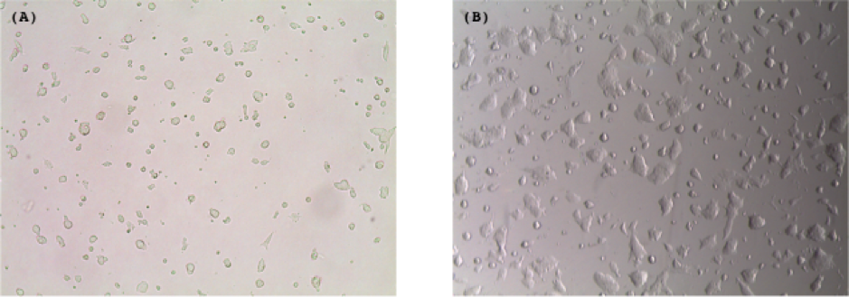
Figure 2. Representative images of wildtype AN3-12 cells, 20 hours post thaw (A), and 70 hours post thaw (B).
If you experience any problems in reviving wildtype cells and clones, respectively, please feel free to contact us by email.

Passaging
We routinely feed AN3-12 cells every day with fresh ESCM and split them before they get too confluent. The split ration can vary. As a rule of thumb, you can use the split ratio 1:3 if you need the cells to be ready the next day (i.e. Mon to Tue), or a split ratio 1:10 if you need them another day later (i.e. Mon to Wed). A ratio of 1:30-1:40 is sufficient to get them over the weekend and feeding them once on Sunday.
- Check the confluency of the cells under a tissue culture microscope to ensure cells are ready for passage
- Aspirate the spent medium from the dish with an aspirator pipette, and wash the dish once with PBS.
- Aspirate PBS and add 1x trypsin solution to the dish containing the cells.
- Incubate the dish for 6 minutes in a 37°C, 5% CO₂ incubator until cells dissociate and start to round up. Gently tap the sides of the culture vessels to detach the majority of the cells from the surface of the culture vessels.
- Add an ESCM to the dish to stop inhibit trypsin reaction. Pipet the cells up and down to dissociate to single cell suspension.
- Transfer the cell suspension into a 15ml Falcon tube and centrifuge the tube at 310 x g for 5 minutes to pellet the cells.
- Aspirate the supernatant and resuspend the pellet with an appropriate amount of ESCM according to the split ratio and the number of dishes required.
- Mix the cell suspension and dispense appropriate volume into the dish and incubate at 37°C, 5% CO₂.
Note: For colonies to form from single cells, it takes about 10 days. When colonies are visible to the naked eye proceed with picking.

Picking of Colonies
- Aspirate off the spend media from 10cm plate and wash with PBS.
- Add PBS to the plate ready for picking colonies.
- Pick a colony from the 10cm plate by sucking up and/or slightly scraping the colonies off of the dish.
- Transfer the 20μl PBS colony suspension into a well of a round bottom 96 well plate.
- Add 5μl of 5x trypsin solution to the 20μl PBS colony suspension.
- Incubate the plate the 96 well plate at 37°C and 5%CO₂ for 6 minutes.
- Check under a microscope to see if individual colonies dissociate to single cells.
- Add 175μl of ESCM to each well to inactivate trypsin and split the colonies according to your needs (i.e. 1:5 in when using a 96F-well plate format, or directly into a 24well plate.

Freezing Cells into Cryovials
- Aspirate spent media and wash with PBS.
- Add trypsin and incubate.
- Check under a microscope to ensure that the colonies have lifted.
- Add an ESCM to the dish to stop inhibit trypsin reaction. Pipet the cells up and down to dissociate to single cell suspension.
- Transfer the cell suspension into a 15ml Falcon tube and centrifuge the tube at 310 x g for 5 minutes to pellet the cells.
- Resuspend cells either in ESCM and subsequently add an equal volume of 2x FM, or alternatively, resuspend the cells directly in 1x FM.
- Mix gently then aliquot into cryovials (CryoTube Vials, Thermo Scientific).
- Put cryovials into a freezing container (e.g. Nalgene Cryo1˚C Freezing Container, Cat. No. 5100-0001).
- Transfer into a -80ºC freezer for 24hrs overnight then transfer to liquid Nitrogen as soon as possible for long term storage.

Haploid Cells (1n) FACS Sorting
Note: Keep in mind that the wildtype AN3-12 cells can become diploid over time (Elling et al. (2011), Cell Stem Cell, 9(6): 563-74). If you require a large number of "pure" haploid ES cells, you can sort the cells by FACS and gate the "1n haploid" peak as shown in Figure 3.

To prepare cells grown on a 15cm dish for FACS sorting,
- Aspirate spent media and wash with PBS.
- Trypsinize the cells with 6 ml of 1x trypsin for 5-6min at 37˚C.
- Add 12ml of ESCM to inhibit trypsin.
- Carefully pipet up and down to make a single cell suspension.
- Add 30μl of Hoechst DNA stain (10mg/ml Hoechst33342 stock).
- Immediately swirl the plate to distribute the dye.
- Add 12ml of ESCM (total volume 30ml).
- Mix the cells and incubate for 30-40min at 37˚C.
- To avoid settling of the cells during staining, occasionally mix the cells by gently swirling the plate.
- After staining, collect and centrifuge at 310 x g for 5 minutes.
- Aspirate the cell pellet in ~500μl of ESCM.
- Pass the cells through the cell-strainer cap of a FACS tube (Falcon 352235).
- Keep the cells on ice until FACS sorting.
- Subject the cells to FACS sorting using a FACS sorter (e.g. BD FACSAriaIII sorter) equipped with a near UV laser.
- Collect the 1n peak (P3) in ESCM (e.g. 8ml of ESCM in a 15ml collection tube). If you intend to purify diploid cells, please gate on 4n (e.g. P6 in the plot below). P4 (2n) represents a mixed population of haploid cells in G2 as well as diploid cells in G1 and is thus not adequate for purification.
- Pellet the cells prior to plating.
- Exchange ESCM after around 8h in order to increase the viability after FACS sorting.

Note: shortly after thawing, i.e. after 1-2 days, the wildtype AN3-12 cells we provide should give you a FACS profile as follows:
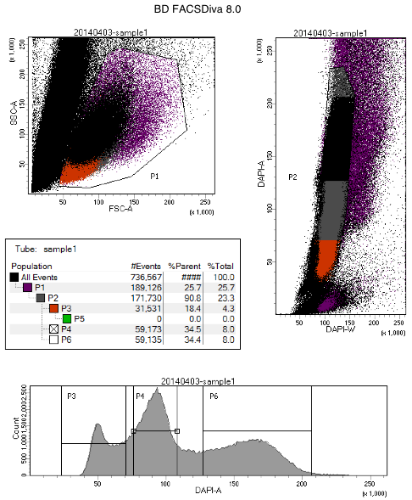
Figure 3. Example for a FACS profile of AN3-12

If you experience any problems FACS sorting wildtype cells, please contact us by email.

Infection of mESC with Lenti- or Retroviral Constructs
Materials & Solutions:
- Lentiviral packaging cells (Lenti-X 293T Cell Line, # 632180, Clonetech Laboratories) or
- Retroviral packaging cells (PlatE, RV-101, Cellbiolabs)
- Lenti- or retroviral constructs
- optional: second plasmid as “negative control”
- LV- or RV-Helper plasmid(s)

Protocol:
- For Lentivirus production follow Clonetech’s User manual, for Retrovirus production follow the protocol on the product data sheet from Cellbiolabs.
- ES cells are propagated by our standard procedures and should be passaged several times prior to infection.
- 3-4h prior to infection seed about 250,000 cells per 6-well or 50,000 cells per 24-well for infection in triplicates.
- Carefully suck off viral supernatant from packaging cells and filter through 0.45µm filter, optional: to increase infection efficiency add to viral supernatant 3mM JQ1 1:60,000 and 8mg/mL Polybrene 1:4,000.
- Distribute viral supernatant on ESCs.
- Change media 8-12h post infection.
- Check infection efficiency by FACS 48h post infection or change to selection medium and select until selection control wells are empty. Note: with Puromycin it takes 3-4 days.

Gene trap flipping in pool
Gene trap cassettes of haploid ES cell clones are integrated either in sense or antisense integration, leading to disruptive or non-disruptive integrations, respectively. As loxP and frt sites flank the gene trap cassette, it is possible to reverse the orientation, e.g. by transiently infecting cells with a Cre/Flp-expressing plasmid. The thereby generated isogenic sister clone can be used as perfect internal control.
The Cre/Flp-expressing plasmid should be linked with a FACS-able color and/or a selection marker (e.g. MLP-mCherry-Cre-puro), to evaluate infection efficiency and/or select for infected cells.

Materials & Solutions:
- packaging cells (see 7.6.)
- Cre/Flp-expressing plasmid with a FACS-able color and/or a selection marker (e.g. MLP-mCherry-Cre-puro)
- optional: second plasmid as “negative control” (e.g. MLP-GFP-puro)
- helper plasmid(s)

Protocol
- Follow the infection protocol above (7.6.).
- Lyse cells and do a gDNA prep.
- Confirm the successful inversion of the gene trap cassette by PCR (please see protocol ‘Inversion PCR’)

Electroporation of mESC
For electroporation we use the Amaxa 4D-Nucleofector X Kit (V4XP-3024, Lonza). Please, also refer to the “Protocol for Mouse Embryonic Stem [ES] Cells” and the device manual.
- Check the confluency of the cells under a tissue culture microscope to ensure that you have enough cells for transfection (3-5 x 10⁶ cells).
- Aspirate the medium from the dish with an aspirator pipette, and wash the dish once with PBS.
- Aspirate PBS and add 1x trypsin solution to the dish containing the cells.
- Incubate the dish for 6 minutes in a 37°C, 5% CO2 incubator until cells dissociate and start to round up. Gently tap the sides of the culture dish to detach the majority of the cells.
- Add ESCM to the dish to stop the trypsin reaction. Pipet the cells up and down to dissociate into single cell suspension.
- Count the cells and transfer 3 - 5 x 10⁶ cells into a 15ml Falcon tube, centrifuge the tube at 310 x g for 5 minutes to pellet the cells.
- Aspirate the supernatant and resuspend the pellet in PBS.
- Centrifuge the tube at 310 x g for 5 minutes to pellet the cells.
- Aspirate the supernatant and centrifuge again at 310 x g for 3 min.
- Aspirate the supernatant to make sure that there is no PBS left in the pellet.
- Resuspend the pellet carefully in room temperature 4D-Nucleofector solution.
- Add required amount of substrates to the sample (max. 10% of final sample volume; max. sample volume of 100 µl). Please have a look in the protocol for detailed amounts.
- Transfer the reaction mix to the Nucleocuvette Vessels.
- Gently tap the Nucleocuvette Vessels to make sure the sample covers the bottom of the cuvette.
- Place Nucleocuvette Vessel with closed lid into the retainer of the 4D-Nucleofector X Unit. Check for proper orientation of the Nucleocuvette Vessel.
- Start Nucleofection Process (see device manual).
- After run completion, carefully remove the Nucleocuvette™ Vessel from the retainer and resuspend cells with 500 µl pre-warmed ESCM.
- Mix cells by gently pipetting up and down and plate the whole sample on a 10 cm dish.
- Change media on the next.
- Start selection or FACS sorting 48hrs post electroporation.

Differentiation methods

Neural Differentiation
(by Kristina Handler)
NSC induction medium:
100 ml Neurobasal medium
100 ml DMEM
2 ml B27 (with Vit. A) (50x)
1 ml N2 (100x)
400 µl 2-Mercaptoethanol (50mM)
2 ml Glutamax
2 ml HEPES
2 ml Penicillin-Streptomycin
2 ml Non-Essential Amino Acid Solution
2 ml Sodium Pyruvate
10 ng/ml FGF (dissolved in DMSO)

NSC expansion medium:
100 ml Neurobasal medium
100 ml DMEM
2 ml B27 (with Vit. A) (50x)
1 ml N2 (100x)
400 µl 2-Mercaptoethanol (50mM)
2 ml Glutamax
2 ml HEPES
2 ml Penicillin-Streptomycin
2 ml Non-Essential Amino Acid Solution
2 ml Sodium Pyruvate
10 ng/ml FGF (dissolved in DMSO)
10 ng/ml EGF (dissolved in DMSO)

FACS sort for diploid cells (NSCs will be more homogeneous) and plate 180.000 cells/well on uncoated 6 well plates in NSC induction medium. Embryoid bodies (EBs) will form and detach. When medium turns orange replace medium every day: EBs will be visible with the eye, so turn the plate so that EBs are on one side on the ground, then remove half of the medium and replace it with fresh neural induction medium. Harvest EBs after 6 days, therefore just take the whole medium with cells from the well and spin it down, then resuspend cells in NSC expansion medium and plate on 0.1% gelatine coated 10cm plate. EBs attach and start growing out NSC like cells, replace medium after EBs attached to get rid of dead cells. After 3-5 days when a lot of cells grew out split 1:5, then split every 3 days (when confluent, sometimes they grow even slower; 1:5 because they need a certain density to proliferate). When splitting incubate with Trypsin only 3 min, then inhibit with ESCM because in the neural medium there is no trypsin inhibitor, then centrifuge and resuspend in new NSC expansion medium.

3D Embryoid Body (EB) Formation
- Trypsinize ES cells and count.
- Seed 9600 cells/well in a PrimeSurface 96U well plate (low attachment plate) in 250μL ESCM without LIF.
- Keep in ESCM without LIF for 14 days with changing medium on day 7. Handle the plate with care in order not to disturb EB formation, especially in the first 3 days. Successful EB generation can be monitored on day 4. EBs can now be used for differentiation and teratoma assays.

Angiogenic Differentiation
- Generate Embryoid bodies (EBs) as described in the “3D Embryoid Body (EB) formation” protocol.
- Incubate EBs with 50 ng/mL VEGF-A (we use some of our in house produced) in ESCM without LIF until vascular differentiation and outgrowth is visible.
- Carefully wash EBs in ESCM without LIF to remove single cells and embed them in 3D Collagen I (PureCol, see “Coating Procedure” in the “Directions for use”-brochure).
- Endothelial tubes can be visualized using anti-CD31 (BD Pharmingen AB9498) or biotinylated GSL Isolectin B4.

We observed the first vascular outgrowth after around 7 days and analyzed capillary like networks 2 weeks after initial embedding of the EBs into the Collagen I matrix.

Keratinocyte Differentiation
- Generate Embryoid bodies (EBs) from 2000 cells as described in the “3D Embryoid Body (EB) formation” protocol.
- After 3 days, transfer 30-50 EBs to an Ultra-Low attachment 6 well plate, stimulated with 1μM retinoic acid.
- Keep EBs in suspended culture for 3 more days.
- Coat 6well dishes with CollagenIV: incubate with 1ml CollagenIV (10μg/ml) for 2hrs at room temperature.
- Transfer EBs onto CollagenIV-coated dishes in ESCM without LIF medium supplemented with 25ng/ml BMP-4.
- After 3 more days, change the medium to CnT-07 keratinocyte medium and culture for 6 more days.
- Enrich for a Keratin14 positive cell population by using the rapid adherence to CollagenIV: plated out trypsinized cells (0.25% Trypsin-EDTA) onto CollagenIV-coated wells and wash off and discard non-adherent cells after 15min incubation at room temperature.
- Passage outgrowing iPSC-keratinocytes for 10 more days in CnT-07 keratinocyte medium and enrich a Keratin14 positive cell population with every passage.

Teratoma assays
- Trypsinze ES cells and wash cells once in PBS.
- Count cells and mix cells at 10⁷ cells/mL in growth factor reduced Matrigel (BD 356231) on ice.
- Inject 100uL (=10⁶ cells) into the flanks of immune compromised mice (keep the cells always on ice) and monitor the teratoma growth on a regular basis.

PCR methods

Barcode PCR: To Confirm the Identity of Individual Clones
Each gene trap vector was initially designed in a way that it contains a unique barcode stretch of 32 bps just downstream of each terminal repeat which can be readily amplified by PCR and Sanger sequenced. The obtained barcode sequence is aligned to the one published for each clone in our collection, thereby confirming the correct identity of the clone at hand. Any deviations from the published barcode sequence are indications that the clone (i) is not the right one, or (ii) carries more than one gene trap.
Barcode PCR primer sequences:
- barcodePCR-F: GGTTGATCTGAGCTACTCATCAACGGT
- barcodePCR-R: CAAGTTCCTTCTGGTTCTGGCTCTGCT

Barcode PCR reaction:
gDNA (crude lysate) 5 µl
primer barcodePCR-F (5 µM) 2 µl
primer barcodePCR-R (5 µM) 2 µl
10 mM dNTP mix 1 µl
10x Klentaq buffer 5 µl
20x Klentaq polymerase 3 µl
dH2O 32 µl
50 µl
Biorad C1000 cycle parameters:
95deg, 3’
95deg, 10” |
58deg, 20” | 35x
72deg, 30” |
72deg, 5’

Analyze 20 µl PCR reaction on an agarose gel, and purify PCR products for Sanger sequencing, e.g. by using illustra ExoStar 1-step kit (GE Healthcare). Use barcodePCR-R primer for Sanger sequencing.

Integration PCR: To Confirm the Genomic Integration Site of Gene Trap Cassettes
An alternative, more direct way to confirm the correct genomic integration site of any haploid ES cell line in our collection is to use the sequence which we initially retrieved by iPCR and used to map the exact genomic location of the mutagen. By obtaining the whole genomic sequence/locus for a particular gene from MGI (http://www.informatics.jax.org) or rather UCSC Genome Browser (http://genome-euro.ucsc.edu), you can design primers* surrounding the "mapped sequence" and integration site, respectively. So the amplicon includes the transition zone between genetrap and the gene where it is integrated (including mapped sequence). Now you can run 4 PCR reactions with gDNA extracted from wildtype/unmodified and mutated ESCs in the following way (Figure 4): by using the primers flanking the potential genomic integration site on wildtype gDNA (wt, black and purple arrows; purple lane in A), you should obtain a single PCR band, confirming that the primers in fact work. Using the same primer pair on gDNA from the respective clone (mut, black and green arrows; green lane in A), you will not obtain a PCR band as the mutagen is too large for PCR amplification. Conversely, under the assumption that the genomic location of the mutagen was mapped correctly, you should obtain a PCR product with a mutagen-specific primer (mut, black and orange arrows; orange lane in A), but not on wt gDNA (wt, black and red arrows; red lane in A). This is graphically summarized below and a typical example shown (A):
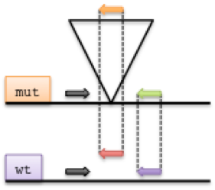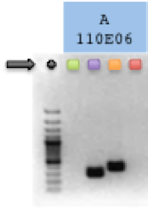
Figure 4. Left: Scheme of the primer location in the PCR reactions, mut: gDNA of the clone, wt: gDNA of wildtype cells; right: example gel-picture of a successful integration PCR.
If you observe any deviation from the expected pattern, (e.g. if you see a PCR product in the green lane, or no PCR product in the orange lane), also compare the results to the bcPCR.
Possible explanations are (i) the retrieved sequence of the INT site was apparently mapped to the wrong chromosomal location, (ii) the clone is a mixed clone, i.e. it contains another clone, which could have been introduced during the production process, or (iii) the clone was initially not targeted homozygously.
Please make sure that you choose the right combination of primers in dependence of the orientation of the mutagen and gene locus, respectively (see Figure 5, preferred primer combinations are marked in red).

Mutagen-specific PCR primer sequences for
- Retro, Lenti, Tol2-GT:
RV-INT-fwd GCCAGAACCAGAAGGAACTTGAC
RV-INT-rev TACAGACGCAGGCGCATAACATC
LV-INT-rev AGAGCTCCTCTGGTTTCCCTTTC
T2-INT-fwd GAGCCAGAACCAGAAGGAACTTG
- Tol2-pA:
T2-INT-rev CCGGGCAATGGATTGATATTGCG
T2-INT-fwd GAGCCAGAACCAGAAGGAACTTG
Integration site-specific PCR primer sequences
Int-F, custom, ~23 bps
Int-R, custom, ~23 bps
designed by Clone Manager 9 Software (Sci-Ed Software)
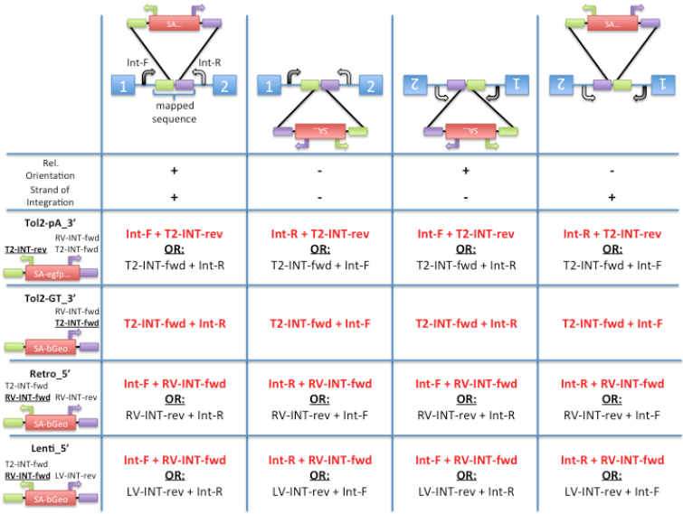
Figure 5. Primer combinations in dependence of gene trap insertion in the integration PCR for the “orange” and “red” reaction for the different mutagenesis systems in dependence of the relative orientation and the strand of integration of the gene trap.

INT-PCR reaction (4 PCR rxns w/ respective primer combinations on gDNA from wt and mut)
gDNA (crude lysate) 5 μl
FWD primer 5 μM 2 μl
REV primer 5 μM 2 μl
10 mM dNTP mix 1 μl
10x Klentaq buffer 5 μl
20x Klentaq polymerase 2 μl
dH2O 33 μl
Total 50 μl

Biorad C1000 cycle parameters
95deg, 3’
95deg, 15” |
58deg, 20” | 35x
72deg, 32” |
72deg, 5’
Analyze 20 ul on an agarose gel according to the scheme from above.
* Please be aware that you have to invert the extracted genomic sequence if the strand of integration for your clone is negative. You can find the “(mapped) sequence” and the information for the strand of integration for each clone on its “cell information”-page. We recommend to design the primers in a way that you get a (wildtype-int) PCR product with a length of 200-500bp. And be aware that the primer sites shouldn’t be or reach into the mapped sequence otherwise you miss the genetrap (depending on mutagen, see FAQs).

Inversion PCR: To Confirm the Inversion of the Splice Acceptor upon Cre/Flp Expression
When inserted into an intron of an expressed gene, the gene traps are transcribed from the respective endogenous promoter of the gene, yielding fusion transcripts in which the upstream exons are spliced to βgeo of the gene trap cassette. Since transcription is terminated prematurely at the inserted polyadenylation site, the processed fusion transcript encodes a truncated and nonfunctional version of the cellular protein plus βgeo. As loxP and frt sites flank the gene trap cassette, it is possible to reverse that KO effect, e.g. by transiently infecting cells w/ a Cre/Flp-expressing plasmid, thereby generating an isogenic sister clone and thus a perfect internal control. If required, that clone can even be reverted a second time with Flp/Cre recombinase due to the presence of frt sites, giving you various possibilities to validate clones. This is schematically summarized in Figure 6:
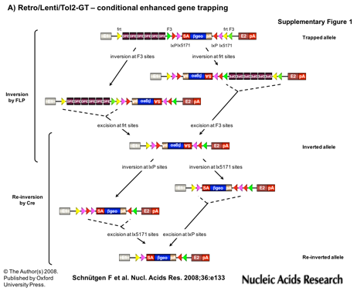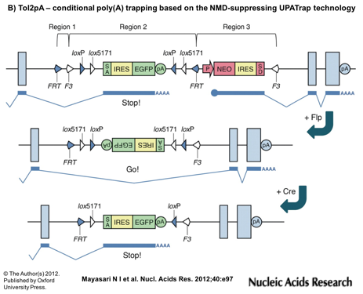
Figure 6. Flipping of genetraps with Flp and/or Cre recombinase.
LTR: long terminal repeat, BC: barcode, OPE: osteopontin enhancer elements, loxP/lox5171: heterotypic Cre recombinase target sequences, FRT/F3: heterotypic FLPe recombinase target sequences, SA: splice acceptor, βgeo: β-galactosidase/neomycinposphotransferase fusion gene, polyA: polyadenylation sequence, L200: tol2 transposon sequence, R175: tol2 transposon sequence, IRES: internal ribosomal entry site, GFP: green fluorescent protein, P: a constitutive promoter of the mouse RNA polymerase II gene, NEO: neomycin resistance protein, SD: splice donor, Flp: Flp recombinase, Cre: Cre recombinase
In order to generate flipped/inverted sister clones, we infect cells w/ a Cre- or FlpO-expressing plasmid linked to a FACS-able color, e.g. EGFP or DsRed (please see protocol ‘Genetrap flipping’). 48hrs post transfection, we FACS-sort cells, collect about 300 green or red cells, and seed those cells onto a 10cm dish. 10-12 days post FACS/seeding, we pick several colonies (24-48 colonies), and subsequently assay them for successful inversion of the splice acceptor as described below, about 4-5 days post picking.
Alternatively, if picking of single cell subclones is not required, a selection marker can be linked to the Cre- or FlpO-expressing plasmid. Transiently transfected cells are then selected until the selection control is empty. Subsequently, assay the crude genomic DNA lysate as described below.
To verify the orientation of the gene trap cassette and thereby the genotype (disruptive/sense to non-disruptive/anti-sense or vice versa), a PCR with three primers is performed on crude ES cell lysates (prepared e.g. from 1x96w). In dependence of the orientation, either a fragment binding the 1st forward primer or the fragment binding the inverse forward primer is amplified.

Mutagenesis System: Lenti, Retro, Tol2GT:
- GT 1st F: TCGACCTCGAGTACCACCACACT
- GT inv F: AAACGACGGGATCCGCCATGTCA
- GT com R: TATCCAGCCCTCACTCCTTCTCT
The expected bands are shown in Figure 7:
- GT 1st F/GT com R: 343bps
- GT inv F/GT com R: 443bps
Expected band if reverted twice (1st Cre, 2nd FlpO):
- GT 1st F/GT com R: 209bps (not shown in picture)
If you turn around the gene trap cassette w/ FlpO first, followed by Cre, length of bands differs slightly (10-25 bps)

Mutagenesis System: Tol2pA:
- Tol2 1st F: TGGGTTCAAGCGATTCTCCTGCCTCA
- Tol2 inv F: AGATAGGCACCCAGGGTGATGCAAGCTC
- Tol2 com R: CCGATCCATCCATCGCATATTTGGGA
The expected bands (w/o and w/ Cre) are shown in Figure 7:
- Tol2 1st F/Tol2 com R: 326bps
- Tol2 inv F/Tol2 com R: 439bps
Expected band if reverted twice (1st CRE, 2nd FlpO):
- Tol2 inv F/Tol2 com R: 453bps
Expected band if reverted twice (1st FlpO, 2nd Cre):
- Tol2 inv F/Tol2 com R: 440bps
Please be aware that if the Tol2pA-construct is flipped w/ FlpO only, the orientation cannot be determined with this PCR (bands are 326bps long in both orientations)!
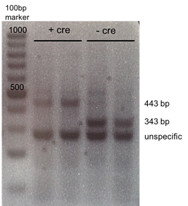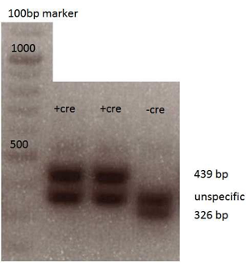
Figure 7. Left: invPCR bands for Lenti, Retro and Tol2GT clones; right: bands for Tol2pA clones
PCR reaction:
gDNA (crude lysate) 5 µl
... 1st F 100 µM 0.1µl
... inv F 100 µM 0.1µl
... com R 100 µM 0.2µl
10 mM dNTP mix 1 µl
10x pol. buffer 5 µl
20x polymerase 3 µl
dH2O 35.6µl
50 µl

Biorad C1000 cycle parameters
95deg, 3’
95deg, 15” |
58deg, 20” | 35x
72deg, 20” |
72deg, 5’

Inverse PCR: To Map Genomic Integration Sites of Gene Trap Vectors
Enzyme1 (E1) is used to fragment the genome. As the recognition sequence for E1 is also present in the terminal repeat of the gene trap vector, it is possible to retrieve the exact integration site of the gene trap cassette within the genome by circularizing E1-digested gDNA (ring ligation) and subsequently amplifying the genomic region by inverse PCR (iPCR) using primers “US” and “DS” (Figure 9 and Figure 10). To improve iPCR efficiency, a linearization step using E2 was introduced, which re-opens the rings generated previously. Moreover, each integration site can be mapped by using two different enzymes E1. We would recommend you to split your samples and use both enzymes E1 on each sample in parallel.
Please keep in mind the "directionality" of the mapping strategies for different mutagens, as this affects the assignment of a particular mutation to the sense and anti-sense strand in the genome, respectively.

Mapping - 5’ strategy (Lenti, Retro):
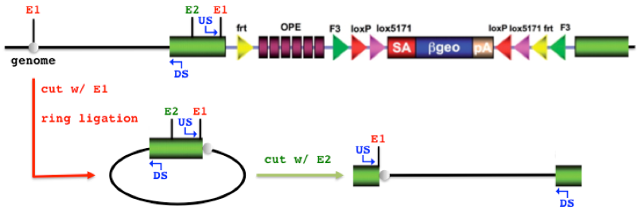
Figure 8. Schematic process of the digestions steps prior the iPCR for clones harboring a Lenti- or Retroviral gene trap. (picture modified from the German Gene Trap Consortium
http://genetrap.helmholtz-muenchen.de/ggtc/info/protocols/vectors.php)

Mapping - 3’ strategy (Tol2-GT, Tol2-pA):
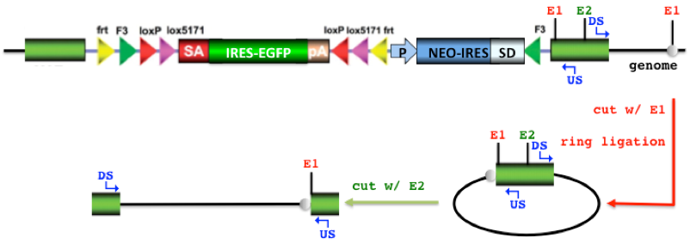
Figure 9. Schematic process of the digestions steps prior the iPCR for clones harboring a Tol2 gene trap. (picture modified from the German Gene Trap Consortium
http://genetrap.helmholtz-muenchen.de/ggtc/info/protocols/vectors.php)
- Mutagenesis systems
Enzyme1 (E1) Enzyme2 (E2) Mapping Strategy
- Lenti NlaIII, TaqI PacI 5'
- Retro NlaIII, MseI SbfI 5'
- Tol2-GT NlaIII, TaqI PacI 3'
- Tol2-pA NlaIII, TaqI PacI 3'
MseI | New England Biolabs | R0525L
NlaIII | New England Biolabs | R0125L
TaqαI | New England Biolabs | R0149L
T4 DNA ligase | Roche Applied Science | 10716359001
SbfI | New England Biolabs | R0642L
PacI | New England Biolabs | R0547L

- Universal iPCR primer sequences
DS: GAGCCAGAACCAGAAGGAACTTGAC
US: GTGACTGGAGTTCAGACGTGTGCTCTTC

Reagents and Buffers:
gDNA purification kit (Isopropanol, 70% Ethanol)
Picogreen, Invitrogen
Restriction enzymes and buffers (see table above)
PCR kit (polymerase and buffer)
QIAquick PCR Purification Kit (Qiagen) or Sera Mag Speedbeads (Thermo, 45152105080350) & Binding Buffer
illustra ExoProStar 1-Step Kit (GE)

Protocol:
Purify gDNA from cells.
Digest samples with enzymes E1 in parallel (per sample two separate reactions!):
gDNA 100ng/µl 10 µl
10x CutSmart 8 µl
Enzyme1 3 µl
dH2O 59 µl
80 µl
incubate at 37˚C or 65˚C (TaqI) over night
Purify restriction digests (Qiagen PCR kit or Mag Speedbeads), elute in 50µl in total.
Ring ligation:
E1-gDNA 50 µl
10x Ligase Buffer 30 µl
T4 DNA Ligase 2 µl
dH2O 218 µl
300 µl
incubate at 16˚C, over night
Heat-inactivate T4 DNA Ligase at 65˚C for 15min.
Linearize samples with enzyme E2 at 37˚C for 2h:
RL-E1-gDNA 300 µl
Enzyme2 1 µl
Purify restriction digest (Qiagen PCR kit or Mag Speedbeads), elute in 50µl in total.
iPCR reaction:
E2-RL-E1-gDNA from 6. 10 µl
primer US 100 uM 0.1 µl
primer DS 100 uM 0.1 µl
10 mM dNTP mix 1 µl
10x pol. buffer 5 µl
20x polymerase 3 µl
dH2O 30.8µl
50 µl
Biorad C1000 cycle parameters
95deg, 3’
95deg, 15” |
61deg, 25” | 37x
72deg, 75” |
72deg, 5’
Analyze 20µl on an agarose gel, purify PCR products using the QIAquick kit or the ExoStar kit and use them for Sanger Sequencing.

