Supplement
IDH1 Mutation
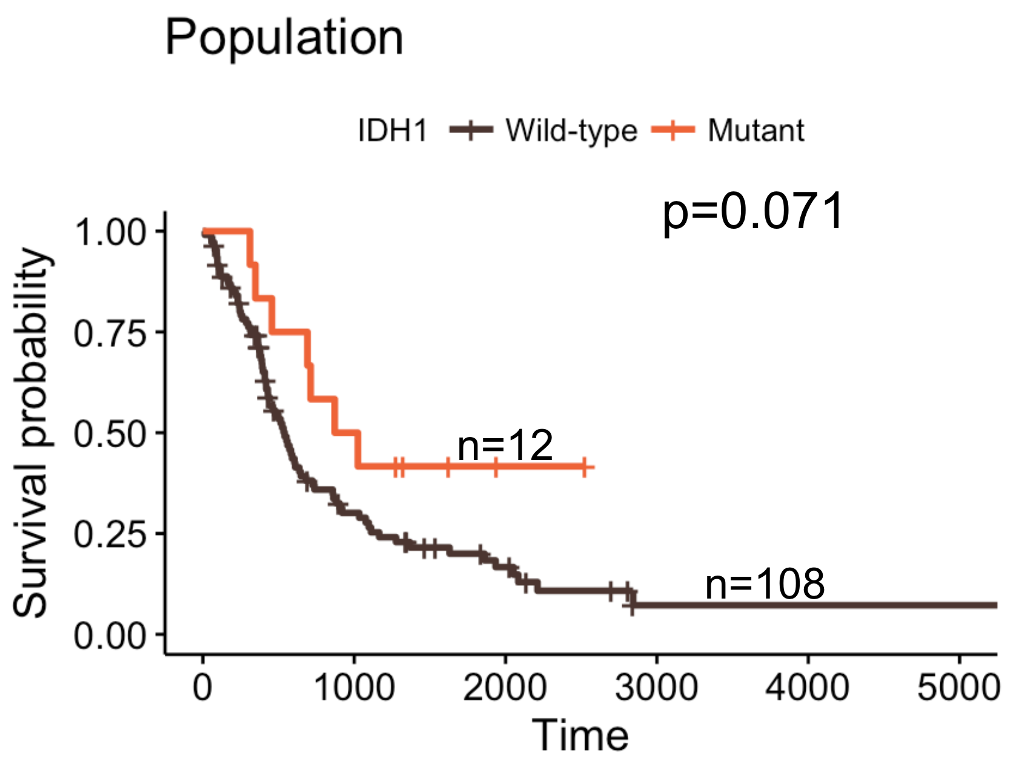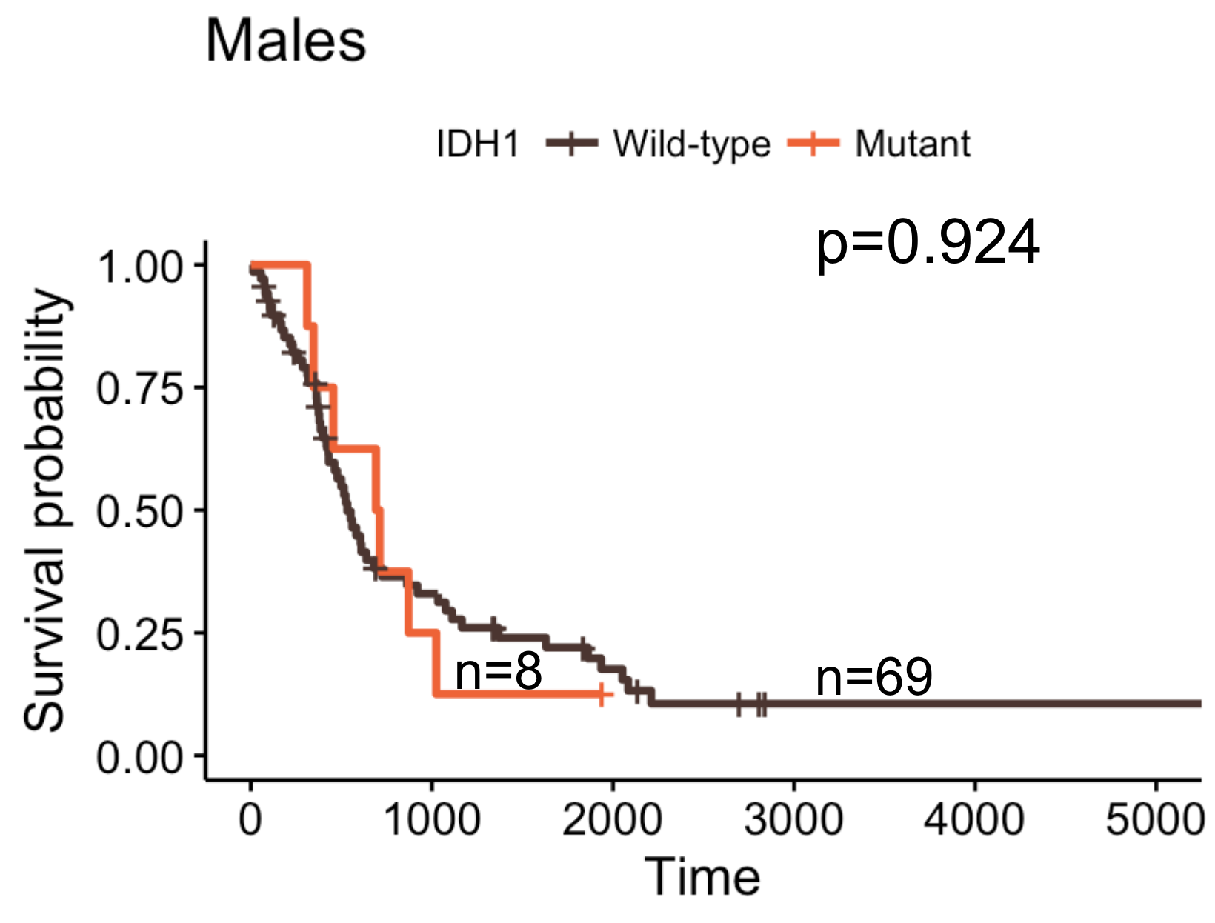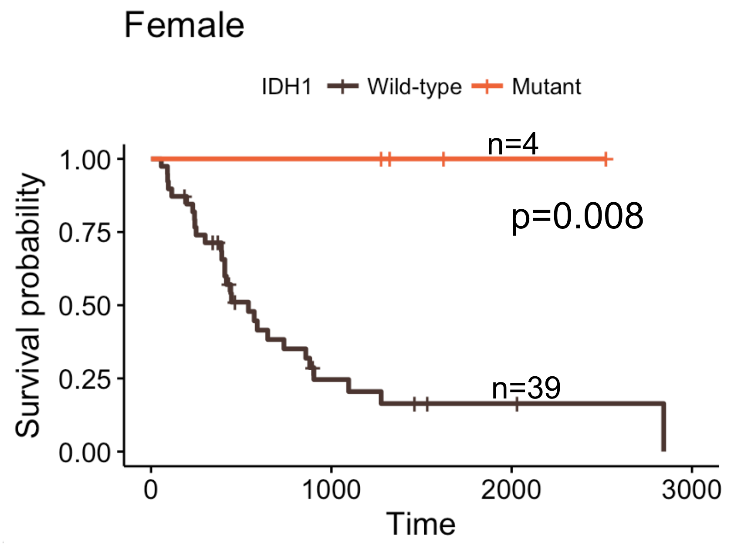
Supplement 1. IDH1 mutation only significantly stratifies survival among females.

 | HR | 95% CI | p-value
Age | 1.024 | 1.005-1.044 | 0.015
Supplement 2. Univariate CPH analysis of 108 IDH1 wild-type patients shows that age is a significant predictor of survival

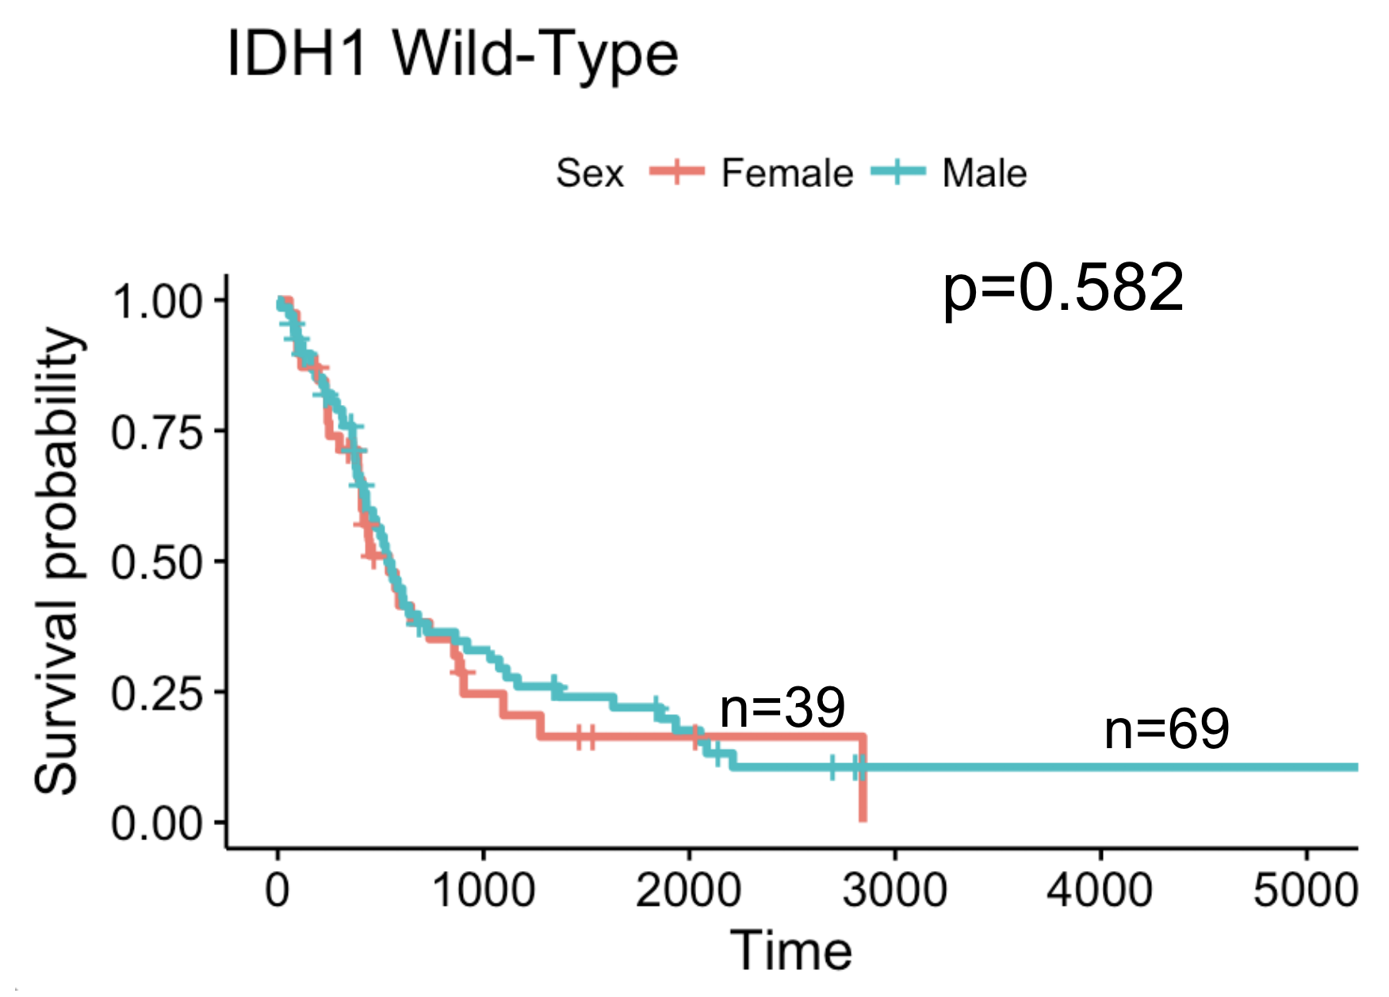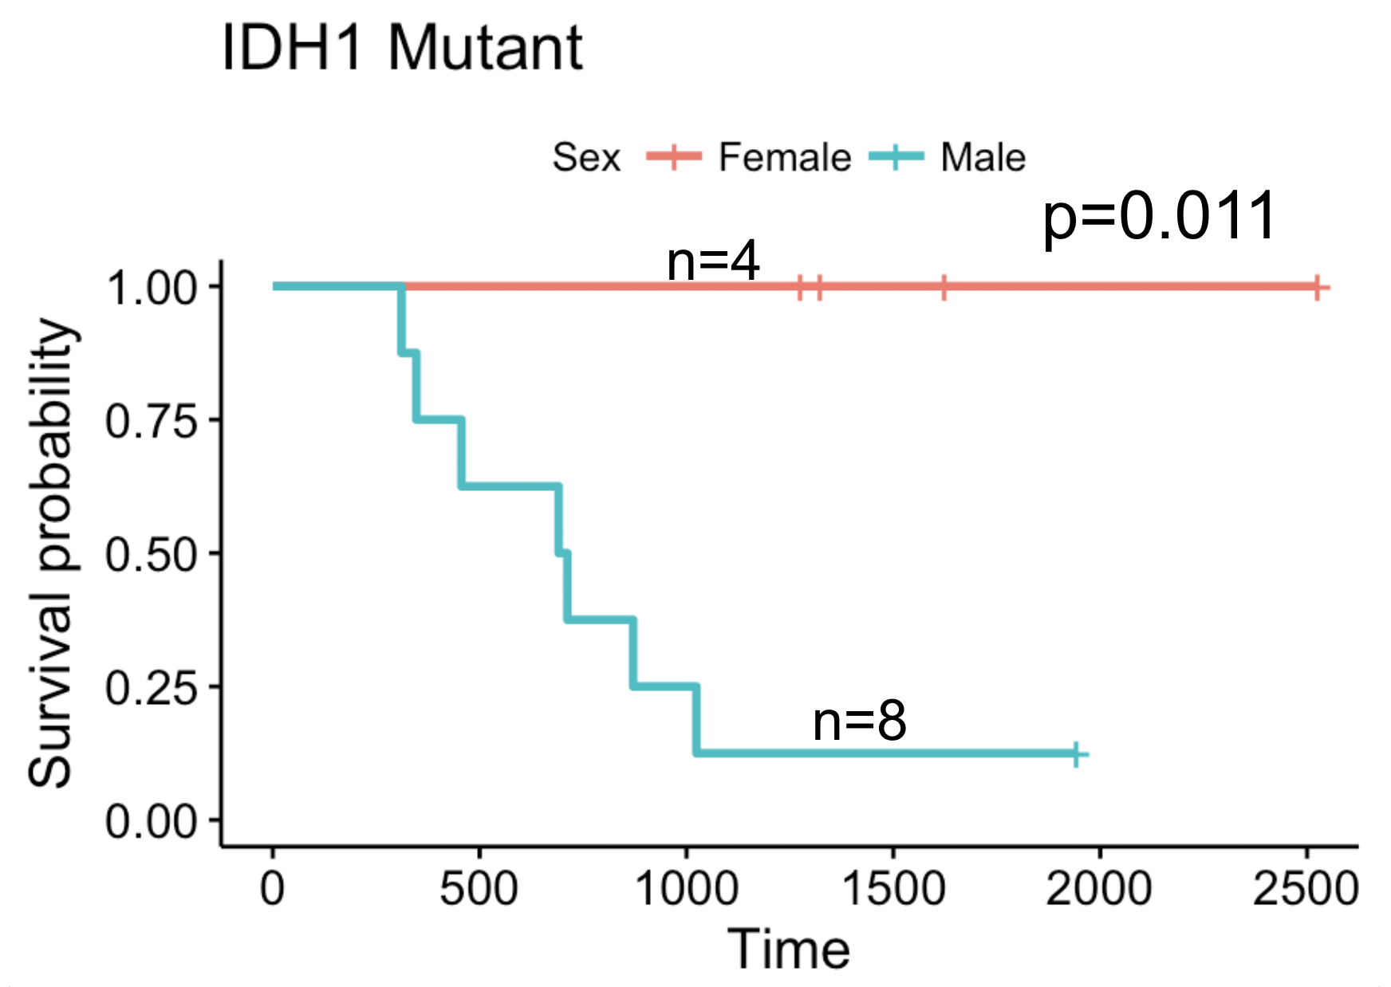
Supplement 3. IDH1 mutant females had significantly better survival than IDH1 mutant males.

MGMT Methylation
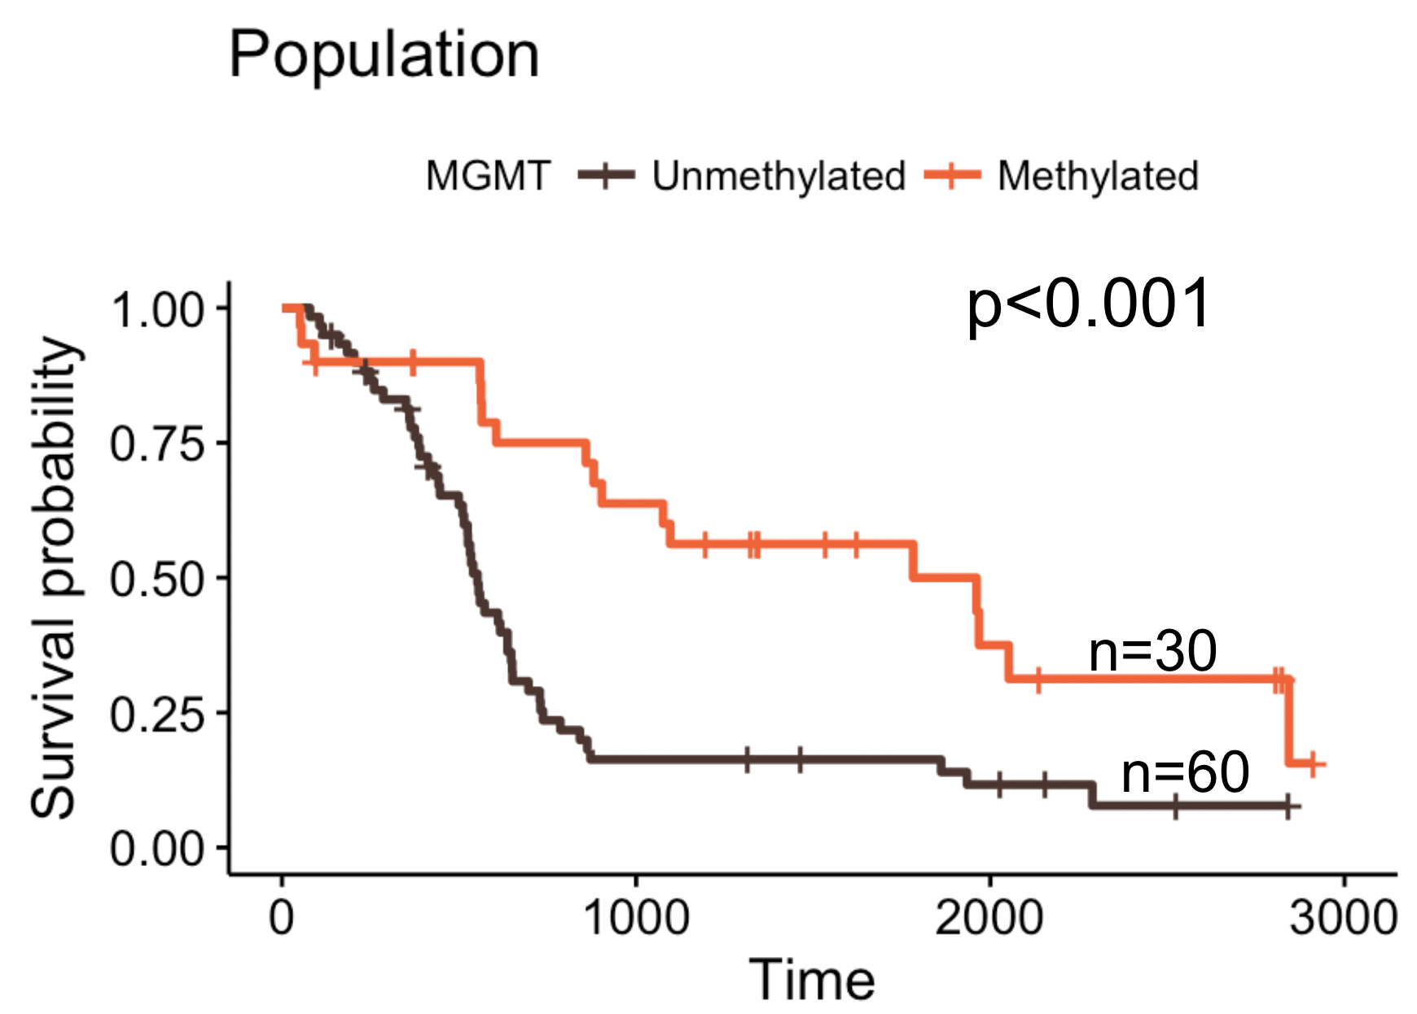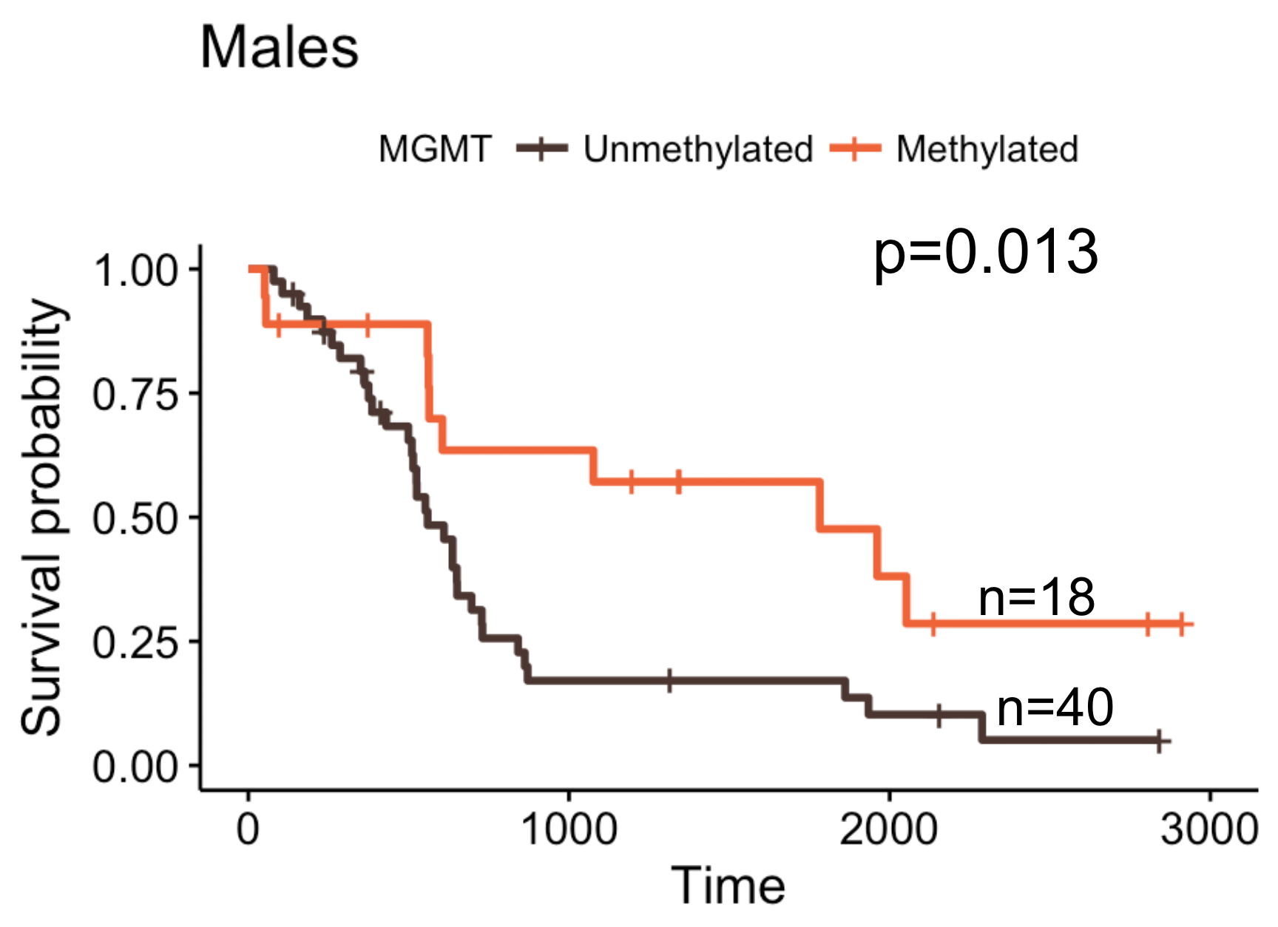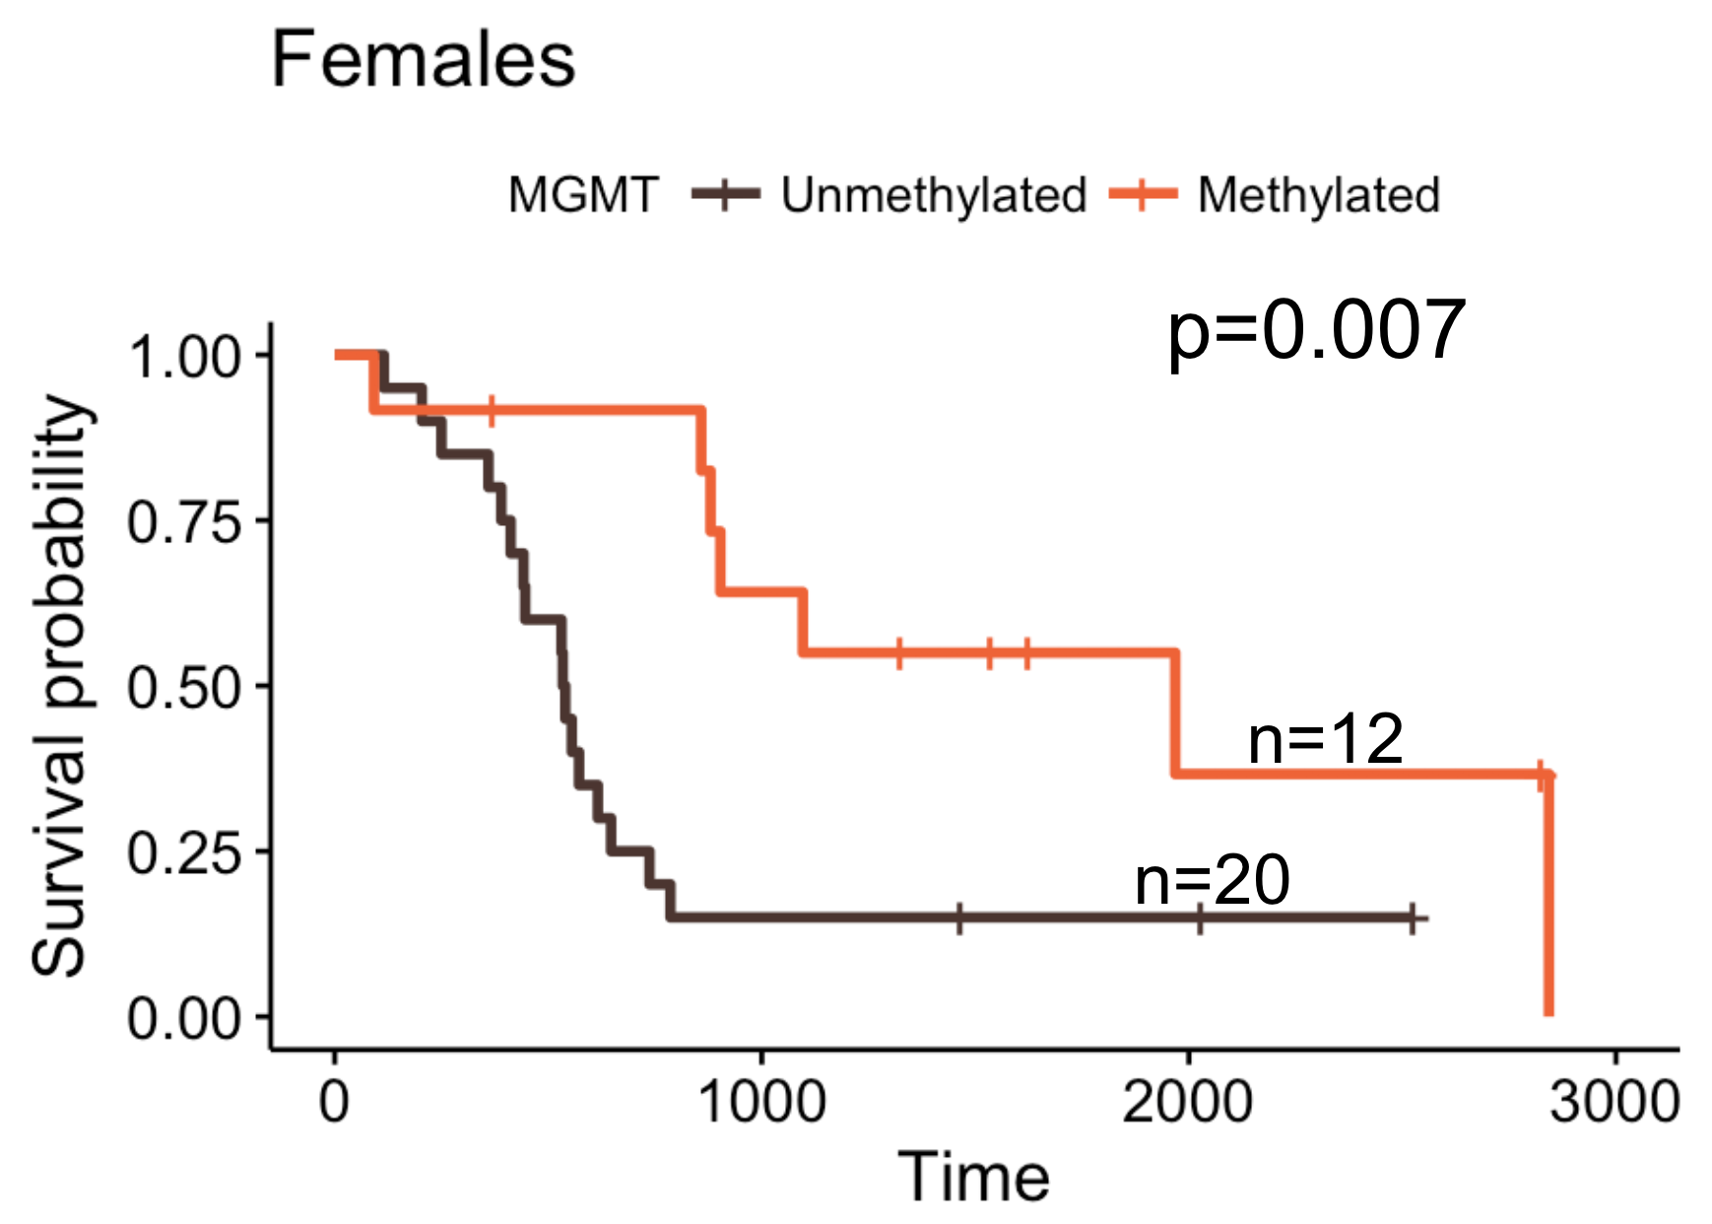
Supplement 4. Patients with MGMT methylation have significantly better survival than those with unmethylated MGMT.

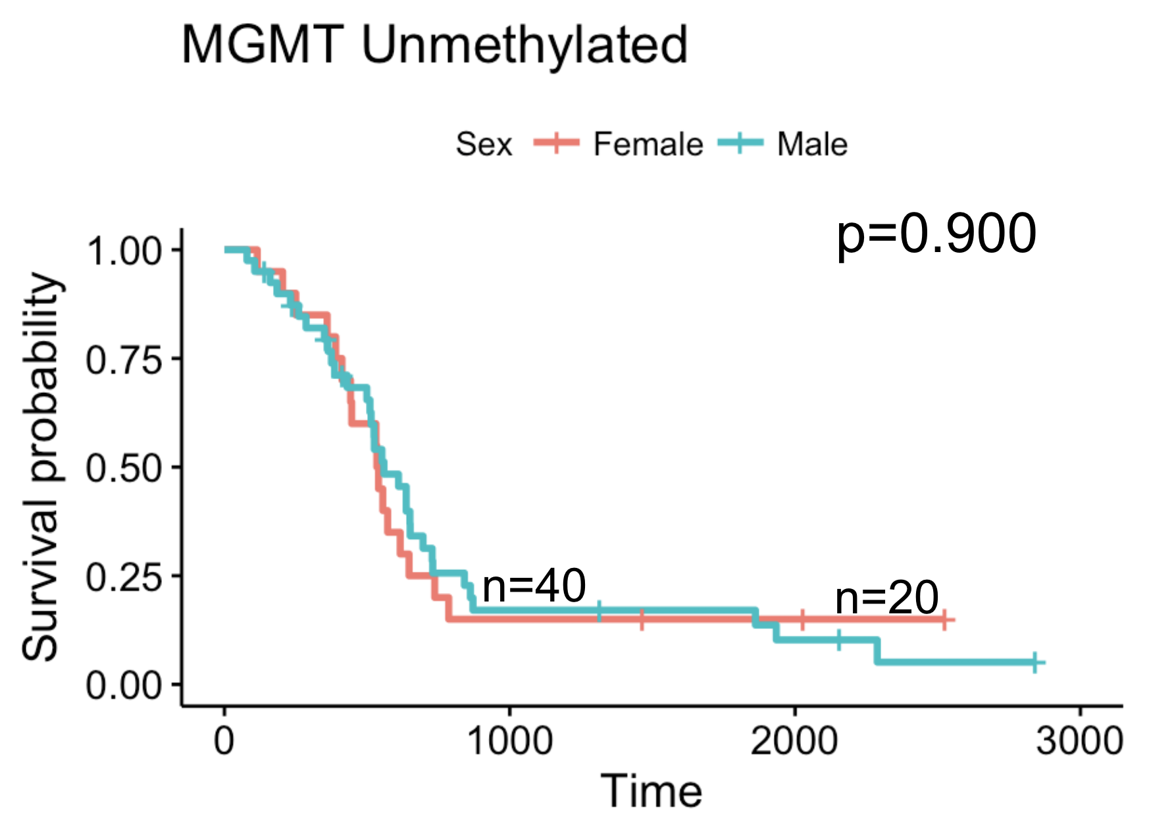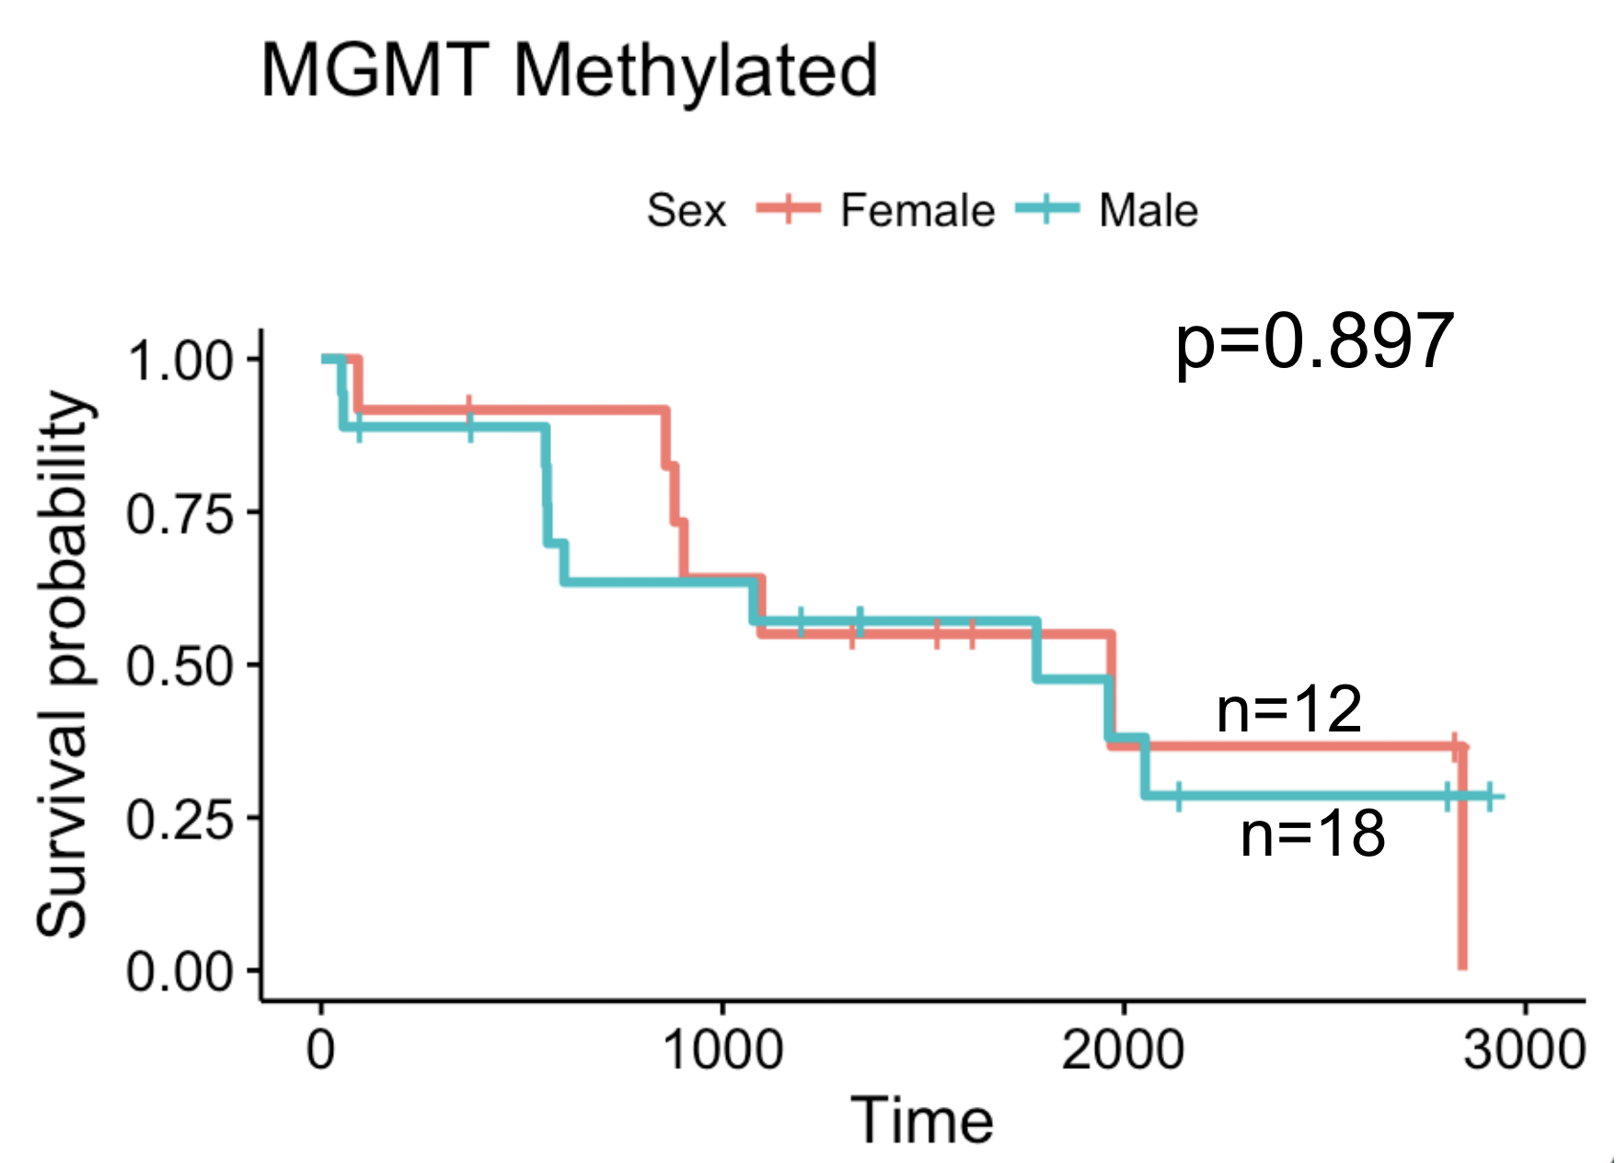
Supplement 5. No difference in survival between males and females among MGMT methylated and unmethylated patients.

Laterality
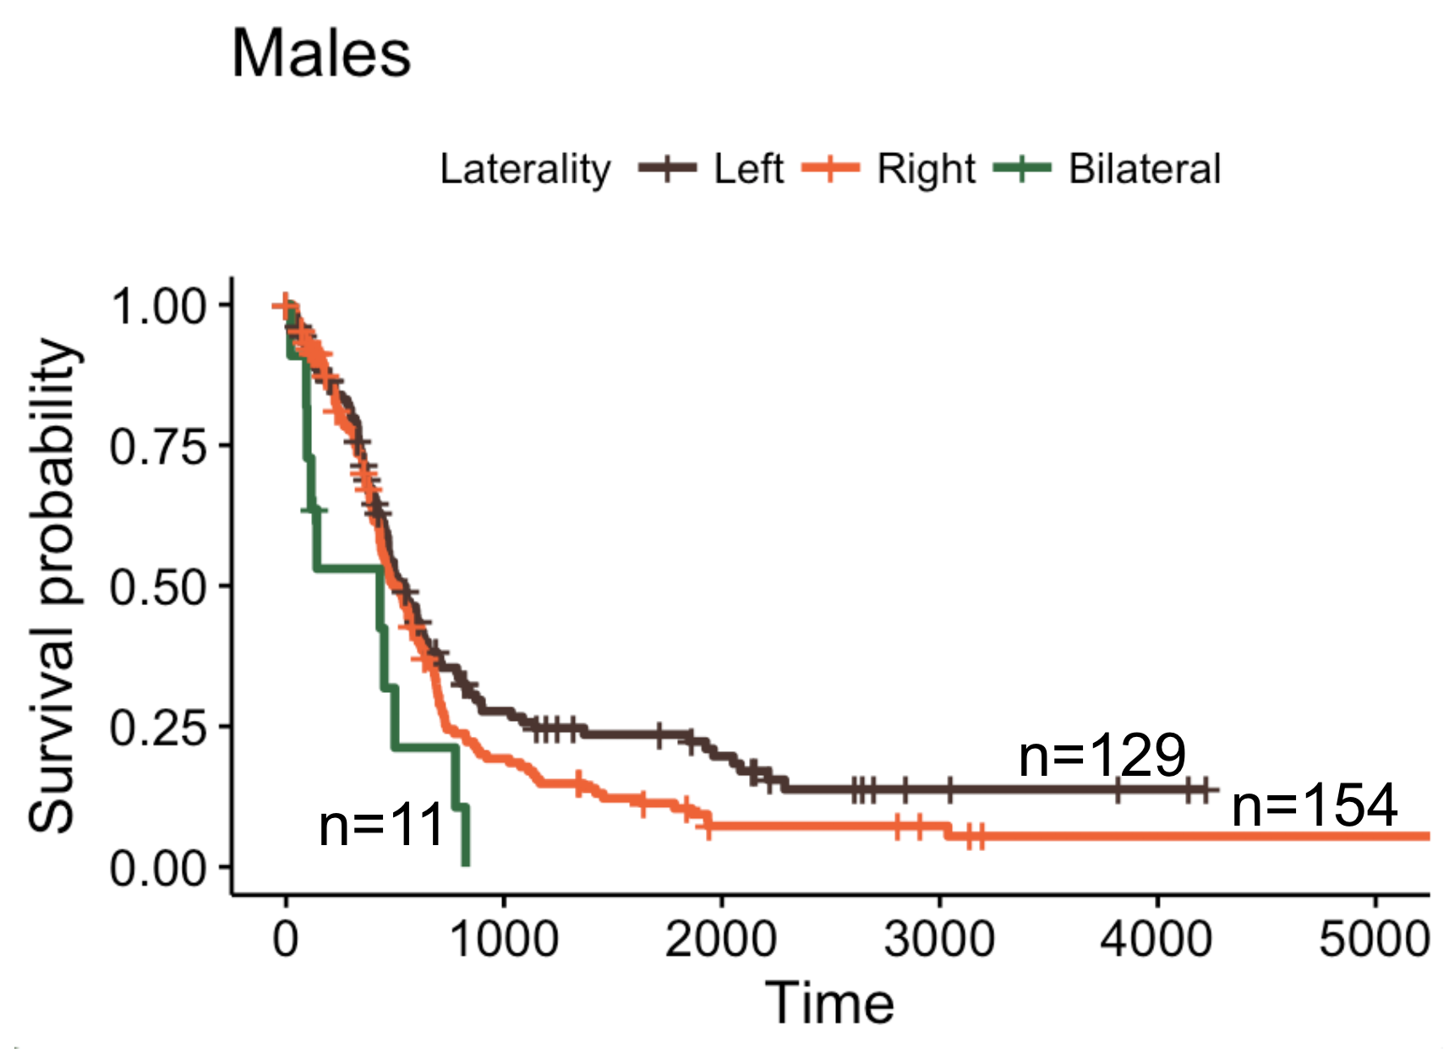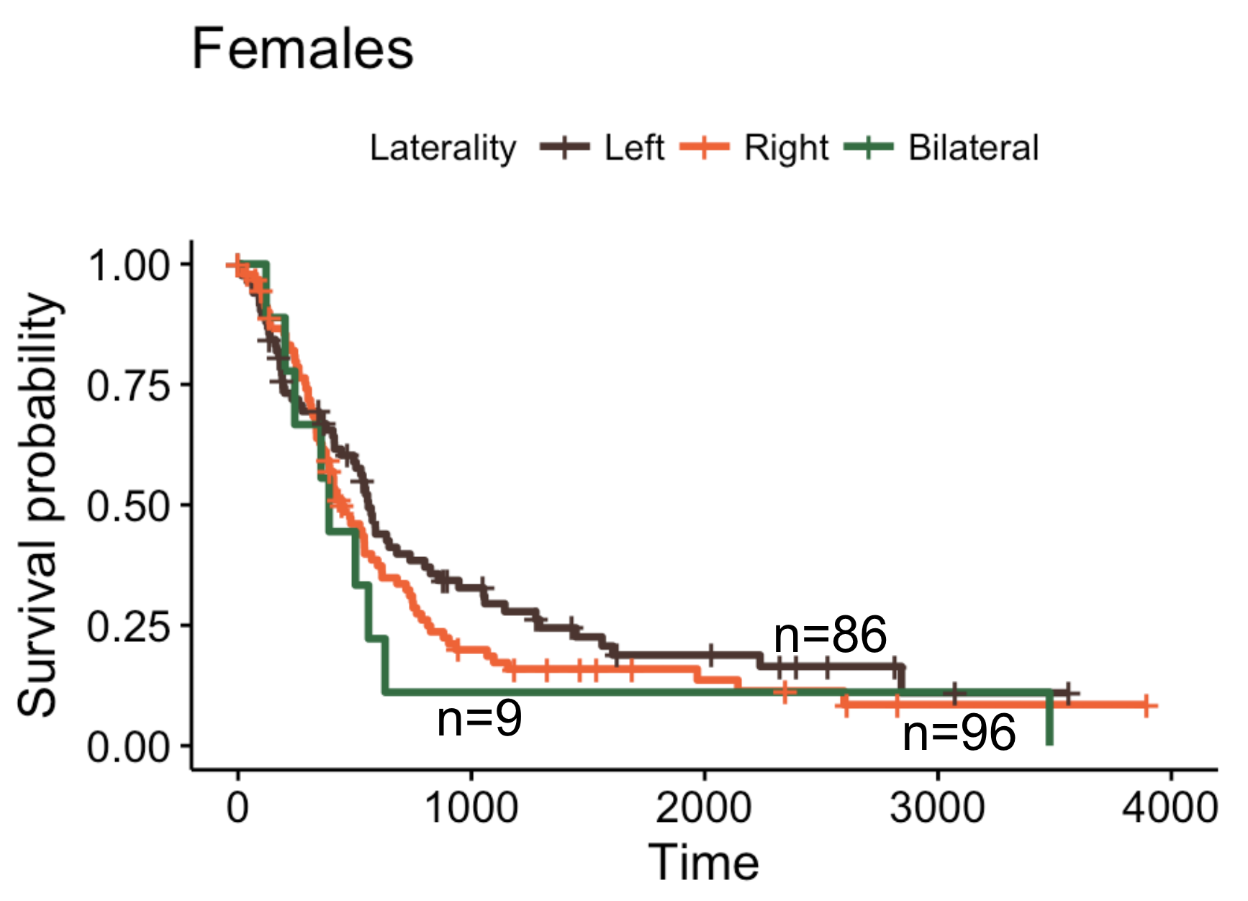
Supplement 6. Males with tumors in the left hemisphere trended towards significantly better survival than males with tumors in the right hemisphere (p=0.077) and had significantly better overall survival than males with bilateral tumors (p=0.010). There was no significant difference in female survival when comparing patients with left hemisphere, right hemispheres, and bilateral tumors (right vs left p=0.218, right vs bilateral p=0.471, left vs bilateral p=0.272).

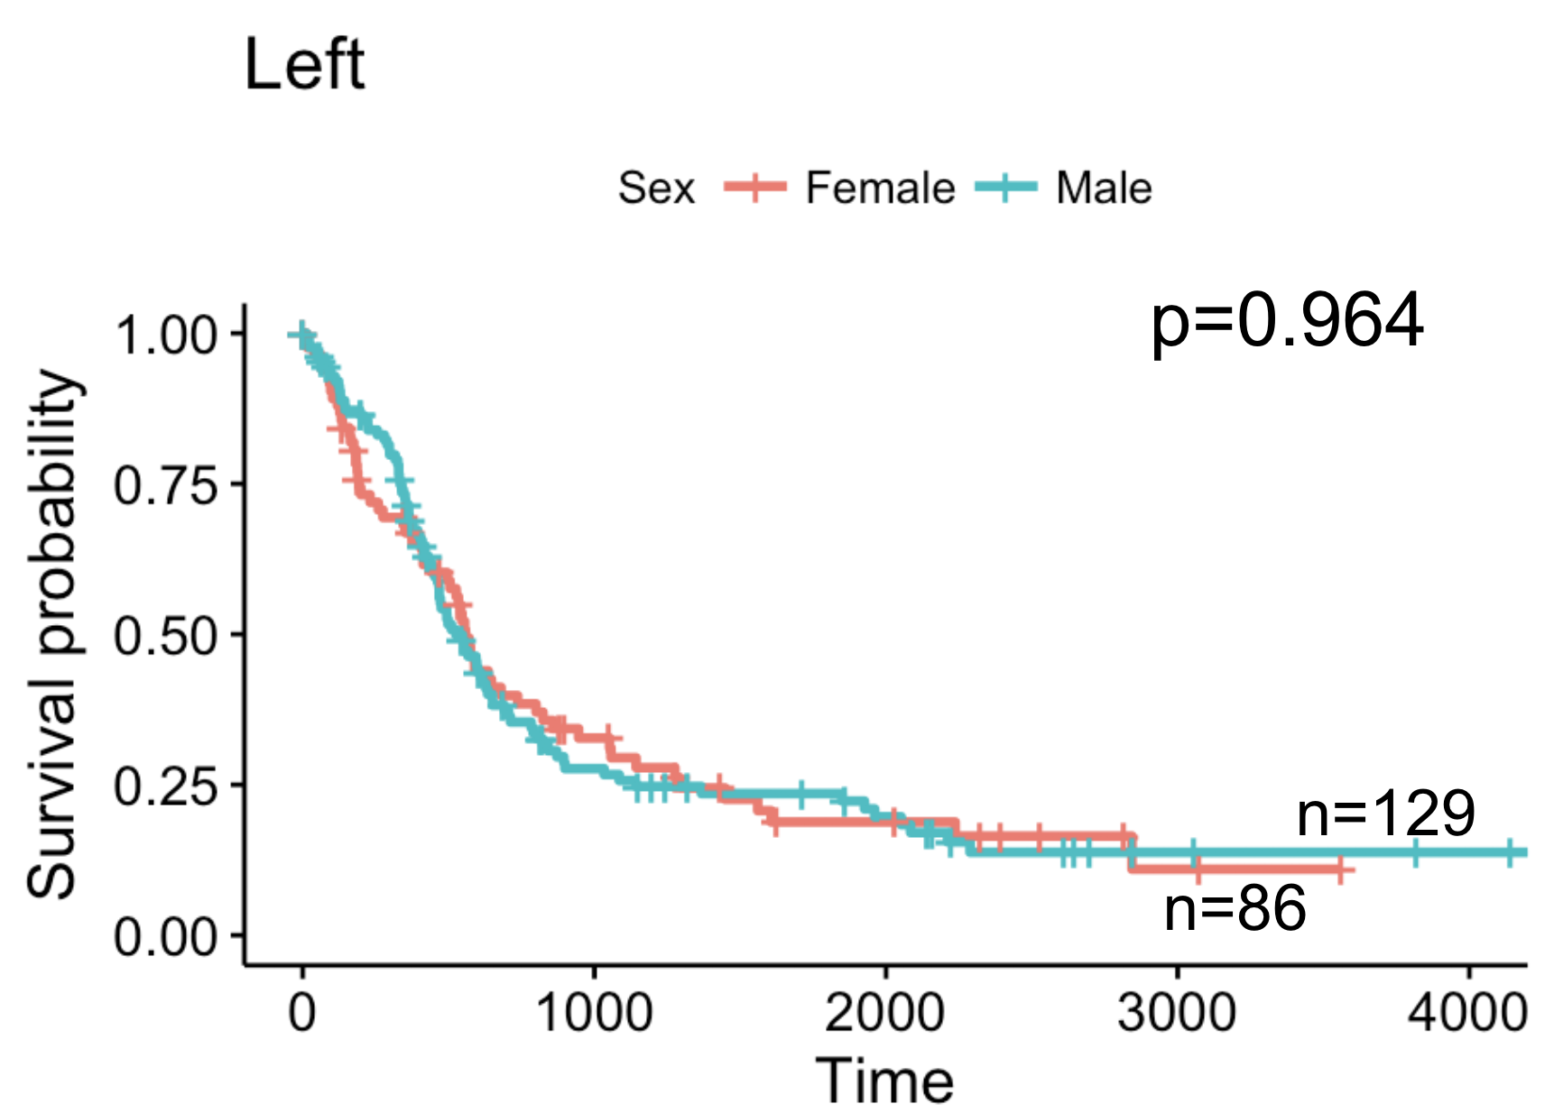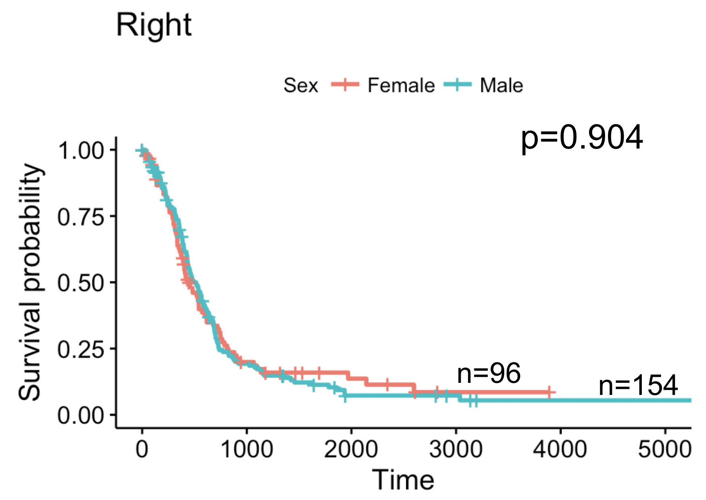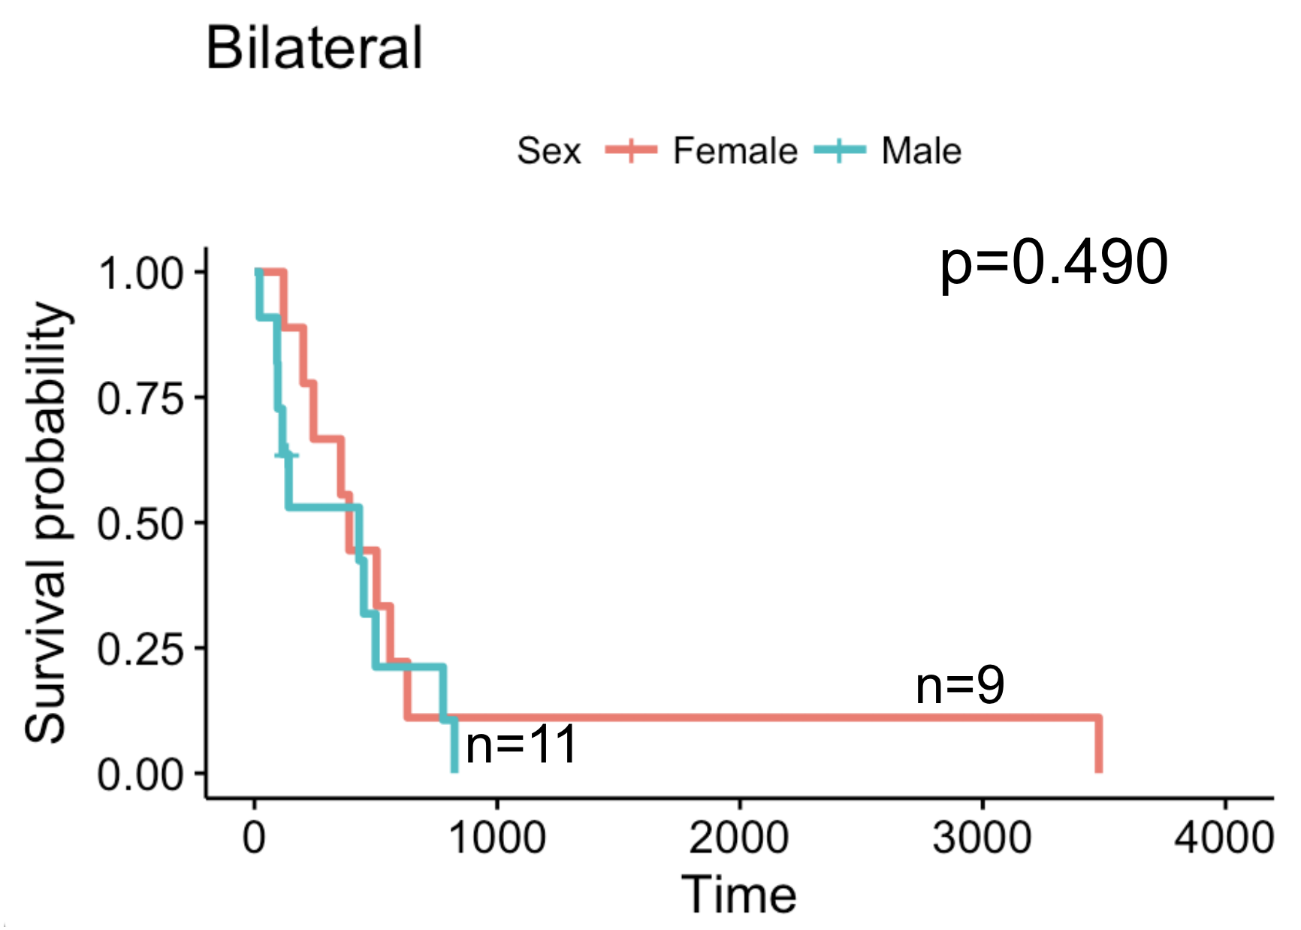
Supplement 7. No difference in survival between males and females among left, right, and bilaterally located tumors.

Extent of Resection
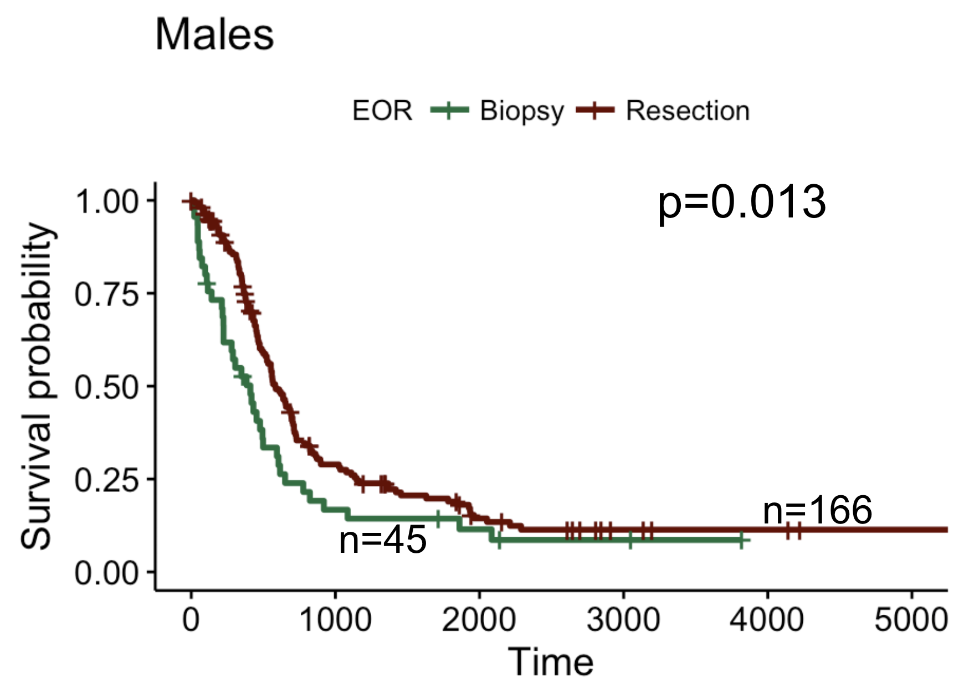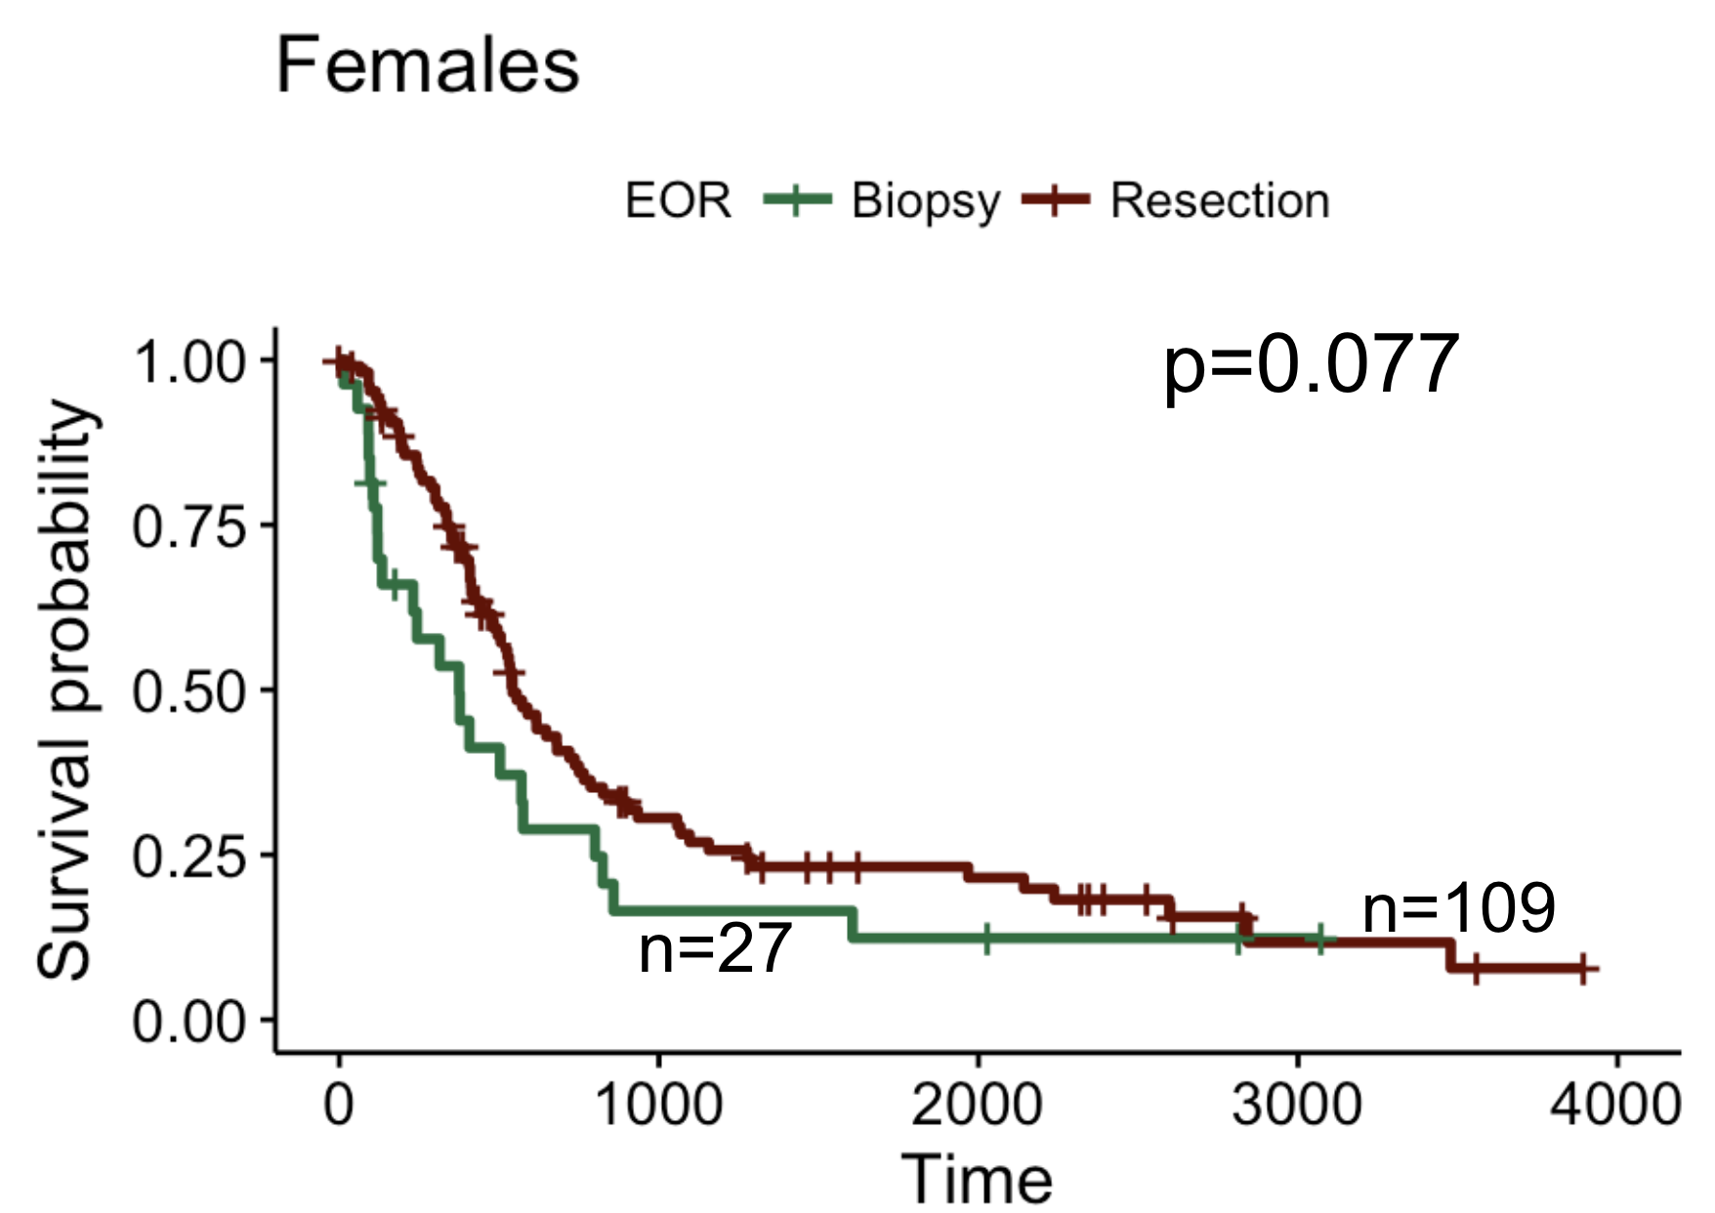
Supplement 8. Both males and females showed improved survival when they received some resection (GTR or STR) compared to just receiving a biopsy.
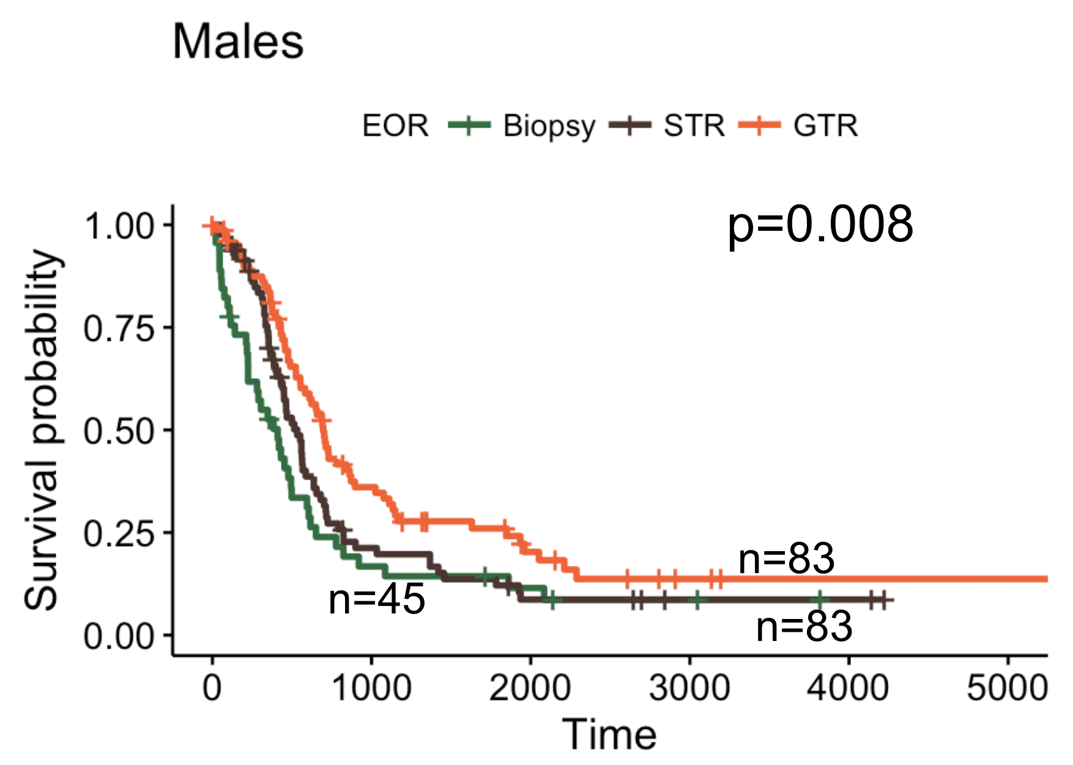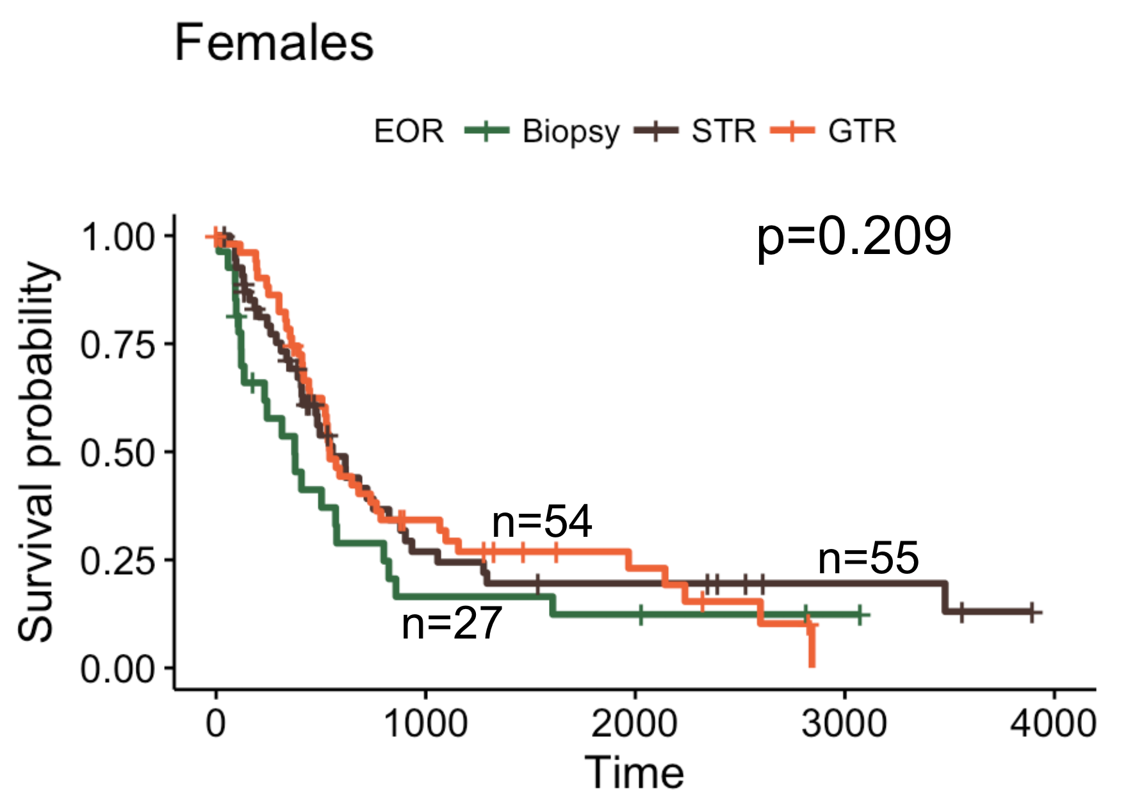
Supplement 9. Males have a significant trend of improved survival when patients who received the three kinds of resection (biopsy, STR, and GTR) are compared. This trend is not significant among females. Males who received GTR had significantly better survival than males who received STR (p=0.013). This comparison was not significant among females (p=0.992).

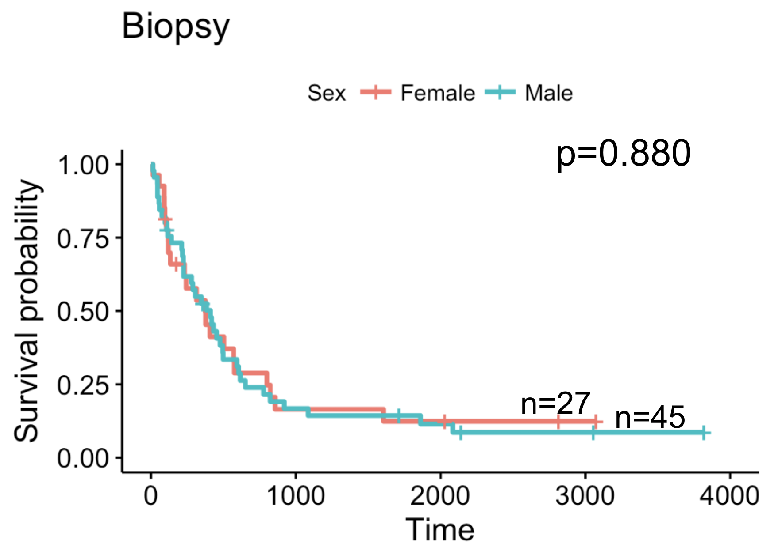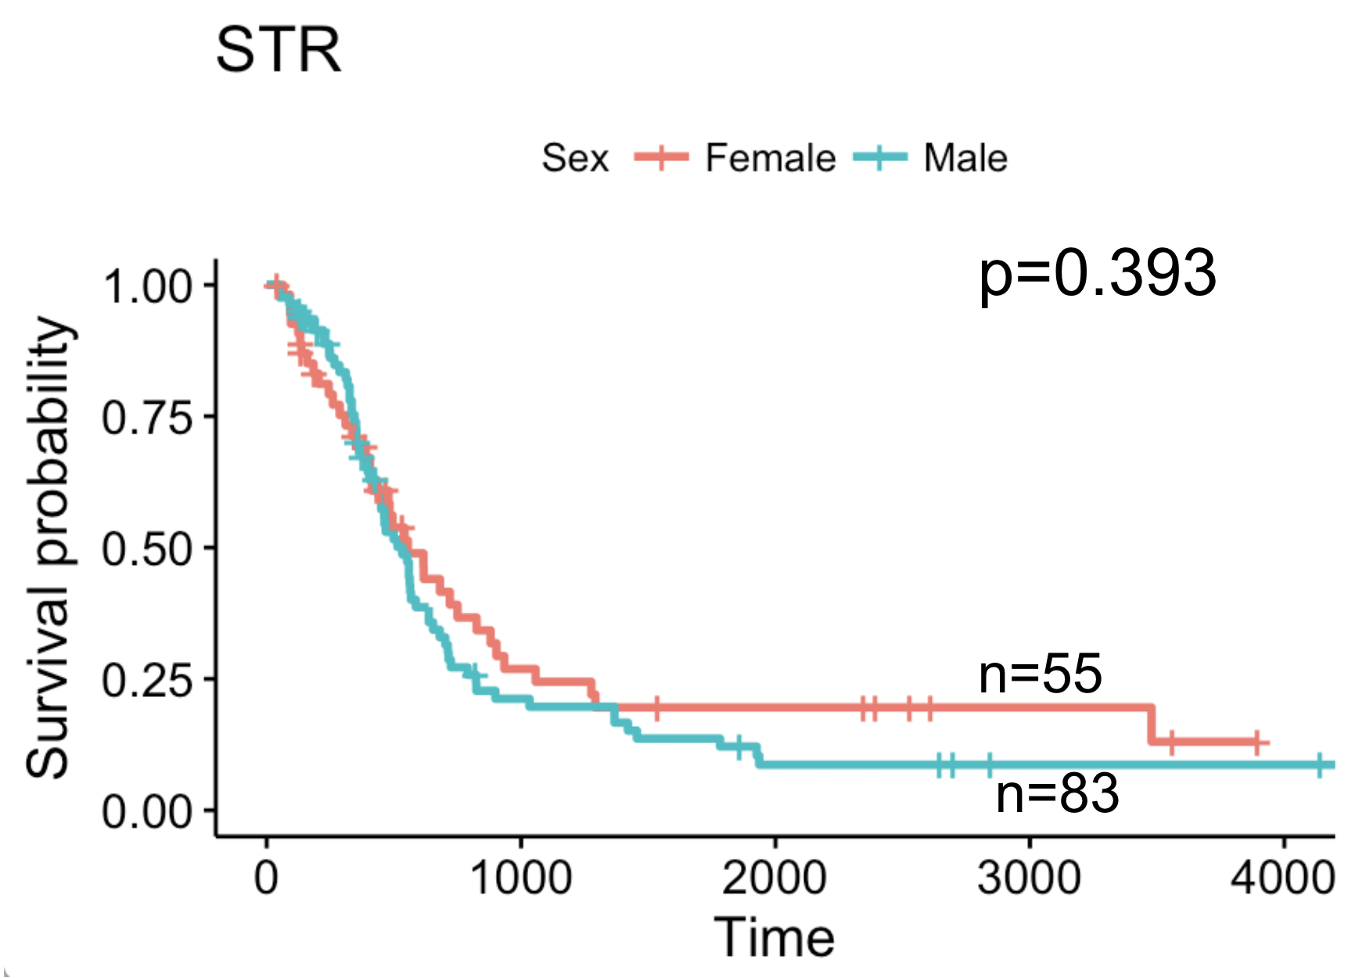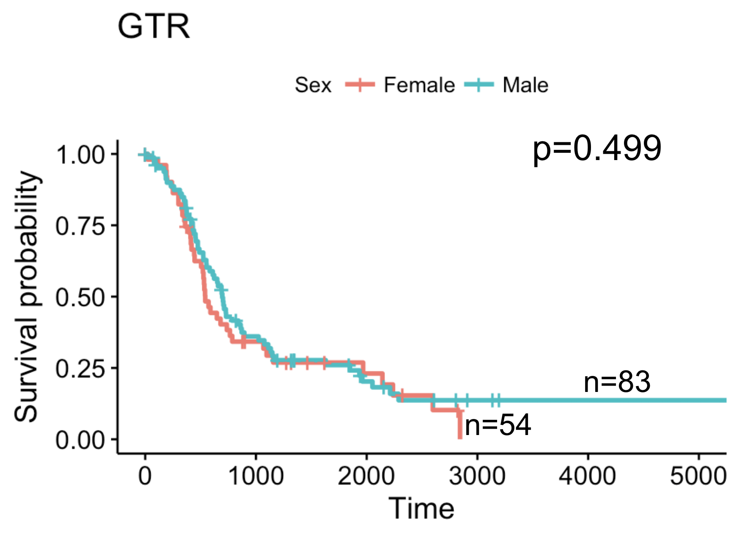
Supplement 10. No difference in survival between males and females among biopsy, STR, and GTR patients.

Covariate | M v F t-test | M v F KS | M v F M-W
Age | 0.546 | 0.122 | 0.220
Necrosis radius | 0.979 | 0.723 | 0.902
T1Gd radius | 0.657 | 0.254 | 0.618
CE Thickness | 0.365 | 0.452 | 0.226
T2/FLAIR radius | 0.870 | 0.912 | 0.824
Necrosis radius / T1Gd radius | 0.906 | 0.408 | 0.870
CE Thickness / T1Gd radius | 0.977 | 0.370 | 0.820
Necrosis radius / (T2/FLAIR radius) | 0.602 | 0.735 | 0.809
CE Thickness / (T2/FLAIR radius) | 0.719 | 0.243 | 0.696
T1Gd radius / (T2/FLAIR radius) | 0.777 | 0.992 | 0.929
PIHNA D | 0.282 | 0.594 | 0.598
PIHNA ϱ | 0.502 | 0.967 | 0.719
PI D/ϱ | 0.742 | 0.108 | 0.303
Supplement 11: Table of p-values for the following tests for males vs females: t-test with Welch’s correction, Kolmogorov-Smirnov distribution test, and Mann-Whitney distribution test (n=494)

Covariate | EXS M vs EXS F t-test | STS M vs STS F t-test
Age | 0.559 | 0.981
Necrosis radius | 0.203 | 0.464
T1Gd radius | 0.061 | 0.333
CE Thickness | 0.387 | 0.609
T2/FLAIR radius | 0.544 | 0.881
Necrosis radius / T1Gd radius | 0.443 | 0.655
CE Thickness / T1Gd radius | 0.443 | 0.655
Necrosis radius / (T2/FLAIR radius) | 0.467 | 0.656
CE Thickness / (T2/FLAIR radius) | 0.514 | 0.993
T1Gd radius / (T2/FLAIR radius) | 0.203 | 0.620
PIHNA D | 0.166 | 0.285
PIHNA ϱ | 0.023 | 0.787
PI D/ϱ | 0.600 | 0.495
Supplement 12: Table of p-values for t-test with Welch’s corrections comparing EXS males vs EXS females and STS males vs STS females (N=135)

Males | Mean∓SD |  |  |  | t-Test p-values
Covariate | EXS | Non-EXS | STS | Non-STS | EXS vs Non-EXS | EXS vs STS | STS vs Non-STS
Age | 51.33 ∓ 11.92 | 58.28 ∓ 13.62 | 65.33 ∓ 15.08 | 56.17 ∓ 12.86 | 0.005 | <0.001 | <0.001
Necrosis radius | 11.02 ∓ 5.31 | 11.39 ∓ 5.80 | 12.44 ∓ 5.54 | 11.15 ∓ 5.86 | 0.722 | 0.267 | 0.157
T1Gd radius | 18.79 ∓ 5.41 | 19.53 ∓ 6.08 | 21.49 ∓ 5.67 | 19.09 ∓ 6.01 | 0.485 | 0.041 | 0.011
CE Thickness | 7.771 ∓ 2.89 | 8.177 ∓ 3.10 | 9.052 ∓ 3.06 | 7.970 ∓ 3.05 | 0.472 | 0.069 | 0.031
T2/FLAIR radius | 27.82 ∓ 5.89 | 27.03 ∓ 6.68 | 28.15 ∓ 5.44 | 26.91 ∓ 6.79 | 0.572 | 0.839 | 0.266
PIHNA D | 32.29 ∓ 25.35 | 32.34 ∓ 22.60 | 43.54 ∓ 28.30 | 30.46 ∓ 21.32 | 0.992 | 0.124 | 0.017
PIHNA ϱ | 25.34 ∓ 25.10 | 70.77 ∓ 206.80 | 115.3 ∓ 244.89 | 57.61 ∓ 186.02 | 0.004 | 0.047 | 0.211
PI D/ϱ | 2.636 ∓ 3.04 | 2.051 ∓ 2.02 | 2.061 ∓ 1.81 | 2.126 ∓ 2.22 | 0.330 | 0.380 | 0.846

Females | Mean ∓SD |  |  |  | T-Test p-values
Covariate | EXS | Non-EXS | STS | Non-STS | EXS vs Non-EXS | EXS vs STS | STS vs Non-STS
Age | 48.29 ∓ 19.11 | 59.36 ∓ 14.08 | 65.26 ∓ 10.29 | 56.47 ∓ 15.38 | 0.032 | 0.003 | <0.001
Necrosis radius | 8.691 ∓ 6.19 | 11.62 ∓ 6.27 | 11.51 ∓ 6.18 | 11.32 ∓ 6.36 | 0.079 | 0.123 | 0.857
T1Gd radius | 15.56 ∓ 5.52 | 19.58 ∓ 6.40 | 20.17 ∓ 6.87 | 18.96 ∓ 6.28 | 0.010 | 0.010 | 0.307
CE Thickness | 6.867 ∓ 3.64 | 7.963 ∓ 3.31 | 8.661 ∓ 3.98 | 7.647 ∓ 3.13 | 0.248 | 0.105 | 0.132
T2/FLAIR radius | 25.91 ∓ 9.27 | 27.09 ∓ 6.80 | 28.38 ∓ 6.36 | 26.61 ∓ 7.17 | 0.688 | 0.432 | 0.226
PIHNA D | 19.7 ∓ 17.24 | 37.92 ∓ 40.07 | 59.52 ∓ 62.33 | 30.34 ∓ 27.21 | 0.008 | 0.003 | 0.018
PIHNA ϱ | 10.79 ∓ 9.46 | 87.89 ∓ 254.54 | 105.0 ∓ 221.44 | 75.73 ∓ 251.98 | 0.001 | 0.027 | 0.535
PI D/ϱ | 3.39 ∓ 4.82 | 1.998 ∓ 2.02 | 2.432 ∓ 2.63 | 2.035 ∓ 2.34 | 0.303 | 0.493 | 0.427
Supplement 13: Full table of t-test results

Males | Univariate |  |  | Multivariate
Covariate | HR | 95% CI | p-value | HR | 95% CI | p-value
Age | 1.027 | 1.018-1.037 | <0.001 | 1.020 | 0.999-1.040 | 0.051
Necrosis radius | 1.018 | 0.996-1.040 | 0.118 |  |  | N/A
T1Gd radius | 1.024 | 1.003-1.046 | 0.025 | 0.967 | 0.909-1.029 | 0.288
CE Thickness | 1.028 | 0.989-1.068 | 0.161 |  |  | N/A
T2/FLAIR radius | 0.996 | 0.972-1.020 | 0.744 |  |  | N/A
Necrosis radius / T1Gd radius | 1.089 | 0.584-2.028 | 0.789 |  |  | N/A
CE Thickness / T1Gd radius | 0.910 | 0.483-1.714 | 0.771 |  |  | N/A
Necrosis radius / (T2/FLAIR radius) | 1.787 | 0.740-4.318 | 0.197 |  |  | N/A
CE Thickness / (T2/FLAIR radius) | 1.897 | 0.689-5.222 | 0.215 |  |  | N/A
T1Gd radius / (T2/FLAIR radius) | 3.278 | 1.267-8.481 | 0.014 | 7.485 | 0.334-167.7 | 0.205
PIHNA D | 1.003 | 0.997-1.010 | 0.266 |  |  | N/A
PIHNA ϱ | 1.001 | 1.000-1.001 | 0.064 | 1.000 | 0.999-1.001 | 0.942
PI D/ϱ | 0.932 | 0.872-0.996 | 0.038 | 1.006 | 0.852-1.187 | 0.948
IDH1 Mutation | 1.021 | 0.461-2.259 | 0.959 |  |  | N/A
MGMT Methylation | 0.412 | 0.201-0.845 | 0.016 | 0.342 | 0.148-0.791 | 0.012
EOR | 0.732 | 0.601-0.891 | 0.002 | 0.831 | 0.598-1.155 | 0.271
Laterality | 1.271 | 0.974-1.659 | 0.077 | 1.879 | 1.117-3.159 | 0.017

Females | Univariate |  |  | Multivariate
Covariate | HR | 95% CI | p-value | HR | 95% CI | p-value
Age | 1.028 | 1.015-1.041 | <0.001 | 1.028 | 1.008-1.049 | 0.006
Necrosis radius | 1.017 | 0.991-1.042 | 0.204 |  |  | N/A
T1Gd radius | 1.026 | 1.000-1.052 | 0.048 | 0.988 | 0.952-1.025 | 0.508
CE Thickness | 1.037 | 0.988-1.088 | 0.143 |  |  | N/A
T2/FLAIR radius | 1.017 | 0.989-1.045 | 0.232 |  |  | N/A
Necrosis radius / T1Gd radius | 1.329 | 0.625-2.825 | 0.460 |  |  | N/A
CE Thickness / T1Gd radius | 0.753 | 0.354-1.600 | 0.460 |  |  | N/A
Necrosis radius / (T2/FLAIR radius) | 1.139 | 0.458-2.833 | 0.779 |  |  | N/A
CE Thickness / (T2/FLAIR radius) | 1.429 | 0.329-6.204 | 0.634 |  |  | N/A
T1Gd radius / (T2/FLAIR radius) | 1.326 | 0.539-3.257 | 0.539 |  |  | N/A
PIHNA D | 1.011 | 1.006-1.016 | <0.001 | 1.009 | 1.001-1.017 | 0.031
PIHNA ϱ | 1.001 | 1.000-1.002 | 0.052 | 1.000 | 0.999-1.002 | 0.609
PI D/ϱ | 0.996 | 0.937-1.059 | 0.906 |  |  | N/A
IDH1 Mutation |  |  | N/A |  |  | N/A
MGMT Methylation | 0.287 | 0.109-0.751 | 0.011 | 0.311 | 0.080-1.211 | 0.092
EOR | 0.833 | 0.639-1.088 | 0.180 | 0.793 | 0.560-1.122 | 0.191
Laterality | 1.238 | 0.882-1.737 | 0.218 | 1.291 | 0.798-2.089 | 0.299
Supplement 14: Table of extended CPH analysis that includes both categorical and quantitative variables. Variable definitions: Laterality (1 = left, 2 = right), EOR (1=biopsy, 2 = STR, 3 = GTR), IDH1 (0 = wt, 1 = mut), MGMT (1 = unmethylated, 2 = methylated)

Supplement 15: Analysis on Stupp protocol patients only
Stupp Protocol Group
N=179
 | Male | Female
All Patients | 113 | 66
Extreme (OS>1825 days) | 18 | 12
Short term (OS<210 days) | 1 | 5
Supplement 15A: Number of males and females in each survival group

Males | Univariate |  |  | Multivariate
Covariate | HR | 95% CI | p-value | HR | 95% CI | p-value
Age | 1.006 | 0.989-1.025 | 0.467
Necrosis radius | 1.014 | 0.979-1.050 | 0.447
T1Gd radius | 1.022 | 0.989-1.056 | 0.201
CE Thickness | 1.033 | 0.976-1.095 | 0.264
T2/FLAIR radius | 0.994 | 0.952-1.037 | 0.781
PIHNA D | 0.999 | 0.989-1.010 | 0.852
PIHNA ϱ | 1.003 | 0.999-1.007 | 0.089 | 1.007 | 1.001-1.014 | 0.026
PI D/ϱ | 0.876 | 0.774-0.991 | 0.035 | 0.916 | 0.792-1.059 | 0.235

Females | Univariate |  |  | Multivariate
Covariate | HR | 95% CI | p-value | HR | 95% CI | p-value
Age | 1.024 | 1.003-1.045 | 0.027 | 1.024 | 0.999-1.050 | 0.052
Necrosis radius | 1.007 | 0.965-1.052 | 0.742
T1Gd radius | 1.010 | 0.965-1.058 | 0.672
CE Thickness | 1.008 | 0.916-1.108 | 0.876
T2/FLAIR radius | 1.014 | 0.965-1.065 | 0.581
PIHNA D | 1.013 | 0.999-1.027 | 0.066 | 1.014 | 1.001-1.027 | 0.037
PIHNA ϱ | 1.001 | 0.999-1.003 | 0.137
PI D/ϱ | 0.984 | 0.864-1.121 | 0.811
Supplement 15B: Results of univariate and multivariate CPH analyses for males and females. Factors that were significant or almost significant (p<0.10) in univariate analysis were included in the multivariate analysis.

Supplement 16:
The Proliferation-Invasion (PI) model is based on two key parameters: the net rate of proliferation, ϱ, and the net rate of invasion, D. By assuming that the T1Gd abnormality coincides with one threshold of tumor cell density relative to the maximum carrying capacity and the T2/FLAIR abnormality coincides with another, lower threshold, one can obtain patient-specific estimates of these two parameters using standard pre-tx imaging¹⁹. This calibration uses two sets of MRI data: one set consists of two pre-tx time points of either T1Gd or T2/FLAIR images and the second set consists of one time point with both T1Gd and T2/FLAIR images. The first set is used to calculate a velocity and the second set is used to estimate the degree of invasion.

The PIHNA model similarly relies on an analogous net rate of invasion and net rate of proliferation and does not require two pretreatment image time points. In the PIHNA calibration approach, the relative size of necrosis is used as a surrogate to the velocity estimate from the two time points of imaging. For the calibration method, a lookup table was created, with each entry being an output from a unique D and ρ PIHNA simulation. The lookup table contains the estimated PI D/ρ value, the size of necrosis, the T1Gd visible portion of the tumor (assumed at >80% cell density) and the T2/FLAIR visible portion (assumed at >16% cell density), throughout each simulation. Given a patient’s T1Gd volume, T2/FLAIR volume, necrosis size, and the PI estimated D/ρ at one time point, the lookup table points to a sub­table of simulation points that match the T2/FLAIR size on MRI within a small measurement tolerance. A D and ρ is then chosen based on the simulations that match the PI D/ρ and necrosis size within a small tolerance. If multiple D ρ pairs exist that satisfy the aforementioned criteria, the pair that minimizes the T1Gd size is chosen.

