Supplementary Figure 1. Distributions of the Propensity Scores Before and After Matching

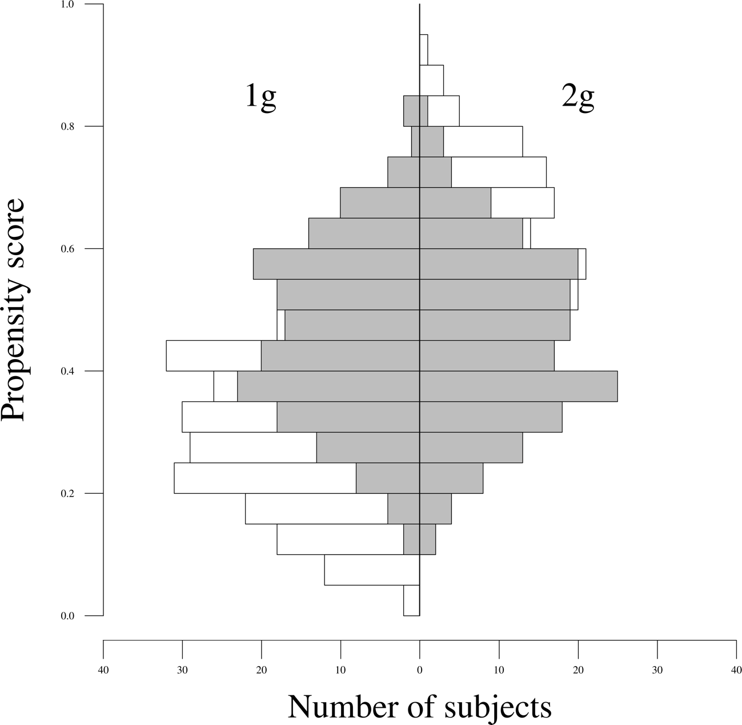
Note: The histogram is based on 5% steps in the propensity score. White bars represent the data before matching and the gray bars represent the data after matching.

