SUPPLEMENTARY INFORMATION 1

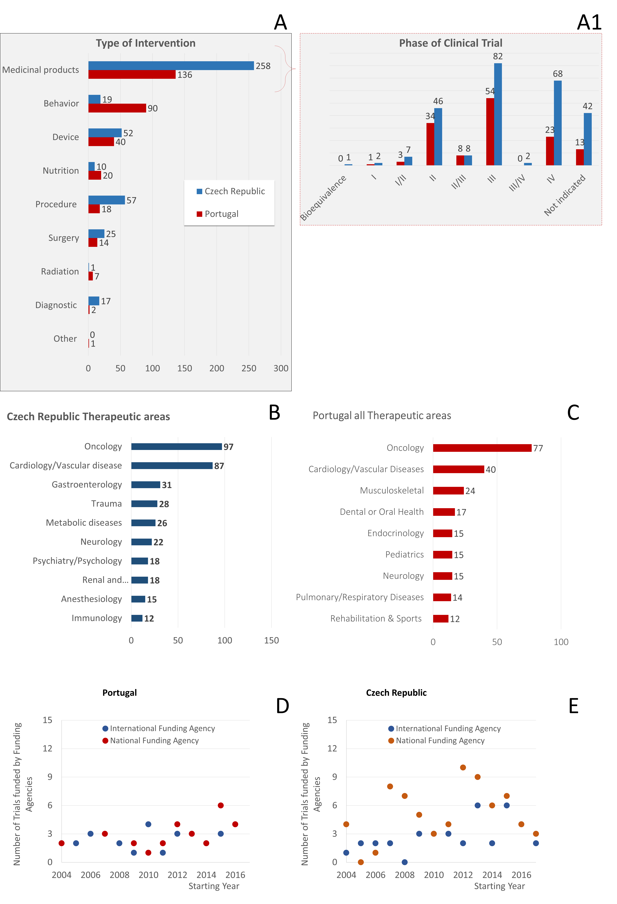
Figure 1 – Number of IICTs in the Czech Republic and in Portugal according to the type of intervention (A, A1), therapeutic areas (B,C) and type of funding agency by starting year (D,E).

