The geography of evolutionary divergence in the highly endemic avifauna from the Sierra Madre del Sur, Mexico
ALBERTO ROCHA-MÉNDEZ, LUIS A. SÁNCHEZ-GONZÁLEZ, CLEMENTINA GONZÁLEZ, & ADOLFO G. NAVARRO-SIGÜENZA

Supporting Information
Final tested hypothetical scenarios of diversification of 4 bird taxa in Mesoamerica.
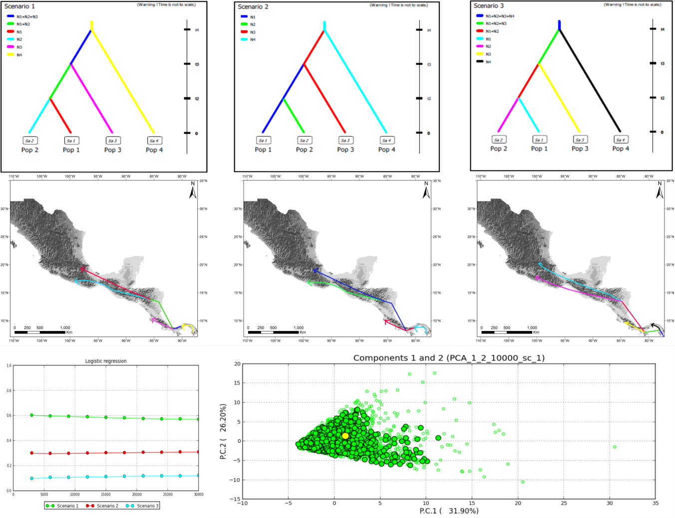
Fig. 5: Competing demographic scenarios of Aulacorhynchus with four populations, posterior probability of scenarios assessed with a logistic regression on the 1% of the simulated datasets closest to the observed data, and model checking for the best supported scenario (scenario 1) applying a PCA on test statistic vectors to visualize fit between simulated and observed datasets.

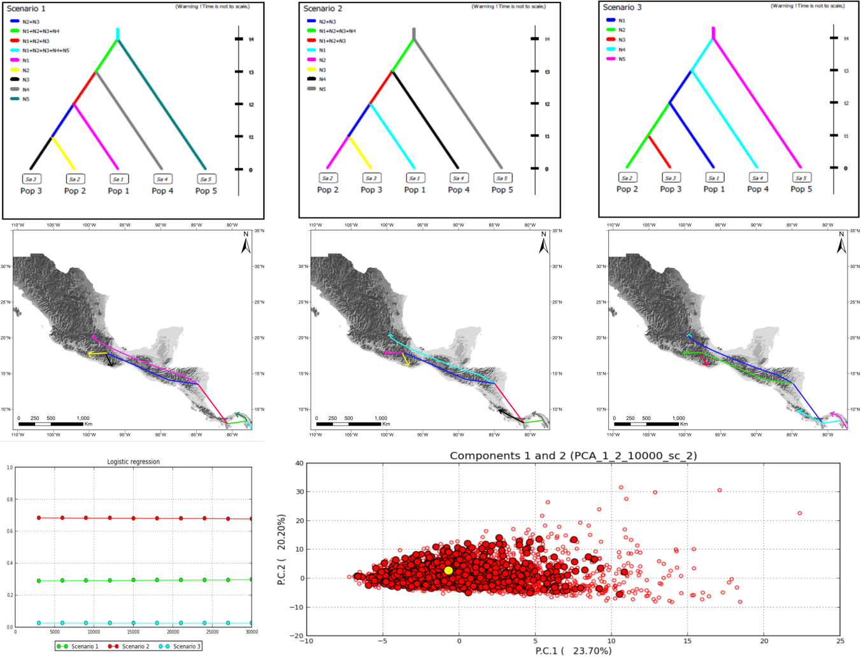
Fig. 6: Competing demographic scenarios of Aulacorhynchus with five populations, posterior probability of scenarios assessed with a logistic regression on the 1% of the simulated datasets closest to the observed data, and model checking for the best supported scenario (scenario 2) applying a PCA on test statistic vectors to visualize fit between simulated and observed datasets.

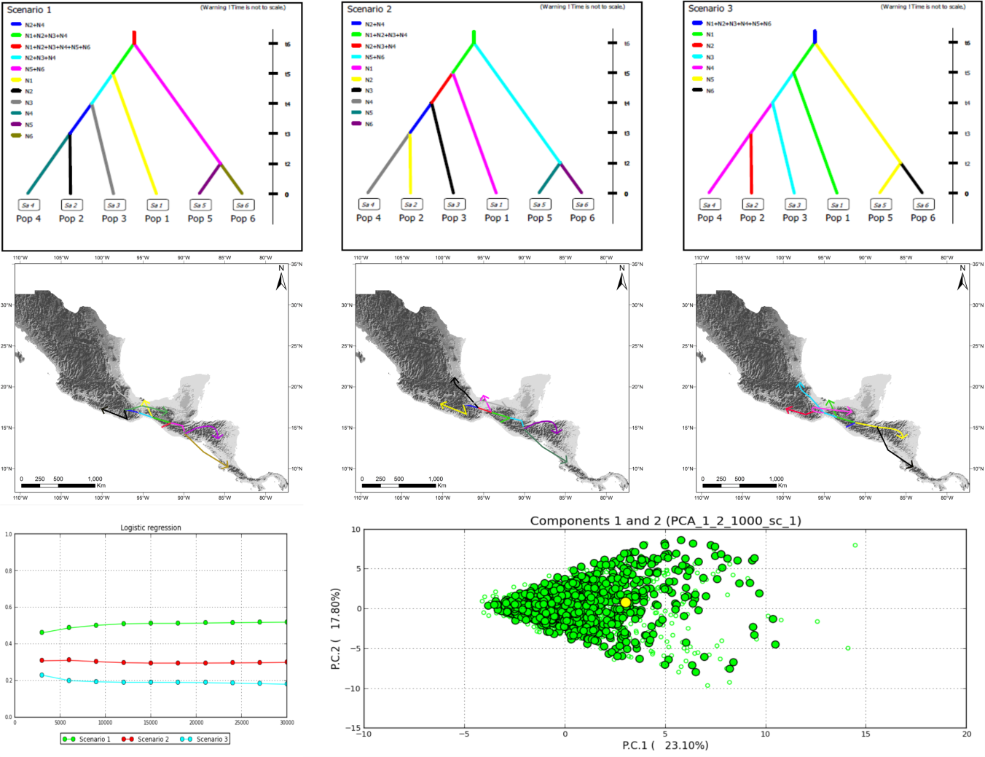
Fig. 7: Competing demographic scenarios of Chlorospingus with six populations, posterior probability of scenarios assessed with a logistic regression on the 1% of the simulated datasets closest to the observed data, and model checking for the best supported scenario (scenario 1) applying a PCA on test statistic vectors to visualize fit between simulated and observed datasets.

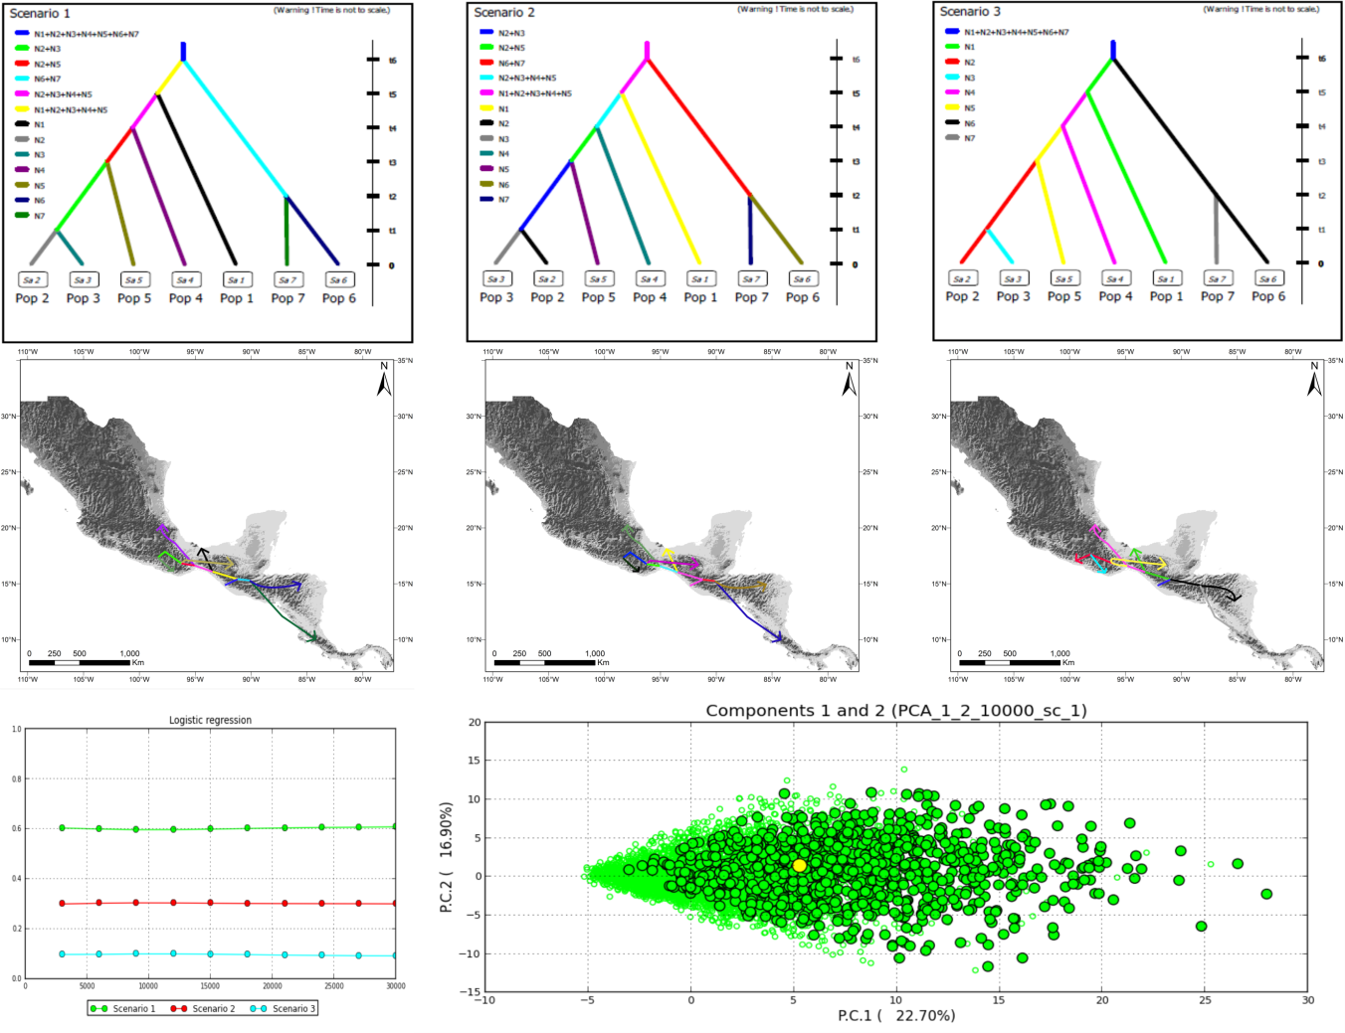
Fig. 8: Competing demographic scenarios of Chlorospingus with seven populations, posterior probability of scenarios assessed with a logistic regression on the 1% of the simulated datasets closest to the observed data, and model checking for the best supported scenario (scenario 1) applying a PCA on test statistic vectors to visualize fit between simulated and observed datasets.

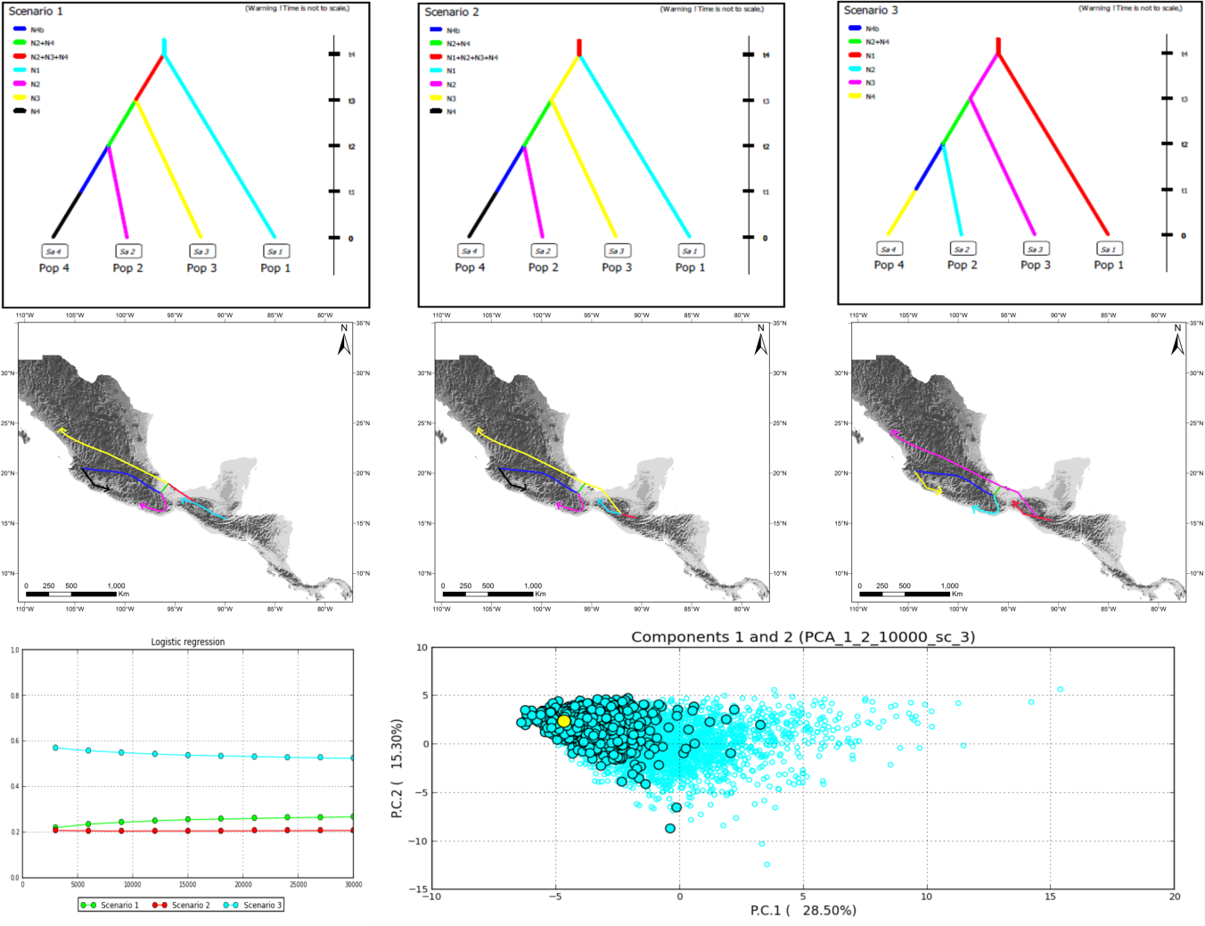
Fig. 9: Competing demographic scenarios of Cardellina, posterior probability of scenarios assessed with a logistic regression on the 1% of the simulated datasets closest to the observed data, and model checking for the best supported scenario (scenario 3) applying a PCA on test statistic vectors to visualize fit between simulated and observed datasets.

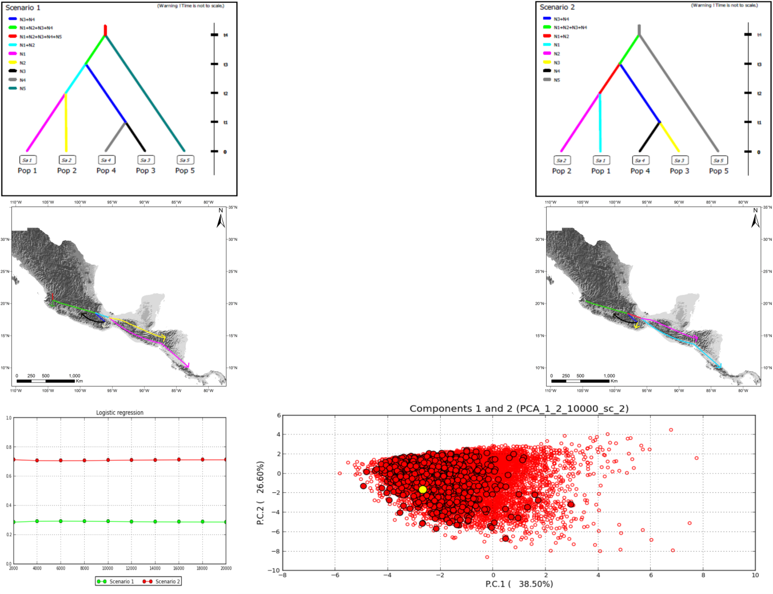
Fig. 10. Competing scenarios of Eupherusa-Thalurania, posterior probability of scenarios assessed with a logistic regression on the 1% of the simulated datasets closest to the observed data, and model checking for the best supported scenario (scenario 2) applying a PCA on test statistic vectors to visualize fit between simulated and observed datasets.

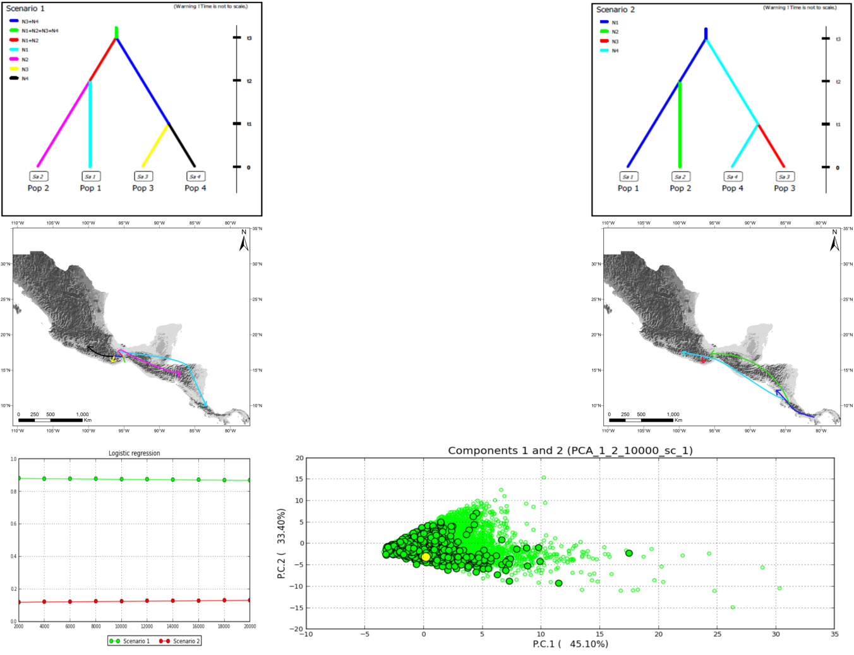
Fig. 11: Competing scenarios of Eupherusa, posterior probability of scenarios assessed with a logistic regression on the 1% of the simulated datasets closest to the observed data, and model checking for the best supported scenario (scenario 1) applying a PCA on test statistic vectors to visualize fit between simulated and observed datasets.

