Additional (Supplementary) Figures and Legends

Additional file 1: Figure S1. Representation of mitochondrial genomes of three pseudoscorpions: Atemnus politus, Paratemnoides elongatus and Pseudogarypus banksi. The annotation was performed using MITOS and representation using Geneious. The CDS genes are represented in green, the ribosomal genes in red and tRNA in pink. The percentage of GC content in represent by a blue graph inside the circular genomes and the percentage of AT content by a green graph.
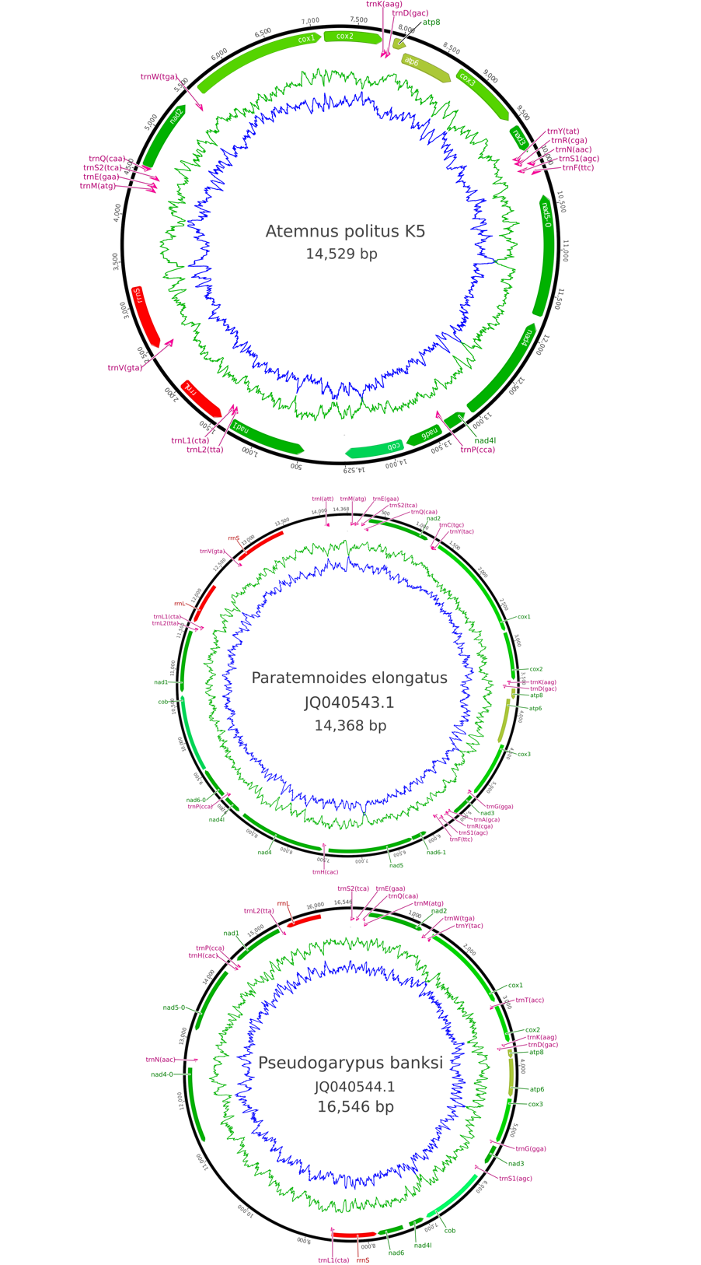
Additional file 2: Figure S2. Unrooted phylogenetic trees of Wolbachia based on 13 markers by Maximum Likelihood. Analysis based on concatenation of groEL, fabK, nuoG, NADH dehydrogenase I subunit F, aspS, gltA, coxA, ftsZ, wsp, orpB, nuoD, isocitrate dehydrogenase gene, TPR domain-containing protein gene; the total length of datasets is 6,461 bp. The topology was inferred using Maximum Likelihood (ML) inference using IQTREE. The Best-fit model calculated using ModelFinder according to BIC index was GTR+R3. Nodes are associated with Bootstrap values based on 1,000 replicates, only bootstrap value superior to 70 are indicated. The Wolbachia supergroups (A–S) are indicated.

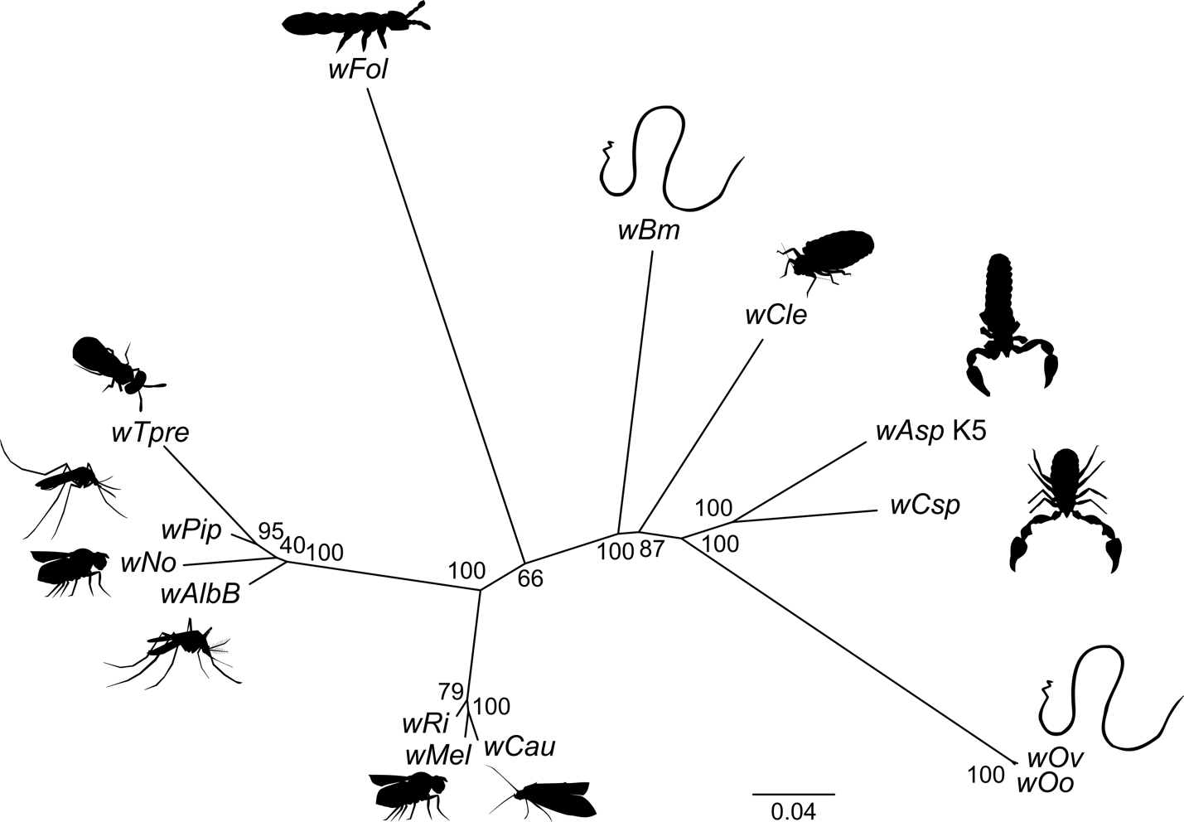

Additional file 3: Figure S3. BUSCO Assessment Result of 15 draft or complete Wolbachia genomes. BUSCO v3 was used to estimate the completeness of genomes analyzing gene content and comparing to selection of near-universal single-copy orthologue genes (here, 221 genes in common among proteobacteria (proteobacteria_odb9)).

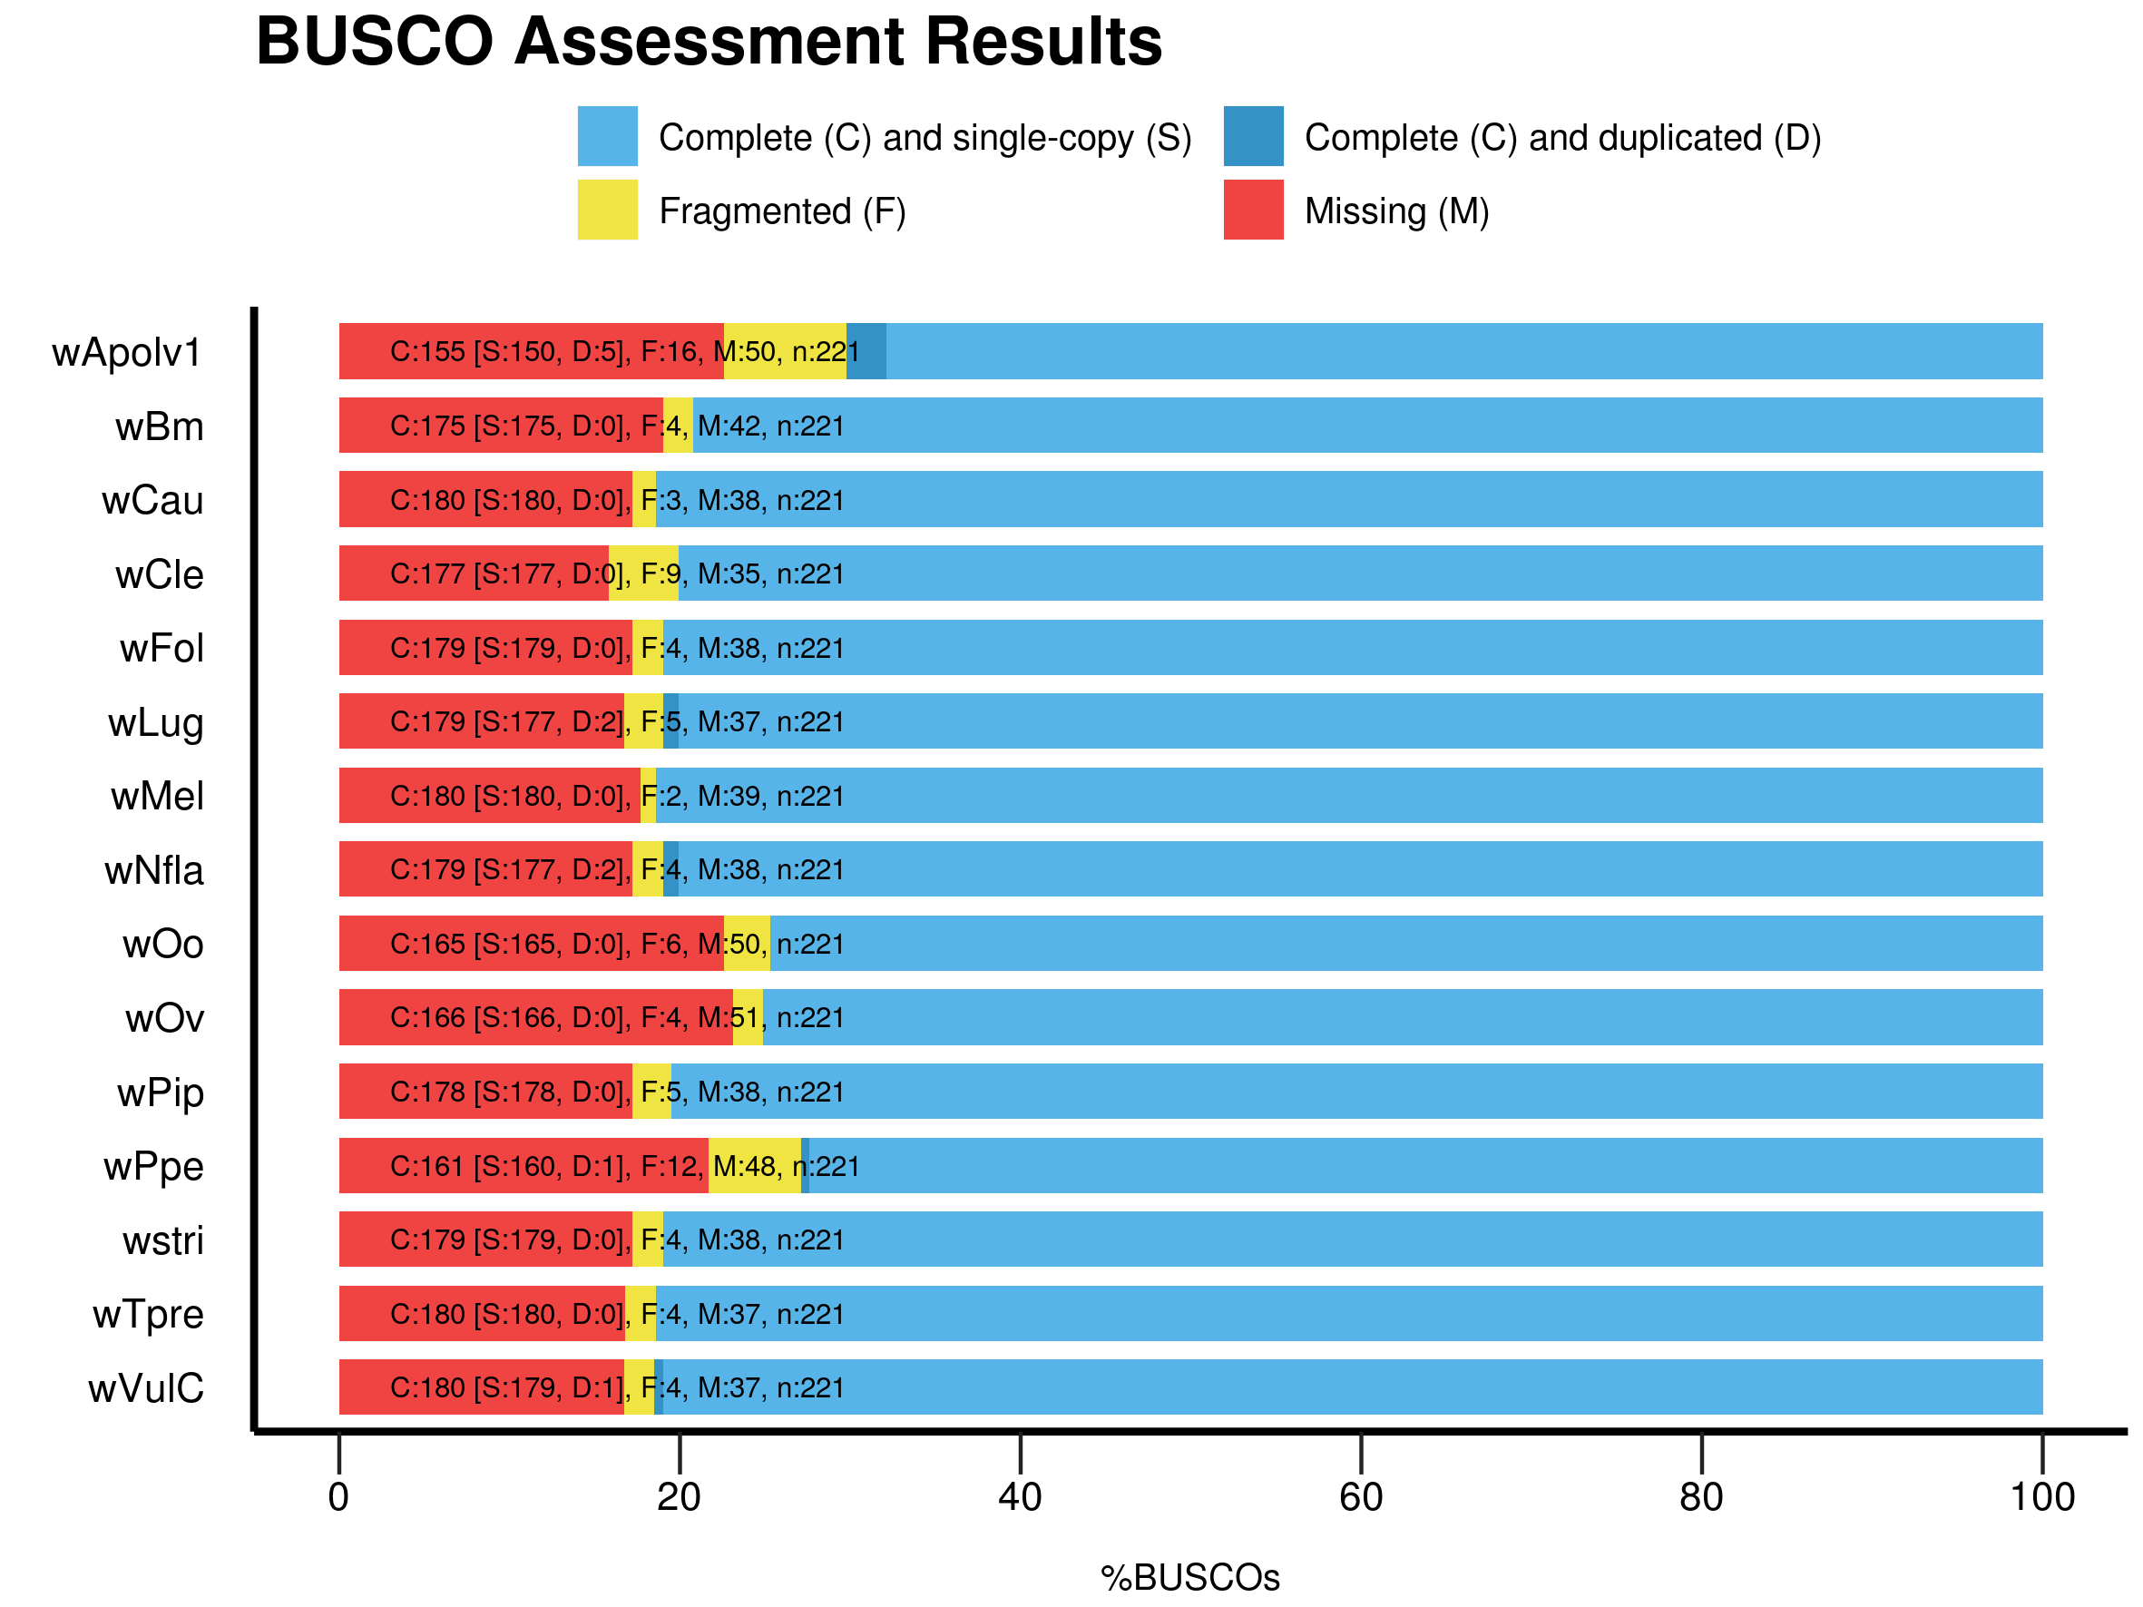

Additional file 8: Figure S4. Diagram of the contigs of wApol draft genome containing the effector type IV secretion system (T4SSs) genes. The genes involved the T4SS has been detected using RAST. The diagram of the contigs of wApol containing these genes are summarized.
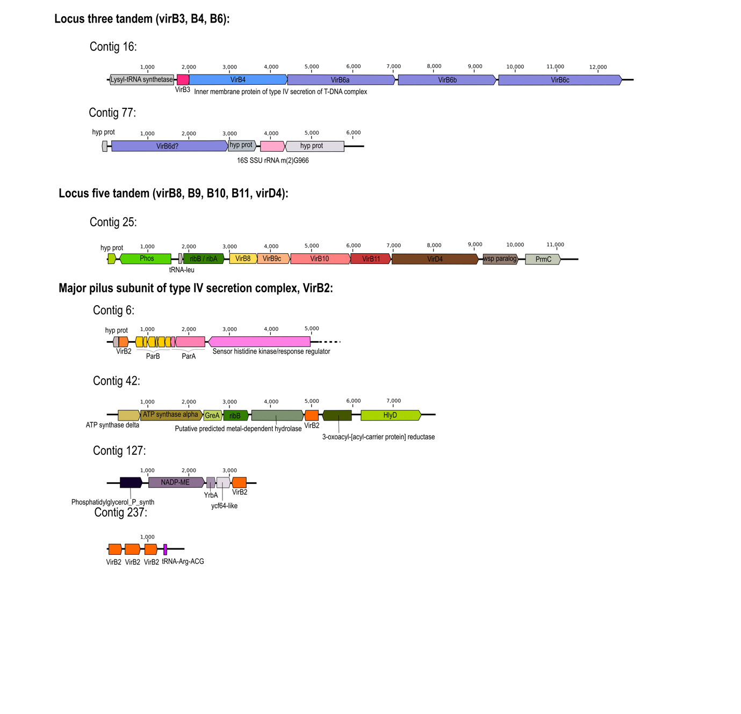

Additional file 11: Figure S5. Phylogeny of homolog of WOVitA1 bacteriophage region (gwv 1154, gwv 1152, gwv 1140 to 1142, gwv 1123 to 1127). The topology was inferred using Maximum Likelihood (ML) inference using IQTREE. The Best-fit model calculated using ModelFinder according to BIC index: HKY+G4 for gwv 1154 part 1 and TN+I for the part 2; HKY+G4 for gwv 1552; TIM3+G4 for gwv 1140-42; TN+G4 for gwv 1123 to 1127 part1 and HKY+G4 for part2.Nodes are associated with Bootstrap values based on 1,000 replicates. The Wolbachia supergroups are indicated by colour: orange for type A, blue for type B, dark pink for type E, purple for type F, green for type S.
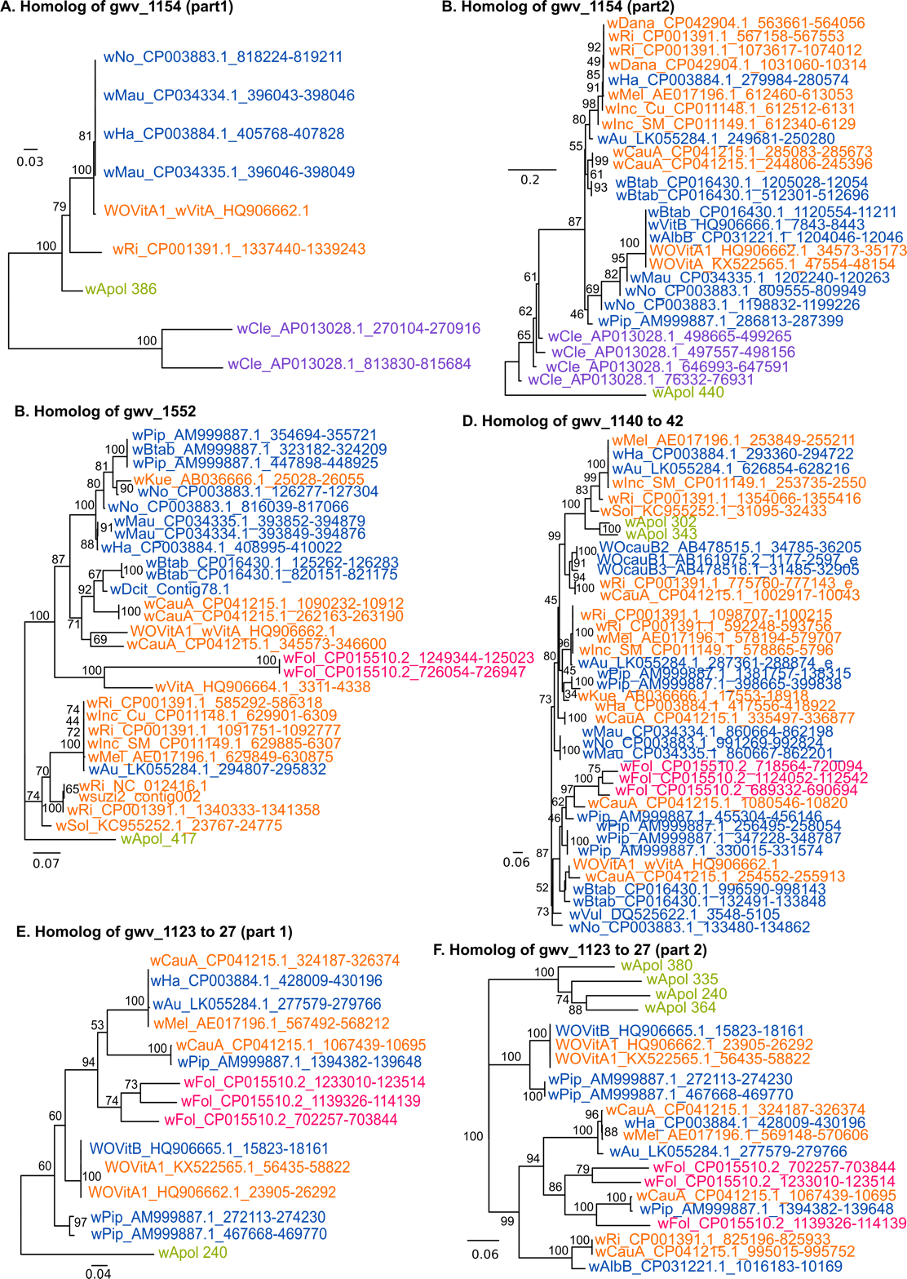

Additional file 12: Figure S6. Phylogeny of homolog of WOVitA1 bacteriophage region (gwv 1119 to 1121, gwv 1115 to 1116, gwv 1114). The topology was inferred using Maximum Likelihood (ML) inference using IQTREE. The Best-fit model calculated using ModelFinder according to BIC index: HKY+G4 for gwv 1119 to 1121 part1 and TPM3u+R2 for part 2; TIM2+G4 for gwv 1115 to 1116 (part1&2); HKY+G4 for gwv 1114 part1 and TN+G4 for part2. Nodes are associated with Bootstrap values based on 1,000 replicates. The Wolbachia supergroups are indicated by color: orange for type A, blue for type B, dark pink for type E, purple for type F, green for type S.
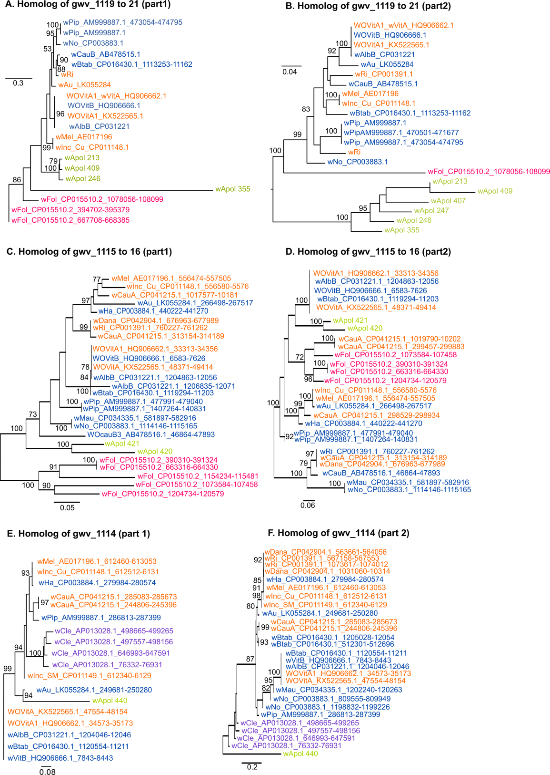

Additional file 13: Figure S7. Phylogeny of homologues of WOVitA1 bacteriophage region (gwv 1103 to 1113, gwv 1096, gwv 1093 to 1094). The topology was inferred using Maximum Likelihood (ML) inference using IQTREE. The Best-fit model calculated using ModelFinder according to BIC index: TPM3u+G4 for gwv 1103 to 1113 part 1 and HKY+G4 for part2 and TN+I+G4 for part3; K3Pu+G4 for gwv 1096; TIM+R2 for gwv 1093 part1 and HKY+G4 for part2; K3Pu for gwv 1093 to 1094. Nodes are associated with Bootstrap values based on 1,000 replicates. The Wolbachia supergroups are indicated by color: orange for type A, blue for type B, dark pink for type E, purple for type F, green for type S.
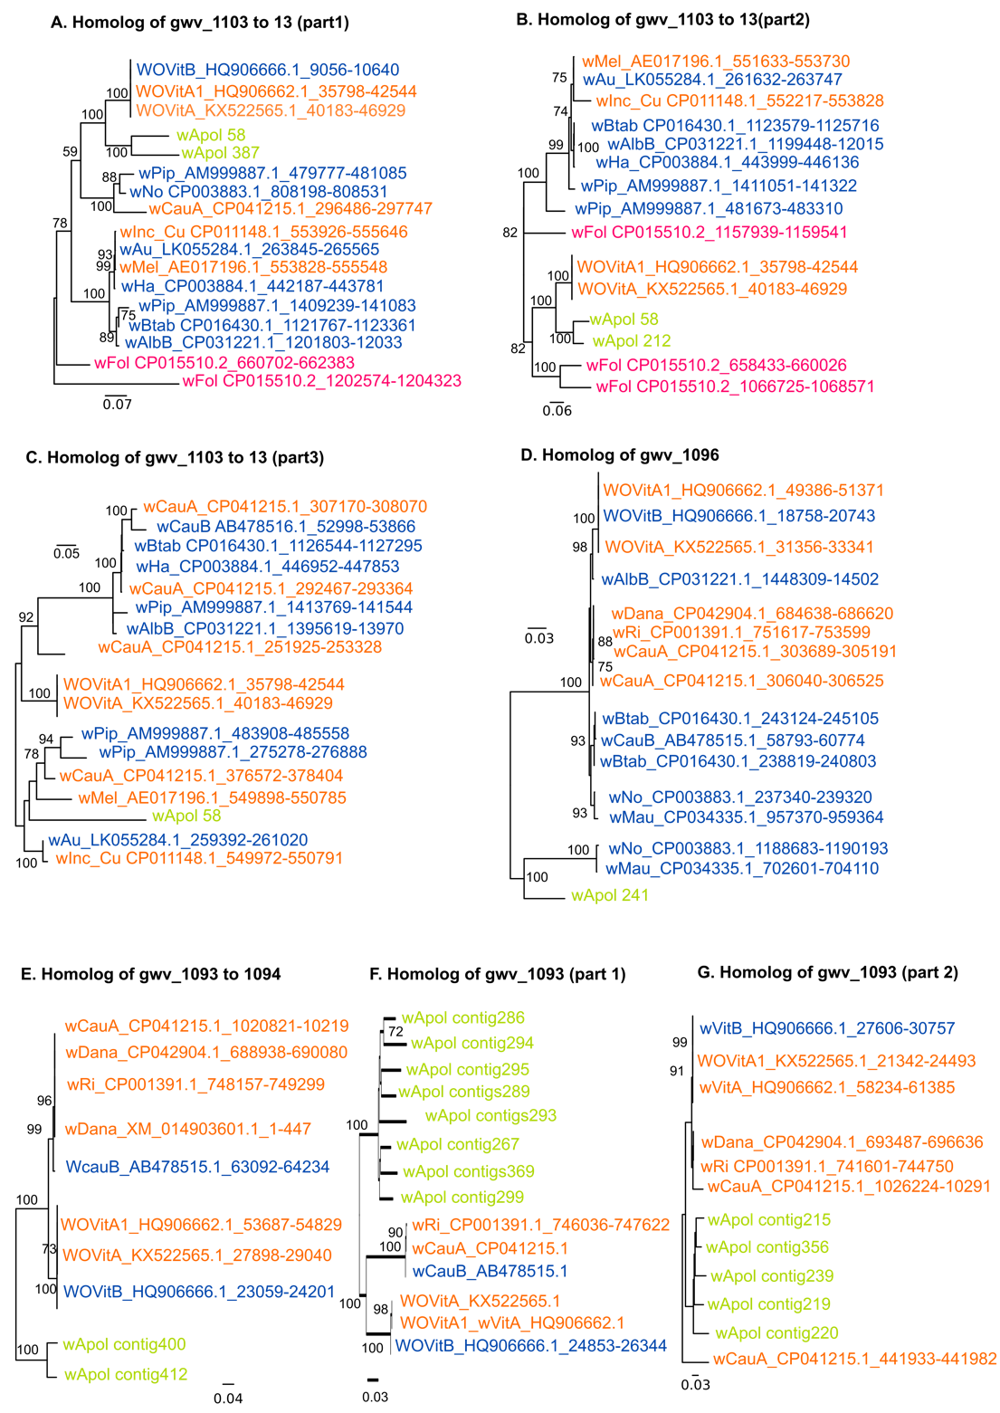

Additional file 14: Figure S8. Phylogeny of homologues of the wmk gene. The topology was inferred using Maximum Likelihood (ML) inference using IQTREE. The Best-fit model calculated using ModelFinder according to BIC index was TVM. Nodes are associated with Bootstrap values based on 1,000 replicates. The Wolbachia supergroups are indicated by color: orange for type A, blue for type B, dark pink for type E, purple for type F, green for type S.
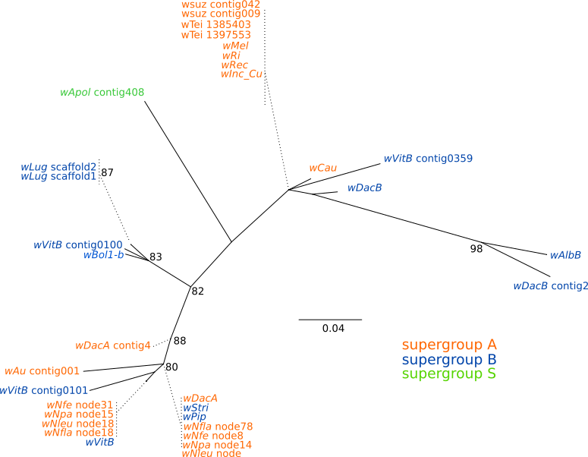

Additional file 15: Figure S9. Phylogeny of Wolbachia based on 16S gene. Analysis based on alignment of 101 16S rRNA sequences of the total length 445 bp. The topology was inferred using Maximum Likelihood (ML) inference using IQTREE. The Best-fit model calculated using ModelFinder according to BIC index was K2P+R2. Nodes are associated with Bootstrap values based on 1,000 replicates.
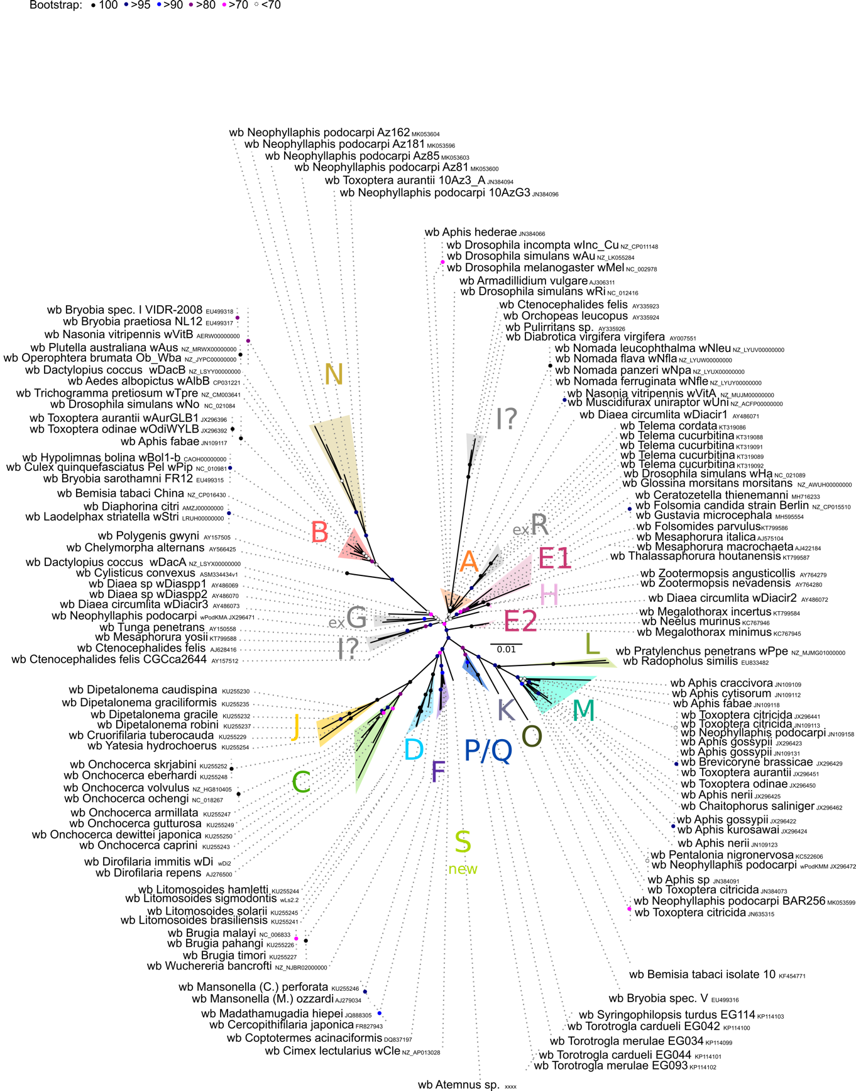
Additional file 16: Figure S10. Phylogeny of Wolbachia based on ftsZ gene. Analysis based on alignment of 95 ftsZ sequences of the total length 779 bp. The topology was inferred using Maximum Likelihood (ML) inference using IQTREE. The Best-fit model calculated using ModelFinder according to BIC index was TIM3+G4. Nodes are associated with Bootstrap values based on 1,000 replicates.

