Additional File 1_ Appendix 1**;** we presented the DAG for other CVD risk factors

**Appendix 1;** (continued)

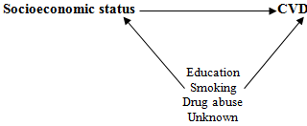

**Appendix 1;** (continued)

