**Table 1.**

**The baseline clinical characteristics and the final pathology report of the study subjects**



**Table 2**

**The location of TBLB and TBLC were summarized in the table**



**RUL: Right upper lobe; RLL: Right lower lobe; LUL: Left upper lobe; LLL: Left lower lobe**

**Table 3**

**The diagnostic yield of crybiopsy (CB) and forceps biopsy (FB). The diagnostic yield increased from 46.7% with the FB to 73.3% after adding CB (p = 0.038)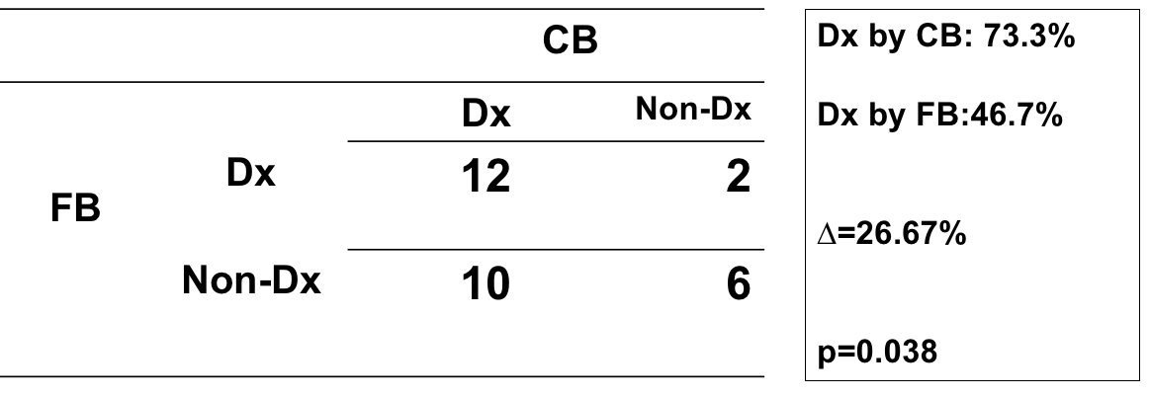Dx: diagnosis; CB: cryobiopsy; FB: forceps biopsy**

**Table 4.**

**The detailed information on sample size and the diagnosis of the 12 patients with inconsistent diagnostic results with forceps biopsy and cryobiopsy**



**CB: cryobiopsy; FB: forceps biopsy; PAP:** **pulmonary alveolar proteinosis**

**Table 5.**

**The clinical basic characteristics of these two groups: (1) those with initially non-diagnostic specimens by forceps biopsy who then had a definite diagnosis after adding cryobiopsy; (2) those who still had the same diagnostic results or non-diagnostic specimens after adding cryobiopsy.**



**CB: cryobiopsy; FB: forceps biopsy; ILD: interstitial lung diseases;**

**EBUS: endobronchial ultrasound**

**Table 6.**

**The complication after the transbronchial lung forceps biopsy and transbronchial lung cryobiopsy**



**Bleeding**

**Nil : slight, self-limited**

**Mild : needing norepinephrine injection**

**Moderate to severe: needing coagulation or Argon plasma coagulaiton**