Supplementary Information

Appendix 1. Bayesian multinomial mixture model description

Our model describes the empirical distribution of isolates of different groups (STs, AMRs profiles) y as a mixture of K different sampled origins noted x₁, x₂, ..., x_{K} with corresponding mixture coefficient α₁, α₂, ..., α_{K} (with α₁ + α₂ + ... + α_{K} = 1). These coefficients are weights describing the contributions of each origin to the observed distribution of interest. We noted n₁, n₂, ..., n_{K} the sample sizes of the origins, and n the sample size of y. Assuming that all origins contribute independently to y, the distribution of y is defined as:

y ~ Multinomial(α₁ φ₁, α₂ φ₂, ..., α_{K} φ_{K}, n)

where φ_{i} is the frequency distribution of the groups in origin i. Similiary, the empirical distribution within any origin i is defined as:

x_{i} ~ Multinomial(φ_{i}, n_{i})

Given these distributions, we can write the posterior distribution of our model as:

p(y, x₁, x₂, ..., x_{K} | α₁ φ₁, α₂ φ₂, ..., α_{K} φ_{K}) =
( p(y, x₁, x₂, ..., x_{K} | α₁ φ₁, α₂ φ₂, ..., α_{K} φ_{K}) p(α₁ φ₁, α₂ φ₂, ..., α_{K} φ_{K}) ) / p(y, x₁, x₂, ..., x_{K})

where p(y, x₁, x₂, ..., x_{K}) is a constant representing the marginal probability of the data. This posterior distribution is then proportional to:

p(y, x₁, x₂, ..., x_{K} | α₁ φ₁, α₂ φ₂, ..., α_{K} φ_{K}) p(α₁ φ₁, α₂ φ₂, ..., α_{K} φ_{K})

where the first term is the likelihood of our model, and the second term represents the priors. The likelihood is written as a product of independent terms:

p(y, x₁, x₂, ..., x_{K} | α₁ φ₁, α₂ φ₂, ..., α_{K} φ_{K}) =
p(y | α₁ φ₁, α₂ φ₂, ..., α_{K} φ_{K}) p(x₁ | α₁ φ₁) p(x₂ | α₂ φ₂) ... p(x_{K} | α_{K} φ_{K}) =
F_{M}(y, α₁ φ₁, α₂ φ₂, ..., α_{K} φ_{K,} n) F_{M}(x₁, φ₁, n₁) F_{M}(x₂, φ₂, n₂) ... F_{M}(x_{K}, φ_{K}, n_{K})

where F_{M} refers to the Multinomial probability mass function.

The joint prior distribution is rewritten as a product of independent components:

p(α₁ φ₁, α₂ φ₂, ..., α_{K} φ_{K}) =
p(α₁, α₂ , ..., α_{K}) p(φ₁, φ₂, ..., φ_{K}) =
p(α₁, α₂ , ..., α_{K}) p(φ₁) p(φ₂) ... p(φ_{K})

We assume no prior information on the mixture coefficients or the group frequencies so that these priors can be modelled by a constant Dirichlet distribution, and are effectively treated as constants in the estimation procedure.

The model above can be easily extended to incorporate an unsampled origin, by adding a new origin x_{unsampled} containing only 0s and with sample size n_{unsampled} = 0, and frequencies φ_{unsampled}.

Estimation
Markov Chain Monte Carlo can be used to derive samples of the parameters from the posterior distribution. We use a simple Metropolis algorithm for all parameters, using Dirichlet proposals for the mixture coefficients and for the group frequencies. In theory, both the contribution coefficients and the frequencies could be estimated simultaneously. However, for computational efficiency frequencies of groups in the different origins φ_{i} can also be fixed to their Maximum Likelihood estimates so that φ_{i} = x_{i} / n_{i}. Note that if the model includes an unsampled origin, group frequencies φ_{unsampled} have to be estimated, whether or not other frequency distributions φ_{i} are estimated or fixed. Convergence is assessed by ensuring stationarity of the different parameters from visual inspection of their traces.

Availability
The Bayesian Mixture model has been implemented in the R package bmmix available from CRAN and github:

CRAN: https://cran.r-project.org/web/packages/bmmix/index.html
github (development version): https://github.com/thibautjombart/bmmix

bmmix is distributed under Gnu General Public License (GPL) ≥ 2.

Study name | Period | Location | Study type | Study population | Study aims
The Vietnam Initiative on Zoonotic Infections (VIZIONs). | Not specified (5 years of retrospective and 5 years of prospective data from provincial hospitals) and high risk-cohorts. | Provincial hospitals in Dong Thap, Ho ChiMinh City, Dak Lak, Khanh Hoa, Hue, Hanoi, and Ba Vi; and high risk cohorts in Dong Thap, Dak  Lak, and Ba Vi. | Hospital-based surveillance program + longitudinal cohort study | 1) Disease surveillance in provincial hospitals: ongoing enrollment of patients (>12,000 over 5 years) with diarrhea, respiratory tract infections, aundice/hepatitis, and central nervous system infections.  2) High-risk cohort and social studies: Animal baseline sampling in three provinces; enrolment of 852 cohort members (farmers, animal health workers, butchers, market traders); follow-up sampling every 12 months. | 1. To establish international collaborative consortium with an integrated approach to human and animal health research;  2. To estimate the burden of zoonotic diseases disease and investigate the disease epidemiology in hospitalized patients and individuals occupationally exposed to animals;  3. To characterize genetic diversity and describe disease transmission;  4. To identify socio-demographic, environmental, and behavioral drivers for disease emergence.
The bacterial etiology and antimicrobial susceptibility profile of bloodstream infections at the Hospital for Tropical Diseases in Ho Chi Minh City. | January 2010-December 2013 | Hospital for Tropical Diseases (HTD), Ho Chi Minh City, Vietnam | Retrospective hospital-based study | Patients at HTD with a positive bacterial culture from a blood sample from the 1st January 2010 to 31st December 2013 | To understand the main causes of bacteremia and their associated antimicrobial susceptibility profiles at HTD.
The aetiology diarrheal disease in children in Hoi Chi Minh City | May 2009-April 2010 | Children’s Hospital 1 (CH1), Children’s Hospital 2 (CH2), and the Hospital for Tropical Diseases (HTD), Ho Chi Minh City, Vietnam | Prospective hospital-based study | Patients at CH1, CH2, and HTD with a positive bacterial culture from stool | To understand the aetiology of diarrhea in Southern Vietnam
The Vietnam Bacterial Resistance (VIBRE). | March 2012 to April 2013 | Tien Giang | Cross-sectional study | 204 backyard chicken farms, 204 farmers and 306 matched individuals not exposed to chicken farming. | To investigate the risk of NTS colonization in humans as a result of direct animal exposure.

Table S1. Characteristics of the studies included in our analyses

Table S2. The distribution of NTS serovars and corresponding sequence types among human blood isolates in Vietnam.
Serovar/ Sequence type | No. | %
Enteritidis | 62 | 41.89
ST 11 | 62 | 100
Typhimurium | 44 | 29.73
ST 34 | 28 | 63.64
ST 19 | 14 | 31.82
ST 1544 | 2 | 4.55
Choleraesuis | 15 | 10.14
ST 68 | 14 | 93.33
ST 139 | 1 | 6.67
Paratyphi B var Java | 3 | 2.03
ST 42 | 1 | 33.33
ST 135 | 1 | 33.33
ST 423 | 1 | 33.33
Rissen | 3 | 2.03
ST 469 | 3 | 100
Stanley | 3 | 2.03
ST 29 | 3 | 100
Corvallis | 2 | 1.35
ST 1541 | 2 | 100
Give | 2 | 1.35
ST 516 | 2 | 100
Sub species IV | 2 | 1.35
ST 958 | 2 | 100
Albany | 1 | 0.68
ST 292 | 1 | 100
Brandenburg | 1 | 0.68
ST 20 | 1 | 100
Derby | 1 | 0.68
ST 40 | 1 | 100
Indiana | 1 | 0.68
ST 17 | 1 | 100
Montevideo | 1 | 0.68
ST 1531 | 1 | 100
Newport | 1 | 0.68
ST 31 | 1 | 100
Schwarzengrund | 1 | 0.68
ST 96 | 1 | 100
Weltevreden | 1 | 0.68
ST 365 | 1 | 100
N/A | 4 | 2.70
ST 48 | 2 | 50
ST 1864 | 1 | 25
ST 1873 | 1 | 25
Total | 148 | 100

Table S3. The distribution of NTS serovars and corresponding sequence types among human stool isolates in Vietnam.
Serovar/Sequence type | No. | %
Typhimurium | 46 | 21.8
ST 19 | 21 | 45.65
ST 34 | 20 | 43.48
ST 36 | 2 | 4.35
ST 99 | 1 | 2.17
ST 313 | 1 | 2.17
ST 1544 | 1 | 2.17
Weltevreden | 41 | 19.43
ST 365 | 33 | 80.49
ST 1500 | 8 | 19.51
Newport | 11 | 5.21
ST 46 | 9 | 81.82
ST 31 | 2 | 18.18
Derby | 10 | 4.74
ST 40 | 10 | 100
Stanley | 9 | 4.27
ST 29 | 8 | 88.89
ST 1550 | 1 | 11.11
Rissen | 8 | 3.79
ST 469 | 8 | 100
Enteritidis | 6 | 2.84
ST 11 | 6 | 100
Litchfield | 5 | 2.37
ST 1499 | 3 | 60
ST 214 | 2 | 40
Corvallis | 4 | 1.9
ST 1541 | 4 | 100
Paratyphi B var Java monophasic | 4 | 1.9
ST 423 | 4 | 100
Give | 3 | 1.42
ST 516 | 3 | 100
Virchow | 3 | 1.42
ST 359 | 2 | 66.67
ST 197 | 1 | 33.33
Anatum | 2 | 0.95
ST 64 | 2 | 100
Braenderup | 2 | 0.95
ST 22 | 2 | 100
Bredeney | 2 | 0.95
ST 1543 | 2 | 100
Hadar | 2 | 0.95
ST 33 | 2 | 100
Kentucky | 2 | 0.95
ST 314 | 2 | 100
London | 2 | 0.95
ST 155 | 2 | 100
Mbandaka | 2 | 0.95
ST 413 | 2 | 100
Ohio | 2 | 0.95
ST 329 | 2 | 100
Bareilly | 1 | 0.47
ST 203 | 1 | 100
Cerro var. Siegburg | 1 | 0.47
ST 367 | 1 | 100
Indiana | 1 | 0.47
ST 17 | 1 | 100
Meleagridis | 1 | 0.47
ST 463 | 1 | 100
Muenchen | 1 | 0.47
ST 82 | 1 | 100
Orientalis | 1 | 0.47
ST 558 | 1 | 100
Pomona | 1 | 0.47
ST 451 | 1 | 100
Rubislaw | 1 | 0.47
ST 820 | 1 | 100
Saintpaul | 1 | 0.47
ST 50 | 1 | 100
Subspecies IIIb | 1 | 0.47
ST 430 | 1 | 100
Worthington | 1 | 0.47
ST 592 | 1 | 100
N/A | 34 | 16.11
ST 1542 | 10 | 29.41
ST 292 | 7 | 20.59
ST 48 | 3 | 8.82
ST 74 | 2 | 5.88
ST 1546 | 2 | 5.88
ST 909 | 1 | 2.94
ST 1545 | 1 | 2.94
ST 1547 | 1 | 2.94
ST 1548 | 1 | 2.94
ST 1549 | 1 | 2.94
ST 1561 | 1 | 2.94
ST 1562 | 1 | 2.94
ST 1867 | 1 | 2.94
ST 1871 | 1 | 2.94
ST 1874 | 1 | 2.94
Total | 211 | 100

Table S4. The distribution of NTS serovars and corresponding sequence types among NTS animal isolates in Vietnam.
Serovar/ Sequence type | No. | %
Weltevreden | 43 | 13.74
ST 1500 | 41 | 95.35
ST 365 | 2 | 4.65
Typhimurium | 32 | 10.22
ST 1544 | 14 | 43.75
ST 19 | 9 | 28.13
ST 34 | 7 | 21.88
ST 36 | 2 | 6.25
Paratyphi B var Java monophasic | 26 | 8.31
ST 423 | 13 | 50
ST 42 | 8 | 30.77
ST 135 | 4 | 15.38
ST 43 | 1 | 3.85
Indiana | 18 | 5.75
ST 17 | 18 | 100
Newport | 17 | 5.43
ST 31 | 11 | 64.71
ST 46 | 6 | 35.29
Enteritidis | 16 | 5.11
ST 11 | 14 | 87.5
ST 180 | 1 | 6.25
ST 1863 | 1 | 6.25
Derby | 14 | 4.47
ST 40 | 14 | 100
Rissen | 10 | 3.19
ST 469 | 10 | 100
Anatum | 8 | 2.56
ST 64 | 8 | 100
Hadar | 8 | 2.56
ST 33 | 8 | 100
Oslo | 8 | 2.56
ST 1370 | 8 | 100
Give | 7 | 2.24
ST 516 | 7 | 100
Kentucky | 7 | 2.24
ST 314 | 6 | 85.71
ST 1865 | 1 | 14.29
Meleagridis | 6 | 1.92
ST 463 | 6 | 100
London | 5 | 1.6
ST 155 | 5 | 100
Albany | 4 | 1.28
ST 292 | 4 | 100
Senftenberg | 4 | 1.28
ST 14 | 4 | 100
Stanley | 4 | 1.28
ST 29 | 2 | 50
ST 182 | 2 | 50
Tennessee | 4 | 1.28
ST 319 | 4 | 100
Braenderup | 3 | 0.96
ST 22 | 3 | 100
Litchfield | 3 | 0.96
ST 1499 | 3 | 100
Sandiego | 3 | 0.96
ST 1568 | 3 | 100
Virchow | 3 | 0.96
ST 359 | 3 | 100
Bareilly | 2 | 0.64
ST 203 | 2 | 100
Corvallis | 2 | 0.64
ST 1541 | 2 | 100
Bovismorbificans | 1 | 0.32
ST 1058 | 1 | 100
Heidelberg | 1 | 0.32
ST 15 | 1 | 100
Mbandaka | 1 | 0.32
ST 413 | 1 | 100
Saintpaul | 1 | 0.32
ST 50 | 1 | 100
Tananarive | 1 | 0.32
ST 1794 | 1 | 100
Urbana | 1 | 0.32
ST 512 | 1 | 100
N/A | 50 | 15.97
ST 1547 | 13 | 26
ST 74 | 9 | 18
ST 1546 | 9 | 18
ST 1562 | 7 | 14
ST 292 | 4 | 8
ST 1861 | 3 | 6
ST 1867 | 3 | 6
ST 1866 | 1 | 2
ST 1868 | 1 | 2
Total | 313 | 100

Table S5. Distribution of 40 antimicrobial susceptibility profiles among human blood NTS isolates in Vietnam.
Antimicrobial susceptibility profileª | No. of antimicrobial agents | No. of isolates | %
Fully susceptible | 0 | 28 | 18.92
Gen | 1 | 1 | 0.68
Cip | 1 | 18 | 12.16
Amp | 1 | 19 | 12.84
ChlCip | 2 | 2 | 1.35
CtxCip | 2 | 1 | 0.68
AmpSxt | 2 | 7 | 4.73
AmpGen | 2 | 1 | 0.68
AmpCip | 2 | 7 | 4.73
AmpChl | 2 | 3 | 2.03
AmpGenSxt | 3 | 1 | 0.68
AmpCpSxt | 3 | 1 | 0.68
AmpChlSxt | 3 | 4 | 2.7
AmpChlGen | 3 | 1 | 0.68
AmpChlCip | 3 | 3 | 2.03
AmpCipGenSxt | 4 | 4 | 2.7
AmpChlGenSxt | 4 | 3 | 2.03
AmpChlCipSxt | 4 | 4 | 2.7
AmpChlCipGen | 4 | 2 | 1.35
AmpAkChlSxt | 4 | 1 | 0.68
AmpAkChlCip | 4 | 2 | 1.35
AmpChlCipGenSxt | 5 | 16 | 10.81
AmpAkCipGenSxt | 5 | 1 | 0.68
AmpAkChlGenSxt | 5 | 2 | 1.35
AmpAkChlCipSxt | 5 | 2 | 1.35
AmpAkChlCipGen | 5 | 2 | 1.35
AmpCfzCtxChlGenSxt | 6 | 1 | 0.68
AmpAkChlCipGenSxt | 6 | 9 | 6.08
AmpAkCtxChlCipGenSxt | 7 | 1 | 0.68
AmpAkCfzCtxChlCipGenSxt | 8 | 1 | 0.68
Total |  | 148 | 100

ªAbbreviated antimicrobial agents: Amp, ampicillin; Ak, amikacin; Caz, ceftazidime, Ctx, ceftriaxone; Chl, chloramphenicol, Cip, ciprofloxacin; Gen, gentamicin; Stx, trimethoprim-sulfamethoxazole

Table S6. The distribution of 30 antimicrobial susceptibility profiles among human stool NTS isolates in Vietnam.
Antimicrobial susceptibility profileª | No. of antimicrobial agents | No. of isolates | %
Fully susceptible | 0 | 111 | 52.61
Sxt | 1 | 8 | 3.79
Gen | 1 | 5 | 2.37
Cip | 1 | 6 | 2.84
Chl | 1 | 5 | 2.37
Amp | 1 | 16 | 7.58
CipSxt | 2 | 1 | 0.47
ChlSxt | 2 | 1 | 0.47
AkChl | 2 | 1 | 0.47
AmpSxt | 2 | 4 | 1.9
AmpAk | 2 | 3 | 1.42
ChlCipSxt | 3 | 1 | 0.47
CfzChlCip | 3 | 1 | 0.47
AmpGenSxt | 3 | 2 | 0.95
AmpChlSxt | 3 | 16 | 7.58
AmpChlGen | 3 | 3 | 1.42
AmpChlGenSxt | 4 | 7 | 3.32
AmpChlCipSxt | 4 | 1 | 0.47
AmpAkGenSxt | 4 | 1 | 0.47
AmkAkChlSxt | 4 | 3 | 1.42
AmpAkChlGen | 4 | 2 | 0.95
AmkAkChlCip | 4 | 1 | 0.47
AmpAkCfzCtx | 4 | 2 | 0.95
AmpChlCipGenSxt | 5 | 2 | 0.95
AmpAkChlGenSxt | 5 | 1 | 0.47
AmkAkChlCipSxt | 5 | 1 | 0.47
AmkAkChlCipGen | 5 | 2 | 0.95
AmkAkCfzCtxGenSxt | 6 | 1 | 0.47
AmkAkCfzCtxChlSxt | 6 | 2 | 0.95
AmpAkCfzCtxChlCipGenSxt | 8 | 1 | 0.47
Total |  | 211 | 100

ªAbbreviated antimicrobial agents: Amp, ampicillin; Ak, amikacin; Caz, ceftazidime, Ctx, ceftriaxone; Chl, chloramphenicol, Cip, ciprofloxacin; Gen, gentamicin; Stx, trimethoprim-sulfamethoxazole

Table S7. The distribution of 34 antimicrobial susceptibility profiles among animal NTS isolates in Vietnam.
Antimicrobial susceptibility profileª | No. of antimicrobial agents | No. of isolates | %
Fully susceptible | 0 | 167 | 53.35
Sxt | 1 | 10 | 3.19
Gen | 1 | 3 | 0.96
Cip | 1 | 29 | 9.27
Chl | 1 | 8 | 2.56
Cfz | 1 | 1 | 0.32
Ak | 1 | 1 | 0.32
Amp | 1 | 15 | 4.79
CipSxt | 2 | 1 | 0.32
CipGen | 2 | 1 | 0.32
ChlSxt | 2 | 14 | 4.47
ChlCip | 2 | 1 | 0.32
CtxChl | 2 | 1 | 0.32
AkCip | 2 | 1 | 0.32
AmpSxt | 2 | 4 | 1.28
AmpCip | 2 | 2 | 0.64
AmpChl | 2 | 3 | 0.96
AmpAk | 2 | 4 | 1.28
ChlCipSxt | 3 | 1 | 0.32
AkChlSxt | 3 | 1 | 0.32
AkChlCip | 3 | 1 | 0.32
AmpGenSxt | 3 | 1 | 0.32
AmpCipSxt | 3 | 1 | 0.32
AmpChlSxt | 3 | 12 | 3.83
AmpChlGenSxt | 4 | 3 | 0.96
AmpChlCipSxt | 4 | 9 | 2.88
AmpAkCipSxt | 4 | 1 | 0.32
AmpAkChlSxt | 4 | 2 | 0.64
AmpChlCipGenSxt | 5 | 5 | 1.6
AmpAkChlCipSxt | 5 | 4 | 1.28
AmpAkChlCipGen | 5 | 1 | 0.32
AmpAkCfzCtxChl | 5 | 1 | 0.32
AmpAkChlCipGenSxt | 6 | 3 | 0.96
AmpAkCfzCtxChlGen | 6 | 1 | 0.32
Total |  | 313 | 100

ªAbbreviated antimicrobial agents: Amp, ampicillin; Ak, amikacin; Caz, ceftazidime, Ctx, ceftriaxone; Chl, chloramphenicol, Cip, ciprofloxacin; Gen, gentamicin; Stx, trimethoprim-sulfamethoxazole

Table S8. The distribution of 66 ST-AMR profiles among human blood NTS isolates in Vietnam.

ST_Antimicrobial susceptibility profileª | No. of antimicrobial agents | No. of isolates | %
11_Fully susceptible | 0 | 19 | 12.84
11_Cip | 1 | 9 | 6.08
11_Amp | 1 | 18 | 12.16
11_AmpSxt | 2 | 5 | 3.38
11_AmpGen | 2 | 1 | 0.68
11_AmpCip | 2 | 5 | 3.38
11_AmpChl | 2 | 1 | 0.68
11_AmpCipSxt | 3 | 1 | 0.68
11_AmpChlSxt | 3 | 1 | 0.68
11_AmpChlCip | 3 | 2 | 1.35
17_AmpAkChlCipGenSxt | 6 | 1 | 0.68
19_Fully susceptible | 0 | 2 | 1.35
19_Gen | 1 | 1 | 0.68
19_AmpCipGenSxt | 4 | 2 | 1.35
19_AmpChlCipSxt | 4 | 3 | 2.03
19_AmpAkChlCip | 4 | 2 | 1.35
19_AmpAkChlSxt | 4 | 1 | 0.68
19_AmpChlCipGen | 4 | 1 | 0.68
19_AmpChlCipGenSxt | 5 | 1 | 0.68
19_AmpAkCipGenSxt | 5 | 1 | 0.68
20_Fully susceptible | 0 | 1 | 0.68
29_Fully susceptible | 0 | 1 | 0.68
29_Cip | 1 | 1 | 0.68
29_Amp | 1 | 1 | 0.68
31_CtxCip | 2 | 1 | 0.68
34_Cip | 1 | 1 | 0.68
34_ChlCip | 2 | 1 | 0.68
34_AmpCip | 2 | 2 | 1.35
34_AmpChl | 2 | 1 | 0.68
34_AmpChlSxt | 3 | 1 | 0.68
34_AmpChlCip | 3 | 1 | 0.68
34_AmpChlGen | 3 | 1 | 0.68
34_AmpChlGenSxt | 4 | 1 | 0.68
34_AmpChlCipGen | 4 | 1 | 0.68
34_AmpChlCipGenSxt | 5 | 5 | 3.38
34_AmpAkChlGenSxt | 5 | 2 | 1.35
34_AmpAkChlCipSxt | 5 | 1 | 0.68
34_AmpAkChlCipGen | 5 | 2 | 1.35
34_AmpAkChlCipGenSxt | 6 | 7 | 4.73
34_AmpAkCtxChlCipGenSxt | 7 | 1 | 0.68
40_AmpChl | 2 | 1 | 0.68
42_Cip | 1 | 1 | 0.68
48_AmpChlGenSxt | 4 | 1 | 0.68
48_AmpChlCipGenSxt | 5 | 1 | 0.68
68_AmpChlSxt | 3 | 1 | 0.68
68_AmpGenSxt | 3 | 1 | 0.68
68_AmpCipGenSxt | 4 | 2 | 1.35
68_AmpChlGenSxt | 4 | 1 | 0.68
68_AmpChlCipGenSxt | 5 | 8 | 5.41
68_AmpAkCfzCtxChlCipGenSxt | 8 | 1 | 0.68
96_AmpChlCipGenSxt | 5 | 1 | 0.68
135_Gen | 1 | 1 | 0.68
139_AmpCfzCtxChlGenSxt | 6 | 1 | 0.68
292_AmpAkChlCipSxt | 5 | 1 | 0.68
365_Cip | 1 | 1 | 0.68
423_Cip | 1 | 1 | 0.68
469_AmpSxt | 2 | 2 | 1.35
469_AmpChlSxt | 3 | 1 | 0.68
516_ChlCip | 2 | 1 | 0.68
516_AmpChlCipSxt | 4 | 1 | 0.68
958_Fully susceptible | 0 | 2 | 1.35
1531_Cip | 1 | 1 | 0.68
1541_Cip | 1 | 2 | 1.35
1544_Fully susceptible | 0 | 2 | 1.35
1864_Fully susceptible | 0 | 1 | 0.68
1873_AmpAkChlCipGenSxt | 6 | 1 | 0.68
Total |  | 148 | 100

ªAbbreviated antimicrobial agents: Amp, ampicillin; Ak, amikacin; Caz, ceftazidime, Ctx, ceftriaxone; Chl, chloramphenicol, Cip, ciprofloxacin; Gen, gentamicin; Stx, trimethoprim-sulfamethoxazole

Table S9. The distribution of 110 ST-AMR profiles among human stool NTS isolates in Vietnam.

ST_Antimicrobial susceptibility profileª | No. of antimicrobial agents | No. of isolates | %
11_Fully susceptible | 0 | 1 | 0.47
11_Amp | 1 | 5 | 2.37
17_AmpAkChlCipGen | 5 | 1 | 0.47
19_Fully susceptible | 0 | 3 | 1.42
19_Sxt | 1 | 2 | 0.95
19_Chl | 1 | 1 | 0.47
19_Amp | 1 | 1 | 0.47
19_AmpSxt | 2 | 2 | 0.95
19_AmpGenSxt | 3 | 1 | 0.47
19_AmpChlSxt | 3 | 7 | 3.32
19_AmpChlGenSxt | 4 | 1 | 0.47
19_AmpAkChlGen | 4 | 1 | 0.47
19_AmpAkChlCipSxt | 5 | 1 | 0.47
19_AmpAkCfzCtxGenSxt | 6 | 1 | 0.47
22_CipSxt | 2 | 1 | 0.47
22_AmpAk | 2 | 1 | 0.47
29_Fully susceptible | 0 | 5 | 2.37
29_Gen | 1 | 1 | 0.47
29_AmpChlSxt | 3 | 2 | 0.95
31_Fully susceptible | 0 | 1 | 0.47
31_ChlCipSxtCtx | 4 | 1 | 0.47
33_AmpAk | 2 | 2 | 0.95
34_Fully susceptible | 0 | 1 | 0.47
34_Amp | 1 | 8 | 3.79
34_AmpChlSxt | 3 | 1 | 0.47
34_AmpChlGen | 3 | 1 | 0.47
34_AmpAkChlGen | 4 | 1 | 0.47
34_AmpAkCfzCtx | 4 | 1 | 0.47
34_AmpChlGenSxt | 4 | 2 | 0.95
34_AmpChlCipGenSxt | 5 | 1 | 0.47
34_AmpAkChlGenSxt | 5 | 1 | 0.47
34_AmpAkChlCipGen | 5 | 1 | 0.47
34_AmpAkCfzCtxChlSxt | 6 | 1 | 0.47
34_AmpAkCfzCtxChlCipGenSxt | 8 | 1 | 0.47
36_Fully susceptible | 0 | 2 | 0.95
40_Fully susceptible | 0 | 3 | 1.42
40_Chl | 1 | 3 | 1.42
40_AkChl | 2 | 1 | 0.47
40_AmpGenSxt | 3 | 1 | 0.47
40_AmpChlGenSxt | 4 | 1 | 0.47
40_AmpChlCipGenSxt | 5 | 1 | 0.47
46_Fully susceptible | 0 | 7 | 3.32
46_Cip | 1 | 1 | 0.47
46_AmpAkCfzCtx | 4 | 1 | 0.47
48_AmpChlGen | 3 | 1 | 0.47
48_AmpChlGenSxt | 4 | 2 | 0.95
50_Fully susceptible | 0 | 1 | 0.47
64_AmpSxt | 2 | 1 | 0.47
64_AmpAkGenSxt | 4 | 1 | 0.47
74_Fully susceptible | 0 | 2 | 0.95
82_Fully susceptible | 0 | 1 | 0.47
99_Fully susceptible | 0 | 1 | 0.47
155_Fully susceptible | 0 | 2 | 0.95
197_Fully susceptible | 0 | 1 | 0.47
203_Fully susceptible | 0 | 1 | 0.47
214_Fully susceptible | 0 | 1 | 0.47
214_AmpChlSxt | 3 | 1 | 0.47
292_Sxt | 1 | 2 | 0.95
292_AmpChlSxt | 3 | 1 | 0.47
292_AmpAkChlSxt | 4 | 3 | 1.42
292_AmpAkCfzCtxChlSxt | 6 | 1 | 0.47
313_Fully susceptible | 0 | 1 | 0.47
314_Fully susceptible | 0 | 2 | 0.95
329_Cip | 1 | 1 | 0.47
329_CfzChlCip | 3 | 1 | 0.47
359_Fully susceptible | 0 | 2 | 0.95
365_Fully susceptible | 0 | 27 | 12.8
365_Sxt | 1 | 2 | 0.95
365_Gen | 1 | 1 | 0.47
365_Cip | 1 | 1 | 0.47
365_Amp | 1 | 1 | 0.47
365_AmpChlSxt | 3 | 1 | 0.47
367_Gen | 1 | 1 | 0.47
413_Fully susceptible | 0 | 2 | 0.95
423_Fully susceptible | 0 | 4 | 1.9
430_Fully susceptible | 0 | 1 | 0.47
451_Fully susceptible | 0 | 1 | 0.47
463_Fully susceptible | 0 | 1 | 0.47
469_Fully susceptible | 0 | 7 | 3.32
469_AmpSxt | 2 | 1 | 0.47
516_Cip | 1 | 1 | 0.47
516_AmpChlSxt | 3 | 1 | 0.47
516_AmpChlCipSxt | 4 | 1 | 0.47
558_Cip | 1 | 1 | 0.47
592_Sxt | 1 | 1 | 0.47
820_AmpAkChlCip | 4 | 1 | 0.47
909_Fully susceptible | 0 | 1 | 0.47
1499_Fully susceptible | 0 | 1 | 0.47
1499_Chl | 1 | 1 | 0.47
1499_AmpChlSxt | 3 | 1 | 0.47
1500_Fully susceptible | 0 | 6 | 2.84
1500_Sxt | 1 | 1 | 0.47
1500_Cip | 1 | 1 | 0.47
1541_Fully susceptible | 0 | 4 | 1.9
1542_Fully susceptible | 0 | 9 | 4.27
1542_Gen | 1 | 1 | 0.47
1543_AmpChlGen | 3 | 1 | 0.47
1543_AmpChlGenSxt | 4 | 1 | 0.47
1544_Fully susceptible | 0 | 1 | 0.47
1545_Amp | 1 | 1 | 0.47
1546_Fully susceptible | 0 | 2 | 0.95
1547_Fully susceptible | 0 | 1 | 0.47
1548_ChlSxt | 2 | 1 | 0.47
1549_Fully susceptible | 0 | 1 | 0.47
1550_AmpChlSxt | 3 | 1 | 0.47
1561_Fully susceptible | 0 | 1 | 0.47
1562_Gen | 1 | 1 | 0.47
1867_Fully susceptible | 0 | 1 | 0.47
1871_Fully susceptible | 0 | 1 | 0.47
1874_Fully susceptible | 0 | 1 | 0.47
Total |  | 211 | 100

ªAbbreviated antimicrobial agents: Amp, ampicillin; Ak, amikacin; Caz, ceftazidime, Ctx, ceftriaxone; Chl, chloramphenicol, Cip, ciprofloxacin; Gen, gentamicin; Stx, trimethoprim-sulfamethoxazole

Table S10. The distribution of 133 ST-AMR profiles among animal NTS isolates in Vietnam.

ST_Antimicrobial susceptibility profileª | No. of antimicrobial agents | No. of isolates | %
11_Fully susceptible | 0 | 7 | 2.24
11_Cip | 1 | 2 | 0.64
11_Amp | 1 | 4 | 1.28
11_AmpCipSxt | 3 | 1 | 0.32
14_Fully susceptible | 0 | 3 | 0.96
14_AmpChlGenSxt | 4 | 1 | 0.32
15_Fully susceptible | 0 | 1 | 0.32
17_Fully susceptible | 0 | 2 | 0.64
17_Sxt | 1 | 4 | 1.28
17_ChlSxt | 2 | 6 | 1.92
17_AkChlSxt | 3 | 1 | 0.32
17_AmpAkChlSxt | 4 | 1 | 0.32
17_AmpChlCipGenSxt | 5 | 3 | 0.96
17_AmpAkChlCipGenSxt | 6 | 1 | 0.32
19_Fully susceptible | 0 | 3 | 0.96
19_AmpSxt | 2 | 1 | 0.32
19_AmpChl | 2 | 1 | 0.32
19_AmpChlSxt | 3 | 3 | 0.96
19_AmpChlGenSxt | 4 | 1 | 0.32
22_Cip | 1 | 3 | 0.96
29_Fully susceptible | 0 | 2 | 0.64
31_Fully susceptible | 0 | 5 | 1.6
31_Sxt | 1 | 1 | 0.32
31_Cip | 1 | 2 | 0.64
31_CipSxt | 2 | 1 | 0.32
31_ChlSxt | 2 | 1 | 0.32
31_ChlCipSxtCtx | 4 | 1 | 0.32
33_Fully susceptible | 0 | 5 | 1.6
33_Amp | 1 | 1 | 0.32
33_AmpAk | 2 | 2 | 0.64
34_Amp | 1 | 2 | 0.64
34_AmpGenSxt | 3 | 1 | 0.32
34_AmpChlCipGenSxt | 5 | 1 | 0.32
34_AmpAkChlCipGen | 5 | 1 | 0.32
34_AmpAkChlCipGenSxt | 6 | 1 | 0.32
34_AmpAkCfzCtxChlGen | 6 | 1 | 0.32
36_Fully susceptible | 0 | 1 | 0.32
36_AmpChlSxt | 3 | 1 | 0.32
40_Fully susceptible | 0 | 5 | 1.6
40_Chl | 1 | 3 | 0.96
40_ChlSxt | 2 | 1 | 0.32
40_AmpChl | 2 | 1 | 0.32
40_AmpChlSxt | 3 | 1 | 0.32
40_AmpChlGenSxt | 4 | 1 | 0.32
40_AmpChlCipSxt | 4 | 1 | 0.32
40_AmpChlCipGenSxt | 5 | 1 | 0.32
42_Fully susceptible | 0 | 6 | 1.92
42_Cip | 1 | 1 | 0.32
42_CtxChl | 2 | 1 | 0.32
43_Fully susceptible | 0 | 1 | 0.32
46_Fully susceptible | 0 | 5 | 1.6
46_Cip | 1 | 1 | 0.32
50_Cip | 1 | 1 | 0.32
64_Fully susceptible | 0 | 2 | 0.64
64_Chl | 1 | 1 | 0.32
64_ChlSxt | 2 | 3 | 0.96
64_AmpSxt | 2 | 1 | 0.32
64_AmpAkCipSxt | 4 | 1 | 0.32
74_Fully susceptible | 0 | 8 | 2.56
74_Cip | 1 | 1 | 0.32
135_Fully susceptible | 0 | 4 | 1.28
155_Fully susceptible | 0 | 2 | 0.64
155_AmpChlSxt | 3 | 3 | 0.96
180_Cip | 1 | 1 | 0.32
182_Fully susceptible | 0 | 2 | 0.64
203_Sxt | 1 | 1 | 0.32
203_AmpAk | 2 | 1 | 0.32
292_Sxt | 1 | 1 | 0.32
292_AmpAk | 2 | 1 | 0.32
292_AmpChlSxt | 3 | 1 | 0.32
292_AmpAkChlSxt | 4 | 1 | 0.32
292_AmpAkChlCipSxt | 5 | 4 | 1.28
314_Fully susceptible | 0 | 5 | 1.6
314_AmpChl | 2 | 1 | 0.32
319_Fully susceptible | 0 | 3 | 0.96
319_ChlCip | 2 | 1 | 0.32
359_Fully susceptible | 0 | 3 | 0.96
365_Fully susceptible | 0 | 1 | 0.32
365_Cip | 1 | 1 | 0.32
413_CipGen | 2 | 1 | 0.32
423_Fully susceptible | 0 | 10 | 3.19
423_Cip | 1 | 2 | 0.64
423_Ak | 1 | 1 | 0.32
463_Fully susceptible | 0 | 6 | 1.92
469_Fully susceptible | 0 | 5 | 1.6
469_Chl | 1 | 1 | 0.32
469_Amp | 1 | 1 | 0.32
469_AmpSxt | 2 | 2 | 0.64
469_AmpChlSxt | 3 | 1 | 0.32
512_Fully susceptible | 0 | 1 | 0.32
516_Fully susceptible | 0 | 2 | 0.64
516_Chl | 1 | 1 | 0.32
516_AkChlCip | 3 | 1 | 0.32
516_AmpChlCipSxt | 4 | 3 | 0.96
1058_Fully susceptible | 0 | 1 | 0.32
1370_Fully susceptible | 0 | 6 | 1.92
1370_Sxt | 1 | 1 | 0.32
1370_Cip | 1 | 1 | 0.32
1499_Fully susceptible | 0 | 2 | 0.64
1499_Amp | 1 | 1 | 0.32
1500_Fully susceptible | 0 | 25 | 7.99
1500_Sxt | 1 | 2 | 0.64
1500_Cip | 1 | 8 | 2.56
1500_Cfz | 1 | 1 | 0.32
1500_Amp | 1 | 1 | 0.32
1500_ChlSxt | 2 | 1 | 0.32
1500_AmpCip | 2 | 2 | 0.64
1500_AmpAkChlCipGenSxt | 6 | 1 | 0.32
1541_Chl | 1 | 1 | 0.32
1541_ChlSxt | 2 | 1 | 0.32
1544_Fully susceptible | 0 | 8 | 2.56
1544_Gen | 1 | 3 | 0.96
1544_Amp | 1 | 3 | 0.96
1546_Fully susceptible | 0 | 1 | 0.32
1546_Cip | 1 | 3 | 0.96
1546_AkCip | 2 | 1 | 0.32
1546_AmpChlCipSxt | 4 | 4 | 1.28
1547_Fully susceptible | 0 | 11 | 3.51
1547_Cip | 1 | 1 | 0.32
1547_AmpChlCipSxt | 4 | 1 | 0.32
1562_Fully susceptible | 0 | 7 | 2.24
1568_Amp | 1 | 1 | 0.32
1568_AmpChlSxt | 3 | 1 | 0.32
1568_AmpAkCfzCtxChl | 5 | 1 | 0.32
1794_Amp | 1 | 1 | 0.32
1861_Fully susceptible | 0 | 2 | 0.64
1861_ChlSxt | 2 | 1 | 0.32
1863_Fully susceptible | 0 | 1 | 0.32
1865_Fully susceptible | 0 | 1 | 0.32
1866_AmpChlSxt | 3 | 1 | 0.32
1867_Fully susceptible | 0 | 1 | 0.32
1867_Cip | 1 | 2 | 0.64
1868_Fully susceptible | 0 | 1 | 0.32
Total |  | 313 | 100

ªAbbreviated antimicrobial agents: Amp, ampicillin; Ak, amikacin; Caz, ceftazidime, Ctx, ceftriaxone; Chl, chloramphenicol, Cip, ciprofloxacin; Gen, gentamicin; Stx, trimethoprim-sulfamethoxazole

Table S11. Source attribution models of NTS in human blood and human stool by ST, AMR, and ST-AMR profile
1. Model with observed sources
 | Human blood (n=148) |  |  |  |  |  |  | Human stool (n=211)
 | Mixture coefficient α (x 100)ª  (95% CrI)^{b} |  |  |  |  |  |  | Mixture coefficient α (x 100)ª  (95% CrI)^{b}
 | Human stool (n=211) | Chicken (n=136) | Duck (n=75) | Pig  (n=65) | Rodent (n=37) |  |  | Human blood (n=148) | Chicken (n=136) | Duck (n=75) | Pig  (n=65) | Rodent (n=37)
ST | 55.7 (41.3-67.6) | 38.7  (26.4-51.0) | 2.6  (0.2-7.7) | 1.4  (0.1-6.7) | 0.7  (0.0-3.8) |  |  | 26.7  (16.9-36.1) | 19.7  (10.9-28.6) | 2.1  (0.1-7.3) | 25.6  (16.4-34.8) | 25.1  (18.3-32.8)
AMR | 17  (4.9-29.8) | 36.5  (23.9-48.5) | 12.2  (2.3-26.2) | 30.3  (16.9-46.1) | 2.8  (0.1-11) |  |  | 7.8  (1.7-16.4) | 7.3  (0.4-20.7) | 24.0  (11.8-39.9) | 45.2  (30.5-58.7) | 13.5  (2.2-27.4)
ST-AMR | 31.8  (18.6-46.4) | 53.5  (39.9-66.1) | 3.8  (0.7-9.6) | 7.4  (2.3-16.0) | 1.9  (0.2-6.3) |  |  | 11.0  (5.8-18.2) | 10.8  (4.4-19.3) | 7.5  (3.2-14.0) | 40.2  (31.7-49.4) | 29.6  (22.0-37.4)
2. Model with unobserved sources
 | Human blood (n=148) |  |  |  |  |  |  | Human stool (n=211)
 | Mixture coefficient α (x 100)ª  (95% CrI)^{b} |  |  |  |  |  |  | Mixture coefficient α (x 100)ª  (95% CrI)^{b}
 | Human stool (n=211) | Chicken (n=136) | Duck (n=75) | Pig  (n=65) | Rodent (n=37) | Unobserved source |  | Human blood (n=148) | Chicken (n=136) | Duck (n=75) | Pig  (n=65) | Rodent (n=37) | Unobserved source
ST | 44.1  (31.8-59.7) | 36.0  (20.9-48.2) | 2.2  (0.1-7.3) | 1.8  (0.0-7.0) | 0.7  (0.0-3.5) | 12.8  (7.7-24.8) |  | 2.8  (0.2-11.3) | 34.4  (20.5-47) | 2.5  (0.2-8.5) | 2.0  (0.1-8.4) | 1.2  (0.0-4.9) | 54.7  (42.7-67.3)
AMR | 6.2  (0.3-25.2) | 19.4  (3.0-37.6) | 4.9  (0.1-20.1) | 31.2  (13.4-46.5) | 12.3  (0.6-26.8) | 21.9  (14.6-31.0) |  | 2.3  (0.1-10.3) | 5.7  (0.3-18.5) | 21.7  (8.0-38.2) | 45.3  (32.1-58.5) | 16.8  (3.1-30.6) | 5.4 (2.4-9.7)
ST-AMR | 2.8  (0.2-11.3) | 34.4  (20.5-47) | 2.5  (0.2-8.5) | 2.0  (0.1-8.4) | 1.2  (0.0-4.9) | 54.7  (42.7-67.3) |  | 2.6  (0.3-7.6) | 6.2  (0.6-15.2) | 2.4  (0.1-8.1) | 28.4  (20.9-35.8) | 6.1  (0.7-15.7) | 52.9  (44.8-61.4)
ªExpressed as percentage
^{b}95% credibility interval

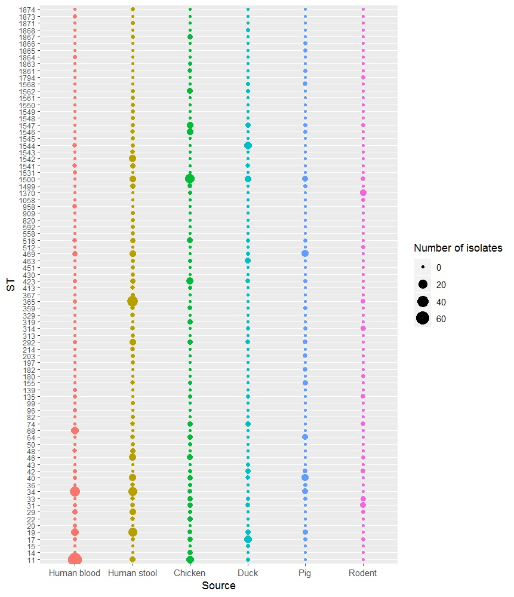

Figure S1. Distribution of sequence types by the source of isolate

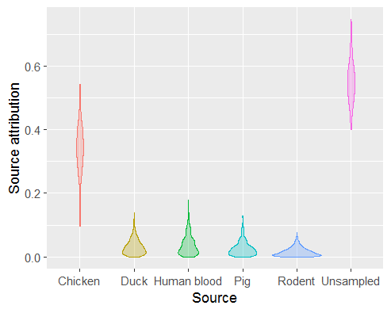
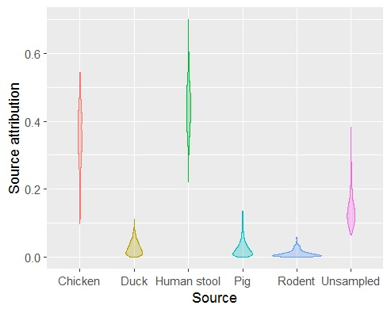
A. B.

Figure S2. Source attribution of human NTS isolates in Vietnam by sequence type.

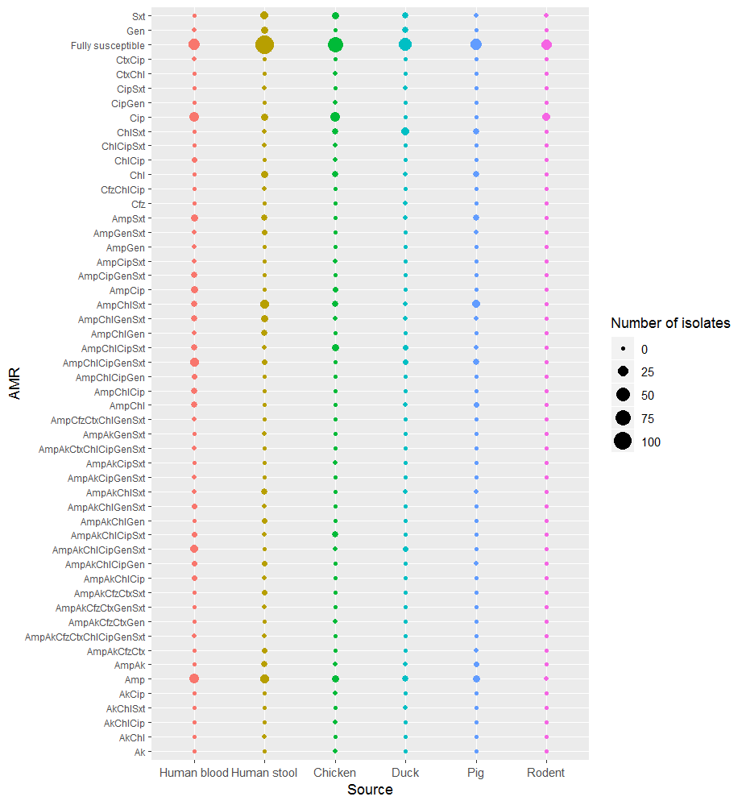

Figure S3. Distribution of AMR profiles by the source of isolate.

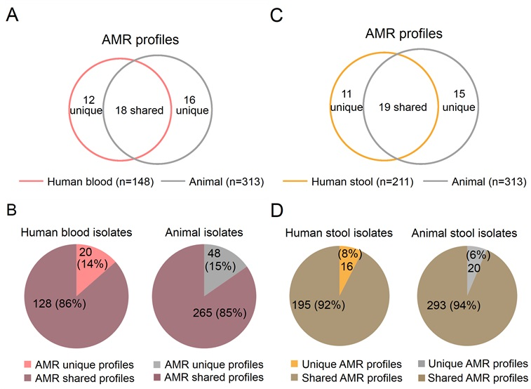

Figure S4. Number and proportion of unique and shared AMR profiles among human and animal NTS isolates in Vietnam.

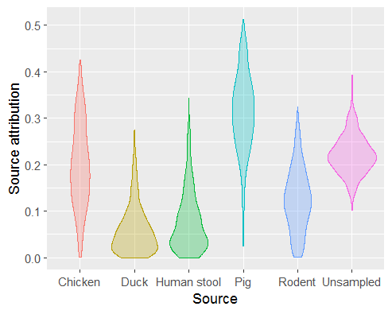
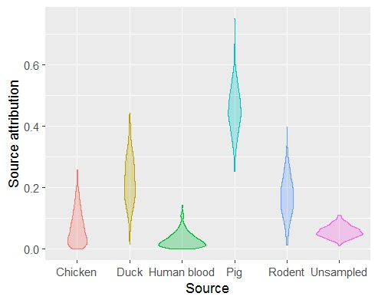
A B

Figure S5. Source attribution of NTS isolates in humans by AMR profile in Vietnam.

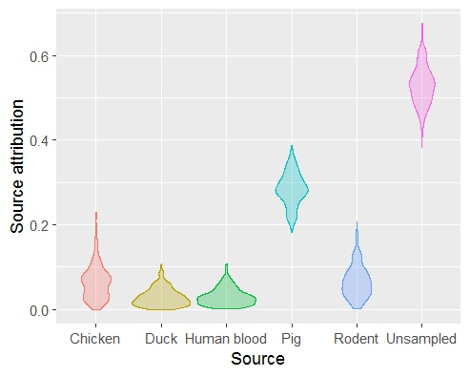
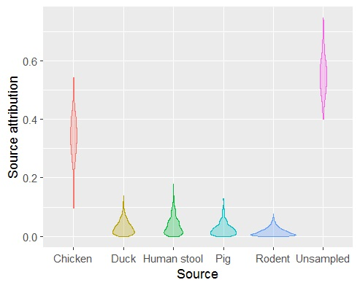
A B

Figure S6. Source attribution of NTS isolates in humans by ST-AMR profile in Vietnam.

