Supplementary file

Supplementary Figures
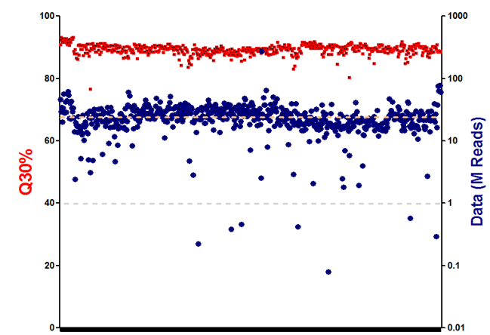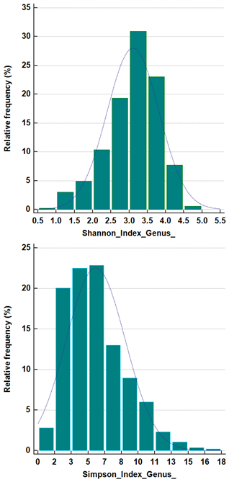

Figure S1. Quality control of dataset. (a) Q30 and data depth were calculated to filter low quality samples. (b) Distribution of alpha-diversities, Shannon index and Simpson index.

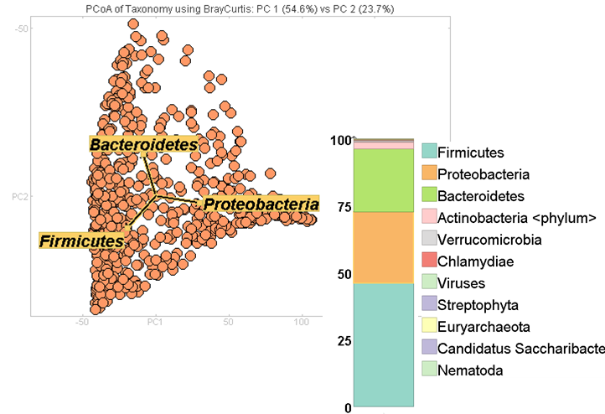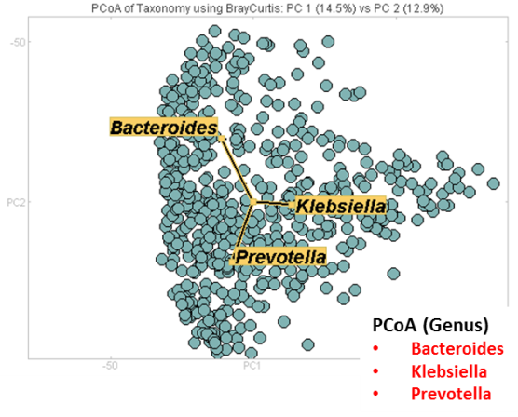
Figure S2. Metagenomic data summary and traits of dataset in genus and phylum level. Three enterotypes were identified in phylum level including Firmicutes, Bacteroidetes, and Proteobacteria. Most abundant genera were Bacteroides, Klebsiella, and Prevotella.

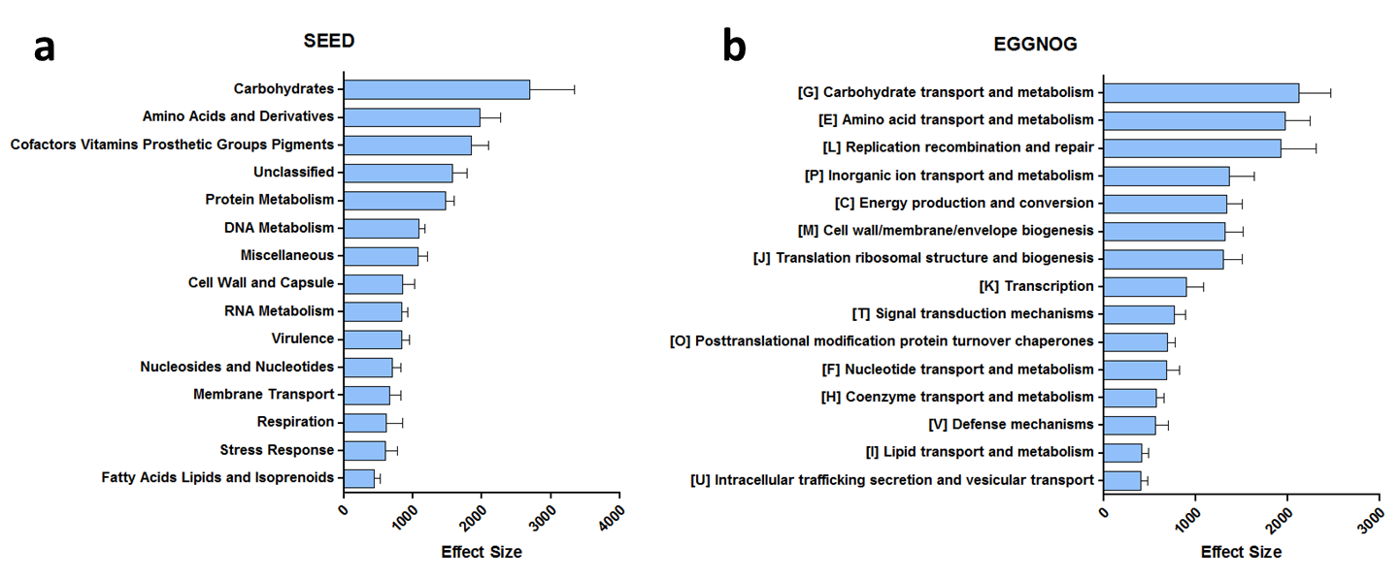
Figure S3. Functional annotation of gut microbiome in TIS individuals. Main SEED (a) and EGGNOG (b) functions were enriched in carbohydrates and amino acid metabolism.

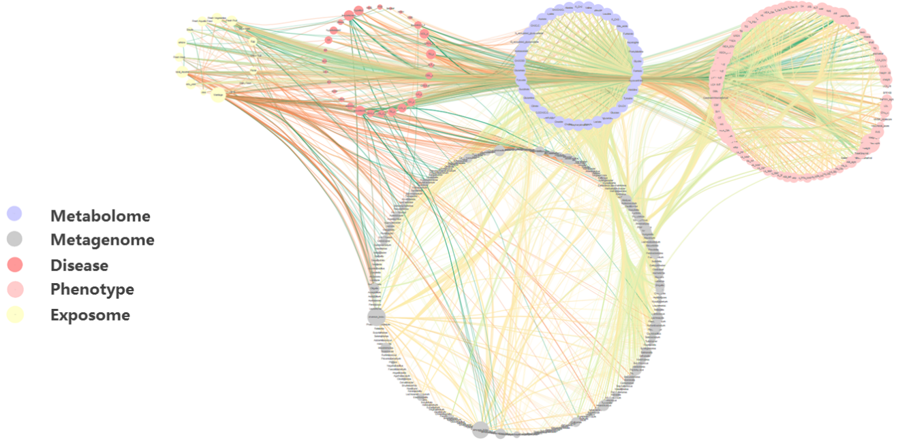

Figure S4. Association between characteristics and in metagenomic data. 221 Genera were associated with 142 factors including 22 sociodemographic and exposures (3 demography, 4 life style, 3 physical measurement results, 2 socio-economic, 10 diet habits), 16 disease status, 66 physiological phenotypes (4 arterial stiffness, 12 blood biochemistry, 6 blood pressure, 6 bone mass density, 30 carotid ultrasonographic, 2 cognitive function, 6 electrocardiography features), and 38 metabolite features.

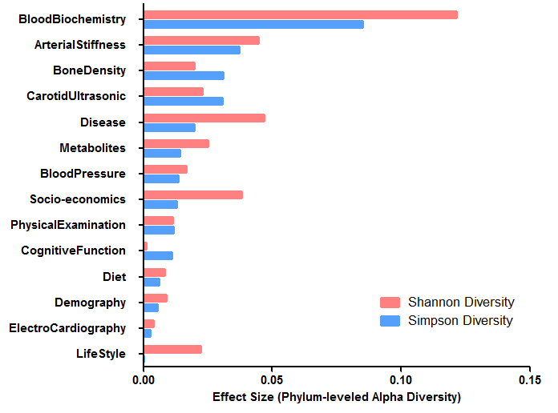
Figure S5. Alpha diversity explained by gut microbiome in TIS individuals. Functional principal component analysis (FPCA) was applied to identify all 14 categorical variables in association with individual alpha-diversity measurements (Simpson’s index and Shannon index). Blood chemistry, arterial stiffness, bone mass density and carotid ultrasonographic measurements significantly explained variation of phylum-leveled alpha-diversity.

Figure S6. Beta-diversity associated variables. Categorical phenotypes such as heart function, disease status, demographic data, social economic status and arterial stiffness were found strongly linked to individual gut distances. EKG indicators such as RV5, cognitive assessment including MoCA, and socio-demographic factors like total income were especially responsible for the gut beta-diversity.

Figure S7. The edge counts (a) and eccentricity (b) were calculated in the network to obtain the breadth and depth each variable category. Demography, carotid ultrasonography, arterial stiffness, blood biochemistry and physical examination measurements were found among the most influential or influenced categories in the network.

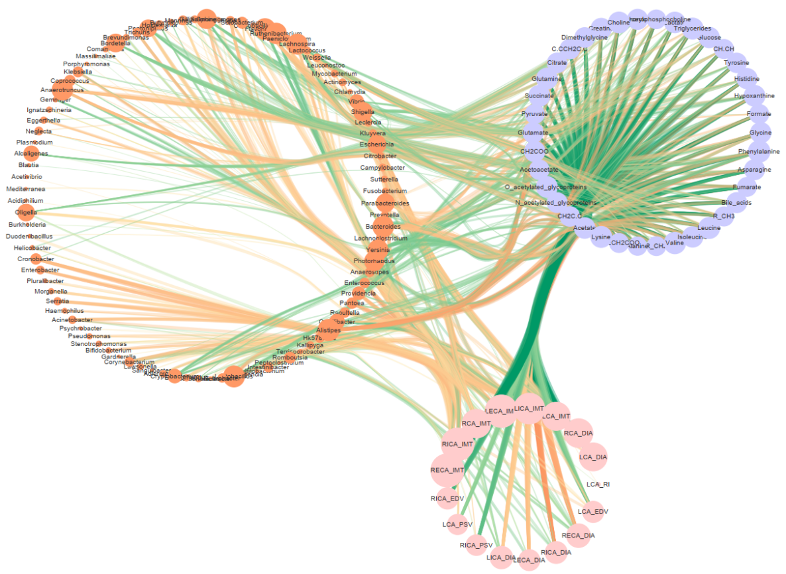
Figure S8. Mediation analysis of metabolomics. Mediation analysis the effect of the microbiota on carotid IMT index was mediated by metabolomics, including Choline, phosphocholine and amino acids.

Supplementary Tables

Table S1. Variables in TIS cohort.
Table S2. Association analysis of variables.
Table S3. Mediation proportion and coefficient of lifestyle, microbiota and carotid ultrasonography.
Table S4. Attribute of 142 variables and 14 categories.

