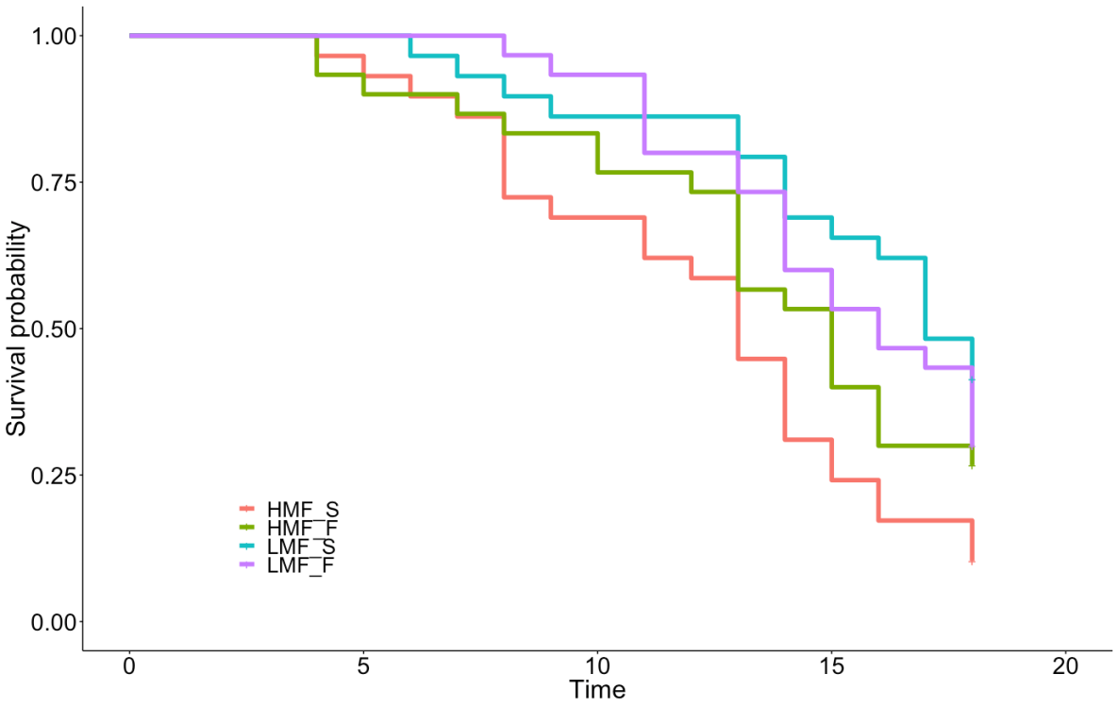
Fig. S1. Effect of mating frequency and male morph on female lifespan. Kaplan-Meier survival plots for females maintained in high mating frequency (HMF) or low mating frequency (LMF) groups and mated with scrambler (S) or fighter (F) male morphs.

Females mated with: | Fixed effect: | Coef. | s.e. | z | P
 | Treatment | -0.9978 | 0.32 | -3.147 | 0.00165
Scrambler | Mating with more than one male | -0.7834 | 0.36 | -2.162 | 0.031
 | Treatment | -0.2586 | 0.31 | -0.845 | 0.398
Fighter | Mating with more than one male | 0.4911 | 0.35 | 1.393 | 0.164

Table S1. Results of a Cox proportional hazard model of female survival probability as a function of mating with a scrambler or fighter in high mating frequency and low mating frequency groups, with experimental treatment and number of mated males as fixed effects.

